Title:

Author:
Ewain Williams
(1905588)

Supervisor:
Dr Michael Fairbank

Second Assessor:
TODO: remember who this is

Abstract
In the current graphics climate where the demands for ever increasing graphical fidelity keep ballooning the complexity of libraries to keep up with the features that users want, there is a lack of simple alternatives to the rendering juggernauts (OGRE3D, BGFX, MAGNUM).
While smaller alternatives do exist (raylib) they are rare and like their larger counterparts often come with baggage that make them difficult to integrate with existing code. This contrasts heavily with the 2D graphics library scene (SDL2, Love2D, libGDX) where solutions are often highly flexible and modular with low barriers to entry and sufficient on demand optional depth to cover almost all use cases.
VSR (Vulkan SDL renderer) aims to fill this 3D niche, offering a simple Immediate mode rendering style API while exposing as much optional depth via shaders + accessible data as possible. With a suite and functions designed in the SDL2 style and implemented in C99 integrating into your current or new projects is simple.
With <30 semicolons or <50 LOC for a spinning cube, VSR can start pushing pixels to your screen with minimal setup. And add basic custom lighting to that scene with only an additional 10 semicolons for 15 LOC ( not counting shader code )
VSR is designed with the intent of being able to grow with you as your demands increase and while due to its infrastructure it will never be able to completely compete with the AAA solutions with easily hackable well organized source code an experienced user will be able to extended where required to fit requirements.

VSR was designed with game jams in mind and is perfect for rapid prototyping although with features like lighting or animation left to the user to implement(through custom descriptor and shaders), a ‘warm up’ period would be recommended before jumping in!

Acknowledgements
TODO: acknowledge Dr Fairbank

Contents
TODO: sort when report is finished

Preamble
TODO: add another paragraph to make this look less mean?

this report uses a large amount of technical terminology surround graphics and the Vulkan™ API. While efforts will be made to contextualize and partially explain these terms, an exact explanation or information beyond the bare minimum will be EXCLUDED from the scope of this report

Project overview
VSR or Vulkan™ SDL renderer is a replacement for the existing rendering API provided by SDL offering primarily native 3D support, but also more advanced features such as custom shaders, and device descriptors.

VSR aims to feel as familiar as possible to existing SDL users by mirroring the naming convention for structs, enums, and function signatures and like SDL2 is written in C99. VSR differentiates itself not only by it’s naming scheme and SDL compatibility but also in it’s rendering style, VSR is an immediate style renderer like the SDL renderer it’s replacing which is becoming increasingly uncommon when compared to the more common and often more complex retained mode style renderer.

Like the SDL renderer VSR has a very limited scope: take rendering data and present to the SDL window surface (or off-screen image), in this regard VSR is NOT an engine and it’s very deliberate in this, like the rest of the SDL subsystems it is a mere part of the puzzle and as a result does not include any functions that do not directly relate to the graphics presented to a surface.

Despite the increased maths often involved in 3D rendering VSR provides no maths facilities, where maths are primarily required however (VSR_MAT4) structs have been designed to be pointer compatible with the most commonly used C Math library cglm.

Project scope
The scope of VSR is primarily tied to its raison d'être: to replace the SDL renderer, attempting to maintain it’s simplicity at face value but adding optional depth without overcomplicating the interface and keeping the source code easy to hack and modify should the end user desire.

For the purpose of this report: ‘depth’ in the context of rendering is taken to be the option of using more advanced 3D rendering techniques that the interface does not explicitly expose such as but not limited to: physically based rendering, mesh optimisation, morph target animation, shadow mapping, deferred rendering.

Interface overview

VSR_Renderer
The renderer is the collection of data used by the implementation, it handles almost all of the state in the program as well as memory used for rendering (both host and device), as a result almost all interface functions require the renderer handle, this is a deviation from SDL’s singleton style ‘subsystems’ but exactly matches the SDL_Renderer from which it was based on. While the singleton style may have simplified the interface using the VSR_Renderer struct makes it’s purpose more evident as a replacement for the SDL_Renderer.

Instantiation does however differ from the SDL style and for good reason, SDL typically uses flag during instantiation however in the case of the pipeline and renderer this does not offer enough fine grain control, instead a pseudo-builder pattern is employed to alter the defaults via the VSR_RendererCreateInfo and VSR_GraphicsPipelineCreateInfo which are obtained by the ‘VSR_*GenerateCreateInfo’

VSR_GraphicsPipeline
the VSR_Graphics pipeline is in essence a wrapper around the shaders, this allows the user to quickly swap them out when doing multiple render-passes, it contains the render pass information as well as frame-buffers allowing users to quickly switch these as well.

VSR_Mesh
just as SDL has surfaces and textures, this paradigm has been copied. VSR_Meshes represent host side representation of model data, this data is then used to create or update models that will then store the mesh data in device allocations. Meshes store both the vertex and index data but also any per model vertex attributes (see vertex data)

VSR_Model
Models are the handle for GPU data used in rendering, they hold the offset of the GPU memory in which per vertices, indices, and model vertex attribute data is stored (see instanced rendering for more info) models are used with an arbitrary number of per model transforms and samplers to draw.

VSR_Image and VSR_ImageView
VSR_Image is a wrapper around Vulkan™ images, it’s format, the allocation that stores it, and the SDL2 surface that was used to create it. Looking through the source code you may notice that VSR_ImageView shares most of it’s fields with VSR_Image, this is done for a reason. Do to the nature of particularly swap-chain images it is possible to have an image view without an image and image without an image view [Vulkan Programming guide chapter 5 page 143]

VSR_Mat4 and VSR_Sampler
VSR_Mat4 and VSR_Sampler represent the current per instance data for rendering, they also track user modification via functions in order to signal when sections of device memory are out of date.

VSR_Framebuffer and VSR_Shader
these structs are the main alterable aspects of the pipeline: VSR_Shader holds the shader code the pipeline uses for the creation of images and the VSR_Framebuffer is extra information held by a sampler created with the correct flags and swap-chain images, which dictate where the result of a render-pass will be stored.

Implementation
Vulkan™ Initialisation
the use of the two stage creation process aids in the Vulkan™ Initialisation particularly the population of the ‘CreateInfo’ structs Vulkan™ uses, due to these two steps and the very standard nature of the basic systems (instance, physical device, logical device, swap-chain) most of the creation info can be pre-populated leaving only the more dynamic things (image-surface format, swap-chain image count, physical device selection) for the second step of creation. pre-populating relevant structs with defaults also allows optional levels of control over objects as per the project goals.

to help with making as much of the complexity as optional as possible certain aspects of the implementation contain byte arrays of what would have otherwise been user provided data and allows people learning the API to ignore the more complex aspects, ‘compiled in’ defaults include: Shader byte code for basic textured rendering, a fallback texture which the texture array defaults to, a default sampler that is used to prevent API errors when rendering to a sampler.

Descriptor sets
Descriptor sets allow users to upload arbitrary data to the device for use in shaders by using the descriptor functions provided. This is done by specifying the size of the descriptors you want at set indexes during renderer creation, VSR is then capable of querying and testing the device for support and then creating the requested number of storage descriptors with the relavent sizes in the second descriptor set.
These descriptors are different to vertex data and will be available throughout all shaders and writeable and persistent across renderer draws, this is a very important optional aspect as it is the feature that allows for any extra data required in rendering such as light positions for lighting, particle system information, level geometry, etc.

the descriptors are limited storage buffers which are slower then their uniform buffer cousins[Vulkan Programming guide chapter 6 page 209] however as allowing the user to request descriptors of an arbitrary type is not currently supported, storage buffers were the best option for the single type

Texture arrays
Textures are stored as combined image samplers that contain both the images and the samplers they use to get arbitrary pixels. To limit state the samplers are stored in a large array of an arbitrary length in descriptor set 1, and to ensure no sampler is in an undefined state all index default to default sampler and the built in fallback texture. Textures are specified by an index in the array and can via custom shaders be sampled in anyway the user wishes such as dividing the texture array into arbitrary sections and using the index as an offset into said sections sample multiple textures off of a single index.

The `VSR_Sampler`s are responsible for encapsulating this state as well as the more complex aspect of using images such as image transitions. The samplers are created from SDL_Surfaces and will upon creation: convert the SDL_Surface in a format that matches the swap-chain format, copy the surface into a host visible staging buffer, create a transfer destination optimal image buffer on the device, copy the surface to the image buffer, create the corresponding image view, if the sampler has been flagged as a possible render target a frame-buffer will also be created for it’s image view, transition the image to a shader usage optimal format, combine the newly created images with their vkSampler and finally update the descriptor array at the set index to point at the image and sampler memory ready for use in shaders

In the event that a sampler is set as a render target an additional transition happens to make it attachment optimal and the sampler is swapped out with fallback to prevent accessing it while it’s invalid. The sampler is transitioned back to the default shader optimal format when the render target is swapped out. With this the result of a render can be stored in a sampler and used in subsequent passes allowing multi-pass rendering by adding a single function. The default size of the texture array is 256, this should be more then enough if users are using texture atlases as is recommended.
command pools and buffer
In order do set work on the device from several contexts, a manner to obtain command buffers to which work can be recorded and then submitted was required, the command-pool provides functions to obtain both graphics and transfer command buffers from their relevant pool. Following best practices 15[nvidia dos and dont’s] exclusive[intel API guide-3-5] one time submit[intel API guide-3-5] buffers are created, this number can be modified to n buffers per pool via requesting more or less during renderer creation. Each command buffer has a fence associated with it, for internal and external synchronisation.

Synchronisation
due to to VSR’s nature as an immediate mode renderer it faces some interesting problems

Vulkan™ provides two main methods for synchronisation semaphores for controlling ownership across multiple queues & fences which are for waiting on device completion of submitted work [Vulkan Programming guide chapter 11 page 369]

a fences’ primary use is to prevent the access of data in use by the device and that is the near sole reason it’s used in VSR. The primary (by weight of times the code is ran) use of fences in VSR is (sub)allocation of the n command buffers for each pool, to prevent command buffers being recorded while they’re in a pending or executed state. To achieve this when acquiring a command buffer from a pool, the command buffers are first checked via `vkGetFenceStatus` then if no un-signalled fence Is found (fences are signalled when their associated submission has completed) the program will hang until a fence becomes available, the command buffer associated is then retrieved, reset, generation increased, and transitioned into a one time submit recording state and the fence that was signalled is reset and then both are given back to the caller to record and submit. on completion of which the associated fence is signalled and the unused command buffer is ready to be reused.

The generation of the command buffer + fence is important as creating fences is a medium-expensive operation and it aids in tracking data as in cases command buffers and fences could be reused and reset before their required check so a command queue can be considered complete if its corresponding fence OR it’s generation has altered which means it was signalled prior and reused. This is used for tracking memory as transfer operations will keep a handle to the fence the transfer operation was submitted with and the generation of the fence that was used, so then when further transfers are signalled using the source or destination of previous transfer the transfer is both thread safe and safe from the device’s perspective.

Swap-chain images also use generation fences, swap-chain image management is complex and requires many synchronisation objects to track which swap-chain image is in which state.
Firstly an unused swap-chain is acquired from the host system a semaphore is used to track the present queue relishes control of the image. Drawing commands are then queued up, the key is when graphics commands are submitted. The submission uses a wait semaphore to halt the execution of the submitted commands until the swap-chain image is available to draw. Once the this is signalled the pipeline draws to the image and signals the next semaphore that the image is ready to be read, which allows the next submission which was the command to present the image to the screen to run. Using a separate index for synchronisation primitives used from the index of the image in swap-chain we can decouple the swap-chain images from the host as much as can be hoped for as all of these commands can be submitted and moved on from while there are available images.

Vertex data
Vertex data is split across 4 fronts: Meshes, Models, Input Attribute description, and Device memory.
Meshes are the host storage for the vertex data and is only used to create models, models track the per vertex vertex data: that is to say vertices indices normals and UVs(texture coordinates). Out of all of those fields only the vertices are actually required the others can be set to NULL during mesh creation and VSR will auto generate them based on the vertex data, although they will be far from optimal and in UVs case partially unusable beyond rendering as a single solid colour.

The rest is per instance vertex data and stored in the individual objects: VSR_Mat4 VSR_Sampler. Which are the model transform and texture index respectively. This is the data that allows for instanced rendering of models at a set array of positions and samplers

Instanced rendering in an immediate context
Instanced or batch rendering is a well know method for speeding up the rendering of scenes consisting of multiple sets of shared data (most commonly mesh data), one of the advantages of retained style rendering is that it naturally lends itself to these batched methods making it simple to benefit from the speed ups it can provide. However with performance losses in other sections of the API in exchange for simplicity, this is a prime area for VSR to get a speed up.

The first step was to split up vertex buffers by input rate, this ended up with two device buffers and staging buffers: one for per vertex data and one for per instance data, splitting data like this gives the advantage of knowing exactly how many per-instance data sets can fit in the stage and the device memory. This information can then be used as pre-processing as if usage is tracked it is very simple to determine how much of the incoming instance data can fit before the existing data has to be sent to the device to free up space for more renders.

It also helps with fragmentation as it is simple to store data adjacent (which is required), as vertex data cannot insert itself between instance data, However just rendering in batches does not provide large speed ups as if all instance data is being uploaded every render call there is little difference between batched rendering and rendering independently if transfers are submitted together.

For the maximum efficiency in instanced renderer data retention must be leveraged, however VSR is immediate not retained so how can it benefit from retained data on the device?

Firstly the per instance is cut in half so it stores an equal number of samplers and mat4s.
Then a check if any amount of these arrays have been used, if so increasing the starting offset by that amount
A queued render struct is allocated and attached to a linked list of queued renders then starting at the offset: Check the host instance data if the data ID matches what was last placed at that position or the data needs updating.
Compare it’s position to the last position in the transfer list + the size of it’s transfer.
If it’s adjacent increase the size of the last transfer.
If it snot check how much space is in the transfer list doubling the list if more space is required.
Add the new entry with the size of 1 transfer.
Repeat for the batch count.
this gives us a list of host data that needs to be move into the device in order to render this batch.
Submit and move the transfers into as much of staging memory as possible then queue up the all the transfers on the device.
When the per instance buffer is full or the renderpass ends, the renderer runs the linked list submitting the queued renderers for drawing.

The goal of this is that on the next run of the function if no data has been signalled for update and the renderers are queued in the exact same order then no transfers need to occur and the link list can be simply recreated and rendered at a much faster rate.

Implementation notes on the Instanced rendering
the batch rendering was developed using a 1,000,000 cube stress test to really push the limits of the system and hopefully lead to the best design. 1,000,000 sets of per instance data can take up a large portion of your device’s space so one of the first things that happens on being called is the function will compare the required batch size to the amount of instance data the staging buffers and device memory available and will split itself up accordingly and flush between runs to ensure everything fits.

It is for this reason users are encouraged to make their per Instance buffers large enough to store their largest possible batch, however in testing the system could handle batch sizes of 1,000,000 with less then 128mb of per instance storage.

The above overview mentioned checking host data for updates however it did not go into detail about this, as you may have guess memory bandwidth is far to precious to be wasted on reading device buffers and doubling everything in memory would be a waste of space so instead VSR_Mat4s and VSR_Samplers have a UUID and a ‘updateRequired’ field. The UUID is very simple at the creation per instance buffer an array containing a UUID for every piece of per instance data is created which can track what data is stored in device memory at any given moment, perInstance UUIDs are created with an ever incrementing uint64 so 2^64 sets of data would have to be in use before a collision occurs.

The ‘updatedRequired’ unfortunately comes with more sacrifices as now VSR_Mat and Samplers must become opaque pointers for the good of the user. As modifying these in anyway even in a single threaded environment may have all sorts of unintended side effects.

The particular note of the transfer list doubling in size on growth could also be considered a minor optimization as set with the idea that if one mesh out of order in need of an update is found then it is very likely there are going to be more, and the more found the more likely that more are going to be found in an exponential fashion

Memory synchronisation was also turned into a bit of a minefield during this, with this function being the main driving for more robust memory tracking and safety for both host and device.

However the results speak for themselves.

Admittedly this was using the 1m cubes which is a very artificial bench mark but the speed increase of 37.172us (26fps) to 12.798us (78 fps) gives a sorely needed burst of speed to help ease other short comings in the API.

Renderer memory management and allocations
For the sake of simplicity VSR manages several buffers with several discrete uses. With Vulkan™ correct resource management and minimal allocation are vital for good performance [nvidia memory management]. As a result the only recourse was to write a custom allocator to fit the specific needs to the application.
The Renderer_Memory.c file contains almost all of this fine detail allowing the rest of the API to avoid worrying about the complexities of memory. It provides Renderer_Memory Renderer_MemoryAlloc structs for internal use.

VSR currently uses 4 memory zones which is sub allocates.

PerModelVertexGPUBuffer perInstanceVertexGPUBuffer
vertex buffers store the vertex input data and are split by their input rate

USDGPUBuffer
the USD buffer is more interesting as it has become sort of a ‘dumping’ ground for any allocation where to memory does not need to be continuous between allocations. USD stands for Uniforms, (combined) Samplers, and Descriptors.

The placement of samplers here may be confusing but its quite simple really: VSR_Sampler isn’t actually a sampler it’s a per instance index to an array of combined image samplers that can be used during shaders. The samplers stored in USD are the actual image data buffers and sampler information that allow texels to be used in the shaders. This gives USD a rather different set of requirements then the vertex buffers, as images can be very specific about the kind of memory they whish to reside in and the boundary's at which they want to sit.

vertexStagingBuffer USDStagingBuffer
staging buffers are vital for proper memory management, this report makes mention of both host memory and device memory, this distinction is Important as the host cannot directly access device memory and device access of host memory is immensely slow [nvidia memory management].
This is the purpose of staging buffers which are used to move large amounts of data to device local memory in a single transfer. `USDGPUBuffer` has it’s own staging buffer where as both `VertexGPUBuffer`s share a staging buffer due to their indentical memory properties with the split existing only for convenience.

The Renderer_MemoryAlloc are sub-allocations using a used-list first fit allocator, the Renderer_Memory has a root allocator which begins a linked list marking all the occupied space in the memory. A used list is used rather then a free list to allow where it is required information about the allocated memory to be used outside of the allocator, it also minimised the number of structs required (a second pointer struct would be required a used list node is both)

Allocations are created by running the used list from the root node checking the spaces between every node until a region of free memory of the correct size is found, in the case of alligated allocations then the free space is calculated from the first alignment boundary. By the end of traversing the list either an allocation has failed or succeeded. Renderer_Memory does NOT deallocate, this is on purpose and defragmenting would take up an unacceptable portion of the device memory band-width.

Renderer Memory synchronisation
to keep memory safe in high performance and multithreaded situations careful control of memory is import to eliminate race conditions and use after modify etc issues. Via use of the prior mentioned generational fences transfer source and destinations can be protected form access and improper times. This is done by during the start of a transfer giving a reference to fence that syncs the transfer queue operation in effect signalling ownership of the data to that fence, which can then be check in any place the data would be used, eventually dropping the reference when the operation is complete. Not only is this safer memory wise but it also offers performance increases giving as much time as possible for any halt when the data would be used.

Pipeline push constants
push constants are a small amount of constant data that can be pushed along with commands onto a queue, push constants are per pipeline as part of their quick change out powers. Push constants are 128 bytes and can store 2 mat4s or 128 bytes or 1 mat4 + 64 bytes depending on your requirements.

Push constants are perhaps best used to send projection matrices to shaders, however they are not the only way to do that and there is nothing wrong with storing this information in a descriptor and using these 128 bytes for another purpose

the data of a push constant is what decides how the data goes to the shader as it will use NULL or not NULL status of a point to decided which configuration it is in, in accordance with the above rules

TODO: Anything left to talk about?
Project management
As you can probably tell the interface is perhaps the most import part of this project, and was the focus of development from the beginning. For managed this project the first thing I did was map out the API I wanted, considering the needs and requirements and how it might all fit together. I then logged a bug for each unimplemented function and got to work.

Due to the nature and complexity of Vulkan™ there are definite peaks and troughs in the flow where more complex issues cropped up, such as complex memory management, synchronisation issues, image transitions descriptor management.

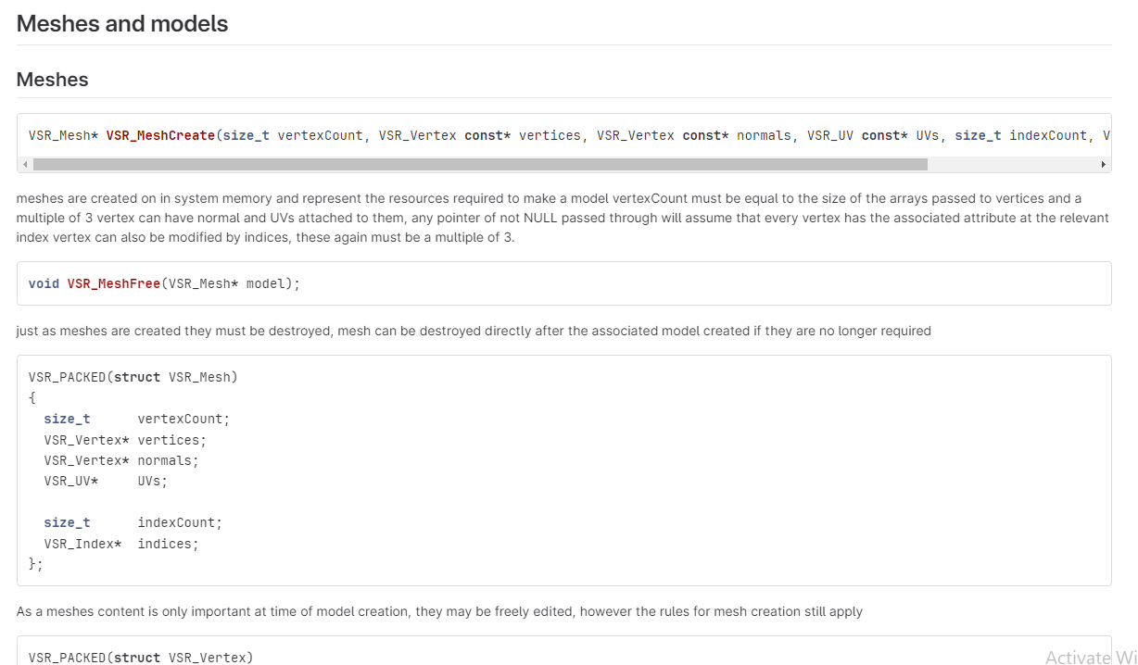

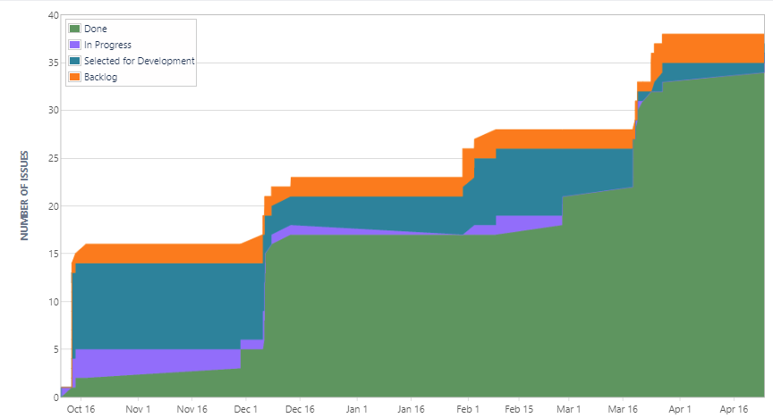

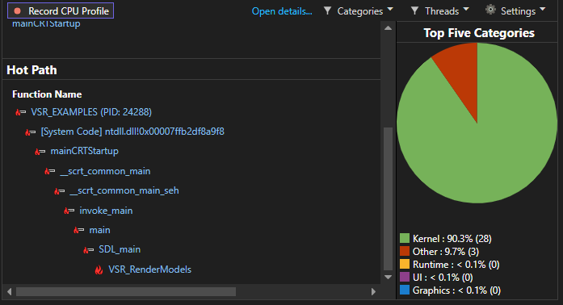
throughout this processes profiling was utilised making sure to take regular measurements to try and pre-empt some of the more hidden pitfalls, and make sure the host was not not taxed too hard and the device remained as active as possible. Native profile tools such as perf as well as benchmarking libraries like ubench where the main focus of this. Sanitisers and memory checks were also a constant part of the development process

Features left to implement
while almost all of the goals set out on, on the initial undertaking of this project have been completed, there remains two that haven't been completed:

user control over render subpasses.
Right now the it’s a very 1999 style rendering system with a depth pass followed by a colour pass.
The immediate thought that jumps to mind is that when doing shadow passes that colour pass is completely wasted, it could also offer performance increases and vastly simplifier how users might go about doing deferred rendering.

Add support for geometry, tessellation shaders
which fairly self explanatory, right now there are two shaders stages where the end users could actual do interesting things but is unused.

Closing thoughts
I am really happy with how this project went, I’m satisfied with the technical achievement, and the end product. There are still some behind the scene things I will probably redo before a full release, the vertex data for example, it’s fairly simple to add new per vertex data it’s just a bit of a chore, I’d like to move some things around so then the vertex input attribute descriptions are more stored in a central place that can be edited a lot quicker to enable the users to quick modify/add vertex data for their needs. If there was one things I could change it’s more with Vulkan™ then with the API as the API bends around it due to Vulkan™. As part of my research I read a lot of books on rendering and learned about some other alternatives to Vulkan and OpenGL mainly apple’s metal™ which does something I really wish was possible with Vulkan™ and would really give some interesting options: they treat everything as a descriptor including vertex and index data which Vulkan™ treats as a special case for some hardware edge cases. I feel like with that I could manage GPU data better without having to juggle it so much when it comes to rendering models and it would allow that customisation in users vertex attributes that I wanted.
TODO: sort this aIlong with the [unfinshed] reference into IEEE format
https://developer.nvidia.com/vulkan-memory-management
https://www.intel.com/content/www/us/en/developer/articles/guide/arc-a-series-gaming-api-developer-optimization.html#inpage-nav-3-5
https://developer.nvidia.com/blog/vulkan-dos-donts/

And efficient
And by extension glm should also work with very little effort
This is an oversimplification: the ownership of swap-chain images is stateful so it’s simpler to treat it this way
Most Vulkan™ objects have a set order they should be created in and doing things in two/three steps simplifies this (the creation of the VSR_GraphicsPipeline could be considered a ‘3rd’ stage as it relies on object created by the renderer)
This is currently largely irrelative as only one queue per family is created so not sharing is really possible anyway
Events are technically a 3rd option but are too complex/fine grain to be considered a ‘goto’ synchronisation method
These fences are created in a signalled state as if they’ve already been submitted and completed to simplify this
Not necessarily a bad thing, but it does make the codebase more difficult to approach.
Unless it utilises reBar technology
skeletal animation and per vertex colouring comes to mind

