**Booya!**

Gerard Kasemba Samantha Doherty Casen Luck Troy Allen

**Project Description**

The purpose of this application is to create a social media site allowing users to post and view challenges posed by other users. The user can log in to the system and see challenges (Physical, Mental, or Other) and complete them. These challenges could be as simple as "10 pushups in the morning" or as daunting as "1 pull-up in the morning".

Upon completing challenges the user will have a running score tallied and be able to follow other user's scores. The user will also have the opportunity to upload an image or short video of their completed challenge.

**User Story**

AS A USER I want to be able to post, view and accept challenges posed by other users.

and be able to complete and interact with other challenges.

AS A USER I want to be able to track challenges i've completed and be able to view other

users completed challenges

AS A USER once I complete a challenge I want to see the points awarded added to my running total.

**Breakdown of Tasks**

Api Routes - Troy Allen

Front End - Samantha Doherty

Database - Casen Luck

Media integration - Gerard Kasemba

**Wireframe**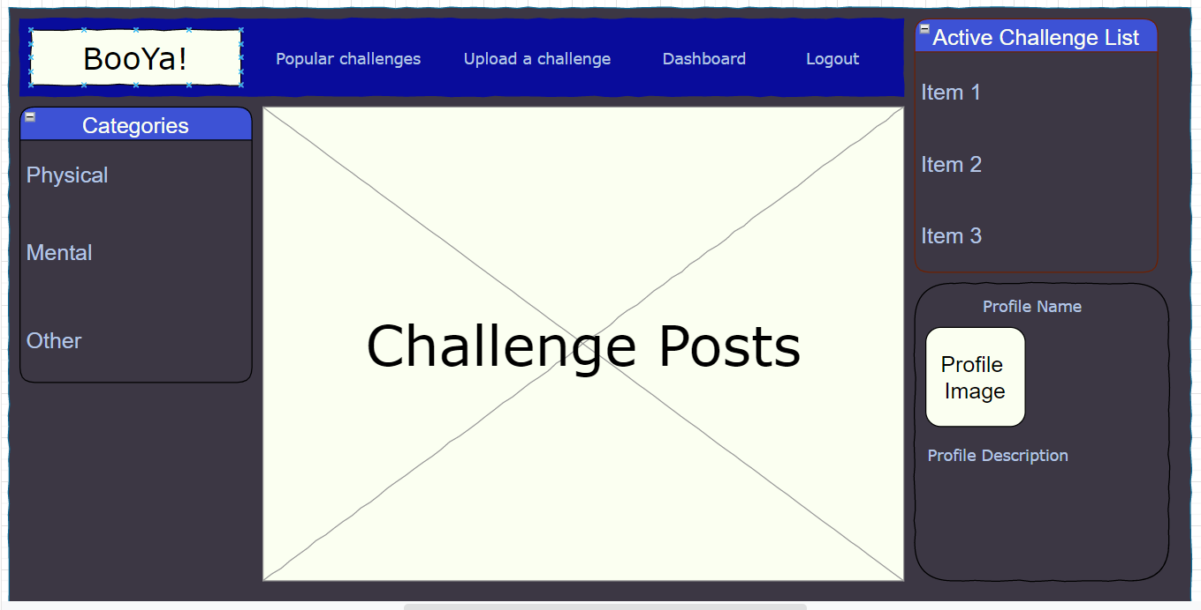

Tables

| User | Challenge | Accepted | Completed |
| --- | --- | --- | --- |
| id | id | user_id | user_id |
| password | name | challenge_id | challenge_id |
| name | user_id | expires_at | image |
| score | score |  |  |
| image |  |  |  |