**Disclaimer—**This paper partially fulfills a writing requirement for first year (freshman) engineering students at the University of Pittsburgh Swanson School of Engineering. *This paper is a* ***student, not a professional***, paper. This paper is based on publicly available information and may not provide complete analyses of all relevant data. If this paper is used for any purpose other than these authors’ partial fulfillment of a writing requirement for first year (freshman) engineering students at the University of Pittsburgh Swanson School of Engineering, the user does so at his or her own risk.

SPRING 2018: OUTLINE and CONFERENCE PAPER

FORMATTING REQUIREMENTS

Author Name, email, 0012 section, Author Name, email, 0012 section

***Abstract—****Your abstract must be formatted as you see here,*

single spaced (1.0); full justified, with the word **Abstract** in bold followed by a dash. Your (approximately 200 word) abstract must concisely summarize the focus and content of your paper. If your Abstract is longer than one paragraph, indent (Tab 0.3) all paragraphs after the first paragraph Do not underline your focus/topic sentences. Put a space between your **Abstract** and your Key Words.

Key Words—Your Key Words section must include from five to seven key words or brief phrases, listed alphabetically, separated by commas, in 10 pt. Times New Roman or Cambria, italics, with “Key Words” followed by a dash. For example: Key Words—First key word, Next key word, Third key word. Note that Key Words are listed only; you do not define or explain terms in this section. List those terms that would make for an effective key word search for your paper and that might usefully appear in an index of a book that includes your paper.

YOU MUST FOLLOW THESE 2018 FORMATTING REQUIREMENTS EXACTLY!

For the Conference Paper you must follow these formatting instructions exactly. Are you using format instructions that do not say SPRING 2018: OUTLINE AND CONFERENCE PAPER FORMATING REQUIREMENTS at the top of the page? If your formatting instructions do not say, SPRING 2018: OUTLINE AND CONFERENCE PAPER FORMATTING REQUIREMENTS at the top of the page, then you are using the WRONG formatting requirements! Use only the requirements/instructions that say SPRING 2018: OUTLINE AND CONFERENCE PAPER FORMATING REQUIREMENTS. There will be a (minimum) 3-point deduction for each formatting error.

**OVERALL FORMAT REQUIREMENTS**

This list details format requirements for the paper, overall, as well as for the header and footer.

* Top and bottom margins: 1.0"
* Left and right margins: 0.75"
* Headers and Footers 0.5"
* All text Times New Roman or Cambria
* All text (except MAIN TITLE, author/email, section headings and subheadings) full justified
* 2 column format for the body of the document
* Spacing between columns: 0.2"
* Column width: 3.4"
* Line spacing: Single (1.0) space for text in all sections.
* Body text 10 pt. Times New Roman or Cambria
* Space between Disclaimer and MAIN TITLE; between MAIN TITLE and names/emails; between names/emails and Abstract, between Abstract and Key Words, between Key Words and first SECTION HEADING; between SECTION HEADINGS and section text; between section subheadings and subsection text
* Disclaimer (you must have exactly the Disclaimer shown at the top of this page at the top of your first page (you can simply copy and paste it in.) The word Disclaimer in bold followed by a dash (as shown, above)
* MAIN TITLE, 14 PT, ALL CAPS, BOLD, CENTERED
* Authors’ names, emails, sections: 10 pt., bold, centered; use only your 0012 section instructor’s last name (for example: Author Name, email, Mena 10:00)
* SECTION HEADINGS, 12 pt., ALL CAPS, BOLD, CENTERED
* Section Subheadings, 10 pt. bold, centered
* Header, Page 1: 10pt. bold, aligned left
* Conference Session
* Paper # (Paper # goes under Conference Session)
* Header, after Page 1: 10pt. bold, aligned left
* Author Name

Author Name (2nd Author Name goes under first author name)

* Footer, Page 1: 10pt. bold, aligned left
* University of Pittsburgh, Swanson School of Engineering (on one line)
* Footer, Page 1: Page number, 10 pt., bold, centered
* Submission date: mm.dd.yyyy, bold (submission date goes under University of Pittsburgh, Swanson School of Engineering)
* Footer, after Page 1: Page number, 10 pt., bold, centered

IN-TEXT CITATIONS AND YOUR SOURCES SECTION

*Always* Provide In-text Citation Numbers

As you have been doing this semester, and as you did last semester, you will use a bracketed reference number in your text for *every* quotation, paraphrase, or summary, chart, graph, drawing, photograph, formula, and/or equation from a source. The system you will use is the same as the system you have been using: the first source material that appears in your paper is [1]. Material from your next source is [2], and so on. Material from the same page of the same source gets the same in-text reference number as when it was first used.

***Always* Locate In-Text Reference Numbers Effectively: Do This!**

As you learned last semester, quotations must have a reference number right after the quoted material. **Paraphrases must have reference numbers right after or very soon after the paraphrased material.** **If you have a relatively lengthy paraphrase, “break it up” with indications to the reader that you are continuing to paraphrase.** For example, if you have 4 sentences of paraphrased material (from a source authored by X), and you want to keep these paraphrases in the same paragraph, you might do this: Paraphrased material paraphrased material paraphrased material paraphrased material. Paraphrased material paraphrased material paraphrased material paraphrased material [1]. X goes on to explain the variables that affect durability, noting that paraphrased material paraphrased material paraphrased material paraphrased material. Paraphrased material paraphrased material paraphrased material paraphrased material [1]. You can manage summaries and their reference numbers in the same way.

**Contextualize Source Material (Be Sure to Also Contextualize Charts, Graphs, Drawings, Photos, Etc.)**

Remember the “quotation sandwich” from last semester (if you do not remember, go back and look at the PowerPoints from last semester)? Most of your **quotations, paraphrases, and summaries must be “introduced”**—you mustestablish the authority of the source material by letting readers know who the authors of the material are and/or where the material comes from. Then, be sure you are **contextualizing the quoted, paraphrased, or summarized material**. In other words, *always be sure* you are *explaining and analyzing* source material; avoid just “dropping” source material into a section of your paper. The same “contextualizing” requirements for explanation/context apply to charts, graphs, drawings, photos, etc.

**Correct Formatting for Bibliographic Information in Your Sources Section**

The bibliographic details (author, date, title, etc.) for each number in your Sources Section must correctly correspond to the reference numbered source material in your text. Bibliographic details must be complete and accurate. To correctly present the bibliographic information for your sources “How to Present Sources” under Steps 1, 2, 3. and 4 on the Conference Information Page.

**Do not put spaces** between sources listed in your Sources section or between sources listed in your Additional Sources sections.

FORMATTING FOR FIGURES (PHOTOS, CHARTS, GRAPHS, DRAWINGS, ETC.)

All figures must have a FIGURE number, a [citation number], and a caption

* FIGURE NUMBER (for all photographs, drawings, charts, tables, etc.), 10 pt., ALL CAPS, bold, centered
* Number each figure sequentially, starting with 1; FIGURE 1 is the first picture, drawing, chart, table, etc. that you include in your paper; FIGURE 2 is the next one, etc.
* Place the FIGURE NUMBER below the picture, drawing, chart, etc.
* Use a bracketed number as your in-text citation for the figure (as you would for any material taken from a source); place the bracketed number just after the FIGURE NUMBER.
* Place figure caption below the figure number; the caption must be 10 pt., bold, centered. Figure captions are brief descriptions of the photograph, drawing, chart,

Put a space between the figure and the FIGURE NUMBER; put a space between the caption and the “body” text. For example:

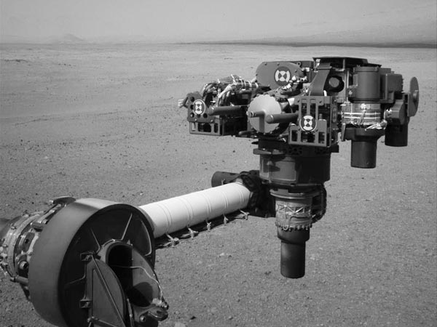

FIGURE 1 [3]

Mars Rover Curiosity’s tool turret and flexible arm

Body text further contextualizing/explaining the figure

ADDITIONAL SOURCES SECTION

Additional Sources must be listed alphabetically by author’s last name (or first main word of the source title, if there is no author). An Additional Sources section is *not required.* Do not put spaces between sources listed in your listed in your Additional Sources sections.

ACKNOWLEDGMENTS

Your Conference Paper *must have* an Acknowledgments section. As shown, here, the Acknowledgments section goes *after* the Sources and Additional Sources sections.