Avery Peiffer

ECE 1195 – Spring 2021

Lab 5 Report

The following report shows a series of images illustrating my completion of Lab 5. The first image shows the code for my sw_conv function.

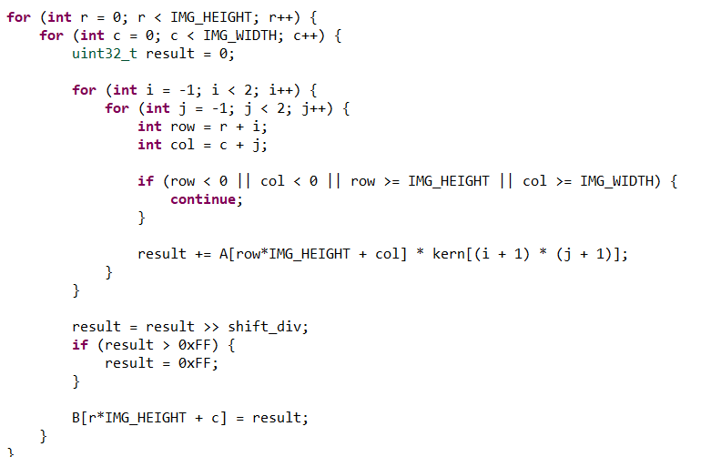

The following three images show my code for the hw_conv function.

The next set of images shows the synthesis report for my Vivado HLS code. I was not able to fully attempt the bonus because I ran out of time before having to return my kit, but I tried it and ran into some issues with executing the Linux commands on Putty. Dr. Mahmoud said that this could be because my design uses too many flip-flops and lookup tables.

The next set of images shows my results from running the Vivado HLS code. From left to right, the images are: the original rock image, the software convolution result, and the hardware convolution result. The hardware and software results are blurred to the same degree; this means that the filter was applied in the same intensity to both images.

The final set of images shows the HLS code being integrated into a Vivado block diagram. The first image shows the hardware accelerator replacing AXIS_DATA_FIFO subcomponent within the ACCEL component. The second image shows the successful bitstream generation, while the third image shows the implemented design that was created from this bitstream.

