Name ____________Avery Peiffer___________________________________

ECE 0247 Quiz #7

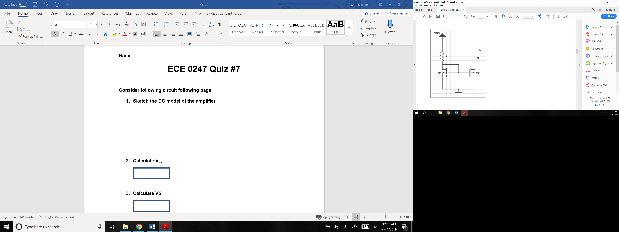

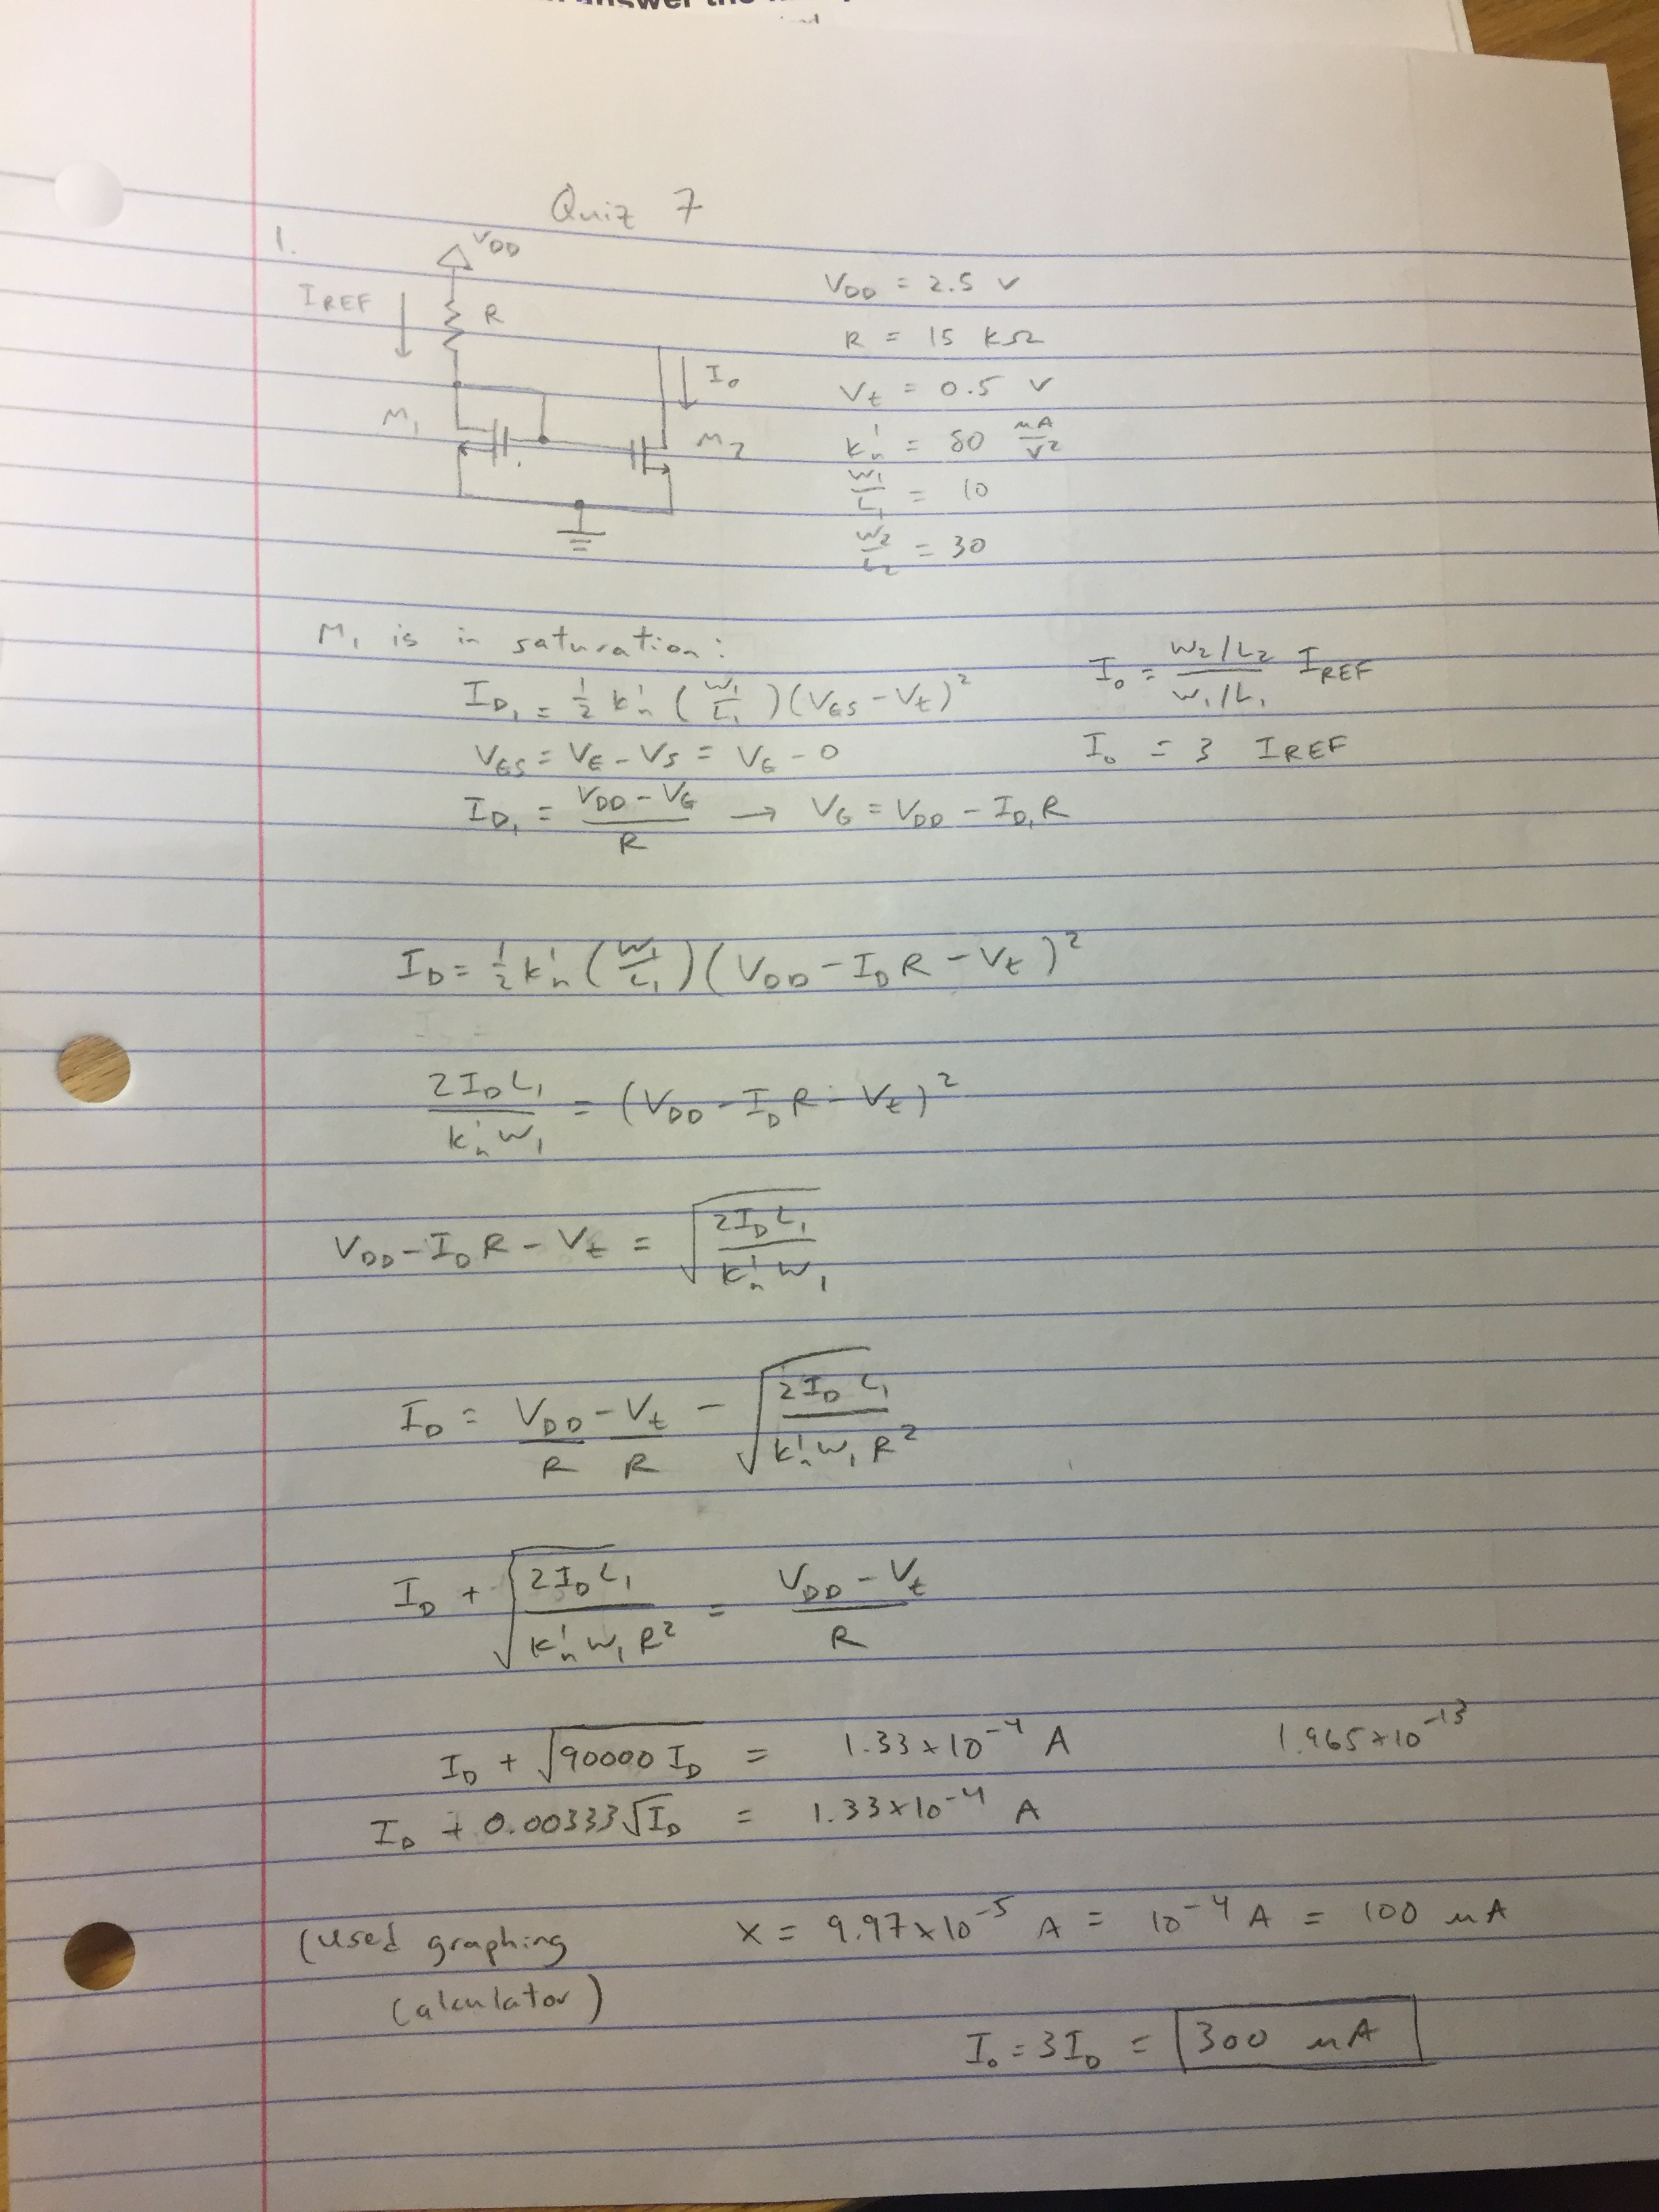

**Io = 300 µA**

1. ( 8 points) For this circuit what is the value of the output current, Io?

Assume that VDD = 2.5V, R = 15 kΩ, Vt = 0.5V, k’n = 80 uA/V2, W1/L1 = 10 and W2/L2 = 30

(Report your answer in units of µA)

2. (2 points) Sketch a transistor-level schematic for an active-loaded Common Gate Amplifier that uses only transistors (NMOS and/or PMOS) and no more than one resistor

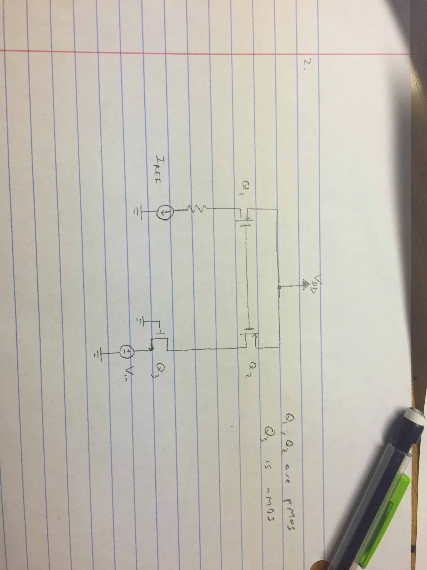

**EXTRA PAGES**

[Leave the page unchanged if you are not going to use. Otherwise, specify the problem number you are working on here. Don’t forget to notify “TO BE CONTINUED” in the original problem box]