**CS2770: Homework 1**

**Due:** 2/16/2021, 11:59pm  
  
This assignment is worth 100 points.  
  
  
**Important:** If you haven't used Python to work with matrices and images before, please spend a few hours going through this [tutorial](http://cs231n.github.io/python-numpy-tutorial/). You're welcome to use specialized packages, as long as they don't implement the functionality that you are asked to implement. If you are unsure about what is fair to use, please ask the instructor or TA.  
  
  
Part A: Image Responses with Filters (15 points)  
  
In this problem, you will measure the responses of images to different filters. For each image, you will compute the response of each image pixel to the filters from a "filter bank" as discussed in class. In a later assignment, you will use these responses to filters to compute image representations.

1. Download these images: [cardinal1](https://people.cs.pitt.edu/~kovashka/cs2770_sp21/hw1/cardinal1.jpg), [cardinal2](https://people.cs.pitt.edu/~kovashka/cs2770_sp21/hw1/cardinal2.jpg), [leopard1](https://people.cs.pitt.edu/~kovashka/cs2770_sp21/hw1/leopard1.jpg), [leopard2](https://people.cs.pitt.edu/~kovashka/cs2770_sp21/hw1/leopard2.jpg), [panda1](https://people.cs.pitt.edu/~kovashka/cs2770_sp21/hw1/panda1.jpg), [panda2](https://people.cs.pitt.edu/~kovashka/cs2770_sp21/hw1/panda2.jpg).
2. Download the [Leung-Malik filter bank](http://www.robots.ox.ac.uk/~vgg/research/texclass/filters.html) from [here](https://people.cs.pitt.edu/~kovashka/cs2770_sp21/hw1/filters.mat) (this is a Matlab file; in Python you can read it with loadmat). Each filter F(:, :, i) is of size 49x49, and there are 48 filters.
3. [5 pts] Read in all images, and convert all images to the same square size (e.g. 100x100), so that the visual map of responses can be more comparable across images. Also convert the images to grayscale. Then convolve your image with each of the 48 filters, e.g. using [convolve](https://docs.scipy.org/doc/scipy-0.18.1/reference/ndimage.html).
4. [5 pts] For each filter, generate a 2x4 subplot showing the following subplot rows: (1) the filter and a blank subplot, (2) the responses to the cardinal images, (3) the responses to the leopard images, and (4) the responses to the panda images.
5. [5 pts] Choose and include in your submission (1) one filter where the responses of images of the same animal are similar, while the responses of images of different animals are quite distinct; and (2) one filter where responses of different animals look fairly similar. Name the files same_animal_similar.png and different_animals_similar.png. See an example for one filter below.

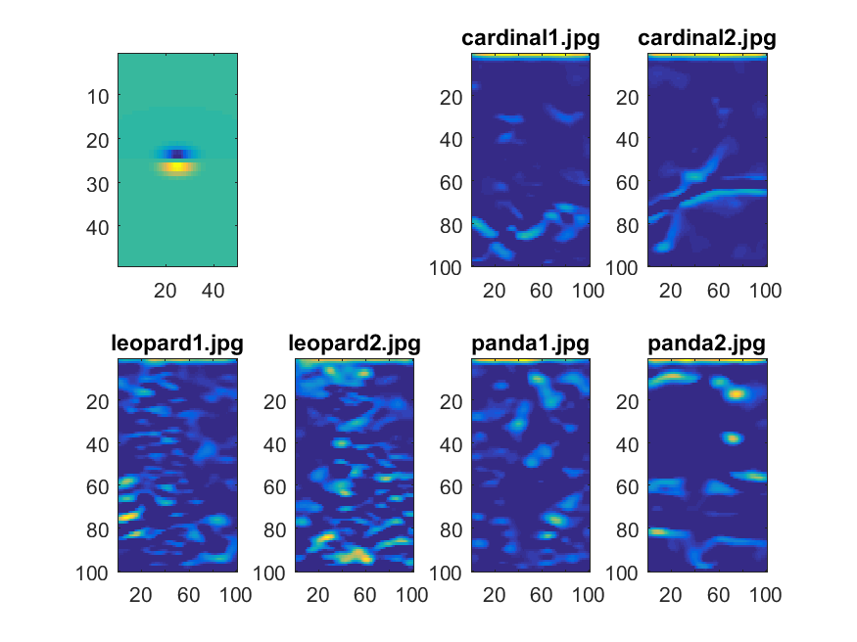  
  
Part B: Image Description with Texture (5 points)  
  
In this problem, you will use texture to represent images. You will compute two image representations based on the filter responses. The first will simply be a concatenation of the filter responses for all pixels and all filters. The second will contain the mean of filter reponses (averaged across all pixels) for each image.  
  
Write a function computeTextureReprs with inputs image, F where image is an RGB image and F is the 49x49x*num_filters* matrix of filters you used before. The function should output two arguments texture_repr_concat, texture_repr_mean defined below.

1. [1 pts] First, create a new variable responses of size *num_filters*x*num_rows*x*num_cols*, where *num_rows*x*num_cols* is the size of the image. Convert the input image to grayscale.
2. [2 pts] Compute the responses of the image to each of the filters, and store the results in responses.
3. [1 pts] Create the first image representation texture_repr_concat by simply converting responses to a vector, i.e. concatenating all pixels in the response images for all filters.
4. [1 pts] Now let's compute the image representation in a different way. This time, the representation texture_repr_mean will be of size *num_filters*x1. Compute each entry in texture_repr_mean as the mean response across all pixels to the corresponding filter. In other words, rather than keeping information about how each pixel responded to the filter, we are collapsing that information to a single value: the mean across all pixels.

Part C: Hybrid Images (10 points)  
  
In this problem, you will create a hybrid image (which looks like one thing zoomed in and another zoomed out) like the one shown in class.

1. Download one pair of images:
   * [woman_happy](https://people.cs.pitt.edu/~kovashka/cs2770_sp21/hw1/woman_happy.png) and [woman_neutral](https://people.cs.pitt.edu/~kovashka/cs2770_sp21/hw1/woman_neutral.png), or
   * [baby_happy](https://people.cs.pitt.edu/~kovashka/cs2770_sp21/hw1/baby_happy.jpg) and [baby_weird](https://people.cs.pitt.edu/~kovashka/cs2770_sp21/hw1/baby_weird.jpg).
2. [3 pts] Read in the first image in the pair as im1 and the second as im2. Resize both images to the same square size (e.g. 512x512), and convert them to grayscale.
3. [2 pts] Create and apply a Gaussian filter; see [gaussian_filter](https://docs.scipy.org/doc/scipy-0.18.1/reference/ndimage.html). Save the results as im1_blur, im2_blur.
4. [2 pts] Obtain the detail image by subtracting im2_blur from im2, and save the result as im2_detail.
5. [3 pts] Now add im1_blur and im2_detail, show the image, save it as 'hybrid.png', and include it with your submission. Play with scaling it up and down to see the "hybrid" effect.

Part D: Feature Detection (30 points)  
  
In this problem, you will implement feature extraction using the Harris corner detector, as discussed in class. Write a function extract_keypoints with the following inputs/outputs:  
  
Input:

* image is a color image which you should convert to grayscale in your function.

Outputs:

* Each of x,y is an *n*x1 vector that denotes the x and y locations, respectively, of each of the *n* detected keypoints (i.e. points with "cornerness" R scores greater than a threshold who survive the non-maximum suppression). Keep in mind that x denotes the horizontal direction, hence *columns* of the image, and y denotes the vertical direction, hence *rows*, counting from the top-left of the image.
* scores is an *n*x1 vector that contains the R score for each detected keypoint.
* Ix,Iy are matrices with the same number of rows and columns as your input image, and store the gradients in the x and y directions at each pixel.

Step-by-step instructions:

1. [5 pts] Let's do some preprocessing. First, set some parameters for use in your functions, at the beginning of your function: set the value of *k* (from the "Harris Detector: Algorithm" slide) to 0.05, and use a window size of 5. Second, read in the image, and convert it to grayscale. Compute the horizontal image gradient Ix and the vertical image gradient Iy. Finally, initialize with zeros a matrix R of the same size as the image that will store the "cornerness" scores for each pixel.
2. [10 pts] Use a double loop to compute the cornerness score R(i, j) at each pixel i, j. This score depends on a 2x2 matrix M computed for each pixel, as shown in the slides. Use a window function of 1 inside, 0 outside, i.e. all neighbors of i, j that are less than half_window_size away from it have the same weight, and other neighbors don't contribute. Thus, the matrix M for a given pixel is a summation of window_size^2 matrices, each of size 2x2. Each of the 2x2 entries is the product of gradient image values at that particular pixel. After computing M, use the formula from class to compute the R(i, j) score for that pixel. If a pixel is less than 2 pixels from the top/left or 2 pixels from the bottom/right of the image, set its R score to 0.
3. [5 pts] After computing all R(i, j) scores, it is time to threshold them in order to find which pixels correspond to keypoints. You can set the threshold for the "cornerness" score *R* however you like, e.g. (a) you can set it to 5 times the average *R* score, or (b) you can output the top *n* keypoints (e.g. top 1%).
4. [5 pts] Perform non-maximum suppression by removing those keypoints whose R score is not larger than all of their 8 neighbors; if a keypoint does not have 8 neighbors, remove it. The scores/x/y that you output should correspond to the final set of keypoints, after non-max suppression.
5. [5 pts] Display the input image, and visualize the keypoints you have detected, for example by drawing circles over them. Use the scores variable and make keypoints with higher scores correspond to larger circles. Include the visualization for three images in your submission (named vis1.png, vis2.png, vis3.png).

Part E: Feature Description (20 points)  
  
In this problem, you will implement a feature description pipeline, as discussed in class. While you will not exactly implement that, [the SIFT paper](http://www.cs.ubc.ca/~lowe/papers/ijcv04.pdf) by David Lowe is a useful resource, in addition to Section 4.1 of the Szeliski textbook.  
  
Write a function compute_features with inputs x, y, scores, Ix, Iy defined as above. The output features is an *n*x*d* matrix where each row contains the *d*-dimensional descriptor for the *n*-th keypoint. We'll simplify the histogram creation procedure a bit, compared to the original implementation presented in class. In particular, we'll compute a descriptor with dimensionality *d*=8 (rather than 4x4x8), which contains an 8-dimensional histogram of gradients computed from a 11x11 grid centered around each detected keypoint (i.e. -5:+5 neighborhood horizontally and vertically).

1. If any of your detected keypoints are less than 5 pixels from the top/left or 5 pixels from the bottom/right of the image, i.e. pixels lacking 5+5 neighbors in either the horizontal or vertical direction, set its descriptor to be a vector of zeros.
2. [5 pts] To compute the gradient magnitude *m(x, y)* and gradient angle *θ(x, y)* at point (x, y), take *L* to be the image and use the formula below shown. If the gradient magnitude is 0, then both the *x* and *y* gradients are 0, and you should ignore the orientation for that pixel (since it won't contribute to the histogram).  
   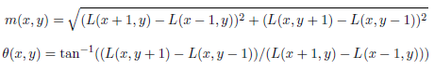
3. [5 pts] Quantize the gradient orientations in 8 bins (so put values between -90 and -67.5 degrees in one bin, the -67.5 to -45 degree angles in another bin, etc.). For example, you can have a variable with the same size as the image, that says to which bin (1 through 8) the gradient at that pixel belongs.
4. [5 pts] To populate the SIFT histogram, consider each of the 8 bins. To populate the first bin, sum the gradient magnitudes that are between -90 and -67.5 degrees. Repeat analogously for all bins.
5. [5 pts] Finally, you should clip all values to 0.2 as discussed in class, and normalize each descriptor to be of unit length. Normalize both before and after the clipping. You do not have to implement any more sophisticated detail from the Lowe paper.

Part F: Image Description with SIFT Bag-of-Words (10 points)  
  
In this part, you will compute a bag-of-words histogram representation of an image. Conceptually, the histogram for image *Ij* is a *k*-dimensional vector: *F(Ij) = [ freq1, j    freq2, j    ...    freqk, j ]*, where each entry *freqi, j* counts the number of occurrences of the *i*-th visual word in image *j*, and *k* is the number of total words in the vocabulary. (Acknowledgement: Notation from Kristen Grauman's assignment.)  
  
Write a function computeBOWRepr with inputs features, means where features is the *n*x8 set of descriptors computed for the image and means is the *k*x8 set of cluster means. A set of files with cluster means are provided for you on Canvas (for *k*={5, 10, 50, 100, 200}). The output should be a normalized bag-of-words histogram bow_repr.

1. [2 pt] A bag-of-words histogram has as many dimensions as the number of clusters *k*, so initialize the bow variable accordingly.
2. [4 pts] Next, for each feature (i.e. each row in features), compute its distance to each of the cluster means, and find the closest mean. A feature is thus conceptually "mapped" to the closest cluster.
3. [4 pts] To compute the bag-of-words histogram, count how many features are mapped to each cluster.
4. [2 pts] Finally, normalize the histogram by dividing each entry by the sum of the entries.

Part G: Comparison of Image Descriptors (10 points)  
  
In this part, we will test the quality of the different representations. A good representation is one that retains some of the semantics of the image; oftentimes by "semantics" we mean object class label. In other words, a good representation should be one such that two images of the same object have similar representations, and images of different objects have different representations. We will test to what extent this is true, using our images of cardinals, leopards and pandas.  
  
To test the quality of the representations, we will compare two averages: the average *within-class distance* and the average *between-class distance*. A representation is a vector, and "distance" is the Euclidean distance between two vectors (i.e. the representations of two images). "Within-class distances" are distances computed between the vectors for images of the same class (i.e. leopard-leopard, panda-panda). "Between-class distances" are those computed between images of different classes, e.g. leopard-panda. If you have a good image representation, should the average within-class or the average between-class distance be smaller?

1. [1 pts] Read in the cardinal, leopard, and panda images again, and resize them to 100x100.
2. [1 pts] Use the code you wrote above to compute three image representations (bow_repr, texture_repr_concat, and texture_repr_mean) for each image.
3. [6 pts] Compute and print the ratio *average_within_class_distance / average_between_class_distance* for each representation. To do so, use one vector to store within-category distances (distances between images that are of the same animal category), and another to store between-category distances (distance between images showing different animal categories). Compute the mean of each of the two vectors, then compute the ratio of the means.
4. [2 pts] Then, in a file answers.txt, answer the following questions.
   * For which of the three representations is the within-between ratio smallest?
   * Does the answer to this question depend on the value of *k* that you use?
   * Does it depend on the number of keypoints you extract? (Try 500, 1000, 2000, 3000.)
   * Which of the three types of descriptors that you used is the best one? How can you tell?
   * Is this what you expected? Why or why not?