Avery Peiffer

ECE 1150

Assignment 1

1. (a) A packet-switched network would be better for this application because the network’s resources can be allocated on-demand. This network has a short duration of connection and a low probability of connection, so allocating resources to a circuit switching network would be inefficient and slow.

(b) A circuit-switched network would be more appropriate for this application

because it is a more consistent application. The connections also run for a relatively long period of time, so it mitigates the setup cost for connections.

2. (a) In the star topology, all nodes are connected to a central node. These networks are susceptible to traffic problems and have a single point of failure. The tree topology establishes a parent-child relationship between routers and end devices, but also suffers from having a single point of failure. The ring topology connects all devices in a loop, which can lead to poor communication latency for long routes. Finally, mesh networks establish links directly between devices, which is flexible but can be more expensive and harder to manage.

(b) In simplex communications, communication can occur in one direction only, at all times. Half-duplex communications have bi-directional communication, but only one direction is possible at a time. Full-duplex communications have communication in both directions simultaneously.

(c) Personal Area Networks (PANs) tend to encompass an individual. Local Area Networks (LANs) connect a building. Metropolitan Area Networks (MANs) connect cities and Wide Area Networks (WANs) connect entire countries.

3. (a)

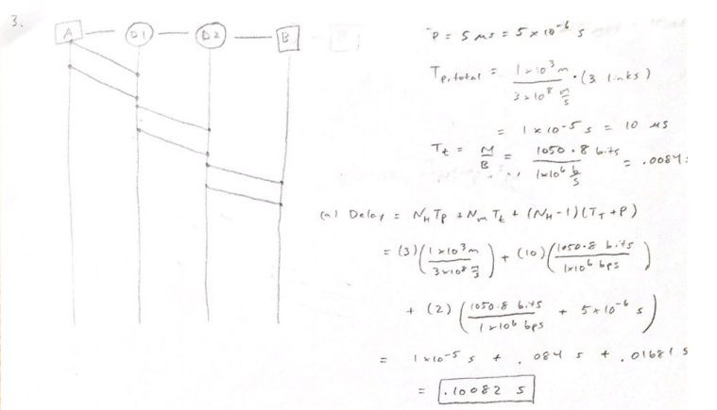

(b)

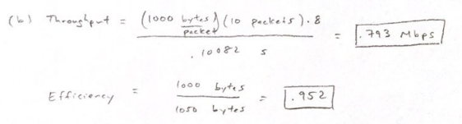

(c) 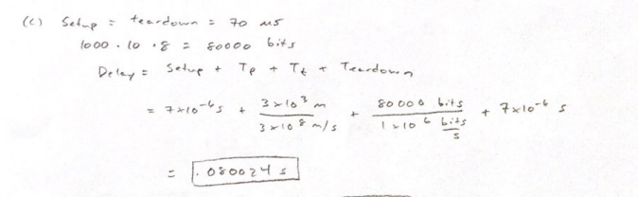

(d) The circuit switching network looks to be more efficient for this application.

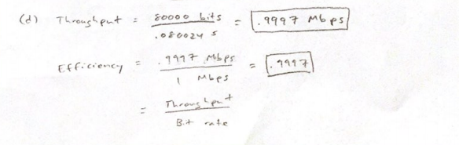

4.



5. (a)



(b) Used Python to output to console

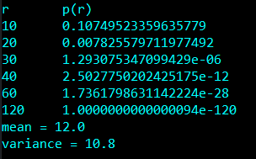

6. (a) 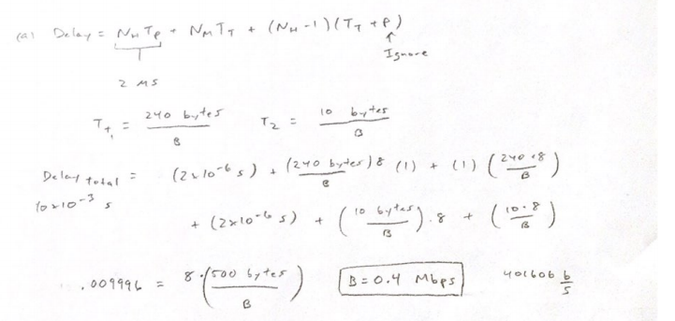

(b)

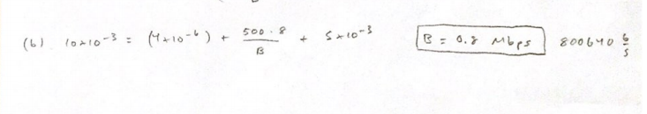

(c) The premium DSL technology is the only one that would support this application because it requires too high of a bit rate for the other two options.

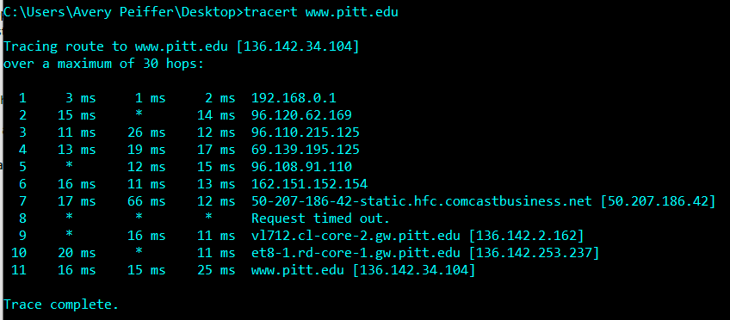7. (a)

(b) There are 26 hops from my device to the destination.