Avery Peiffer

ECE 1150

Assignment 3

1. The copper cables (twisted pair and coaxial) are better for short distances, as they are more susceptible to noise and have more limited data rates. Of these, twisted pair cables have a low capacity and high noise susceptibility, while coaxial cables have good capacity and a lower noise susceptibility than twisted pair cables. Optical fibers are used for long-distance communications as they are better for long distances and have extremely fast data rates. Both multimode fibers and single mode fibers have very low noise susceptibility, with single mode fibers having the highest capacity of any transmission cable. According to Shannon’s Theorem, noise susceptibility and capacity have an inverse relationship; that is, an increase in noise susceptibility causes a decrease in channel capacity, and vice versa.

2. Attenuation is an expression of the power lost as energy is scattered and absorbed as it is transmitted. Distance has a linear relationship with attenuation, which itself is on a logarithmic scale, so in absolute terms the relationship is exponential. In wired links, attenuation is just a function of distance; however, in wireless links, attenuation is a function of distance and frequency.

3. 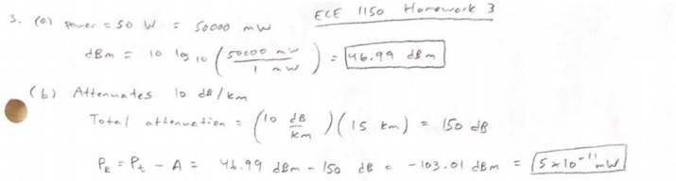

4. 

5. 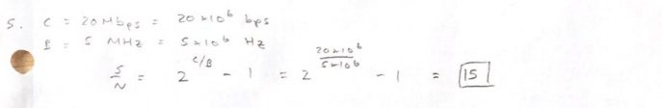

6. 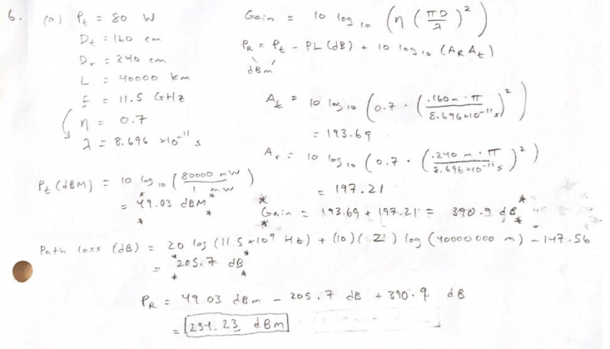

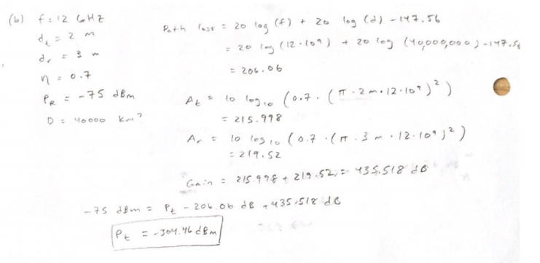

7. 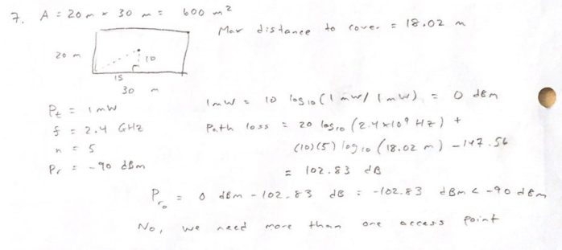

8.

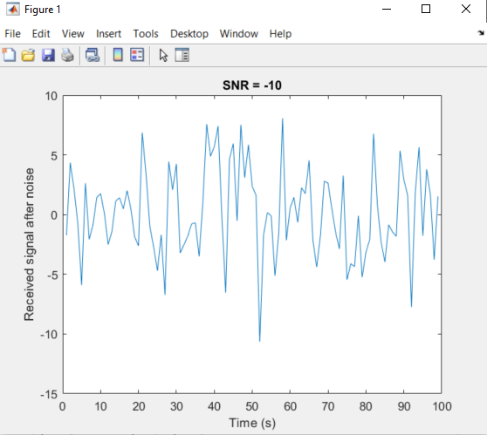

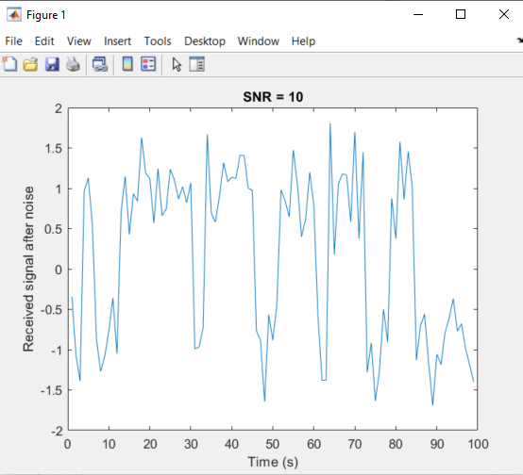

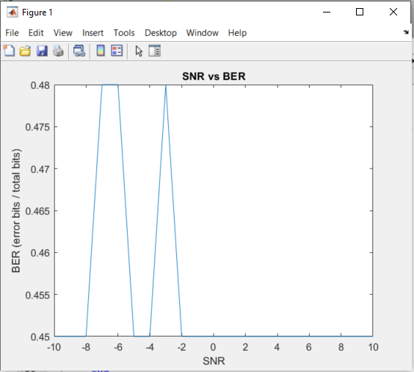

The simulation seems to be somewhat erratic, but it seems clear that as SNR increase, BER decreases.