Ice cream sale and temperature

Real data from an ice cream shop in Southern California:

|  |  |
| --- | --- |
| Average Weekly Temp. (ºC) over 3 months 14.2° 16.4°  11.9° 15.2°  18.5°  22.1° 19.4°  25.1°  23.4°  18.1°  22.6°  17.2° | Amount of ice cream sold  ($American Dollars$) $215 $325 $185 $332 $406 $522 $412 $614 $544 $421 $445 $408 |

1. Load dataset named ‘icecream_sales.dat’ from CourseWeb week 4 lecture. This data set contains two columns. Column 1: temp and column 2: sales.
2. Fit a curve through the data (hint: plot the data using scatter command and inspect which curve type fits best) and write down the equation of the curve: y = 30.0879x – 159.4742
3. Does outside temperature affect ice cream sales? Is the statistical variance significant? (hint: calculate the R-squared value for the fit curve; see next page for formula) R-squared = .9093
4. What will be the anticipated sale on days with average temperatures of 15°, 17.5°, 28°, an 33°? 291.84, 367.06, 682.97, 833.43
5. What is the range and standard deviation of the temperature presented? What is the median sale value? 13.2, 4.0111, 410

Calculating R-squared

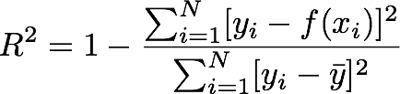

R2 =

