**Avery Peiffer**

**4042056**

**ECE 2390 – Fall 2021**

**Problem Set 5 Report**

TEXT RESPONSES

1a. I blurred the images with the 5x5 kernel used in the Sobel functions for computing gradients.

1b. It is difficult to accurately capture the motion since the displacements are more than one pixel. The Lucas Kanade algorithm only really works for short displacements, so it is starting to fall apart on the pairs that are displaced by more than one pixel.

IMAGE OUTPUTS

Ps5-1-a-1.png

Ps5-1-a-2.png

Ps5-1-b-1.png

Ps5-1-b-2.png

Ps5-1-b-3.png

Ps5-2-a-1.png

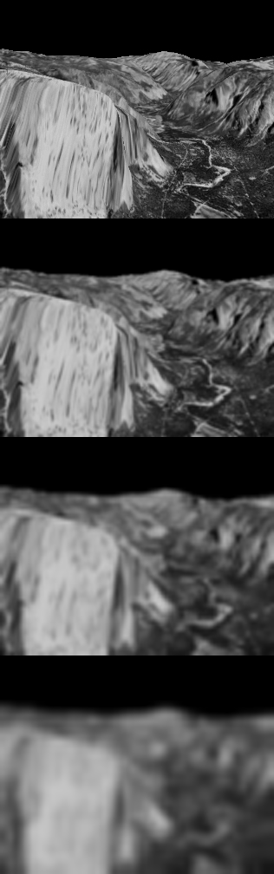

Ps5-2-a-2.png

Ps5-3-a-1.png

Ps5-3-a-2.png

Ps5-3-a-3.png

Ps5-3-a-4.png

Ps5-4-a-1.png

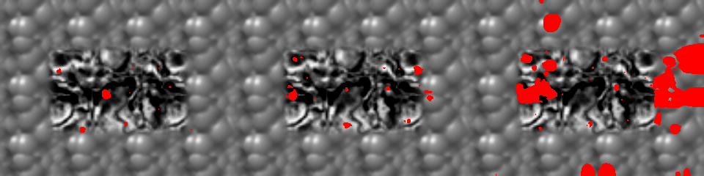

Ps5-4-a-2.png

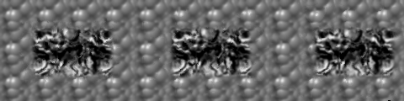

Ps5-4-b-1.png

Ps5-4-b-2.png

Ps5-4-c-1.png

Ps5-4-c-2.png

