**Homework Assignment #1**

**ECE 0257 – Spring 2019**

**Name**

Avery Peiffer

**Collaborators**

Daniel Stumpp

**Book Problems (50 pts)**

Sedra & Smith 4.2(a-d)

Sedra & Smith 4.3(a,b)

Sedra & Smith 4.4(a-k)

Sedra & Smith 4.7

Sedra & Smith 4.9(a,b)

Sedra & Smith 4.13

**Section 1 Simulation Problems (20 pts)**

Exercises (a) – (c)

**Section 2 Simulation Problems (30 pts)**

Exercises (a)-(h)

**Save this file as a PDF before uploading to Courseweb!**

**Sedra & Smith 4.2(a-d)**

[Insert a photograph showing your work and answers for this problem. If you wish, you may type up your answers and work instead]

**Sedra & Smith 4.3(a,d)**

[Insert a photograph showing your work and answers for this problem. If you wish, you may type up your answers and work instead]

**Sedra & Smith 4.4(a-d)**

[Insert a photograph showing your work and answers for this problem. If you wish, you may type up your answers and work instead]

**Sedra & Smith 4.4(e-h)**

[Insert a photograph showing your work and answers for this problem. If you wish, you may type up your answers and work instead]

**Sedra & Smith 4.4(i-k)**

[Insert a photograph showing your work and answers for this problem. If you wish, you may type up your answers and work instead]

**Sedra & Smith 4.7**

[Insert a photograph showing your work and answers for this problem. If you wish, you may type up your answers and work instead]

**Sedra & Smith 4.9 (a,b)**

[Insert a photograph showing your work and answers for this problem. If you wish, you may type up your answers and work instead]

**Sedra & Smith 4.13**

[Insert a photograph showing your work and answers for this problem. If you wish, you may type up your answers and work instead]

**Simulation Exercise (a) (Section 1)**

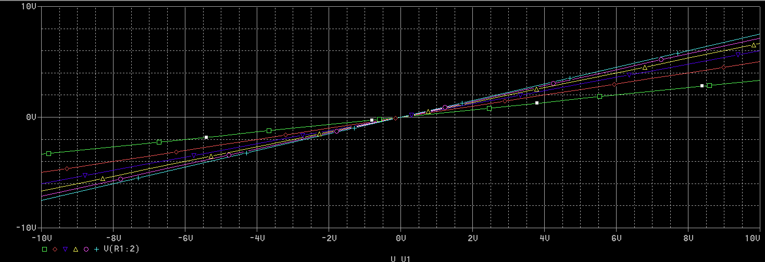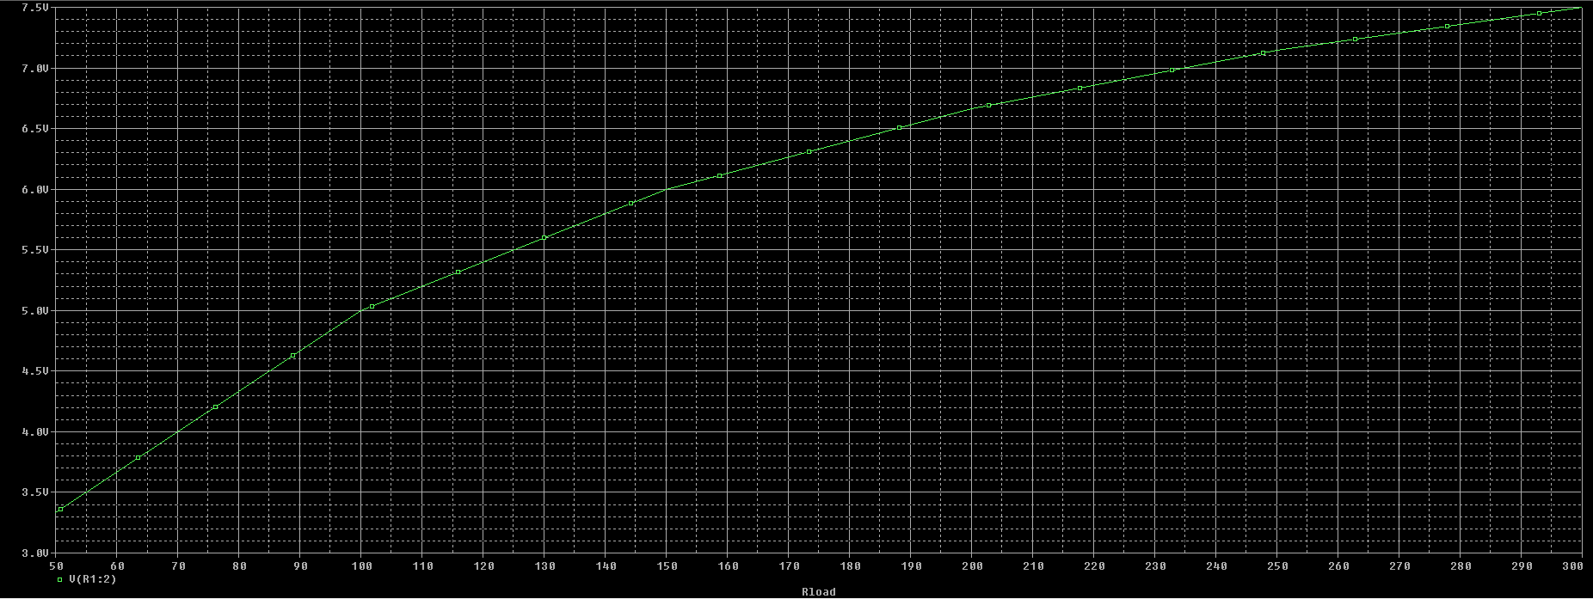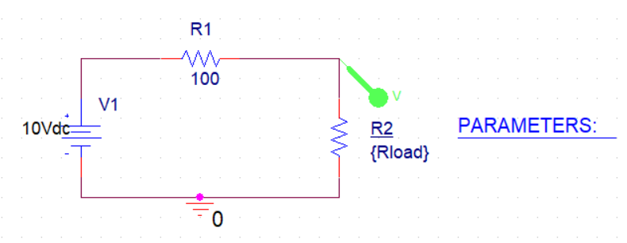

**Simulation Exercise (b) (Section 1)**

Rload = 100 ohms results in the maximum power dissipation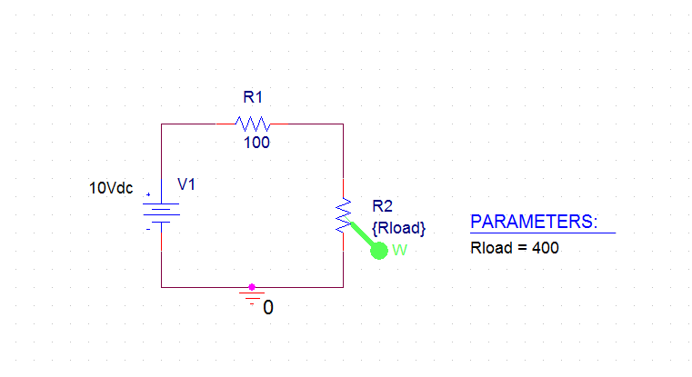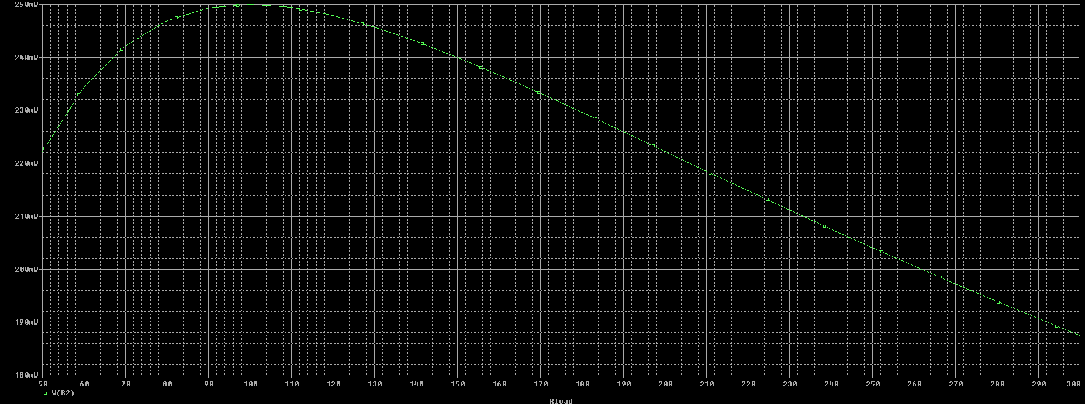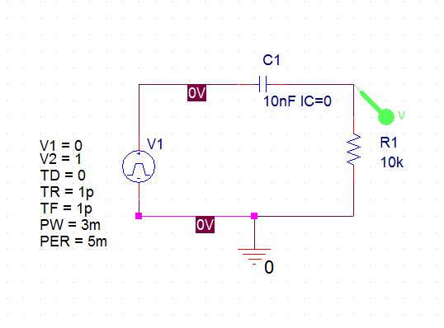

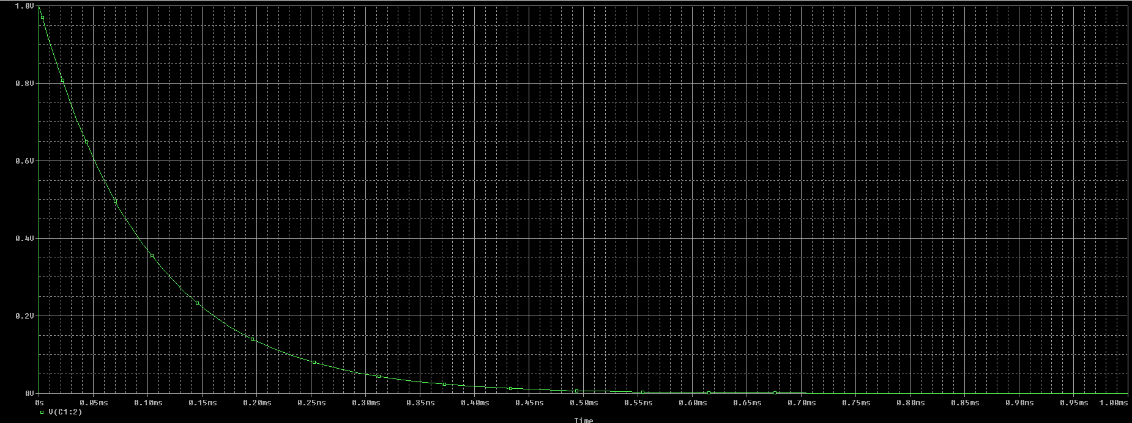[Capacitor voltage graph from exercise B]

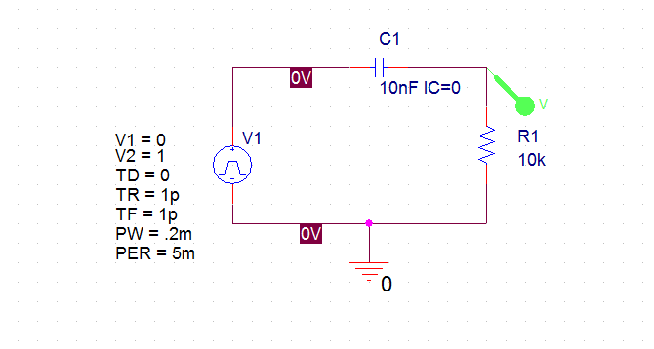**Simulation Exercise (c) (Section 1)**

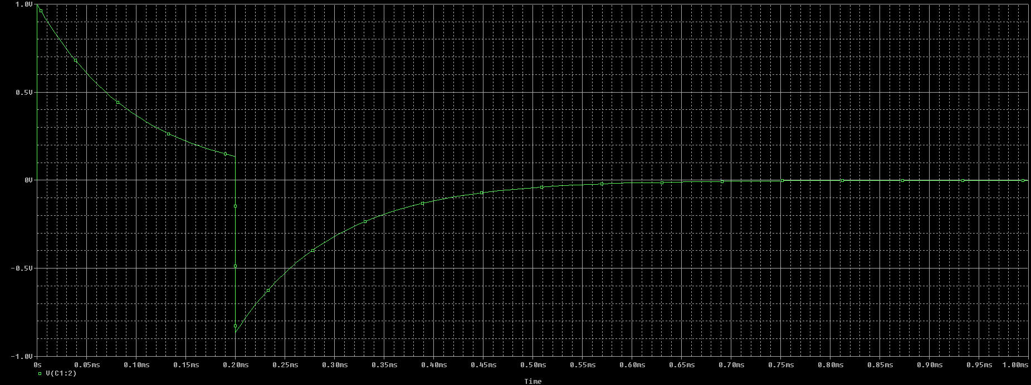

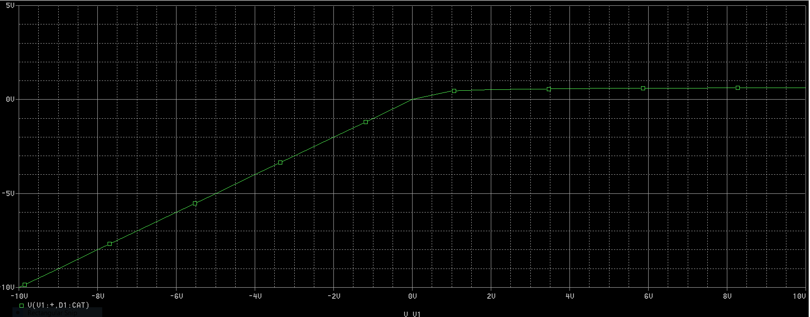**Simulation Exercise (a) (Section 2)** 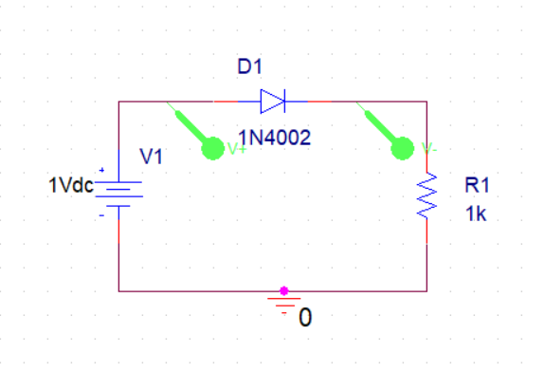

Observations: When the input voltage is less than 0, the output voltage across the diode is negative. When the input voltage is greater than 0, the output voltage is 0 as the diode turns into a short circuit.

**Simulation Exercise (b) (Section 2)**

The diode begins to conduct when the input voltage is greater than or equal to 0.

**Simulation Exercise (c) (Section 2)**

The device does not behave as an ideal diode. If it did, the value of the output voltages would be exactly equal to its corresponding input voltage – there would be a slope of 1. Since there is some difference between a corresponding pair of the two values, the diode is not ideal.

**Simulation Exercise (d) (Section 2)**

The turn-on voltage is 0.

**Simulation Exercise (e) (Section 2)**

I am able to determine the turn-on voltage from looking at the plot because it the plot is a measure of the difference in voltage between the anode and cathode. When the voltage is less than 0, the diode does not conduct and there is no voltage drop across it. The turn-on voltage is the point at which the diode does begin to conduct and is where the plot begins to show a nonzero voltage drop across the diode.

**Simulation Exercise (f) (Section 2)**

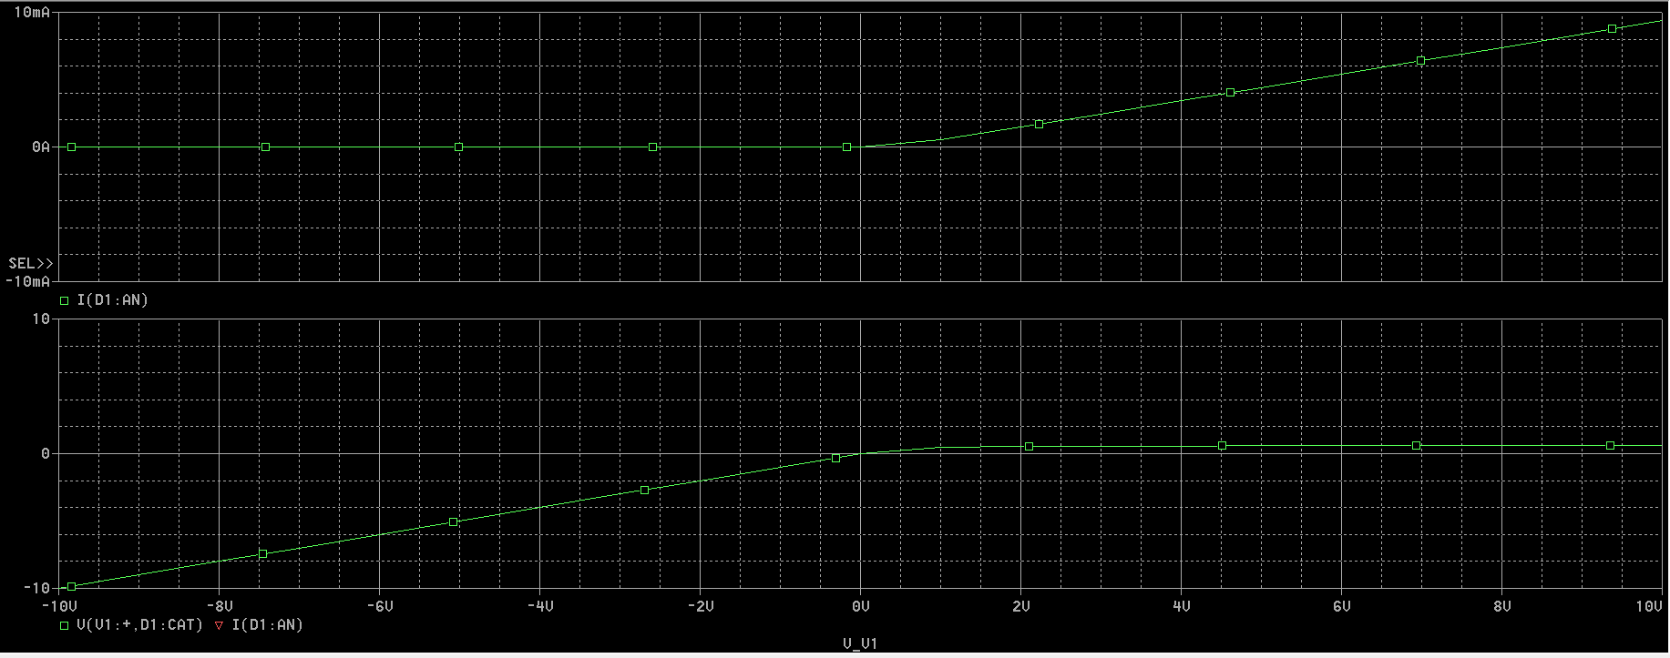This plot does verify my turn-on voltage findings from the previous questions. This second plot shows that the current (top subplot) does not flow until there is a voltage drop between the anode and the cathode (input voltage is greater than 0). When there is a voltage drop between the anode and the cathode, the current flowing through the diode is positive and should be approximately equal to the input voltage divided by the resistance.

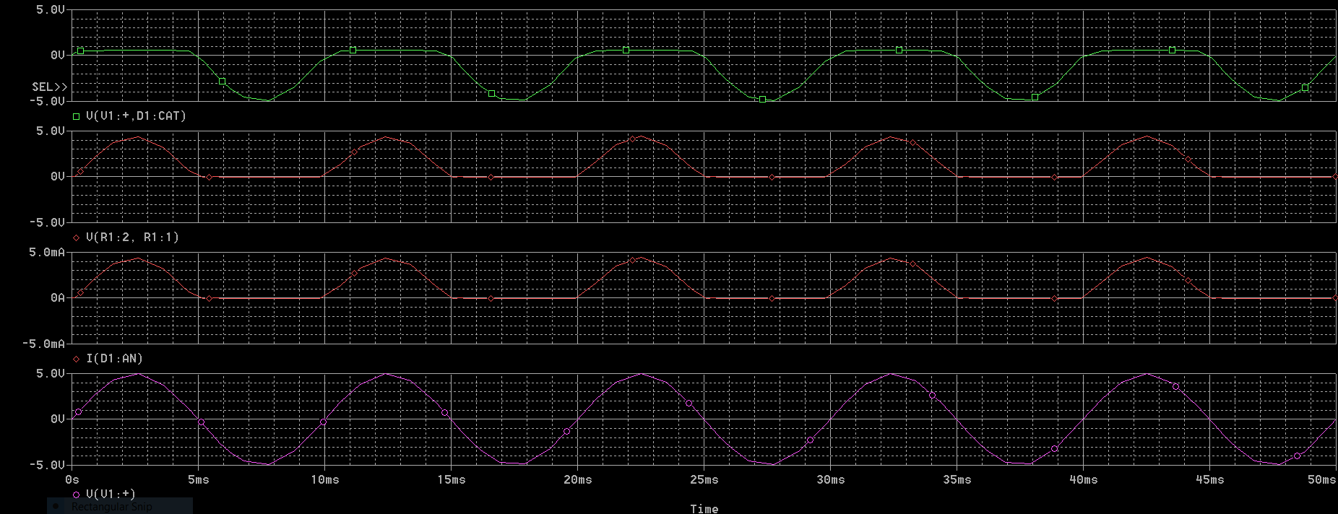**Simulation Exercise (g) (Section 2)**

(From bottom to top: input voltage, current through diode, output across resistor, voltage drop across diode)

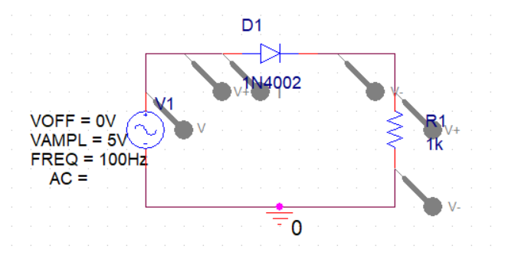

The plot of the input voltage is a fairly straightforward graph, as it is just a sinusoidal curve. The current through the diode is positive when the input voltage is positive, and zero when the input voltage is negative. The same is true for the output voltage across the resistor, as it is dependent on current flowing through the diode. The voltage across the diode is close to zero when the input voltage is positive, though not entirely so because it is not an ideal diode. When the input voltage is negative, the voltage across the diode is also negative.

**Simulation Exercise (h) (Section 2)**

