**Study Guide for Exam 1 - Chapters 1-2, Lectures 1-5**

**This is a general study guide meant to convey what will be emphasized in general on the test. It does not mean that there is a specific question linked to each number. Again, you would do well to focus on material appearing BOTH in the text and in lecture. There is a sample question at the end that illustrates the format of several questions, not necessarily the level of difficulty.**

1. Know the 6 main areas of biological psychology. Be able to identify the defining features of research in each area that we discussed in class. To help with this, try to think of examples of how the same or a similar question would be studied by a scientist working in physiological psychology vs. psychopharmacology vs. neuropsychology, etc.
2. Know what convergent evidence means and understand its importance as illustrated by historical examples from lecture.
3. Know the main external and internal structures of neurons and the structural differences among kinds and classes of neurons (e.g., unipolar, bipolar, sensory, etc.). Remember how the structure of a neuron relates to its function. Know the external features of dendrites discussed in class.
4. Know the main types of glia and their general functions.
5. Understand what the resting membrane potential is, how it is measured, and the forces and factors that cause it. If you had to explain the resting membrane potential to one of your parents (assuming they have no background in neuroscience), how would you explain it in plain English?
6. Know where specific negatively charged and positively charged ions are most highly concentrated with respect to the inside and outside of a neuron at rest.
7. Know how the competing forces of diffusion and electrostatic pressure act on different ions to contribute to the resting potential.
8. Know what sodium-potassium pumps are and how they work in general – what are they involved in?
9. Know these terms: hyperpolarized, depolarized, graded potential, and threshold of excitation.
10. Understand how an action potential is conducted down an axon and how myelin sheaths and nodes of Ranvier affect conduction.
11. Know the specific phases of an action potential and know what is generally happening to sodium and potassium ion channels during each phase.
12. Know what absolute and relative refractory periods mean.
13. Know what the all-or-none law is and know what saltatory conduction means.
14. Know the characteristics of chemical and electrical synapses.
15. Know the different kinds of synapses (e.g., axodendritic, etc.).
16. Be able to understand what the terms pre- and post-synaptic mean.
17. Understand the process of exocytosis (the steps leading to the fusion of vesicles to the membrane, followed by the release of transmitter molecules).
18. Know the basic structural differences between ionotropic and metabotropic receptors. Understand the differences between ionotropic and metabotropic effects. In other words, what does an ionotropic receptor look like? What are its mechanisms of action and what are the characteristics of the effects it might have on a cell? Same questions apply to metabotropic receptors.
19. Understand the general properties of excitatory and inhibitory postsynaptic potentials – in other words, what are they? What do they look like in a figure? How they bring axons closer to or farther away from firing.
20. Know the difference between temporal and spatial summation and how these affect likelihood of an axon firing (having an action potential).
21. Know what neuromodulation means (presynaptic facilitation, inhibition) – know what kind of synapse enables facilitation or inhibition (i.e., would it be axodendritic, axoaxonic, etc.?)
22. Know how glial cells affect synapses.
23. Study Table 2.2 in the text, and be able to understand the processes illustrated in Figure 2.22
24. Be able to describe how transmitters can get “de-activated.” Could you differentiate between degradation or re-uptake by looking at a figure?
25. Know what agonists and antagonists are, and how they can affect neurotransmitter release.
26. *Again: if material appears in BOTH the chapter and the lecture, then emphasize this in your studying.*
27. I usually do not ask that you know the names of particular people, and I don’t usually expect that you know the dates of particular events in history. I prefer to emphasize concepts, illustrations, and problem solving. However, if there is a particular name used in the exam, it will be accompanied by some context and connection to a concept.

*Sample question to illustrate common format used---*

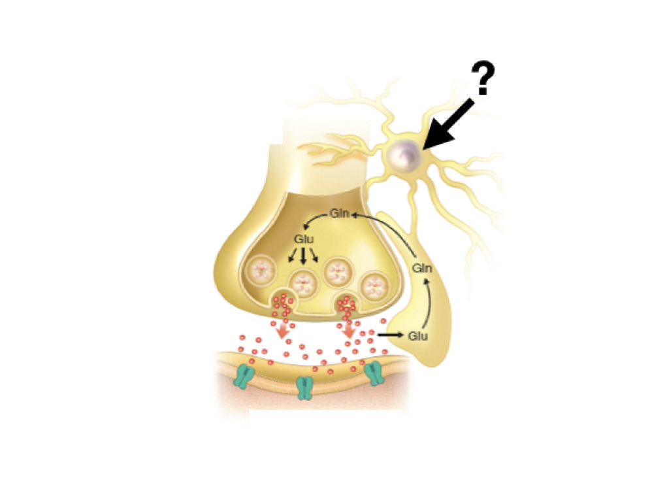

*In the figure above, the question mark is pointing to _________, which is absorbing glutamate and returning its precursor so that it can ultimately be used to repackage glutamate into _________.*

*A. An oligodendrocyte; vesicles*

*B. An astrocyte; vesicles*

*C. An oligodendrocyte; ribosomes*

*D. An astrocyte; ribosomes*

*Figures like this can be used in different ways to emphasize class and lecture material. Can you take a figure like this and label all the key parts of what what’s being shown and what these parts are important for? Can you describe the all the processes being shown, step-by-step?*