TECHNICAL REPORT
YOLOv7 Deployment and NPU-Only Performance Evaluation on the AMD Versal AI Edge VEK280
VE2802 NPU · Vitis 2025.2 · Vitis-AI 6.2
Table 1. Final YOLOv7 profiling configuration
Parameter | Value
Board | AMD Versal AI Edge VEK280 / VE2802
Vitis / Vitis-AI | 2025.2 / 6.2
Model and input | YOLOv7, fixed 640 × 640
NPU | VE2802 NPU, A304 configuration (VE2802_NPU_IP_O00_A304_M3)
Execution mode | NPU-only
CPU subgraphs | Disabled / skipped
Runner | Native VART/NPU runner
Profiling | Final NPU-only configuration, stage-level profiler
Purpose | Measure YOLOv7 with the neural network fully on the NPU, without CPU-subgraph fallback
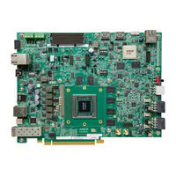
Figure 1. AMD Versal AI Edge VEK280 evaluation board.

1. Executive Summary
This report documents the deployment and profiling of YOLOv7 on the AMD Versal AI Edge VEK280 using Vitis 2025.2 and Vitis-AI 6.2. All final results come from the NPU-only configuration, in which the CPU subgraph is skipped and the neural network executes on the VE2802 NPU. Measurements with the CPU subgraph enabled are retained only as a development baseline (Section 5).
7.1 ms  NPU inference per frame (640×640) | 27.0 → 13.3  End-to-end FPS, 320×240 → 1920×1080 | 52–61%  AIE-ML core activity (304 tiles) | ≈3.55 W  Average monitored-rail power

- The NPU stage takes 7.12–7.18 ms per frame at every source resolution, an NPU-stage ceiling of about 140 FPS.
- Complete-pipeline throughput falls from 27.01 FPS (320×240) to 13.33 FPS (1920×1080); the loss is caused by CPU-side read/decode and preparation, not by the NPU.
- With the official VART runner, skipping the CPU subgraph reduced latency from 175.44 ms to 73.75 ms (2.38×).
- All 404 test images (101 per resolution) completed successfully.

2. Platform and Hardware
The VEK280 is built around the AMD Versal AI Edge VE2802 adaptive SoC, which combines Arm processing resources, programmable logic (PL) and an AI Engine-ML (AIE-ML) array. This heterogeneous design lets the CPU handle general application work while a dedicated NPU executes the compute-intensive neural-network layers.
Table 2. Main board components used in the project
Component | Specification | Role
Versal SoC | VE2802 (XCVE2802-2MSEVSVH1760) | Main compute device (PS, PL, AIE-ML)
AIE-ML array | 38 × 8 = 304 tiles, NPU at 500 MHz | Core NPU acceleration resource
Programmable logic | NPU IP VE2802_NPU_IP_O00_A304_M3 | NPU datapath and interfaces
Processing system | Arm CPU, PetaLinux 2025.2, Python 3.12.11 | Application, pre/post-processing
LPDDR4 | 12 GB, 192-bit, 3733 Mb/s | Model data and buffers
MicroSD | Boot card; snapshot in /run/media/mmcblk0p1 | Boot and model storage
Ethernet / UART | RJ-45; USB-UART /dev/ttyUSB1, 115200 8N1 | SSH, file transfer, console
HDMI / camera | HDMI 2.1; Logitech Pro 9000 (640×480, 30 FPS) | Display and video tests
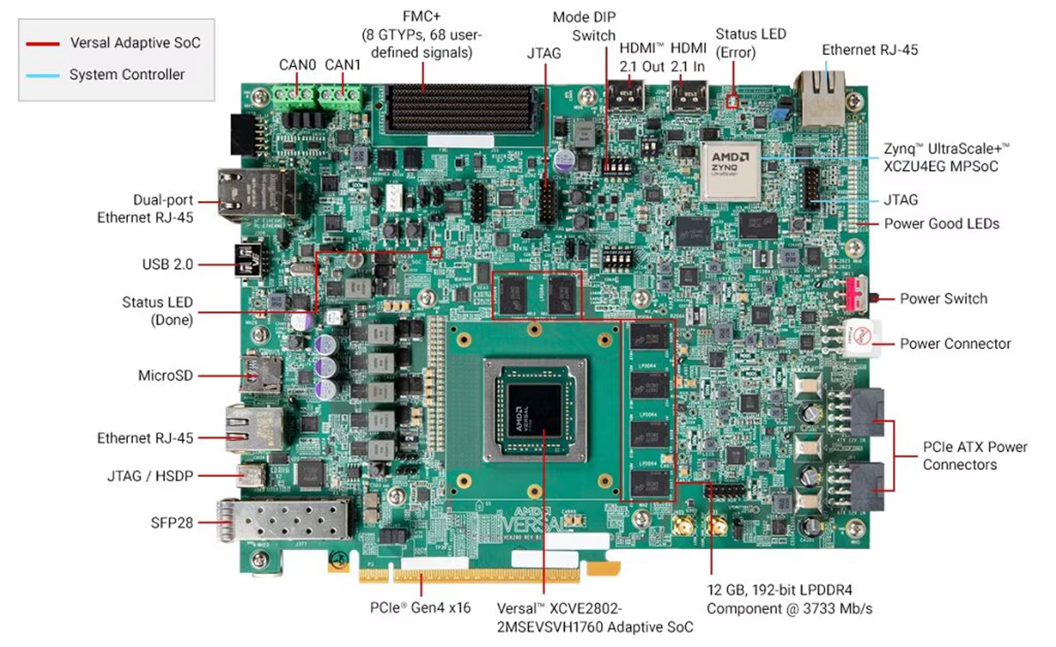
Figure 2. VEK280 board with its main components and interfaces labeled.

2.1 Physical connections
The board is powered from its supplied power input and boots from the MicroSD card. It connects to the host PC over Ethernet for SSH and file transfer, and uses USB-UART for console and debug. A USB webcam and an HDMI display are attached for the video experiments.
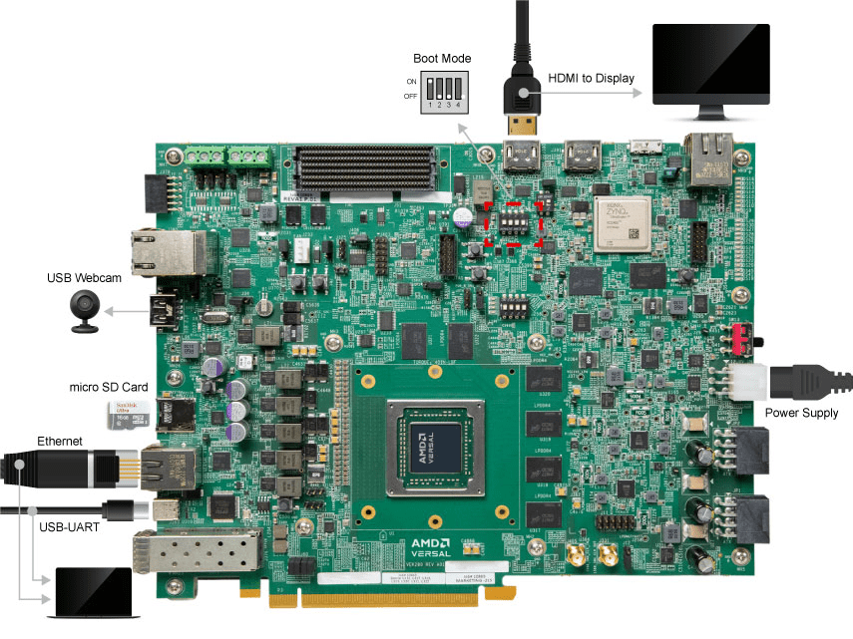
Figure 3. Physical connections used in the project.

3. NPU Architecture and Execution
A general-purpose CPU can run neural networks but is not optimized for their matrix and tensor operations. The VEK280 offloads them to the NPU, built from the PL and the AIE-ML array. This is the newer AI Engine-based approach, in contrast to the DPU used on earlier AMD/Xilinx platforms, so the model must be compiled specifically for the VE2802 NPU target; the final path is YOLOv7 → quantization → NPU compilation → snapshot → VART runtime → NPU.
Table 3. Where each stage executes
Stage | Executes on | Notes
Image read/decode, letterbox, input preparation | Processing system (CPU) | Grow with source resolution
Neural-network inference (INT8) | NPU (PL + AIE-ML) | Fixed 640×640 workload
Output decode, NMS, drawing | Processing system (CPU) | About 3 ms per frame
Model data, input/output buffers | LPDDR4 | Shared working memory

4. Model Deployment Flow
A .pt model is not copied to the board and run as ordinary PyTorch. It is prepared on the x86 host for the target NPU and packaged as a snapshot. Compilation is not pruning: pruning removes weights, quantization lowers precision, and compilation maps the prepared graph to the accelerator.
Table 4. Deployment steps
# | Step | Location | Description
1 | Export | Host | Trained YOLOv7 exported to ONNX where required
2 | Quantize | Host | INT8 quantization for NPU execution
3 | Compile | Host | Mapped to the VE2802 NPU IP configuration (A304)
4 | Snapshot | Host | Network, weights, calibration and input-size data packaged
5 | Deploy | Board | Snapshot and application files copied to the MicroSD card
6 | Infer | Board | VART/NPU application loads the snapshot and feeds input tensors
7 | Post-process | Board | Detection decode and NMS applied to the NPU output
Deployed snapshot:
/run/media/mmcblk0p1/snapshot.VE2802_NPU_IP_O00_A304_M3.yolov7.TF

5. YOLOv7 Final Configuration
The detector uses a fixed 640 × 640 model input, a confidence threshold of 0.25 and an NMS IoU threshold of 0.45. Changing the source resolution therefore changes only the CPU-side preparation, not the NPU workload.
Table 5. Deployed tensors and thresholds
Parameter | Value
Application input tensor | (1, 3, 640, 640) float32 NCHW
Native NPU input tensor | (1, 640, 640, 4) INT8 NHWC4
Output tensor | (1, 25200, 85)
Confidence / NMS IoU | 0.25 / 0.45
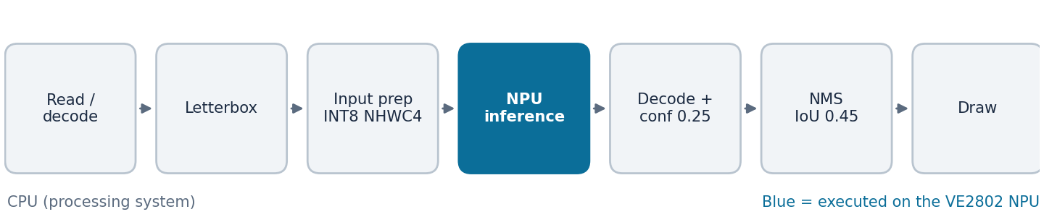
Figure 4. YOLOv7 inference procedure; only the inference stage runs on the NPU.

5.1 NPU-only mode and why it matters
In NPU-only mode the runtime skips the CPU subgraph and reports:
NPU only mode set. Skipping node wrp_network_embd_export_2_cpu_subgraph_call.
- Removes CPU fallback work from the neural-network path, giving a cleaner measurement of accelerator performance.
- Gives a consistent configuration for all final benchmarks and the demonstration.
- "NPU-only" refers to the network execution; the CPU still runs image handling, decoding, NMS and display.
The CPU-subgraph configuration is kept only as a development stage. Figure 5 shows the progression; the first two bars come from the same VART runner, while the last two come from the custom profiler and are not strictly like-for-like.
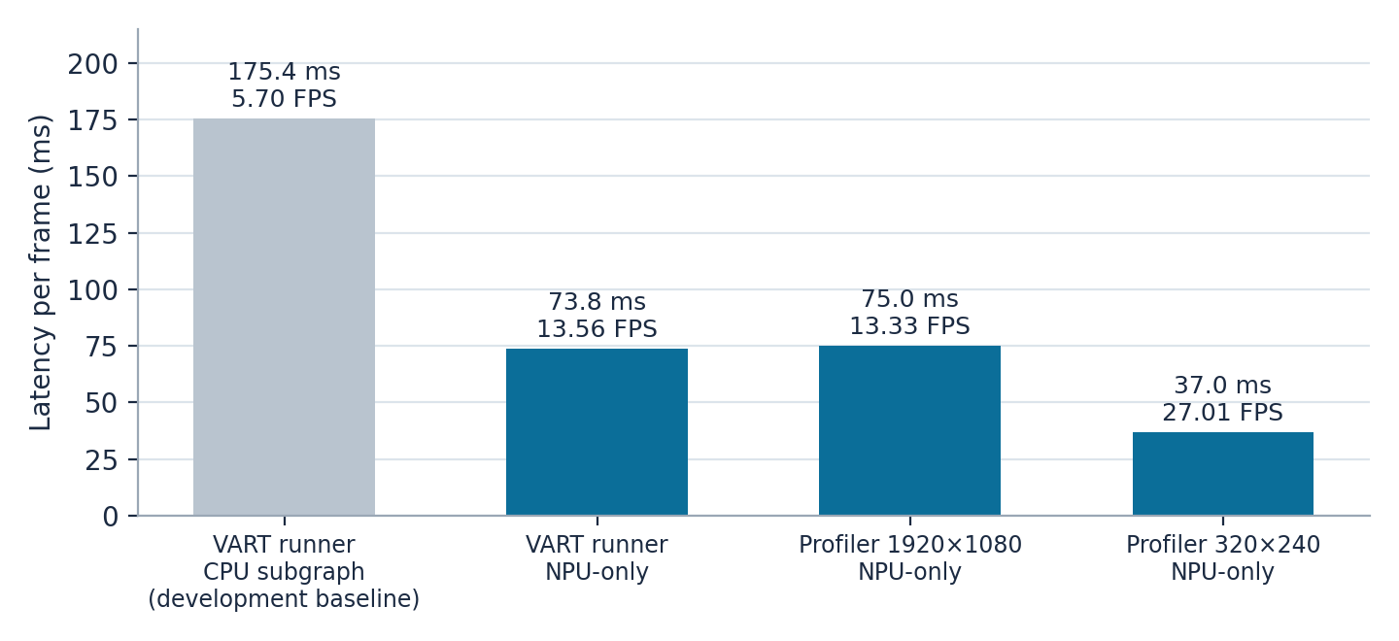
Figure 5. Latency progression from the development baseline to the final NPU-only configuration.

6. Profiling Methodology
Table 6. Final profiling setup
Item | Description
Profiler | Stage-level application (/root/run_profile.py) timing read/decode, letterbox, preparation, NPU, output decode, NMS and drawing
Dataset | 101 images at each of 320×240, 640×480, 1280×720 and 1920×1080 (404 images); 404/404 completed
Metrics | Per-frame averages; NPU latency percentiles; CPU busy; peak RSS
AIE-ML activity | XRT profiling of all 304 tiles (CORE_ACTIVE and CORE_GROUP_STALL), run separately from benchmarks
Power | INA226 monitored rail, 26–45 samples per resolution; not total board power
Video / webcam | 211-frame recorded video and 100-frame live webcam capture; demonstration only, no final benchmark values reported

7. Final NPU-Only Profiling Results
Table 7. Average per-frame results by source resolution (ms unless noted)
Stage | 320×240 | 640×480 | 1280×720 | 1920×1080
Read/decode | 9.52 | 16.07 | 30.50 | 44.31
Letterbox | 4.58 | 0.69 | 3.17 | 7.97
Preparation | 12.78 | 12.41 | 12.25 | 12.22
NPU | 7.18 | 7.14 | 7.12 | 7.12
Output decode | 2.39 | 2.55 | 2.44 | 2.42
NMS | 0.24 | 0.25 | 0.24 | 0.24
Draw | 0.31 | 0.44 | 0.57 | 0.69
Frame total | 37.02 | 39.57 | 56.32 | 74.99
End-to-end FPS | 27.01 | 25.27 | 17.76 | 13.33
CPU busy | 72% | 72% | 80% | 95%
Peak RSS | 170 MB | 171 MB | 177 MB | 190 MB
NPU p50 / p95 / max | 7.03 / 7.66 / 8.68 | 7.10 / 7.28 / 8.67 | 7.15 / 7.20 / 7.26 | 7.14 / 7.20 / 7.25
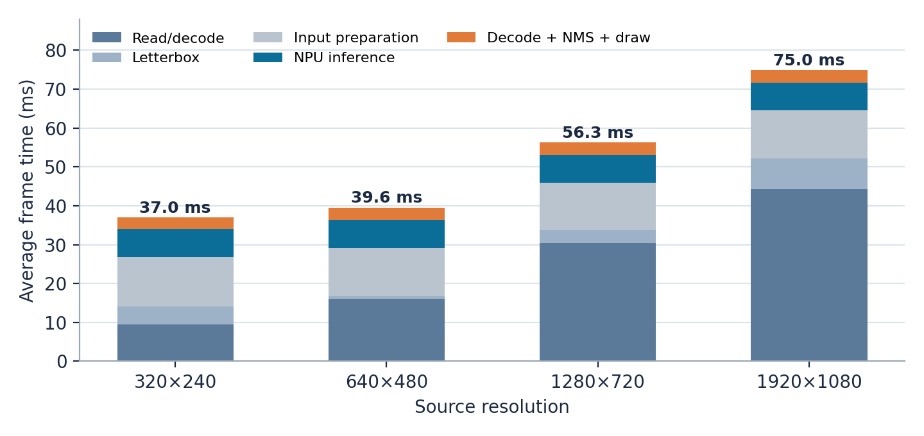
Figure 6. Per-frame time breakdown: the NPU segment is constant while read/decode grows.
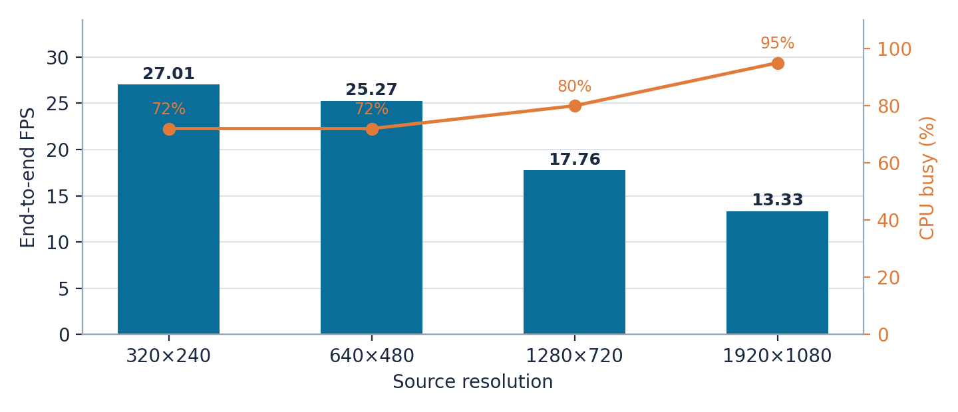
Figure 7. End-to-end FPS and CPU load by source resolution.

7.1 Analysis
- NPU latency is stable (7.12–7.18 ms) because the model always receives 640×640 input; the NPU-stage ceiling of about 140 FPS is roughly 10× the best end-to-end rate.
- Read/decode dominates at high resolution: it rises 4.7× (9.52 to 44.31 ms) and is about 59% of frame latency at 1920×1080, with letterbox adding about 11% and CPU load reaching 95%.
- Input preparation is a fixed 12.2–12.8 ms cost, larger than the NPU stage, while decode, NMS and drawing together add only about 3–3.5 ms.
- Optimization targets: JPEG decode, resize/letterbox, input preparation, and overlapping these stages with NPU execution.

7.2 AIE-ML activity and power
Table 8. AIE-ML activity and monitored-rail power
Metric | Value | Condition
Average AIE-ML activity | 51.65–52.07% | 320×240 to 1280×720
Average AIE-ML activity | 61.45% (tiles 59.19–64.40%) | 1920×1080
Average AIE-ML activity | 52.48% (52.21–52.77%) | Later 1920×1080 capture
Average power | 3.546–3.565 W | 4 resolutions
Peak power | 3.705–3.966 W | 4 resolutions
Energy per frame | 0.131–0.267 J | Average power / clean E2E FPS
Activity is evenly distributed across tiles. AIE profiling adds large overhead (1920×1080 rose from 74.99 ms to about 136 ms, 13.33 to about 7.3 FPS), so it is reported separately and never used for benchmarking. Power values are INA226 rail measurements, not total board power.

8. End-to-End Performance and Video/Webcam Demonstration
The final end-to-end results use the NPU-only configuration with CPU subgraphs disabled/skipped. Table 9 consolidates them from Table 7.
Table 9. Final end-to-end latency and FPS (NPU-only)
Source resolution | E2E latency | E2E FPS | NPU time | CPU busy
320×240 | 37.02 ms | 27.01 | 7.18 ms | 72%
640×480 | 39.57 ms | 25.27 | 7.14 ms | 72%
1280×720 | 56.32 ms | 17.76 | 7.12 ms | 80%
1920×1080 | 74.99 ms | 13.33 | 7.12 ms | 95%
The recorded video (211 frames, 640×480, about 30 FPS) and the live webcam capture (Logitech Pro 9000, 640×480, 30 FPS) use the same NPU-only inference pipeline and show that the deployment works on video and camera input as well as still images. Earlier video and webcam timings were taken before the NPU-only configuration, so they are not reported as results. NPU-only video and webcam measurements were not part of the final profiling data.

9. Supporting Models
Model | Task | Status
ResNet50 | Image classification | Tested successfully; validated the NPU runtime
YOLOX-S | Object detection | Tested successfully as a supporting detection model
YOLOv7 | Object detection | Main focus: deployment, profiling, source-resolution and camera testing

10. Conclusions
- YOLOv7 was deployed on the VE2802 NPU and benchmarked in the final NPU-only configuration with the CPU subgraph skipped.
- The NPU completes a 640×640 inference in a stable 7.1 ms; the complete optimized pipeline reaches 13.33–27.01 FPS depending on source resolution.
- The official VART runner improved from 175.44 ms to 73.75 ms when the CPU subgraph was skipped.
- The next gains lie in the CPU-side pipeline: faster decode, resize and preparation, overlapped with NPU execution.

References
- AMD VEK280 Evaluation Board User Guide (UG1612)
- AMD Vitis-AI Documentation: Quick Start and Default Reference Design
- AMD Vitis Getting Started documentation for VEK280

