
Department | FED
Subject | DSA-2
Academic Year
Faculty Name | SREERAM MURTHUY SIR
Student Name | TALLURI AKILESH
Roll Number | 2520030570
Branch | CSE
Course Outcome

Case Study Topic: DFS — Reachability & Post-order

Work Done Summary:

A Depth First Search (DFS) based Dead Code Elimination (DCE) approach was applied on the Control Flow Graph (CFG) of a function to identify unreachable basic blocks. Starting from the entry block, DFS marked all reachable blocks, and the remaining blocks were classified as dead code. Post-order traversal was also generated to support subsequent dataflow analysis and optimization passes in the compiler.

Implementation Details:
- Represented the CFG using an adjacency list.
- Performed iterative DFS starting from the entry block (B0).
- Marked all visited blocks as reachable.
- Identified dead blocks by subtracting reachable blocks from the set of all blocks.
- Implemented post-order traversal using DFS.
- Added blocks to the post-order list only after processing all successors.
- Used reverse post-order for efficient dataflow analysis.

Result/Outout: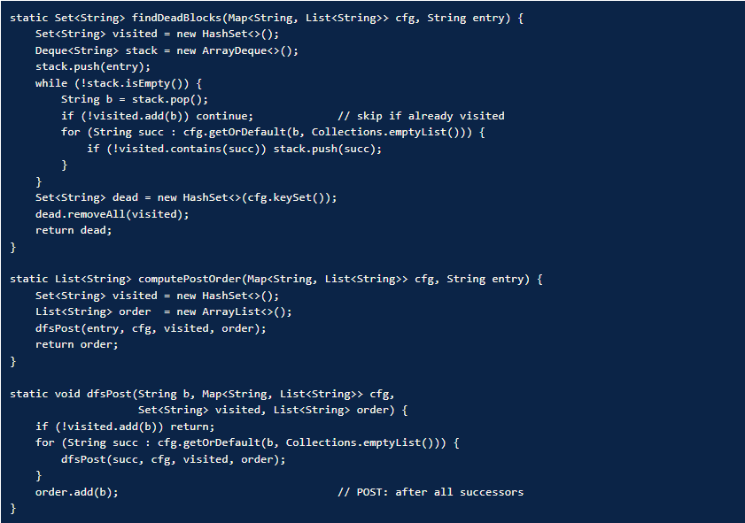

Time Complexity:
- DFS Traversal: O(V + E)
- Dead Block Detection: O(V)
- Post-Order Computation: O(V + E)
- Space Complexity: O(V)
Where:
V = Number of basic blocks (vertices)
E = Number of CFG edges

GitHub Link:
