
Department | FED
Subject | DSA-2
Academic Year
Faculty Name | SREERAM MURTHY SIR
Student Name | TALLURI AKILESH
Roll Number | 2520030570
Branch | CSE
Course Outcome

Case Study Topic: Reliance Jio Call-Detail Record Sorting using Bucket Sort
Work Done Summary:

In this case study, we analyzed how Reliance Jio processes call-detail-record (CDR) durations using Bucket Sort.
The call durations ranged from 0 to 3600 seconds with a highly skewed distribution where most calls were below 60 seconds.
We applied Bucket Sort on a sample dataset using 10 buckets, sorted each bucket independently using insertion sort, and concatenated all buckets to obtain the final sorted order.
We also studied the performance of Bucket Sort under uniform and skewed distributions and compared it with Counting Sort and Radix Sort.

Implementation Details:
- Input array used:
[37, 12, 78, 25, 91, 4, 56, 8, 33, 67, 19, 45]
- Created 10 buckets representing ranges:
b0 = 0–9, b1 = 10–19, ..., b9 = 90–99.
- Distributed elements into buckets based on their values.
- Bucket Assignments:
- b0 → [4, 8]
- b1 → [12, 19]
- b2 → [25]
- b3 → [37, 33]
- b4 → [45]
- b5 → [56]
- b6 → [67]
- b7 → [78]
- b8 → []
- b9 → [91]
- Sorted each bucket independently using insertion sort.
- Concatenated all buckets sequentially to obtain the final sorted array.

Result / Output:
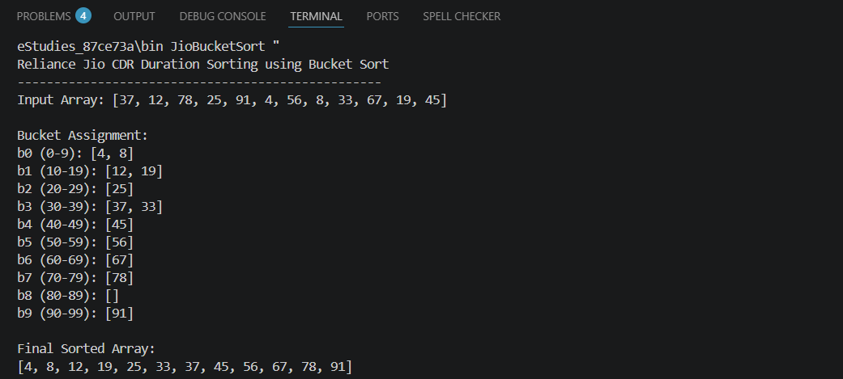
Time Complexity:
Average Case: O(n + k), when values are uniformly distributed
Worst Case: O(n log n), because each bucket is sorted using Collections.sort()
Space Complexity: O(n + k)

Sorting Comparison:
Counting Sort: Best for small integer range
Bucket Sort: Best for uniform or adaptive numeric distribution
Radix Sort: Best for fixed-digit-width keys

GitHubLink: