
Department | FED
Subject | DSA-2
Academic Year
Faculty Name | SREERAM MURTHY SIR
Student Name | TALLURI AKILESH
Roll Number | 2520030570
Branch | CSE
Course Outcome

Case Study Topic: Sparse Tables (read-heavy range queries)
Work Done Summary:

A Sparse Table was constructed for Spotify's skip-position data to efficiently answer range minimum queries (RMQ). The table was built using precomputed minimum values for intervals of size 2k2^k2k, enabling constant-time query processing. The solution was compared with a Segment Tree to evaluate performance under Spotify's read-heavy workload, demonstrating that Sparse Tables are more efficient when queries greatly outnumber updates.

Implementation Details:
1. Stored skip-position values in an array.
2. Built the Sparse Table level by level using interval lengths 2k2^k2k.
3. Precomputed minimum values for all valid ranges.
4. Used the RMQ formula to answer range-min queries in O(1).
5. Calculated k=⌊log⁡2(length)⌋k = \lfloor \log_2(\text{length}) \rfloork=⌊log2​(length)⌋ for each query.
6. Compared Sparse Table and Segment Tree performance for different query-update ratios.

Result/Output :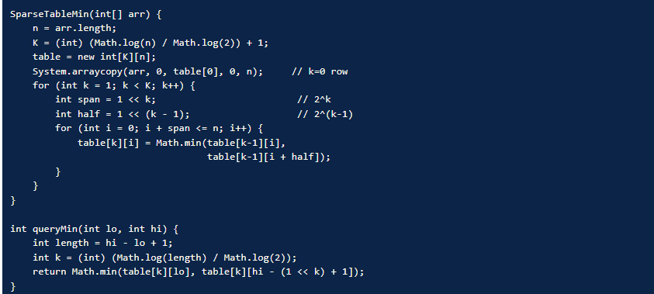

Time Complexity:
1. Build Sparse Table: O(n log n)
2. Range Minimum Query: O(1)
3. Update (Rebuild Required): O(n log n)
4. Space Complexity: O(n log n)

GitHub Link:
