A CASE-STUDY BASED REPORT
ON
Online Course Recommendation System
submitted in partial fulfilment of the requirements for the Course
MACHINE LEARNING
BACHELOR OF TECHNOLOGY
in
COMPUTER SCIENCE AND ENGINEERING
A.Y.: 2026-27
by
S.Sri sai pradhyumn (2520030595)
T.Akilesh (2520030570)
Under the Esteemed guidance of
Dr.G.S.Raghavendra
Asst.professor, Department of CSE



INDEX
Abstract 3
Introduction 5
Background 4
Motivation for the Project 5
Overview of the Work Carried Out 6
Scope and Responsible-Use Statement 7
Problem Statement 8
Case-Study Scenario 8
Central Case-Study Question 8
Formal Problem Definition 8
Objectives that Guide the Study 9
Assumptions and Limitations 10
Dataset and Course Catalogue Analysis 11
About the Dataset 11
Purpose of EDA 12
Preparation Steps Actually Performed 13
Course Catalogue Exploration - Implementation 15
Summary of Dataset Findings 16
Recommendation Algorithm and Implementation 18

Conclusion 21

Signature of the Team members

S.Sri Sai Pradhyumn
T.Akilesh

ABSTRACT
Online learning platforms provide a large number of courses across programming, data science, web development, databases, and other subjects. Learners may find it difficult to identify courses that match their interests, skills, academic level, and previously completed subjects. This project, Online Course Recommendation System, presents a browser-based application that recommends relevant courses and provides a short explanation for each suggestion.
The application uses a course catalogue stored in a JSON file. Each course contains information such as its title, description, skills, year level, and prerequisites. The learner selects an academic year, enters interests and skills, and marks relevant prerequisite courses as completed. The system combines the learner profile with the text associated with each course. TF-IDF (Term Frequency–Inverse Document Frequency) converts course text into numerical vectors, and cosine similarity estimates how closely a course matches the learner profile.
The recommendation process considers the selected year and prerequisite information, ranks eligible courses by content similarity, and presents recommendations with a match score and a brief explanation based on overlapping interest or skill terms. The web interface also supports browsing courses, searching the catalogue, viewing prerequisites, and saving basic learner details in browser local storage. The project demonstrates a beginner-friendly content-based recommendation workflow using Python, Flask, scikit-learn, HTML, CSS, and JavaScript. It is an educational prototype and does not claim to represent official Coursera or Udemy recommendations.

INTRODUCTION
Background
Online education has made courses available to learners across many subjects and skill levels. However, the size of an online course catalogue can make it difficult to choose what to learn next. A learner may need recommendations that reflect their stated interests, current skills, completed subjects, and prerequisite knowledge. A course recommendation system helps organize available options and makes discovery more focused.
The Online Course Recommendation System is a content-based recommendation application built with Python and Flask, supported by a browser interface using HTML, CSS, and JavaScript. The catalogue is loaded from a JSON file. Course titles, descriptions, and skill tags are processed using scikit-learn’s TF-IDF vectorizer, while cosine similarity measures the relationship between a learner profile and each course.
The application does more than display a ranked list. Learners can select their year of study, browse and search courses, enter interests and skills, and mark prerequisite courses as completed. Recommendations include a content-match score and a short explanation of why a course may suit the learner. This helps users understand the suggestions instead of receiving unexplained results.
Motivation for the Project
The main motivation is to reduce the time and effort learners spend searching a large catalogue and to help them discover courses related to their goals. A learner interested in Python, for example, can receive suggestions whose titles, descriptions, or skills overlap with that interest.
A second motivation is to demonstrate how text processing and similarity measures can be used in a practical recommendation system. Rather than requiring ratings from many users, content-based filtering compares the learner’s stated profile and completed subjects with the available course information.
Overview of the Work Carried Out
The project was developed as an integrated course browsing and recommendation application. The major work carried out includes:
- Course Catalogue: Course records are loaded from a JSON file with titles, descriptions, skills, year levels, and prerequisite information.
- Text Processing: Course titles, descriptions, and skills are combined into text documents and processed with TF-IDF using English stop-word removal and unigrams/bigrams.
- Learner Profile: Interests, skills, and titles of completed prerequisite courses are combined to represent the learner’s current profile.
- Content-Based Matching: Cosine similarity is used to compare the learner profile vector with course vectors and rank suitable courses.
- Recommendation Explanations: The application identifies overlapping terms between the learner profile and course content to produce a short reason for each recommendation.
- Browsing and Search: Users can browse courses by year, search the catalogue, inspect prerequisite courses, and request personalized recommendations.
- Web Application: A Flask backend provides API endpoints while the frontend displays course cards, match scores, prerequisite information, and explanations.
Together, these modules demonstrate a simple and understandable approach to personalized course discovery using the content already available in a course catalogue.

PROBLEM STATEMENT
Case-Study Scenario
Consider a learner who has completed introductory programming subjects and is interested in Python, data science, or web development. A large catalogue may contain hundreds of courses, and manually comparing their descriptions, skills, and prerequisites can be time-consuming. A learner may also select a course before completing a subject that it assumes as prior knowledge.
A simple catalogue search can find courses containing a keyword but may not rank options by overall similarity to the learner’s interests and skills. Therefore, a system is needed that compares course content with a learner profile, considers year level and completed prerequisites, and explains why each suggestion is relevant.
The Online Course Recommendation System addresses this problem by applying TF-IDF and cosine similarity to course text, filtering by the selected year and prerequisite information, and displaying ranked recommendations with short explanations in a web interface.
Central Problem Statement
“How can course content, learner interests, skills, and completed subjects be used to recommend relevant courses and explain why each recommendation matches the learner?”
Formal Problem Definition
Let each course be represented by text and metadata, including its title, description, skill tags, year level, and prerequisites. Let the learner profile contain stated interests, skills, and titles of completed prerequisite courses.
The objective is to transform course text and the learner profile into TF-IDF vectors, calculate cosine similarity, and rank eligible courses according to content similarity. The application then presents recommended courses with match scores and brief explanations, while using the selected academic year and prerequisite status to help the learner navigate suitable options.
The system therefore performs the following major tasks:
- Load and inspect course records from the JSON catalogue.
- Combine course titles, descriptions, and skills into searchable text.
- Convert course text into TF-IDF feature vectors.
- Build a learner profile from interests, skills, and completed subjects.
- Calculate cosine similarity and rank eligible courses.
- Display match scores and a short explanation for each recommendation.
- Support course browsing, keyword search, and prerequisite selection through a web interface.
Objectives
- To develop a web-based content recommendation system for online courses.
- To represent course descriptions, titles, and skills using TF-IDF text features.
- To compare the learner profile and course vectors using cosine similarity.
- To rank relevant courses based on content similarity and selected year level.
- To use completed-subject and prerequisite information when presenting course options.
- To provide a short, understandable explanation for each recommendation.
- To provide browsing, search, and prerequisite-selection features in the interface.
- To build the application using a Python Flask backend and HTML, CSS, and JavaScript frontend.
Assumptions and Limitations
Assumptions
- The course catalogue contains course identifiers and metadata required for browsing and recommendation.
- Course titles, descriptions, and skill tags provide useful signals about course topics.
- A learner’s stated interests and skills are assumed to represent their current learning goals.
- The application is intended as an educational prototype for demonstrating content-based filtering.
Limitations
- Recommendation quality depends on the completeness and accuracy of the course catalogue and learner profile.
- Content-based similarity may favour courses that use similar words and may miss relevant courses expressed with different terminology.
- The prototype does not learn from a large history of user ratings, clicks, or course completion outcomes.
- The supplied project uses a local JSON catalogue and does not require a live connection to Coursera or Udemy.
- A high content-match score indicates textual similarity, not a guarantee that a course is the best choice for every learner.
DATASET AND COURSE CATALOGUE ANALYSIS

About the Dataset
The project uses a course catalogue stored in a JSON file within the application. Each course record includes information such as a course ID, title, description, skills, year level, and prerequisite course identifiers. The backend loads the catalogue at startup and builds a mapping from course IDs to course records. Course titles, descriptions, and skills are combined to form the text used by the TF-IDF vectorizer.
The catalogue includes both text fields and structured metadata. Text fields support similarity calculations and keyword matching, while year level and prerequisite information support filtering and learner navigation.
Attribute | Type | Description
id | Identifier | Unique identifier for a course
title | Text | Name of the course
description | Text | Summary of topics covered by the course
skills | List of text | Skills or topics associated with the course
year | Integer | Academic year level used for catalogue filtering
prerequisites | List of IDs | Courses that may be required before taking this course
interests | Learner input | Topics the learner wants to study
skills input | Learner input | Skills entered by the learner
completed courses | Learner selection | Prerequisite courses marked as completed
TF-IDF vector | Numerical vector | Weighted representation of course text
similarity score | Numerical output | Cosine similarity between learner profile and course text
The course records are the source material for recommendation. The project does not demonstrate that the catalogue is a live scrape of Coursera or Udemy; it uses the bundled JSON data provided with the application.
Purpose of EDA
Course catalogue inspection is useful for understanding the content and metadata available to the recommendation algorithm. The main purposes are:
- To inspect course titles, descriptions, skill tags, and prerequisite fields.
- To understand how courses are grouped by academic year.
- To examine the text fields used to represent each course.
- To verify that the catalogue contains records suitable for browsing and recommendation.
- To identify prerequisite relationships that should be shown to learners.
- To check whether course descriptions and skill tags provide meaningful recommendation signals.
- To understand how learner interests and course content are compared.
Preparation Steps Performed
The following preparation and implementation steps are used by the application:
- Course records are loaded from courses.json when the Flask application starts.
- Course title, description, and skill tags are combined into a text document for each course.
- TfidfVectorizer uses English stop-word removal and n-gram range (1, 2) to create course feature vectors.
- The learner profile combines entered interests, entered skills, and titles of completed prerequisite courses.
- Cosine similarity compares the learner profile vector with course vectors, and recommendations are ranked by their similarity score.
- The recommendation function filters the catalogue using the selected year and considers missing prerequisites when preparing course suggestions.
- The Flask backend returns course data and recommendation results to the browser interface through API routes.
Course Catalogue Exploration – Implementation
The catalogue can be inspected using Python and JSON operations. Useful checks include counting courses, reviewing the fields available in each record, checking the distribution of courses by year, and inspecting prerequisite links. The current implementation uses a bundled JSON catalogue rather than a downloaded live dataset.
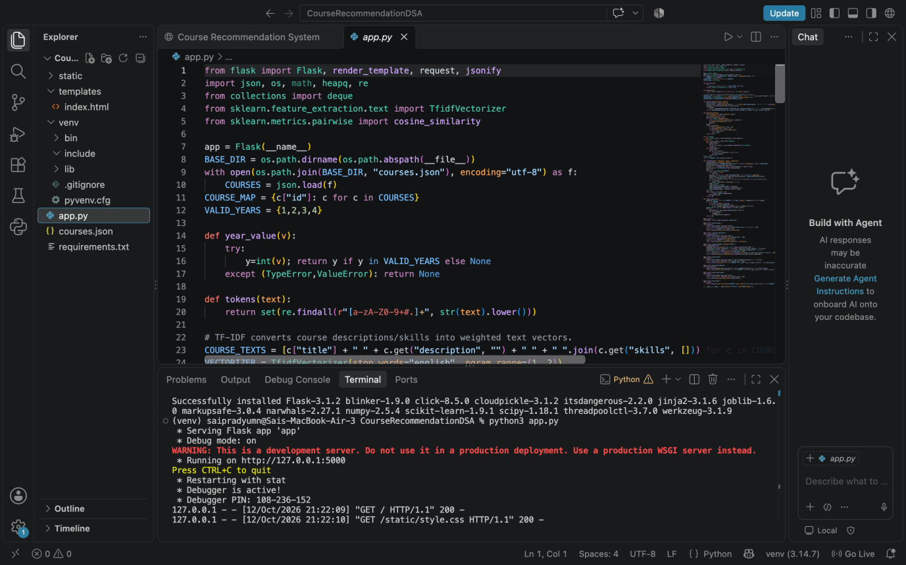
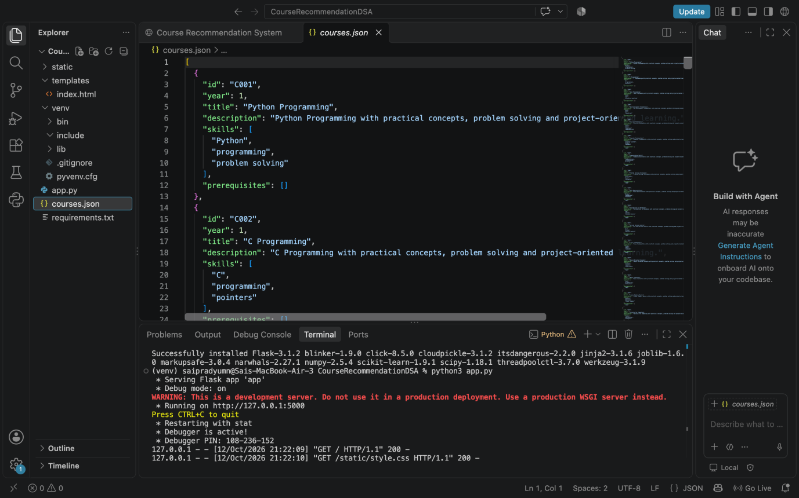

Course records can be grouped by year and reviewed by title, skills, and prerequisites. This helps verify that learners can browse the catalogue and that recommendation results are drawn from the selected year.
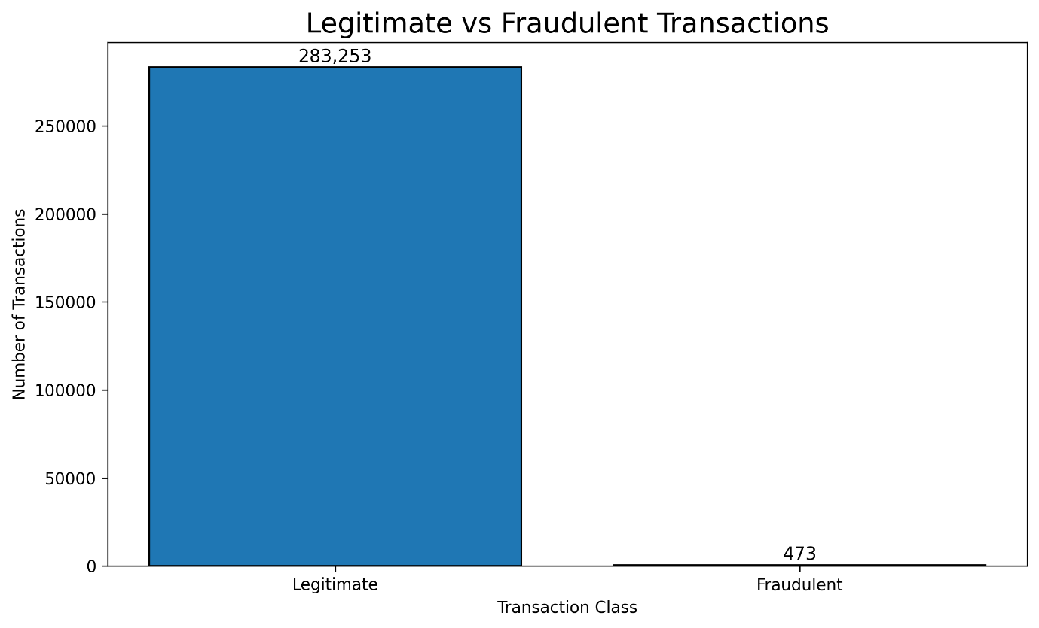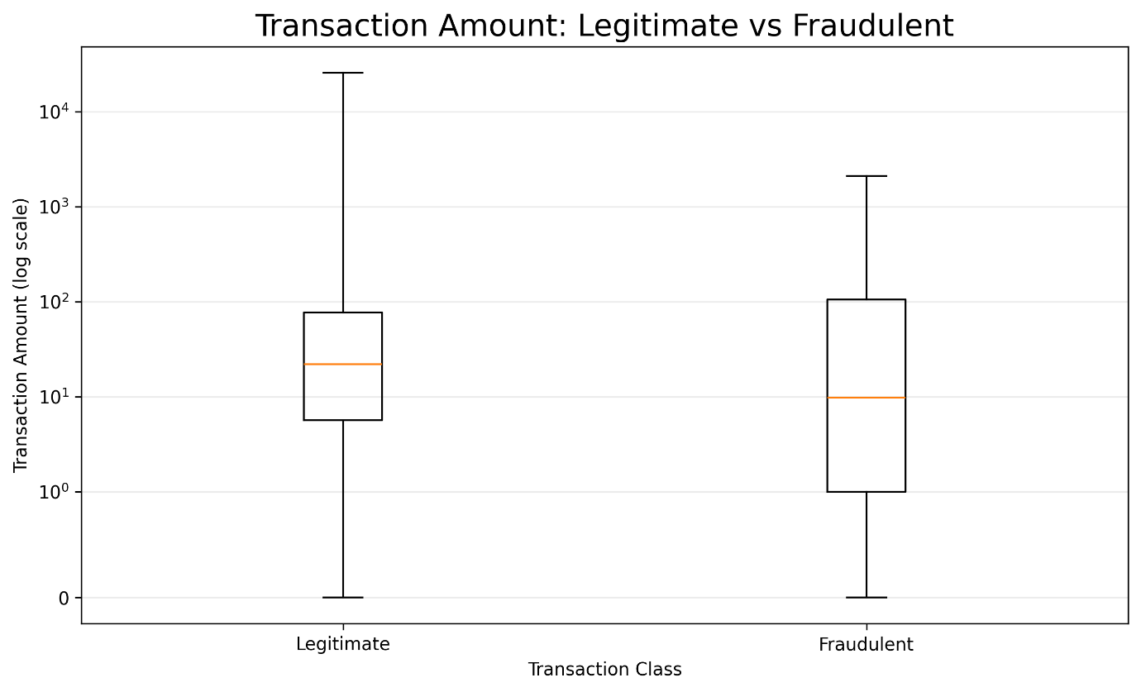
The most important data quality checks are whether each course has a usable title and description, whether skills are represented consistently, and whether prerequisite identifiers refer to valid course records. The application builds a course-ID lookup so completed prerequisite IDs can be mapped back to course titles when constructing a learner profile.
Text content varies in length and vocabulary. TF-IDF gives greater weight to terms that are informative within the catalogue and reduces the influence of common terms. Combining titles, descriptions, and skills gives the similarity calculation more context than using course titles alone.
The learner profile is transformed using the same vectorizer as the course catalogue so that the vectors share the same feature space. Cosine similarity then measures alignment between the profile and each course. This is a content similarity measure and should not be interpreted as a measured probability of course success.

Summary of Dataset Findings
The course catalogue contains text and structured fields that support browsing, searching, prerequisite selection, and recommendation. Course titles, descriptions, and skills provide the text signals for TF-IDF and cosine similarity, while year and prerequisite metadata support filtering and learner navigation. Recommendation quality depends on the catalogue’s coverage and the information supplied by the learner.
The inspection and preparation process provides the foundation for the content-based recommendation pipeline and its explanation feature. The project does not report a formal offline accuracy benchmark or user study, so the results should be interpreted as functional recommendations from the current prototype rather than validated educational outcomes.

RECOMMENDATION ALGORITHM AND IMPLEMENTATION
Choice of Approach
The project treats course recommendation as a content-based ranking task. Each course is represented by its title, description, and skills, while the learner profile is created from interests, skills, and completed prerequisite course titles. TF-IDF converts text into weighted vectors, and cosine similarity measures how closely the profile matches each eligible course.
The principal techniques implemented in the project are TF-IDF vectorization for text representation and cosine similarity for content-based ranking. The application also uses keyword matching to generate a concise explanation of the match.
Technique | Purpose | Reason for Use
TF-IDF Vectorizer | Text representation | Converts course titles, descriptions, and skills into weighted numerical vectors
Cosine Similarity | Content-based ranking | Measures alignment between the learner profile and each course vector
Data Preparation and Text Processing
At application startup, course records are read from courses.json. The course text is constructed by joining the title, description, and skill tags. The TF-IDF vectorizer is fitted to the catalogue text using English stop words and unigrams/bigrams. When a learner requests recommendations, their profile is transformed using this same vectorizer.
The recommendation function uses the selected year and completed prerequisite identifiers while evaluating courses. It calculates similarity between the profile vector and each course vector, ranks candidates, and returns recommendation data to the frontend. The code also checks prerequisite information so that the interface can show missing prerequisites where relevant.
TF-IDF and Cosine Similarity
TF-IDF assigns weights to terms based on their frequency in a document and how informative they are across the collection of documents. In this project, a document is formed from each course title, description, and skill list. Cosine similarity compares the learner-profile vector with each course vector; a higher score indicates greater textual alignment.
The system returns a content-match score and an explanation. The explanation function checks for terms shared by the learner profile and the course title, description, or skills. If overlapping terms are found, up to five terms are included in the reason; otherwise, the application explains that the overall course content is similar to the learner profile. The score is useful for ranking, but it is not a guarantee of course quality.
The recommendation output includes the selected course details, similarity score, and explanation so that the learner can compare suggestions. The current report does not include validated accuracy, precision, recall, or ROC-AUC results because the project is a content-based recommendation application rather than a supervised fraud-classification model.
Component | Implementation
Catalogue | JSON file containing course records
Text features | Title, description, and skills
Vectorization | TF-IDF with English stop words and 1–2 word n-grams
Ranking | Cosine similarity between profile and course vectors
Explanation | Shared profile/course terms or overall content similarity
The interface displays course recommendations as cards containing the title, description, skill tags, prerequisite details, content-match score, and explanation.
Input / Stage | Details | Output
Learner profile | Interests, skills, completed subjects | Combined profile text
Text processing | Apply the fitted TF-IDF vectorizer | Profile feature vector
Similarity | Compare profile vector to course vectors | Content-match scores
This design makes the recommendation process more transparent by showing the textual reasons associated with each suggestion instead of presenting a ranked list without context.
Recommendation Ranking and Explanation
The application considers course year and prerequisite metadata when listing suitable options. Learners can open a prerequisite selection panel, search prerequisite courses, mark completed courses, and save the selection for the current session. The learner can then enter interests and skills to request a refreshed recommendation list.
Recommendation results are returned by the Flask backend and rendered by the JavaScript frontend. The interface handles empty input, loading state, errors, and the final list of course cards.
Stage | Details | Result
Filtering | Selected academic year and prerequisite data | Eligible course candidates
Ranking | Sort candidates by content similarity | Ranked course list
Presentation | Show score, course details, and explanation | Understandable recommendations
The system ranks course options by content similarity and provides explanations; it does not use collaborative filtering, learner ratings, or a trained neural recommendation model.
Overall Algorithm Design
The implemented system follows the general workflow:
Course Catalogue → Text Preparation → TF-IDF Vectors → Learner Profile → Cosine Similarity → Ranked Recommendations with Explanations
The project can be evaluated functionally by checking whether the selected year is respected, recommendations are returned for entered interests or skills, prerequisite details are shown, and explanations correspond to overlapping terms or overall content similarity. A formal user study or benchmark evaluation is not included in the supplied project files.

CONCLUSION
The Online Course Recommendation System demonstrates how content-based filtering can help learners discover courses that relate to their interests, skills, and completed subjects. The application loads a structured course catalogue, combines course titles, descriptions, and skill tags, and applies TF-IDF to represent course text numerically. Cosine similarity is then used to rank courses against the learner profile.
The browser interface supports course browsing by year, keyword search, entry of interests and skills, prerequisite selection, and display of recommended course cards. Each recommendation includes a content-match score and a short explanation based on shared terms or overall similarity. These features make the output easier for a learner to interpret.
The implementation uses Python, Flask, scikit-learn, JSON, HTML, CSS, and JavaScript. The project demonstrates a beginner-level recommendation pipeline without requiring a user-rating history. However, recommendation quality depends on the course catalogue and profile information, and textual similarity alone cannot guarantee course suitability.
Overall, the project provides a foundation for personalized course discovery using TF-IDF and content-based filtering. Future improvements could include a larger verified Coursera/Udemy dataset, user feedback and ratings, more detailed prerequisite logic, and systematic evaluation with learner studies or relevance metrics.

