Vina Le

CS372-1 P. Tucker

Final Project Personal Write-up

With prior knowledge with Java back in high school, I came up with a shell project that eventually became the final project I was doing for this class. When I first started out, I had only gotten all the images to show up on the screen (and frankly, I spent the majority of my time on making it look pretty). It was in this course that I focused more on the algorithm that went into the game. Due to the fact that all my text and variables in the game were made from images, I did not see it applicable to use JFrame, JLabels, or JButtons. However, I was able to use inheritance and implementing the ‘Parent’ and ‘Children’ constructor as well as the animation library. I was able to apply what I learned years prior and from this course to make this game successful.

My game is a simple arcade game of using a ball and bat to hit the bricks and make them disappear. The algorithm that was created is able to turn the visibility of the images off once the ball hits the coordinate plane of the brick. Scores are implemented by the amount of disappearing bricks that have went off-screen. The bonuses that are implemented into random bricks that can be implement or overwrite randomly during a level. The colors of the bricks do not give more points, but there are two types of bricks that have special features. The “broken” bricks needs to be hit twice while the grey ones have to depend on a bonus to execute the clearance. Players can only move on to the next level once all the bricks have been cleared and there are still lives available. Lives can be earned throughout a level, but no new lives will be provided at the beginning of each levels.

In addition to putting the game together, I have modified the finished version with an interface that the app can be played on either the keypad arrows and Enter key or on the mouse. I had originally had only six levels, but once everything was finished, I went back and added four more levels implemented with a “cement” brick that is indestructible unless using the ‘Strike’ bonus. The ball then got a make-over with a modifier that will increase the speed of the ball over time despite it receiving the bonus ‘Grow Ball’ or ‘Shrink Ball’, which can be used on top of the increased speed. Once the player lost a life, the speed will be reset to its starting speed – like starting over in a game. Otherwise, I have made a constructor that allows the random Bonus drops to be limited. Those that can clear more bricks are dropped less often compared to those which only modified the size of the bat or ball. One thing that also got modified was which bonuses gets to be used simultaneously. Only those with different entities (like the ball and bat) can be use together. If the bonus deals with the brick like ‘Strike’ and ‘Extra Life’ cannot be used with any other bonus.

This project gave me an appreciative feeling because this is the first time I created a console game by myself, even though I had a lot of help from my peers and instructors. It helped me realize that I am able to accomplish projects by myself. When I first started thinking about the project, I wanted to do something easy. Then thinking back to this unfinished game, I was able to push myself to put it together and get it working. Despite having some setbacks with implementing the images upon import, the algorithm was easier to work with once I got the right size and placement where I wanted it. Then, it was the point of making the ball move and apply ‘translate’ to the bat that will bounce the ball if it was in the same vicinity. I had struggles with getting certain pictures to show up and/or calling it in the right place. If I were to do this over again, I would make harder levels so that I can create a shooter that would destroy. I find it really difficult to make the pictures display and do with the programmer wants it to do. Often times, I get extremely frustrated when the pictures had an error and does not show up, thus causing the algorithm to fail. Overall, it was an enjoyable project that made me more headstrong in getting the code up and working. In all, I did not hesitate to ask for help, and realized that asking for 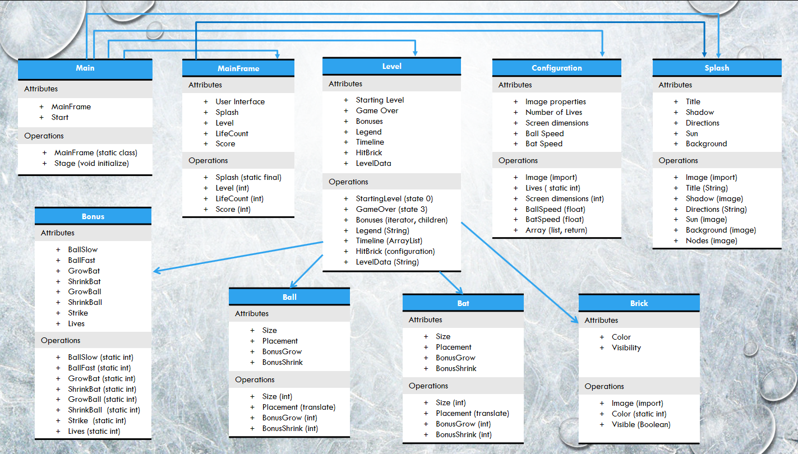help doesn’t make me useless or weak.