CHECKLIST: JAVA GUI ORDERING SYSTEM
PROGRAMMER: TALOB, DAVE DANIEL R.

NOTE: Once specific task is completed, record the date on the right side and highlight it in blue. Use Rubric number 2.

1. LOGIN MODULE
USER INTERFACE
- Create login window (JFrame/JavaFX Stage) - April 07, 2026
- Add:
  - Username field
  - Password field
  - Correct Labelling/Labels
  - Login button
  - Clear button
  - Show/Hide password toggle
  - Register New User / Create an Account
  - Forgot Password
  - Three Security Question in Password Recovery
- Center layout and apply clean design
- Add system title/logo
FUNCTIONALITY
- Capture input values
- Apply input validation in all Text Fields
- Validate:
  - Empty fields (provide error message)
  - Input format (provide error message if incorrect data format)
- Display inline error messages
- Clear all fields once Done
- Focus cursor in textfield1 always

- DATABASE
- Connect via JDBC
- Use PreparedStatement
- Query user credentials
- SECURITY
- Hash passwords (SHA-256/BCrypt)
- Avoid plain text comparison
- NAVIGATION
- Redirect to dashboard on success
- Store session (username/role)
- Dispose all not needed Forms
- 2. DASHBOARD MODULE
- USER INTERFACE
- Create main dashboard window
- Sidebar navigation:
  - Orders
  - Products
  - Customers
  - Reports
  - Logout
- Main content panel (CardLayout)
- Welcome message
- FUNCTIONALITY
- Add button event handlers
- Load modules dynamically
- Display date/time
- Should have a Calendar upon Click
- LOGOUT
- Confirm logout (provide information/confirmation message)
- Clear session
- Return to login
- 3. ORDER MANAGEMENT MODULE
- USER INTERFACE
- Product list (JTable/ComboBox)
- Quantity field
- Add to Cart button
- Cart table
- Total price label
- Place Order button
- FUNCTIONALITY
- Load products from Table or in DB
- Add item to cart
- Update quantity if duplicate
- Remove/edit cart items
- Auto-compute total
- DATABASE
- Insert into orders table
- Insert into order_details table
- EXTRA
- Generate order ID
- Reduce stock
- Show confirmation/receipt
- Printed receipt
- 4. PRODUCT MANAGEMENT MODULE
- USER INTERFACE
- Product form:
  - Name
  - Price
  - Stock
- Product table
- Buttons (password protected):
  - Add
  - Update
  - Delete
  - Clear
- FUNCTIONALITY
- Validate inputs
- Populate fields on row select
- Perform CRUD operations
- SQL
- INSERT
- UPDATE
- DELETE
- SELECT
- 5. CUSTOMER MANAGEMENT MODULE
- Customer form (name, contact, address)
- Customer table
- CRUD operations
- Link customer to orders
- 6. REPORT MODULE
- USER INTERFACE
- Date filters (start/end)
- Report table
- Buttons:
  - Generate
  - Export
  - Print
- FUNCTIONALITY
- Generate:
  - Daily sales
  - Monthly sales
  - Product sales
- Compute totals
- EXPORT (password protected)
- CSV
- PDF
- DOC
- 7. DATABASE DESIGN
- TABLES
- Users
- Products
- Customers
- Orders
- Order Details
- SETUP
- Configure JDBC connection
- Normalize tables
- Use foreign keys
- Handle exceptions
- 8. EVENT HANDLING AND NAVIGATION
- Implement ActionListener
- Use CardLayout
- Handle table clicks
- Prevent unauthorized access
- 9. UI/UX DESIGN
- VISUAL DESIGN
- Consistent color scheme (2–3 colors)
- Consistent fonts and sizes
- Proper spacing and alignment
- Use icons with labels
- Avoid clutter
- LAYOUT
- Sidebar navigation
- Highlight active menu
- Group related components
- Keep key actions visible
- USER EXPERIENCE
- Minimize clicks
- Use clear labels
- Add placeholder text
- Enable keyboard navigation
- Auto-focus inputs
- Use ToolTipText
- ERROR HANDLING
- Friendly error messages
- Highlight invalid fields
- Confirmation dialogs
- Success notifications
- FEEDBACK
- Loading indicators
- Disable buttons during processing
- TABLES
- Sortable columns
- Search/filter bar
- Highlight selected rows
- Align numeric values
- FORMS
- Logical grouping
- Default values
- Dropdowns instead of free text
- Input validation
- NAVIGATION FLOW
- Smooth transitions
- Back/Home buttons
- Confirm exit
- ADDITIONAL FEATURES
- Dark mode
- Animations (JavaFX)
- Dashboard charts
- ACCESSIBILITY
- Readable fonts
- High contrast colors
- Keyboard accessibility
- 10. SECURITY AND VALIDATION
- Input validation
- Prevent SQL injection
- Role-based access (Admin/User)
- Exception handling
- 11. TESTING
- Test login scenarios
- Test order process
- Test reports accuracy
- Test database operations
- Handle edge cases
- 12. DEPLOYMENT
- Export as JAR file
- Setup database configuration
- Provide documentation:
  - User guide
  - Installation guide
- Backup database
13. ADVANCED FEATURES (OPTIONAL)
- Barcode scanner
- Receipt printing
- Inventory alerts
- Multi-user system
- Sales analytics dashboard

“Precision in Code, Passion in Design.”

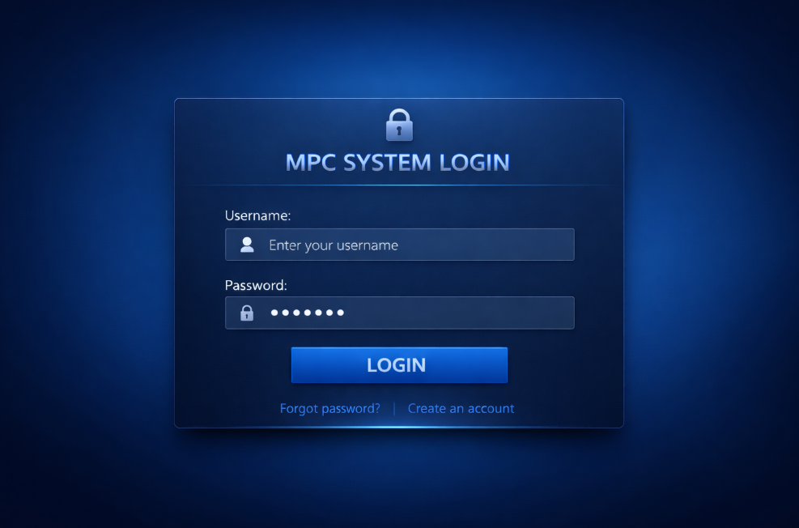

Figure 1. LogIn Form
A Java login system without SQL is typically implemented using local storage methods such as text files, object serialization, or in-memory data structures like ArrayLists and HashMaps. In this setup, user credentials (username and password) are stored locally in a file (e.g., .txt or .dat) instead of a database. When a user attempts to log in, the program reads the stored file, retrieves the saved credentials, and compares them with the input provided in the login form. This type of system is commonly built using Java Swing or JavaFX for the graphical user interface, where users interact through text fields, buttons, and labels. Basic validation is applied to ensure that empty fields are not submitted, and simple logic checks are used to confirm whether the entered credentials match existing records.
In addition, a non-SQL Java login system often includes features like account creation, where new user data is appended to a file or added to a collection, and a “forgot password” option that may rely on security questions or simple verification methods. Since there is no database involved, security measures are more limited, so developers usually apply basic encryption or hashing (such as SHA or MD5) to protect passwords before saving them. Error handling is also essential to manage cases like incorrect logins, duplicate usernames, or missing files. While this approach is simpler and ideal for beginner-level projects or academic requirements, it is less scalable compared to database-driven systems. However, it effectively demonstrates core programming concepts such as file handling, condition checking, and user authentication logic in Java.

Figure 2. Dashboard Module
Discussion here…

Figure 3. Ordering Management Module
Discussion here…

Figure 4. Product Management Module
Discussion here…

Figure 5. Customer Management Module
Discussion here…

Figure 6. Reports Module
Discussion here…

What techniques and strategies did you apply to complete the system? What features does your system have that others do not?

Rubric: Java GUI Ordering System
Programmer: Ronel D. Paglomutan

Criteria | Excellent (4) | Good (3) | Satisfactory (2) | Needs Improvement (1) | Score
Login Module | Login works flawlessly, secure password hashing, proper session handling, error messages clear | Login mostly works, minor validation issues, session handled | Login works but lacks validation or security measures | Login incomplete or non-functional
Dashboard Module | Fully functional dashboard, smooth navigation, dynamic panels, logout works | Minor navigation issues, most buttons functional | Basic dashboard, navigation limited | Dashboard missing or non-functional
Order Management Module | Products load correctly, cart updates in real-time, totals computed, orders saved to DB, stock updated | Most functions work, minor UI/logic issues | Basic add to cart works, some DB operations missing | Incomplete or non-functional
Product Management Module | Full CRUD operations, proper validations, table displays all products | Minor errors in CRUD or validation | Basic CRUD with missing validation | Incomplete or non-functional
Customer Management Module | Full CRUD operations, linked to orders, validation applied | Minor errors in CRUD or linking | Basic CRUD, partial functionality | Incomplete or non-functional
Reports Module | Reports generated accurately, filters work, export to CSV/PDF, totals computed | Minor inaccuracies, exports partially working | Basic report generation | Incomplete or non-functional
Database Design | Proper normalized tables, foreign keys implemented, JDBC working without errors | Minor issues in table design or DB connection | Basic DB connection, some tables incomplete | Poor or missing database design
UI/UX Design | Clean, professional, consistent design, smooth flow, accessible, keyboard navigation, proper feedback | Mostly consistent design, minor flow issues | Basic design, lacks some UX principles | Poor UI/UX, confusing layout, no feedback
Event Handling and Navigation | All buttons and panels responsive, CardLayout/Scene switching works smoothly, unauthorized access prevented | Minor event issues, mostly functional | Basic events work | Non-functional or missing
Security and Validation | Proper input validation, SQL injection prevented, role-based access enforced, exceptions handled | Minor validation/security gaps | Basic validation, some vulnerabilities | Poor or missing security
Testing | All modules tested, edge cases handled, no major bugs | Minor bugs, mostly stable | Some testing done, multiple bugs | Untested or non-functional
Deployment | JAR file runs without errors, DB configured, documentation complete | Minor deployment issues, documentation mostly complete | JAR or DB setup incomplete | Non-functional or missing
Advanced Features (Optional) | All features implemented (barcode, receipt printing, alerts, analytics) | Some features implemented | Minimal advanced features | No advanced features
TOTAL SCORE

