**Tuple Programs**

Các phép toán Tuple trong Python

Dưới đây là các phép toán tuple của Python.

* Tạo một tuple

* Tạo một Tuple có nhiều kiểu dữ liệu hỗn hợp

* Truy cập vào Python Tuple

* Sự nối các Tuple

* Cắt lát Tuple

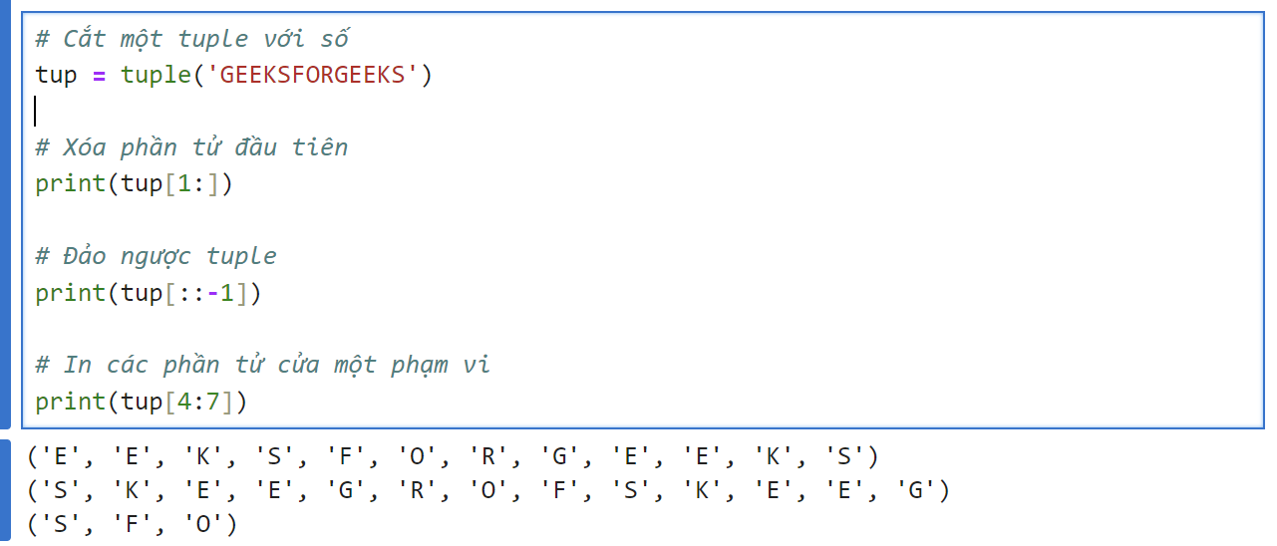

* Xóa một Tuple

1. [Find the size of a Tuple](https://www.geeksforgeeks.org/find-the-size-of-a-tuple-in-python/)

1. [Maximum and Minimum K elements in Tuple](https://www.geeksforgeeks.org/python-maximum-and-minimum-k-elements-in-tuple/)

1. [Create a list of tuples from given list having number and its cube in each tuple](https://www.geeksforgeeks.org/python-program-to-create-a-list-of-tuples-from-given-list-having-number-and-its-cube-in-each-tuple/)

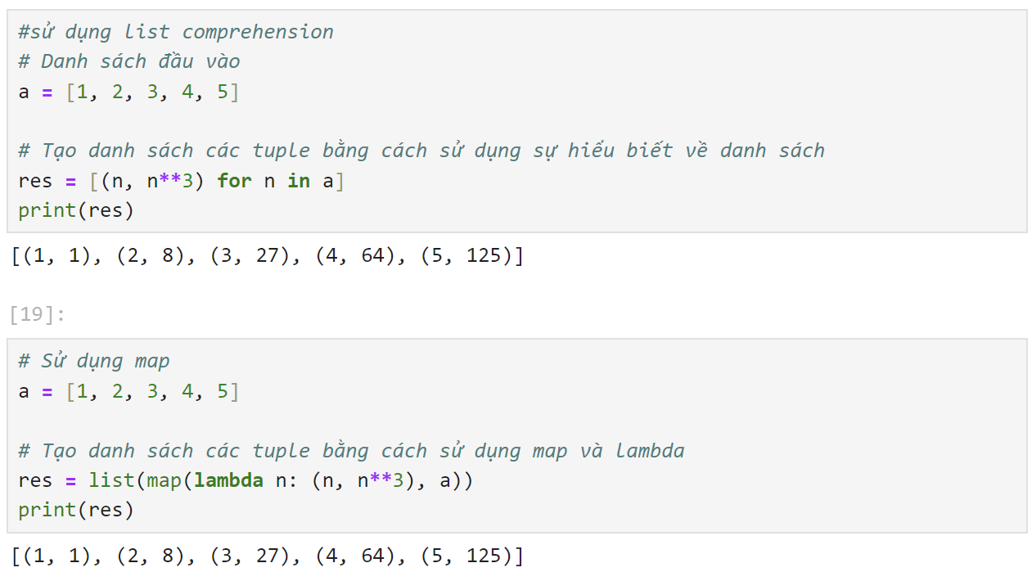

1. [Adding Tuple to List and vice – versa](https://www.geeksforgeeks.org/python-adding-tuple-to-list-and-vice-versa/)

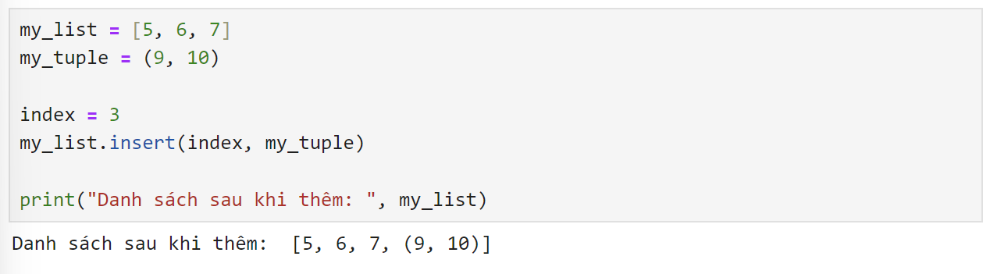

1. [Closest Pair to Kth index element in Tuple](https://www.geeksforgeeks.org/python-closest-pair-to-kth-index-element-in-tuple/)

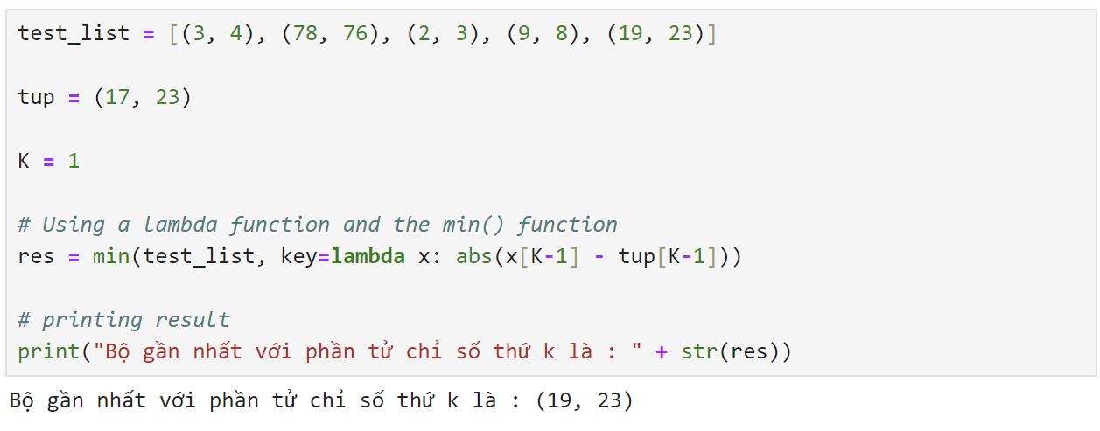

1. [Join Tuples if similar initial element](https://www.geeksforgeeks.org/python-join-tuples-if-similar-initial-element/)

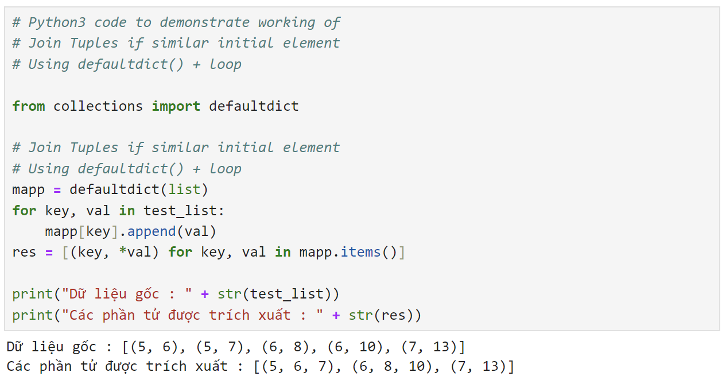

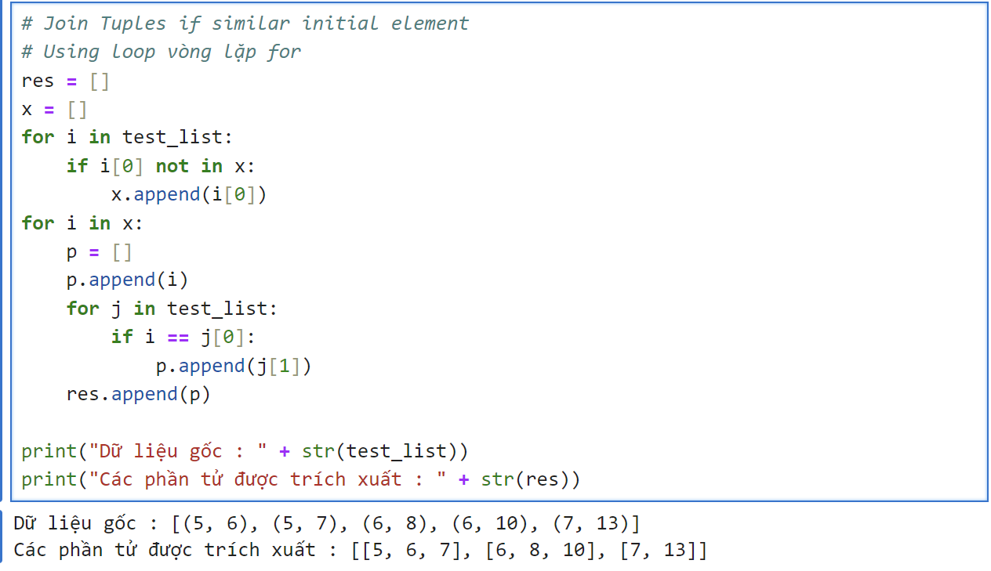

1. [Extract digits from Tuple list](https://www.geeksforgeeks.org/python-extract-digits-from-tuple-list/)

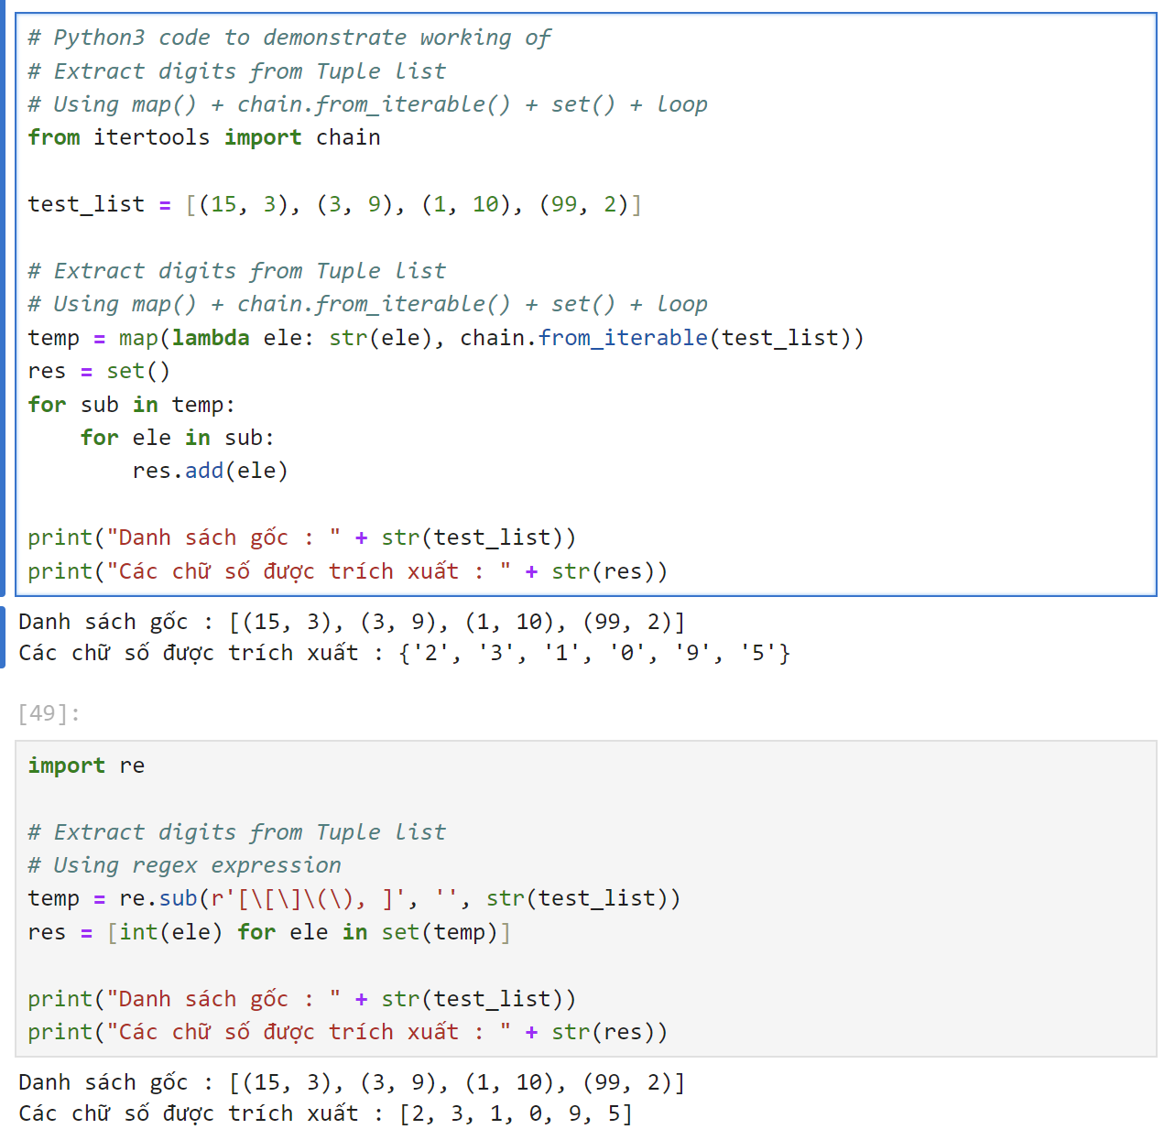

1. [All pair combinations of 2 tuples](https://www.geeksforgeeks.org/python-all-pair-combinations-of-2-tuples/)ư

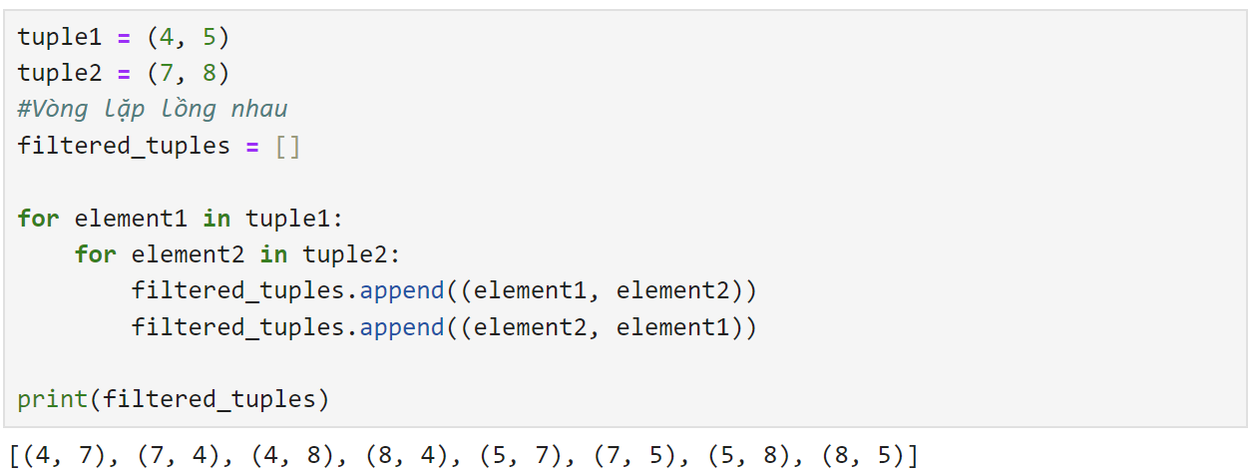

1. [Remove Tuples of Length K](https://www.geeksforgeeks.org/python-remove-tuples-of-length-k/)
2. [Sort a list of tuples by second Item](https://www.geeksforgeeks.org/python-program-to-sort-a-list-of-tuples-by-second-item/)
3. [Order Tuples using external List](https://www.geeksforgeeks.org/python-order-tuples-by-list/)
4. [Flatten tuple of List to tuple](https://www.geeksforgeeks.org/python-flatten-tuple-of-list-to-tuple/)
5. [Convert Nested Tuple to Custom Key Dictionary](https://www.geeksforgeeks.org/python-convert-nested-tuple-to-custom-key-dictionary/)