Erledigte Tasks:

- prompt templates
- improved description – more abstract and preciese
- context variable more general and appropriate
- better prediction of necessary key words (like column names etc)
- testing final model – find errors and solutions
- extension to longterm memory – so far not possible with pandasai
- collecting possible approaches

Description examples:

1) This table contains geographic information, sales data and profitability of Adidas US Sales Datasets.

2) This table contains session details, location information and other details of online shoppers' intentions.

3) This table contains survey details and employee responses from an employee engagement survey.

Context examples:

product details
survey details
human resources
training and development
user demographic information
operations research
advertising budget
training and development
geographic information

REQUEST: CORRECT

Show the performance of the different ad spends in relation to the gender and sales.

Selected tables: Advertising Budget and Sales

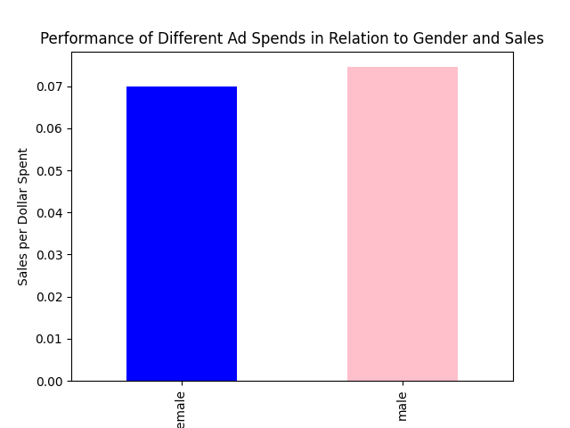

Code from AI:

grouped_df = df.groupby('gender').sum()

grouped_df['Total Ad Spend ($)'] =
grouped_df['TV Ad Budget ($)'] + grouped_df['Radio Ad Budget ($)'] + grouped_df['Newspaper Ad Budget ($)']

grouped_df['Sales per Dollar Spent'] = grouped_df['Sales ($)'] / grouped_df['Total Ad Spend ($)']
grouped_df['Sales per Dollar Spent'].plot(kind='bar', color=['blue', 'pink'])

REQUEST: MOSTLY CORRECT

Compare the operating margins between the sales methods and list their differences per city.

Selected tables: ADIDAS

ERROR for executing a code snippet

Sales Method : In-store Online Outlet

City In-store Online Outlet Difference

0 Albany 0.365972 0.486528 NaN -0.120556
1 Albuquerque NaN 0.397847 0.383056 NaN
2 Anchorage NaN 0.412222 0.287500 NaN
3 Atlanta NaN 0.419792 0.401528 NaN
4 Baltimore 0.343750 0.471111 NaN -0.127361
5 Billings NaN 0.535139 0.406944 NaN
6 Birmingham NaN 0.623056 0.518819 NaN
7 Boise NaN 0.466250 0.444306 NaN
8 Boston 0.290278 0.417222 0.333889 -0.126944
9 Burlington 0.385417 0.515139 0.432222 -0.129722
10 Charleston 0.393750 0.461991 NaN -0.068241
11 Charlotte NaN 0.463542 NaN NaN
12 Cheyenne 0.340972 0.464583 NaN -0.123611
13 Chicago NaN 0.510139 0.388889 NaN
14 Columbus NaN 0.459028 NaN NaN
15 Dallas NaN 0.531806 0.427708 NaN
16 Denver 0.365278 0.488889 NaN -0.123611
17 Des Moines 0.358333 0.483472 NaN -0.125139
18 Detroit 0.413194 0.538333 NaN -0.125139

**only a section printed

ISSUE | REASON | SOLUTION
The difference of what? | Unspecific question | User need to be more specific – ask the user
Missing values - NaN | Original dataset | Interpolation or Drop
Definition of Difference missing | No rules | Define every column name

REQUEST: MOSTLY CORRECT

What the best distribution of budget between TV, Radio and Newspaper Ads is and list their ROAS?

Selected tables: Advertising Budget and Sales; CMO dashboard

Best Distribution of Budget Average ROAS

Best Distribution of Budget Average ROAS
TV 0.732063 0.167024
Radio 0.115822 inf
Newspaper 0.152116 1.320172

ISSUE | REASON | SOLUTION
Inf value | Devision by zero – Math problem | numeric solutions (approx.)  or replace by NaN

REQUEST: CORRECT

Check if there is a correlation between pay zones and the reason why people left.

Selected tables: employee_data; shopping_trends

Answer:

There is no significant correlation between pay zones and the reason why people left.

Code from AI:
df = df.dropna(subset=['PayZone', 'TerminationType'])
# Process: Manipulating data for analysis (grouping, filtering, aggregating, etc.)
contingency_table = pd.crosstab(df['PayZone'], df['TerminationType'])
# Analyze: Conducting the actual analysis
chi2, p, dof, expected = chi2_contingency(contingency_table)
if p < 0.05:
result = "There is a significant correlation between pay zones and the reason why people left."
else:
result = "There is no significant correlation between pay zones and the reason why people left."

REQUEST: WRONG

Give me some insights about the relation of subscription types, location, genders and devices.

Selected tables: Netflix Userbase; shopping_trends

Repeated ERROR for executing some code snippet.

Last trial code:

df1.rename(columns={'User ID': 'Customer ID'}, inplace=True)
df2.rename(columns={'gender': 'Gender'}, inplace=True)

merged_df = pd.merge(df1, df2, on='Customer ID') ** Assumed those are the same customers

grouped_df = merged_df.groupby(
['Subscription Type', 'Location', 'Gender', 'Device']
).size().reset_index(name='Count')

merged columns :

['Customer ID', 'Subscription Type', 'Monthly Revenue', 'Join Date',
'Last Payment Date', 'Country', 'Age_x', 'Gender_x', 'Device',
'Plan Duration', 'Age_y', 'Gender_y', 'Item Purchased', 'Category',
'Purchase Amount (USD)', 'Location', 'Size', 'Color', 'Season',
'Review Rating', 'Subscription Status', 'Payment Method',
'Shipping Type', 'Discount Applied', 'Promo Code Used',
'Previous Purchases', 'Preferred Payment Method',
'Frequency of Purchases']

No Result.

ISSUE | REASON | SOLUTION
Assumes tables belong to the same comapany | Undefined relationship btw  tables | Add relationship or company / devision names
Tried to access gender col | When merging the names changes. Its a pandas rule. | ?

REQUEST: WRONG

Are there any patterns in the job roles and the duration of employment?

Selected tables: online_shoppers_intention

Answer:

The provided data does not contain information about job roles or duration of employment.

Similarity Result:
Element: (1700092390869348, 'Job Title') - Score: 0.662529706954956
Element: (1700092362344043, 'Supervisor') - Score: 0.598232626914978
Element: (1700092362344043, 'JobFunctionDescription') - Score: 0.5774050951004028
Element: (1700092362344043, 'EmployeeType') - Score: 0.5185337066650391
Element: (1700092377314948, 'Administrative') - Score: 0.5149404406547546
Similarity Result:
Element: (1700092381859424, 'Plan Duration') - Score: 0.5834157466888428
Element: (1700092404695104, 'Training Duration(Days)') - Score: 0.5574712157249451
Element: (1700092377314948, 'Administrative_Duration') - Score: 0.5512425899505615
Element: (1700092377314948, 'Informational_Duration') - Score: 0.5294865965843201
Element: (1700092377314948, 'ProductRelated_Duration') - Score: 0.5084898471832275

ISSUE | REASON | SOLUTION
What do you mean by pattern? | Unspecific question | User need to be more specific – ask the user or create default tasks when question too generic.

REQUEST: CORRECT

Analyze whether the employee performance has a relation to the frequency of termination.

Selected tables: employee_data

Answer:

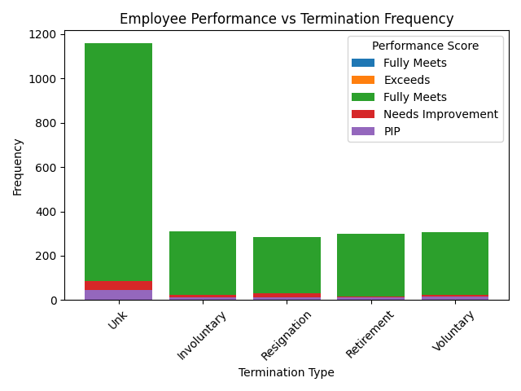

REQUEST: CORRECT

Summarize the sales of Apparel products per city, but exclude all sales that had an operating margin of less than 30%.

Selected tables: ADIDAS

0 Albany 8412662.0
1 Albuquerque 2671288.0
2 Anchorage 2921273.0
3 Atlanta 2900474.0
4 Baltimore 2413213.0
5 Billings 2091564.0
6 Birmingham 5987852.0
7 Boise 6107046.0
8 Boston 2402402.0
9 Burlington 4721753.0
10 Charleston 14612661.0
11 Charlotte 8797552.0
12 Cheyenne 3130736.0
13 Chicago 3063686.0
14 Columbus 6750935.0
15 Dallas 6785812.0
16 Denver 3627688.0
17 Des Moines 2576392.0
18 Detroit 6705667.0
19 Fargo 2602995.0
20 Hartford 3871998.0
21 Honolulu 4147468.0
22 Houston 8302223.0
23 Indianapolis 3102446.0
24 Jackson 5759109.0
25 Knoxville 6143882.0

**only a section printed

REQUEST: MOSTLY CORRECT

Categorize different marketing campaigns. Show me the distribution of the marketing costs.

Selected tables: CMO dashboard

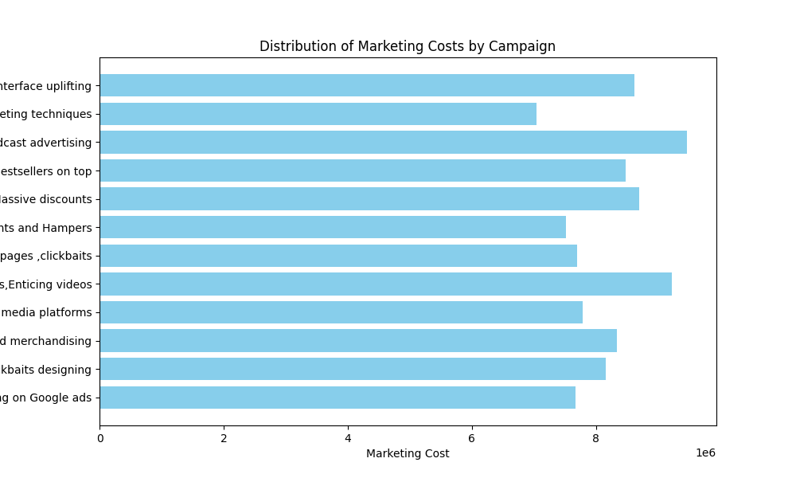
ISSUE | REASON | SOLUTION
Plot image is cut – not readable | Unspecified size | Specify a default size
Didn’t create categories | Too complex – no memory | conversational

