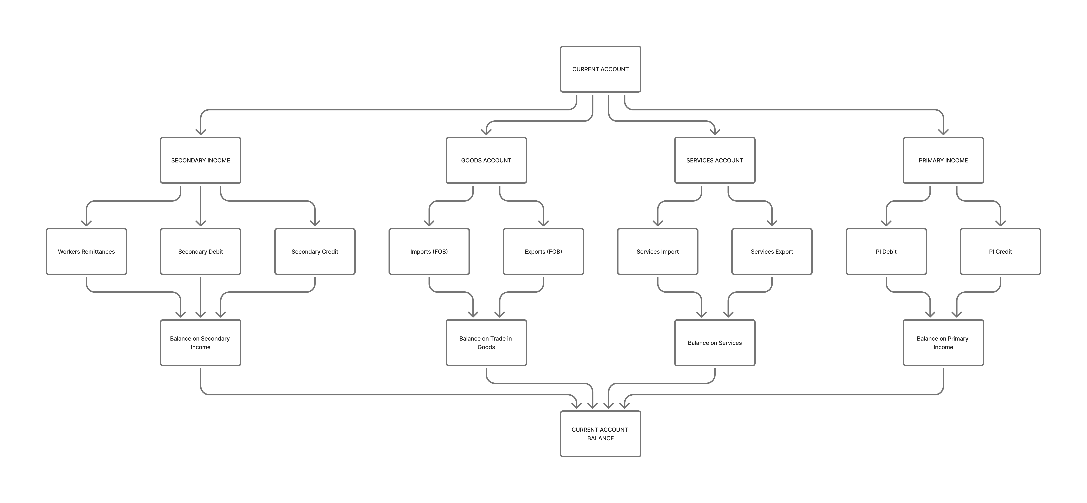
CURRENT ACCOUNT- RELATIONSHIPS

Current Account Indicators — Complete Hierarchy Tree
CURRENT ACCOUNT
│
├── 1. TRADE IN GOODS (Goods Account)
│ ├── Exports of goods FOB
│ ├── Imports of goods FOB
│ └── Balance on trade in goods
│ = Exports – Imports
│
├── 2. SERVICES ACCOUNT
│ ├── Services exports
│ ├── Services imports
│ └── Balance on services
│ = Services exports – Services imports
│
├── 3. PRIMARY INCOME
│ ├── Primary income: credit
│ ├── Primary income: debit
│ └── Balance on primary income
│ = Credit – Debit
│
├── 4. SECONDARY INCOME
│ ├── Secondary income: credit
│ ├── Secondary income: debit
│ ├── Workers remittances (subset of secondary income: credit)
│ └── Balance on secondary income
│ = Credit – Debit
│
└── 5. CURRENT ACCOUNT BALANCES (FINAL)
├── Current account balance
├── Current account balance excluding official transfers
└── Current account balance without official transfers

Indicator Relationships (Exact Dependencies)

