Nitw-News
Consider the following different processes at Nitw∼News Channel Studio as shown in sample figure below. Editor(E) gets news from Reporters(R). Reporters type news through keyboard and send to Editor. Whenever Editor receives a news, he sends the news to News Reader’s table(IPC). The News Readers N1 and N2 reads the news alternatively, i.e. arrange to display the news onto the Screen.(A news will be displayed only once onto the screen). If a News Reader notices a decimal number in the start of news content, then it gets connected to a Live telecaster(L) (whose pid is that number). After connecting, the News Reader arranges to echo onto the screen, whatever it gets from Live telecaster. At this moment the other News Reader should not read any news as live telecast is going on. Once live telecast is over, the news reading will be done alternatively by N1 and N2 as usual. The News Reader who has got connected to live telecast should also notify the Editor(for this notifying no IPCs should be used), so that the editor will maintain a total count of live telecasts at any moment. This count can be seen/known by anybody in the studio. If Editor notices a news message with prefix “/d” from any of the Reporters, then it passes that Reporter to Document Writer(D). The Document Writer stores the news messages that it gets from the Reporter in a file(document).

Code for all the different type of processes involved in this News Channel Studio scenario.
You must have to use all the IPC (Inter Process Communication) mechanisms, 90% of I/O multiplexing system calls. (You can comfortably avoid threads)

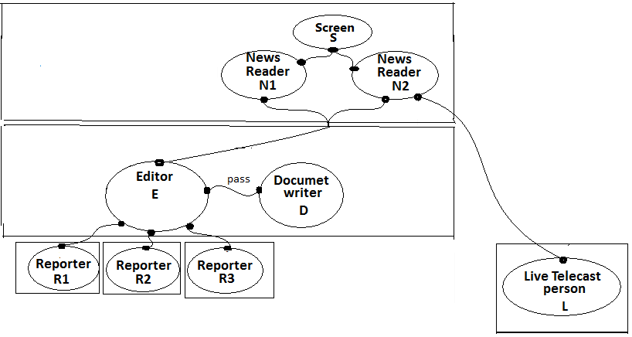

“There are three constants in life: change, choice and codes / principles”
— Stephen R. Covey

“The above can be coded with 10% change of the codes which you have already coded. Choice is yours”.

