Session 3, Exercise 1 (Labs 2–3): Understand the Block & Write the Content Contract
  - Demo walkthrough on the NORC homepage · 40 minutes (deck: 12-minute hands-on)

What this exercise is for
Goal: understand exactly how authored content becomes the page, then decide what authors maintain before anyone writes JavaScript.
Output: a content contract (fields, required/optional, absent-handling), at least two variants, and acceptance criteria, approved at the facilitator gate.
Deck slide 11 bullet | Where it is answered below
Identify your source-page section and its purpose | Part A, step 1
Decide whether Cards, Columns, Hero or another block fits | Part B, step 5a
Describe required fields, optional fields and any variants | Part B, step 6
Specify empty-state, long-text and responsive behavior | Part B, step 7
Define three acceptance criteria before implementing | Part B, step 8
Say: “A block is two things: an authoring contract and a frontend implementation. Today we design the contract first. Code comes after we agree on it.”

Adobe certification course reference
Every concept in this exercise comes from the official Adobe course Adobe Experience Manager Edge Delivery Services – Developer Professional (EDS-D200), mostly Module 2, “From Document to Page”. Each step below has a 📘 Adobe course note: which lesson it comes from, the course’s own screenshot where it helps, and the public aem.live guide that lesson points to.
 | Link (Adobe ID sign-in needed for the course)
Course home | https://certification.adobe.com/courses/1308
Module 2: From Document to Page | https://certification.adobe.com/courses/playScorm/1343/1308
Lessons used | 2 “Structure of an Edge Delivery Services Page”, 3 “Decorating the DOM”, 4 “Block Development”
Module 4: Optimizing Content Delivery (CLS, Lighthouse alt text) | https://certification.adobe.com/courses/playScorm/1345/1308
Module 5: Launching Your Website (Go-Live Checklist) | https://certification.adobe.com/courses/playScorm/1346/1308
Verified: every module link above appears on the course home page (catalog ID EDS-D200), and every 🔗 lesson link below opens the named lesson inside that module. Module links need an Adobe ID sign-in; the direct lesson links open without one.
Say: “Nothing here is our own invention. Each decision maps to a lesson in Adobe’s EDS developer course, and I’ll show you which one as we go.”

Part A: Lab 2, understand the block (20 min)

Step 1: Name the section and its purpose
Our source page is www.norc.org, imported to norc/index.plain.html (served at http://localhost:3006/norc/). The section we picked is the Cards block, which appears in three places on that page:
Section on norc.org | How it’s authored in our file | Items | Purpose (what to say)
NORC News | <h2>NORC News</h2> then cards | 6 cards | Drives clicks to the latest research. Each card: category (“Center for AI & Data Quality”, “Expert View”), linked title, usually a photo.
NORC in the Media | <h2>NORC in the Media</h2> then cards | 3 cards | Builds trust through press coverage. Each card: outlet logo, headline, outlet name.
NORC Solutions | <p>NORC Solutions:</p> then cards | ~10 tiles | Sends visitors to NORC products (AmeriSpeak and others). Each tile: one linked logo.
Show: the live site first, then our imported version of the same three sections (screenshots are in the Lab 1 doc, Step 5: lab1-source-norc-*.jpg and before-*.png).
Say: “Three sections, three different jobs: News drives clicks, Media builds trust, Solutions routes to products. All three are the same block, Cards. The purpose tells us what each card needs: News needs a category and a link, Media needs the logo shown whole, Solutions needs only a clickable logo.”
Point out: “NORC Solutions:” is a plain <p>, not an <h2> like the other two headings. It’s default content outside the block (that’s Step 3’s topic). Turning it into a proper heading is a content fix in DA, not a block change.
📘 Adobe course: Module 2 › Lesson 2, Structure of an Edge Delivery Services Page, intro. The course says the aim of document-based authoring is to keep authoring as simple as possible, so pages should closely match their source documents. That’s why we begin from the real norc.org sections, not a design idea.
🔗 Lesson: Module 2 › Lesson 2: Structure of an Edge Delivery Services Page. Direct link: https://certification.adobe.com/scorm-data/1343/scormcontent/index.html#/lessons/htUJM8Sej0YW9zDd7aw48vWRqasu9aPJ
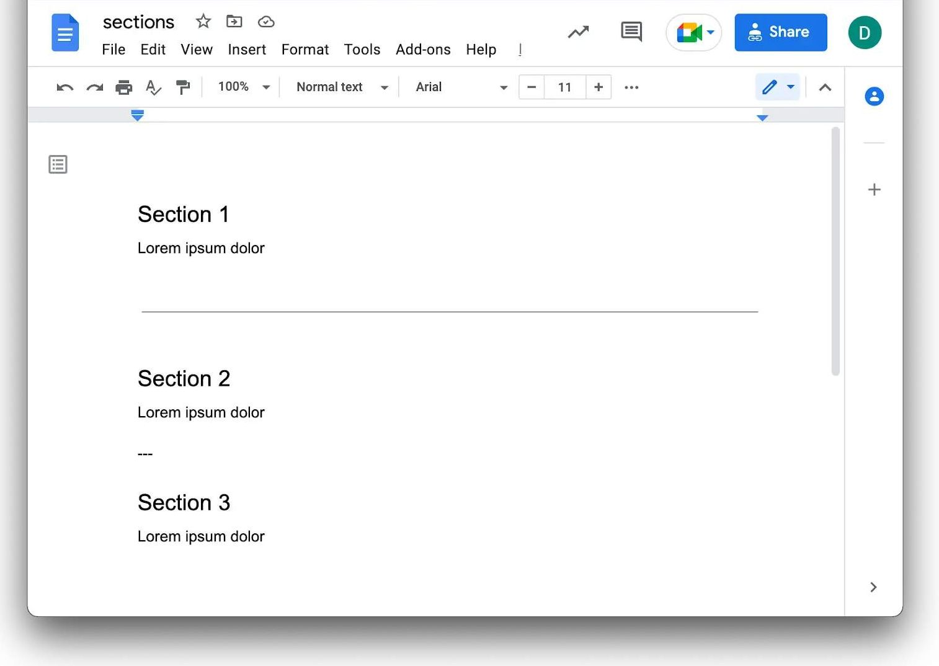
Adobe course, Module 2 Lesson 2: sections, default content and blocks in a document

Step 2: Trace content → markup → JS → CSS → screen
Show this diagram (built from the real files and the real browser DOM):
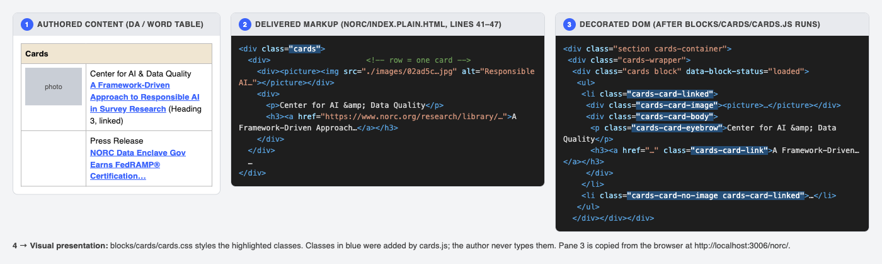
Content → delivered markup → decorated DOM
Walk it left to right:
- Authored content. In DA or Word, the author makes a table titled Cards. Each row is one card: an image cell and a text cell.
- Delivered markup. EDS turns the table into nested <div>s. class="cards" comes from the table title. That’s all the author controls.
- Decorated DOM. blocks/cards/cards.js turns rows into a <ul><li> list and adds the classes highlighted in blue. Authors never type these classes.
- Visual presentation. blocks/cards/cards.css styles those classes.
📘 Adobe course: Module 2 › Lesson 3, Decorating the DOM. The course calls this a two-step process: (1) AEM turns the document into clean semantic markup, which you can see with view-source: on the .aem.page URL; (2) scripts.js, aem.js and the block’s JS enhance that markup into the DOM you style. Our diagram is that same two-step flow, drawn on our own NORC page.
🔗 Lesson: Module 2 › Lesson 3: Decorating the DOM. Direct link: https://certification.adobe.com/scorm-data/1343/scormcontent/index.html#/lessons/TtknoIOmDabkhLw-PRN509rvg8fkpeBS
Here’s the course’s own Cards example after decoration. Note cards-wrapper, cards block, <ul><li>, cards-card-image and cards-card-body, the same classes as in our diagram:
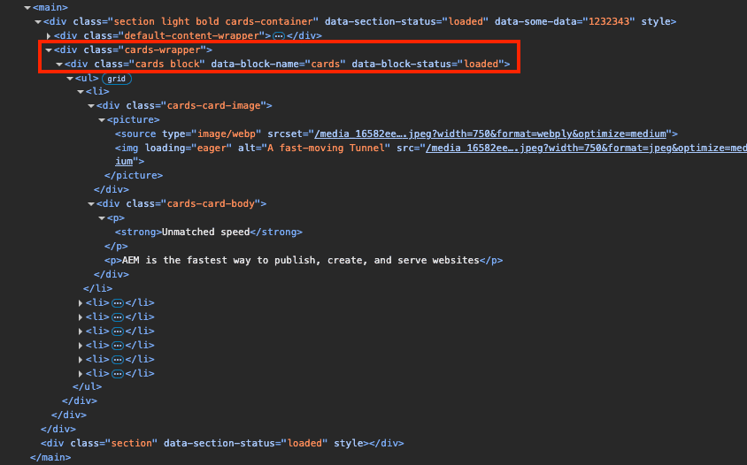
Adobe course, Module 2 Lesson 2: decorated Cards DOM
Public guide: https://www.aem.live/developer/markup-sections-blocks

Step 3: Show the authored table in VS Code
Do: in VS Code, open norc/index.plain.html and go to line 40.
Show:
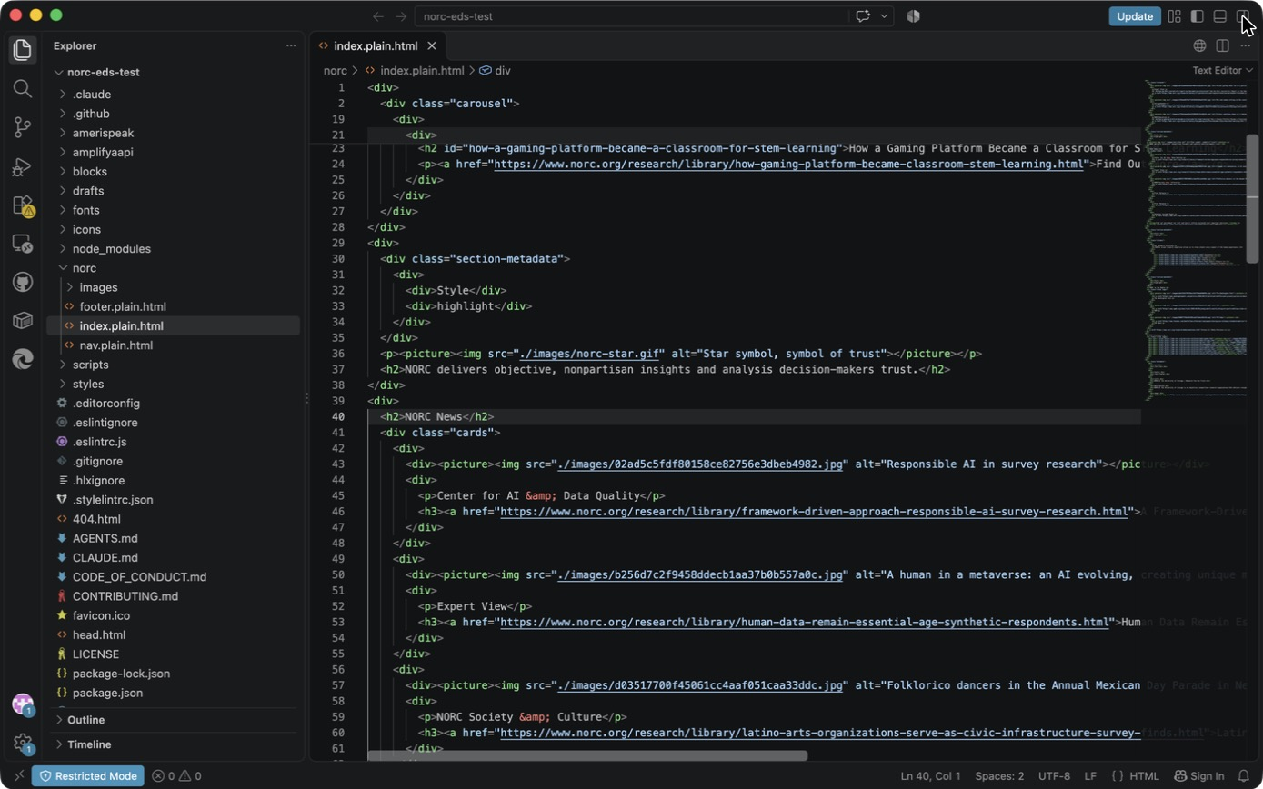
VS Code: norc/index.plain.html, the NORC News cards table
Point at:
- Line 40, <h2>NORC News</h2>: default content. It’s a plain heading, not part of the block.
- Line 41, <div class="cards">: the block starts here.
- Lines 42–48: one row = one card. The first cell is the <picture>, the second holds <p> (category) and <h3><a> (linked title).
- Lines 30–35, section-metadata → Style: highlight: a section wrapper setting, which makes that section grey. It belongs to the section, not to the block.
Say: “Notice what’s not here: no CSS classes for eyebrow, no ‘clickable’ flag. The author writes plain content. Everything else is code’s job.”
📘 Adobe course: Module 2 › Lesson 2, Structure of an Edge Delivery Services Page, sections Sections, Section metadata, Default content and Blocks. What the course teaches, and where it shows up in our file:
🔗 Lesson: Module 2 › Lesson 2: Structure of an Edge Delivery Services Page. Direct link: https://certification.adobe.com/scorm-data/1343/scormcontent/index.html#/lessons/htUJM8Sej0YW9zDd7aw48vWRqasu9aPJ
Course concept (paraphrased) | In our norc/index.plain.html
All content sits in a section; each section becomes a <div> | Each top-level <div> is one section
Section metadata is a name/value table. Style becomes a class on the section <div>. Use it only when needed. | Lines 30–35, Style: highlight
Default content is anything not in a block (headings, text, images, lists). Prefer it where you can. | Line 40, <h2>NORC News</h2>
A block is a table whose first row is the block name | Line 41, <div class="cards">
The course’s own example: a Cards table with a Section Metadata table under it in Google Docs. It’s the same pattern as ours.
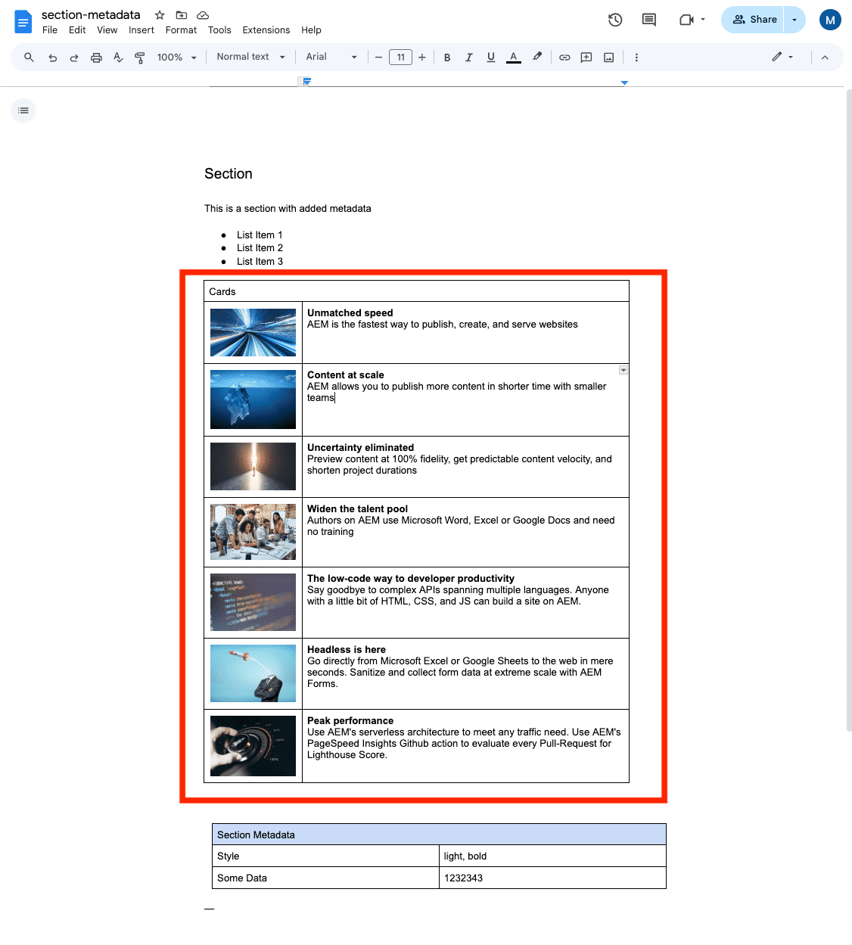
Adobe course, Module 2 Lesson 2: a Cards block table plus section metadata in a document
Public guides: https://www.aem.live/developer/markup-sections-blocks#default-content, https://www.aem.live/developer/block-collection/section-metadata

Step 4: Find the block code and judge reuse
Show: VS Code Explorer, blocks/cards/ (cards.js + cards.css), and the original cards.js:
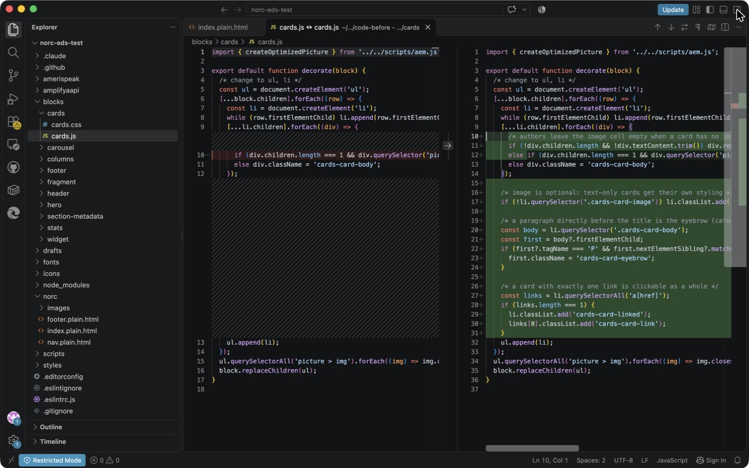
VS Code: Explorer showing blocks/cards
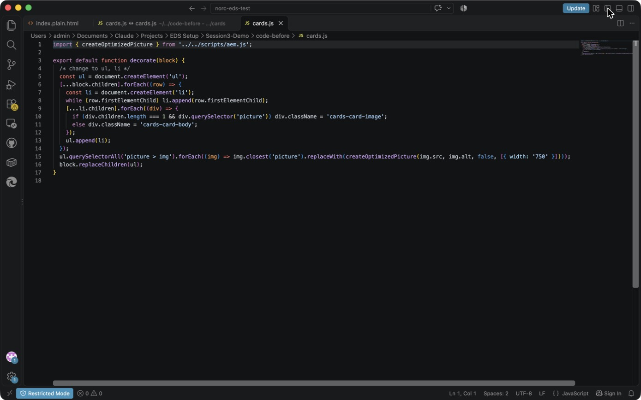
VS Code: the original 17-line boilerplate cards.js
Explain the original code line by line:
- Line 5: create a <ul>.
- Lines 6–8: for each row, create an <li> and move the row’s cells into it.
- Lines 9–12: a cell holding only a picture becomes cards-card-image; anything else becomes cards-card-body.
- Line 15: swap each image for an optimized, responsive <picture> (750 px).
- Line 16: replace the block contents with the list.
What it does not know about: optional images, an empty image cell, a category label, clickable cards, or logos.
Reusable or page-specific? Reusable. Cards appears 8 times across 3 sites in this repo (NORC ×3, AmeriSpeak ×3, Amplify AAPI ×2). That’s why we fix the block, not the page.
📘 Adobe course: Module 2 › Lesson 4, Block Development, sections Boilerplate blocks, Block code and JavaScript › decorate function.
🔗 Lesson: Module 2 › Lesson 4: Block Development. Direct link: https://certification.adobe.com/scorm-data/1343/scormcontent/index.html#/lessons/_dOUOg6VLpUUN-zwi9laYbxho37Nrt4v
- Every block lives in blocks/<name>/, with <name>.js and <name>.css named after the folder. That’s exactly where we found blocks/cards/.
- Every block’s JS exports a default decorate function, and the course uses the Cards block as its example. It’s the same logic as our 17-line file; the only difference is the last step, which the course writes as block.textContent = ''; block.append(ul) and our copy writes as block.replaceChildren(ul).
- Cards is a boilerplate block: boilerplate blocks are in nearly every AEM project, widely tested, and meant to be customized. That’s why we reuse it.
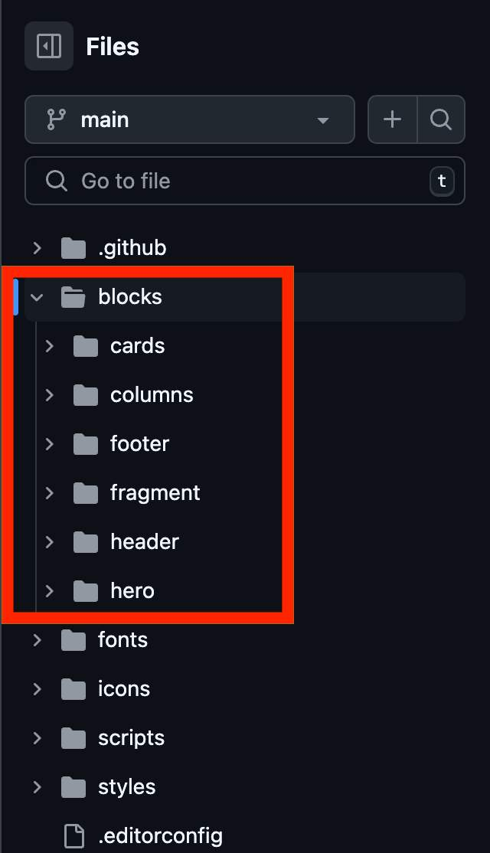
Adobe course, Module 2 Lesson 4: boilerplate blocks folder (cards, columns, footer, fragment, header, hero)
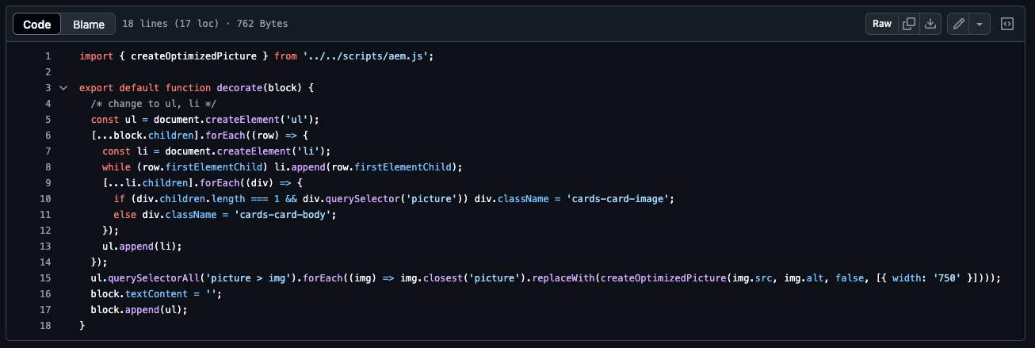
Adobe course, Module 2 Lesson 4: the Cards decorate function
Public guides: https://www.aem.live/developer/block-collection#boilerplate, https://github.com/adobe/aem-boilerplate/tree/main/blocks

Part B: Lab 3, model the content (20 min)

Step 5: Which standard block fits, and the reuse decision

5a. Does Cards, Columns, Hero or another standard block fit? (deck slide 11)
Choose by the content’s shape, not its look. These are the standard blocks in our repo’s blocks/ folder: cards, columns, hero, carousel, fragment and stats.
Block | Its content shape | Fits News / Media / Solutions? | Why
Cards | Many rows, each with image + text | ✅ Yes | Each news item, press mention or logo is one row with an image and text, and rows repeat
Columns | One row split into side-by-side panels | ❌ | Built for 2–3 panels, not a list of 6–10 repeating items; adding an item would mean adding a column
Hero | One large image plus a heading at the top of the page | ❌ | One per page and not repeating; the NORC page already has a carousel at the top
Carousel | Rotating slides | ❌ | Hides items behind arrows; news and logos should all be visible
Default content | Plain headings, text and images | ❌ | Can’t lay out a grid of repeating image and text items
New block | — | ❌ | Not needed; this content isn’t different enough from Cards
Say: “We didn’t ask ‘what should this look like’. We asked ‘what shape is this content’. It’s a repeating list of image plus text, which is exactly Cards. Columns is for side-by-side panels, Hero is a single banner, Carousel hides content.”
📘 Adobe course: Module 2 › Lesson 4, Block Development, sections Boilerplate blocks, Block collection and Block Party. The course’s order of preference is: (1) boilerplate blocks such as Cards, Columns and Hero, which are in almost every project; (2) the Block Collection, blocks used on more than half of projects; (3) the Block Party, community blocks. It also says it’s often more efficient to start from an existing block that roughly matches and adjust it than to build from scratch. Lesson 2 adds that authors should use default content wherever possible and reach for a block only when needed.
🔗 Lesson: Module 2 › Lesson 4: Block Development. Direct link: https://certification.adobe.com/scorm-data/1343/scormcontent/index.html#/lessons/_dOUOg6VLpUUN-zwi9laYbxho37Nrt4v
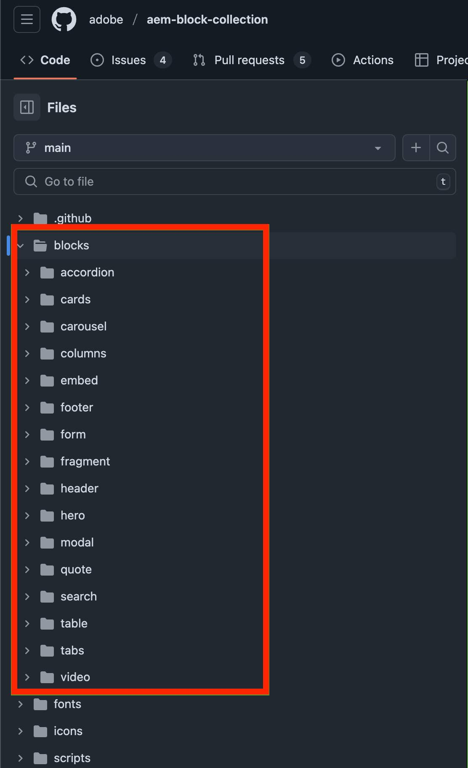
Adobe course, Module 2 Lesson 4: the Block Collection
Public guides: https://www.aem.live/developer/block-collection, https://www.aem.live/developer/block-party/

5b. The reuse decision (worksheet Lab 3)
The worksheet offers four choices:
Option | Our choice? | Why
Default content | ✗ | Repeating structured items need a block
Existing block | ✓ (base improvements) | Cards already has the right shape: image + text per row
Variant | ✓ (logos) | Logos need different image behavior, but the same table
New block | ✗ | “A new block is justified only when its content model or behavior is genuinely different” (prerequisites §4). It isn’t.
Decision: improve Cards and add the Cards (logos) variant. In DA the author just renames the table header from Cards to Cards (logos). EDS turns that into class="cards logos".
Show it in VS Code: the Media and Solutions tables now say cards logos (lines 120 and 147):
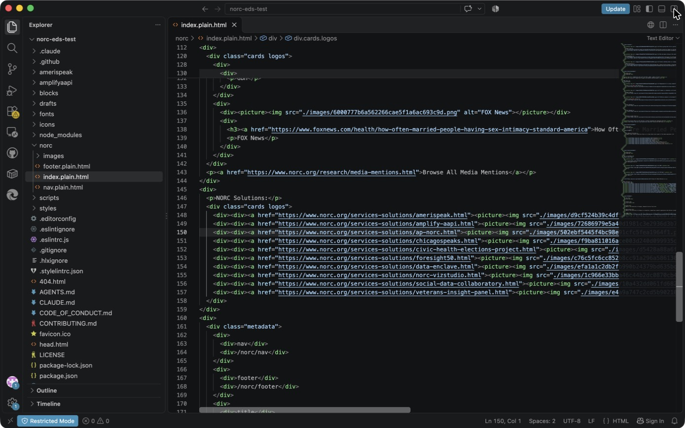
VS Code: the cards logos variant in the page
📘 Adobe course: Module 2 › Lesson 2, Structure of an Edge Delivery Services Page, section Block options. Block options let authors change a block’s look by adding classes to the block container, and developers then style or change behavior per class. The course’s example is the Cards block itself: “Cards (wide)” becomes <div class="cards wide block">, which is exactly how “Cards (logos)” becomes class="cards logos".
🔗 Lesson: Module 2 › Lesson 2: Structure of an Edge Delivery Services Page. Direct link: https://certification.adobe.com/scorm-data/1343/scormcontent/index.html#/lessons/htUJM8Sej0YW9zDd7aw48vWRqasu9aPJ
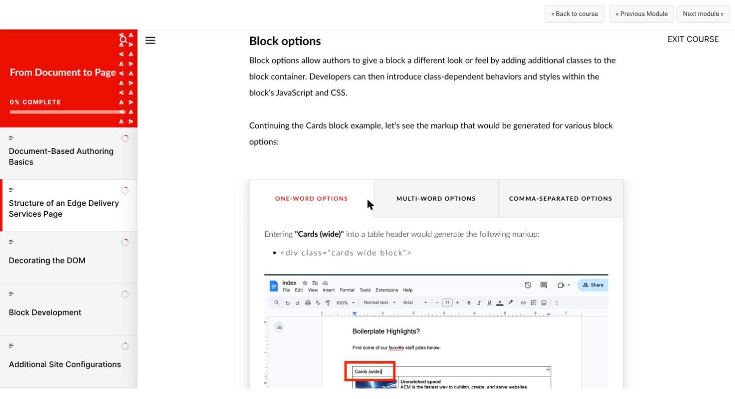
Adobe course, Module 2 Lesson 2: Block options
Public guide: https://www.aem.live/developer/markup-sections-blocks#block-options

Step 6: The content contract (fill-in table)
This follows the Adobe content-modeling skill’s Collection model: one row per item, at most 4 cells (we use 2).
Field / row | Required? | Example value (from norc.org) | Handling when absent
Image (cell 1) | ☐ Y ☒ N | Folklorico dancers photo; Washington Post logo | Card becomes text-only, with a blue top accent and light background. An empty image cell is removed.
Image alt text (on the image) | ☒ Y ☐ N (whenever there’s an image) | “The Washington Post”, “AmeriSpeak” | Must not be empty. On a logo-only tile it’s the link’s only name for screen readers. Flag it in review; Lighthouse reports it too.
Title (heading in cell 2) | ☒ Y ☐ N (default Cards); ☐ Y ☒ N (logos tiles) | “Human Data Remain Essential in the Age of Synthetic Respondents” | Default Cards: renders, but flag it in review as an authoring error. Logo tiles (NORC Solutions) have no title by design; the alt text names the tile.
Description (paragraph after the title) | ☐ Y ☒ N | “The Washington Post” or a summary | Not shown
CTA / URL (link on title or logo) | ☐ Y ☒ N | research-library article URL | 0 links: card not clickable. 1 link: whole card clickable. 2+ links: each link works on its own.
Other: eyebrow (paragraph directly before the title) | ☐ Y ☒ N | “Expert View”, “Press Release” (slide 10’s “Client/sponsor”) | Not shown; title moves up
Other: variant | ☐ Y ☒ N | logos | Default: photo 4:3, cropped to fill
At a glance (say this before walking the table):
- Required: a title on every default card, and alt text on every image.
- Optional: image, eyebrow, description, link.
- Variant: logos, chosen by the author in the table header.
Expected row structure (what the author types). There are three real shapes on /norc/:
NORC News: Cards (6 rows like this)
| Cards | |
| [photo] | Eyebrow (optional) |
| | ### [Linked title](https://…) |
NORC in the Media: Cards (logos) (3 rows like this)
| Cards (logos) | |
| [outlet logo] | ### [Linked headline](https://…) |
| | Outlet name (description) |
NORC Solutions: Cards (logos) (10 rows, one cell each)
| Cards (logos) |
| [linked logo] |
Point at: norc/index.plain.html line 148. A Solutions tile is one cell holding <a><picture>: no title, no text. The code still marks it cards-card-image, and because it has exactly one link, the whole tile is clickable.
Variants and use cases:
- Cards: news and research cards (NORC News; AmeriSpeak and Amplify feature cards).
- Cards (logos): logos never cropped (NORC in the Media; NORC Solutions).
Say: “Required means the card is wrong without it; optional means the card still looks deliberate without it. Logos aren’t a different content model, just a different image behavior, so they’re a variant, not a new block.”
📘 Adobe course: where the field rules come from:
🔗 Lesson: Module 2 › Lesson 4: Block Development. Direct link: https://certification.adobe.com/scorm-data/1343/scormcontent/index.html#/lessons/_dOUOg6VLpUUN-zwi9laYbxho37Nrt4v 🔗 Also: Module 2 › Lesson 2: Structure of an Edge Delivery Services Page. https://certification.adobe.com/scorm-data/1343/scormcontent/index.html#/lessons/htUJM8Sej0YW9zDd7aw48vWRqasu9aPJ 🔗 Also: Module 4 › PageSpeed Insights. https://certification.adobe.com/scorm-data/1345/scormcontent/index.html#/lessons/5bMlTz-yUMoxyiXU9fAhGqsDQKm2I7Ea 🔗 Also: Module 5 › Go-Live Checklist. https://certification.adobe.com/scorm-data/1346/scormcontent/index.html#/lessons/tVlzeBUh57XSCsowBwLysj3lGB39YFkl
- Rows and cells → nested <div>s: Module 2 › Lesson 4, Block Development › Block authoring design. A block’s table becomes nested <div>s, one per row and cell. That’s why “one row = one card” and “cell 1 = image” is the whole contract.
- 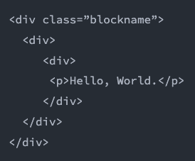
- Adobe course, Module 2 Lesson 4: a block’s rows and cells become nested divs
- Variant = block option: Module 2 › Lesson 2, Block options (see Step 5b).
- Alt text is required: Module 4 Optimizing Content Delivery › Lesson PageSpeed Insights (Lighthouse’s accessibility check looks at alt text), and Module 5 Launching Your Website › Lesson Go-Live Checklist (check images have appropriate alt text before launch).
- Images render as responsive <picture>: Module 2 › Lesson 2, Default content. That’s why the contract only asks for “an image”, never sizes or formats.
📘 Adobe course: Module 2 › Lesson 4, Block Development, section Block authoring design. Three points drive our contract:
🔗 Lesson: Module 2 › Lesson 4: Block Development. Direct link: https://certification.adobe.com/scorm-data/1343/scormcontent/index.html#/lessons/_dOUOg6VLpUUN-zwi9laYbxho37Nrt4v
- Keep things simple and intuitive for authors; the development team absorbs the complexity. That’s why the eyebrow is just “a line above the title”, not a new column.
- An author should be able to copy and paste a block and understand how each table change affects the page. That’s why it stays one row per card.
- Don’t parameterize blocks by treating table cells as arguments; the code should adapt the markup the author already wrote. That’s why there’s no “clickable: yes” cell: one link means the whole card is clickable.
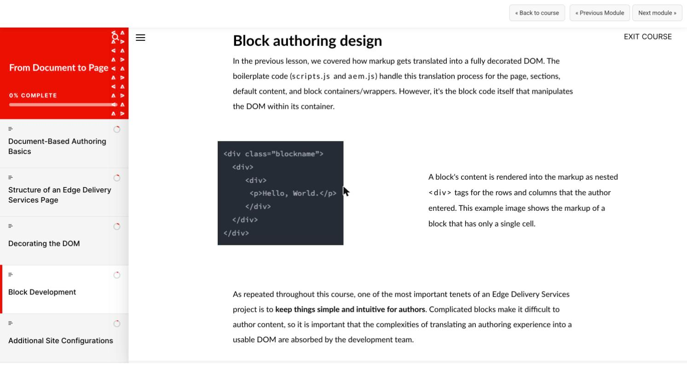
Adobe course, Module 2 Lesson 4: Block authoring design
The Adobe content-modeling skill’s Collection model (one row per item, at most 4 cells) is the agent-side version of the same guidance. Public guides: https://www.aem.live/docs/davidsmodel, https://www.aem.live/developer/markup-sections-blocks#blocks

Step 7: Empty-state, long text, responsive
For each behavior, the contract says what the author will see. The CSS/JS column is how Exercise 2 delivers it, and the last column is where Exercise 3 proves it.
Empty states
Situation | Behavior | How (code) | Proved in Exercise 3
Card has no image | Text-only card with a blue top accent and light background, so a mixed row looks deliberate | li.cards-card-no-image (cards.css lines 67–71) | Scenario 2
Image cell left empty | The empty cell is removed: no blank gap, and the eyebrow still works | div.remove() in cards.js | Scenario 2b (the defect we found)
No eyebrow / description / link | Not shown; the card is not clickable when it has no link | Classes only added when the content exists | Scenario 3
Only one card | Stays card-sized (one grid column) instead of stretching across the page | auto-fill keeps the empty grid tracks | Scenario 5
Long text
Situation | Behavior | How (code) | Proved in Exercise 3
Long title, or one very long word or URL | Wraps; never overflows the card | overflow-wrap: anywhere on the card h3 (cards.css line 53) | Scenario 4
Long description | Wraps normally | — | Scenario 4
Anything long | Nothing is truncated (no …, no line clamp), so authors always see everything they typed | No text-overflow or line-clamp in cards.css | Scenario 4
Responsive
Width | Columns | How (code)
Phone (375 px) | 1 | grid-template-columns: repeat(auto-fill, minmax(257px, 1fr)) (cards.css line 6): as many 257 px+ columns as fit, with no breakpoint code
Tablet (768 px) | 2 | same rule
Desktop (1200 px) | 4 | same rule
Images | Photos keep a fixed 4:3 shape; logos a fixed 2:1 shape | aspect-ratio reserves the space before the image loads, so nothing jumps (no layout shift)
Touch screens | No hover lift on phones | Hover effect only runs under (hover: hover)
Say: “This is the contract’s promise to authors: whatever you leave out, whatever you type, on whatever screen, the card still looks intentional. And we’ll prove each row in Exercise 3.”
📘 Adobe course:
🔗 Lesson: Module 4 › PageSpeed Insights. Direct link: https://certification.adobe.com/scorm-data/1345/scormcontent/index.html#/lessons/5bMlTz-yUMoxyiXU9fAhGqsDQKm2I7Ea 🔗 Also: Module 5 › Go-Live Checklist. https://certification.adobe.com/scorm-data/1346/scormcontent/index.html#/lessons/tVlzeBUh57XSCsowBwLysj3lGB39YFkl 🔗 Also: Module 2 › Lesson 4: Block Development. https://certification.adobe.com/scorm-data/1343/scormcontent/index.html#/lessons/_dOUOg6VLpUUN-zwi9laYbxho37Nrt4v 🔗 Also: Module 2 › Lesson 2: Structure of an Edge Delivery Services Page. https://certification.adobe.com/scorm-data/1343/scormcontent/index.html#/lessons/htUJM8Sej0YW9zDd7aw48vWRqasu9aPJ
- Layout stability: Module 4 Optimizing Content Delivery › Lesson PageSpeed Insights, section Cumulative Layout Shift (CLS). CLS measures elements jumping as the page loads; it’s 25% of the Lighthouse performance score and is tracked separately for mobile and desktop. That’s why images get a fixed aspect-ratio.
- Mobile and desktop both matter: Module 5 Launching Your Website › Lesson Go-Live Checklist. Aim for a Lighthouse score of 100 on both mobile and desktop, and check that images render properly on mobile before launch.
- Simple, scoped CSS: Module 2 › Lesson 4 Block Development › CSS. Prefix every selector with the block class and avoid complex, brittle selectors. That’s why one grid rule replaces a set of breakpoints.
- Responsive images for free: Module 2 › Lesson 2 › Default content. Every image becomes a <picture> with desktop and mobile sizes and webp.
Public guide: https://www.aem.live/developer/keeping-it-100
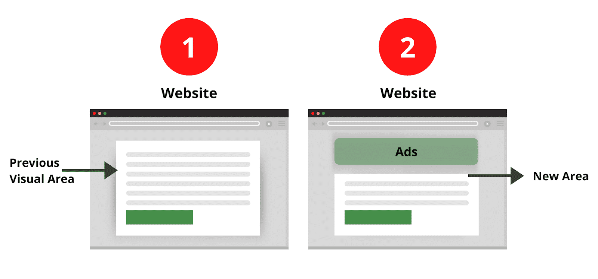
Adobe course, Module 4 PageSpeed Insights: a layout shift (CLS) when content moves as the page loads

Step 8: Acceptance criteria
Why now: criteria are written before any code, so “done” is agreed in advance and can’t drift to fit whatever the agent produces. In this exercise ☒ means agreed at the facilitator gate; pass or fail is recorded in Exercise 3.
The deck asks for three and the worksheet lists five; we wrote five, made testable. If you only have time for three, lead with 1, 3 and 5: authoring, optional content, quality. Criteria 2 and 4 are guard-rails the reviewer checks in the diff.
- ☒ The author changes content, not code. Add, remove or reorder cards and switch to logos in the table only.
- ☒ Reuse. Extend Cards with a variant; no new block, no new dependency.
- ☒ Optional content is graceful. No image, empty image cell, no eyebrow, no description and no link all look right.
- ☒ No nested blocks and no hard-coded NORC content in JS/CSS.
- ☒ Responsive, accessible, performant. No horizontal scroll at 375 px, alt text kept, keyboard focus visible, prefers-reduced-motion respected, lint clean.
What makes each criterion testable:
# | How we test it | Pass condition | Where it’s proved
1 | Change only the table: add or remove a row, rename the header to Cards (logos) | Page updates correctly with no change to cards.js / cards.css | Exercise 3 test page (8 scenarios, content only); Exercise 2 Step 6 (the only page change is the header)
2 | git diff --stat and package.json | Only blocks/cards/* and the page changed; no new block folder; package.json and the lockfile unchanged | Exercise 4 Step 2 (3 files, +109 / −3)
3 | Test page scenarios 2, 2b, 3, 4 and 5 | Every card looks deliberate: no blank gap, no broken layout | Exercise 3 Step 2
4 | Read the diff; search the block code for site names | No block inside a block; no “NORC”, URLs or copy in cards.js / cards.css; every selector starts with .cards | Exercise 2 Steps 4–5
5 | DevTools at 375 px, Tab key, Console, npm run lint | scrollWidth === 375; focus ring on the card; all alt text kept; 0 new console errors; lint passes | Exercise 3 Step 4
Say: “Every criterion has a test and a pass condition. If we can’t test it, it isn’t a criterion, it’s a wish.”
📘 Adobe course: where each criterion comes from:
🔗 Lesson: Module 2 › Lesson 4: Block Development. Direct link: https://certification.adobe.com/scorm-data/1343/scormcontent/index.html#/lessons/_dOUOg6VLpUUN-zwi9laYbxho37Nrt4v 🔗 Also: Module 2 › Lesson 2: Structure of an Edge Delivery Services Page. https://certification.adobe.com/scorm-data/1343/scormcontent/index.html#/lessons/htUJM8Sej0YW9zDd7aw48vWRqasu9aPJ 🔗 Also: Module 4 › PageSpeed Insights. https://certification.adobe.com/scorm-data/1345/scormcontent/index.html#/lessons/5bMlTz-yUMoxyiXU9fAhGqsDQKm2I7Ea
Criterion | Course source (Module 2 unless noted)
1. Author changes content, not code | Lesson 4, Block authoring design: authors change the table; developers absorb the complexity
2. Reuse an existing block or variant | Lesson 4, Boilerplate blocks / Block collection; Lesson 2, Block options
3. Optional content is graceful | Lesson 4, Block authoring design: code adapts to the markup the author provided
4. No nested blocks, nothing hard-coded | Lesson 2, Blocks: blocks should never be nested. Lesson 4, CSS: scope every selector to the block class (.cards …)
5. Responsive, accessible, performant | Lesson 2, Default content: every image renders as a responsive <picture> (desktop/mobile sizes, webp). Lesson 4, loadBlock: only blocks on the page load their JS/CSS. Module 4, PageSpeed Insights: Lighthouse checks alt text and keyboard navigation
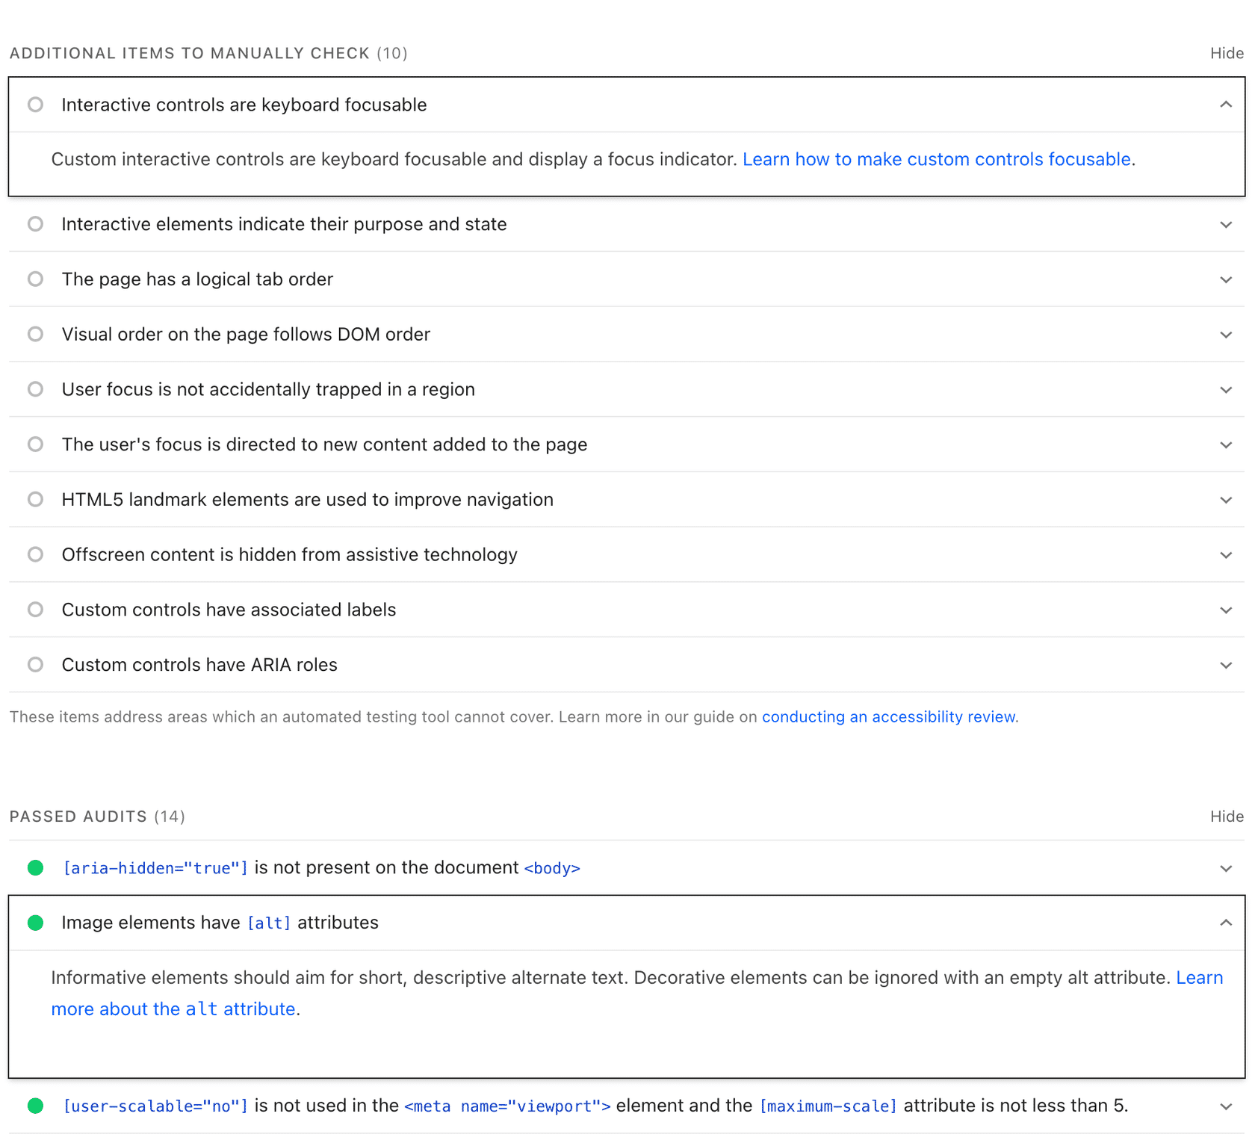
Adobe course, Module 4 PageSpeed Insights: Lighthouse keyboard-focus and alt-text audits

Facilitator gate
Say (stop here): “Before anyone touches code, does this contract make sense to the authors in the room? If yes, we approve it, and only then does the agent edit files.”
☒ Content contract reviewed and implementation approach approved before the AI edits code.
When: the facilitator notes say to enforce this approval at minute 50 of the session, before anyone starts Lab 4.
Gate checklist (ask the room, one line each):
Question to the room | Answer we show | From
Is this the right section, for the right purpose? | News, Media and Solutions on /norc/ | Step 1
Is reusing Cards (plus a logos variant) right, rather than a new block? | Yes: same content shape; logos are a block option | Step 5
Could an author fill this table in without asking a developer? | One row per card; optional lines are just typed or left out | Step 6
Do we agree what happens when content is missing, long, or on a phone? | The three tables | Step 7
Do we agree what “done” means? | 5 criteria, each with a test | Step 8
If the room says no: change the contract (the tables above), not code. There’s no code yet, which is the whole point: changing a table costs minutes, changing an implementation costs hours.
How the gate carries into Exercise 2: the prompt we give the agent ends with “Do not make code changes until the plan is approved.” The agent proposes the same contract back, and we approve it with an explicit scope: only blocks/cards/* and the two table headers.
Say: “Content first, code second. That’s the Content Driven Development rule from Adobe’s skill, and it’s why the agent isn’t allowed to touch a file until this gate is passed.”
📘 Adobe course: Module 2 › Lesson 4 Block Development › Block authoring design. The course gives a three-step order for designing a block’s table: (1) picture how the block will look and work on the page; (2) choose the table structure an author would find easiest to understand; (3) only then judge how far that table’s markup is from the final HTML. The gate is where we confirm steps 1–2 are agreed before anyone does step 3, the code.
🔗 Lesson: Module 2 › Lesson 4: Block Development. Direct link: https://certification.adobe.com/scorm-data/1343/scormcontent/index.html#/lessons/_dOUOg6VLpUUN-zwi9laYbxho37Nrt4v
Adobe course, Module 2 Lesson 4: Block authoring design
Worksheet fields:
- Current content pattern: row = image cell + text cell; no notion of optional, eyebrow, link or logo.
- Existing files involved: blocks/cards/cards.js, blocks/cards/cards.css, norc/index.plain.html.
- Block name / candidate: cards + cards (logos).

Questions you may get
- “Why not make the eyebrow its own column?” It would be a third cell authors must leave empty most of the time. A line typed above the title is how authors already write it.
- “Why is ‘logos’ a variant and not auto-detected?” The author’s intent is explicit and reviewable; auto-detection guesses. Block options are the standard EDS way.
- “Why not crop the logo images instead?” That pushes the problem onto every author, forever.

