Session 3, Exercise 2 (Lab 4): Implement with the Agent + Adobe Skills
  - Demo walkthrough on the NORC homepage · 35 minutes

What this exercise is for
Goal: have the AI agent implement the approved content contract inside one block, then review every line yourself.
Output: a working Cards block, a list of changed files, and a note of what you rejected or corrected.
The flow is deck slide 12: Analyze → Plan → Approve → Implement. Exercise 1 did Analyze and Plan; this exercise is Approve and Implement.
Deck slide 13 bullet | Where it is covered
Ask the agent to inspect the existing implementation and reuse options | Step 2 (prompt items 1–2)
Require a content model and acceptance criteria before edits | Step 2 (items 3–4; done in Exercise 1)
Approve the approach and limit the change to one block | Step 3
Review the generated content, JS and CSS in VS Code | Steps 4–6

Worksheet Lab 4 checklist item | Where it is covered
Copilot (the agent) summarized the current implementation | Step 2, “What the agent reported”
Reviewed reuse vs new-block recommendation | Step 2, “What the agent reported”
Approved the model before code changes | Step 3
Implemented / refactored the selected block | Steps 4–6
Inspected changed files rather than accepting generated code blindly | Steps 4–6
Files changed | Worksheet fields
AI suggestion rejected or corrected | Worksheet fields (4 corrections)
Say: “The agent is fast, but it’s not the reviewer. Our job in this exercise is to scope it, approve it and read what it wrote.”

Adobe certification course reference
Each step below has a 📘 Adobe course note from the official course Adobe Experience Manager Edge Delivery Services – Developer Professional (EDS-D200).
 | Link (Adobe ID sign-in needed for the course)
Course home | https://certification.adobe.com/courses/1308
Module 2: From Document to Page (Lesson 4 “Block Development”) | https://certification.adobe.com/courses/playScorm/1343/1308
Module 3: Setting Up Edge Delivery Services (Lesson “Initial Setup and Configuration”) | https://certification.adobe.com/courses/playScorm/1395/1308
Module 4: Optimizing Content Delivery (Lesson “Additional Best Practices”) | https://certification.adobe.com/courses/playScorm/1345/1308
Verified: every module link above appears on the course home page (catalog ID EDS-D200), and every 🔗 lesson link below opens the named lesson inside that module. Module links need an Adobe ID sign-in; the direct lesson links open without one.

Step 1: Create the feature branch, and the gotcha
Do: confirm the baseline is safe (the tree is clean and the page still loads), then branch.
git status # expect: nothing to commit, working tree clean
git switch -c cards-refactor
Show what happened when we used the prerequisites’ branch name:
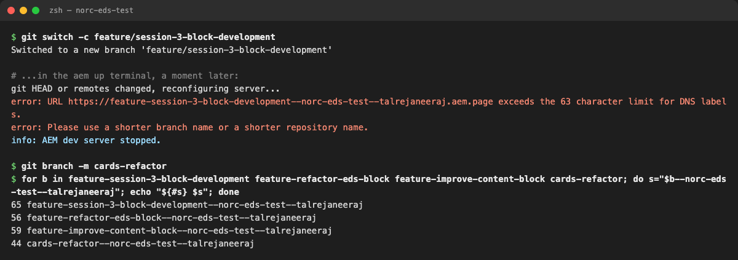
Terminal: the long branch name stopped the dev server
Explain: an EDS preview address is {branch}--{repo}--{owner}.aem.page, and that first part must be 63 characters or fewer (it’s a single DNS label; / becomes -). The three Session 3 documents suggest three different names:
Source | Branch | Length of {branch}--norc-eds-test--talrejaneeraj | Works?
Prerequisites | feature/session-3-block-development | 65 | No
Deck slide 13 | feature/improve-content-block | 59 | Yes
Worksheet Lab 4 | feature/refactor-eds-block | 56 | Yes
We used | cards-refactor | 44 | Yes
Say: “This is a real production gotcha. Long repo names and usernames eat the budget fast. Short branch names, always.”
claude # the worksheet uses: copilot
📘 Adobe course: Module 3 › Initial Setup and Configuration, sections Selecting content and code with URLs and AEM Command Line Interface (CLI).
🔗 Lesson: Module 3 › Initial Setup and Configuration. Direct link: https://certification.adobe.com/scorm-data/1395/scormcontent/index.html#/lessons/mopjdHluFIPYbbWleIqmjkXQPJHYN01L 🔗 Also: Module 4 › Additional Best Practices. https://certification.adobe.com/scorm-data/1345/scormcontent/index.html#/lessons/yzfcSloqZm2Y8B2rrt8bFe-HGNfXtkWC
- Every branch gets its own preview at https://<branch>--<repo>--<owner>.aem.page/ (and .aem.live). The course calls this “a 1:1 preview environment for each active branch”, so you don’t need a staging environment. That’s why the branch name matters: it becomes part of a URL.
- The course’s own example branch is short and ticket-style: ft-1283-contact-page. Ours, cards-refactor, follows the same pattern.
- The AEM CLI (aem up) is how a developer tests changes locally before pushing a branch. That’s the server the long name broke.
- The course doesn’t state the 63-character limit; it comes from the DNS rule that one label can’t exceed 63 characters. Public guide: https://www.aem.live/developer/tutorial
Module 4 › Additional Best Practices › GitHub management adds: “Don’t push directly to the main branch” and “Keep branches private”. So we work on our own feature branch, never main.
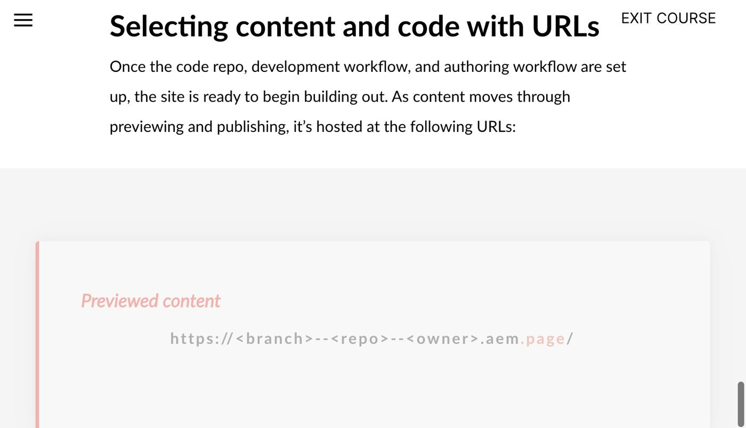
Adobe course, Module 3 Initial Setup: preview (.aem.page) and live (.aem.live) URLs per branch
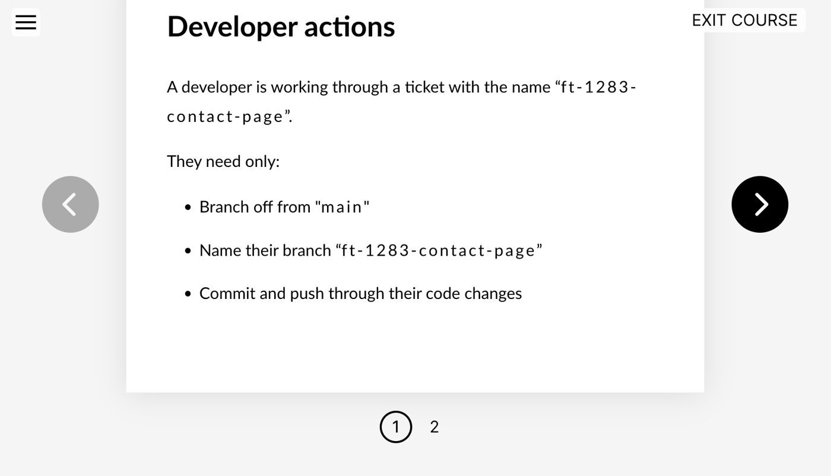
Adobe course, Module 3 Initial Setup: the course example branch ft-1283-contact-page

Step 2: The prompt
Paste the worksheet prompt (deck slide 14) into Claude Code, filling in the brackets:
Use the Adobe content-driven-development workflow to improve the selected
block on my imported NORC page.
1. Inspect the existing content, markup, CSS, and JavaScript.
2. Identify whether a boilerplate or Block Collection implementation can be reused.
3. Propose an author-friendly content model with required, optional, and variant fields.
4. Define acceptance criteria before modifying code.
5. After I approve the design, implement the changes using EDS conventions.
6. Preserve content and functionality; do not add unnecessary dependencies.
7. Explain the files changed and how to validate the implementation.
Selected block: cards
Details: norc/index.plain.html uses Cards three times: NORC News (photo optional,
category eyebrow, linked title), NORC in the Media (outlet logo + headline + outlet),
NORC Solutions (linked logo tiles). Logos are cropped by object-fit: cover; cards
without photos look broken; only the title is clickable. Also used on amerispeak/
and amplifyaapi/, so no regressions there.
Do not make code changes until the plan is approved.
Explain why each line matters:
- “content-driven-development” loads Adobe’s CDD skill, which forces content first, code second.
- Item 2 makes it check the boilerplate and Block Collection before inventing anything.
- Item 6 keeps it to plain JS and CSS: no frameworks, no npm packages.
- “Do not make code changes until the plan is approved” is the facilitator gate, enforced on the agent.
- “Details” should be specific. The more real content you describe, the better the model.
What the agent reported (worksheet: “summarized the current implementation” and “reuse vs new block”):
- blocks/cards/cards.js is the unchanged 17-line boilerplate: each row becomes an <li>, each cell is classed cards-card-image or cards-card-body, and images are optimized. It has no handling for missing images, eyebrows or logos.
- blocks/cards/cards.css has a single rule for images: aspect-ratio: 4/3; object-fit: cover. That’s what crops the logos.
- Recommendation: reuse Cards and add a logos variant. Columns doesn’t fit (no repeating items), and there’s no Block Collection “logo grid” block. That matches the decision in Exercise 1, Step 5a.
📘 Adobe course: for item 6, Module 2 › Lesson 4 › Development stack and Module 4 › Additional Best Practices › JavaScript.
🔗 Lesson: Module 2 › Lesson 4: Block Development. Direct link: https://certification.adobe.com/scorm-data/1343/scormcontent/index.html#/lessons/_dOUOg6VLpUUN-zwi9laYbxho37Nrt4v 🔗 Also: Module 4 › Additional Best Practices. https://certification.adobe.com/scorm-data/1345/scormcontent/index.html#/lessons/yzfcSloqZm2Y8B2rrt8bFe-HGNfXtkWC
- Module 2 says simple blocks should stay in plain CSS and JavaScript for performance. Frameworks (React, Vue, Tailwind…) are only for application-like blocks, and “any framework adds in an additional build step”.
- Module 4 says “Minimize framework usage” and “Keep a web project build-less, unless required.”
- That’s why the prompt says “do not add unnecessary dependencies”, and why we check package.json at the end (Worksheet fields).
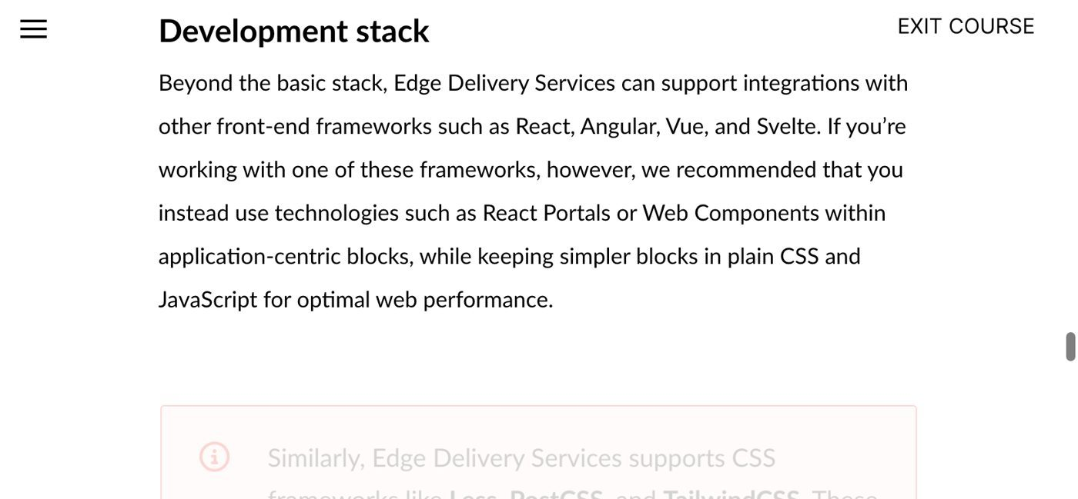
Adobe course, Module 2 Lesson 4: Development stack, keep simple blocks in plain CSS and JS
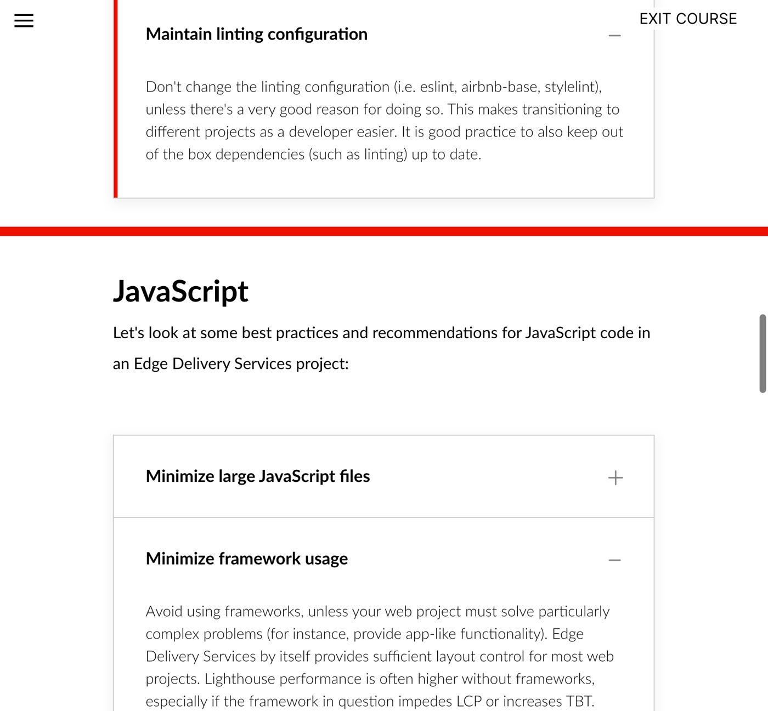
Adobe course, Module 4 Additional Best Practices: Maintain linting configuration and JavaScript rules

Step 3: Approve and scope
The agent proposed the same contract as Exercise 1. We approved it with one restriction: only blocks/cards/* and the two table headers in norc/index.plain.html. No other blocks, no global styles, no scripts/aem.js, no packages.
Say: “Approval is a scope, not a thumbs-up. I tell the agent exactly which files it may touch.”
📘 Adobe course: Module 2 › Lesson 4 › JavaScript › loadBlock function, and Module 4 › Additional Best Practices.
🔗 Lesson: Module 2 › Lesson 4: Block Development. Direct link: https://certification.adobe.com/scorm-data/1343/scormcontent/index.html#/lessons/_dOUOg6VLpUUN-zwi9laYbxho37Nrt4v 🔗 Also: Module 4 › Additional Best Practices. https://certification.adobe.com/scorm-data/1345/scormcontent/index.html#/lessons/yzfcSloqZm2Y8B2rrt8bFe-HGNfXtkWC
- aem.js loads a block’s blocks/<name>/<name>.css and .js (red boxes below), then runs its default export (green box). The course concludes that blocks “should be modular and self-contained” and only change the DOM inside their own container. So everything we need fits inside blocks/cards/.
- Module 4: “Do not modify the AEM library with project-specific extensions” (that’s aem.js), and “Keep PRs small and manageable.” One block keeps the PR small.
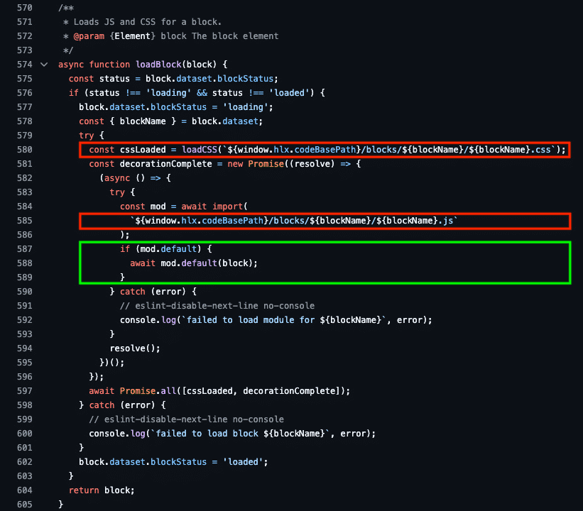
Adobe course, Module 2 Lesson 4: loadBlock in aem.js loads the block’s CSS and JS, then calls its default function

Step 4: Review the JavaScript change in VS Code
Do: compare the original file with the new one: code --diff <original> blocks/cards/cards.js.
Show:
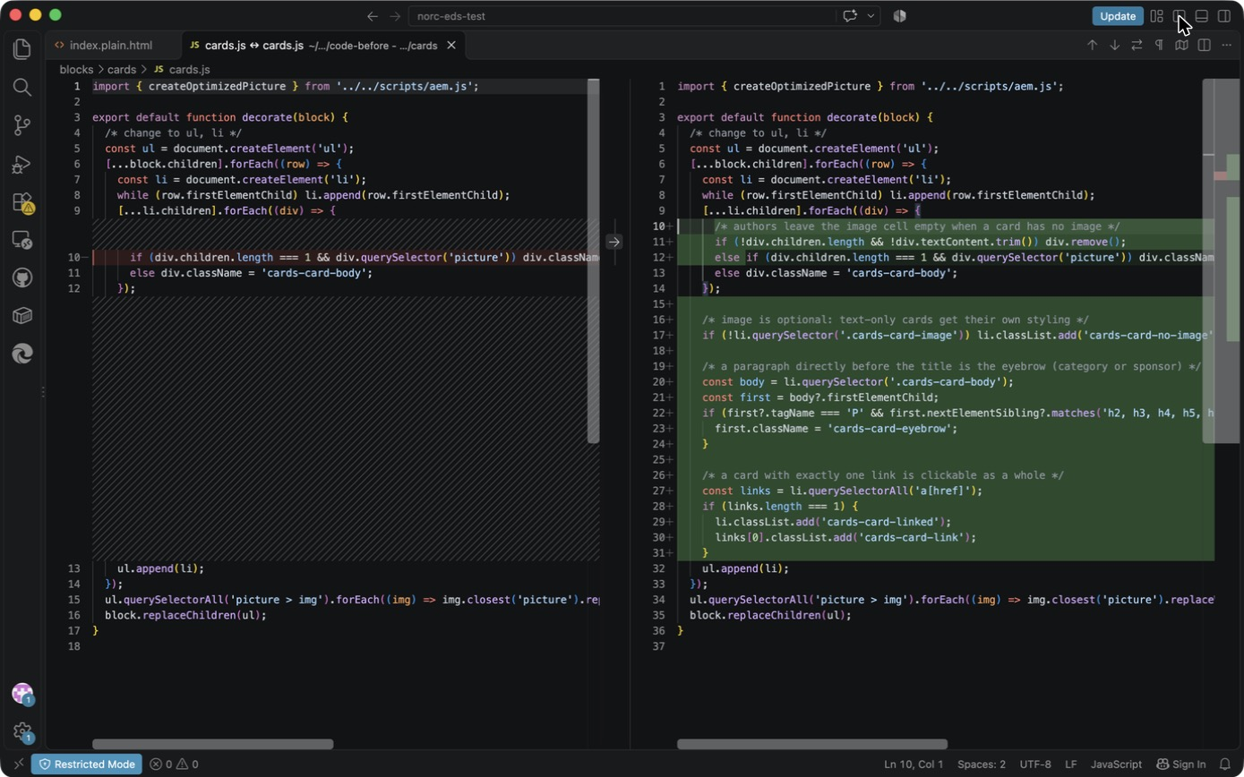
VS Code diff: original cards.js (left) vs new (right)
Walk the green lines top to bottom:
Lines (right) | Code | What it does | Why
10–11 | if (!div.children.length && !div.textContent.trim()) div.remove(); | Removes an empty cell | DA saves a 2-column row even when the author leaves the image cell blank. Found in testing (Exercise 3).
12 | else if (… picture) … | Same as before, now an else | Keeps the original behavior
16–17 | if (!li.querySelector('.cards-card-image')) li.classList.add('cards-card-no-image'); | Marks text-only cards | Lets CSS style them deliberately
19–24 | first?.tagName === 'P' && first.nextElementSibling?.matches('h2…h6') | A paragraph directly before the title becomes the eyebrow | Authors just type a line above the title; no new field
26–31 | links.length === 1 → cards-card-linked, cards-card-link | Exactly one link makes the whole card clickable | With 2+ links a whole-card click would be ambiguous, so we don’t do it
Say: “Four small behaviors, about 20 lines, all inside the existing loop. 16 of the original 17 lines are unchanged; the only edit is one if that became else if. That’s why the other sites didn’t break.”
📘 Adobe course: Module 2 › Lesson 4 › CSS and Module 4 › Additional Best Practices › CSS › Simplify CSS with additional elements.
🔗 Lesson: Module 2 › Lesson 4: Block Development. Direct link: https://certification.adobe.com/scorm-data/1343/scormcontent/index.html#/lessons/_dOUOg6VLpUUN-zwi9laYbxho37Nrt4v 🔗 Also: Module 4 › Additional Best Practices. https://certification.adobe.com/scorm-data/1345/scormcontent/index.html#/lessons/yzfcSloqZm2Y8B2rrt8bFe-HGNfXtkWC
- Module 2: “avoid using complex or brittle CSS selectors… using JavaScript to add classes can help avoid this.”
- Module 4: “Instead of utilizing complex CSS selectors, decorate additional CSS classes or elements onto your DOM to write more readable CSS.”
- That’s exactly what lines 16–31 do. The JS marks the card (cards-card-no-image, cards-card-eyebrow, cards-card-linked, cards-card-link) so the CSS can use simple class selectors instead of guessing structure.
- Module 4, Prioritize evergreen browser compatibility: the course names optional chaining (?., lines 21–22) as a feature to use knowingly. All current evergreen browsers support it, and the boilerplate already needs dynamic import(), which is newer.
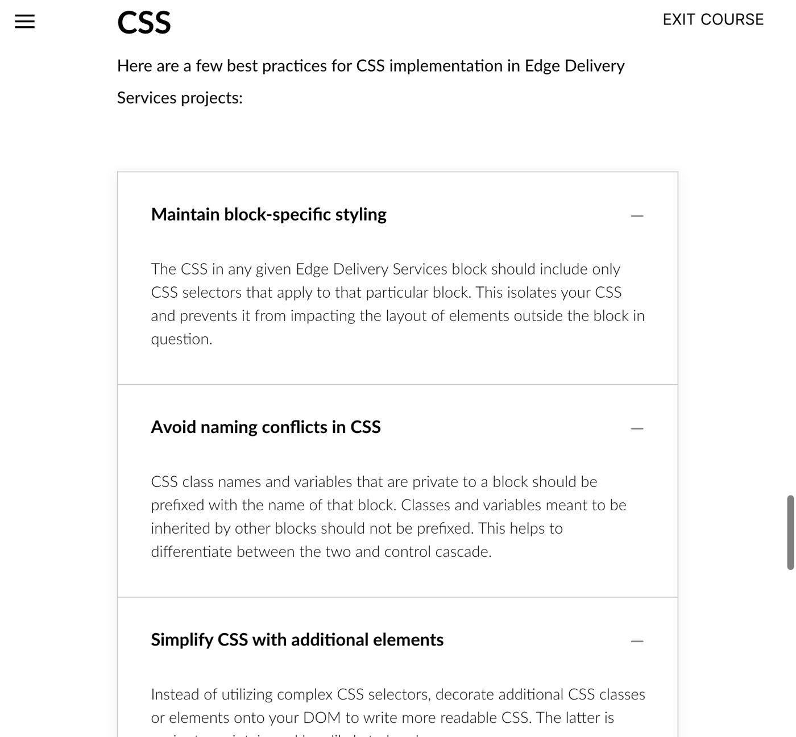
Adobe course, Module 4 Additional Best Practices: CSS rules (block-specific styling, naming, simple selectors)

Step 5: Review the CSS change in VS Code
Show the eyebrow and title rules:
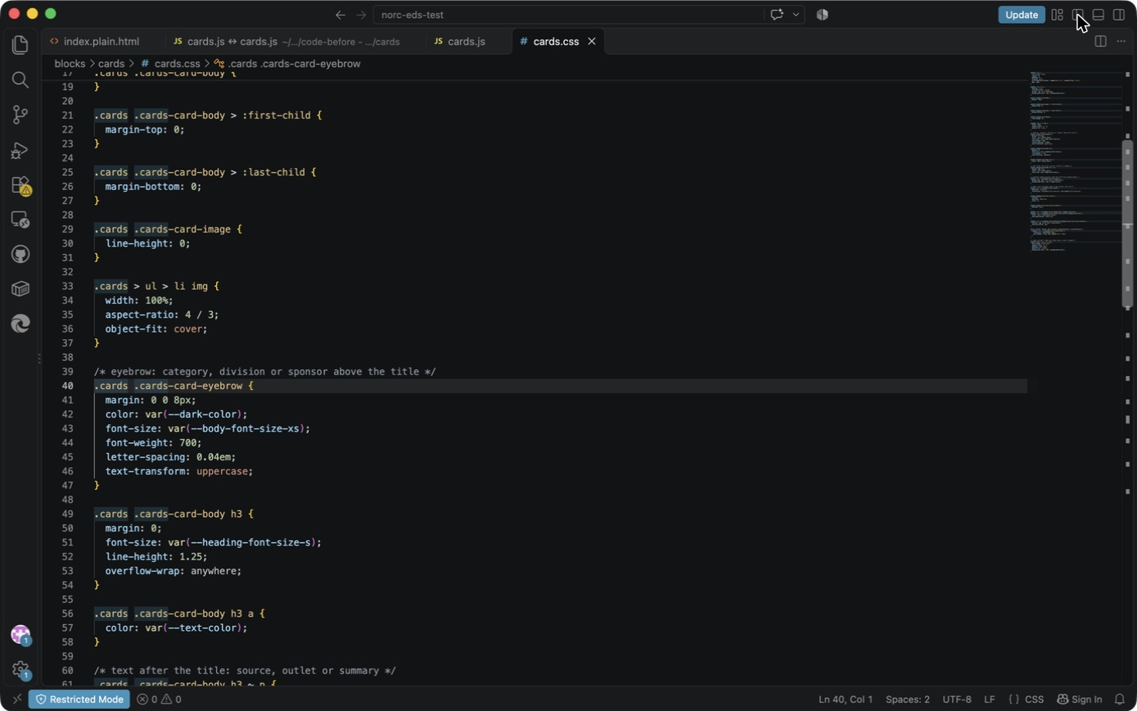
VS Code: cards.css, eyebrow and title
- Lines 39–47, .cards-card-eyebrow: small, bold, uppercase, grey. Uses the existing tokens --dark-color and --body-font-size-xs.
- Lines 49–54, card h3: --heading-font-size-s instead of the page-sized h3; overflow-wrap: anywhere for long words.
- Lines 56–58: titles in dark text, like the source site.
- Lines 60–65, h3 ~ p: the source/outlet/summary line after the title: smaller and grey.
Show the text-only card and whole-card link rules:
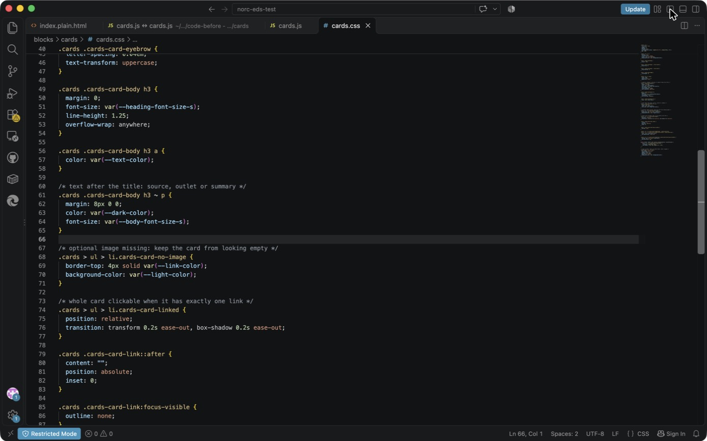
VS Code: cards.css, no-image accent and stretched link
- Lines 67–71, li.cards-card-no-image: blue top border plus a light background.
- Lines 73–83, the “stretched link”: the real <a> gets an ::after pseudo-element covering the whole card (position:absolute; inset:0). Screen readers still hear one link, with the title as its text.
- Lines 85–87: the link’s own outline is hidden because the card shows the focus ring instead (next screenshot).
- Lines 89–93: hovering or focusing anywhere on the card underlines the title, so users can see what the click will open.
Show the focus ring, motion and the variant:
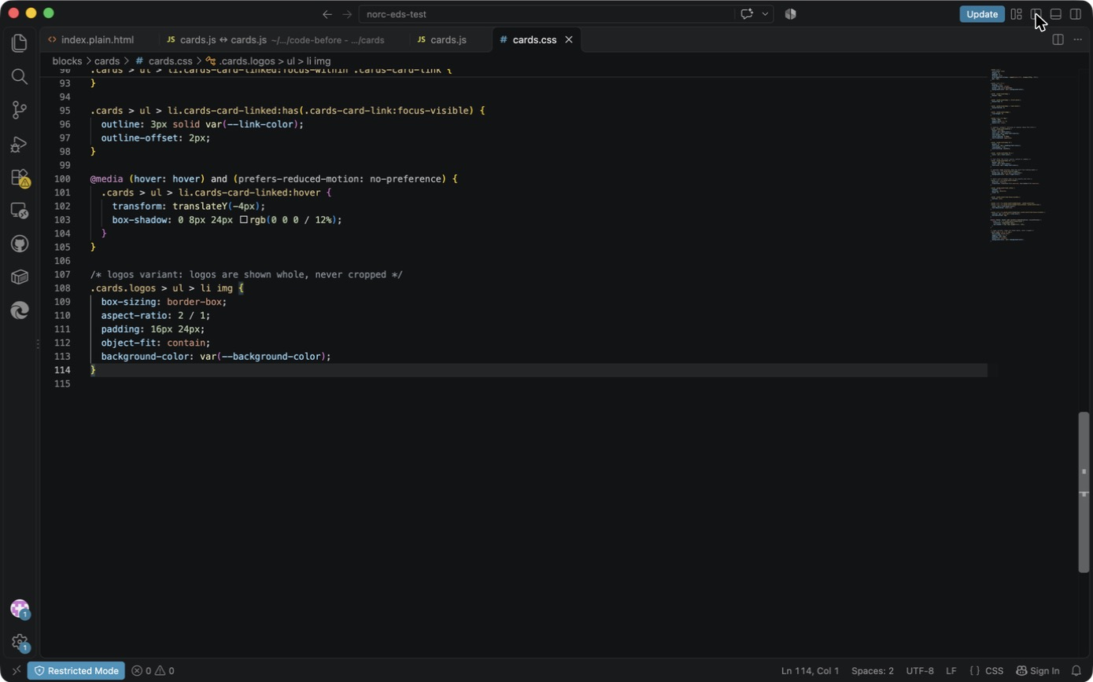
VS Code: cards.css, focus ring, reduced-motion hover, and the logos variant
- Lines 95–98: li:has(.cards-card-link:focus-visible) draws a 3 px ring around the card for keyboard users.
- Lines 100–105: the hover lift runs only with a mouse (hover: hover) and when the user hasn’t asked for reduced motion. It’s transform-only, so it stays smooth.
- Lines 107–114, .cards.logos … img: the variant. object-fit: contain in a 2:1 box with padding, so logos are never cropped.
Say: “No new fonts, no libraries, no JavaScript animation. Everything uses the boilerplate’s existing color and size tokens, so when NORC’s brand styles land, this block follows them.”
📘 Adobe course: Module 2 › Lesson 4 › CSS › The Cards block CSS, and Module 4 › Additional Best Practices › CSS. Each rule, checked against our file:
🔗 Lesson: Module 2 › Lesson 4: Block Development. Direct link: https://certification.adobe.com/scorm-data/1343/scormcontent/index.html#/lessons/_dOUOg6VLpUUN-zwi9laYbxho37Nrt4v 🔗 Also: Module 4 › Additional Best Practices. https://certification.adobe.com/scorm-data/1345/scormcontent/index.html#/lessons/yzfcSloqZm2Y8B2rrt8bFe-HGNfXtkWC
Course rule | Our cards.css
“All block level CSS should be scoped to the block… all selectors prefixed with the block class” | All 20 selectors start with .cards (or .cards.logos)
“Class names… private to a block should be prefixed with the name of that block” | cards-card-eyebrow, -no-image, -linked, -link
“Keep class names simple” | Plain descriptive names, no namespaces
“Avoid redundant semantic definitions” (ARIA) | No ARIA added; a native <a>, <ul>/<li> and <h3> carry the meaning
“Mobile first… your mobile site should render without media queries” | Layout is the boilerplate repeat(auto-fill, minmax(257px, 1fr)) grid: 1 column on phones, more as width grows, with no breakpoints. The only media query is the hover/reduced-motion one.
“Use 600px, 900px and 1200px (all min-width)… Don’t combine min-width and max-width” | Not needed here; we added no breakpoints
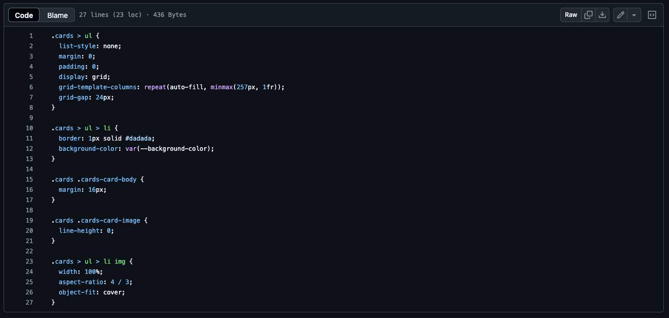
Adobe course, Module 2 Lesson 4: the boilerplate Cards CSS, every selector prefixed with .cards
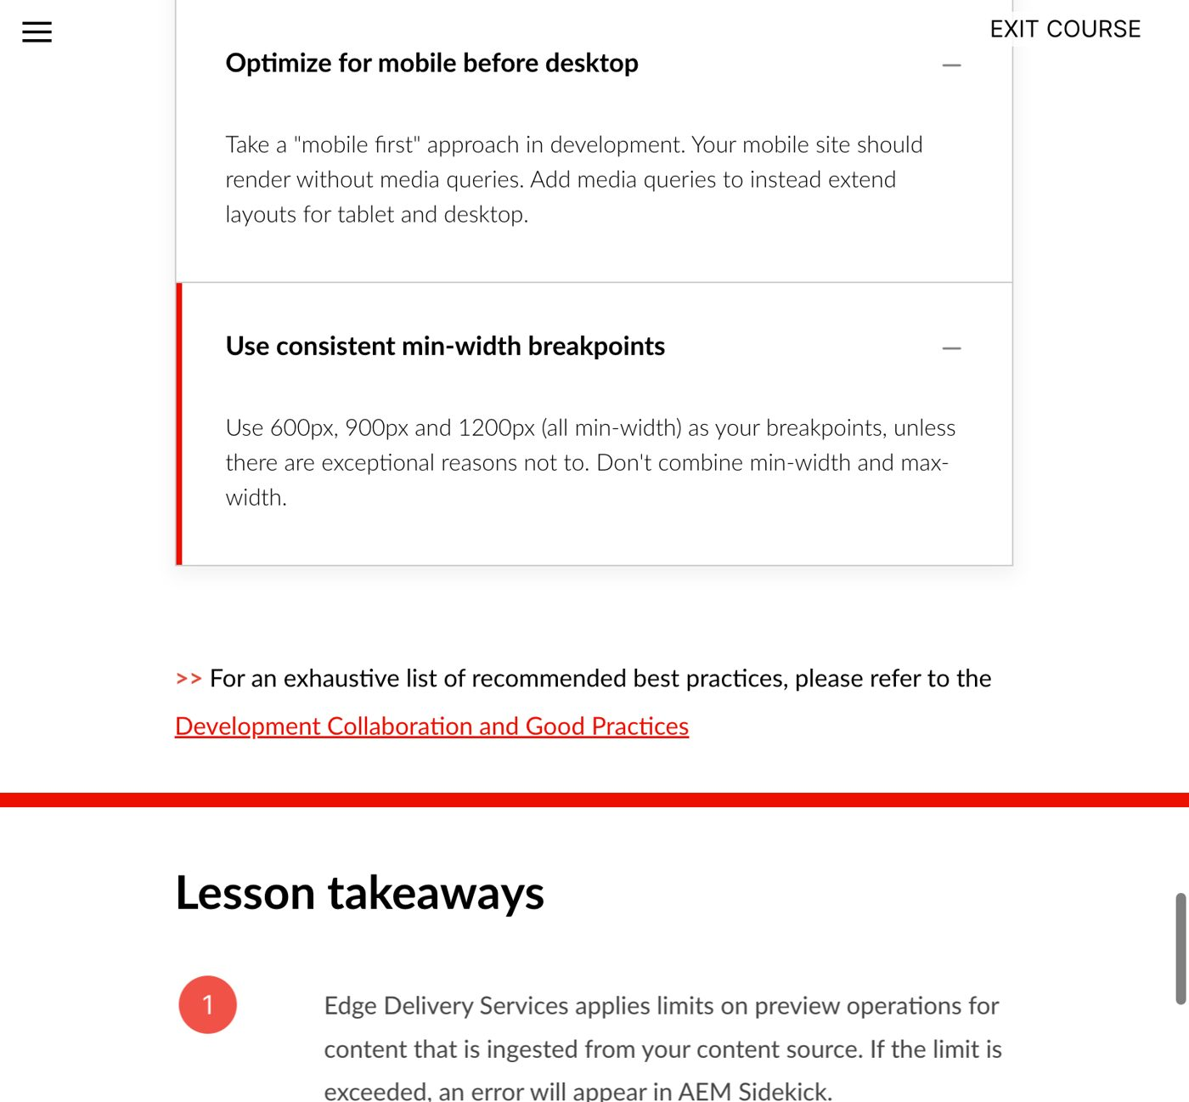
Adobe course, Module 4 Additional Best Practices: mobile first and min-width breakpoints

Step 6: Review the content change
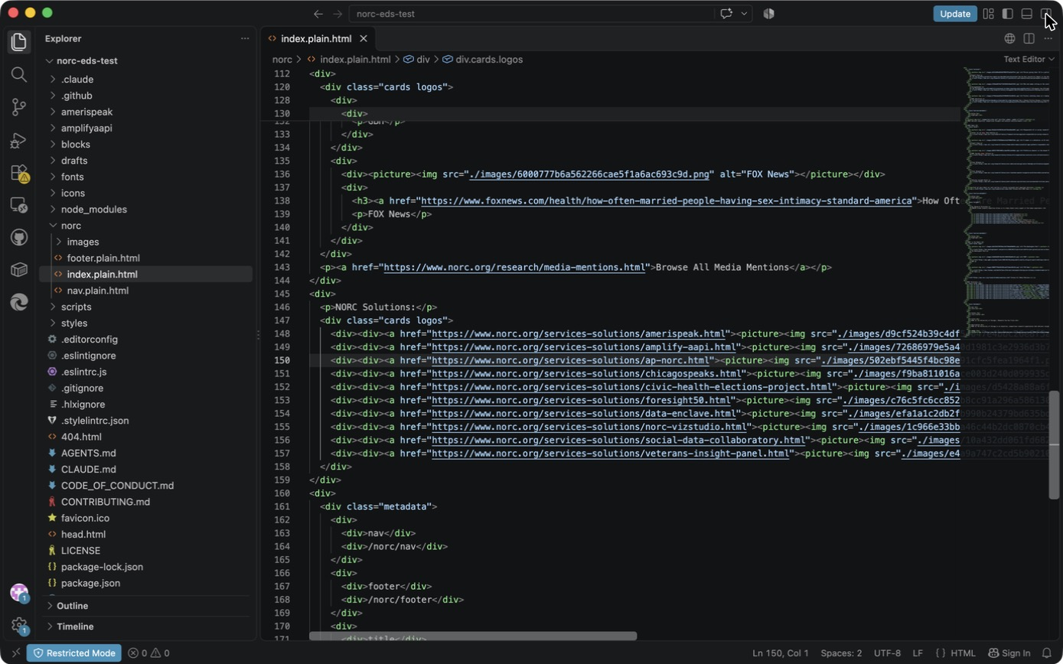
VS Code: the two table headers that changed
Only class="cards" → class="cards logos" on lines 120 and 147. In DA that’s renaming the table header to Cards (logos). NORC News (line 41) stays plain cards.
📘 Adobe course: Module 2 › Lesson 2 › Block options: an author writes Cards (logos) in the table header and it becomes class="cards logos". This is the same course reference as Exercise 1, Step 5b; now you can see it in the real file.
🔗 Lesson: Module 2 › Lesson 2: Structure of an Edge Delivery Services Page. Direct link: https://certification.adobe.com/scorm-data/1343/scormcontent/index.html#/lessons/htUJM8Sej0YW9zDd7aw48vWRqasu9aPJ
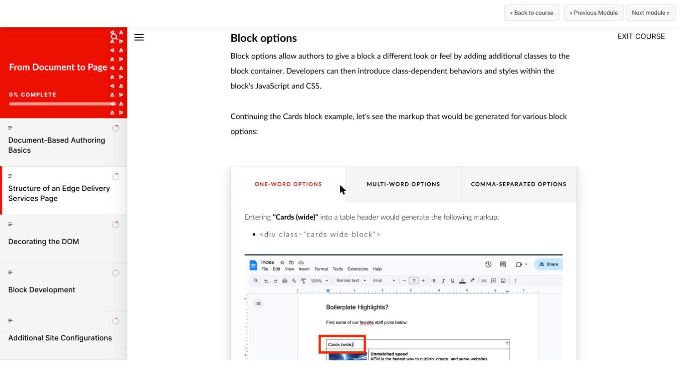
Adobe course, Module 2 Lesson 2: Block options

Worksheet fields: filled in
- The agent summarized the current implementation (17-line boilerplate; no optional or logo handling)
- Reviewed reuse vs new block (variant chosen)
- Approved the model before code changes
- Implemented the selected block
- Inspected changed files rather than accepting generated code blindly
Files changed (from git diff --numstat site-folders...cards-refactor):
File | Lines | What
blocks/cards/cards.js | +20 −1 | Empty cells, no-image flag, eyebrow, whole-card link
blocks/cards/cards.css | +87 | Styles for the above, plus the logos variant
norc/index.plain.html | +2 −2 | Two table headers → cards logos
Not changed: package.json and package-lock.json (no dependencies), scripts/aem.js, the lint configuration. The test content drafts/tmp/cards.plain.html is local only.
📘 Adobe course: Module 4 › Additional Best Practices › Maintain linting configuration: “Don’t change the linting configuration (eslint, airbnb-base, stylelint) unless there’s a very good reason.” We didn’t, and npm run lint passes (Exercise 3).
🔗 Lesson: Module 4 › Additional Best Practices. Direct link: https://certification.adobe.com/scorm-data/1345/scormcontent/index.html#/lessons/yzfcSloqZm2Y8B2rrt8bFe-HGNfXtkWC
Adobe course, Module 4 Additional Best Practices: Maintain linting configuration and JavaScript rules
AI suggestions rejected or corrected:
What happened | Correction
Used the prerequisites’ branch name | Too long for EDS; renamed to cards-refactor
First logo box was 3:2 with 24 px padding (tiny logos in big white tiles) | Tuned to 2:1, 16px 24px after looking at the screenshot
First JS treated an empty image cell as a body | Fixed after the Exercise 3 test
Worksheet Lab 6 says git add . | Rejected; see Exercise 4

Questions you may get
- “Why :has()?” It lets the card show focus when its link is focused, with no JS. It’s supported in all current browsers (the course’s “evergreen browser” rule).
- “Why not wrap the whole card in <a>?” A link containing a heading, an image and more text is read out as one long link name, and it breaks when a card has two links.
- “Did it add dependencies?” No. package.json is unchanged.
- “Why not edit aem.js or styles.css?” The course says block code stays in the block and the AEM library isn’t changed for project needs. A global change would also affect every block on every site in this repo.

