Session 3, Exercise 3 (Lab 5): Validate Content Scenarios
  - Demo walkthrough on the NORC homepage · 20 minutes

What this exercise is for
Goal: test content variability, not only “does it look like the screenshot”. Prove the block survives what real authors will do.
Output: a filled test table, evidence (screenshots), and at least one issue found and corrected.
Say: “The original page passes, but that’s the easy case. Authors will leave out images, write long titles, add one card or ten. That’s what we test.”
When: the facilitator notes say “At minute 85, shift everyone to validation; limit optional enhancements.” Whatever isn’t finished by then becomes a known limitation in the PR, not more code.
Deck slide 16 item | Where it is covered
Original imported data | Scenario 1, Step 3 (before/after on /norc/)
No image / no CTA | Scenarios 2, 2b (no image), 3 (no link = no CTA)
Long title or description | Scenario 4
One and multiple entries | Scenario 5 (one); 6 and 10 cards on /norc/ (multiple)
Desktop + mobile | Step 4, Desktop and mobile
Alt text and semantics | Step 4, Keyboard, semantics and alt text; Lighthouse
Keyboard operation as needed | Step 4, focus ring screenshot
Console and network errors | Step 4, Console and network errors
“Capture at least one issue found and corrected” | Scenario 2b, plus “Defects found and corrected”

Worksheet Lab 5 | Where it is covered
“Start/keep the server running with aem up and use browser DevTools” | Step 1 (server on port 3006); Step 4 (DevTools device toolbar, Console, Lighthouse)
“Source content plus at least two alternate content scenarios” | Scenario 1 + 8 alternates (2–7)
Test table (6 rows) and “Defects found and corrected” | “Worksheet test table: filled in”

Adobe certification course reference
 | Link (Adobe ID sign-in needed for the course)
Course home | https://certification.adobe.com/courses/1308
Module 3: Setting Up (AEM CLI, local testing) | https://certification.adobe.com/courses/playScorm/1395/1308
Module 4: Optimizing Content Delivery (PageSpeed Insights; Performance Optimization Techniques › Block testing) | https://certification.adobe.com/courses/playScorm/1345/1308
Module 5: Launching Your Website (Go-Live Checklist › Content and design QA) | https://certification.adobe.com/courses/playScorm/1346/1308
Verified: every module link above appears on the course home page (catalog ID EDS-D200), and every 🔗 lesson link below opens the named lesson inside that module. Module links need an Adobe ID sign-in; the direct lesson links open without one.

Step 1: Build a test page from real content
Do: create drafts/tmp/cards.plain.html with one section per scenario, using real NORC News, Media and Solutions content (the CDD skill’s “local HTML” approach). It’s served at http://localhost:3006/drafts/tmp/cards.
Show it in VS Code:
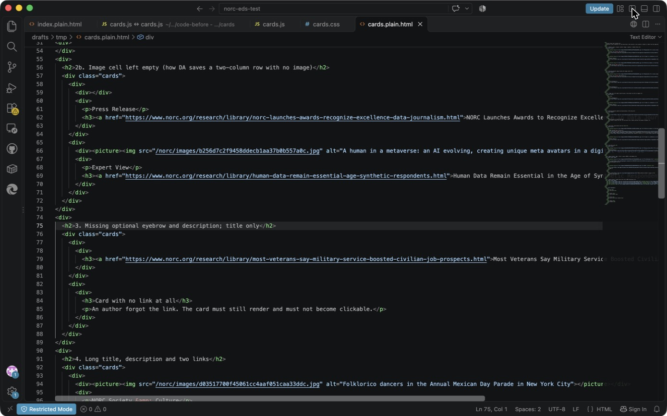
VS Code: test content, scenarios 2b (empty image cell) and 3 (title only / no link)
Point at:
- Line 59, <div></div>: an image cell left empty. This is how DA saves a 2-column row with no image.
- Lines 83–85: a card with no link. It must render and must not become clickable.
Say: “This file is our test harness. It isn’t committed; it only lives on my machine.”
📘 Adobe course: Module 4 › Performance Optimization Techniques › Block testing.
🔗 Lesson: Module 4 › Performance Optimization Techniques. Direct link: https://certification.adobe.com/scorm-data/1345/scormcontent/index.html#/lessons/OTt279XR69CtYDWVrFSDTKaYhdLF8uAv 🔗 Also: Module 3 › Initial Setup and Configuration. https://certification.adobe.com/scorm-data/1395/scormcontent/index.html#/lessons/mopjdHluFIPYbbWleIqmjkXQPJHYN01L
- The course’s method: build a test page that contains the block and test it, thinking about “not only what content has been added to that test page but also the order of it.”
- Its example puts a new Scoreboard block on a test page (below). Its PR example tests a page at /drafts/video, the same drafts/ convention as our drafts/tmp/cards.
- Module 3 › AEM CLI: you test locally with aem up before pushing a branch for others.
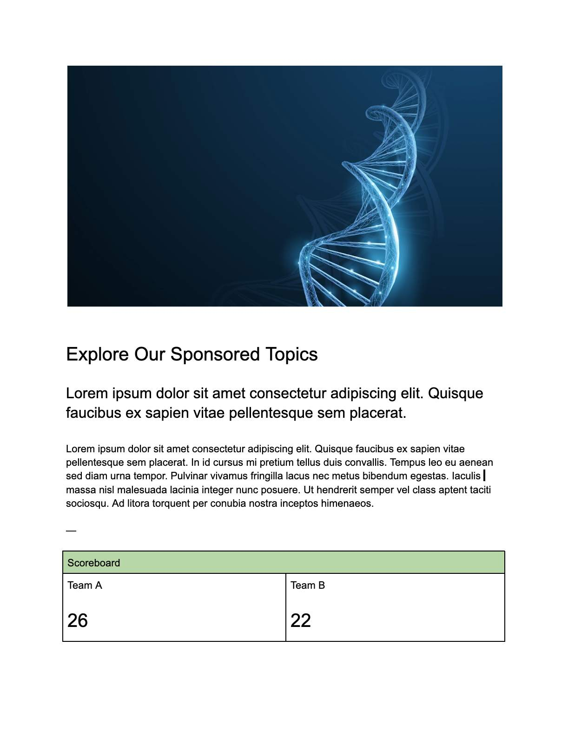
Adobe course, Module 4: a test page holding the block under test (Scoreboard)

Step 2: Run each scenario

Scenario 1: Original imported content
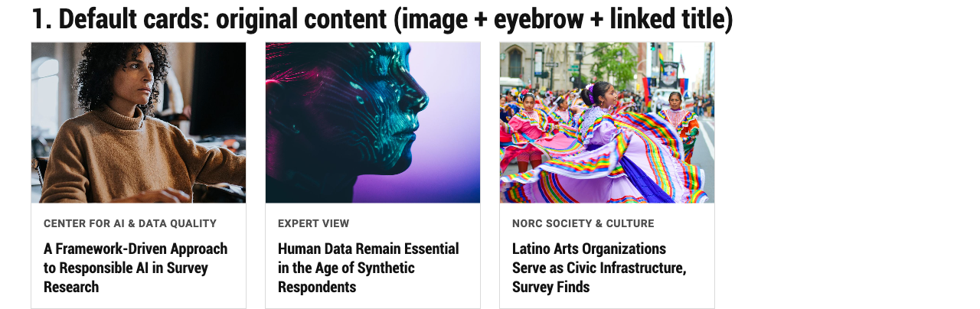
Default cards: image, eyebrow and linked title
Check: the eyebrow is small and uppercase, titles are consistent, the whole card is clickable. Pass.

Scenario 2: Missing optional image
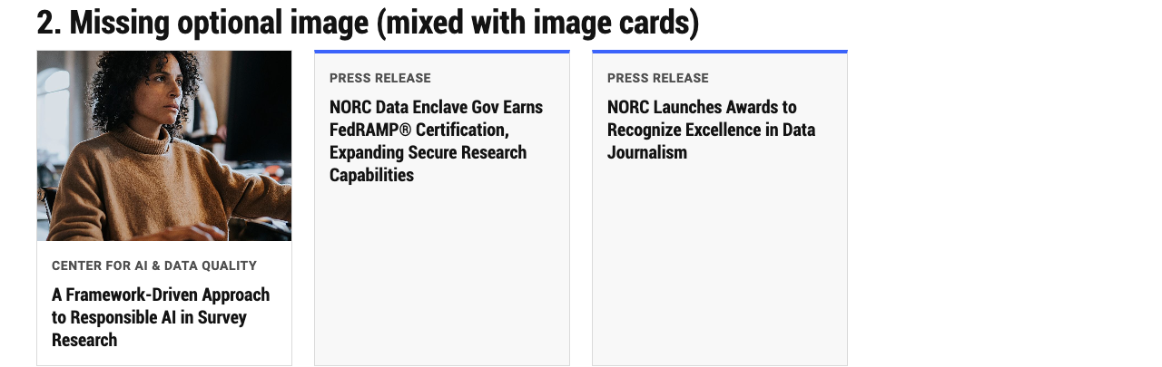
Cards without images, mixed with an image card
Check: text-only cards have a blue accent and light background, so they look intentional. Pass.

Scenario 2b: Image cell left empty. The defect we found.
Before the fix: the empty cell became an empty card body. That added a blank gap at the top and hid the eyebrow, because the code looked for it in the first (empty) body.

Before the fix: blank gap and plain “Press Release”
Fix: one line in cards.js removes empty cells before anything else (diff lines 10–11):
if (!div.children.length && !div.textContent.trim()) div.remove();
After the fix:

After the fix: no gap and the eyebrow is styled
Say: “This is exactly why the deck says ‘Capture at least one issue found and corrected.’ The original page never had an empty cell, so we’d never have seen this without a test scenario.”

Scenario 3: No eyebrow, no description, no link
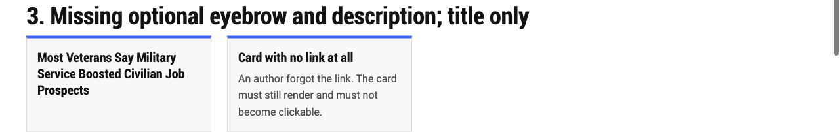
Title-only card, and a card with no link
Check: both render; the card with no link has no hover and isn’t clickable. Pass.

Scenario 4: Long title, description and two links
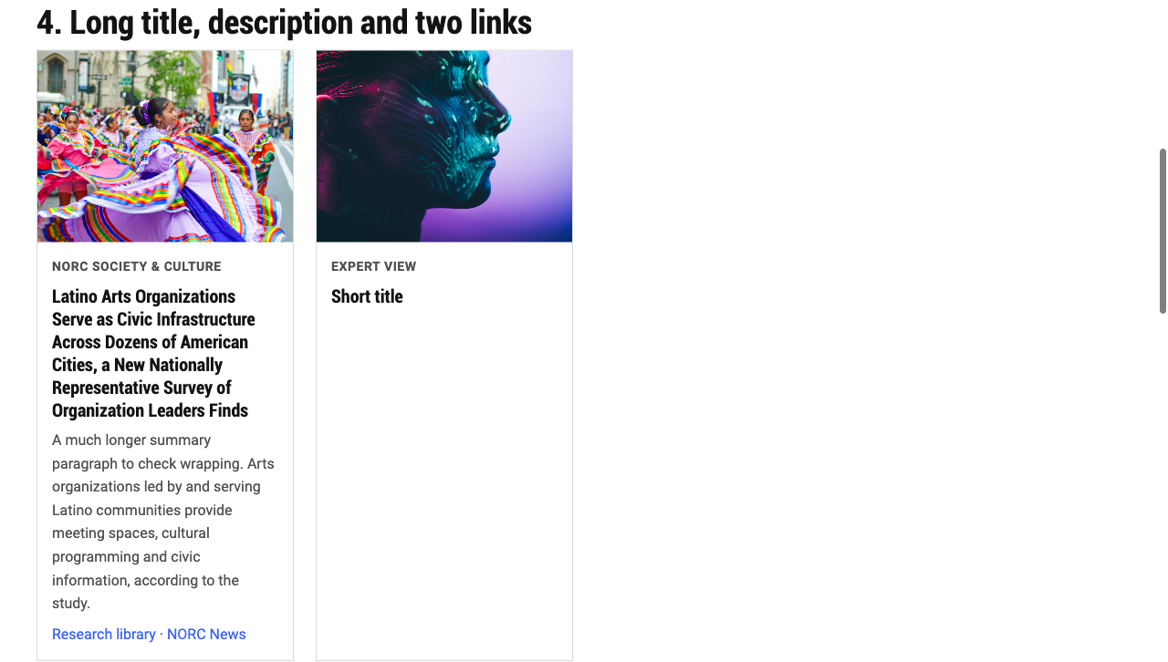
Long title, summary and two links
Check: the text wraps cleanly with no overflow. Because there are two links, the card isn’t clickable as a whole, and each link works on its own. Pass.

Scenario 5: One entry only
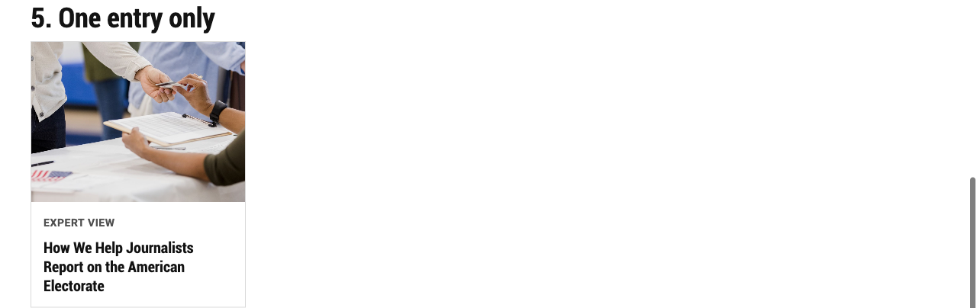
A single card
Pass.

Scenario 6: Logos variant with text (NORC in the Media)
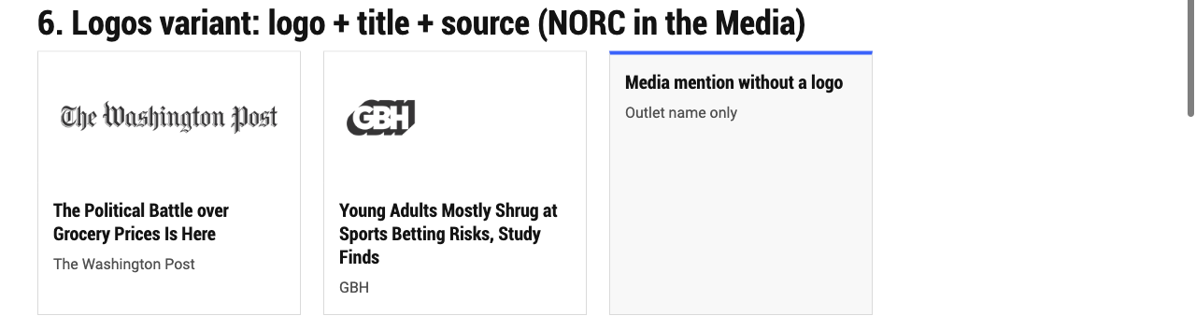
Logos variant: logo, headline, outlet
Check: the Washington Post and GBH logos are whole. A card without a logo falls back to the text-only style. Pass.

Scenario 7: Logos variant, tiles only (NORC Solutions)
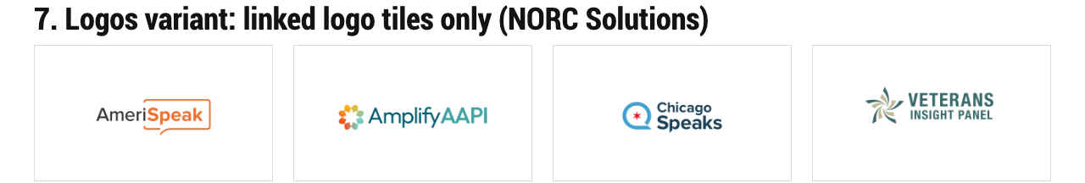
Logos variant: logo tiles
Pass. (The 4th tile has no link on purpose; it isn’t clickable.)

Step 3: The real page, before vs after
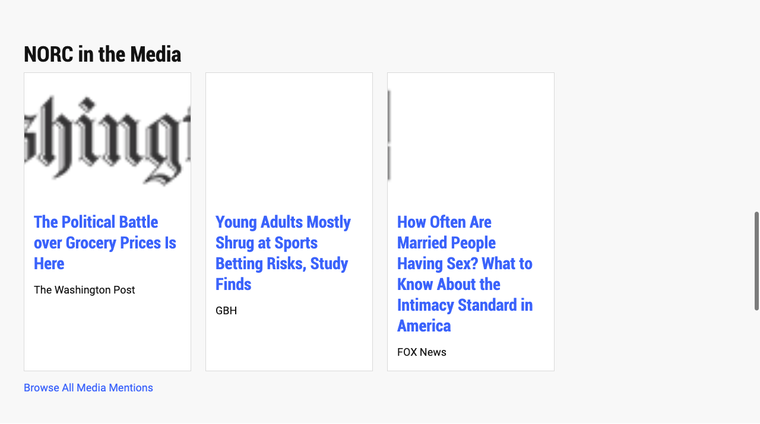
Before: NORC in the Media
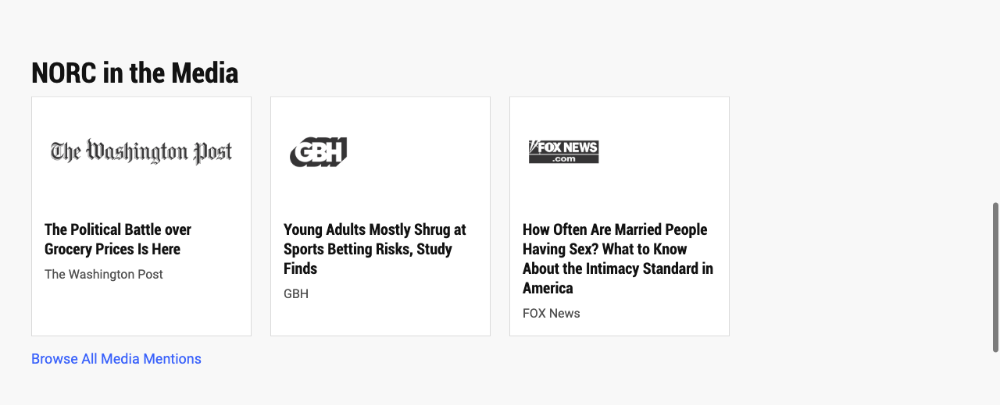
After: NORC in the Media
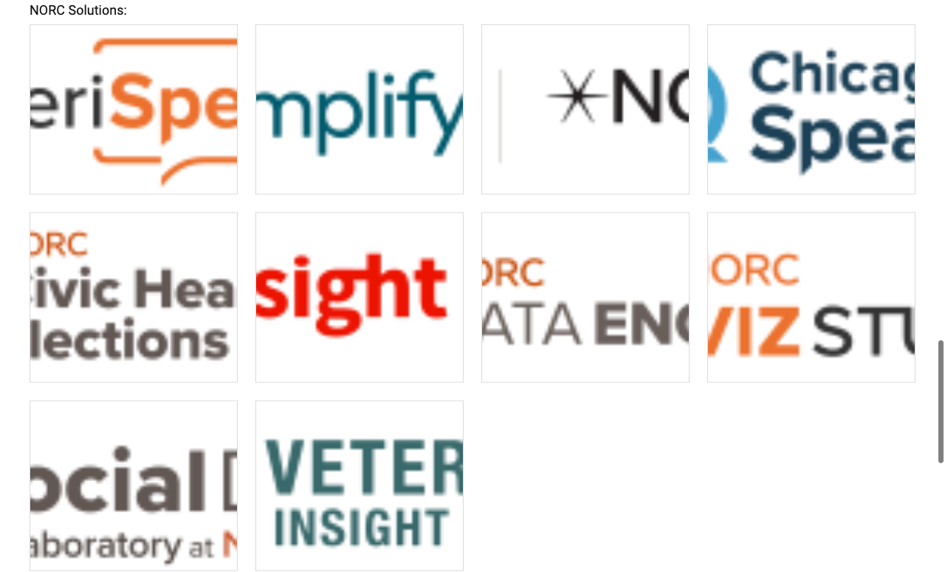
Before: NORC Solutions
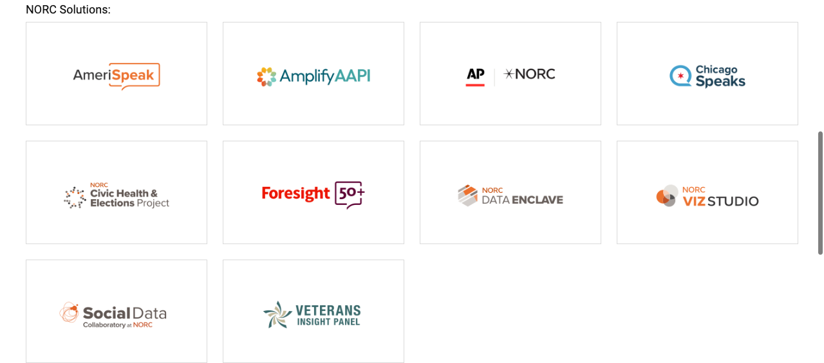
After: NORC Solutions
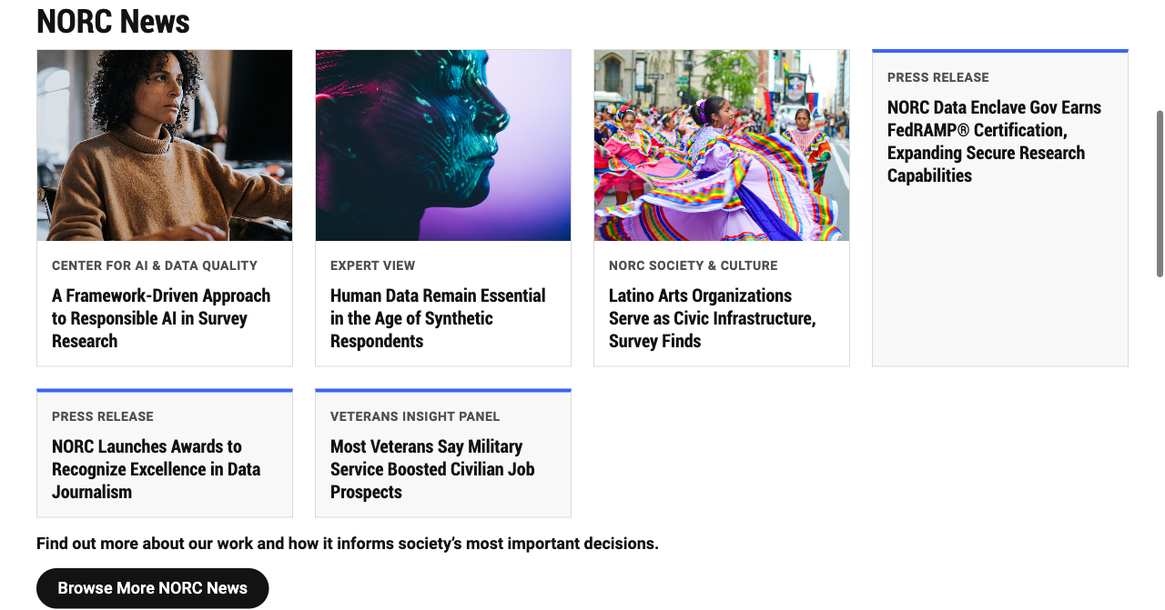
After: NORC News

Step 4: Quality checks

Desktop and mobile
Do: set the browser width to 375 px (DevTools device toolbar → iPhone).
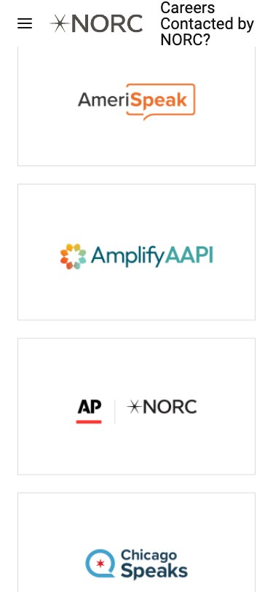
Check: one column, and the page is exactly 375 px wide (document.documentElement.scrollWidth === 375), so there’s no horizontal scroll. Pass.
📘 Adobe course: Module 4 › Additional Best Practices › Optimize for mobile before desktop: “Your mobile site should render without media queries.” Our Cards grid has no breakpoints; it goes from 1 column (375 px) to 2 (768 px) to 4 (1200 px) on its own. Module 5 › Go-Live Checklist › Content and design QA: “Confirm that the design renders correctly across various browsers and devices.”
🔗 Lesson: Module 4 › Additional Best Practices. Direct link: https://certification.adobe.com/scorm-data/1345/scormcontent/index.html#/lessons/yzfcSloqZm2Y8B2rrt8bFe-HGNfXtkWC 🔗 Also: Module 5 › Go-Live Checklist. https://certification.adobe.com/scorm-data/1346/scormcontent/index.html#/lessons/tVlzeBUh57XSCsowBwLysj3lGB39YFkl
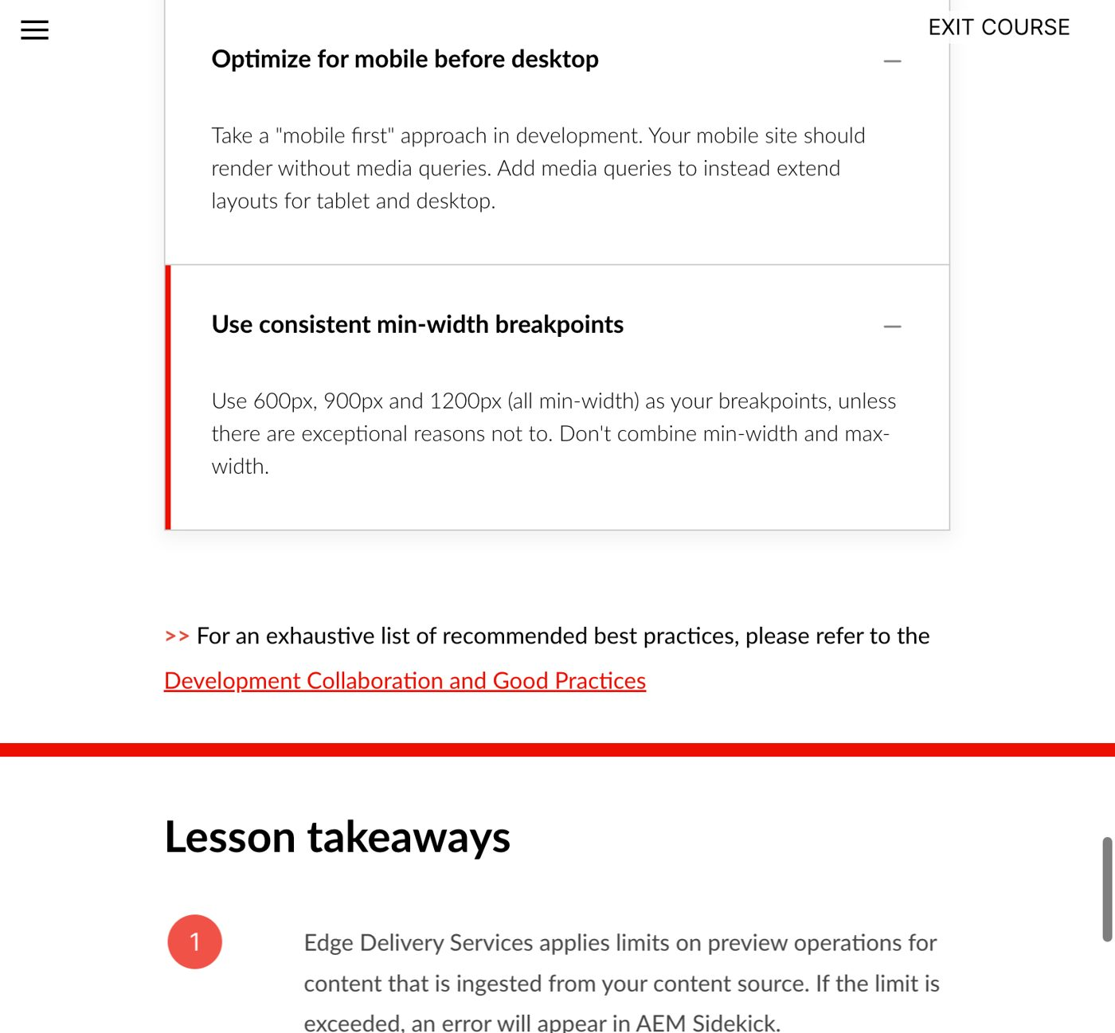
Adobe course, Module 4 Additional Best Practices: mobile first and min-width breakpoints

Keyboard, semantics and alt text
Do: press Tab until you reach a card.

Keyboard focus: the ring wraps the whole card
Check:
- Cards are a <ul> of <li>, and titles stay <h3>.
- Every image keeps its alt text.
- Focus is visible on the whole card.
- Pass.
📘 Adobe course: Module 4 › PageSpeed Insights › Accessibility: “Lighthouse examines alt text and keyboard navigation support”, and an audit fails if even 1 of 10 images lacks alt text. The course’s screenshot shows the two checks we did by hand: “Interactive controls are keyboard focusable” and “Image elements have [alt] attributes”. Module 5 › Content and design QA: “Verify accessibility… appropriate alt text for images, and proper use of header tags.”
🔗 Lesson: Module 4 › PageSpeed Insights. Direct link: https://certification.adobe.com/scorm-data/1345/scormcontent/index.html#/lessons/5bMlTz-yUMoxyiXU9fAhGqsDQKm2I7Ea 🔗 Also: Module 5 › Go-Live Checklist. https://certification.adobe.com/scorm-data/1346/scormcontent/index.html#/lessons/tVlzeBUh57XSCsowBwLysj3lGB39YFkl
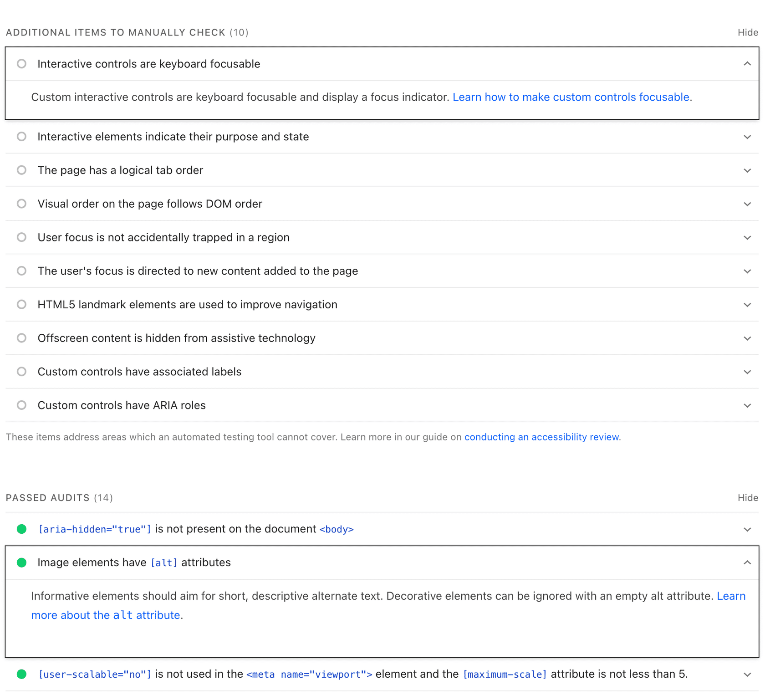
Adobe course, Module 4: Lighthouse accessibility, keyboard focus and alt text audits

Lighthouse (accessibility, best practices, SEO)
Do: DevTools → Lighthouse on http://localhost:3006/drafts/tmp/cards, mobile and desktop.
Category | Mobile | Desktop | What failed | Inside Cards?
Accessibility | 95 | 95 | target-size: small header/footer links (“Careers”, footer lists, social icons) | No. All 15 flagged links are in <header> / <footer>
Best Practices | 96 | 96 | doctype: the local server couldn’t load head.html (404 from the main proxy) | No. It’s a local-setup issue
SEO | 63 | 63 | is-crawlable: <meta name="robots" content="noindex"> | No. Preview pages are noindex on purpose
Result: 0 Lighthouse failures inside the Cards block. Pass for the block. The header/footer touch targets go under “Known limitations”, for the header/footer owner.
Say: “Lighthouse is where the course wants a 100. Our block adds no failures. What’s red belongs to the header, the footer and the local setup, and we write that down instead of hiding it.”
📘 Adobe course: Module 4 › Block testing: “thoroughly test new code changes against PageSpeed Insights before merging.” Module 5 › Performance validation: aim for 100 on mobile and desktop (90+ may be acceptable). Module 5 › Sitemap and robots: “keep aem.page and aem.live hidden from crawlers… done by default”, which explains the SEO 63.
🔗 Lesson: Module 4 › Performance Optimization Techniques. Direct link: https://certification.adobe.com/scorm-data/1345/scormcontent/index.html#/lessons/OTt279XR69CtYDWVrFSDTKaYhdLF8uAv 🔗 Also: Module 5 › Go-Live Checklist. https://certification.adobe.com/scorm-data/1346/scormcontent/index.html#/lessons/tVlzeBUh57XSCsowBwLysj3lGB39YFkl
Gap to state honestly: the Performance score needs PageSpeed Insights on a public .aem.live URL. This repo’s preview URLs return 404 today (see Exercise 4, Step 4), so performance is checked when the PR’s preview works. Until then it’s a next step in the PR.
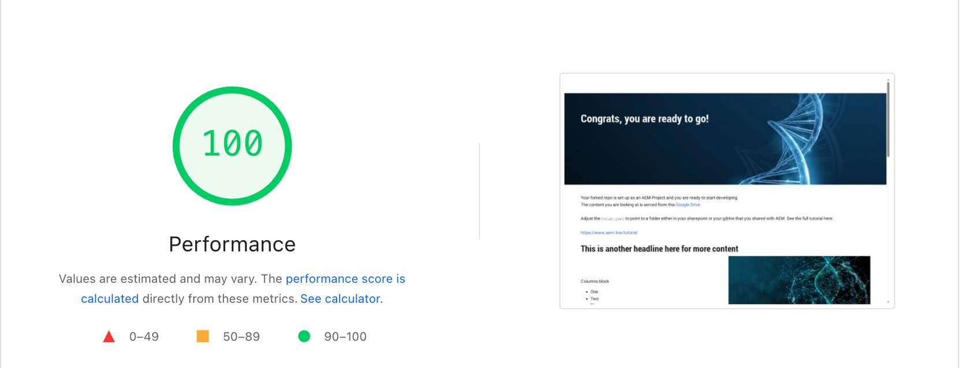
Adobe course, Module 4 PageSpeed Insights: the Lighthouse score to aim for

Console and network errors
Do: open DevTools → Console on the test page.
Check:
- 0 errors, 0 warnings on the test page.
- On /norc/, the only messages are the 3 that were there before: placeholders.json 404 and section-metadata.css 404 (twice). Neither is related to Cards.
- Pass.

Regression: other sites that use Cards
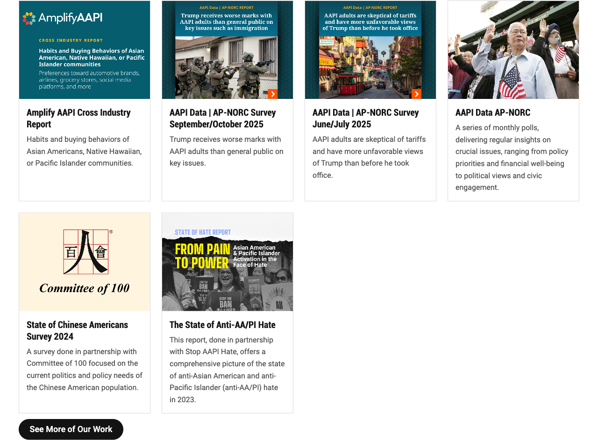
Amplify AAPI cards, unchanged

AmeriSpeak cards, unchanged
Pass: all blocks loaded and no broken images.
📘 Adobe course: Module 4 › Block testing: “be mindful of its different possible configurations to ensure the block does not degrade… regardless of where or how it is placed on a page.” Other sites using Cards are those other configurations.
🔗 Lesson: Module 4 › Performance Optimization Techniques. Direct link: https://certification.adobe.com/scorm-data/1345/scormcontent/index.html#/lessons/OTt279XR69CtYDWVrFSDTKaYhdLF8uAv
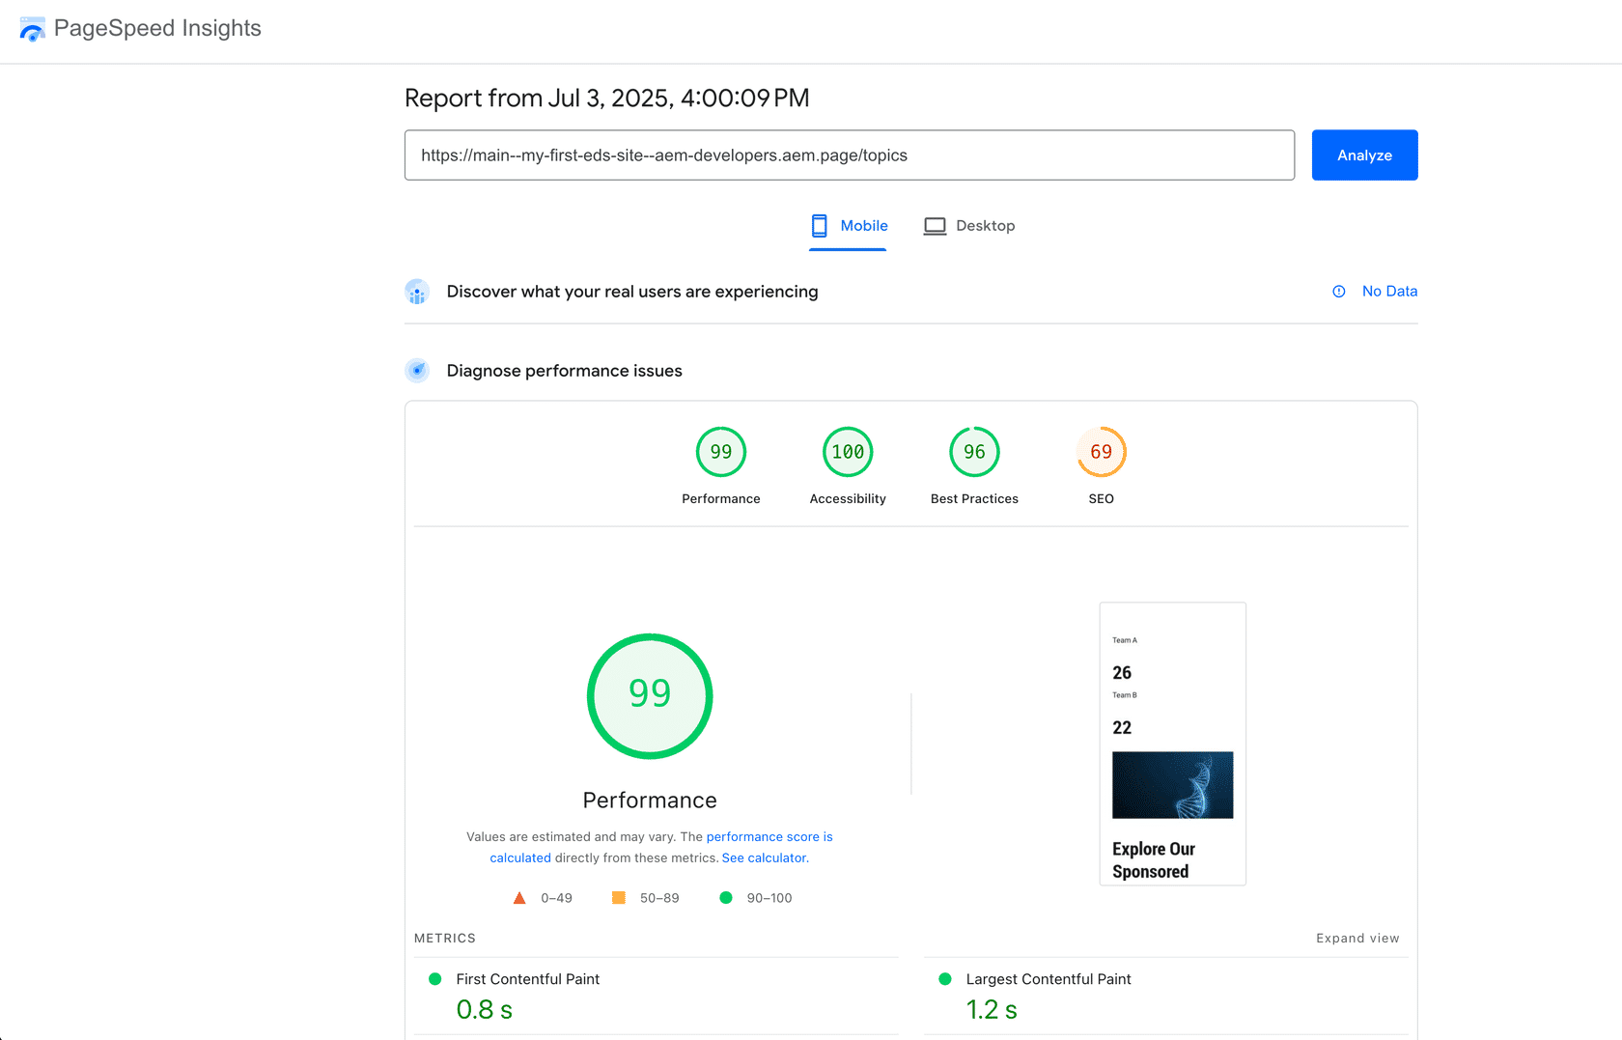
Adobe course, Module 4 Performance Optimization Techniques: Block testing, placement and layout shift

Lint
npm run lint
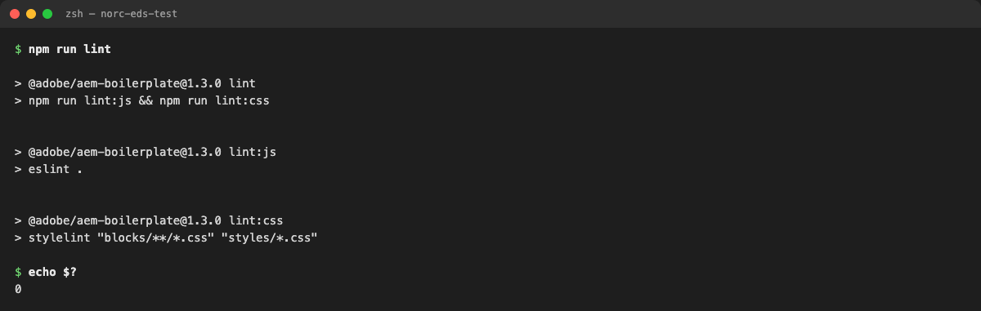
Terminal: npm run lint passes
Re-checked for this doc: npm run lint exits with code 0 on cards-refactor.
📘 Adobe course: Module 4 › Additional Best Practices › Meet linting and Lighthouse standards: “Don’t submit a PR that has linting errors or a low Lighthouse score… these are minimum criteria.”
🔗 Lesson: Module 4 › Additional Best Practices. Direct link: https://certification.adobe.com/scorm-data/1345/scormcontent/index.html#/lessons/yzfcSloqZm2Y8B2rrt8bFe-HGNfXtkWC
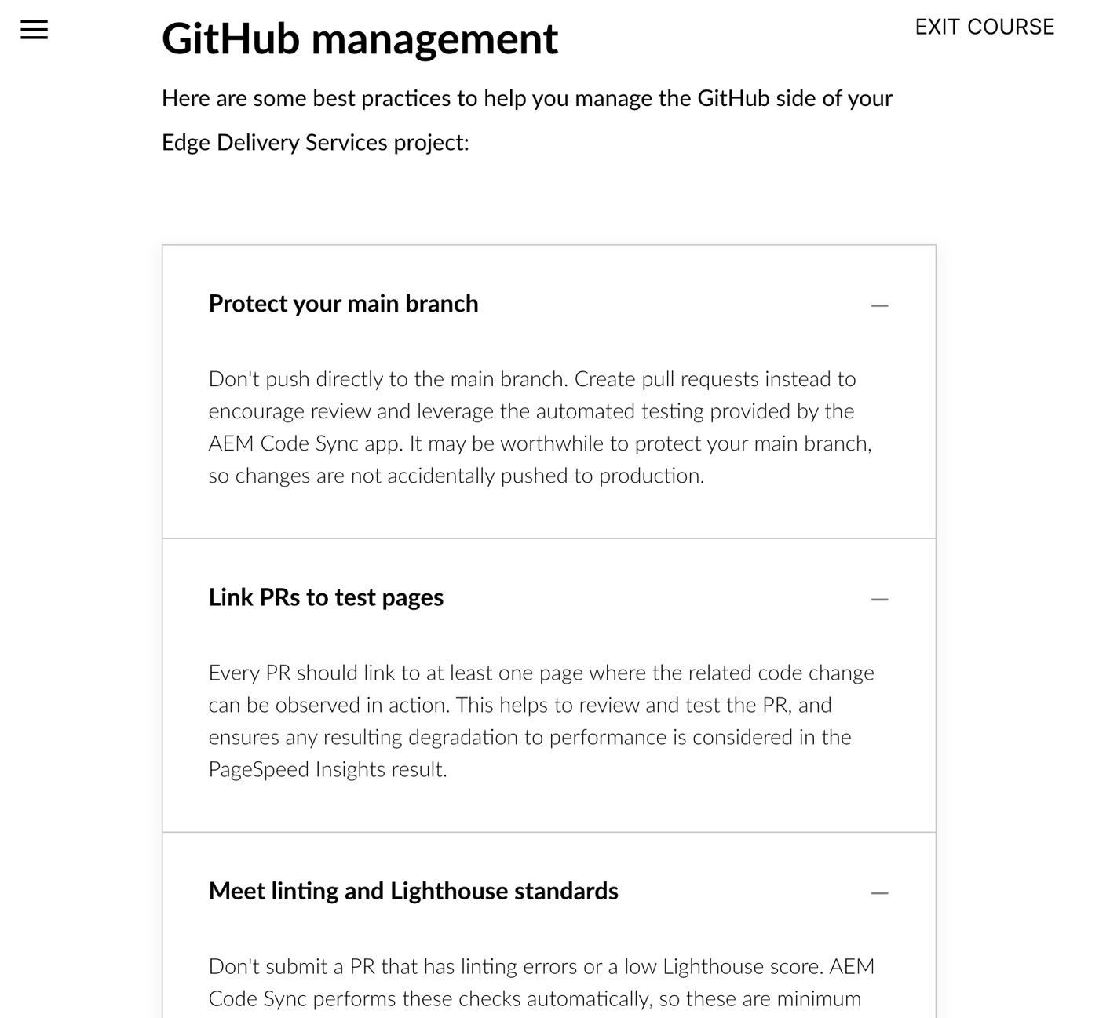
Adobe course, Module 4 Additional Best Practices: GitHub management

Worksheet test table: filled in
Test scenario | Pass / fail | Notes / screenshot
Original imported content | ☒ Pass | Scenario 1; /norc/ 5/5 blocks loaded, 20 images, 0 broken
Missing optional image/description | ☒ Pass | Scenarios 2, 2b (after the fix), 3
Long title or extra item | ☒ Pass | Scenario 4; 6 and 10 items on /norc/
Desktop and mobile | ☒ Pass | 1280 / 375 px, no horizontal scroll
Keyboard / semantics / alt text | ☒ Pass | Focus ring on the card; ul/li/h3; all alt kept; Lighthouse: 0 failures in Cards
Console / network errors | ☒ Pass | 0 new; 3 that were already there and unrelated
Defects found and corrected:
- An empty image cell left a blank gap and hid the eyebrow. Fixed in cards.js (one line).
- Logo tiles had too much white space at 3:2. Changed to 2:1.
- The branch name was over the 63-character limit and stopped the server. Renamed (see Exercise 2).

Questions you may get
- “Isn’t a local HTML test page cheating?” It’s the CDD skill’s documented approach when there’s no CMS content yet. Before the PR is final, the same content should be created in DA so reviewers get a preview link.
- “How do you know the mobile check passed and didn’t just look fine?” We measured scrollWidth = 375.
- “Accessibility is 95, not 100. Did we break something?” No. Every failing node is in the header or footer, which this change doesn’t touch. We list it as a known limitation so it isn’t lost.

