NORC EDS Session 3: Exercise Walkthrough & Demo Script
  - Reusable Blocks & Content Modeling, worked on the imported NORC homepage (www.norc.org)
2 November 2026

How to use this document
This document is a worked example of every Session 3 exercise, done on one real NORC page. Use it in three ways:
- Demo script. Each exercise has a Say / Show / Run box you can follow live.
- Answer key. The worksheet’s blank fields (selected section, content contract, files changed, test results) are filled in with real values.
- Rationale. Every decision has a Why and the Options we rejected, so you can answer “why not X?” questions.
Item | Value
Repository | github.com/talrejaneeraj/norc-eds-test (local: <your-workspace>/norc-eds-test)
Source NORC domain | https://www.norc.org/ (imported in Session 2 into norc/index.plain.html)
Local page | http://localhost:3006/norc/
Test-content page | http://localhost:3006/drafts/tmp/cards
Feature branch | cards-refactor, commit f101f2e, pushed over HTTPS
Pull request | https://github.com/talrejaneeraj/norc-eds-test/pull/5 (draft, base site-folders)
Per-exercise docs | 01_Lab1… to 05_Exercise4… .docx: each objective in full, with Adobe course references and screenshots
Block refactored | Cards (existing boilerplate block) + new logos variant
Tooling | macOS + Claude Code with the Adobe aem-edge-delivery-services skills, used where the worksheet says WSL + GitHub Copilot

Adobe certification course map
Every concept used here comes from the Adobe course Adobe Experience Manager Edge Delivery Services – Developer Professional (EDS-D200): https://certification.adobe.com/courses/1308 (Adobe ID sign-in needed). The per-exercise docs quote each lesson and include the course’s screenshots.
Exercise | Course module › lesson | What it backs up
1: Content contract | Module 2 › Structure of a Page; Decorating the DOM; Block Development (boilerplate blocks, Block Collection, block options, block authoring design) | Sections/blocks/default content, reuse Cards, Cards (logos) variant, keep tables simple for authors
2: Implement | Module 2 › Block Development (JS decorate, loadBlock, CSS scoping, development stack); Module 3 › Initial Setup (branch URLs, AEM CLI); Module 4 › Additional Best Practices (JS, CSS, GitHub) | One self-contained block, no aem.js edits, no frameworks, block-prefixed classes, mobile-first, short branch names
3: Test | Module 4 › Block testing, PageSpeed Insights › Accessibility; Module 5 › Go-Live Checklist (content and design QA, performance) | Test page with variants, alt text + keyboard, Lighthouse, devices
4: Review & PR | Module 3 › Development workflow (AEM Code Sync); Module 4 › Automated PR testing, GitHub management | Small PRs, test URLs in the PR, Code Sync PageSpeed comment, never push to main

1. The exercise list
The deck and the worksheet number the work differently. The deck has 4 hands-on exercises. The worksheet splits the same work into 6 labs. This is how they map:
Deck exercise (slide) | Worksheet lab | Time | What you produce
(Session start, slide 5) | Lab 1: Baseline & candidate selection | 10 min | Server running, git state recorded, candidate chosen
Exercise 1: Document your content contract (slide 11) | Lab 2: Understand the block + Lab 3: Model the content | 20 + 20 min | Block anatomy, content contract, acceptance criteria
Exercise 2: Implement or refactor (slides 13–14) | Lab 4: Implement with Copilot + Adobe Skills | 35 min | Working block, reviewed code
Exercise 3: Test the block (slide 16) | Lab 5: Validate content scenarios | 20 min | Test table, defect found and fixed
Exercise 4: Review and commit (slide 17) | Lab 6: Review, commit, PR | 15 min | Clean diff, commit, PR (stretch)
Definition of done (slide 18) | Final deliverables + Retrospective | — | Checklist

Every bullet, by exercise
Lab 1: Baseline & candidate selection
- Open the Session 2 repository in your editor
- Start the local server and show the imported page
- Record existing git changes before editing
- Select a realistic component to improve
Exercise 1 / Labs 2–3: Content contract
- Identify the source-page section and its purpose
- Trace authored content → section/block markup → blocks/<name>/<name>.js + .css → decorated DOM → rendering
- Identify default content versus blocks, section wrappers and section metadata
- Locate the block JavaScript and CSS; decide if the block is reusable or page-specific
- Compare the candidate with existing Cards/Columns patterns
- Make the reuse decision: default content / existing block / variant / new block
- Decide whether Cards, Columns, Hero or another standard block fits
- Fill in the field table (Image, Title, Description, CTA/URL, Other), with required/optional, example and “handling when absent”
- Write down the row structure and at least two variants
- Specify empty-state, long-text and responsive behavior
- Define acceptance criteria (deck: three; worksheet: five listed)
- Facilitator gate: get the contract approved before the AI edits code
Exercise 2 / Lab 4: Implement
- Create a feature branch after confirming the baseline is safe
- Ask the agent to inspect the current implementation and the reuse options
- Require a content model and acceptance criteria before any edit
- Approve the approach and limit the change to one block
- Review the generated content, JS and CSS yourself; record what you rejected or corrected
Exercise 3 / Lab 5: Test
- Original imported content
- No image / no CTA (missing optional image or description)
- Long title or description; extra item
- One entry and multiple entries
- Desktop and mobile
- Keyboard, semantics, alt text
- Console and network errors
- Capture at least one issue found and corrected
Exercise 4 / Lab 6: Review & commit
- git status, git diff --check, git diff --stat, git diff
- Diff contains only intended files; no secrets, local paths or unneeded packages
- Commit, push the feature branch, open a PR with the content model, screenshots, test evidence and limitations

2. The plan: why Cards on the NORC homepage

The candidate sections on our imported page
The Session 2 import of www.norc.org produced 6 sections with these blocks:
Section | Block used | Uses | Candidate?
1. Featured stories | Carousel | 1 | No. Interactive behavior (slides, buttons) makes it a poor first lab.
2. “NORC delivers objective…” | Default content + highlight style | 1 | No. No block, so nothing to model.
3. NORC News | Cards | 6 cards | Yes
4. Research Divisions | Columns | 1 | Possible, but only one instance with a fixed layout
5. NORC in the Media | Cards | 3 cards | Yes
6. NORC Solutions | Cards | 10 logo tiles | Yes
Selected section: the Cards block, which renders three sections of the same page: NORC News, NORC in the Media and NORC Solutions.
Why change is needed: we saw it in the browser before touching code:
Problem seen in the “before” screenshots | Who it hurts
Logo images are cropped: GBH and FOX News logos are invisible, and every solution logo is cut off (“eriSpe”, “mplify”) | Readers; NORC brand
News cards without a photo look broken next to cards that have one | Readers
Category labels (“Press Release”, “Expert View”) look like body text | Readers scanning the page
Only the title text is clickable, not the card | Mouse, touch and keyboard users
Titles render at the full h3 page size (34 px on mobile) | Readability
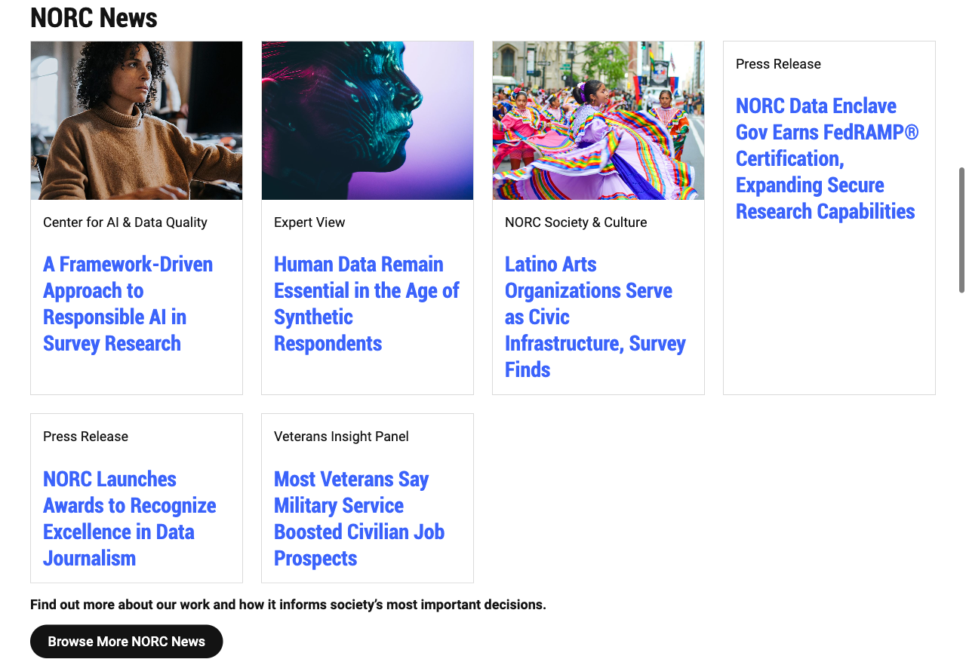
Before: NORC News
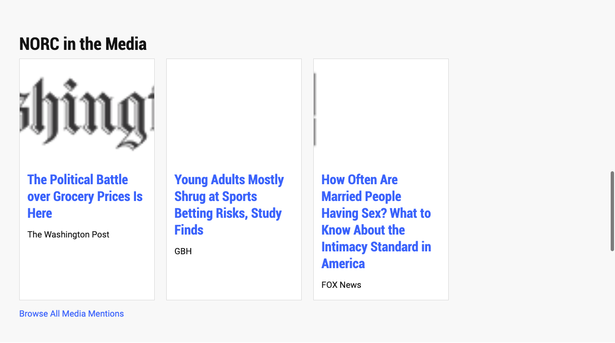
Before: NORC in the Media, with GBH and FOX logos cropped to nothing
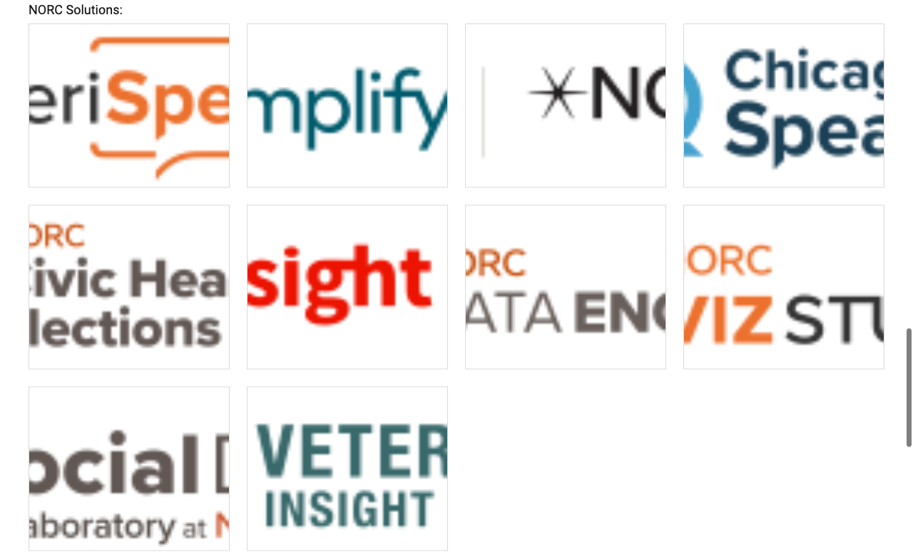
Before: NORC Solutions, every logo cropped

Why this is the right pick (the argument for the demo)
- It matches what the prerequisites ask for. They say: “Start with the existing Cards or Columns block if it already meets the need.” The facilitator notes add: “Demonstrate Cards/Columns first; avoid overly complex custom components.”
- One block, three real content shapes. The same block shows a news card (image + category + linked title), a media card (logo + title + outlet) and a logo tile (linked logo only). That makes the reuse-vs-new-block decision real, not theoretical.
- Slide 10’s example fits. The deck’s “NORC Research Card” (title required; image, description, client optional; standard/featured variant) is exactly the NORC News card.
- It is shareable. AmeriSpeak and Amplify AAPI in the same repo already use Cards (3 and 2 instances). Anything we improve is a candidate NORC shared standard (retrospective question 3).
- It is low risk. No API calls, no forms, no search: the things the prerequisites say to avoid.

Options we rejected
Option | Why we said no
Carousel | Interactive JS and accessibility (live regions, buttons) is too big for a 35-minute lab
Columns (Research Divisions) | Only one instance and nothing visibly broken, so there’s no variation to model
A new news-card + a new logo-grid block | Same table shape as Cards (image + text per row). The worksheet says a new block is “justified only when its content model or behavior is genuinely different.” It isn’t.
Fix the logos by re-cropping the images | Moves the problem to every author, forever. Code should handle logos once.
Auto-detect logos in JS | The author’s intent (“these are logos”) is clearer as an explicit block option, which is standard EDS.

3. Exercise 1 (Labs 2–3): Understand the block and write the content contract

Lab 2: Block anatomy, traced on our page
This is the “content → markup → code → rendered” chain from slide 7, with our real files:
Stage | Where it lives | What it looks like for NORC News
Authored content | Document/DA table, here norc/index.plain.html | A table titled Cards; each row is image cell + text cell
Generated markup | Delivered HTML | <div class="cards"><div><div><picture>…</picture></div><div><p>Expert View</p><h3><a>…</a></h3></div></div>…</div>
Block decoration | blocks/cards/cards.js | Turns rows into <ul><li>, names cells cards-card-image / cards-card-body, makes optimized <picture>
Visual presentation | blocks/cards/cards.css | Grid of cards, minmax(257px, 1fr), 4:3 cover images
Default content vs blocks in the NORC News section: the <h2>NORC News</h2> heading and the two closing paragraphs (“Find out more…”, “Browse More NORC News”) are default content. Only the grid is a block.
Section wrappers and section metadata: NORC in the Media has section-metadata with Style: highlight, so the section gets the light-grey highlight class. NORC News and Solutions have no section metadata.
Existing files involved: blocks/cards/cards.js, blocks/cards/cards.css, norc/index.plain.html. No other code depends on the Cards classes.
Reusable or page-specific? Reusable: 5 instances across 3 sites in this repo.
Current content pattern (the original boilerplate JS, 17 lines): every row → <li>, a cell holding only a picture → image, everything else → body. There’s no idea of an optional image, an eyebrow, a clickable card or a logo.
Say: “Notice the block code knows nothing about NORC. It only knows rows and cells. That is why one block can serve News, Media and Solutions. Our job is to teach it about optional content and logo content, not to write a NORC-specific component.”

Lab 3: Reuse decision
Decision: ☒ variant (of the existing Cards block). We also improve the base Cards behavior; all of it is backward compatible.
Block name: cards (default) and cards (logos) (variant). Authors type the variant in the table header: Cards (logos). EDS turns it into class="cards logos".

Content contract
This follows the content-modeling skill’s Collection model: one row per item, at most 2 cells per row (the skill’s limit is 4).
Field / row | Required? | Example value (from norc.org) | Handling when absent
Image (cell 1) | N | Photo of Folklorico dancers; The Washington Post logo | Cell can be empty or missing. The card becomes text-only, with a blue top accent and light background so it doesn’t look broken.
Eyebrow (first paragraph of cell 2, directly before the title) | N | “Expert View”, “Press Release”, “NORC Society & Culture” (the slide 10 “Client/sponsor” field) | Not shown; the title moves up
Title (heading in cell 2) | Y | “Human Data Remain Essential in the Age of Synthetic Respondents” | The card still renders, but it’s an authoring error (flag it in review)
Description / source (paragraph(s) after the title) | N | “The Washington Post” (outlet), or a summary | Not shown
CTA / URL (link on the title, or on the logo) | N | research-library article URL | If there’s no link, the card is not clickable. If there’s exactly one link, the whole card is clickable. If there are 2+ links, each link works on its own and the card is not clickable as a whole (no ambiguous click targets).
Variant (block option) | N | logos | Default card: photo 4:3, cropped to fill
Expected row structure (what an author types):
| Cards (logos) | |
| [image or logo] | Eyebrow (optional) |
| | ### [Linked title](https://…) |
| | Source or description (optional) |
| [next card image] | … |
Variants and use cases (at least two):
- Cards (default): news / research cards. NORC News: photo (optional), eyebrow, linked title. Also AmeriSpeak and Amplify feature cards (image + title + description).
- Cards (logos): logos, never cropped. NORC in the Media (outlet logo + headline + outlet name) and NORC Solutions (linked logo tiles with no text). The logo is shown whole (object-fit: contain, 2:1 box, padding).
Empty-state, long-text, responsive behavior (deck bullet 4):
- Empty: text-only cards get an accent so a mixed row still looks deliberate; an empty image cell is removed, not rendered as blank space.
- Long text: titles wrap. overflow-wrap: anywhere stops long URLs or words from overflowing. No truncation, so authors see everything they typed.
- Responsive: a mobile-first grid, repeat(auto-fill, minmax(257px, 1fr)): 1 column on phones, 2 on tablets, 3–4 on desktop. No breakpoint code needed.

Acceptance criteria
These are the worksheet’s five, made testable for this block:
- AC1: Authors change content, not code. Adding, removing or reordering cards, and switching to logos, is done in the table only (Cards → Cards (logos)).
- AC2: Reuse. Extend the existing Cards block with a variant; no new block, no new dependency.
- AC3: Optional content is graceful. No image, empty image cell, no eyebrow, no description and no link all render cleanly.
- AC4: No nested blocks, no hard-coded NORC content in JS/CSS.
- AC5: Responsive, accessible, performant. No horizontal scroll at 375 px; all images keep alt text; the whole-card link is keyboard-focusable with a visible focus ring; motion respects prefers-reduced-motion; lint passes; no new console errors.
Facilitator gate (worksheet): stop here in the live demo and approve the table above before showing any code. That is the point of the lab: content first.

4. Exercise 2 (Lab 4): Implement with the agent + Adobe skills

Branch: a real gotcha to demo
The three documents suggest three different branch names. We tested all three:
Source | Suggested branch | {branch}--norc-eds-test--talrejaneeraj length | Works on aem.page?
Prerequisites | feature/session-3-block-development | 65 | No: over the 63-character DNS limit
Deck (slide 13) | feature/improve-content-block | 59 | Yes (barely)
Worksheet (Lab 4) | feature/refactor-eds-block | 56 | Yes
We used | cards-refactor | 44 | Yes
When we created feature/session-3-block-development, the running aem up server stopped itself with: “URL https://feature-session-3-block-development–norc-eds-test–talrejaneeraj.aem.page exceeds the 63 character limit for DNS labels.” The longer your repo name or GitHub username, the sooner you hit this. Recommendation for NORC: short branch names, e.g. cards-logos.
cd <your-workspace>/norc-eds-test
git status --short # baseline was clean
git switch -c cards-refactor
claude # instead of: copilot

The prompt (Claude Code version of slide 14)
The worksheet prompt works unchanged in Claude Code. The Adobe skills (content-driven-development, content-modeling, building-blocks, testing-blocks, code-review) load automatically.
Use the Adobe content-driven-development workflow to improve the selected
block on my imported NORC page.
1. Inspect the existing content, markup, CSS, and JavaScript.
2. Identify whether a boilerplate or Block Collection implementation can be reused.
3. Propose an author-friendly content model with required, optional, and variant fields.
4. Define acceptance criteria before modifying code.
5. After I approve the design, implement the changes using EDS conventions.
6. Preserve content and functionality; do not add unnecessary dependencies.
7. Explain the files changed and how to validate the implementation.
Selected block: cards
Details: norc/index.plain.html uses Cards three times: NORC News (photo optional,
category eyebrow, linked title), NORC in the Media (outlet logo + headline + outlet),
NORC Solutions (linked logo tiles). Logos are cropped by object-fit: cover; cards
without photos look broken; only the title is clickable. Also used on amerispeak/
and amplifyaapi/, so no regressions there.
Do not make code changes until the plan is approved.

What changed: 3 files, +109 / −3
1. blocks/cards/cards.js adds 4 small behaviors. The original 17 lines are kept.
[...li.children].forEach((div) => {
/* authors leave the image cell empty when a card has no image */
if (!div.children.length && !div.textContent.trim()) div.remove();
else if (div.children.length === 1 && div.querySelector('picture')) div.className = 'cards-card-image';
else div.className = 'cards-card-body';
});
/* image is optional: text-only cards get their own styling */
if (!li.querySelector('.cards-card-image')) li.classList.add('cards-card-no-image');
/* a paragraph directly before the title is the eyebrow (category or sponsor) */
const body = li.querySelector('.cards-card-body');
const first = body?.firstElementChild;
if (first?.tagName === 'P' && first.nextElementSibling?.matches('h2, h3, h4, h5, h6')) {
first.className = 'cards-card-eyebrow';
}
/* a card with exactly one link is clickable as a whole */
const links = li.querySelectorAll('a[href]');
if (links.length === 1) {
li.classList.add('cards-card-linked');
links[0].classList.add('cards-card-link');
}
Behavior | Why this way
Remove empty cells | DA and Word save a 2-column table even when the image cell is blank. Found in testing (see Exercise 3).
cards-card-no-image class | CSS can style text-only cards without guessing
Eyebrow = “paragraph right before a heading” | Authors don’t need a special field or bold/italic code. They just type a line above the title. A paragraph after the title (Media: outlet name) stays a normal paragraph.
Whole-card link only when there’s exactly one link | Uses the “stretched link” pattern: the real <a> stays the only link, so screen readers announce it once and the title is the link text. With 2+ links a whole-card click would be ambiguous, so we don’t do it.
2. blocks/cards/cards.css adds about 70 lines, all scoped to .cards:
Rule | Purpose
.cards-card-eyebrow | Small, bold, uppercase, grey category label
.cards-card-body h3 | Card titles at --heading-font-size-s, dark text (not the page’s large h3)
h3 ~ p | Outlet/description in smaller grey text
li.cards-card-no-image | Blue top border + light background for text-only cards
.cards-card-link::after { position:absolute; inset:0 } | Makes the whole card the click target
li:has(.cards-card-link:focus-visible) | Visible 3 px focus ring around the card for keyboard users
@media (hover:hover) and (prefers-reduced-motion:no-preference) | 4 px lift + shadow on hover; off for touch and for reduced motion. Transform only, so it stays at 60 fps
.cards.logos … img { object-fit: contain; aspect-ratio: 2/1; padding } | The variant. Logos are never cropped.
Everything uses existing boilerplate tokens (--link-color, --dark-color, --light-color, font-size variables), so the block will follow the NORC theme when Session styling lands. No new dependencies, no fonts, no libraries.
3. norc/index.plain.html changes 2 words of content: cards → cards logos on the Media and Solutions tables. In DA the author would rename the table header to Cards (logos).
Test content (not part of the PR): drafts/tmp/cards.plain.html holds 8 scenarios built from the real NORC content (the CDD skill’s “Option B, local HTML” approach).

AI suggestions rejected or corrected (worksheet field)
What happened | Correction
Worksheet Lab 6 says git add . | Rejected. The CDD skill says “NEVER use git add .”. It would have committed drafts/ and a rewritten package-lock.json. Stage files by name.
npm install (to run lint) rewrote package-lock.json (+15/−42) | Reverted with git checkout -- package-lock.json; not part of this change
The first logo box was 3:2 with 24 px padding, leaving logos tiny in big white tiles | Tuned to 2:1, 16px 24px after looking at the screenshot
The first JS treated an empty image cell as a body | Fixed after the empty-cell test (Exercise 3)
The prerequisites’ branch name | Too long for EDS; renamed to cards-refactor

5. Exercise 3 (Lab 5): Validate content scenarios
Server: aem up --url https://main--norc-eds-test--talrejaneeraj.aem.page --html-folder . --html-mount / --no-open --forward-browser-logs --port 3006
Test scenario | Result | Evidence
Original imported content (NORC page) | Pass | 5/5 blocks loaded, 20 images, 0 broken. Before/after screenshots below.
Missing optional image (mixed row) | Pass | Test page §2: text-only cards get the accent
Image cell left empty | Fail → fixed → Pass | Test page §2b: see “Defects”
Missing eyebrow and description; card with no link | Pass | §3: card renders and is not clickable
Long title + description + two links | Pass | §4: wraps cleanly; with 2 links the card isn’t clickable as a whole and each link works
One entry only | Pass | §5
Logos variant with text (Media) | Pass | §6 and NORC page: Washington Post, GBH, FOX logos all visible
Logos variant, tiles only (Solutions) | Pass | §7 and NORC page: all 10 logos whole
Desktop (1280) and mobile (375) | Pass | 4→1 columns; scrollWidth = 375 (no horizontal scroll)
Keyboard / semantics / alt text | Pass | Cards are <ul><li>; titles stay <h3>; every card image has alt text; focusing the title link draws the ring around the card
Console / network errors | Pass | Test page: 0 errors, 0 warnings. NORC page: only the 3 errors that were already there (placeholders.json, section-metadata.css), unrelated to Cards.
Lighthouse (a11y / best practices / SEO) | Pass for Cards | 95 / 96 / 63 on mobile and desktop; 0 failures inside Cards. Failures are header/footer touch targets, a local head.html 404 and preview noindex.
Regression: AmeriSpeak (3 Cards blocks), Amplify AAPI (2) | Pass | All loaded, 0 broken images, layout unchanged except the smaller, consistent title size
Lint (npm run lint: ESLint + Stylelint) | Pass | exit 0

Defects found and corrected
- Empty image cell produced a blank gap and hid the eyebrow. When an author leaves the image cell blank (normal in DA), the empty <div> was classed as a body. That added a blank 16 px margin, and because the code looked for the eyebrow in the first body (the empty one), the eyebrow was missed. Fix: remove empty cells before classifying (one line in cards.js).  
- Branch name over the 63-character limit stopped the dev server. Renamed the branch.
- Logo tiles were mostly white space at 3:2. Changed to 2:1.

After: the same three sections
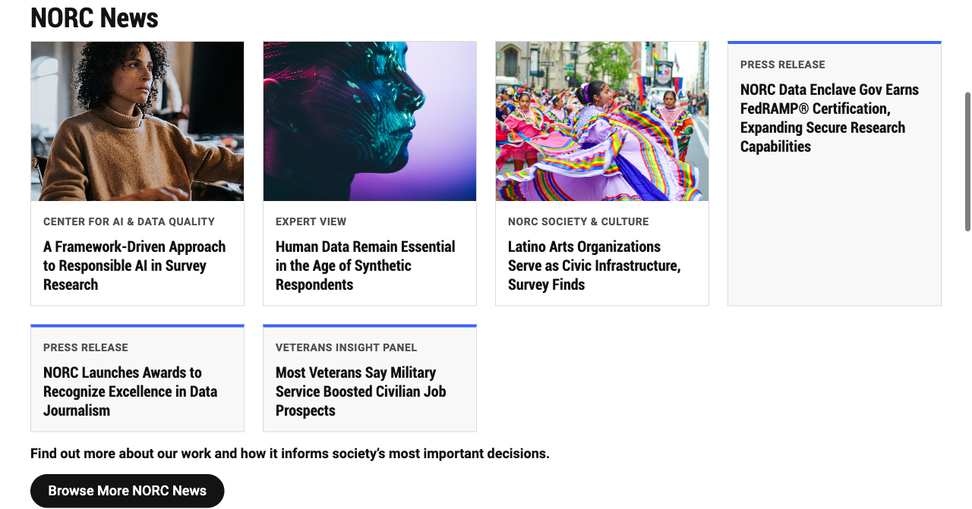
After: NORC News, with category eyebrow, consistent titles, accent on text-only cards

After: NORC in the Media, with all three logos visible
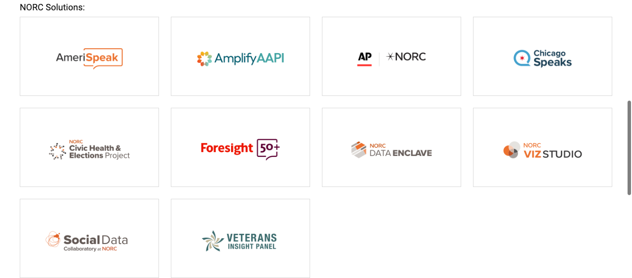
After: NORC Solutions, every logo whole
Keyboard focus ring on a whole card:

Keyboard focus
Full test page, desktop: img/test-desktop.jpg · mobile: img/test-mobile.jpg

6. Exercise 4 (Lab 6): Review, commit, pull request
Status: committed (f101f2e), pushed over HTTPS, and opened as draft PR #5 after your go-ahead.
git status --short
# M blocks/cards/cards.css
# M blocks/cards/cards.js
# M norc/index.plain.html
# ?? drafts/ <- local test content, do not commit
git diff --check # clean
git diff --stat # 3 files, +109 / -3
Review checklist
- The diff contains only the intended files (lockfile change reverted; drafts/ excluded)
- No secrets, no /Users/… paths, no new packages
- Content model and test results documented (this document becomes the PR description)
- Feature branch pushed and PR opened: #5 (draft)
Commands to ship (staging by file name instead of the worksheet’s git add .):
git add blocks/cards/cards.js blocks/cards/cards.css norc/index.plain.html
git commit -m "feat(cards): optional image, eyebrow, whole-card link, logos variant"
git push -u origin cards-refactor
gh pr create --title "Cards: author-friendly optional content and logos variant"
PR test links (required by the CDD skill):
- Before: https://main--norc-eds-test--talrejaneeraj.aem.page/norc/
- After: https://cards-refactor--norc-eds-test--talrejaneeraj.aem.page/norc/
Limitation: these links return 404 today. Even code files 404, so the AEM Code Sync GitHub app isn’t connected to this repo yet, and there’s no DA content source either. That’s why the PR is a draft and has no Code Sync PageSpeed comment yet. To finish: install Code Sync, connect DA, create the test page, then switch the test links to .aem.live (the course and the repo’s PR template both use .aem.live).
Dependency: cards-refactor was branched from site-folders (PR #4: per-site folders, headers and footers). Merge PR #4 first, then the Cards PR shows only these 3 files.

7. Definition of done (slide 18)
Item | Status
Documented content model and reuse decision | ✅ Section 3
Block works with the original migrated content | ✅ NORC page: 3 sections
Two additional content variants validated | ✅ 8 scenarios + logos variant
Desktop and mobile verified | ✅ 1280 / 375
Change set reviewed and pushed | ✅ cards-refactor, f101f2e
PR opened (stretch) | ✅ #5 (draft); Code Sync PSI check pending

8. Retrospective answers (worksheet last page)
- What was easiest to reuse? The boilerplate Cards block itself. Its row → <li> and cell → image/body logic needed no rewrite, and block options gave us a variant with zero new files.
- What did the agent get wrong? It followed git add . from the worksheet (this would have committed test content and a rewritten lockfile). It used the prerequisites’ branch name, which is too long for EDS. Its first logo sizing left too much white space. It didn’t handle an empty table cell until testing showed it.
- Which block could be shared across NORC properties? Cards (logos): every NORC property has a “partners / solutions / as seen in” logo row. Cards itself, with the eyebrow, already serves NORC, AmeriSpeak and Amplify.
- What should be standardized before production work?
  - a branch-name rule (short, under the 63-character limit)
  - a shared token set (NORC colors and fonts in styles.css)
  - a list of approved block options (logos, …) so authors don’t invent new ones
  - “stage by file name, never git add .”
  - a DA test page per block so PRs get real preview links

9. Live demo script (about 20 minutes)
Min | Say | Show / Run
0–2 | “One real NORC page, one existing block, three real uses.” | http://localhost:3006/norc/; scroll to News, Media, Solutions
2–5 | “Here’s what’s broken, and none of it is the author’s fault.” | The “before” screenshots: cropped logos, uneven text-only cards
5–8 | “Content → markup → JS → CSS.” | Open norc/index.plain.html (the table), then blocks/cards/cards.js, then DevTools showing ul > li.cards-card-…
8–11 | “Contract before code.” | Section 3 table and acceptance criteria. Ask the room to approve the gate.
11–14 | “The agent proposes; I review.” | Run claude with the prompt. Show the 4 JS behaviors and the logos CSS. Point out what we rejected.
14–18 | “Test variability, not just looks.” | http://localhost:3006/drafts/tmp/cards: §2b empty cell (the defect), §4 long title, §7 logos; resize to mobile; Tab to a card
18–20 | “Review like a reviewer.” | git status, git diff --stat. Explain the lockfile revert, why not git add ., and the branch-name limit.
Backup if something breaks live: every screenshot is in Session3-Demo/img/, and the working branch cards-refactor is on disk.

