Session 3, Lab 1: Baseline & Candidate Selection
  - Demo walkthrough on the NORC homepage (www.norc.org → /norc/) · 10 minutes

What this lab is for
Goal: prove the Session 2 project still works before changing anything, and pick one realistic component to improve.
Output: a running local server, a recorded git baseline, and a chosen section with a reason.
Item | Our value
Repository | github.com/talrejaneeraj/norc-eds-test
Local folder | <your-workspace>/norc-eds-test
Source NORC domain | https://www.norc.org/
Imported page (local) | http://localhost:3006/norc/
Selected section | Cards block: NORC News, NORC in the Media, NORC Solutions
Say (opening, 20 seconds): “We are not building anything new today. We take the NORC page we imported in Session 2 and make one part of it author-friendly and reusable. Step one is to show that the baseline works and record it, so we can prove later exactly what we changed.”

Step 1: Open the project and record the git baseline
Do: open a terminal and run:
cd <your-workspace>/norc-eds-test
git status --short
git branch --show-current
git log --oneline -3
git remote -v
Show:
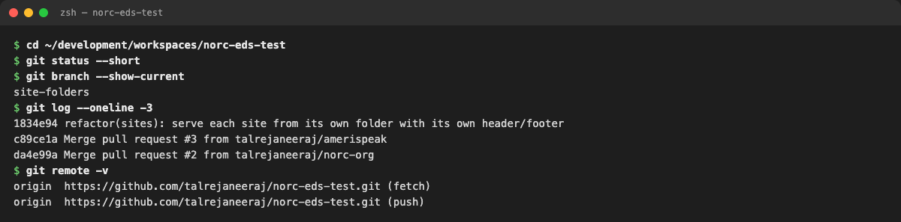
Terminal: the baseline at the start of the lab. The working tree is clean and we’re on site-folders.
Explain each line:
- git status --short prints nothing, so there are no uncommitted changes. The worksheet bullet “Recorded existing Git changes before editing” is satisfied: there were none.
- git branch --show-current shows site-folders: the branch with the per-site folders from Session 2 (PR #4).
- git log shows the last commits, so we can always get back to this exact point.
- git remote -v shows HTTPS to the talrejaneeraj account. No SSH and no other user.
Say: “Clean tree, known commit, correct account. If anything goes wrong later, this is the line we roll back to.”
If someone’s git status is not clean: commit or git stash it first. Never discard Session 2 work (prerequisites §3).

Step 2: Check the tools (Mac + Claude Code version of the WSL checklist)
Do:
node --version && npm --version
aem --version
claude --version
git config user.name
Show:
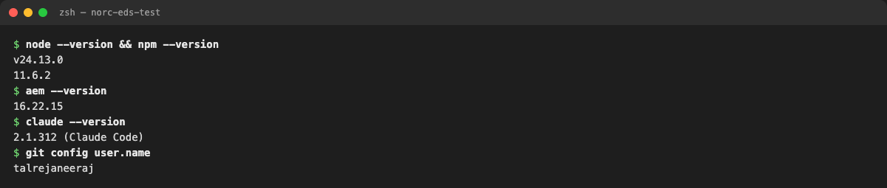
Terminal: tool versions
Explain: the prerequisites list Node via nvm, npm, the AEM CLI and an AI agent. On this Mac we use Claude Code in place of the GitHub Copilot CLI, with the same Adobe skills loaded from github.com/adobe/skills. Node 24, npm 11 and AEM CLI 16 are the versions we used throughout.

Step 3: Start the local server
Do: in a separate terminal tab (it keeps running):
aem up --url https://main--norc-eds-test--talrejaneeraj.aem.page \
--html-folder . --html-mount / --no-open --forward-browser-logs --port 3006
(npm run start does the same on port 3000.)
Show:
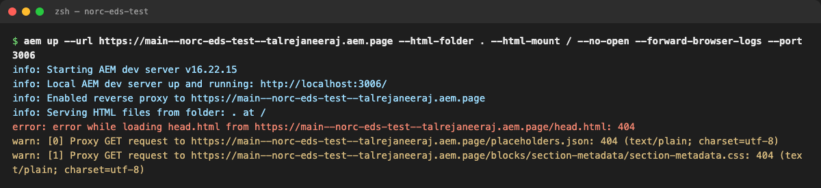
Terminal: aem up output
Explain the flags. These are the questions people always ask:
Flag | Why
--url …aem.page | Code and anything not on disk come from our site’s preview
--html-folder . | Serve our imported pages straight from the repo folder (we have no DA content yet)
--html-mount / | Mount that folder at /, so norc/index.plain.html is served at /norc/
--forward-browser-logs | Browser console errors also print in this terminal
--port 3006 | Leaves port 3000 free for anyone else
Explain the red and yellow lines (they look scary but are expected):
- error: … head.html … 404: the remote preview has no content source yet, so the local head.html is used instead. Harmless.
- warn: … placeholders.json 404 and section-metadata.css 404: two files that don’t exist on this site. They were there before our change and are unrelated to Cards.

Step 4: Show the imported page, not just the homepage
Do: open http://localhost:3006/norc/ (the prerequisites say “Validate the imported page path, not only the homepage”).
Show:
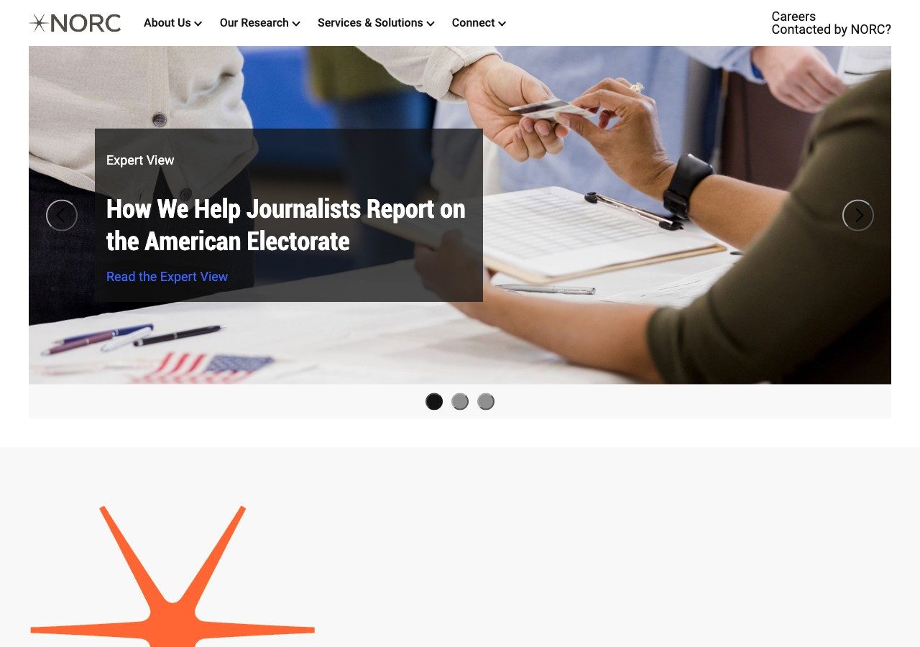
Browser: the imported NORC page at /norc/
Then scroll the whole page and narrate the sections: carousel, highlight statement, NORC News, Research Divisions, NORC in the Media, NORC Solutions.
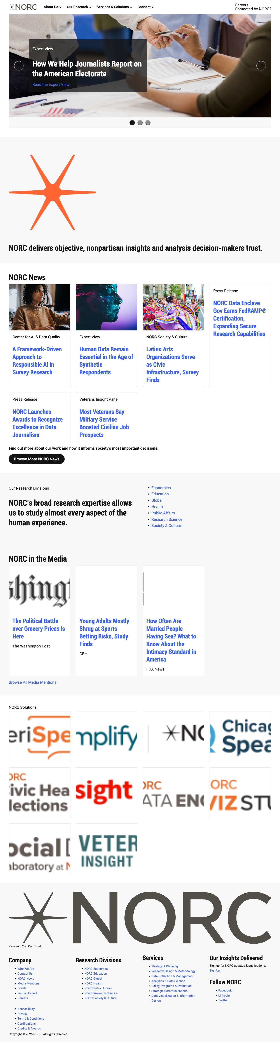
Browser: the full page before any change (click to zoom)

Step 5: Pick the candidate (the important part)
Show the source site first (prerequisites: “Prepare a screenshot of your candidate source section”):
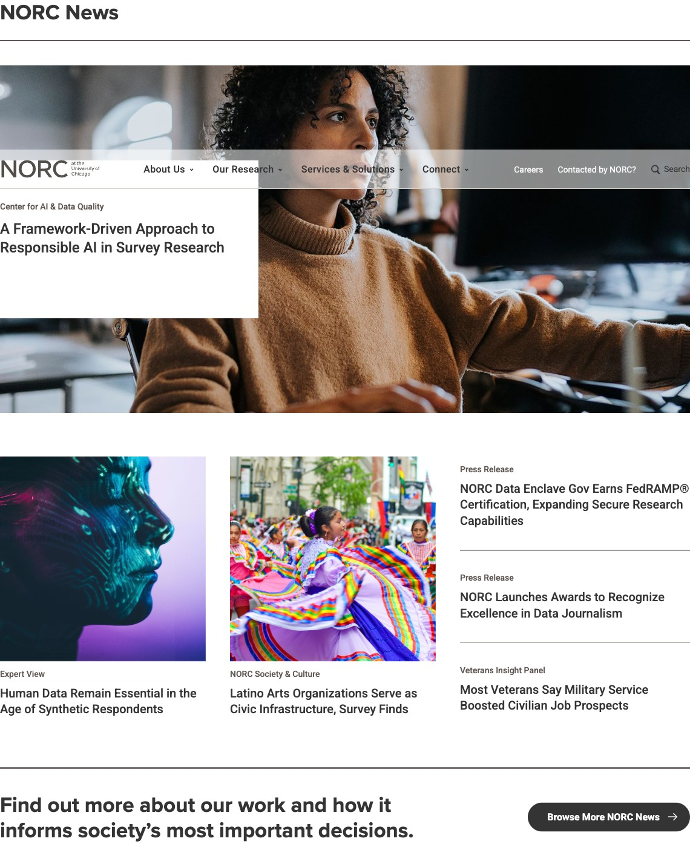
www.norc.org: NORC News on the live site
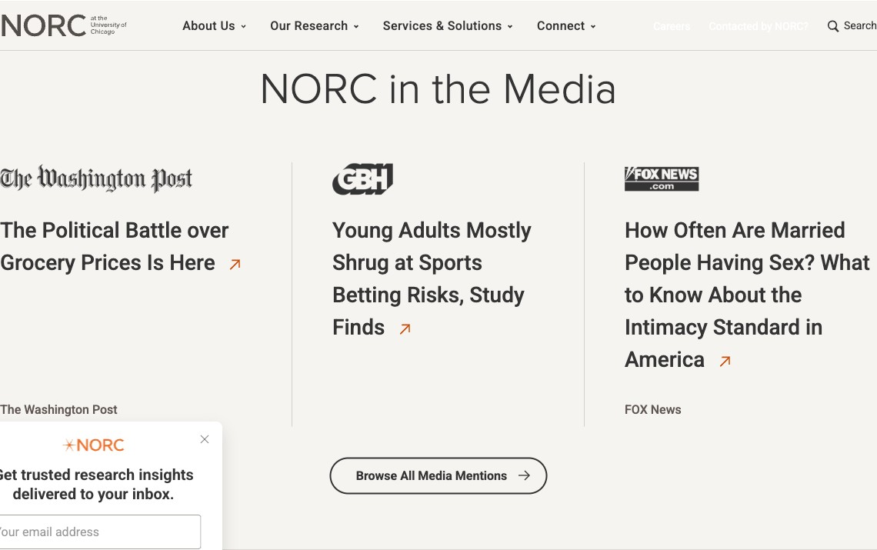
www.norc.org: NORC in the Media (logo, headline, outlet)

www.norc.org: NORC Solutions logo row
Then show our imported version of the same three sections:
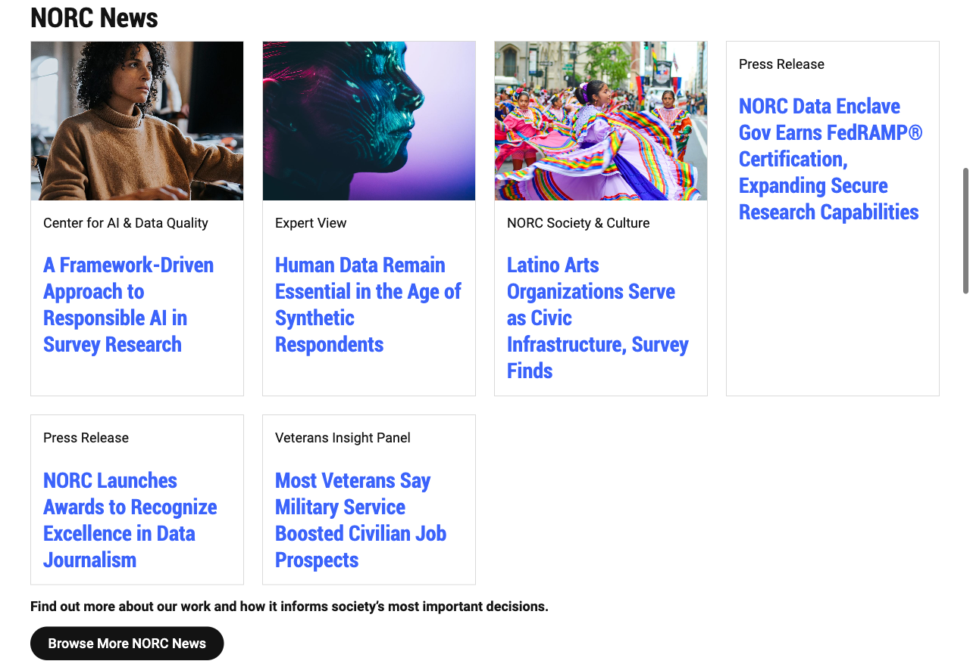
Imported: NORC News. Cards without photos look unfinished, and the category labels look like body text.

Imported: NORC in the Media. The GBH and FOX logos are cropped to nothing.
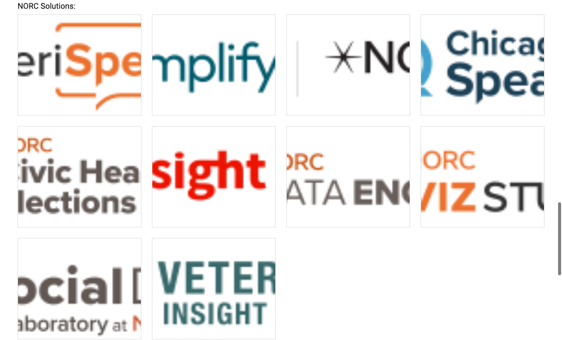
Imported: NORC Solutions. Every logo is cut off.
Say: “Same content, three different shapes, and all three are the Cards block. That’s our candidate. The logos are cropped, text-only news cards look unfinished, and only the title is clickable. None of this is the author’s fault; it’s the block.”

Why Cards and not something else
Candidate on this page | Decision | Reason
Cards (3 sections, 19 items) | Chosen | Visible defects; 3 real content shapes; also used by AmeriSpeak and Amplify AAPI, so it’s shareable
Carousel | Rejected | Interactive JS, buttons, accessibility: too big for a first lab
Columns (Research Divisions) | Rejected | One instance, nothing broken, no variation to model
Highlight statement | Rejected | Default content only; no block to model
The prerequisites support this choice: “Start with the existing Cards or Columns block if it already meets the need,” and the facilitator notes say “Demonstrate Cards/Columns first.”

Worksheet fields: filled in
- Opened the Session 2 repository in the editor (VS Code on Mac instead of WSL)
- Started the local server and displayed the imported page (/norc/)
- Recorded existing git changes before editing (none; clean on site-folders)
- Selected a realistic component to improve
Selected section: the Cards block on /norc/: NORC News, NORC in the Media, NORC Solutions.
Why change is needed: logos are cropped (GBH and FOX invisible), cards without images look broken, category labels are unstyled, only the title is clickable, and title sizes are inconsistent.

Questions you may get
- “Why port 3006?” It avoids clashing with someone’s existing server on 3000. Any free port works.
- “Why do I see a 404 at /?” Each site lives in its own folder; use /norc/, /amerispeak/ or /amplifyaapi/.
- “Do I need DA or Universal Editor?” No. The worksheet says not to require publishing for this lab.

