Session 3, Exercise 4 (Lab 6): Review, Commit & Pull Request
  - Demo walkthrough on the NORC homepage · 15 minutes

What this exercise is for
Goal: review the change the way a reviewer would, commit only what belongs, and open a PR that someone else can validate.
Output: a clean commit on a feature branch and a PR with the content model, screenshots, test evidence and limitations.
Say: “Git is where a good change becomes a reviewable change. The two traps here are committing too much and describing too little.”
Deck slide 17 / worksheet Lab 6 | Where it is covered
git status, git diff --check, git diff --stat, git diff | Steps 1–2
git add . → commit → git push -u origin <branch> | Step 3 (with one correction: stage by file name)
“Open a PR with the content model, screenshots, test evidence and limitations” | Step 4
☐ Diff contains only intended files | Step 1, Step 2 checklist
☐ No hardcoded secrets, local paths, or unnecessary packages | Step 2 checklist (with the checks we ran)
☐ Content model and test results documented in PR description | Step 4
☐ Feature branch pushed and PR created (stretch goal) | Steps 3–4
Branch / Commit / PR URL fields | “Worksheet fields: filled in”
Final deliverables (6 items) and slide 18 Definition of done | “Definition of done”
Retrospective (4 questions) | “Retrospective answers”

Adobe certification course reference
 | Link (Adobe ID sign-in needed for the course)
Course home | https://certification.adobe.com/courses/1308
Module 3: Setting Up (Authoring and Development Flows › Development workflow; AEM Code Sync) | https://certification.adobe.com/courses/playScorm/1395/1308
Module 4: Optimizing Content Delivery (Performance Optimization Techniques › Automated PR testing; Additional Best Practices › GitHub management) | https://certification.adobe.com/courses/playScorm/1345/1308
Verified: every module link above appears on the course home page (catalog ID EDS-D200), and every 🔗 lesson link below opens the named lesson inside that module. Module links need an Adobe ID sign-in; the direct lesson links open without one.

Step 1: Review the working tree, and catch what doesn’t belong
Show what git status looked like right after running lint:
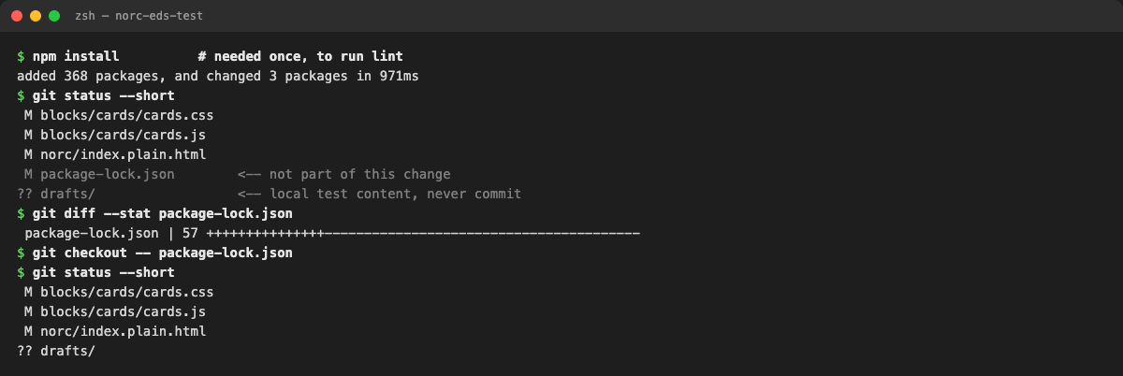
Terminal: npm install rewrote package-lock.json; we reverted it
Explain:
- package-lock.json changed because npm install (needed to run lint) rewrote it. It isn’t part of this change, so we reverted it with git checkout -- package-lock.json.
- drafts/ is our local test page. It never gets committed.
- That leaves exactly the 3 intended files.
Say: “This is why the worksheet’s git add . is dangerous. It would have committed both of these.”

Step 2: Run the worksheet’s review commands
git status
git diff --check
git diff --stat
git diff
Show (after the commit, comparing with the previous commit):
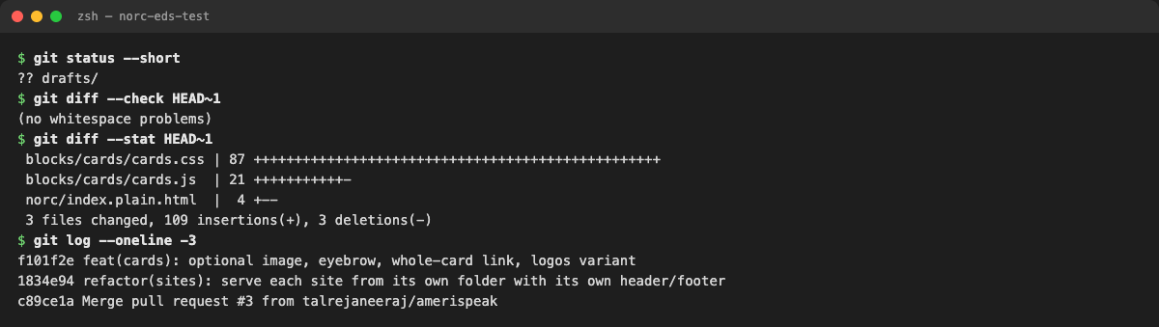
Terminal: review commands
Explain:
- git diff --check reports no whitespace problems.
- git diff --stat shows 3 files, +109 / −3, which matches what we reviewed in VS Code in Exercise 2.
- git diff is the full line-by-line review. Do it in VS Code’s diff view; it’s easier to read.
Review checklist:
- The diff contains only the intended files
- No hard-coded secrets, local paths (/Users/...) or unnecessary packages
- Content model and test results go in the PR description
- Feature branch pushed and PR created (stretch goal)
How each item was checked (so you can say “we checked”, not “we looked”):
Item | Check | Result
Only intended files | git diff --stat site-folders...cards-refactor | 3 files: cards.js, cards.css, norc/index.plain.html
No local paths | search the diff for /Users/ and localhost | none
No secrets | search the diff for token, key, password, secret | none
No unnecessary packages | git diff … -- package.json package-lock.json | empty (no changes)
Nothing untracked slipped in | git status | only drafts/ untracked, never staged
📘 Adobe course: Module 3 › Development workflow: when code is pushed to GitHub, the AEM Code Sync app copies it to the Code Bus, and every branch is served at its own aem.page / aem.live URL. In other words, anything you commit gets published to a URL. That’s why local paths, secrets and test files must never be committed.
🔗 Lesson: Module 3 › Authoring and Development Flows. Direct link: https://certification.adobe.com/scorm-data/1395/scormcontent/index.html#/lessons/0UYSnsREq1kk5ZfsNxKQNonsAy0pDaOG
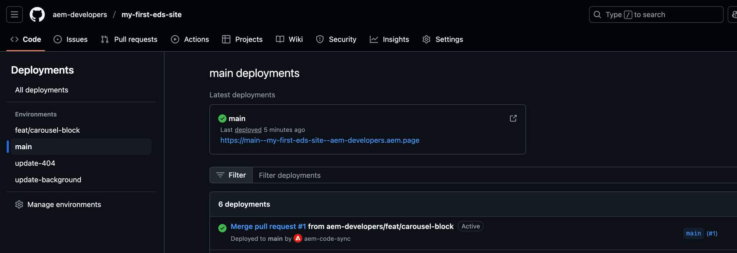
Adobe course, Module 3 Authoring and Development Flows: AEM Code Sync deployments for each branch

Step 3: Commit and push
One correction to the worksheet: stage files by name. The Adobe CDD skill says “NEVER use git add .”
git add blocks/cards/cards.js blocks/cards/cards.css norc/index.plain.html
git commit # message below
git push -u origin cards-refactor
Commit message (conventional-commit format: what changed, then why):
feat(cards): optional image, eyebrow, whole-card link, logos variant
- Remove empty cells so a blank image cell does not leave a gap
- Style text-only cards; mark the paragraph before the title as an eyebrow
- Make a card with exactly one link clickable as a whole (stretched link,
visible focus ring, hover lift gated by prefers-reduced-motion)
- Add the logos variant: logos are contained, never cropped
- Use Cards (logos) for NORC in the Media and NORC Solutions
Show the real output:
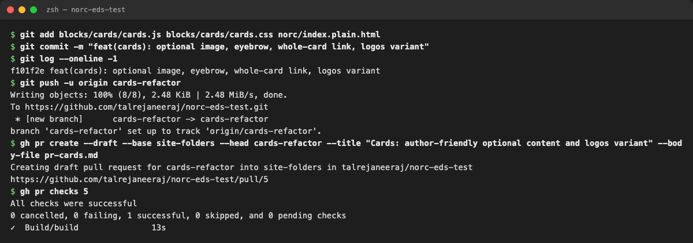
Terminal: commit, push, PR and checks
Explain:
- The commit is one logical change to one block. Module 4 says “Keep PRs small and manageable”: “small and short-lived… reduces the effort and complexity to review.”
- The push goes over HTTPS to talrejaneeraj. No SSH, no other account.
- The PR is a draft because its preview links can’t render yet (see the gap in Step 4). The CDD skill says to open a draft in that case.
- Its base is site-folders, not main, because this branch builds on PR #4. That keeps the PR to just our 3 files. Merge #4 first.

Step 4: The pull request
Show: https://github.com/talrejaneeraj/norc-eds-test/pull/5
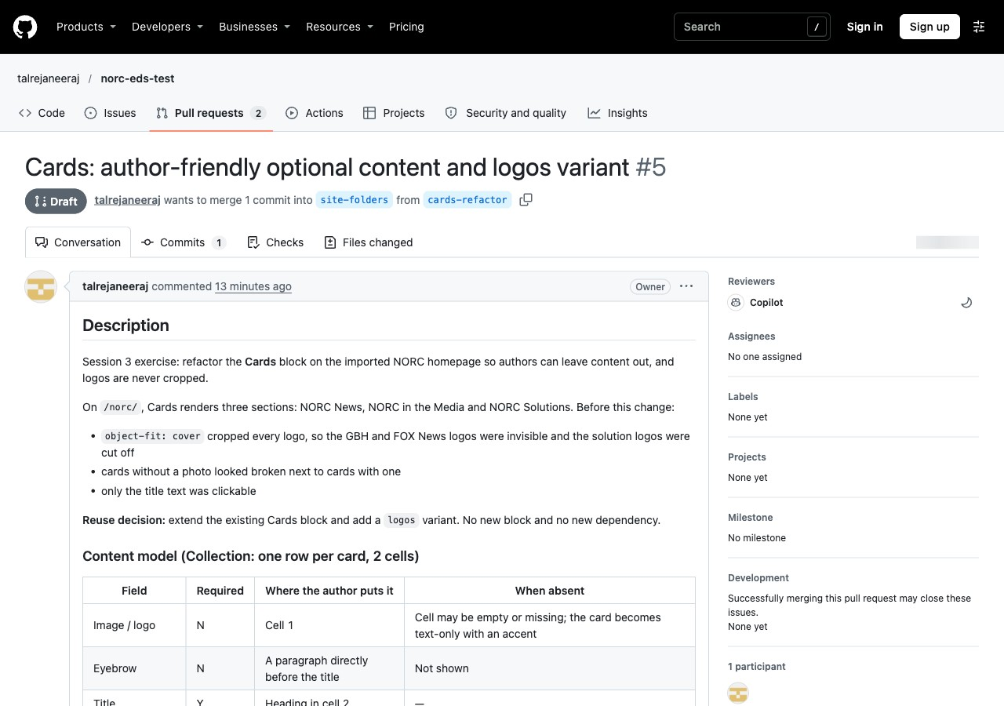
GitHub: PR #5, a draft with the content model in the description
Walk the PR description (slide 17: “content model, screenshots, test evidence and limitations”):
- Description: what was broken and the reuse decision.
- Content model: the field table from Exercise 1.
- Changes: one bullet per file.
- Test: the scenario table from Exercise 3, plus before/after preview URLs:
  - https://main--norc-eds-test--talrejaneeraj.aem.page/norc/
  - https://cards-refactor--norc-eds-test--talrejaneeraj.aem.page/norc/
- Next steps: merge #4, create the DA test page, mark ready.
- Known limitations: on mobile, logo tiles are one per row; the 3 console errors that were already there.
Show the Files changed tab:
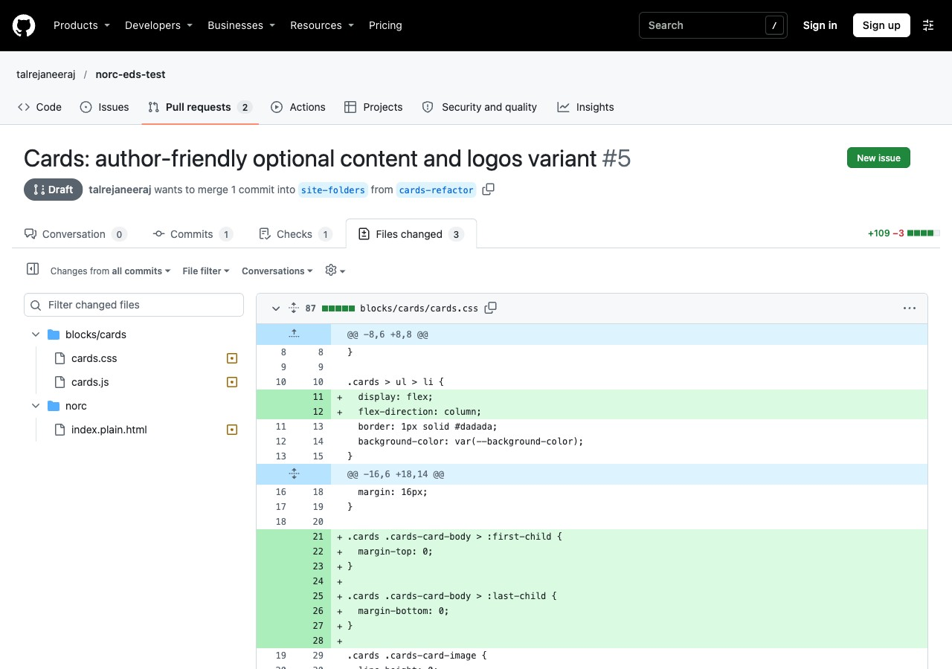
GitHub: Files changed, 3 files only
CI: the Build check (the repo’s lint workflow, .github/workflows/main.yaml) passed in 13 s on commit f101f2e.
📘 Adobe course: Module 4 › Performance Optimization Techniques › Automated PR testing, and Additional Best Practices › GitHub management.
🔗 Lesson: Module 4 › Performance Optimization Techniques. Direct link: https://certification.adobe.com/scorm-data/1345/scormcontent/index.html#/lessons/OTt279XR69CtYDWVrFSDTKaYhdLF8uAv 🔗 Also: Module 4 › Additional Best Practices. https://certification.adobe.com/scorm-data/1345/scormcontent/index.html#/lessons/yzfcSloqZm2Y8B2rrt8bFe-HGNfXtkWC
- “Every PR should link to at least one page where the related code change can be observed.” Our PR links before/after URLs for /norc/.
- The boilerplate PR template asks for Before/After test URLs (below). The AEM Code Sync app uses that URL to run PageSpeed Insights and posts the scores as a PR comment (second image).
- “Don’t push directly to the main branch. Create pull requests instead.” “Don’t submit a PR that has linting errors or a low Lighthouse score.”
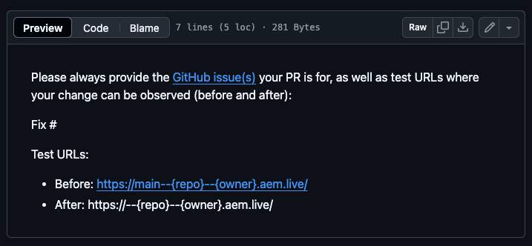
Adobe course, Module 4: the boilerplate PR template (Before / After test URLs on .aem.live)
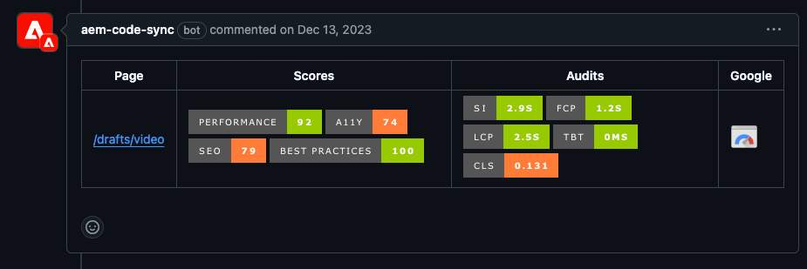
Adobe course, Module 4: the aem-code-sync bot comment with PageSpeed Insights scores for the test page
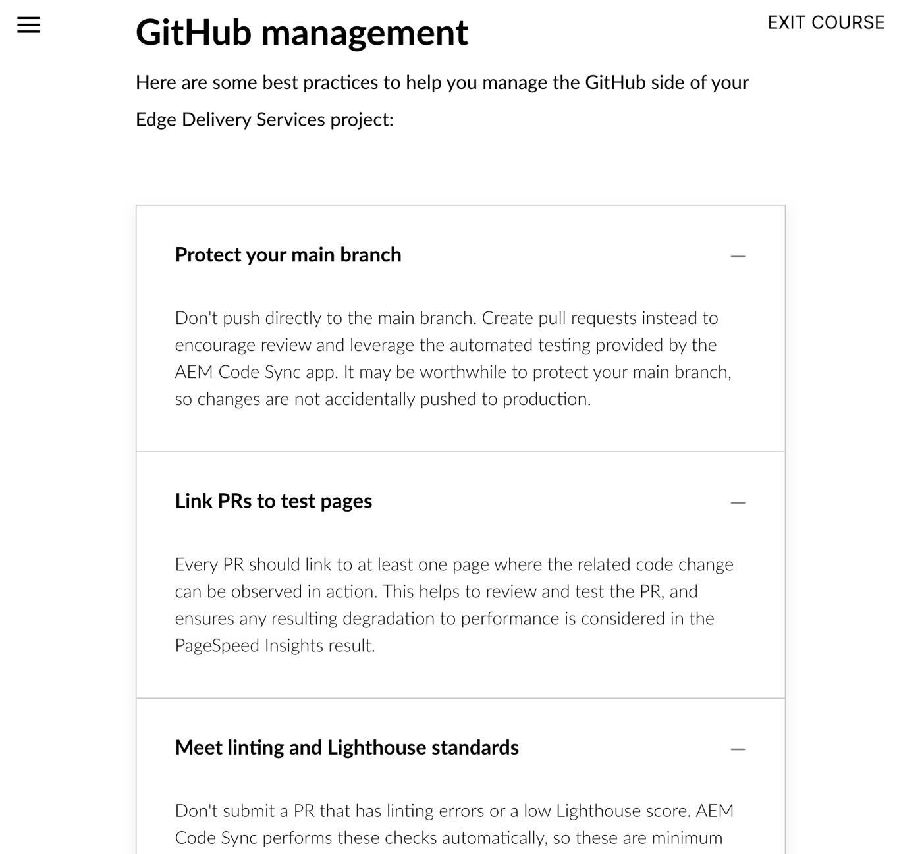
Adobe course, Module 4 Additional Best Practices: GitHub management

Gap found while checking: no PageSpeed comment on PR #5
What the course says should happen, compared with what PR #5 shows:
Course expects | PR #5 today | Why
An aem-code-sync bot comment with PSI scores | Only the GitHub Actions Build check | The code isn’t on AEM’s Code Bus (even the CSS file returns 404; URL below), so the AEM Code Sync app isn’t installed or connected for this repo
Test links on .aem.live (“link to the cached .live environment whenever possible”) | Links on .aem.page | Our choice when writing the PR. The repo’s own template (.github/pull_request_template.md) uses .aem.live.
Evidence: https://cards-refactor--norc-eds-test--talrejaneeraj.aem.page/blocks/cards/cards.css returns 404, and so does main--…/. Code files are served once Code Sync has synced them, whatever the content source (Module 3 › Initial Setup › AEM Code Sync GitHub app).
What to do (the repo owner, before marking the PR ready):
- Install the AEM Code Sync app on talrejaneeraj/norc-eds-test: https://github.com/apps/aem-code-sync
- Connect DA as the content source and create the test page from drafts/tmp/cards (CDD skill, draft-PR steps).
- Change the PR’s test URLs to .aem.live, then check that the aem-code-sync PSI comment appears.
Say: “This is why the PR is a draft. Locally everything passes, but the course’s real gate is the Code Sync PageSpeed comment on a live URL, and this repo isn’t connected to Code Sync yet.”
📘 Adobe course: Module 3 › Authoring and Development Flows › Development workflow: a developer pushes or merges on GitHub, then Code Sync deploys it. This is the course’s picture of a merged PR that Code Sync has deployed (“This branch was successfully deployed”). We’ll get there once the app is installed.
🔗 Lesson: Module 3 › Authoring and Development Flows. Direct link: https://certification.adobe.com/scorm-data/1395/scormcontent/index.html#/lessons/0UYSnsREq1kk5ZfsNxKQNonsAy0pDaOG
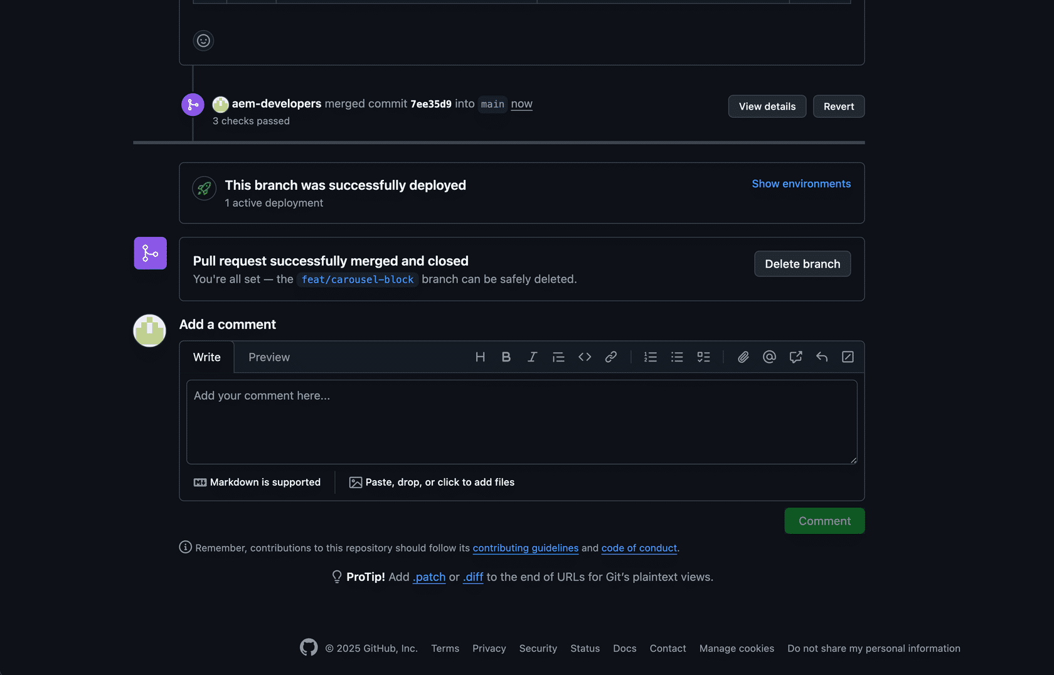
Adobe course, Module 3: a merged PR, deployed by AEM Code Sync

Worksheet fields: filled in
- Branch: cards-refactor
- Commit: f101f2e feat(cards): optional image, eyebrow, whole-card link, logos variant
- PR URL: https://github.com/talrejaneeraj/norc-eds-test/pull/5 (draft, base site-folders)

Definition of done (slide 18) and final deliverables (worksheet)
Item | Status
Documented content model and reuse decision | ✅ Exercise 1 + PR description
Block works with the original migrated content (worksheet: “Working block on the Session 2 imported page”) | ✅ /norc/, 3 sections
Two additional content variants validated (worksheet: “Two or more”) | ✅ 8 scenarios + logos variant
Desktop and mobile verified (worksheet: “Responsive and accessibility checks completed”) | ✅ 1280 / 375 px; keyboard, alt text, Lighthouse 0 failures in Cards
Local preview verified (worksheet only) | ✅ aem up on port 3006: /norc/ and /drafts/tmp/cards
Change set reviewed and pushed to a feature branch | ✅ cards-refactor, f101f2e
Pull request opened (stretch; worksheet: “PR opened if time allows”) | ✅ #5 (draft). Code Sync PSI check pending; see the gap in Step 4

Retrospective answers
- What was easiest to reuse? The boilerplate Cards block. Its row → <li> logic needed no rewrite, and block options gave us a variant without a new block.
- What did the agent get wrong?
  - It used the over-long branch name.
  - It followed git add ..
  - Its first logo sizing left too much white space.
  - It missed the empty-cell case until testing.
- Which block could be shared across NORC properties? Cards (logos): every NORC property has a partner, solution or “as seen in” logo row.
- What should be standardized before production?
  - short branch names (63-character limit)
  - shared NORC color and font tokens
  - an approved list of block options
  - “stage by file name”
  - a DA test page per block, so every PR has a working preview link
  - AEM Code Sync installed on every NORC repo, so every PR gets the PageSpeed comment
  - PR test links on .aem.live, per the course and the boilerplate template

Questions you may get
- “Why draft?” Reviewers can’t open a preview yet. Draft says “not ready to merge” honestly.
- “Why not target main?” It would show PR #4’s 30 files as well. Stacking keeps review focused.
- “Why isn’t there a PageSpeed score on the PR?” Code Sync isn’t connected to this repo yet (Step 4 gap). Locally, Lighthouse found 0 failures in the Cards block (Exercise 3).
- “Who is the Copilot reviewer on the PR?” GitHub lists it as a reviewer; we did not request it. It comes from the account or repo settings.

