**ASP.Net MVC Web Application Development**

**Required Programming Technologies:**

HTML : 3 Days

CSS +Bootstrap : 4 Days

Java Script (Jquery + Ajax) : 5-7 Days

C# Programming Basics +OOP : 6-7 Days

**MVC Framework : 11-13 Days**

-Creating New Project + Basic Structure

-CRUD Operation ( Basic + Using Ajax )

- Master Detail Form Design

-Entity framework

-Scafolding

-Linq

-Lamda Expression

**MS SQL : 3 Days**

**Crystal Report : 5 Days**

**Total= 37-42 Days (Approximate)**

**Development Environment:**

**Visual Studio** IDE (Integrated Development Environment or Developer or Compiler) + MS SQL + Management Studio 2012

Download Link: <https://visualstudio.microsoft.com/downloads/> (VS 2015)

**Tutotorial Links:**

[**https://www.w3schools.com/**](https://www.w3schools.com/) **(HTML CSS JS )**

<http://www.tutorialsteacher.com/mvc/create-first-asp.net-mvc-application>

<https://docs.microsoft.com/en-us/aspnet/mvc/overview/getting-started/introduction/getting-started>

<https://www.codeproject.com/Articles/808610/First-MVC-Application-for-Beginners>

<https://www.asp.net/mvc>

<https://www.tutorialspoint.com/mvc_framework/mvc_framework_first_application.htm> (Easy )

**MVC Routing**

First Web Page View

**AppStart-> Routconfig.cs ->**

routes.MapRoute(

name: "Default",

url: "{controller}/{action}/{id}",

defaults: new { controller = "student", action = "Info", id = UrlParameter.Optional }

);

**Controller -> studentController->**

public class studentController: Controller

    {

Public Actionresult Info()

{

Return view()

}

    }

**View-> student-> Info.cshtml**

**Link-Create New Controller And Add View**

http://techfunda.com/howto/105/create-new-controller

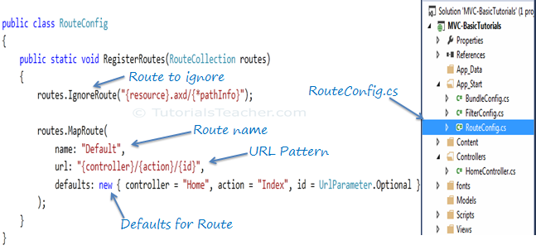

**Basics C#**

<https://www.youtube.com/watch?v=gfkTfcpWqAY>

**C# App**

<https://play.google.com/store/apps/details?id=com.jaindev.csharp>

**MVC-**

<https://www.tutorialspoint.com/asp.net_mvc/>

**MVC Basic All Topic Wise – Venket**

[**https://www.youtube.com/watch?v=-pzwRwYlXMw&list=PL6n9fhu94yhVm6S8I2xd6nYz2ZORd7X2v**](https://www.youtube.com/watch?v=-pzwRwYlXMw&list=PL6n9fhu94yhVm6S8I2xd6nYz2ZORd7X2v)

**MVC Project – Mose Hamedani**

[**https://www.youtube.com/watch?v=E7Voso411Vs**](https://www.youtube.com/watch?v=E7Voso411Vs)

**Three Approches-**

1. Code First
2. Database first
3. Model First

**Code First –**

Step 1: create model class

Step 2: create dbcontext class

Step 3: run 3 commands in nugget console to creat database

Enable-migrations

Add-migration init

Update database

**Database first –**

Step 1: create database table

Step 2: **if new project** -use wizard to create model and dbcontext **else** create model class manually

**Scafolding – is the mechanism to create controller with all views(crud) using model and dbcontext class**

**Change design as Theme**

**Add Jquery and Ajax in crud operation**

**Crystal Reports Steps –**

1. **Menu creation for parameter Form**
2. **Create get action for parameter view**
3. **Create parameter form**
4. **Create post action in Report controller**
5. **Query Data (Linq or lamda expression)**
6. **Create dataset in report dataset folder**
7. **Add Query data to dataset in controller post action**
8. **Create report in reports folder**
9. **Add dataset to report**
10. **Design report**
11. **Call the report from controller post action**