+----------------------------------------------------------

**Development of an AI-Enabled Menu Recommendation Chatbot for the Hotel Industry**

Student's Name: Hemanth Kumar Talupula

Professor Name: Farshid Amirabdollahian

Course: Advanced Computer Science 7COM1039

Date: 21/08/2023

**Contents:**

Background Research 4

Summary In Progress 6

Consideration of ethical, legal, professional and social issues 9

Project Plan 10

References 11

Appendices 12

INTRODUCTION

TOURISM:

Throughout our lives, as we seek to discover these wonders, we are all exposed to the enthralling notion known as the tourism industry. The significance of ICT (information and communication technology) in the tourism industry has risen significantly (Ishita Chanda and Manohar Sajnani, 2022). Hotel and lodging sector, which can be described to as the travel and tourism sector's spine, accounts for most of the business.

HOTEL INDUSTRY:

The hotel and restaurant sector are a subset of the tourism and hospitality sector that specialises in offering potential consumers with lodging services, including food and beverages. As per the recent reports after pandemic in an average hotel industry produces 1.21 billion $(USD) At its best of decade hotel industry generated 1.52 billion $ (USD) in 2019 (IBIS World 2022).

ARTIFICIAL INTELLEGENCE:

Artificial intelligence (AI), a branch of computer science, aims to develop algorithms and approaches which empower machines with skills that would normally need intellect from humans, such as learning, reasoning, and comprehending (Miguel-Ángel and García-Madurga, 2023). The Artificial Intelligence (AI) industry has grown steadily in recent years, thanks to the lightning-fast advancements in technological advances and smartphone connectivity, as well as big data and the rise of cloud computing (Lei Peng, 2020)

BACKGROUND RESEARCH

AI IN HOTEL INDUSTRY:

The "digital revolution" has profoundly changed the customer experience over the past two decades (Wayne D, Mirja Kroschke and Bernd Schmitt , 2020). AI has become prevalent in the social lives of individuals, especially in a new way of interacting as a representative of the hospitality sector, and all kinds of new type of intelligent hotel emerge in endlessly, brush a face, VR room experience, customers personal portrait, not only optimise the operation of hotels leadership effectiveness and superior quality of service (Lei Peng, 2020). Among of the most important areas where the use of AI increases rapid check-in and checkout, more personalised expertise, effective interaction with guests, greater production of revenue, digitalized conditions etc., are some of the enhanced features. AI and machine learning which uses python to determine in creating chatbots and smart talk back devices created a revolution in the industry.

SCOPE OF AI IN HOTEL INDUSTRY:

Businesses in the restaurant and hotel sector may capitalise on services provided on-site, operations, and improve client (guest) experiences with the utilisation of AI.Maintaining in connected with clients and meeting their requirements is essential for maintaining the overall level of quality.Because artificial intelligence (AI) enables the offering of personalised experiences, the concept of a smart lodging establishment (Joanna Citak and Mieczysław L and Owoc, 2022). In 2016 Hilton hotels group has taken this Ai into another step by onboarding a new AI enabled Robot called “Connie” in their guest experience environment.

There are various areas in hotel industry AI can be deployed such as robot servers, AI hotel booking system, Smart hotel recommendation system, AI powered chatbots, Digital marketing and data driving discounts for value added customers.

RESEARCH AREA OF THIS PROJECT:

Among the different artificial intelligence (AI) systems currently in use in the hotel business, a particular component has been overlooked and underutilised while providing complete assistance. The hotel menu and the customers' dietary needs are the two major areas of focus for every hotel or restaurant. A menu selection and meal recommendation system should account both human sentiments on dietary restrictions and the nutritional value of the food menu (Tanvir Islam and Anika Rahman Joyita, 2022).

Dining out has become one of the most difficult problems for persons with allergies to foods. The dread of encountering an allergic response when dining out has a negative impact on young adults' relationships with others. The tedious procedure of looking on the web and talking with eateries enhances their anxiousness (Hsu, P. (Pei-Ting), Zhao, J., Liao, K., Liu, T. and Wang, C. 2017). Allergic reactions and intolerances to particular foods are recognised to have catastrophic consequences and are viewed as such major impacts on customer choices regarding food that certain countries have even implemented standards to inform customers to any allergic potential to the food they are supplied (Dinushika Gunawardena and Kumuduni Sarathchandra, 2020).

Machine learning, also known as a branch of computational intelligence, varies from typical algorithmic problem-solving in that it doesn't aim to programme an exhaustive set of specific instructions or guidelines. An artificial intelligence system, on the other hand, trains from instances and generalises to new situations based on their similarity to previously learnt examples (instance-based learning) or develops a framework using data to refine its set of parameters through optimisation and makes recommendations using various new algorithms (XiangyuDeng and ShuhaoCao and AbigailL.Horn, 2021).

KEY RESEARCH ASPECT:

To overcome the for the purpose of to accomplish the highest possible outcomes for the purpose of this assignment, the method known as the Smart Menu Recommendation algorithm will be mostly used. Recommendation algorithms are a type of system that filters information because they increase the quality of results from searches by providing items that are more appropriate to the query item or are connected to the search query the user entered.

Artificial Intelligence (AI) chatbots, also known as conversational agents, are machines that use dialogue engines to enable natural language speeches with people through the language.

AI chatbots, fuelled by the processing of natural language and cloud computing infrastructures, may engage in a wide spectrum of discussions, from confined (i.e., rule-based) to unrestrained (i.e., human-to-human contact) (Yoo Jung Oh and Jingwen Zhang and Min‑Lin Fang, 2021).

SUMMARY OF PROGRESS TO DATE

Throughout this technologically fuelled quest, I have come across numerous significant notions that will assist me improve my planned project. Two main aspects that I considered while investigating directed to comprehend various AI technologies and chatbot generation systems employing python-based language models were literature review and methodology.

I studied 76 publications, ranging from (research papers, journals, articles, books, and worldwide conferences) and filtered them applying a customised string-based search, which yielded 50 publications pertaining regarding my subject, which I thoroughly reviewed.

In detailed Literature review is written as per requirement of the project covering every aspect which includes technical, legal, ethical, social values.

METHODOLY:

In this chapter of methodology explained about functioning as scenario a button-based user-friendly smart menu recommendation AI infused chatbot will be developed where it will be preloaded with existed menu which acquired from established hotel in London. NLP concepts such as data cleaning and processing will be done as per standards and sorted into their dedicated database systems. Considering existing and prior user inquiries, the generative model provides more satisfactory responses than the other three models. These chatbots are more human-like in appearance and employ machine learning algorithms and deep learning techniques. However, there are challenges in developing and training them (Eleni Adamopoulou and Lefteris Moussiades. 2020).

The following sections in methodology include topics associated with this project such as collecting information from the hotel, menu data being cleaned and processed and organising it into outlined spreadsheets for storage in a database. The conversational AI framework and its development are clearly explained in the introductory section, followed by training using existing algorithms, button creation, data obtaining training, smart menu identification, and machine learning and natural language processing.

In this assignment, I'm using the Python to construct a chatbot powered by artificial intelligence that can answer to users according to already trained hotel menu data while taking allergens and dietary restrictions into account. The following section explains in detail how to recognise several Python frameworks and their context functions, chatbot testing, and feedback from customers on failures. I attempted to learn everything I could about their uses and applications.

Till here I have explained about data acquisition, data cleaning, processing, model base setup, data sorting into tables. My thesis will be in detail and clear as it will be easily understandable about python programming, machine learning and Ai concepts which I have used in this project.

Initially I have faced challenges while learning about python libraries and their applications, AI chatbot framework selection, SQL database creation limitations, deployment criteria for my project. But I have overcome those by constant practicing in dedicated topics by doing research such as deep learning, neural networks, data structures and algorithms which helps to create my model.

TECHNICAL ASPECTS:

This project is updated and worked on established python compiler called as PyCharm which is professional ease for the work. I have used Trello project management board in order to track every update for this project and updated all changes. Along with that for this project I have created a private repository on Bitbucket where I have updated each and every change for reference and version control. One drive which is one the best cloud storge platform is helped me a lot while hosting the repository remotely so that I can access it anywhere in future.

Tasks which are remained in the upcoming schedule are creating chatbot framework, user testing and fetching deployment resources.

CONSIDERATION OF ETHICAL, LEGAL, PROFESSIONAL AND SOCIAL ISSUES

I would like the mention some of the key points regarding various issues applicable for this project.

1. The Catalogue used as a dataset for my project was obtained from an internet site (the hotel's website) of a hotel in central London. There will be no legal or ethical challenges to deal with.
2. 2. I officially attended and had a conversation with the hotel's digital employees, and I am granted full authorization to use the restaurant's menu for constructing a chat bot initial prototype which results no professional or social implications.
3. Only this specific hotel cuisine will be utilised across the course of my work for model development and evaluation in order to fulfil my project's deadline.

PROJECT PLAN

In order to complete my project on time, I prepared an established schedule based on multiple categories. Below mentioned chart refers to the schedule and their deadlines.

|  |  |  |  |  |  |  |  |  |
| --- | --- | --- | --- | --- | --- | --- | --- | --- |
| **WEEK DATA** | **WEEKS** | | | | | | | |
| **1** | **2** | **3-4** | **5-6** | **7-11** | **12-13** | **13-14** | **15** |
| **Introduction** |  |  |  |  |  |  |  |  |
| **Literature Review** |  |  |  |  |  |  |  |  |
| **Methodology** |  |  |  |  |  |  |  |  |
| **Hotel Menu Data Acquisition and Processing** |  |  |  |  |  |  |  |  |
|  |  |  |  |  |  |  |  |
| **Chat Bot and Data base Creation** |  |  |  |  |  |  |  |  |
| **Model Testing and User Feedback** |  |  |  |  |  |  |  |  |
| **Final Documentation and Protype Demonstration** |  |  |  |  |  |  |  |  |

REFERENCES

Chanda, I., Sajnani, M. and Gowreesunkar, V.G. (2022). Smart Tourism Technologies - A Key to Success and Survival for Sustainable Eco-tourism Development in Dooars Region (West Bengal). *2022 10th International Conference on Reliability, Infocom Technologies and Optimization (Trends and Future Directions) (ICRITO), Reliability, Infocom Technologies and Optimization (Trends and Future Directions) (ICRITO), 2022 10th International Conference*, [online] pp.1–7

Citak, J., Owoc, M.L. and Weichbroth, P. (2021). A note on the applications of artificial intelligence in the hospitality industry: preliminary results of a survey. *Procedia Computer Science*, [online] 192, pp.4552–4559

Deng, X., Cao, S. and Horn, A.L. (2021). Emerging Applications of Machine Learning in Food Safety. *Annual Review of Food Science and Technology*, 12(1).

García-Madurga, M.-Á. and Grilló-Méndez, A.-J. (2023). Artificial Intelligence in the Tourism Industry: An Overview of Reviews. *Administrative Sciences*, [online] 13(8), p.172.

Goel, R., Singh, T., Sahdev, S.L., Baral, S.K. and Choudhury, A. (2022). *Impact of AI & IOT in Sustainable & Green Practices Adopted in Hotel Industry and Measuring Hotel Guests’ Satisfaction*. [online] IEEE Xplore.

Gunawardena, D. and Sarathchandra, K. (2020). *BestDish: A Digital Menu and Food Item Recommendation System for Restaurants in the Hotel Sector*. [online] IEEE Xplore.

Hoyer, W.D., Kroschke, M., Schmitt, B., Kraume, K. and Shankar, V. (2020). Transforming the Customer Experience Through New Technologies. *Journal of Interactive Marketing*, 51(1), pp.57–71.

Hsu, P. (Pei-Ting), Zhao, J., Liao, K., Liu, T. and Wang, C. (2017). AllergyBot. *Proceedings of the 2017 CHI Conference Extended Abstracts on Human Factors in Computing Systems - CHI EA ’17*.

Islam, T., Joyita, A.R., Alam, M.G.R., Hassan, M.M., Hassan, M.R. and Gravina, R. (2023). *Human Behavior-based Personalized Meal Recommendation and Menu Planning Social System*. [online] arXiv.org.

issuu.com. (2022). *Food Recommendation System using Chatbot by IRJET Journal - Issuu*. [online] Available at: [Accessed 21 Aug. 2023].

Kushwaha, A.K., Kumar, P. and Kar, A.K. (2021). What impacts customer experience for B2B enterprises on using AI-enabled chatbots? Insights from Big data analytics. *Industrial Marketing Management*, 98, pp.207–221.

Miller, T. (2019). Explanation in artificial intelligence: Insights from the social sciences. *Artificial Intelligence*, 267, pp.1–38.

Namgung, K., Kim, T.-H. and Hong, Y.-S. (2019). Menu Recommendation System Using Smart Plates for Well-balanced Diet Habits of Young Children. *Wireless Communications and Mobile Computing*, 2019, pp.1–10.

Nohria, V., Soni, V., Mishra, M., Kumar, V. and Lamba, S. (2023). *Intelligent Food Recommendation System Based on Nutritional Information and Preferences of Customers*. [online] IEEE Xplore.

Oh, Y.J., Zhang, J., Fang, M.-L. and Fukuoka, Y. (2021). A systematic review of artificial intelligence chatbots for promoting physical activity, healthy diet, and weight loss. *International Journal of Behavioral Nutrition and Physical Activity*, 18(1).

Peng, L. (2020). Research on the influence of AI on Chinese hotel industry. *Proceedings of the 2020 2nd International Conference on Big Data and Artificial Intelligence*.

Sharma, Y., Bhatt, J. and Magon, R. (2015). A Multi-criteria Review-Based Hotel Recommendation System. *2015 IEEE International Conference on Computer and Information Technology; Ubiquitous Computing and Communications; Dependable, Autonomic and Secure Computing; Pervasive Intelligence and Computing*.

Takahashi, O. and Sasaki, S. (2022). *A Dinner Menu & Recipe Recommendation System with Food Expiration-date Notification Functions*. [online] IEEE Xplore.

APPENDICES

BITBUCKET:

The following snippet is about the git repository which I am hosting I bitbucket for my project up to date.

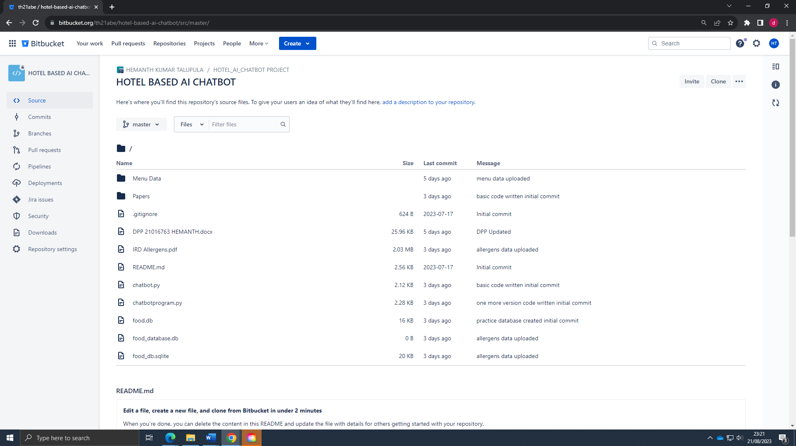

Repository Link: <https://th21abe@bitbucket.org/th21abe/hotel-based-ai-chatbot>.

In this repository I have updated in frequent basis about all my project version controls, code practice, project reports, research papers which I have referred for the project best results.

Trello :

Below mentioned snippet is regarding my project management board where I have followed project management kanban board in order to track the daily updates, project deadlines, next upcoming schedules.

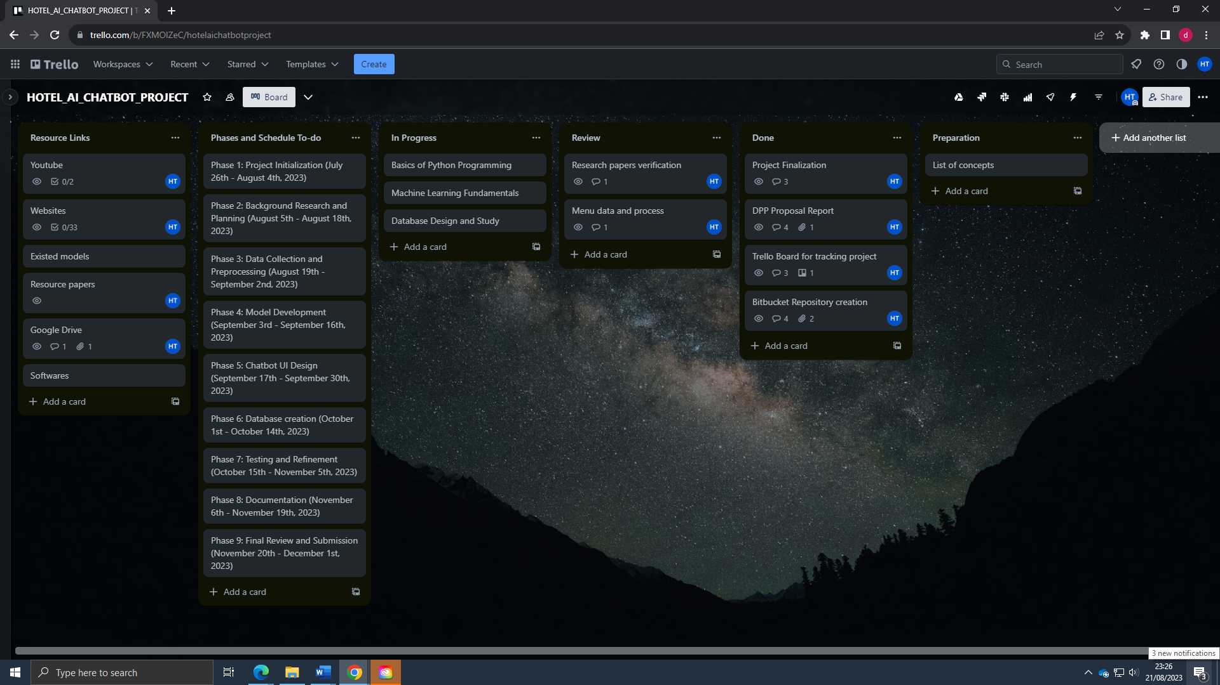

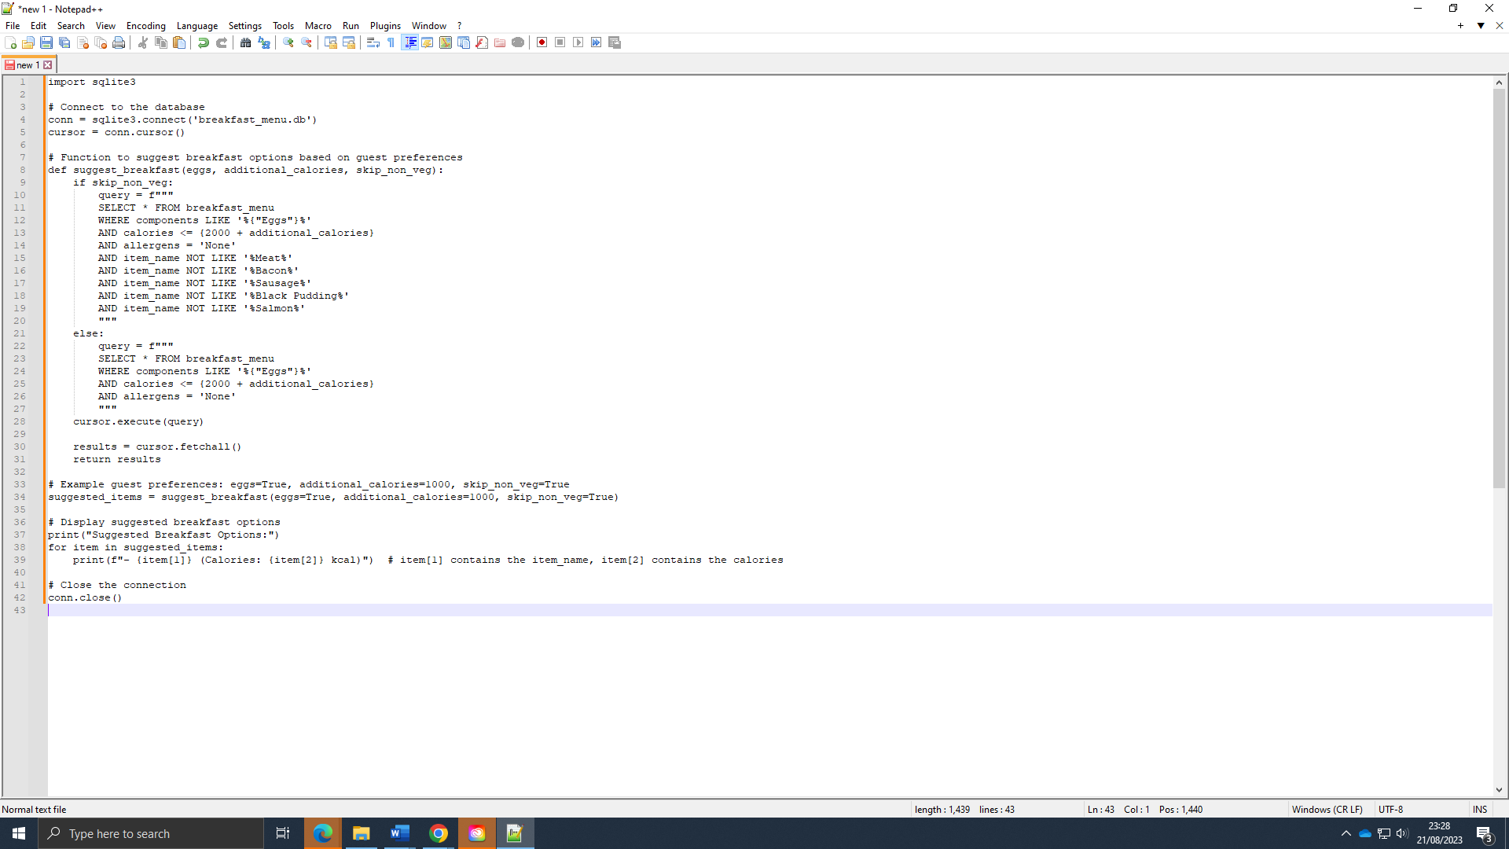



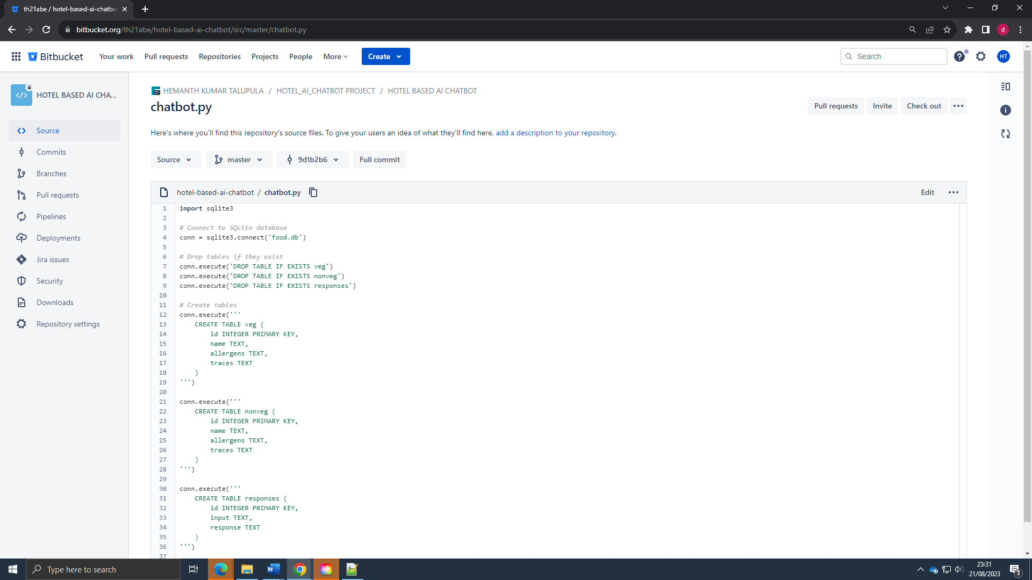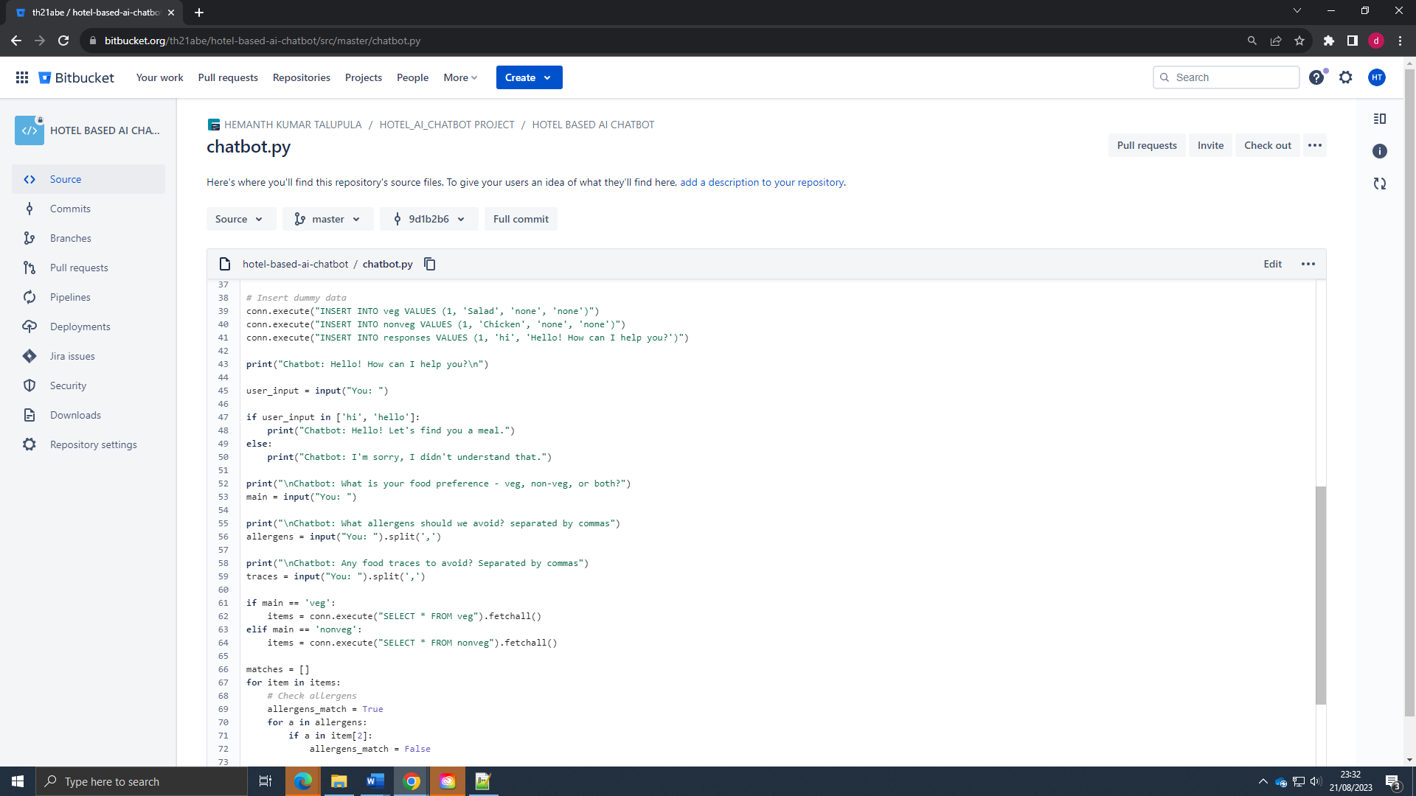

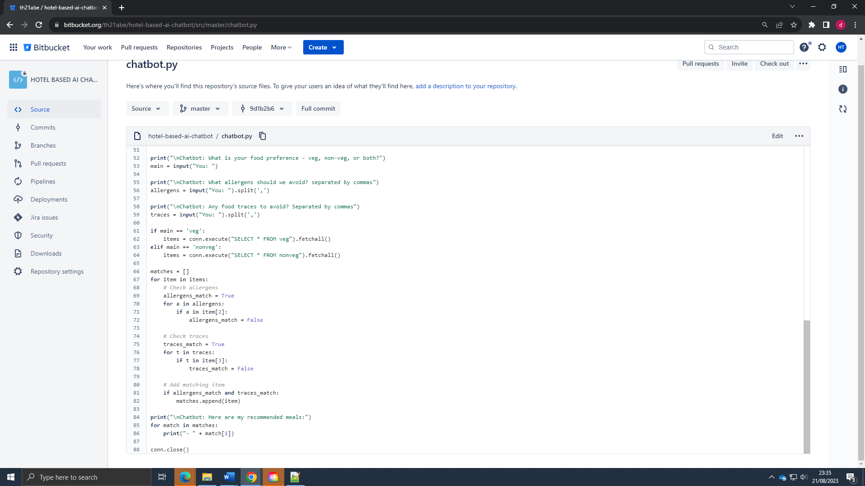

Sample of some of data:

