Tim Alvarado

8/9/2022

Assignment 1.2 – GitHub Repository Setup

GitHub Link

<https://github.com/talvarad11/csd-340.git>

GitHub Screenshot

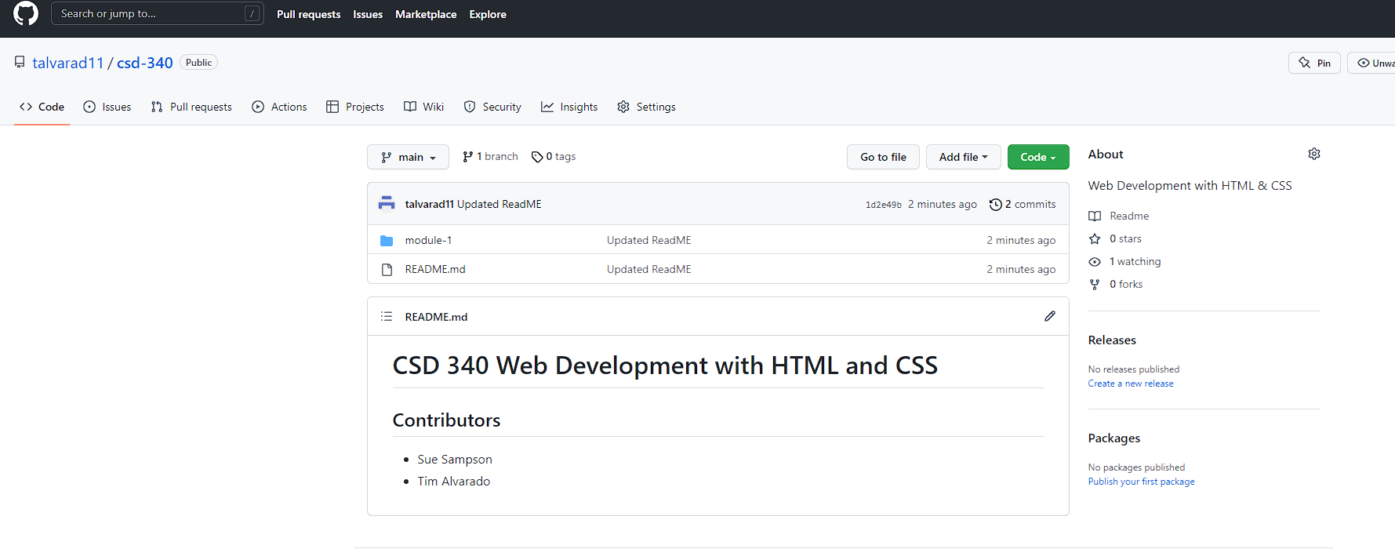

Directory Screenshot

