JAVA DEMONSTRATION OF THE MINIMAX ALGORITHM

Sheri Lynn Grimes
B.A., California State University, Humboldt, 1991

PROJECT

Submitted in partial satisfaction of
the requirements for the degree of

MASTER OF SCIENCE

in

Software Engineering

at

CALIFORNIA STATE UNIVERSITY, SACRAMENTO

SPRING
2004

JAVA DEMONSTRATION OF THE MINIMAX ALGORITHM

A Project

by

Sheri Lynn Grimes

Approved by:

, Committee Chair
Dr. Du Zhang

, Second Reader
Dr. Meiliu Lu

Date:

Student: Sheri Lynn Grimes

I certify that this student has met the requirements for format contained in the University format manual, and that this Project is suitable for shelving in the Library and credit is to be awarded for the Project.

Dr. Cui Zhang, Graduate Coordinator Date
Department of Computer Science
Abstract
of
JAVA DEMONSTRATION OF THE MINIMAX ALGORITHM
by
Sheri Lynn Grimes

For a student of artificial intelligence, the minimax algorithm search process can be difficult to understand. This is especially true once you add to it the complexity of alpha-beta pruning. The explanations and static diagrams in the artificial intelligence textbooks are often not sufficient for a true understanding of the algorithm.

The goal of this software project was to create a java applet application that visually demonstrates the minimax algorithm with and without alpha-beta pruning to students of artificial intelligence. This goal was met with an application that is easy to use, provides a variety of configuration options, and clearly demonstrates each step of the algorithm search process with visual and textual aids.

In comparison with other minimax algorithm demonstrations, this demonstration offers a wide enough range of configuration settings and features to remain usable without getting overly complicated or too simplistic. Features such as textual description of each step and custom terminal node value entry make this algorithm demonstration the better choice by students to enable deeper knowledge of the minimax algorithm and its optimization, alpha-beta pruning.

, Committee Chair
Dr. Du Zhang

Date
TABLE OF CONTENTS
Page

LIST OF FIGURES ix
CHAPTER 1 - INTRODUCTION 1
1.1. Background 1
1.2. Problem Statement 1
1.3. Current State-of-the-Practice 2
1.4. Approach 3
1.5. Results and Contributions 4
CHAPTER 2 - DESIGN 5
2.1. High-Level Design 5
2.1.1. Graphical User Interface 5
2.1.2. Internal Software Structure 6
2.2. Detailed Design 7
2.2.1. Graphical User Interface 7
2.2.2. Internal Software Structure 13
2.2.3. Program Flow 14
CHAPTER 3 - IMPLEMENTATION 19
3.1. Overview 19
3.1.1. Overview of Minimax Algorithm 20
3.1.2. Overview of Minimax with Alpha-Beta Pruning Algorithm 21
3.2. Implementation Details 22
3.2.1. Stack Structure 22
3.2.2. Implementation of the Minimax Algorithm 23
3.2.3. Implementation of the Alpha-Beta Algorithm 24
CHAPTER 4 - PERFORMANCE ANALYSIS 27
4.1. Software Performance 27
4.1.1. State Control 27
4.1.2. Usability 29
4.2. Comparisons 30
CHAPTER 5 - CONCLUSION AND FUTURE WORK 37
5.1. Results 37
5.2. Future Improvements 37
APPENDIX A - SOFTWARE CODE 39
APPENDIX B - USE CASES 74
APPENDIX C - OBJECTS 78
BIBLIOGRAPHY 94

LIST OF FIGURES

Figure 2.1 - Graphical User Interface 5
Figure 2.2 - Internal Software Structure 6
Figure 2.3 - Menu System 8
Figure 2.4 - Button Panel 8
Figure 2.5 - Custom Values Entry Panel 8
Figure 2.9 - Object Diagram 13
Figure 2.11 - Run Mode 18
Figure 3.1 - Minimax Algorithm 20
Figure 3.2 - Minimax with Alpha-Beta Algorithm 21
Figure 4.2 - Run Mode 28
Figure 4.3 - Run mode selections 29
Figure 4.4 - Non-Technical Menu Wording Example 30
Figure 4.5 - Clear Visuals Example 31
Figure 4.6 - MIT Demonstration Example 32
Figure 4.7 - U.C. Berkeley Demonstration Example 33
Figure 4.7 - Tree Node Values Selection 34
Figure 4.8 - MIT Demonstration Tree Node Selections 35
Figure 4.9 - U.C. Berkeley Tree Node Values Selection 36

CHAPTER 1 - INTRODUCTION

1.1. Background
Artificial intelligence (AI) as currently taught at the college level involves extensive reading of AI books and manual demonstrations via chalkboard or overhead slides of AI algorithms. Often the static descriptions of AI algorithms presented in books are insufficient to create real understanding of the AI algorithm by the student. To make up for the book’s shortcomings, the AI teacher will attempt to educate the student of AI algorithms via chalkboard demonstrations and use of multiple slides presented in series. Often due to time constraints, the student is still left with a lack of understanding of the algorithms.

The student of artificial intelligence could greatly benefit from live, interactive demonstrations of artificial intelligence algorithms. In particular, a website that explains an algorithm in text format and then provides a live interactive demonstration of the AI algorithm would greatly aid understanding by the student. The student could read the website in his/her own timeframe and could replay the demonstration as many times as needed until the workings of the algorithm are understood. This website could be used as a companion to the AI textbook and the teacher’s lecture to create a greater understanding of AI concepts.

1.2. Problem Statement
A very popular area of artificial intelligence involves game algorithms. In order for a software engineer to create a game that involves a computer as one of the players, the engineer must use an artificial intelligence algorithm to make the computer a viable player in the game. For two-player games, such as chess, checkers and tic-tac-toe, a common algorithm to use is the minimax algorithm [4]. This algorithm is designed to find the best play for the computer by searching through all the possible choices for both players down to the final state of the game (win, lose, draw, etc.). Often, in a timed game such as chess, the algorithm does not have time to search through all choices to the final state of the game. An optimized version of the minimax algorithm was developed, called minimax with alpha-beta pruning [4], that allows the computer to eliminate the need to search through all possible choices, thereby reducing the time required to find the best play.

For a student of artificial intelligence, the minimax algorithm search process can be difficult to understand. This is especially true once you add to it the complexity of alpha-beta pruning. The explanations and static diagrams in the artificial intelligence textbooks are often not sufficient for a true understanding of the algorithm. This is a case where a visual demonstration of the minimax, and minimax with alpha-beta pruning, algorithm search process could greatly aid the student in understanding this algorithm.

1.3. Current State-of-the-Practice
A thorough search was conducted of all websites containing AI algorithm demonstrations to determine if an interactive demonstration had already been completed for the minimax algorithm with alpha-beta pruning. One demonstration of the minimax algorithm was found at the MIT Open Courseware website [5] (MIT demonstration). This website provides a java-based demonstration of the minimax algorithm with and without alpha-beta pruning. Although this demonstration technically works, it is very cryptic and lacks descriptive explanations for each step in the algorithm search process. It lacks the feature to allow students to proceed through each step of the algorithm manually and only lets a user run the algorithm at differing speeds. It also lacks the ability to let students specify the final outcomes of the game (i.e. terminal node values of the search tree). Unless a student already thoroughly understands the minimax algorithm with and without alpha-beta pruning, this demonstration is insufficient to aid the student in understanding.

A second demonstration was found at a University of California at Berkeley student website [2] (U.C. Berkeley demonstration). This demonstration was simpler than the MIT demonstration and, unlike the MIT demonstration, allows for a student to step through the algorithm search processes manually. It does not, however, allow for a student to run the algorithm in its entirety. It also lacks descriptive explanations for each step and does not allow a user to specify the final outcome values of the game tree.

1.4. Approach
This project involves the creation of a java-based demonstration of the minimax algorithm which will be placed on the Artificial Intelligence Concept Animation Library (AICAL) [6] website at California State University, Sacramento (CSUS) for use by students to aid understanding of this algorithm. This demonstration illustrates the minimax algorithm both with alpha-beta pruning and without alpha-beta pruning. Unlike the MIT and U.C. Berkeley demonstrations, this demonstration is interactive and allows students to specify leaf node values of the game tree. Students can manually step through each part of the algorithm process or simply run the algorithm demonstration in its entirety. A textual description of each step in the algorithm search process is also provided to aid greater understanding by the student.

Functionality included in the demonstration:
- A 3-ply tree diagram is used to illustrate the minimax algorithm with and without alpha-beta pruning.
- Users can enter terminal node values for the 3-ply search tree.
- Users can select pre-setup 3-ply trees (with terminal values already specified) from a menu.
- Users can choose to either step through the algorithm demonstration or run the algorithm demonstration in its entirety.
- Each step is explained in text as the user steps through the demonstration.
- With each step, the relevant nodes are highlighted on the 3-ply tree diagram.
- A help area within the application is provided to explain how to setup and run the algorithm demonstration.
- Troubleshooting information will be provided on the web page outside the application to help users who are having technical problems loading the application.
- No game examples that use the minimax algorithm are provided.
- No examples of search trees for specific games are provided.

The user interface includes the following:
- The interface consists of a Java applet placed on a web page.
- A graphic representation of a 3-ply search tree is used to demonstrate the algorithm.
- A menu system is provided to allow users to choose options for setting up the algorithm demonstration.
- A help menu entry is provided.
- Graphic buttons are provided to allow for starting, stepping-through and stopping the algorithm demonstration.
- There is a textual description of each step visible to the user while the algorithm demonstration is running.

1.5. Results and Contributions
By using this minimax algorithm demonstration, the student of artificial intelligence can come to a greater understanding the minimax algorithm search process both with and without the optimization of alpha-beta pruning. That knowledge can then be applied to the creation of smarter, faster two-player software games.

CHAPTER 2 - DESIGN

2.1. High-Level Design

2.1.1. Graphical User Interface
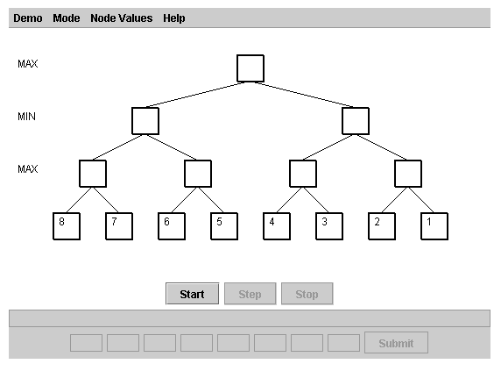
Figure 2.1 - Graphical User Interface
The software application is designed as a Java applet using the Java 2 Platform, Standard Edition, v 1.4.2 API. The Graphical User Interface (GUI) depicted in Figure 2.1 is completely event-driven. It contains a menu system for setup and configuration, as well as for access to help and about areas. Graphical buttons are available for the user to start, step and stop the algorithm demonstration. A panel containing text fields and a submit button is made available for the entry of custom terminal node values. A graphical representation of a search tree is drawn on the screen. At each step of the demonstration, the relevant node in the tree is highlighted and textual information is displayed pertaining to that step.

2.1.2. Internal Software Structure
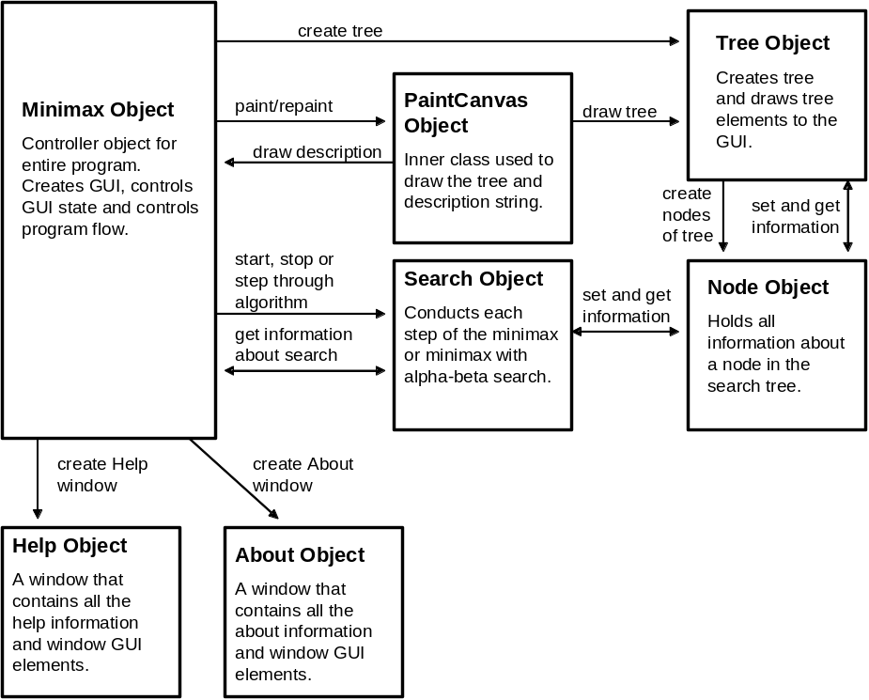
Figure 2.2 - Internal Software Structure
The core of the application consists of the Minimax class, which acts as the controller for the entire application. When the java applet is loaded, an object of type minimax is created. The minimax object both creates and controls the creation of all the GUI elements seen by the user, such as the menu system; the start, step, and stop buttons; the custom values entry panel, the 3-ply tree diagram, etc. The minimax object also controls the flow of the program. It enables and disables different GUI elements depending upon the user choices. It requests the creation of the search tree by the Tree object. It controls the requests to the Search object to conduct the minimax or alpha-beta search steps of the program. The minimax object is also responsible for re-drawing all the GUI elements every time the application state changes in a way that would affect the appearance of the GUI elements.

The Tree class is responsible for everything associated with the search tree. The tree class handles creating the search tree, drawing the graphical representation of the search tree, drawing the player levels (MIN or MAX), and drawing the alpha-beta values above each node. The Node class contains all information associated with each node of the search tree. When an object of the Tree class creates a tree, it instantiates an object of the Node class for every node in the tree. Each node contains information about that node such as children of the node, value of the node, current alpha-beta value of the node, the height and width of the node, etc. The function of the Search class is to search through the tree nodes using the Minimax or Alpha-Beta algorithms. It contains methods used by the Minimax object to start, step-through and stop the algorithm demonstrations for both minimax and minimax with alpha-beta pruning. The Help and About objects contain all the information needed to create the Help and About windows, respectively.

2.2. Detailed Design

2.2.1. Graphical User Interface
The GUI consists of two main areas: the menu system and the content pane. The content pane is a container of type Container from the Java AWT library. Except for the menu system, all other GUI elements must be added to the content pane in order to be visible. The content pane for this application uses the BorderLayout manager from the Java AWT library. Border layout allows for objects to be placed in positions north, south, east and west in the content pane [3].

As stated in Section 2.1, the Minimax object acts as the main controller for the application. The Minimax object inherits all the properties of a JApplet from the Java 2 Swing library. When the user opens the web page containing the applet, the Minimax object creates all constants and variables of the Minimax object and then automatically calls the init( ) method [3]. The init( ) method acts as a constructor for the applet. It initializes variables and creates the GUI objects of the menu system, the buttons, and the custom values entry panel.

2.2.1.1. Menu System
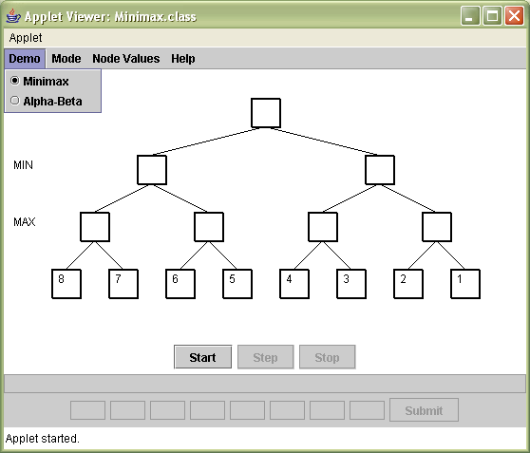
Figure 2.3 - Menu System
From the init( ) method, the Minimax object creates five JMenu items comprising the Demo menu, Mode menu, Run sub menu, Node Values menu, and the Help menu. The menu entries are created by instantiating JRadioButtonMenuItem objects and adding them to the appropriate JMenu objects. The JRadioButtonMenuItem objects are added to a ButtonGroup that was created for each menu, which allows for only one item at a time in a menu to be toggled. The JMenu objects are then placed in an object of type JMenuBar. The JMenuBar is made visible in the GUI using the command “setJMenuBar(bar);” [3].

2.2.1.2. Button Panel
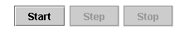
Figure 2.4 - Button Panel
To create the buttons seen in the GUI, the Minimax object instantiates three objects of type JButton, creates a panel of type JPanel, and adds the button objects to the panel. A layout manager of type FlowLayout is used to place the buttons on the panel horizontally from left to right. The layout manager is part of the Java AWT library. The button panel is added to the bottom panel, a panel that contains the GUI buttons and custom values entry area. The bottom panel is then added to the content pane.

2.2.1.3. Custom Values Entry Panel
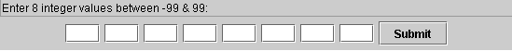
Figure 2.5 - Custom Values Entry Panel
The custom values entry panel consists of two panels: the instruction panel and the values panel. The instruction panel is an object of type JPanel and contains an object of type JTextField called instructionTextField. The instructionTextField is disabled so that users cannot enter values. It is used to convey the message “Enter 8 integer values between -99 & 99” and “INCORRECT ENTRY! Enter 8 integer values between -99 & 99.” The values panel contains the text fields that allow a user to enter values and the submit button. The text fields are each objects of the type JTextField. The values panel uses flow layout to display the text fields and the submit button horizontally from left to right. Both the instruction panel and values panel are added to the bottom panel in order to be displayed in the GUI.

2.2.1.4. Action Listeners
The Minimax class implements the Java 2 library ActionListener class. This allows it to “listen” for GUI events such as a menu selection being made by the user and respond appropriately. For each menu item and button object in the application, an action listener is added to enable the application to trigger the appropriate actions for that object.

When a user selects a menu item or button in the GUI, an action event is automatically sent to the method actionPerformed( ). Within the actionPerformed( ) method are conditional statements that look to see what type of action event was sent and take appropriate action based on that event. After actions are performed for each action event, the GUI is repainted by calling the repaint( ) method of the Java 2 Platform API.

2.2.1.5. Tree Graphic Panel
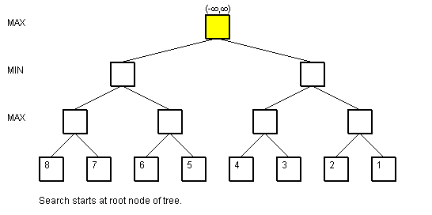
Figure 2.6 - Tree Graphic Panel
The tree graphic panel differs from the other GUI elements in that it is a collection of Graphic objects drawn to the screen. The Graphics class is an abstract class in the Java AWT package [3]. The graphics class allows the application to draw lines, rectangles and text (in the form of a graphic) to the screen. All Graphics objects are automatically drawn to the content area of the screen, or to a JPanel, using the paint( ) method.

The tree graphic is actually created by an object of the Tree class. The Tree class inherits all the properties of the JPanel class. The Tree object uses Graphics objects to create the nodes, lines, colors, node values, and player levels of the tree. The Minimax object must use the paint( ) method to draw the graphics contained in the tree graphic panel onto the content pane of the GUI. The description string is drawn by the Minimax class directly to the content pane of the applet.

During development of the GUI, it was noticed that elements of the tree panel object could be “seen through” the menu items when a menu was pulled down. In other words, the menus were not covering up the graphics on the tree graphic panel. This problem had to do with the order in which all the graphics were drawn on the screen automatically by Java. A work-around to this situation was to create the inner class PaintCanvas. The PaintCanvas class simply contains the paint method. Placing the paint method within a separate class vs. placing the paint method directly in the Minimax class solved the menu transparency problem because the Minimax class could now control the order at which the PaintCanvas object was instantiated (and the paint method called) instead of letting Java paint items automatically in its own chosen order.

2.2.1.6. Help Window
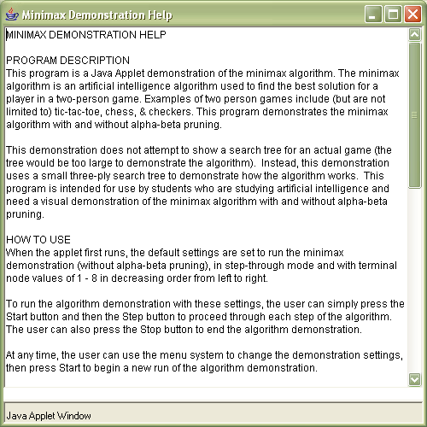
Figure 2.7 - Help Window
The help window is created by the Minimax object by instantiating an object of the Help class. The Help class inherits the properties of the JFrame class of the Java 2 Swing library. A JFrame is a type of window object. Instantiating an object of type JFrame causes a separate window to appear. This window is completely independent of the main application and contains its own GUI elements. A user can open as many Help windows as he/she desires.

The help text is contained within a TextArea that has been disabled for editing by the user. Scroll bars are enabled so that the user can see information that does not fit within the window area. The window is set to DISPOSE_ON_CLOSE, which means that all memory used by the Help window is freed when the user exits the window by pressing the X in the upper right corner of the window [3].

2.2.1.7. About Window
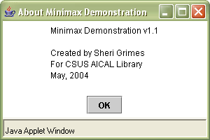
Figure 2.8 - About Window
The about window is created by the Minimax object by instantiating an object of the About class. Like the Help class, the About class also inherits the properties of the JFrame class of the Java 2 Swing library. A user can open as many About windows as he/she desires.

The text in the about window is created using a JTextArea that has been disabled for editing. The JTextArea is added to a JPanel object called aboutPanel. The OK button is an object of type JButton that is added to a JPanel object called the buttonPanel. The aboutPanel and buttonPanel objects are added to the content pane for the window using a border layout. The window uses method “setVisible(true);” [3] to make the panels visible to the user. The window is also set to DISPOSE_ON_CLOSE, which means that all memory used by the About window is freed when the user exits the window by pressing the X in the upper right corner of the window or presses the OK button [3].

2.2.2. Internal Software Structure
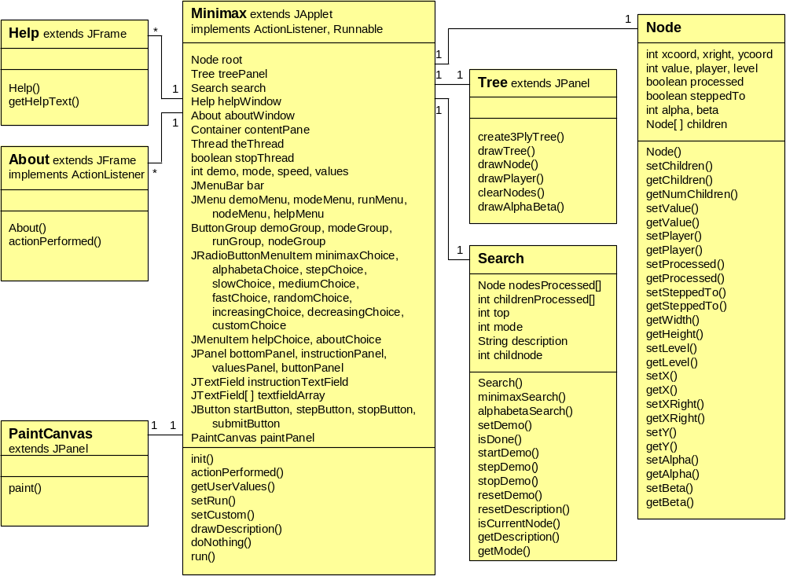
Figure 2.9 - Object Diagram
Figure 2.9 depicts the all the classes used in the application and their relationships. As described in Section 2.1, the Minimax class acts as the controller class for the application. When the Minimax object is instantiated at the time of loading the application applet, in addition to setting up the GUI as described in Section 2.2.1, the init( ) method instantiates objects of type Tree, Node, and Search. The init( ) method also sets the up the default values for the application by setting the demo, mode, speed, and values. It creates and array of values for the default tree and calls the Tree object to create a tree. It then paints the entire GUI to the screen, including the tree object. Lastly, it goes into “listen” mode to wait for the user to select an item in the GUI.

Whenever the user generates an event by selecting an item in the GUI, the setRun( ) method is called. The setRun( ) method is responsible for setting the GUI to the correct state based upon the event generated by the user. When the Start button is selected, the setRun( ) method disables the custom values entry panel, clears nodes of node & alpha-beta values, clears nodes of highlights, clears display of description, disables the Start button, enables the Stop button, enables the Step button if in Step mode or disables the Step button if in Run mode.

When a menu entry selected, or the demonstration finishes, the setRun( ) method enables the Start button, disables the Step button, disables the Stop button, stops any currently running algorithm demonstration (see Section 3 for a discussion of the implementation of the algorithm demonstration), clears nodes of highlights, clears nodes of node & alpha-beta values, clears the display of the description, and stops any currently running algorithm demonstration thread (see Section 2.3.3.9 for a discussion of thread usage). However, if the user stops the demonstration by pressing the Stop button, the setRun( ) method performs the above operations, except it does not clear nodes of node & alpha-beta values and does not clear the display of the description. This allows the user to stop a demonstration and be able to view the state of the demonstration without it being erased. Lastly, if the current mode is not set to Custom, then the setRun( ) method also disables the custom values entry panel.

2.2.3. Program Flow
2.2.3.1. Menu Selections
As described above, when the user makes a menu selection the setRun( ) method is called to stop and clean up from any currently running demonstration. In addition, variables are set and methods are called depending on the exact menu entry that is selected. With the exception of the Help menu, the menu entries are solely used to configure the algorithm demonstration. The algorithm demonstration is not started until the user presses the Start button.

2.2.3.2. Demo Menu
When an item in the demo menu is selected, the demo variable is set to the type of demo that is selected (MINIMAX or ALPHABETA). The setDemo( ) method of the Search class is also called to set the Search object to the selected demonstration mode.

2.2.3.3. Mode Menu
When an item in the mode menu is selected, the mode variable is set to the type of mode that is selected (Step-Through or Run). If the user chooses the run mode by selecting a speed value, then the mode is set to Run and the speed variable is set to the speed selected.

2.2.3.4. Node Values Menu
When an item in the Node Values menu is selected, the values variable is set to the selected node values entry. In the case of the Random, Increasing, and Decreasing selections, an array is created holding all integer node values for the tree, and the method create3PlyTree of the Tree class is called to create a tree structure using those values. The integer random node values are created using the Java 2 Platform Random class. In the case of the Custom selection, the setCustom() method is called which enables the custom values entry panel. Enabling the custom values entry panel causes the eight text fields to be enabled, the Submit button to be enabled, and the message “Enter 8 integer values between -99 & 99:” to be displayed. (For more details on entering custom values, see Section 2.2.3.6.)

2.2.3.5. Help Menu
Selecting an item in the Help menu simply calls the setRun method to disable any currently running algorithm demonstration and instantiates an object of either the Help or About menu.

2.2.3.6. Custom Values Entry
When the selection of Custom is made from the Node Values menu, the setCustom() method is called which enables the custom values entry panel. No other action is taken until the user presses the Submit button. Once the Submit button is pressed, the method getUserValues( ) is called from within a try/catch structure. The try/catch structure will catch exceptions of type NumberFormatException. The getUserValues( ) method gets the user entry from each text field, converts that value to an integer, checks that the integer is within the range of -99 & 99 and places that text field entry in an array of integer values that is used to create the search tree. If all the values are correct, then the create3PlyTree( ) method of the Tree class is called to create a tree structure containing the submitted values and the custom values entry panel is disabled. If any user entered value cannot be converted to an integer or the value is not in the range -99 & 99, then a NumberFormatException is thrown. If a NumberFormatException is thrown, then the catch part of the try/catch structure will display the message “INCORRECT ENTRY! Enter 8 integer values between -99 & 99:” and allow the user to re-enter the values.

2.2.3.7. Algorithm Demonstration
The menu selections are solely for configuration of the demonstration and to open the Help and About windows. The actual algorithm demonstration is controlled by the user through the Start, Step and Stop buttons. The Start button allows the user to start the demonstration. Once the user presses the Start button, two possible scenarios can take place depending on whether the demonstration is set to Step-Through mode or Run mode (Slow, Medium, Fast). These two scenarios are described in the following two sections.

2.2.3.8. Step-Through Mode
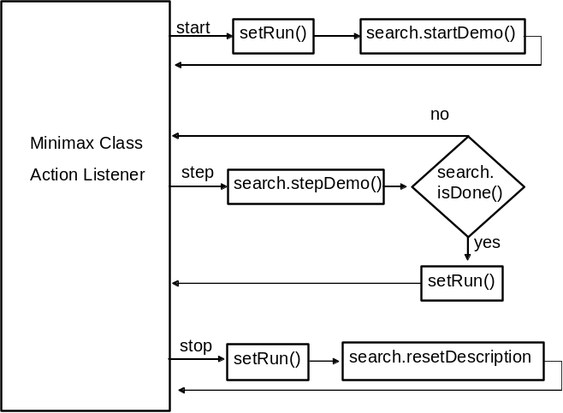
Figure 2.10 - Program Flow of Step-Through Mode
If the mode type is set to Step-Through mode, when the user presses the Start button the setRun( ) method is called (as described in Section 2.2.2), which enables the Step and Stop buttons and disables the Stop button in the GUI. The startDemo( ) method of the Search class is then called to initialize the demonstration and take the first step in the demonstration. (Details of the Search class are discussed in detail in Chapter 3 - Implementation.)

When the user presses the Step button, the stepDemo( ) method of the Search class is then called to take the next step in the algorithm demonstration. At each step taken, the isDone( ) method of the Search class is checked to see if the demonstration is complete. If it is not complete, then the Minimax class will wait for the user to press the Step button again. If the demonstration is complete, then the Minimax class will call the setRun( ) method in order to disable the Step and Stop buttons, re-enable the Start button, and clean up the other GUI elements.

If the user presses the Stop button, the setRun( ) method is called to disable the Step and Stop buttons, re-enable the Start button, and clean up other GUI elements. The resetDescription( ) method of the Search class is also called to clear the description string from the GUI.

2.2.3.9. Run Mode
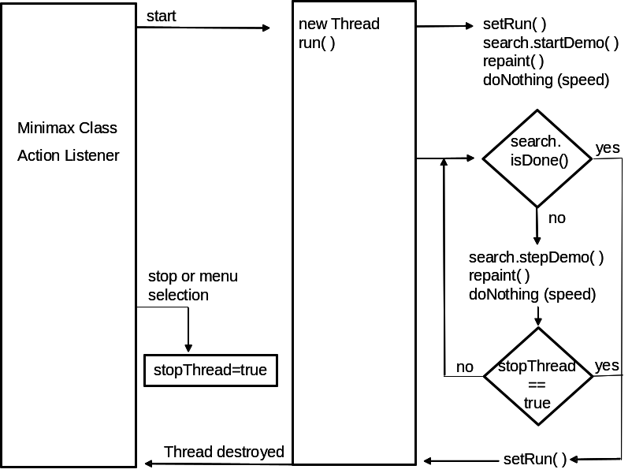
Figure 2.11 - Run Mode
In order to keep the GUI available to the user while a demonstration is being run, the Run mode uses a separate thread on which to run the demonstration. The stopThread boolean variable is used to tell the separate thread to stop when the user has either selected the Stop button or a menu entry. When the user presses the Start button, the stopThread boolean is initialized to false, a new thread object of the Thread class is then created and started using the start( ) method of the Thread object. (The Thread class is a part of the Java 2 Platform.) The start method of the Thread object automatically calls the run( ) method of the Minimax class. The run( ) method calls the setRun( ) method to disable the Start and Step buttons, enable the Step button, and clean up other GUI elements. It then calls the startDemo() method of the Search class to initialize the demonstration and take the first step. It then goes into a while loop where it takes one step, pauses for a period of speed determined by the speed mode (Slow, Medium or Fast) and checks the stopThread boolean to see if the user has selected to stop the demonstration. The while loop stops when either the stopThread boolean is true, or the demonstration has completed. In either case, the GUI is reset to the appropriate state and the separate thread is destroyed.

CHAPTER 3 - IMPLEMENTATION

3.1. Overview
The minimax algorithm is a recursive algorithm that is used to find the best move for MAX in a two-player game [4]. The minimax algorithm searches through the tree of all possible moves (nodes) until it reaches a final game state (terminal node) in the search tree. Each terminal node has a “utility” value [4] that tells the algorithm how much that end state is worth to the player MAX. The algorithm then uses the utility value of the terminal node to determine the utility value of nodes one level higher in the search tree [4]. The best play for MAX is the child node with the highest utility value. The best play for MIN is the child value with the lowest utility value. The algorithm continues backing up the search tree toward the root node of the tree, determining the best play for MAX and MIN alternatively. Eventually, the search reaches the root node of the tree, at which time the best move for MAX is determined. The algorithm assumes that MIN will always make the best move for MIN by always choosing the lowest utility value.

In most two-player games, the search tree of all possible moves is huge. Since the minimax algorithm must search through the tree to the terminal nodes, the speed at which the minimax algorithm can find a best play for MAX can be quite slow. An optimization of the minimax algorithm is called alpha-beta pruning [4]. With alpha-beta pruning the minimax algorithm is able to compute the best move for MAX without having to examine every node in the search tree. The algorithm accomplishes this by keeping a set of values: alpha and beta. Alpha is the best choice found so far in the search tree for MAX. Beta is the best value found so far in the search tree for MIN. While searching through the tree, if the algorithm determines that it has found a better choice either at the parent node of the current node or further up in the search tree, then does not need to examine the current node’s descendents. It can effectively “prune” that branch of the tree.

There are many pseudocode versions of the minimax algorithm available in textbooks and on the World Wide Web. This project utilized pseudocode from the textbook Artificial Intelligence, A Modern Approach [4], the Game Trees website [2], and the Minimax Explained website [1]. For explanation and comparison purposes, the pseudocode from the Game Trees website [2] is presented in Sections 3.1.1 and 3.1.2.

3.1.1. Overview of Minimax Algorithm
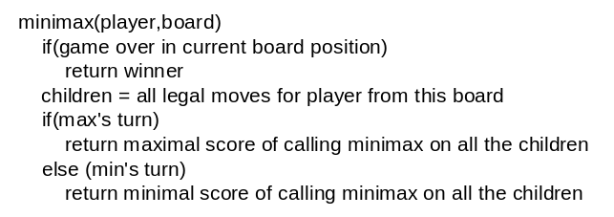
Figure 3.1 - Minimax Algorithm
In Figure 3.1, the minimax algorithm pseudocode [2] starts by checking if the search has reached a terminal node of the search tree. If it has then, the utility value of that terminal node is returned. If the search has not reached a terminal node then a list of all legal moves for the current player are generated. If it is MAX’s turn (which it will always be at the beginning) then the minimax function is recursively called on all the possible legal moves generated and the value of the node with the highest score is returned. If it is MIN’s turn then the minimax function is recursively called on all the possible legal moves generated and the value of the node with the lowest score is returned. Due to the recursive nature of the algorithm, the recursive function calls will not stop until terminal nodes are reached. Then the algorithm begins the process of examining the node values and returning the optimal value for the player at that level. The final result of the search tree is that nodes at each level of the search tree contain the optimal value for the player of that level. If the player for that level is MAX, then each node at that level contains the highest value of all the children moves generated from that node. If the player for that level is MIN, then each node contains the lowest value of all the children moves generated from that node. The final value returned to the first node in the search tree (MAX’s turn) is the value that delineates the best move for MAX in the game.

3.1.2. Overview of Minimax with Alpha-Beta Pruning Algorithm
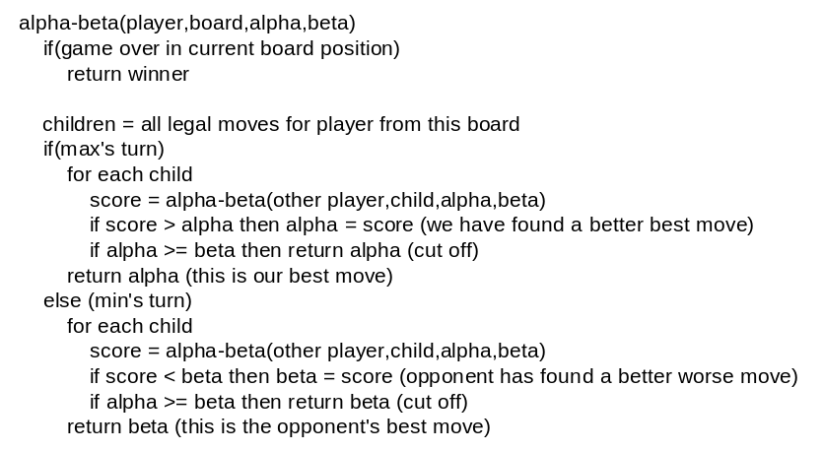
Figure 3.2 - Minimax with Alpha-Beta Algorithm
In the alpha-beta algorithm pseudocode of Figure 3.2 [2], the game starts in the same way as in minimax algorithm of Figure 3.1. It starts by checking if the search has reached a terminal node of the search tree. If it has, then the utility value of that terminal node is returned. If the search has not reached a terminal node then a list of all legal moves for the current player are generated. The alpha-beta function is then recursively called on all legal moves. Eventually the recursive search will reach a terminal state and return. At this point, if the calling function was in MAX’s turn, then the score is compared with the alpha value. If the score is greater than the alpha value, then the alpha value gets set to that score. Then if the alpha value is greater than or equal to the beta value, no further searching is needed and the alpha value is returned without examining any more children nodes. If the alpha value is not greater than or equal to the beta value, then the algorithm search continues to examine the next child node. If at no point in examining the child nodes alpha is greater than or equal to the beta value then the final alpha value is returned. The situation is similar for MIN, except that beta is the returned value.

3.2. Implementation Details

3.2.1. Stack Structure
As described in Section 3.1, the minimax and minimax with alpha-beta pruning use recursion to search the tree. When a computer program executes recursion, it creates stacks to hold values for each stage of the algorithm process. This stack creation is done internally to the application and is not in the application programmer’s control. For the purposes of the step-through features of this application, control was needed over each step of the algorithm procedure. To gain this control, the search algorithms were implemented with a method that utilizes its own stack structure to accomplish recursion instead of utilizing a method that uses recursion and creates its own stack. In other words, instead of letting a recursive method create its own internal stack, this application took control of the recursion process by creating its own stack structure to do the recursion.

The stack structure nodesProcessed is created when an object of the Search class is instantiated by the Minimax object. This stack structure consists of an array of Node objects. It is used to conduct a depth first search, starting with the left-most nodes of the tree. The array holds the nodes that have been stepped-through, but are not yet finished being examined. The stack structure array is set up to be at least as big as the number of levels of the tree. The variable “top” holds an integer number that represents the position in the array that is currently the top of the stack. At any time, the value of top-1 represents the current node being processed in the search tree. Once a node in the search tree is examined, and no further processing to that node is needed, then that node is taken off the stack by decrementing the top variable. When the value of the top variable becomes zero, then it is known that the algorithm has finished.

An array of integers, childrenProcessed, is used to determine how many of a node’s children have been examined. Each time the child node is examined, the array element in childrenProcessed, which corresponds to the array element of the parent node in nodesProcessed, is incremented. When the number of children of the parent node equals the integer in the corresponding childrenProcessed element, then it is known that all children of the parent node have been processed. In this way, the algorithm knows to continue to search through the rest of the tree.

When the user presses the Start button, the variables and structures of the Search object are initiated. The variable top is set to one and the root node is placed in the nodesProcessed array at location top-1. The first element in childrenProcessed is set to zero. If the algorithm demonstration is set to alpha-beta, then the alpha and beta variables of the root node are also set. At this point, when the GUI is refreshed and the drawTree method is called by the paint method, the user sees the root node graphically represented in yellow. This is because the drawTree( ) method always draws the current node (the node in nodesProcessed at location top-1) in yellow. The algorithm search process actually begins when the user presses the Step button, at which point the minimaxSearch( ) or alphabetaSearch( ) methods are called. The minimaxSearch( ) and alphabetaSearch( ) methods are described in detail in Sections 3.2.2 and 3.2.3.

3.2.2. Implementation of the Minimax Algorithm
Each time the minimaxSearch( ) method is called, one step of the algorithm search process is conducted. At each step, a description string is set to explain that step in the algorithm search process. The minimaxSearch( ) method is divided into four conditionals:
- If the value of the top variable is equal to zero, then it is known that the algorithm search is finished and the minimaxSearch( ) method simply returns.
- If the current node (nodesProcessed[top-1]) is a terminal node then the node is marked as processed, the top variable is decremented and the minimaxSearch( ) method ends and returns. This is similar to the first step in the algorithm of Figure 3.1, where the method returns the utility value of a function if it is determined that the search has reached a terminal node. The only difference is that in this stack implementation, the method simply returns. It does not return a utility value. Examination of the node values is not completed until step 3 of minimaxSearch( ).
- If all the children of the current node have been stepped-to then, in the same way as the algorithm of Figure 3.1, the current node will choose the optimal value from among its children nodes. If the player is MAX, all the children node values are examined and the current node value is set to the largest value of its children nodes. If the player is MIN, all the children node values are examined and the current node value is set to the smallest value of its children nodes. The minimaxSearch( ) method then marks the node as processed, decrements the top variable, ends and returns.
- If not all the children of the current node have been stepped-to, then the next child node that has not been stepped-to becomes the current node. The minimaxSearch( ) method then increments the top value, ends and returns.
When the minimaxSearch( ) method returns to the calling Minimax object, the Minimax object repaints the GUI and the most current node is drawn in yellow on the screen. The current description string is also drawn to the screen. Lastly, those nodes that have been marked as processed are drawn with their values filled-in.

3.2.3. Implementation of the Alpha-Beta Algorithm
Each time the alphabetaSearch( ) method is called, one step of the algorithm search process is conducted. At each step, a description string is set to explain that step in the algorithm search process. The alphabetaSearch( ) method is divided into four conditionals:
- If the value of the top variable is equal to zero, then it is known that the algorithm search is finished and the alphabetaSearch( ) method simply returns.
- If the current node (nodesProcessed[top-1]) is a terminal node then the node is marked as processed. Similar to Figure 3.2, the child node’s value is compared with the parent node’s alpha/beta values. If the parent node is player MAX, then the child node’s value is compared to the parent node’s alpha. If the child node’s value is greater than the parent node’s alpha then the parent node’s alpha is set to the child node’s value. If the parent node is player MIN, then the child node’s value is compared to the parent node’s beta. If the child node’s beta is less than the parent node’s beta then the parent node’s beta is set to the child node’s value. The top variable is decremented and the alphabetaSearch( ) method ends and returns.
- If all the children of the current node have been stepped-to, and the player is MAX, all the children node values are examined and the current node value is set to the largest value of its children nodes. If the player is MIN, all the children node values are examined and the current node value is set to the smallest value of its children nodes. The top variable is then decremented, so that the parent of the previous current node is now current node. The current node is then compared to the previous node. If the player is MAX and the previous node’s beta value is greater than the current node’s alpha value, then the current node’s alpha value gets set to the beta value of the previous node. If the player is MIN and the previous node’s alpha value is less than the current node’s beta value then the current node’s beta value gets set to the alpha value of the previous node. The alphabetaSearch( ) method then marks the node as processed and stepped-to. Then ends and returns.
- If not all the children of the current node have been stepped-to, then the alpha and beta values are examined to determine if the search process needs to search down the next branch of the search tree. This conditional is divided into two more conditionals:
  - In the same way as in Figure 3.2, if the current node’s alpha is greater than or equal to the current node’s beta, then the branch of the tree can be pruned. The value of the current node is still filled with the highest or lowest child value examined, depending upon whether the current node’s player level is MAX or MIN respectively. The value of top is then decremented and the new current node is examined (the parent of the previous current node). The alpha and beta values of the previous node and the current node are compared. If the player is MAX and the previous node’s beta value is greater than the current node’s alpha value, then the current node’s alpha value gets set to the beta value of the previous node. If the player is MIN and the previous node’s alpha value is less than the current node’s beta value then the current node’s beta value gets set to the alpha value of the previous node. The method then ends and returns.
  - If the current node’s alpha is not greater than or equal to the current node’s beta, then the branch of the tree cannot be pruned. In this case the next child node that has not been stepped-to becomes the current node. The alphabetaSearch( ) method then sets the alpha and beta values of the new current node to the alpha and beta values of the previous current node (parent node), increments the top value, sets the current node as stepped-to, ends and returns.
When the alphabetaSearch( ) method returns to the calling Minimax object, the Minimax object repaints the GUI and the current node is drawn in yellow on the screen. The current description string is drawn to the screen. Those nodes that have been marked as processed are drawn with their values filled-in. Lastly, the alpha-beta values are drawn above those nodes that have been marked as stepped-to.

CHAPTER 4 - PERFORMANCE ANALYSIS

4.1. Software Performance

4.1.1. State Control
The GUI is event driven, which means it waits for user input to take an action. Great care was taken when developing and testing the application to ensure that at any time during the running of the algorithm demonstration the user can access the menu without causing the application to get into an unexpected state. When in Run mode, the event of the user selecting the Start button starts a new thread for the algorithm demonstration, thus allowing the user to still access the application GUI to stop the demonstration or select a menu entry. When in Step-Through mode, the application state changes to event listen mode between each step, allowing the user full access to the GUI. Any feature that should not be accessed during the algorithm demonstration is disabled so that the user cannot accidentally cause the application to get into an unexpected state. For example, in Figure 4.1, the start button and custom values entry panel are disabled while the algorithm demonstration is running in step-through mode. In Figure 4.2, the start button, step button, and custom values entry panel are disabled while the algorithm demonstration is in run mode. The menu system, however, is always available to the user.
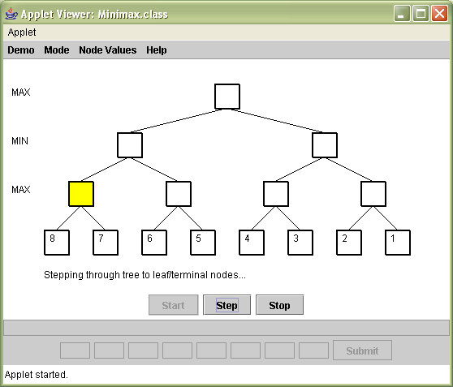
Figure 4.1 - Step-Through Mode
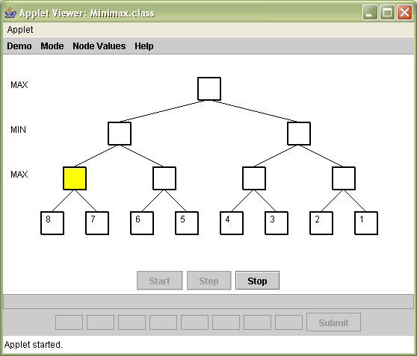
Figure 4.2 - Run Mode
Since the application is event-driven, the user controls the speed at which the application performs. The only time that the user does not have full control of the application is while a demonstration is being executed in Run mode. However, the user is given some control by being able to choose various speeds at which to run the application demonstration. Internally this is implemented using a thread pause method.
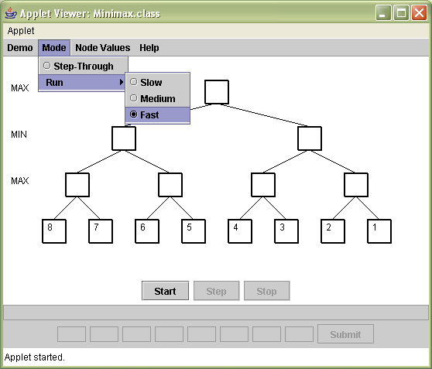
Figure 4.3 - Run mode selections

4.1.2. Usability
The user interface for the application is very straight-forward and easy to use. The menu system is very easy to understand and uses non-technical terms when possible. The start, step and stop buttons make common sense to the running of the algorithm demonstration. The custom values entry panel is simple and easy to use. The algorithm demonstration uses color and text to graphically show the user the current step of the algorithm process. A help area is also provided to explain the configuration settings and running of the application.

4.2. Comparisons
The algorithm demonstration located on the MIT website [5] uses technical wording and graphically represents the algorithm demonstration in a way that is very cryptic and hard-to-view. It does offer a number of configuration choices to the user, but the wording is often cryptic and there is no help section for explanation. The U.C. Berkeley demonstration [2] on the other hand is extremely simple and easy to understand, but does not offer the student enough choices for running the algorithm demonstration. It also has no help area. On the other hand, this CSUS project offers a balance between being too technical and too simplistic. The menu selections are worded in a non-technical manner. The visuals as the user runs the demonstration provide a clear picture of what is happening at the moment. The application offers enough choices for configuration to make the demonstration useful. A help area is also provided to explain all the menu selections and how to run the application.
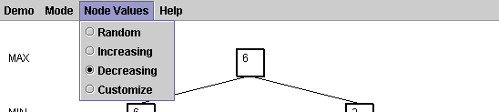
Figure 4.4 - Non-Technical Menu Wording Example

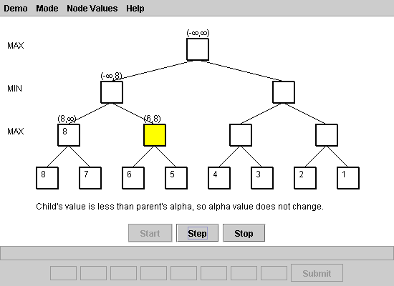
Figure 4.5 - Clear Visuals Example

The MIT demonstration application offers a choice between a number of large search trees. As seen in Figure 4.6, some of the search trees are so large, however, as to be unusable due to the small size of nodes and font. The smaller trees offer a good size to demonstrate the alpha-beta pruning algorithm. The U.C. Berkeley demonstration offers two sizes of trees, one of which offers a large enough tree to properly demonstrate the alpha-beta pruning algorithm. This CSUS project offers only one tree size. This tree size is just large enough to properly demonstrate the alpha-beta pruning algorithm without getting to big to fit on the screen and be easily viewed.
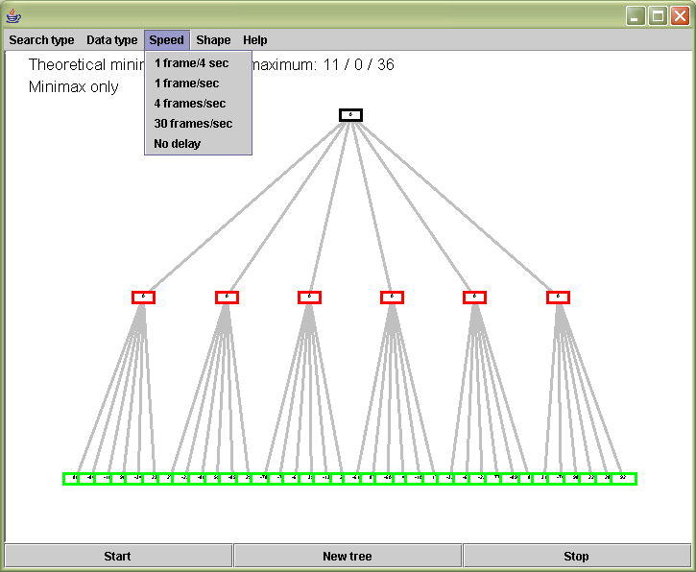
Figure 4.6 - MIT Demonstration Example

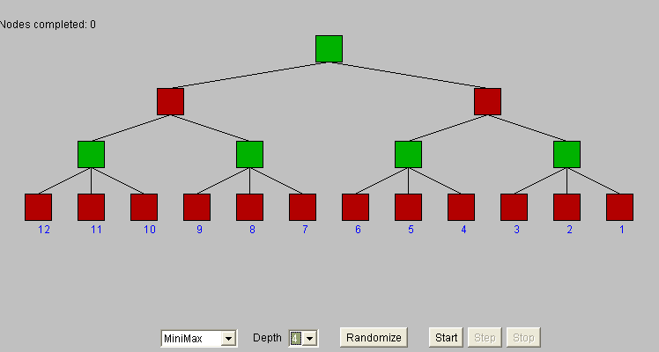
Figure 4.7 - U.C. Berkeley Demonstration Example

The MIT demonstration only offers a run-through mode at various speeds, while the U.C. Berkeley demonstration only offers a step-through mode. This CSUS project offers the user the choice of both a step-through mode and a run-through mode at various speeds.

This CSUS project also offers a textual description of each step of the algorithm process when in step-through mode or slow run mode (see Figure 4.5). Both the MIT and U.C. Berkeley demonstrations fail to offer this type of feature, and therefore, do not explain the algorithm process as well as this CSUS project.

Lastly, neither the MIT nor U.C. Berkeley algorithm demonstrations offer the user the choice of entering custom terminal node values for the tree. The MIT demonstration offers a selection of five preset trees (Figure 4.8), while the U.C. Berkeley demonstration offers a choice of choosing random tree node values or decreasing values at startup only (Figure 4.9). Once the user has chosen random values for the tree, he/she no longer has the option of choosing decreasing values. This is a flaw in the program structure. As seen in Figure 4.7, this CSUS project offers the user four choices for specifying terminal node values of the tree, one of which is to enter custom values. At any time the user may change the terminal node values of the tree.
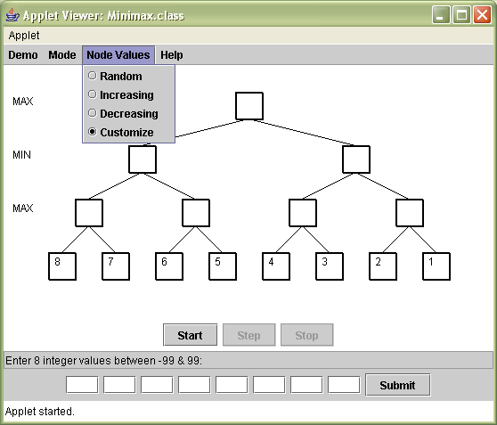
Figure 4.7 - Tree Node Values Selection

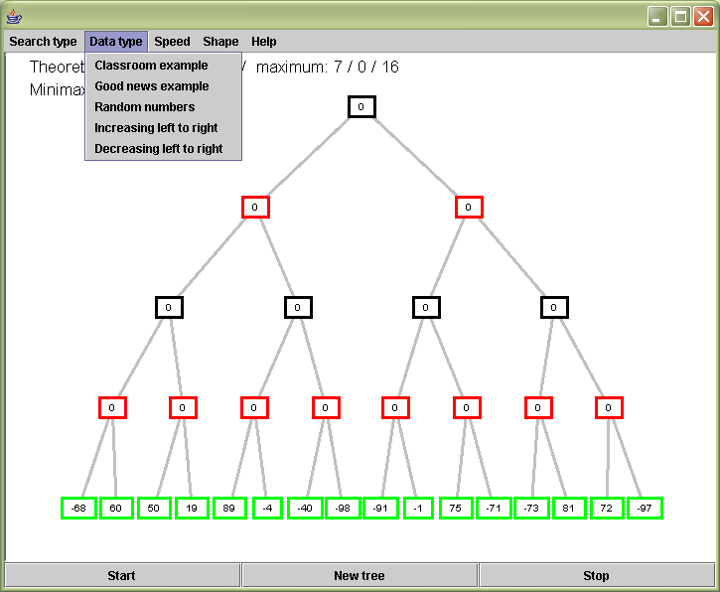
Figure 4.8 - MIT Demonstration Tree Node Selections

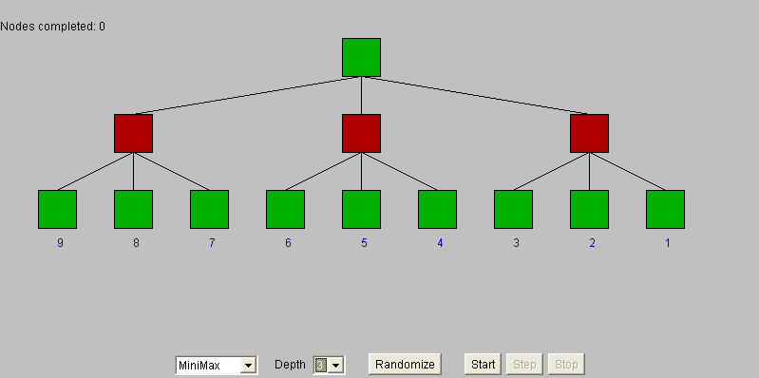
Figure 4.9 - U.C. Berkeley Tree Node Values Selection

CHAPTER 5 - CONCLUSION AND FUTURE WORK

5.1. Results
The goal of this software project was to create a java applet application that demonstrated the minimax algorithm with and without alpha-beta pruning to students of artificial intelligence in order to facilitate deeper understanding of the minimax algorithm. This goal was met with an application that is easy to use, provides a variety of configuration options, and clearly demonstrates each step of the algorithm search process with visual and textual aids.

The design uses event-driven programming to allow the user control over the GUI at all times. Recursion is used to quickly and efficiently create and draw the tree structure. A stack structure is used to allow the application to stop at each step of the algorithm demonstration. The program starts a separate thread while in run mode to ensure that the application GUI is always available to the user. Lastly, the GUI was designed and tested so that the user cannot put the application into a bad state.

In comparison with other minimax algorithm demonstrations, this demonstration offers a wide enough range of configuration settings and features to remain usable without getting overly complicated or too simplistic. Features such as textual descriptions of each step and custom terminal node value entry make this algorithm demonstration the better choice by students to enable deeper understanding of the minimax algorithm and its optimization, alpha-beta pruning.

5.2. Future Improvements
This application could be greatly improved by adding choices for larger tree sizes. This would allow more ways to see the pruning of the alpha-beta pruning algorithm, which would aid students in the understanding of this algorithm. However, the addition of choices for larger tree sizes would add much complexity to the application due to the need to dynamically determine the screen size needed to fit the larger trees, the need to allow users to enter custom values for multiple types of trees, and the need to set up the different combinations of preset terminal node values for the trees.

APPENDIX A - SOFTWARE CODE
//******************************************************************
//Class: Minimax
//Main class that creates applet, sets up the GUI and
//manages program flow
//******************************************************************

import javax.swing.JApplet;
import javax.swing.JFrame;
import javax.swing.JMenu;
import javax.swing.JMenuItem;
import javax.swing.ButtonGroup;
import javax.swing.JRadioButtonMenuItem;
import javax.swing.JMenuBar;
import javax.swing.JButton;
import javax.swing.JPanel;
import javax.swing.JTextField;
import java.awt.Container;
import java.awt.BorderLayout;
import java.awt.FlowLayout;
import java.awt.Color;
import java.awt.event.ActionListener;
import java.awt.event.ActionEvent;
import java.awt.Graphics;
import java.util.Random;

//class minimax
public class Minimax extends JApplet implements
ActionListener, Runnable
{
//create unchangeable variables
private static final int MINIMAX = 0;
private static final int ALPHABETA = 1;
private static final int STEP = 1;
private static final int RUN = 2;
private static final int SLOW = 1900;
private static final int MEDIUM = 1300;
private static final int FAST = 600;
private static final int RANDOM = 1;
private static final int INCREASING = 2;
private static final int DECREASING = 3;
private static final int CUSTOM = 4;
private static final int TOPMARGIN = 30;
private static final int LEFTMARGIN = 50;

//create variables and objects used in demonstration
private Node root;
private Tree treePanel;
private Search search;
private Container contentPane;
private Thread theThread;
private boolean stopThread;
private int demo;
private int mode;
private int speed;
private int values;

//create objects used for GUI
private JMenuBar bar;
private JMenu demoMenu;
private JMenu modeMenu;
private JMenu runMenu;
private JMenu nodeMenu;
private JMenu helpMenu;
private ButtonGroup demoGroup;
private ButtonGroup modeGroup;
private ButtonGroup runGroup;
private ButtonGroup nodeGroup;
private JRadioButtonMenuItem minimaxChoice;
private JRadioButtonMenuItem alphabetaChoice;
private JRadioButtonMenuItem stepChoice;
private JRadioButtonMenuItem slowChoice;
private JRadioButtonMenuItem mediumChoice;
private JRadioButtonMenuItem fastChoice;
private JRadioButtonMenuItem randomChoice;
private JRadioButtonMenuItem increasingChoice;
private JRadioButtonMenuItem decreasingChoice;
private JRadioButtonMenuItem customChoice;
private JMenuItem helpChoice;
private JMenuItem aboutChoice;
private JPanel bottomPanel;
private JPanel instructionPanel;
private JPanel valuesPanel;
private JPanel buttonPanel;
private JTextField instructionTextField;
private JTextField[] textfieldArray;
private JButton startButton;
private JButton stepButton;
private JButton stopButton;
private JButton submitButton;
private PaintCanvas paintPanel;
private Help helpWindow;
private About aboutWindow;

//**************************************************************
//Method: init
//Constructor for a JApplet
//Preconditions: run applet
//Postconditions: sets all default settings & creates GUI
//**************************************************************
public void init()
{
//CONFIGURING DEFAULTS
demo = MINIMAX;
mode = STEP;
speed = SLOW;
values = DECREASING;
stopThread = false;
treePanel = new Tree();
search = new Search();
int[] treeArray = {0,0,0,0,0,0,0,8,7,6,5,4,3,2,1};
root = treePanel.create3PlyTree(treeArray, 0, 0);

// CREATING MENU
//create Demo menu & set listeners
demoMenu = new JMenu("Demo");
minimaxChoice = new JRadioButtonMenuItem("Minimax");
minimaxChoice.setSelected(true);
minimaxChoice.addActionListener(this);
demoMenu.add(minimaxChoice);
demoGroup = new ButtonGroup();
demoGroup.add(minimaxChoice);
alphabetaChoice = new JRadioButtonMenuItem("Alpha-Beta");
alphabetaChoice.setSelected(false);
alphabetaChoice.addActionListener(this);
demoMenu.add(alphabetaChoice);
demoGroup.add(alphabetaChoice);

//create Configure menu & set listeners
modeMenu = new JMenu("Mode");
runMenu = new JMenu("Run");
stepChoice = new JRadioButtonMenuItem("Step-Through");
stepChoice.setSelected(true);
stepChoice.addActionListener(this);
modeMenu.add(stepChoice);
modeGroup = new ButtonGroup();
modeGroup.add(stepChoice);
modeGroup.add(runMenu);
slowChoice = new JRadioButtonMenuItem("Slow");
slowChoice.setSelected(false);
slowChoice.addActionListener(this);
runMenu.add(slowChoice);
modeGroup.add(slowChoice);
mediumChoice = new JRadioButtonMenuItem("Medium");
mediumChoice.setSelected(false);
mediumChoice.addActionListener(this);
runMenu.add(mediumChoice);
modeGroup.add(mediumChoice);
fastChoice = new JRadioButtonMenuItem("Fast");
fastChoice.setSelected(false);
fastChoice.addActionListener(this);
runMenu.add(fastChoice);
modeGroup.add(fastChoice);
modeMenu.add(runMenu);

//Create Node Values menu & set listeners
nodeMenu = new JMenu("Node Values");
randomChoice = new JRadioButtonMenuItem("Random");
randomChoice.setSelected(false);
randomChoice.addActionListener(this);
nodeMenu.add(randomChoice);
nodeGroup = new ButtonGroup();
nodeGroup.add(randomChoice);
increasingChoice = new JRadioButtonMenuItem("Increasing");
increasingChoice.setSelected(false);
increasingChoice.addActionListener(this);
nodeMenu.add(increasingChoice);
nodeGroup.add(increasingChoice);
decreasingChoice = new JRadioButtonMenuItem("Decreasing");
decreasingChoice.setSelected(true);
decreasingChoice.addActionListener(this);
nodeMenu.add(decreasingChoice);
nodeGroup.add(decreasingChoice);
customChoice = new JRadioButtonMenuItem("Customize");
customChoice.setSelected(false);
customChoice.addActionListener(this);
nodeMenu.add(customChoice);
nodeGroup.add(customChoice);

//Create Help menu & set listeners
helpMenu = new JMenu("Help");
helpChoice = new JMenuItem("Help");
helpChoice.addActionListener(this);
helpMenu.add(helpChoice);
aboutChoice = new JMenuItem("About");
aboutChoice.addActionListener(this);
helpMenu.add(aboutChoice);

//Add menus to menu bar and "activate" menu bar
bar = new JMenuBar();
bar.add(demoMenu);
bar.add(modeMenu);
bar.add(nodeMenu);
bar.add(helpMenu);
setJMenuBar(bar);

// CREATING BUTTONS
startButton = new JButton("Start");
startButton.addActionListener(this);
stepButton = new JButton("Step");
stepButton.addActionListener(this);
stepButton.setEnabled(false);
stopButton = new JButton("Stop");
stopButton.addActionListener(this);
stopButton.setEnabled(false);
submitButton = new JButton("Submit");
submitButton.addActionListener(this);
submitButton.setEnabled(false);

// SETTING GUI LAYOUT
//creating paint panel
paintPanel = new PaintCanvas();
paintPanel.setBackground(Color.WHITE);

//creating panel for instructions on entering custom values
instructionPanel = new JPanel();
instructionPanel.setLayout(new BorderLayout());
instructionTextField = new JTextField(60);
instructionTextField.setEditable(false);
instructionTextField.setText("");
instructionPanel.add(instructionTextField);

//creating custom user values panel
valuesPanel = new JPanel();
valuesPanel.setLayout(new FlowLayout());
textfieldArray = new JTextField[9];
for(int i=0; i<textfieldArray.length; i++)
{
textfieldArray[i] = new JTextField(3);
textfieldArray[i].setEditable(false);
}
for(int i=0; i<8; i++)
valuesPanel.add(textfieldArray[i]);
valuesPanel.add(submitButton);

//create button panel
buttonPanel = new JPanel();
buttonPanel.setLayout(new FlowLayout());
buttonPanel.setBackground(Color.WHITE);
buttonPanel.add(startButton);
buttonPanel.add(stepButton);
buttonPanel.add(stopButton);

//creating panel to put instruction, values & button panels
bottomPanel = new JPanel();
bottomPanel.setLayout(new BorderLayout());
bottomPanel.add(buttonPanel,BorderLayout.NORTH);
bottomPanel.add(instructionPanel,BorderLayout.CENTER);
bottomPanel.add(valuesPanel,BorderLayout.SOUTH);

//add panels to content pane
contentPane = getContentPane();
contentPane.setLayout(new BorderLayout());
contentPane.setBackground(Color.WHITE);
contentPane.add(paintPanel, BorderLayout.CENTER);
contentPane.add(bottomPanel, BorderLayout.SOUTH);
}

//**************************************************************
//Method: actionPerformed
//Listener for GUI events
//Preconditions: GUI event
//Postconditions: fires action based upon GUI event
//**************************************************************
public void actionPerformed(ActionEvent e)
{
String eventString = e.getActionCommand();

//DEMO MENU ACTIONS
if(eventString.equals("Minimax"))
{
demo = MINIMAX;
search.setDemo(MINIMAX);
setRun(false,false);
}
else if(eventString.equals("Alpha-Beta"))
{
demo = ALPHABETA;
search.setDemo(ALPHABETA);
setRun(false,false);
}

//MODE MENU ACTIONS
else if(eventString.equals("Step-Through"))
{
mode = STEP;
setRun(false,false);
}
else if(eventString.equals("Slow"))
{
mode = RUN;
speed = SLOW;
setRun(false,false);
}
else if(eventString.equals("Medium"))
{
mode = RUN;
speed = MEDIUM;
setRun(false,false);
}
else if(eventString.equals("Fast"))
{
mode = RUN;
speed = FAST;
setRun(false,false);
}

//NODE MENU ACTIONS
else if(eventString.equals("Random"))
{
values = RANDOM;
setRun(false,false);

//create array of random values & populate
//terminal node values
Random r = new Random();
int[] treeArray = new int[15];
for(int i = 7; i < 15; i++)
{
int sign = r.nextInt(3);
if(sign%2 == 0)
sign = 1;
else
sign = -1;

treeArray[i] = r.nextInt(99) * sign;
}
root = treePanel.create3PlyTree(treeArray, 0, 0);
}
else if(eventString.equals("Increasing"))
{
values = INCREASING;
setRun(false,false);

//create array of random values & create tree
int[] treeArray = {0,0,0,0,0,0,0,1,2,3,4,5,6,7,8};
root = treePanel.create3PlyTree(treeArray, 0, 0);

}
else if(eventString.equals("Decreasing"))
{
values = DECREASING;
setRun(false,false);

int[] treeArray = {0,0,0,0,0,0,0,8,7,6,5,4,3,2,1};
root = treePanel.create3PlyTree(treeArray, 0, 0);
}
else if(eventString.equals("Customize"))
{
values = CUSTOM;
setRun(false,false);
setCustom(true);
}

//HELP MENU ACTIONS
else if(eventString.equals("Help"))
{
setRun(false,false);
helpWindow = new Help(); //open Help menu
}
else if(eventString.equals("About"))
{
setRun(false,false);
aboutWindow = new About(); //open About window
}

//BUTTON ACTIONS FOR DEMONSTRATION CONTROLS
else if(eventString.equals("Start"))
{
if(mode == STEP)
{
//enable GUI for running
setRun(true,false);

//initialize demo and take first step
search.startDemo(root);
}

if(mode == RUN)
{
//re-set thread run state
stopThread = false;

//create a new thread for run state
Thread theThread = new Thread(this);

//start demonstration run thread
theThread.start();
}
}
else if(eventString.equals("Step"))
{
//go to next step in algorithm demo
search.stepDemo();

//if algorithm demo has finished running
//change state of GUI
if(search.isDone())
setRun(false,true);
}
else if(eventString.equals("Stop"))
{
setRun(false,true);

//clear description if user presses stop button
search.resetDescription();
}

//BUTTON ACTIONS FOR CUSTOM VALUES ENTRY PANEL
else if(eventString.equals("Submit"))
{
try
{
//check user entered values are correct
getUserValues();
setCustom(false);
}
//catch number format exception
//thrown from getUserValues
catch(NumberFormatException e2)
{
//Let user know that values entered are not
//correct and user needs to re-enter
instructionTextField.setText("INCORRECT ENTRY! " +
"Enter 8 integer values between -99 & 99:");
}
}

//refreshes the GUI with the latest values based
//upon the action taken
repaint();
}

//**************************************************************
//Method: getUserValues
//checks the custom terminal node values entered by the user
//Preconditions: textfieldArray exists
//Postconditions: creates tree with terminal node values
// entered by user or throws
// NumberFormatException
//**************************************************************
public void getUserValues() throws NumberFormatException
{
int[] treeArray = new int[15];
for(int i=7; i<treeArray.length; i++)
{
//check custom user values are integers
//while placing in an array
treeArray[i] = Integer.parseInt
(textfieldArray[i-7].getText());

//re-check custom user values to ensure within
//specified parameters
//if not then throw a NumberFormatException
if(treeArray[i] < -99 || treeArray[i] > 99)
throw new NumberFormatException();
}
//create tree using array of custom user values
root = treePanel.create3PlyTree(treeArray, 0, 0);
}

//**************************************************************
//Method: setRun
//Enables or disables GUI elements
//Preconditions: boolean indicating state of demonstration
//Postconditions: GUI buttons are enabled or disabled
//**************************************************************
private void setRun(boolean start, boolean demoDone)
{
//user selected to run the algorithm demonstration
if(start)
{
//disable Custom values entry panel
setCustom(false);

//clears nodes of node & alpha-beta values
treePanel.clearNodes(root);

//clears nodes of highlights
search.resetDemo();

//clears display of description
search.resetDescription();

//disable Start button in GUI
startButton.setEnabled(false);

//enable Stop button in GUI
stopButton.setEnabled(true);

//enable Step button in GUI
if(mode == STEP)
stepButton.setEnabled(true);

//disable Step button in GUI
if(mode == RUN)
stepButton.setEnabled(false);
}
//user has not selected to run algorithm
//demonstration or demo done
else
{
//enable Start button in GUI
startButton.setEnabled(true);

//disable Step button in GUI
stepButton.setEnabled(false);

//disable Stop button in GUI
stopButton.setEnabled(false);

//sets top=0
search.stopDemo();

//clears nodes of highlights
search.resetDemo();

//if the demo is stopped by other
//than stop button or demo finished
//then reset the tree values
if(!demoDone)
{
//clears nodes of node & alpha-beta values
treePanel.clearNodes(root);

//clears display of description
search.resetDescription();
}

//if user has not selected custom node values
//disable the custom values entry panel
if(values != CUSTOM)
setCustom(false);

//stop any Run threads that may be currently running
stopThread = true;
}
}

//**************************************************************
//Method: setCustom
//Enables or disables GUI elements on custom values entry panel
//Preconditions: boolean
//Postconditions: GUI elements enabled or disabled
//**************************************************************
private void setCustom(boolean start)
{
//user has selected to enter custom
//terminal values for the tree
if(start)
{
instructionTextField.setText
("Enter 8 integer values between -99 & 99:");

for(int i=0; i<textfieldArray.length; i++)
{
textfieldArray[i].setText("");
textfieldArray[i].setEditable(true);
}
submitButton.setEnabled(true);
}
//user has selected not to enter custom
//terminal values for tree
else
{
instructionTextField.setText("");
for(int i=0; i<textfieldArray.length; i++)
{
textfieldArray[i].setEditable(false);
textfieldArray[i].setText("");
}
submitButton.setEnabled(false);
}
}

//**************************************************************
//Method: drawDescription
//Draws description of steps from demonstration below tree
//Preconditions: Graphics object, description string from
// Search object
//Postconditions: String is drawn to screen
//**************************************************************
public void drawDescription(Graphics g)
{
String description;

//get current step description
description = search.getDescription();

//draw description
g.drawString(description,LEFTMARGIN,
8*root.getHeight()+TOPMARGIN);
}

//**************************************************************
//Method: doNothing
//Sleeps for number of milliseconds
//Preconditions: integer value indicating number of
// milliseconds to sleep
//Postconditions: sleeps for number of milliseconds
// or outputs "Unexpected interrupt"
//**************************************************************
public void doNothing(int milliseconds)
{
try
{
//pause current thread for number of milliseconds
Thread.sleep(milliseconds);
}
//catch exception if thrown
catch(InterruptedException e)
{
System.out.println("Unexpected interrupt");
//System.exit(0);
}
}

//**************************************************************
//Method: run
//Runs the algorithm demonstration in its entirety
//Preconditions: TreePanel object, Search object
//Postconditions: Algorithm demonstration runs
//**************************************************************
public void run()
{
//enable GUI for running
setRun(true,false);

//initialize demonstration and start running
search.startDemo(root);

//refresh GUI
repaint();

//pause
doNothing(speed);

//While DEMO is not done:
while(!search.isDone())
{
//take next step in demonstration
search.stepDemo();

//refresh GUI
repaint();

//pause
doNothing(speed);

//if user stops demo end while loop
//(GUI has already been reset)
if(stopThread == true)
break;
}

//disable GUI if search is done
if(search.isDone())
setRun(false,true);
}

//**************************************************************
//Method: PaintCanvas
//Custom inner class to draw tree and description
//NOTE: Could not use paint method within Minimax class due to
// problem with drawn elements showsing through menu
//Preconditions: Graphics object, TreePanel object
//Postconditions: Draws the tree and description if mode is STEP
// or mode is Run and speed is SLOW
//**************************************************************
private class PaintCanvas extends JPanel
{
public void paint(Graphics g)
{
super.paint(g);

//draws the tree
treePanel.drawTree(g, root, search,
LEFTMARGIN, TOPMARGIN);

//draws the description
if(mode == STEP || (mode != STEP && speed == SLOW))
drawDescription(g);
}
}
}

//******************************************************************
//Class: Tree
//Contains methods to create tree, draw tree, draw nodes,
//draw player level and unclear all processed nodes.
//******************************************************************

import javax.swing.JPanel;
import java.awt.Graphics;
import java.awt.Color;
import java.awt.FontMetrics;
import java.text.DecimalFormatSymbols;

public class Tree extends JPanel
{
//create unchangeable variables
private static final int MAX = 1;
private static final int MIN = 2;
private static final int TWOPLY = 1;
private static final int THREEPLY = 2;
private static final int RANDOM = 1;
private static final int INCREASING = 2;
private static final int DECREASING = 3;
private static final int CUSTOM = 4;
private static int MINIMAX = 0;
private static int ALPHABETA = 1;

//**************************************************************
//Method: create3PlyTree
//Recursively creates a 3-ply tree of Nodes with 2 children each
//Preconditions: array with node values length of 15
// current node number (starts with zero for root)
// level of tree (starts with zero for top level
// of tree)
//Postconditions: node of tree
// each non-terminal node has an array of child
// nodes. terminal nodes have value of node set
// nodes have player level set (MIN or MAX)
//*************************************************************
public Node create3PlyTree(int[] values, int nodenumber,
int level)
{
int leaves = 2;

//Create a node to be set and returned
Node node = new Node();

//if node is terminal node then set value and
//player and return node
if(nodenumber * leaves + 1 >= values.length)
{
node.setValue(values[nodenumber]);
node.setLevel(level);

if(level%2 == 0)
node.setPlayer(MAX);
else
node.setPlayer(MIN);

return node;
}

//else if non-terminal node, create an array of children
//recursively call createTree to build an
//array of children nodes
Node[] children = new Node[leaves];
for(int childindex=1; childindex<=leaves; childindex++)
children[childindex-1] = create3PlyTree(values,
nodenumber * leaves + childindex, level+1);

//set player and children nodes and return node
if(level%2 == 0)
node.setPlayer(MAX);
else
node.setPlayer(MIN);

node.setChildren(children);
node.setLevel(level);

return node;
}

//**************************************************************
//Method: drawTree
//Recursively draws a tree
//Preconditions: graphics object
// node of tree that was built with createTree
// method x & y coordinates for current node
//Postconditions: tree is drawn to screen
//**************************************************************
public void drawTree(Graphics g, Node node, Search search,
int x, int y)
{
//if node is a terminal node then set its x & y coordinates
//and draw node
if(node.getNumChildren() == 0)
{
node.setX(x);
node.setXRight(x + node.getWidth());
node.setY(y);
drawNode(g, node, x, y, Color.BLACK,
search.isCurrentNode(node), Color.YELLOW);
}
else //if node is not a terminal node
{
//get the array of node's children
Node[] children = node.getChildren();

//get the number of node's children
int childNum = node.getNumChildren();
int k;
int height = node.getHeight();
int xspread = node.getWidth();
int yspread = node.getHeight();

//for each of node's children, recursively draw subtrees
for(k=0; k<childNum; k++)
{
drawTree(g, children[k], search,x,y+height+yspread);
x = children[k].getXRight() + xspread;
}

//draw node and set heigth & width settings for that
//node in tree
node.setX(children[0].getX());
node.setXRight(children[childNum-1].getXRight());
node.setY(y);
x = ((node.getX() + node.getXRight())/2) -
(node.getWidth()/2);
drawNode(g, node, x, y, Color.BLACK,
search.isCurrentNode(node), Color.YELLOW);

//draws the player level of MAX or MIN
g.setColor(Color.BLACK);
drawPlayer(g, node, 10, y+(height/2));

//draw lines connecting current node to all child nodes
g.setColor(Color.BLACK);
for(k=0; k<childNum; k++)
{
int x1 = (node.getX() + node.getXRight())/2;
int y1 = y + node.getHeight();
int x2 = (children[k].getX() +
children[k].getXRight())/2;
int y2 = children[k].getY();
g.drawLine(x1,y1,x2,y2);
}

g.setColor(Color.BLACK);
if(search.getMode() == ALPHABETA)
{
if(node.getSteppedTo())
drawAlphaBeta(g, node, x, y);

if(node.getPrunedChildren())
drawNode(g, node, x, y, Color.RED,
search.isCurrentNode(node), Color.YELLOW);
}
}
}

//**************************************************************
//Method: drawNode
//Draws a node
//Preconditions: graphics object
// node of type Node
// x and y coordinates have been set for node
// color object
//Postconditions: node is drawn at x and y coordinates
// in color specified by color object
// and value filled in for node if applicable
//**************************************************************
public void drawNode(Graphics g, Node node, int x, int y,
Color color, boolean current, Color fillcolor)
{
int width = node.getWidth();
int height = node.getHeight();

//if the search is currently looking at the node
//then draw it differently
if(current)
{
g.setColor(fillcolor);
g.fillRect(x, y, width, height);
}

g.setColor(color);
g.drawRect(x, y, width, height);

//draws again slightly offset to make bold
g.drawRect(x+1, y+1, width, height);

//if node has been processed or the node is a terminal node
//then draw the node value inside the node
if(node.getProcessed() || (node.getNumChildren() == 0))
g.drawString(String.valueOf(node.getValue()),
x+((width/2)/2),y+(height/2));
}

//**************************************************************
//Method: drawPlayer
//Draws the player (MIN or MAX) next to left of passed in node
//Preconditions: graphics object
// node of type Node
// x and y coordinates have been set for node
//Postconditions: player is drawn to left of passed in ode
//**************************************************************
public void drawPlayer(Graphics g, Node node, int x, int y)
{
if(node.getPlayer() == MAX)
g.drawString("MAX",x, y);
else
g.drawString("MIN",x, y);
}

//**************************************************************
//Method: clearNodes
//Recursively resets flags on all nodes in tree to false
//Preconditions: node of type Node
//Postconditions: all nodes are cleared
//**************************************************************
public void clearNodes(Node node)
{
Node[] children = node.getChildren();
node.setProcessed(false);
node.setSteppedTo(false);
node.setPrunedChildren(false);
for(int i = 0; i < node.getNumChildren(); i++)
clearNodes(children[i]);
}

//**************************************************************
//Method: drawAlphaBeta
//Draws the alpha & beta values for the node above the node
//Preconditions: graphics object, node, x & y coordinates
//Postconditions: alpha & beta values for node
//are drawn above node
//**************************************************************
public void drawAlphaBeta(Graphics g, Node node, int x, int y)
{
FontMetrics fontmetrics = g.getFontMetrics();
int width = node.getWidth();
String ab = "";
DecimalFormatSymbols infsym = new DecimalFormatSymbols();
String inf = infsym.getInfinity();

if(node.getAlpha() == -100 && node.getBeta() == 100)
ab = "(-" + inf + "," + inf + ")";
else if(node.getAlpha() == -100)
ab = "(-" + inf + "," + node.getBeta() + ")";
else if(node.getBeta() == 100)
ab = "(" + node.getAlpha() + "," + inf + ")";
else
ab = "(" + node.getAlpha() + "," + node.getBeta() + ")";

g.drawString(ab,x,y-fontmetrics.getDescent() -
fontmetrics.getLeading());
}
}

//******************************************************************
//Class: Node
//Contains variables and get/set methods for a node object.
//******************************************************************

public class Node
{
//constants
private static int WIDTH = 30;
private static int HEIGHT = 30;

//variable declarations
private int xcoord;
private int xright;
private int ycoord;
private Node[] children;
private int value;
private int player;
private boolean processed;
private boolean steppedTo;
private boolean prunedChildren;
private int level;
private int alpha;
private int beta;

//constructor
Node()
{
children = null;
xcoord = 0;
ycoord = 0;
value = 0;
player = 1;
processed = false;
steppedTo = false;
level = 0;
}

//**************************************************************
//Method: setChildren
//Sets the node object as parent for the array
//of children nodes passed
//Preconditions: array of children nodes
//Postconditions: array of children nodes set as children
// of node object
//**************************************************************
public void setChildren(Node nodeArray[])
{
int numChildren = nodeArray.length;
children = new Node[numChildren];
for(int i = 0; i < numChildren; i++)
children[i] = nodeArray[i];
}

//**************************************************************
//ACCESSOR & MUTATOR METHODS
//**************************************************************

//returns a reference to the array of children nodes
public Node[] getChildren()
{
return children;
}

//returns the length of the array of children nodes
public int getNumChildren()
{
if(children != null)
return children.length;
else
return 0;
}

//sets the node value
public void setValue(int i)
{
value = i;
}

//returns the node's current value
public int getValue()
{
return value;
}

//sets the node's player type (min or max)
public void setPlayer(int i)
{
player = i;
}

//returns the node's player type (min or max)
public int getPlayer()
{
return player;
}

//sets a boolean flag to indicate if node
//has been processed by the search algorithm
public void setProcessed(boolean i)
{
processed = i;
}

//returns a boolean indicating if node
//has been processed by the search algorithm
public boolean getProcessed()
{
return processed;
}

//sets a boolean flag to indicate if node has
//been accessed during the search algorithm
public void setSteppedTo(boolean i)
{
steppedTo = i;
}

//returns a boolean to indicate if node has
//been accessed during the search algorithm
public boolean getSteppedTo()
{
return steppedTo;
}

//sets a boolean flag to indicate if node's
//children have been pruned by the search algorithm
public void setPrunedChildren(boolean i)
{
prunedChildren = i;
}

//returns a boolean to indicate if node's
//children have been pruned by the search algorithm
public boolean getPrunedChildren()
{
return prunedChildren;
}

//returns the width of the node
public int getWidth()
{
return WIDTH;
}

//returns the height of the node
public int getHeight()
{
return HEIGHT;
}

//sets the player level
public void setLevel(int i)
{
level = i;
}

//returns the player level
public int getLevel()
{
return level;
}

//sets the node's X coordinate
public void setX(int i)
{
xcoord = i;
}

//returns the node's X coordinate
public int getX()
{
return xcoord;
}

//sets the node's upper right x coordinate
public void setXRight(int i)
{
xright = i;
}

//returns the node's upper right x coordinate
public int getXRight()
{
return xright;
}

//sets the node's Y coordinate
public void setY(int i)
{
ycoord = i;
}

//returns the node's Y coordinate
public int getY()
{
return ycoord;
}

//sets the node's alpha value
public void setAlpha(int i)
{
alpha = i;
}

//returns the node's alpha value
public int getAlpha()
{
return alpha;
}

//sets the node's beta value
public void setBeta(int i)
{
beta = i;
}

//returns the node's beta value
public int getBeta()
{
return beta;
}
}

//******************************************************************
//Class: Search
//Contains methods setup, start, stop and step through minimax and
//alphabeta demonstrations
//******************************************************************

public class Search
{
//constants
private static int MAX = 1;
private static int MIN = 2;
private static int MINIMAX = 0;
private static int ALPHABETA = 1;
private static int MAXDEPTH = 10;

//variable declarations
private Node nodesProcessed[];
private int childrenProcessed[];
private int top;
private int mode;
private String description;
private int childnode;

//constructor
Search()
{
//create a stack 10-deep for Node objects
nodesProcessed = new Node[MAXDEPTH];

//create a stack 10-deep of integers
childrenProcessed = new int[MAXDEPTH];

//reset top of stack
top = 0;

//set algorithm demonstration mode to Minimax
mode = MINIMAX;

description = "";
childnode = MIN;
}

//**************************************************************
//Method: minimaxSearch
//Uses a stack structure to do one step of
//minimax search at a time
//Preconditions: none
//Postconditions: conducts minimax search
//**************************************************************
public void minimaxSearch()
{
//if top is pointing to root node,
//then done with algorithm demo
if(top == 0)
{
//stopDemo();
return;
}

if(nodesProcessed[top - 1].getNumChildren() == 0)
{
//mark node as done being processed
nodesProcessed[top - 1].setProcessed(true);

//pop processed node off stack
top--;

//checking to see if the current node has already looked
//at all its children nodes in order to determine which
//description to output
boolean allprocessed = true;
Node[] children = nodesProcessed[top-1].getChildren();
for(int i=1; i<nodesProcessed[top-1].getNumChildren();
i++)
if(!children[i].getProcessed())
allprocessed = false;
if(allprocessed)
if(nodesProcessed[top - 1].getPlayer() == MAX)
description = "MAX is determining which child "
+ "value is highest value...";
else
description = "MIN is determining which child "
+ "value is lowest node...";
else
description = "Moving to examine next child node...";
}

else if(nodesProcessed[top - 1].getNumChildren() ==
childrenProcessed[top - 1])
{
//mark node as done being processed
nodesProcessed[top - 1].setProcessed(true);
Node[] children = nodesProcessed[top-1].getChildren();

//if it is MAX's turn
if(nodesProcessed[top - 1].getPlayer() == MAX)
{
//set parent node's score to node's
//first child's score
nodesProcessed[top - 1].setValue
(children[0].getValue());

//loop through rest of node's children
//if parent node's score is less than
//next child's score
//then set parent node's score to
//child's score
for(int i=1; i<nodesProcessed[top - 1].
getNumChildren(); i++)
if(nodesProcessed[top - 1].getValue() <
children[i].getValue())
nodesProcessed[top - 1].setValue
(children[i].getValue());
}
//if it is MIN's turn
else
{
//set parent node's score to node's
//first child's score
nodesProcessed[top - 1].setValue
(children[0].getValue());

//loop through rest of node's children
//if parent node's score is more than
//next child's score
//then set parent node's score to child's score
for(int j=1; j<nodesProcessed[top - 1].
getNumChildren(); j++)
if(nodesProcessed[top - 1].getValue() >
children[j].getValue())
nodesProcessed[top - 1].setValue
(children[j].getValue());
}

if(nodesProcessed[top - 1].getPlayer() == MAX)
description = "MAX's node was set to the "
+ "highest value.";
else
description = "MIN's node was set to the "
+ "lowest value.";

//pop off stack
top--;

//checking to see if the current node has already
//looked at all its children nodes
//in order to determine which description to output
if(top != 0)
{
Node[] children2 = nodesProcessed[top-1].
getChildren();
boolean allprocessed = true;
for(int i=1; i<nodesProcessed[top-1].
getNumChildren(); i++)
if(!children2[i].getProcessed())
allprocessed = false;
if(!allprocessed)
description = description +
" Moving to next child node...";
}
else
description = "Setting root node's value with the "
+ "best move for MAX.";
}

else
{
Node[] children2 = nodesProcessed[top-1].getChildren();

nodesProcessed[top] =
children2[childrenProcessed[top - 1]];
childrenProcessed[top - 1]++;
childrenProcessed[top] = 0;
top++;

//determining whether at terminal nodes or not
//in order to determine correct description to output
if(nodesProcessed[top - 1].getNumChildren() == 0)
{
childnode = nodesProcessed[top - 1].getPlayer();
if(childnode == MAX)
description = "Examining child node value...";
else
description = "Examining child node value...";
}
else description = "Stepping through tree to " +
"leaf/terminal nodes...";
}
}

//**************************************************************
//Method: alphabetaSearch
//Uses a stack structure to do one step of alphabeta
//search at a time
//Preconditions: none
//Postconditions: conducts alphabeta search
//**************************************************************
public void alphabetaSearch()
{
//if top is pointing to root node,
//then done with algorithm demo
if(top == 0)
{
return;
}

//if current node is a terminal node
if(nodesProcessed[top - 1].getNumChildren() == 0)
{
Node childnode = nodesProcessed[top - 1];
childnode.setProcessed(true);
top--;

if(top != 0)
{
nodesProcessed[top - 1].setSteppedTo(true);

Node parentnode = nodesProcessed[top - 1];
if(parentnode.getPlayer() == MAX)
{
if(childnode.getValue() > parentnode.getAlpha())
{
parentnode.setAlpha(childnode.getValue());
description = "Child's value greater than "
+ "parent's alpha, so changed "
+ "parent's alpha to child's "
+ "value.";
}
else
description = "Child's value is less than "
+ "parent's alpha, so alpha value does "
+ "not change.";
}
else
{
if(childnode.getValue() < parentnode.getBeta())
{
parentnode.setBeta(childnode.getValue());
description = "Child's value is less than "
+ "parent's beta, so changed parent's beta "
+ "to child's value.";
}
else
description = "Child's value is more than "
+ "parent's beta, so beta value does not "
+ "change.";
}
}

}

else if(nodesProcessed[top - 1].getNumChildren() ==
childrenProcessed[top - 1])
{
Node childnode = nodesProcessed[top - 1];

//SETTING VALUE OF NODE
Node[] children = childnode.getChildren();

//if it is MAX's turn
if(childnode.getPlayer() == MAX)
{
//set parent node's score to node's first
//child's score
childnode.setValue(children[0].getValue());

//loop through rest of node's children
//if parent node's score is less than next
//child's score then set parent node's score
//to highest child's score
for(int i=1; i<childnode.getNumChildren(); i++)
if(childnode.getValue() < children[i].getValue())
childnode.setValue(children[i].getValue());
}
//if it is MIN's turn
else
{
//set parent node's score to
//node's first child's score
childnode.setValue(children[0].getValue());

//loop through rest of node's children
//if parent node's score is more than next child's
//score then set parent node's score to lowest
//child's score
for(int j=1; j<childnode.getNumChildren(); j++)
if(childnode.getValue() > children[j].getValue())
childnode.setValue(children[j].getValue());
}

childnode.setProcessed(true);
top--;

if(top != 0)
{
Node parentnode = nodesProcessed[top - 1];

parentnode.setSteppedTo(true);

if(parentnode.getPlayer() == MAX)
{
if(childnode.getBeta() > parentnode.getAlpha())
{
parentnode.setAlpha(childnode.getBeta());
description = "Child's beta is more than "
+ "parent's alpha, so changed parent's "
+ "alpha to child's beta.";
}
}

else
{
if(childnode.getAlpha() < parentnode.getBeta())
{
parentnode.setBeta(childnode.getAlpha());
description = "Child's alpha is less than "
+ "parent's beta, so changed parent's beta "
+ "to child's alpha.";
}
}
}
else
description = "Setting root node's value with the "
+ "best move for MAX.";
}

else
{
Node childnode = nodesProcessed[top - 1];

//Checking whether need to prune node
if(childnode.getAlpha() >= childnode.getBeta())
{
//SETTING VALUE OF NODE
Node[] children = nodesProcessed[top-1].
getChildren();

//if it is MAX's turn
if(childnode.getPlayer() == MAX)
{
//set parent node's score to node's first
//child's score
childnode.setValue(children[0].getValue());

//loop through node's children that have
//been processed if parent node's score is less
//than next child's score then set parent node's
//score to highest child's score
for(int i=1; i<childnode.getNumChildren(); i++)
if(children[i].getProcessed())
if(childnode.getValue() <
children[i].getValue())
childnode.setValue(children[i].
getValue());
}
//if it is MIN's turn
else
{
//set parent node's score to node's
//first child's score
childnode.setValue(children[0].getValue());

//loop through node's children that
//have been processed if parent node's score is
//more than next child's score then set parent
//node's score to lowest child's score
for(int j=1; j<childnode.getNumChildren(); j++)
if(children[j].getProcessed())
if(childnode.getValue() >
children[j].getValue())
childnode.setValue(children[j].
getValue());
}

childnode.setProcessed(true);
childnode.setPrunedChildren(true);
top--;

if(top != 0)
{
Node parentnode = nodesProcessed[top - 1];

description = "Child's alpha >= child's beta, "
+ "pruning child's branches...";
parentnode.setSteppedTo(true);

if(parentnode.getPlayer() == MAX)
{
if(childnode.getBeta() >
parentnode.getAlpha())
{
parentnode.setAlpha
(childnode.getBeta());
description = "Setting node's alpha to "
+ "child node's beta.";
}
}
else
{
if(childnode.getAlpha() <
parentnode.getBeta())
{
parentnode.setBeta(childnode.getAlpha());
description = description +
"Setting node's beta to child "
+ "node's alpha.";
}
}
}
}
else
{
Node[] children2 = childnode.getChildren();
nodesProcessed[top] =
children2[childrenProcessed[top - 1]];
childrenProcessed[top - 1]++;
childrenProcessed[top] = 0;
nodesProcessed[top].setAlpha(childnode.getAlpha());
nodesProcessed[top].setBeta(childnode.getBeta());
Node node1 = nodesProcessed[top - 1];
top++;
nodesProcessed[top - 1].setSteppedTo(true);

//determining whether at terminal nodes
//in order to determine correct description
//to output
if(nodesProcessed[top - 1].getNumChildren() == 0)
description = "Examining child node's value...";
else description = "Propagating alpha/beta values "
+ "to child nodes as stepping through tree.";
}
}
}

//**************************************************************
//Method: setDemo
//Mutator method to set the mode to MINIMAX or ALPHABETA
//Preconditions: integer value representing MINIMAX or ALPHABETA
//Postconditions: mode variable set
//**************************************************************
public void setDemo(int i)
{
mode = i;
}

//**************************************************************
//Method: isDone
//Boolean method that returns true if search is done
//Preconditions: none
//Postconditions: returns true or false
//**************************************************************
public boolean isDone()
{
return top == 0;
}

//**************************************************************
//Method: startDemo
//Initializes variables and arrays used for minimax and
//alphabeta searches
//Preconditions: root node value
//Postconditions: variables & arrays initialized
//**************************************************************
public void startDemo(Node node)
{
node.setSteppedTo(true);
nodesProcessed[0] = node;
childrenProcessed[0] = 0;
top = 1;
if(mode == ALPHABETA)
{
node.setAlpha(-100);
node.setBeta(100);
}
description = "Search starts at root node of tree.";
}

//**************************************************************
//Method: stepDemo
//Calls the minimaxSearch or alphabeta search methods to take
//one step in search demo
//Preconditions: none
//Postconditions: takes a step in search demo
//**************************************************************
public void stepDemo()
{
if(mode == MINIMAX)
minimaxSearch();
else
alphabetaSearch();
}

//**************************************************************
//Method: stopDemo
//Stops the demo from running by setting stack top
//variable to zero
//Preconditions: none
//Postconditions: sets top to zero
//**************************************************************
public void stopDemo()
{
top = 0;
}

//**************************************************************
//Method: resetDemo
//Resets the elements use in the demo
//Preconditions: none
//Postconditions: sets all stack array elements to null
//**************************************************************
public void resetDemo()
{
for(int i=0; i<nodesProcessed.length; i++)
nodesProcessed[i] = null;
}

//**************************************************************
//Method: resetDescription
//Mutator method resets the description string to empty string
//Preconditions: none
//Postconditions: description string is empty string
//**************************************************************
public void resetDescription()
{
description = "";
}

//**************************************************************
//Method: isCurrentNode
//Boolean method that returns true if the node passed in is
//the current node on the stack
//Preconditions: Node
//Postconditions: returns true or false
//**************************************************************
public boolean isCurrentNode(Node node)
{
boolean current = false;
if(top != 0 && node == nodesProcessed[top - 1])
current = true;
return current;
}

//**************************************************************
//Method: getDescription
//Accessor method for the String variable description
//Preconditions: none
//Postconditions: returns String description
//**************************************************************
public String getDescription()
{
return description;
}

//**************************************************************
//Method: getMode
//Accessor method to get the value of variable mode
//Preconditions: none
//Postconditions: returns integer value representing the mode
//**************************************************************
public int getMode()
{
return mode;
}
}

//******************************************************************
//Class: Help
//A JFrame class to provide help information
//******************************************************************
import javax.swing.JFrame;
import java.awt.Container;
import java.awt.BorderLayout;
import java.awt.TextArea;
import java.awt.Color;

public class Help extends JFrame
{
private static final int WIDTH = 500;
private static final int HEIGHT = 500;

public Help()
{
//set JFrame settings
super("Minimax Demonstration Help");
setSize(WIDTH,HEIGHT);
setDefaultCloseOperation(JFrame.DISPOSE_ON_CLOSE);

//create layout
TextArea helpDisplay = new TextArea("",27,50,
TextArea.SCROLLBARS_VERTICAL_ONLY);
helpDisplay.setBackground(Color.WHITE);
helpDisplay.setEditable(false);
helpDisplay.setText(getHelpText());

//add panels to content pane
Container contentPane = getContentPane();
contentPane.setBackground(Color.WHITE);
contentPane.setLayout(new BorderLayout());
contentPane.add(helpDisplay,BorderLayout.NORTH);

setVisible(true);
}

//returns string with help text
public String getHelpText()
{
String helpText;
helpText = "MINIMAX DEMONSTRATION HELP\n\n";
helpText += "PROGRAM DESCRIPTION\n";
helpText += "This program is a Java Applet demonstration of the minimax algorithm. The minimax algorithm is an artificial intelligence algorithm used to find the best solution for a player in a two-person game. Examples of two person games include (but are not limited to) tic-tac-toe, chess, & checkers. This program demonstrates the minimax algorithm with and without alpha-beta pruning.\n\n";
helpText += "This demonstration does not attempt to show a search tree for an actual game (the tree would be too large to demonstrate the algorithm). Instead, this demonstration uses a small three-ply search tree to demonstrate how the algorithm works. This program is intended for use by students who are studying artificial intelligence and need a visual demonstration of the minimax algorithm with and without alpha-beta pruning.\n\n";
helpText += "HOW TO USE\n";
helpText += "When the applet first runs, the default settings are set to run the minimax demonstration (without alpha-beta pruning), in step-through mode and with terminal node values of 1 - 8 in decreasing order from left to right.\n\n";
helpText += "To run the algorithm demonstration with these settings, the user can simply press the Start button and then the Step button to proceed through each step of the algorithm. The user can also press the Stop button to end the algorithm demonstration.\n\n";
helpText += "At any time, the user can use the menu system to change the demonstration settings, then press Start to begin a new run of the algorithm demonstration.\n\n";
helpText += "The options offered in the menu system are as follows:\n\n";
helpText += "DEMO MENU\n";
helpText += "Minimax - Sets the type of algorithm to be run to the minimax algorithm (without alpha-beta pruning).\n";
helpText += "Alphabeta - Sets the type of algorithm to be run to the minimax algorithm with alpha-beta pruning.\n\n";
helpText += "MODE MENU\n";
helpText += "Step-Through - Sets the demonstration to allow the user to press the Step button to step through each part of the algorithm demonstration.\n";
helpText += "Run - Sets the demonstration to automatically run through the entire algorithm demonstration. User has a choice of three speeds: slow, medium and fast. The slow speed displays a description of each step of the algorithm. Medium and fast speeds do not display a description. The user can stop the algorithm demonstration at any time by pressing the Stop button or selecting a menu option.\n\n";
helpText += "NODE VALUES MENU\n";
helpText += "Random - Sets the terminal node values to random values choosen by the computer.\n ";
helpText += "Increasing - Sets the terminal node values to values 1 - 8 in increasing order from left to right.\n";
helpText += "Decreasing - Sets the terminal node values to values 1 - 8 in decreasing order from left to right.\n";
helpText += "Custom - Allows the user to enter custom terminal node values. When this option is selected, the custom values entry area is enabled. The user must enter integer values between -99 and 99 and press submit in order for the values to appear in the tree. Once the user presses the Start button, or selects another Node Values option (other than Custom) from the menu, the custom values entry becomes disabled.\n\n";
helpText += "HELP MENU\n";
helpText += "Help - Opens Help window, which provides a full description of the program.\n";
helpText += "About - Opens the About window, which provides information about the program and its creator.\n\n";
return helpText;
}

}

//******************************************************************
//Class: About
//A JFrame class to provide information about the program and author
//******************************************************************

import javax.swing.JFrame;
import javax.swing.JPanel;
import javax.swing.JTextArea;
import javax.swing.JButton;
import java.awt.Container;
import java.awt.BorderLayout;
import java.awt.Color;
import java.awt.event.ActionListener;
import java.awt.event.ActionEvent;

public class About extends JFrame implements ActionListener
{
public static final int WIDTH = 300;
public static final int HEIGHT = 200;
public static final Color BCKG_COLOR = Color.WHITE;

public About()
{
//set JFrame settings
super("About Minimax Demonstration");
setSize(WIDTH,HEIGHT);
setDefaultCloseOperation(JFrame.DISPOSE_ON_CLOSE);

//set help text
JTextArea aboutText = new JTextArea
("Minimax Demonstration v1.1\n\nCreated by Sheri Grimes\n"
+ "For CSUS AICAL Library\nMay, 2004");
aboutText.setBackground(BCKG_COLOR);
aboutText.setEditable(false);

//set help panel
JPanel aboutPanel = new JPanel();
aboutPanel.setBackground(BCKG_COLOR);
aboutPanel.add(aboutText);

//set OK button
JButton okButton = new JButton("OK");
okButton.addActionListener(this);

//set button panel
JPanel buttonPanel = new JPanel();
buttonPanel.setBackground(BCKG_COLOR);
buttonPanel.add(okButton);

//set up container to hold text and buttons
Container contentPane = getContentPane();
contentPane.setBackground(BCKG_COLOR);
contentPane.setLayout(new BorderLayout());
contentPane.add(aboutPanel,BorderLayout.NORTH);
contentPane.add(buttonPanel, BorderLayout.SOUTH);

//set window so that it is visible to user
setVisible(true);
}

public void actionPerformed(ActionEvent e)
{
String actionCommand = e.getActionCommand();

if(actionCommand.equals("OK"))
dispose();
}

}

APPENDIX B - USE CASES
The following are use case scenarios corresponding to the requirements specified in the JDMA project proposal. The use cases presented represent only a best sampling of all the possible configuration settings or sequence of events.

Use Case 1
In this use case a user opens the application in his/her browser and the application loads:
1. User opens browser, and goes to URL with applet. The application loads with default settings.

2. Use Case 2
In this use case a user runs the application with default settings:
1. User presses the Start button.
2. User presses the Step button repeatedly until the demonstration is complete.

3. Use Case 3
In this use case a user selects to run the alpha-beta demonstration. All other settings are set to default values:
1. User selects the Demo menu and then Alpha-Beta.
2. Repeat Use Case 2.

4. Use Case 4
In this use case a user selects to run the demonstration slowly in it’s entirety. All other settings are set to default values.
1. User selects the Mode menu, moves mouse down to Run, and selects Slow.
2. User presses the Start button.
3. User watches the demonstration until it is completed.
5. Use Case 5
In this use case a user changes the terminal node values to random. All other settings are set to default values.
1. User selects the Node Values menu and selects Random.
2. Repeat Use Case 2.

6. Use Case 6
In this use case a user changes the terminal node values to customize. All other settings are set to default values.
1. User selects the Node Values menu and selects Customize.
2. User enters correct values in the Custom Values Entry panel and presses Submit.
3. Repeat Use Case 2.

7. Use Case 7
In this use case a user changes the terminal node values to customize and enters incorrect values in customize screen. All other settings are set to default values.
1. User selects the Node Values menu and selects Customize.
2. User enters incorrect values in the Custom Values Entry panel and presses Submit.
3. An error message is displayed and user is asked to re-enter values.
4. User enters correct values in the Custom Values Entry panel and presses Submit.
5. Repeat Use Case 2.

8. Use Case 8
In this use case a user presses the stop button during an algorithm demonstration.
1. User selects the Mode menu, moves down to Run, and selects Medium.
2. User presses the Start button.
3. User runs the algorithm halfway through and presses the Stop button.
4. The demonstration stops.

9. Use Case 9
In this use case a user accesses the menu during a run of the algorithm demonstration.
1. Repeat steps 1 & 2 of Use Case 8
2. While the demonstration is running, the user selects the Demo menu and selects Alpha-Beta.
3. The demonstration stops and tree resets. Terminal node values do not change.

10. Use Case 10
In this use case, after the user half enters custom values, then selects the Node Values menu and changes values to Increasing.
1. User selects the Node Values menu and selects Customize.
2. User enters 4 values in the Custom Values Entry panel.
3. User selects the Node Values menu and selects Increasing.
4. The Custom Values Entry panel grays out and the tree nodes change to increasing values.

11. Use Case 11
In this use case, after the user half enters custom values, then selects the Demo menu and changes demonstration type to Alpha-Beta.
1. User selects the Node Values menu and selects Customize.
2. User enters 4 values in the Custom Values Entry panel.
3. User selects the Demo menu and selects Alpha-Beta.
4. The Custom Values Entry panel remains editable.

12. Use Case 12
In this use case the user selects the Help from the Help menu
1. User selects the Help menu and selects Help.
2. A separate window pops up with the help text.

13. Use Case 13
In this use case the user selects the About from the Help menu
1. User selects the Help menu and selects About.
2. A separate window pops up with the about text.

APPENDIX C - OBJECTS
1. Class: Minimax
Object Name: Minimax
Class: Minimax
Data Type: N/A
Object Type: Class
Purpose: Main class that creates applet, sets up GUI and manages program flow

Object Name: init
Class: Minimax
Data Type: void
Object Type: Method
Purpose: Constructor for a JApplet

Object Name: actionPerformed
Class: Minimax
Data Type: void
Object Type: Method
Purpose: Event handler for GUI menu and buttons

Object Name: getUserValues
Class: Minimax
Data Type: void
Object Type: Method
Purpose: Checks the custom terminal node values entered by the user.

Object Name: setRun
Class: Minimax
Data Type: void
Object Type: Method
Purpose: Enables or disables GUI elements.

Object Name: setCustom
Class: Minimax
Data Type: void
Object Type: Method
Purpose: Enables or disables GUI elements on custom values entry panel

Object Name: drawDescription
Class: Minimax
Data Type: void
Object Type: Method
Purpose: Draws description of steps from demonstration below tree

Object Name: doNothing
Class: Minimax
Data Type: void
Object Type: Method
Purpose: Sleeps thread for number of milliseconds

Object Name: run
Class: Minimax
Data Type: void
Object Type: Method
Purpose: Runs the algorithm demonstration in its entirety on separate thread.

2. Class: PaintCanvas
Object Name: PaintCanvas
Class: PaintCanvas
Data Type: N/A
Object Type: Class
Purpose: Custom inner class to draw tree and description.

Object Name: paint
Class: PaintCanvas
Data Type: void
Object Type: Method
Purpose: Draws tree and description.

3. Class: Tree
Object Name: Tree
Class: Tree
Data Type: N/A
Object Type: Class
Purpose: Contains methods to create tree, draw tree, draw nodes, draw player level, unclear all processed nodes, and draw alpha-beta numbers above nodes.

Object Name: create3PlyTree
Class: Tree
Data Type: Node
Object Type: Method
Purpose: Recursively creates a 3-ply tree of Nodes with 2 children each and returns root node of tree.

Object Name: drawTree
Class: Tree
Data Type: void
Object Type: Method
Purpose: Recursively draws a tree.

Object Name: drawNode
Class: Tree
Data Type: void
Object Type: Method
Purpose: Draws a node.

Object Name: drawPlayer
Class: Tree
Data Type: void
Object Type: Method
Purpose: Draws the player (MIN or MAX) next to left of passed in node

Object Name: clearNodes
Class: Tree
Data Type: void
Object Type: Method
Purpose: Recursively resets flags on all nodes in tree to false.

Object Name: drawAlphaBeta
Class: drawAlphaBeta
Data Type: void
Object Type: Method
Purpose: Draws the alpha & beta values for the node above the node.

4. Class: Node
Object Name: Node
Class: Node
Data Type: N/A
Object Type: Class
Purpose: Contains variables and get/set methods for a node object.

Object Name: Node
Class: Node
Data Type: void
Object Type: Method
Purpose: Constructor method. Initializes variables.

Object Name: setChildren
Class: Node
Data Type: void
Object Type: Method
Purpose: Sets the node object as parent for the array of children nodes passed

Object Name: getChildren
Class: Node
Data Type: Node[ ]
Object Type: Method
Purpose: Returns array of children of node.

Object Name: getNumChildren
Class: Node
Data Type: int
Object Type: Method
Purpose: If array of children is not null, then returns length of array of children of node

Object Name: setValue
Class: Node
Data Type: void
Object Type: Method
Purpose: Mutator method for value variable.

Object Name: getValue
Class: Node
Data Type: int
Object Type: Method
Purpose: Accessor method for value variable

Object Name: setPlayer
Class: Node
Data Type: void
Object Type: Method
Purpose: Mutator method for player variable

Object Name: getPlayer
Class: Node
Data Type: int
Object Type: Method
Purpose: Accessor method for player variable

Object Name: setProcessed
Class: Node
Data Type: void
Object Type: Method
Purpose: Mutator method for processed variable

Object Name: getProcessed
Class: Node
Data Type: boolean
Object Type: Method
Purpose: Accessor method for processed variable.

Object Name: setSteppedTo
Class: Node
Data Type: void
Object Type: Method
Purpose: Mutator method for steppedTo variable.

Object Name: getSteppedTo
Class: Node
Data Type: boolean
Object Type: Method
Purpose: Accessor method for steppedTo variable

Object Name: getWidth
Class: Node
Data Type: int
Object Type: Method
Purpose: Accessor method for width variable

Object Name: getHeight
Class: Node
Data Type: int
Object Type: Method
Purpose: Accessor method for height variable

Object Name: setLevel
Class: Node
Data Type: void
Object Type: Method
Purpose: Mutator method for level variable.

Object Name: getLevel
Class: Node
Data Type: int
Object Type: Method
Purpose: Accessor method for level variable

Object Name: setX
Class: Node
Data Type: void
Object Type: Method
Purpose: Mutator method for xcoord variable

Object Name: getX
Class: Node
Data Type: int
Object Type: Method
Purpose: Accessor method for xcoord variable

Object Name: setXRight
Class: Node
Data Type: void
Object Type: Method
Purpose: Mutator method for xright variable

Object Name: getXRight
Class: Node
Data Type: int
Object Type: Method
Purpose: Accessor method for xright variable

Object Name: setY
Class: Node
Data Type: void
Object Type: Method
Purpose: Mutator method for ycoord variable

Object Name: getY
Class: Node
Data Type: int
Object Type: Method
Purpose: Accessor method for ycoord variable

Object Name: setAlpha
Class: Node
Data Type: void
Object Type: Method
Purpose: Mutator method for alpha variable

Object Name: getAlpha
Class: Node
Data Type: int
Object Type: Method
Purpose: Accessor method for alpha variable

Object Name: setBeta
Class: Node
Data Type: void
Object Type: Method
Purpose: Mutator method for beta variable

Object Name: getBeta
Class: Node
Data Type: int
Object Type: Method
Purpose: Accessor method for beta variable

5. Class: Search
Object Name: Search
Class: Search
Data Type: N/A
Object Type: Class
Purpose: Contains methods setup, start, stop and step through minimax and alphabeta demonstrations

Object Name: Search
Class: Search
Data Type: void
Object Type: Method
Purpose: Constructor for Search class. Initializes variables and sets up structures.

Object Name: minimaxSearch
Class: Search
Data Type: void
Object Type: Method
Purpose: Uses a stack structure to do one step of minimax search at a time.

Object Name: alphabetaSearch
Class: Search
Data Type: void
Object Type: Method
Purpose: Uses a stack structure to do one step of alphabeta search at a time.

Object Name: setDemo
Class: Search
Data Type: void
Object Type: Method
Purpose: Mutator method to set the mode to minimax or alphabeta.

Object Name: isDone
Class: Search
Data Type: boolean
Object Type: Method
Purpose: Boolean method that returns true if search is done.

Object Name: startDemo
Class: Search
Data Type: void
Object Type: Method
Purpose: Initializes variables and arrays used for minimax and alphabeta searches.

Object Name: stepDemo
Class: Search
Data Type: void
Object Type: Method
Purpose: Calls the minimaxSearch or alphabeta search methods to take one step in search demo.

Object Name: stopDemo
Class: Search
Data Type: void
Object Type: Method
Purpose: Stops the demo from running by setting stack top variable to zero.

Object Name: resetDemo
Class: Search
Data Type: void
Object Type: Method
Purpose: Resets stack array elements to null.

Object Name: resetDescription
Class: Search
Data Type: void
Object Type: Method
Purpose: Mutator method to set the String variable description to empty string.

Object Name: isCurrentNode
Class: Search
Data Type: boolean
Object Type: Method
Purpose: Boolean method that returns true if the node passed in is the current.

Object Name: getDescription
Class: Search
Data Type: String
Object Type: Method
Purpose: Accessor method for the String variable description.

Object Name: getMode
Class: Search
Data Type: int
Object Type: Method
Purpose: Accessor method to get the value of variable mode.

6. Class: Help
Object Name: Help
Class: Help
Data Type: N/A
Object Type: Class
Purpose: A JFrame class to provide help information.

Object Name: Help
Class: Help
Data Type: void
Object Type: Method
Purpose: Constructor of Help class. Sets up window and creates content panes/panels.

Object Name: getHelpText
Class: Help
Data Type: String
Object Type: Method
Purpose: Creates and returns a string containing all the help information.

7. Class: About
Object Name: About
Class: About
Data Type: N/A
Object Type: Class
Purpose: A JFrame class to provide information about the program and author.

Object Name: About
Class: About
Data Type: void
Object Type: Method
Purpose: Constructor of About class. Sets up window, creates content panes/panels, and displays information.

Object Name: actionPerformed
Class: About
Data Type: void
Object Type: Method
Purpose: Action event listener for OK button.

BIBLIOGRAPHY
1. Champandard, Alex J. Minimax Explained. AI Depot, 2001-2003. http://ai-depot.com/LogicGames/MiniMax.html

2. Lin, Yosen. Game Trees. 2002-2003. http://www.ocf.berkeley.edu/~yosenl/extras/alphabeta/alphabeta.html

3. Savitch, Walter. Absolute Java, First Edition. Pearson Education, Inc., 2004.

4. Russell, Stuart, and Peter Norvig. Artificial Intelligence, A Modern Approach. New Jersey: Prentice Hall, Inc., 1995.

5. Winston, Patrick. MIT Open Courseware, Minimax Game Java Demonstration. Fall 2002. http://ocw.mit.edu/OcwWeb/Electrical-Engineering-and-Computer-Science/6-034Artificial-IntelligenceFall2002/Tools/detail/minimaxgame.htm

6. Zhang, Du. Artificial Intelligence Concept Animation Library (AICAL). http://gaia.ecs.csus.edu/~zhangd/aical/aical.htm.

