Title
Learner Demographics and Course Enrollment Behavior Analysis on EduPro:
A Descriptive Analytics Approach

Abstract
Online learning platforms serve learners from diverse demographic backgrounds with different interests, learning goals, and skill levels. Understanding learner demographics and course enrollment behavior is important for designing relevant educational content and improving learner engagement. This study presents a descriptive analysis of learner demographics and course enrollment behavior on the EduPro platform using user, course, and transaction data.
The study integrates three datasets containing learner information, course characteristics, and enrollment transactions. Exploratory data analysis techniques are used to examine learner age distribution, gender participation, course category popularity, course-level preferences, and relationships between demographic groups and course selections. Learners are segmented into five age groups: below 18, 18–25, 26–35, 36–45, and above 45 years.
The analysis identifies the demographic groups with the highest participation and examines how enrollment preferences vary across age and gender segments. An interactive Streamlit dashboard was developed to present key performance indicators and visual analytics with demographic and course-related filters. The findings provide a data-driven foundation for understanding learner preferences and supporting educational planning, course design, and targeted learner engagement.
Keywords: EduPro, learner analytics, demographic analysis, exploratory data analysis, course enrollment, Streamlit, educational analytics.

1. Introduction
The rapid growth of online learning platforms has created opportunities for learners from different age groups, genders, educational backgrounds, and learning interests. As the number of learners and courses increases, educational platforms need to understand how learners interact with available courses.
Learner demographic information provides an important foundation for understanding the composition of an online learning community. At the same time, enrollment transactions provide insights into the courses and subjects that learners choose.
EduPro possesses user, course, and transaction data; however, raw datasets alone do not provide clear answers about learner behavior. Descriptive analysis can transform this raw information into meaningful insights that support data-driven educational planning.
This study focuses on descriptive learner intelligence rather than prediction or monetization. The objective is to understand who the learners are, how participation varies across demographic groups, and which types of courses are preferred by different learner segments.
The study addresses questions such as:
- What is the age distribution of EduPro learners?
- Which age groups generate the highest number of enrollments?
- How is learner participation distributed across genders?
- Which course categories attract the highest number of enrollments?
- What course levels are preferred by different learner groups?
- How do course preferences vary across age groups and genders?

2. Problem Statement
Despite having user, course, and transaction data, EduPro lacks a consolidated analytical view of its learner population and enrollment behavior.
Without systematic analysis, it is difficult to determine:
- Which demographic groups constitute the majority of learners.
- Which age groups demonstrate higher enrollment activity.
- Whether course preferences differ across genders.
- Which course categories have the highest enrollment demand.
- Whether particular age groups show preferences for beginner, intermediate, or advanced courses.
Therefore, this project aims to develop a descriptive analytics framework that integrates demographic and enrollment data to identify meaningful learner behavior patterns.

3. Objectives
The major objectives of this study are:

Primary Objective
To analyze learner demographics and course enrollment behavior on the EduPro platform using exploratory and descriptive data analysis techniques.

Specific Objectives
- Analyze the age distribution of unique learners.
- Measure gender participation across the platform.
- Analyze enrollments across different age groups.
- Identify the most popular course categories.
- Analyze course-level preferences.
- Compare course preferences across demographic segments.
- Calculate the average number of courses taken per learner.
- Identify differences between learner population size and enrollment activity.
- Develop an interactive Streamlit dashboard for presenting analytical insights.

4. Dataset Description
The analysis uses three interconnected datasets.

4.1 Users Dataset
The Users dataset contains demographic information about learners.
Field | Description
UserID | Unique learner identifier
UserName | Name of the learner
Age | Age of the learner
Gender | Gender of the learner

4.2 Courses Dataset
The Courses dataset describes the courses available on EduPro.
Field | Description
CourseID | Unique course identifier
CourseName | Name of the course
CourseCategory | Category of the course
CourseType | Type of course
CourseLevel | Beginner, Intermediate, or Advanced

4.3 Transactions Dataset
The Transactions dataset records learner enrollments.
Field | Description
TransactionID | Unique enrollment identifier
UserID | Learner identifier
CourseID | Course identifier
TransactionDate | Date of enrollment

5. Data Integration
The three datasets were integrated using common identifiers.
The UserID field was used to connect learners with their enrollment transactions, while CourseID was used to connect transactions with course information.
The resulting integrated dataset contains demographic information, course attributes, and enrollment information for each transaction.
The integration process can be represented as:
Users
│
│ UserID
↓
Transactions
│
│ CourseID
↓
Courses
Before analysis, the datasets were examined for:
- Missing values
- Duplicate records
- Invalid age values
- Inconsistent categorical values
- Missing user references
- Missing course references
- Referential integrity
This ensured that the analytical results were based on consistent and reliable data.

6. Methodology
The project follows an exploratory and descriptive analytics methodology.

Data Collection
↓
Data Cleaning
↓
Data Integration
↓
Feature Engineering
↓
Exploratory Data Analysis
↓
Demographic Analysis
↓
Enrollment Analysis
↓
Demographics × Course Preferences
↓
Visualization
↓
Streamlit Dashboard
↓
Insights & Recommendations

6.1 Age Group Segmentation
Learners were divided into five age groups:
Age Group | Age Range
<18 | Below 18
18–25 | 18 to 25
26–35 | 26 to 35
36–45 | 36 to 45
45+ | Above 45
This segmentation makes it easier to compare learner participation and enrollment behavior across different stages of age.

7. Key Performance Indicators
The following KPIs were used.

Total Enrollments
Measures the total number of enrollment transactions on the platform.
Total Enrollments=Unique(TransactionID)

Learners by Age Group
Measures the number of unique learners belonging to each age group.
Learnersage​=Unique(UserID)

Gender Participation Ratio
Measures the proportion of learners belonging to each gender.
Gender Ratio=Total LearnersLearnersgender​​×100

Category Popularity
Measures the number of enrollments received by each course category.
Category Popularity=Unique(TransactionID)

Average Courses per Learner
Measures the average number of unique courses taken by a learner.
Average Courses=Total Unique LearnersTotal Unique Course Enrollments​

8. Exploratory Data Analysis

8.1 Age Distribution of Learners
The age distribution analysis measures the number of unique learners within each age group.
The analysis uses UserID rather than transaction records to prevent highly active learners from being counted multiple times.

Figure 1: Age Distribution of Learners
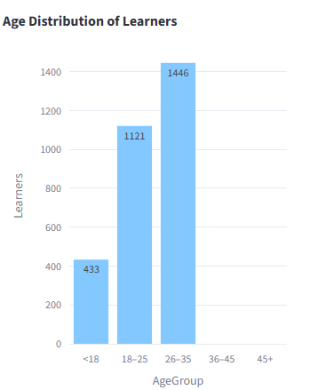

Result
The analysis shows that the [26–35] age group represents the largest proportion of learners. The [35+] groups represents the smallest proportion.

Interpretation
The distribution indicates that EduPro's learner population is concentrated primarily within 26-35 age group. This information can help the platform understand its primary learner demographic and design educational content accordingly.

8.2 Gender Distribution
Gender distribution was analyzed using unique UserID values.

Figure 2: Gender Distribution of Learners

Result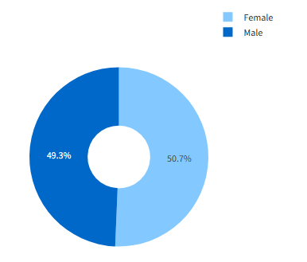
The analysis shows that Female represents the largest proportion of learners at approximately 50.7% followed by Male with 49.3%.

Interpretation
The gender distribution provides an overview of learner participation and can help assess the inclusivity and demographic reach of the platform.

8.3 Age Distribution of Enrollments
Unlike learner distribution, this analysis uses unique TransactionID values.

Figure 3: Age Distribution in Enrollments

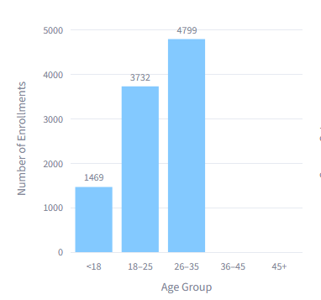

Result
The 26-35 age group recorded the highest number of enrollments with 4799 enrollments, while the 36-45 and 45+ age group recorded the lowest or Zero.

Interpretation
Comparing learner population with enrollment volume helps distinguish between large learner groups and highly active learner groups.
For example, an age group may contain fewer learners but generate a comparatively high number of enrollments, indicating greater course participation per learner.

8.4 Course Category Popularity
Course categories were ranked according to the number of unique enrollment transactions.

Figure 4: Course Category Popularity

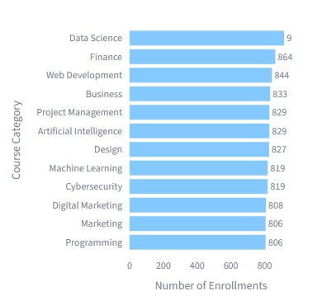

Result
The Data Science category recorded the highest number of enrollments, with 916, while Programming recorded the lowest.

Interpretation
The results indicate differences in subject interest across the platform. Categories with high enrollment volumes may represent areas of strong learner interest.
However, enrollment count should not automatically be interpreted as learner satisfaction or course quality because the analysis is descriptive.

8.5 Course Level Preference
Course enrollments were grouped according to course level:
- Beginner
- Intermediate
- Advanced

Figure 5: Course Level Preference

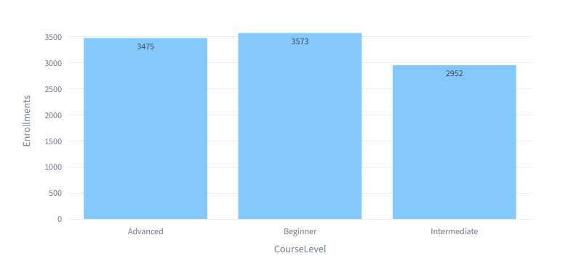Result
The Beginner level received the highest number of enrollments.

Interpretation
The distribution provides an indication of the skill maturity represented within the learner population. A high concentration of beginner enrollments may indicate strong demand from learners starting their learning journey.

9. Demographics × Course Preferences
This section is particularly important because it moves beyond individual distributions.

9.1 Age Group × Course Category
A heatmap can be used to compare enrollment activity between age groups and course categories.

Figure 6: Age Group vs Course Category
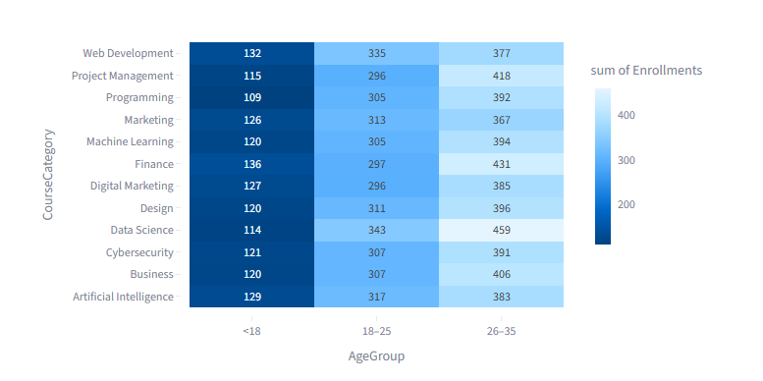The heatmap helps identify:
- Which categories are preferred by younger learners.
- Which categories are more popular among adult learners.
- Categories with consistently high participation.
- Categories with relatively low participation across age groups.

Intrpretation
The analysis indicates that course preferences vary across age groups. The 18–25 segment shows relatively high enrollment in Data Science while the 26–35 segment demonstrates stronger participation also in Data Science.

10. Behavioral Analysis

10.1 Average Courses Taken per Learner

Result
The average learner enrolled in approximately 3 courses.

Interpretation
This metric provides a simple measure of learning activity. A higher value indicates that learners tend to enroll in multiple courses rather than limiting participation to a single course.

10.2 Enrollment Concentration
Enrollment concentration can be analyzed by comparing the enrollment contribution of different learner groups.
For example:
Learner population
↓
Age groups
↓
Enrollment contribution
↓
Identify highly active segments
This helps distinguish platform reach from platform engagement.

11. Streamlit Dashboard
An interactive Streamlit dashboard was developed to make the analysis accessible to users.
The dashboard includes:

Demographic Overview
- Total learners
- Total enrollments
- Age distribution
- Gender distribution

Enrollment Analysis
- Age-wise enrollment
- Course category popularity
- Course-level preference

Demographic Preference Analysis
- Age group × course category
- Gender × course level

Interactive Filters
Users can filter the dashboard by:
- Age group
- Gender
- Course category
- Course level
When a filter is selected, the underlying dataframe is filtered and the visualizations update dynamically.
The dashboard was developed using:
- Python
- Pandas
- Plotly
- Streamlit

12. Findings
- Demographic finding: 26-35 contains the highest number of learners.
- Gender finding: Female represents the largest learner segment.
- Enrollment finding: 26-35 generates the highest number of enrollments.
- Category finding: Data Science is the most enrolled course category.
- Level finding: Beginner receives the highest enrollment volume.
- Behavioral finding: Learners take an average of 3 courses.
- Cross-segment finding: All age groups shows a stronger preference for Data Science Category.

13. Recommendations

13.1 Course Development
EduPro can prioritize the development and improvement of courses in categories demonstrating consistently high enrollment demand.

13.2 Age-Specific Content
If particular age groups show strong preferences for specific categories, course collections can be organized according to learner segments.

13.3 Beginner Learning Pathways
If beginner courses dominate enrollment, EduPro could provide structured beginner-to-intermediate learning pathways.

13.4 Inclusivity
Gender participation patterns can be monitored to understand whether certain demographic groups are underrepresented.

13.5 Personalized Discovery
The demographic-course preference relationships identified in this study can serve as a foundation for future personalized course recommendation systems.

14. Limitations
This study has several limitations.
- The analysis is descriptive and does not establish causal relationships.
- Enrollment does not necessarily indicate course completion or learner satisfaction.
- The dataset does not necessarily capture learning outcomes.
- Demographic variables alone cannot fully explain course selection behavior.
- The analysis does not predict future enrollment behavior.
- The findings are dependent on the quality and completeness of the provided datasets.

15. Future Scope
Future work could extend this project by incorporating:
- Course completion data
- Assessment scores
- Learner engagement duration
- Course ratings and feedback
- Learning outcomes
- Temporal enrollment trends
- Recommendation systems
- Learner segmentation using clustering
- Enrollment prediction
- Personalized course recommendations

16. Conclusion
This study analyzed learner demographics and course enrollment behavior on the EduPro platform using descriptive data analytics. By integrating user, course, and transaction datasets, the study provides a consolidated view of learner participation and course preferences.
The analysis examined age distribution, gender participation, enrollment patterns, course category popularity, course-level preferences, and demographic differences in course selection. The interactive Streamlit dashboard makes these findings accessible through visualizations and user-defined filters.
The results demonstrate how descriptive analytics can transform raw educational data into actionable learner intelligence. These insights can support data-driven course planning, learner engagement strategies, and inclusive educational decision-making.
The project establishes a foundation for future advanced analytics while maintaining its primary focus on understanding who EduPro learners are and how they choose courses.

