**Project - Perceiver**

Submitted by Danny Savla (24D0295) and Priyanka Talwar (23D1387)

# Model Details

Architecture

1. **Perceiver Architecture : Pre-trained model**
2. **For out features, the model's classification head is replaced for classification of 51 classes.**

Device details:

* **The model is trained using CUDA-enabled GPUs for faster computation.**

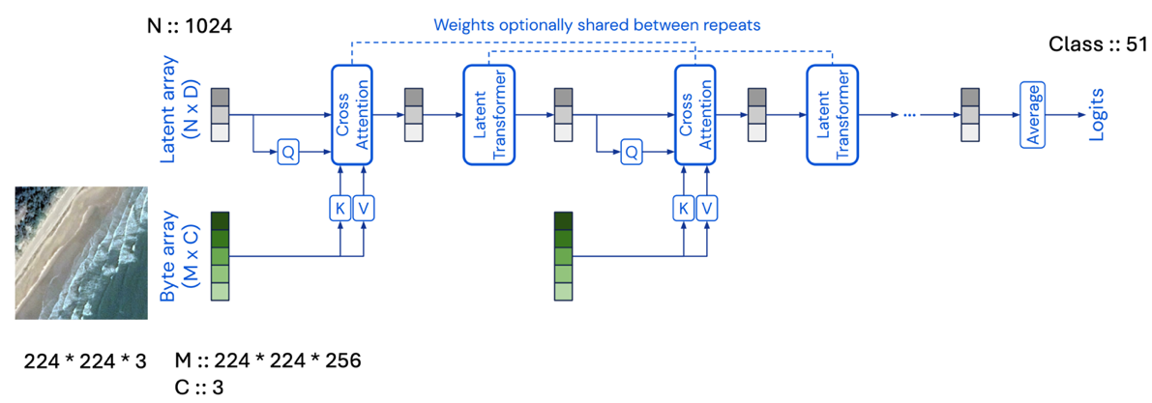

# Training Details

Table 1- Data Set Count Details

|  |  |  |
| --- | --- | --- |
| **Data Set** | **Split** | **Remarks** |
| **Training** | **80%** | **Random split** |
| **Test** | **20%** |

Transformations:

**Training Images**: Resize to 224x224, normalization and Shuffle as True

**Test Images**: Resize to 224x224, normalization and Shuffle as False

Hyperparameters:

**Learning Rate**: 5e-5

**Epochs**: 10

**Batch Size**: 2

**Optimizer** : AdamW

**Scheduler\*\*** : CosineAnnealingLR, total_steps = 40000 [Batch size * epcohs], eta_min= 1e-6 [ *Used in 2nd run* ]

# Output

Accuracy on Test set (20%) [Without scheduler, 1st run ]: **89.45%**

Accuracy on Test set (20%) [With scheduler, 2nd run ]: **87.5%**

**Logs from Training set (80%)** [With scheduler, 2nd run ] **:**

|  |  |
| --- | --- |
|  |  |
|  | Loss Curve for 10 Epochs |
|  |  |
|  | Accuracy Curve for 10 Epochs |

**Accuracy from Test set (20%)** [With scheduler, 2nd run ] **:**

**

*Note : ** The logs file were not generated due to juypter notebook issue.*