**ASSIGNMENT # 01**

**Subject: COMPUTER NETWORKING**



**Submitted by: TALWASA SHAH**

**Submitted to: SIR BAKHTAWAR**

**Program: BSCS**

**Registration #: 2121-3232025**

**Date of Submission: 31st/ Jan/ 2025**

**DEPARTMENT OF COMPUTER SCIENCE**

**PRESTON UNIVERSITY KOHAT**

**TABLE OF CONTENTS**

|  |  |  |
| --- | --- | --- |
| **S#**  **1.**  **2.**  **3.**  **4.**  **5.** | **TITLE**  Introduction   * Overview of Computer Networking * Importance of Communication Protocols   Unicast Protocols   * Definition of Unicast Communication * Three Unicast Protocols   + HTTP (Hypertext Transfer Protocol)   + TCP (Transmission Control Protocol)   + FTP (File Transfer Protocol) * Advantages and Disadvantages * Real-World Example   Multicast Protocols   * Definition of Multicast Communication * Three Multicast Protocols   + IGMP (Internet Group Management Protocol)   + PIM (Protocol Independent Multicast)   + RTP (Real-time Transport Protocol) * Benefits of Multicast Communication * Real-World Example   Cisco Packet Tracer Task   * Brief Description   + Establishing Router Connectivity   + Connecting PCs to Routers * IP Addressing Scheme   + Assigning IP Addresses to Interfaces   Verification and Testing   * + Ping Test   + Checking IP Routes | **PAGE#**  **3**  **4** |

**Q1: Unicast Protocols:**

1. **Definition of Unicast Communication:**
   * Unicast is when one computer sends information to only one other computer on the network. It is like making a personal phone call to a friend.
2. **Three Unicast Protocols:**
   * **HTTP (Hypertext Transfer Protocol):** Used for browsing websites. When you open a website, your browser sends a request to a web server, and the server sends the webpage back to you.
   * **TCP (Transmission Control Protocol):** Ensures that data is sent and received correctly. It is used for emails, downloading files, and sending messages.
   * **FTP (File Transfer Protocol):** Helps in transferring files between computers, like when you upload or download a document.
3. **Advantages and Disadvantages of Unicast Communication:**
   * **Advantages:** Reliable, direct connection, and ensures all data is received.
   * **Disadvantages:** Uses more network resources because each message is sent separately to each user.
4. **Real-World Example**
   * Watching a YouTube video on your phone. The video is sent directly from YouTube’s server to only your device.

**Q2: Multicast Protocols:**

1. **Definition of Multicast Communication:**
   * Multicast is when one computer sends information to many computers at the same time. It is like a teacher talking to a whole class instead of one student.
2. **Three Multicast Protocols:**
   * **IGMP (Internet Group Management Protocol):** Helps computers join or leave a group that is receiving the same data, like a live sports stream.
   * **PIM (Protocol Independent Multicast):** Helps find the best path to send data to many users.
   * **RTP (Real-time Transport Protocol):** Used for live audio and video calls, like Zoom or Skype.
3. **How Multicast Routing Works and Its Benefits:**
   * The data is sent only once, and the network makes copies to reach many users.
   * **Benefit:** Saves bandwidth because the same data does not have to be sent multiple times.
4. **Real-World Example**
   * Watching a live football match online where many users receive the same video at the same time.

**Q3: Cisco Packet Tracer Task:**

**Brief Description:**

This task involves designing and configuring a network topology in Cisco Packet Tracer using three routers and two PCs. The network will be connected through serial links for WAN connections and Ethernet interfaces for LAN connections. Each router interface will be assigned an IP address, with /30 subnet masks for serial connections and /24 subnet masks for LAN segments. Additionally, loopback interfaces will be configured on each router to provide a stable IP address for testing and routing stability.

**Network Setup:**

* Establish connectivity between routers using serial interfaces.
* Connect each PC to a router via Ethernet interfaces.

**IP Addressing Scheme:**

* Assign IP addresses to all router interfaces.
* Utilize a /30 subnet mask for serial (WAN) connections.
* Assign /24 subnet masks for LAN segments where PCs are connected.

**Loopback Interface Configuration:**

* Configure a loopback interface on each router to provide a stable, always-up IP address for testing and routing stability.
* Configure the appropriate network statements to advertise the connected networks.

**Verification and Testing:**

* Use the ping command to test connectivity between devices.
* Verify routing tables with show ip route.

**Network Topology:**

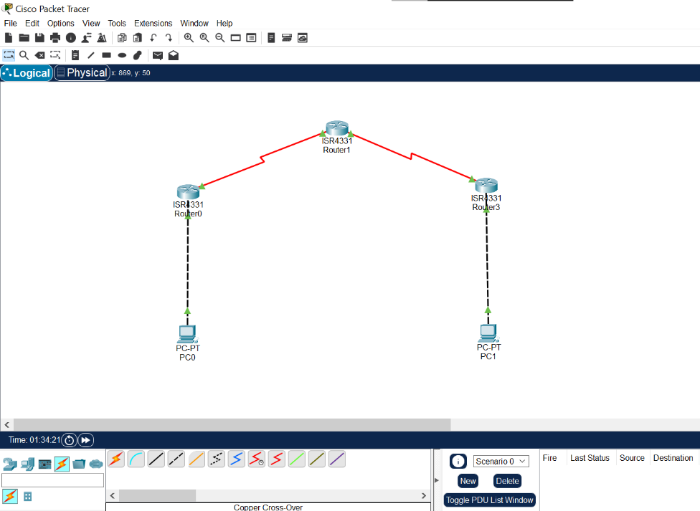

**IP Route Check:**

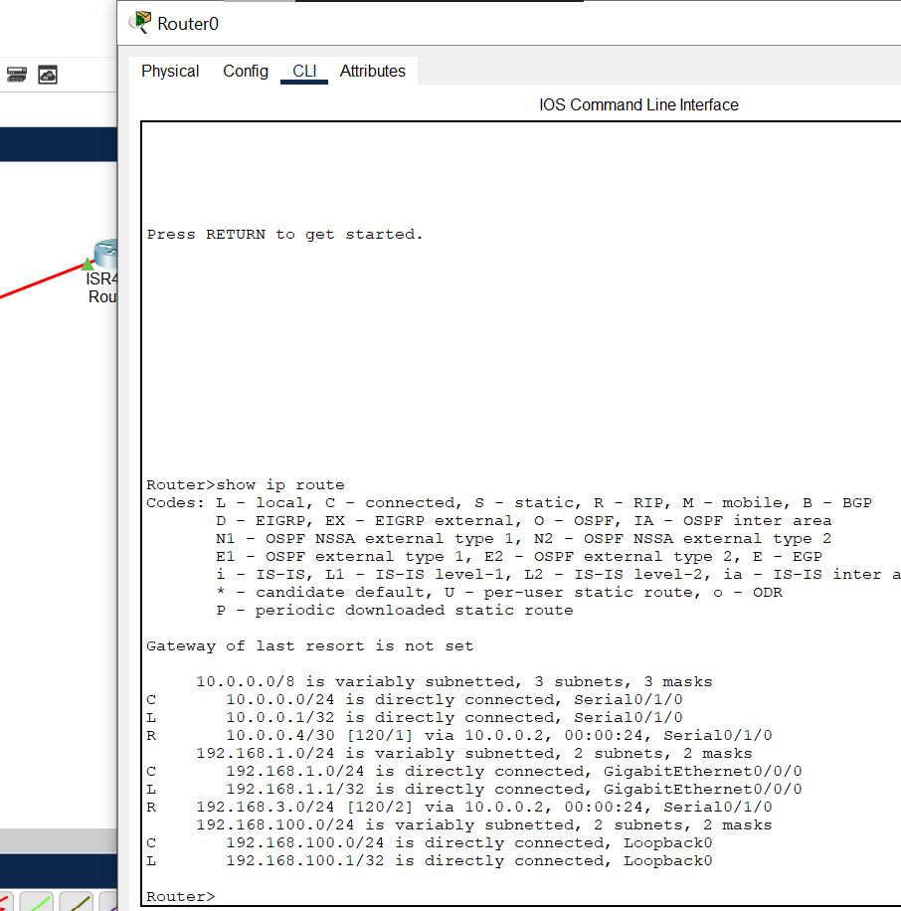

**Ping Test:**

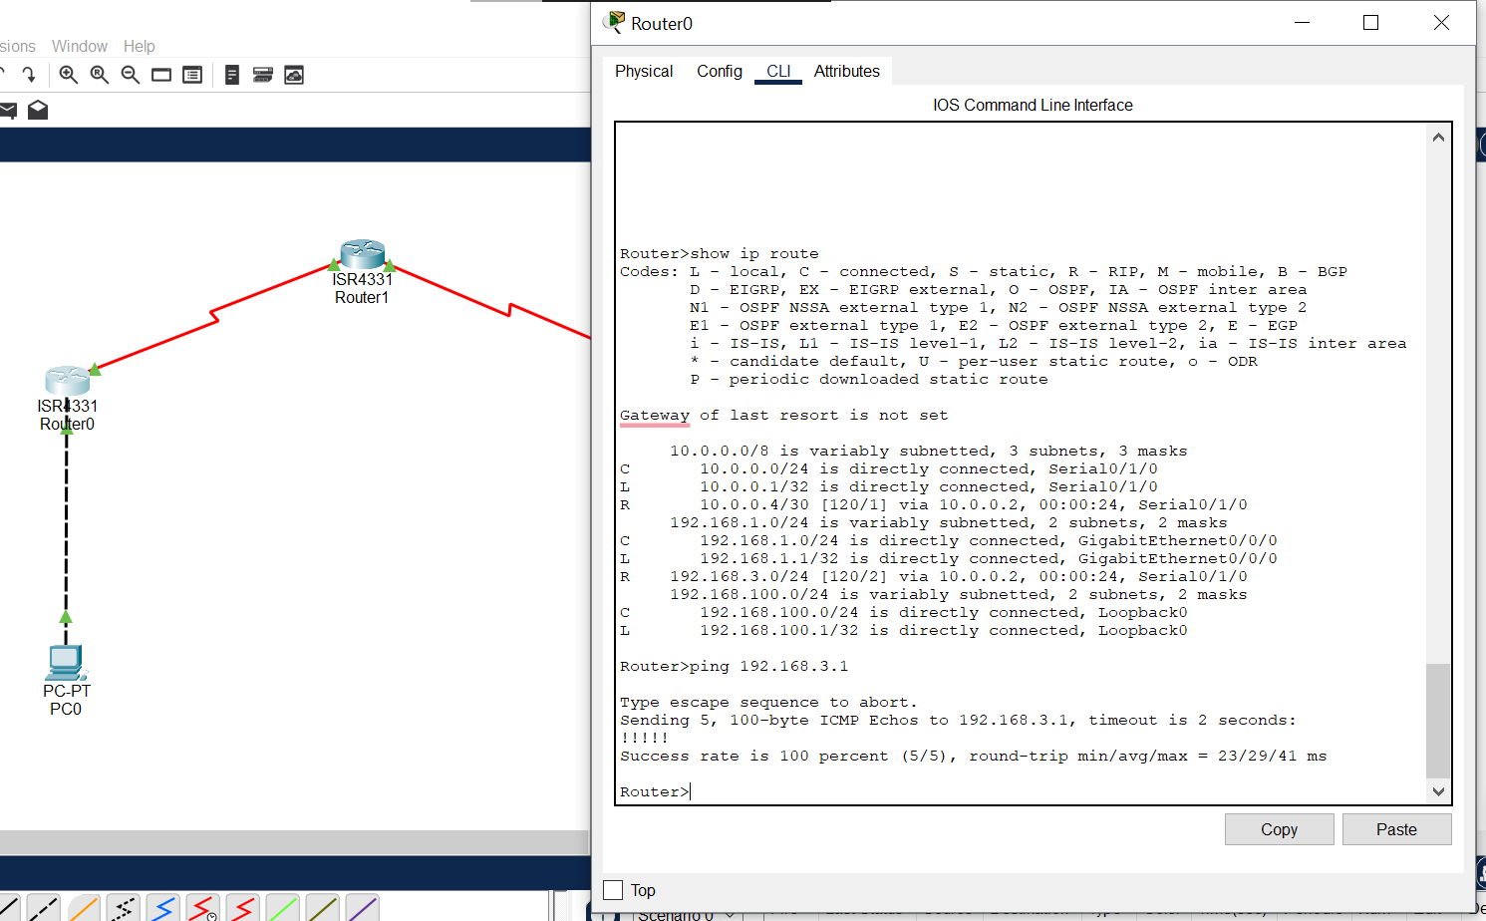

This report has been uploaded on GitHub.