

Investigating the Co-Dynamics of HIV/AIDS and Influenza in regional Australia

Taylor Pan
SID: 520431085

Supervisor: Mahendra Piraveenan

This thesis is submitted in partial fulfilment of
the requirements for the degree of
Bachelor of Advanced Computing

School of Computer Science
The University of Sydney
Australia

21 July 2020

Student Plagiarism: Compliance Statement

I certify that:

I have read and understood the University of Sydney Student Plagiarism: Coursework Policy and Procedure;

I understand that failure to comply with the Student Plagiarism: Academic Board Policy: Academic Dishonesty and Plagiarism can lead to the University commencing proceedings against me for potential student misconduct under the 2012 Academic Dishonesty and Plagiarism in Coursework Policy.

This Work is substantially my own, and to the extent that any part of this Work is not my own I have indicated that it is not my own by Acknowledging the Source of that part or those parts of the Work.

Name: Taylor Pan

Signature: Taylor Pan Date: 7/11/2025

Abstract
The transmission of infectious diseases is rarely independent, with another disease often shaping overall health outcomes in vulnerable populations. Regional and Indigenous populations in Australia experience disproportionately high rates of chronic and infectious diseases due to systematic inequities in healthcare access, lack of awareness and socioeconomic disadvantage. Understanding how multiple pathogens interact in such contexts is critical for designing culturally appropriate and geographically targeted interventions.

This project investigates the epidemiology of both HIV and Influenza in a regional Australian town. Computational epidemiology is used to simulate a disease spread within the Australian town of Bourke with about 2400 individuals. (Australian Bureau of Statistics [ABS], 2021). The project aims to quantify how HIV-induced immunosuppression modifies influenza transmission, prevalence and overall disease burden, with other factors such as demographic and public health responses in rural Australia.

A computational epidemiological model was developed using Python and NetworkX to generate a contact network reflective of Bourke’s demographic — namely age structure, gender distribution and Indigenous proportion (30.3%). Each node represents an individual with demographic attributes and infection states, while sexual relationships form subject to age related and monogamy constraints. HIV and influenza transmission probabilities were parameterised using data from existing epidemiological research. Influenza is modelled as a fast-spreading, short-duration infection of greater severity among immunocompromised hosts, while HIV modelled as a slower spreading, and longer lasting infection.

The method of running the simulation consisted of generating the population with nodes, each node having their own distinct parameters. The initial seeding of the two diseases. Once these two initial steps have been done,

Results show distinct patterns between both diseases. HIV prevalence rose gradually across the simulation, reflecting slow person-to-person sexual transmission. In contrast, influenza displayed a sharp epidemic curve, peaking in a short time, before declining, reflective of recovery dynamics. Influenza incidence hit the total population, highlighting that nearly all individuals were exposed.

When HIV was introduced into the population by itself, about 4.5% of the population had acquired HIV during the 730-day period. While influenza was also mixing in the population, by the end of the 730-day period, around 9.8% of the population had acquired HIV, representing about a relative increase of 10-15% in total HIV infections

The findings suggest that co-dynamics between the two diseases could significantly burden small regional towns. The model demonstrates the value of computational simulations in capturing disease interactions within realistic demographic structures. While preliminary, the results highlight the importance of tailored public health strategies in regional Australian contexts. Future work will refine the network with a more realistic approach, considering interventions such as vaccination and social distancing to reduce epidemic spread.

Acknowledgements
If there is anyone you would like to thank or acknowledge in the completion of the project, it goes here. If there is none, you may remove this section.

I would like to acknowledge Dr Mahendra Piraveenan for taking time out of his weeks to meet up with me and helping me through my thesis study, especially while he was on leave, he still made time for me.

Contents

Student Plagiarism: Compliance Statement ii
Abstract iii
Acknowledgements iv
List of Figures vi
List of Tables Error! Bookmark not defined.
1. Introduction 1
1.1 Problem statement 1
2. Literature Review / Related Works 3
2.1 Review Criteria 1 Error! Bookmark not defined.
3. Methodology 6
3.1 Data Collection Error! Bookmark not defined.
4. Results 10
5. Discussion 17
6. Conclusions 21
Reference List 22
Appendix A: Ethics Approval Submission 23

List of Figures
Figure 1: HIV Prevalence
Figure 2
Figure 3
Figure 4
Figure 5
Figure 6
Figure 7
Figure 8
Figure 9
Figure 10
Figure 11
Figure 12

List of Tables
Table 1

1. Introduction
The project will be to develop a network-based simulation of HIV/AIDs using python and a package called “networkx”. A population will be created based on ABS census data with each node representing an individual in the population. Each node will have its own attributes (age, gender and indigenous status etc.) as well as nodes having edges, representing sexual relationships. HIV will be spreading through these links. Influenza will be modelled via a general contact transmission, and its progression will be altered in nodes already infected with HIV. This model will assess infection prevalence over time and co-infection rates. The insights gained from the model can help rural healthcare strategies and improve resource planning in areas with immunocompromised populations.

Problem statement
The transmission of infectious diseases is often influenced by the presence and prevalence of multiple diseases. In Australian regional towns, where healthcare access and demographic factors differ from metropolitan areas, the co-dynamics of HIV/AIDs and Influenza (flu) in such areas remain underexplored. As HIV/AIDs is immunocompromising, the severity of flu symptoms and transmission rates rise in a susceptible population. The extent to which HIV/AIDs affect influenza spread and outcome in regional Australia where indigenous Australians are more prevalent is still unclear.

The study aims to investigate the co-dynamics of HIV/AIDs and its impact on Influenza within the regional town of Bourke in Australia by analysing transmission dynamics, co-infection rates and healthcare implications. Bouke has a population of 2,340 (Australian Bureau of Statistics [ABS], 2021) and has a proportion of Aboriginal and Torres Strait Islander people of (30.3%). By utilizing a computational epidemiological model, the research and data that will be gathered can be used for future public health strategies not only in Bourke but other towns with a similar demographic.

The model developed can be viewed here.

1.2 Aim and Objectives
Aim: To investigate the co-dynamics of HIV/AIDs and Influenza in a small town like Bourke. This will be done by developing a computational epidemiological model that assess transmission interactions and coinfection risks in the town. This allows for a more informative guide to future health campaigns and give insight on healthcare implications on not just Bourke, but towns with a similar size to Bourke.
Objectives:
- To collect and integrate 2021 ABS census data for Bourke.
- Construct and develop a simulated sexual contract network utilizing computational tools. (python, networkx)
- Evaluate how HIV infection affects Influenza transmission within the model.
- Assess and propose intervention strategies based on findings

1.3 Scope of Project
The project will be focused on the town of Bourke. It has a population of approximately 2,340 (subject to change) and a good proportion of Aboriginal and Torres Strait Islander residents. The project will involve:
- Developing a synthetic population reflective of Bourke using 2021 ABS census data
- Implementing a dual-disease model simulating HIV/AIDs and Influenza co-transmission
- Focusing on heterosexual transmission for HIV modelling

2. Literature Review / Related Works
There have been many studies on the epidemiology of HIV/AIDs and Influenza separately in many different environments but not many studies on the co-dynamics between the two diseases. The co-dynamics of infectious diseases, particularly in the case of one disease altering host susceptibility to another, pose a challenge for epidemiological modelling as well as public health intervention. In immunocompromised populations, such as people living with HIV/AIDS, the introduction of a secondary pathogen like Influenza can lead to amplified transmission (Cohen et al., 2013), and more distinct epidemic patterns. This literature review will focus on transmission dynamics of both diseases, host susceptibility and modelling approaches, with a focus on regional and Indigenous Australian populations.

2.1 Transmission Dynamics
Transmission between the two chosen diseases differ in mechanisms, speed and susceptibility, but the interaction between the two create epidemiological patterns.

HIV/AIDs is primarily transmitted by sexual contact, specifically through the contact of body fluids from people already with HIV. Fluids such as blood, breast milk, semen and vaginal secretions. HIV also can be transmitted to a child during pregnancy and delivery. Its transmission is heavily influenced by behavioural, socio-economic and healthcare access factors. In regional and Indigenous communities of Australia, a higher HIV vulnerability has been linked to limited access to appropriate healthcare and historical marginalisation. (Ward et al. 2016). In Australia there were 633 new HIV diagnoses in 2022, with approximately 24% of such cases being Aboriginal and Torres Strait Islander people, being attributed to heterosexual contact. (Kirby Institute, 2023).
In contrast, Influenza spreads rapidly through respiratory droplets typically following a seasonal pattern. The basic reproduction number (R₀) for influenza typically ranges from 1.2 to 2.0, reflecting moderate but rapid transmissibility (Biggerstaff et al., 2014). Influenza transmission is mainly influenced by population density, mobility and vaccination coverage. In Australia, over 251,000 lab confirmed influenza cases were reported in 2023 (Department of Health, 2023).

In immunocompromised individuals, such as individuals living with HIV, those also infected with influenza may exhibit longer periods of viral shedding, leading to an extended infection period and an increased risk of severe complications. A study in South Africa found that HIV-positive individuals are associated with longer viral shedding periods (median 10 days vs 5 days), and 2-8 times increase in risk of hospitalisation (Cohen et al., 2013). These altered transmission dynamics are crucial in rural towns like Bourke, where tightly connected communities and healthcare access disparities can amplify both disease spread and burden.

2.2 Host Susceptibility
Host susceptibility refers to the degree to which individuals or population subgroups are vulnerable to infection and disease progression. In the case of HIV/AIDS and Influenza susceptibility is shaped by immunological status, healthcare access and sociocultural determinants.

As HIV/AIDS is transmitted sexually, those that are sexually active are more likely to be susceptible to contract the disease. HIV/AIDS impairs host immune responses, specifically by depleting CD4+ T cells. This immunocompromising effect hinders the body’s ability to effectively fend of other infectious diseases such as Influenza studied here. As a result, people with HIV, have higher susceptibility in the infection of Influenza. (Cohen et al., 2013). Approximately 28% of Australians living with HIV are not virally supressed, which heightens their susceptibility to infections such as Influenza (Kirby Institute, 2023).

Influenza infection severity is generally influenced by age, comorbidities and immune status. In immunocompetent host, influenza is often self-limiting, but in populations that are immunocompromised, viral clearance is delayed, and infections are more frequent. (Kunisaki & Janoff, 2009). Notably studies have shown prolonged viral shedding among HIV-Positive individuals, which contributes to higher community transmission. In healthy adults, Influenza typically resolves within 7-10 days, but in immunocompromised individuals, including those with HIV, prolonged viral shedding is observed, with a median of 11 days (Beck et al., 2012).

In addition to the above, in Aboriginal and Torres Strait Islander individuals, there are additional layers of susceptibility. These individuals experience higher rates of chronic diseases, lower vaccination uptake and face structural barriers to healthcare access (Menzies et al., 2013). These social determinants dramatically increase vulnerabilities, increasing susceptibility to both HIV and Influenza infections and complications. This is especially in towns such as Bourke, where a high percentage of its population identifies as Indigenous (ABS, 2021).

2.3 Modelling Approaches
Epidemiological modelling provides a crucial framework for understanding and forecasting disease transmission and patterns, especially in complex co-infection scenarios. While both diseases have been modelled extensively in isolation, there is an absence of integrated models that captures the dynamics between the two diseases, particularly in smaller and rural populations.
HIV/AIDS models are typically based on compartmental structures such as the SIR (Susceptible-Infected-Recovered) framework extended to include chronic stages, long latency periods and behavioural risk factors. These models often incorporate stratifications by CD4 count and viral load.

Influenza models, by contrast, emphasize short term dynamics, seasonality and high transmissibility. They often use age-structured or metapopulation frameworks to simulate transmission in different types of populations, from schools, households and communities. These models are sensitive to contact patterns and mobility, factors that vary between urban and rural populations.

When modelling both diseases at once, we can consider developing a network-based model, powerful tools to simulate the transmission of diseases by representing individuals as nodes and contacts as edges, modelling the sexual contract of HIV/AIDs. One such approach is the Barabasi-Albert model which generates scale free networks. These networks are characterized by a power law degree distribution, meaning that most individuals will have few connections, a small number of individuals act as superspreaders due to a large number of contacts (Barabási & Albert, 1999). This aligns with real world dynamics where most individuals have lesser relationships formed while a few individuals will have a larger number of relationships formed, disproportionately contributing to disease spread.

In the context of HIV/AIDS, the BA model captures the fact that a small subset of the population, due to behavioural factors like high sexual activity, can maintain persistent transmission chains. Similarly, in influenza transmission, certain individuals (caregivers, community hubs) can become central to the spread due to frequent social interactions.

In regional communities such as Bourke, social networks are tightly clustered and highly structured, often involving overlapping family, cultural and service-related interactions. The BA model is relevant here as it allows simulation of how infections can propagate rapidly through key individuals or hubs.
Agent-based models are increasingly prevalent for such contexts, as they allow for fine-scale simulation of individual behaviours, local transmission clusters, and health system interactions (Ajelli & Merler, 2008). These models can be calibrated using census data available.

2.4 Prior Research
South African surveillance during and after the 2009 pandemic found that underlying HIV infection independently increased the risk of severe influenza-associated respiratory infection and hospitalisation, with bacterial co-infection compounding severely. These findings underpin current guidance to prioritise people living with HIV for vaccination and early antiviral treatment.

For Influenza, studies place the basic reproduction number for seasonal epidemics around a median ~1.3, which higher values in pandemic settings. Importantly for small towns, individual based simulations show that “unstructured” community contacts can shift attack rates and intervention impact, so modelling needs to represent everyday mixing rather than only structured settings (Biggerstaff et al. 2014).

While co-infection modelling is well developed for HIV with tuberculosis, hepatitis C, and even COVID-19, explicit HIV-Influenza dynamical coupling remains underexplored. There are methodological reviews of co-infection modelling structures which can guide parameter linking choices, but overall, the gap in literature underscores the contribution of this study.

3. Methodology
This study employed a computational epidemiological network model to investigate the co-dynamics of HIV/AIDS and Influenza in Bourke — a small regional Australian town of about 2,340 residents, of whom 30.3 % identify as Aboriginal or Torres Strait Islander (Australian Bureau of Statistics [ABS], 2021). The model simulated disease transmission over time in a synthetic population reflecting Bourke’s demographic structure. Because HIV infection leads to immune compromise, influenza outcomes and transmissibility were assumed to be worse among infected individuals (Kunisaki & Janoff, 2009; Cohen et al., 2013).

The simulation was implemented in Python using NetworkX to represent individuals as nodes and relationships as edges. The architecture comprised four key modules:
- population_functions.py – population generations
- relationship_functions.py – relationship formation, dissolution
- disease.py – HIV and influenza transmission and progression
- main.py – temporal simulation control and output summary

To note: a relationship in the context of this study is when two individuals have vaginal intercourse with each other.

3.1 Population Generation
The synthetic population (n = 2,340) was constructed to match Bourke’s 2021 ABS age and sex distribution, with 49.7 % males and 30.3% identifying as Aboriginal or Torres Strait Islander (ABS, 2021). Each node contained attributes for age, gender, Indigenous status, and HIV infection state. The function generate_population() assigned ages according to census-derived brackets and seeded twenty randomly selected eligible adults as initially infected (I) individuals. Adult-only infection seeding reflects the epidemiology of sexually transmitted HIV (Ward et al., 2018; Kirby Institute, 2023).

This population structure enabled simulation of heterogeneous contact mixing, consistent with network-based epidemic theory (Barabási & Albert, 1999).

3.2 Relationship Formation and Dissolution
Sexual partnerships were modelled as monogamous heterosexual edges between nodes. The function start_relationship() gave each eligible adult about a 14% daily chance to form a new partnership. Eligible partners were required to be of opposite sex, within ten years of age and not have more than 10 partners already. The 14% chance reflects the approximation that any given couple will have intercourse on average once a week. (Rissel et al., 2014)

A homophily parameter (0.7) increased the probability of relationship formation between individuals sharing Indigenous status, acknowledging sociocultural assortativity observed in Aboriginal and Torres Strait Islander communities (Menzies et al., 2008).

Each relationship persisted probabilistically, with a daily break-up probability of 2%. The 2% chance is an approximation based on casual flings and short-term dating within the community. With such a wide range of relationship status within any given population, 2% was approximated for this model.

3.3 HIV Transmission Model
20 randomly selected eligible individuals were initially seeded with HIV within the population. Transmission is evaluated each day through the transmit() function. Transmission is done via edges, generated by the previous step (relationships). If one partner was infected and the other susceptible, stochastic transmission occurred with empirically derived probabilities:
- Male → Female: 1 / 1,234
- Female → Male: 1 / 2,380
These rates were based on a systematic review of heterosexual HIV transmission per intercourse act (Patel et al., 2014). We also assume in the model that each instance of intercourse was vaginal. Further development of the model would also include anal sex.

Successful transmission updated the recipient’s infection status to I (infected) and the individual would be added to a “currently_infected” list. After 180 days, an infected individual’s transmission risk becomes effectively zero, as the virus can not be transmitted sexually anymore. This is due to antiretroviral therapy being present. In this case, the individual is removed from the list and status I is changed to R (recovered), where they stop their viral shedding. The 180 days is shown as clinical studies, that suppression typically occurs by day 180 (Granich et al., 2009).

Further development of the model would make it so that the recovery time frame is not a static 180 days, but more like a normal distribution, as not everyone would stop viral shedding exactly on day 180.

3.4 Influenza Integration
Influenza transmission was introduced as a fast-spreading respiratory process layered atop the HIV network. The probability of influenza infection and severity were increased for HIV-positive individuals, consistent with findings that immunosuppression elevates influenza morbidity and prolongs viral shedding (Kunisaki & Janoff, 2009; Beck et al., 2012; Cohen et al., 2013).

Influenza was initially seeded with 20 individuals at initialisation and was modelled with two different types of transmission: Edge-Based and Community mixing.

3.4.1 Edge-Based Transmission
Every active relationship between two individuals in the network was treated as a high frequency close contact. If one partner’s influenza status was Infected, and the other was still susceptible, transmission would be attempted with a higher probability (15%). This reflects sustained daily exposure between regular close contacts.

3.4.2 Community mixing
In addition to edge contacts, each infectious individual was assumed to interact with 3 random susceptible individuals per day. For each of these casual contacts, influenza was attempted to be transmitted with a probability of 5%. This models unstructured respiratory spread in workplaces, schools, shops, which are known to accelerate influenza outbreaks far beyond from what would be predicted from stable edge networks. (Ajelli & Merler, 2008)

By including this unstructured mixing layer, the model is able to reciprocate a short, explosive influenza epidemic spread that infect a large portion of the population in a brief window. This is consistent with observed influenza waves in naïve or partially naïve settings. (Biggerstaff et al., 2014; Cohen et al., 2013).

3.4.3 Within host progression & Immunity
Clinical course for influenza within each individual was handled with a progress_flu() function, which would advance infection states daily using a SEIR-like (Susceptible ExposedInfectiousRecovered) logic.
- Susceptible (S) Exposed (E)
A susceptible node becomes E at first infection. Exposed individuals are infected but not yet infectious.

- Exposed (E) Infectious (I)
After an incubation period of 4 days, individuals become infectious and begin shedding virus. The 3-4 day latent period is consistent with typical influenza incubation intervals (Biggerstaff et al., 2014; Department of Health, 2023).

- Infectious (I) Recovered (R)
After 7 days of being infectious, nodes are changed to state R (recovered). During this period, they are counted in influenza prevalence, and can contribute to daily incidence. A one-week infectious window reflects with community influenza data, including high-intensity outbreaks in high-risk groups such as people living with HIV. (Cohen et al., 2013; Kunisaki & Janoff, 2009).

- Recovered (R) Susceptible (S):
Immunity is modelled as temporary immunity rather than permanent. Each recovered node remains protected for 180 days, after which their status go back to susceptible. This is implemented to be consistent with the observed need for repeated annual influenza vaccination and immune escape from circulating strains, following the seasonal pattern that influenza has (Beck et al., 2012; Department of Health, 2023).

3.5 HIV Influenza Interaction
To reflect the higher risk in immunocompromised individuals, influenza transmission probability was multiplied by a factor of 2, if the infectee was HIV positive. This reflects the fact that a person living with HIV would be more likely to be infected by the same exposure, both in edge-based contact, and community mixing transmission.

This design choice is supported by clinical evidence that people living with HIV experience higher influenza morbidity, more severe lower respiratory involvement, and in some cases prolonged viral shedding and hospitalisation rates, especially when unsuppressed (Kunisaki & Janoff, 2009; Cohen et al., 2013; Beck et al., 2012).

3.6 Temporal Simulation
The simulation ran for 730 days (2 years). Each iteration of a day was executed, in order:
- Progress existing flu infections
- Attempt to form new relationships between individuals
- Attempt to transmit flu infections
- Attempt to transmit HIV infections between all relationships
- Attempt to dissolve any relationships
- Apply recovery days for HIV infections

Network and infection statistics were logged each timestep, including total infections (hiv_total_infections), cumulative relationships formed, and number of break-ups. Random seeds ensured reproducibility and allowed mean trajectories to be estimated via multiple runs.

3.7 Data Analysis and Validation
Output data were analysed to calculate prevalence, incidence, and co-infection rates. Comparative validation used literature benchmarks for HIV persistence and influenza attack rates in high-HIV-prevalence settings (Cohen et al., 2013; Kunisaki & Janoff, 2009). The integrated model thus quantified how HIV-driven immunosuppression alters influenza spread and outcomes within a demographically realistic regional population, supporting public-health planning for remote Australian communities.

4. Results
Simulations were conducted for 730 days (two years) in a synthetic population of 2,340 individual’s representative of Bourke, NSW. Each experiment was repeated 21 times using different random seeds to produce mean trajectories and 95% confidence intervals (CIs). Results are presented separately for HIV-only and Influenza-only focus models first, to evaluate the impact both diseases have on one another.

4.1 HIV Focus
This section provides an insight into how HIV behaves by itself when 20 individuals are seeded. Overall, the HIV only model reproduced a realistic chronic-infection trajectory, slow accumulation of cases, low daily incidence, and long-term persistence.

4.1.1 Incidence
Cumulative incidence of HIV infection rose gradually throughout the two years simulation (Figure 1). By the end of the simulation, an average of ~430 individuals had ever been infected (18%-20% of the population). The steady growing graph with widening CI’s reflect the stochastic nature of pair formation and relationship turnover.
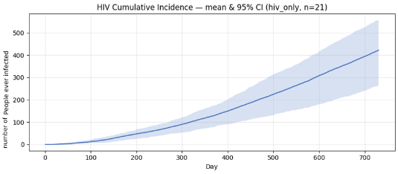
Figure 1: HIV Cumulative Incidence
cumulative number of people infected with hiv on each passing day

Daily incidence fluctuated to around 1 case per day (Figure 2), corresponding to the steady growth seen in Figure 2. This reflects a continuous transmission intensity, followed by occasional spikes that reflect the random synchronisation of new relationship formations and breakup mixing. This pattern is typical of sexually transmitted infections with low per-contact probabilities (Patel et al., 2014; Granich et al., 2009).
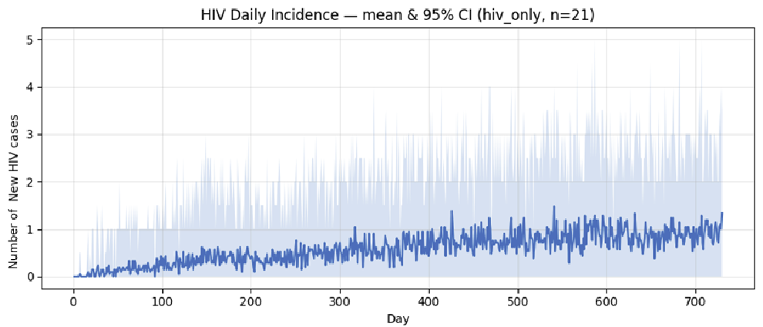
Figure 2: HIV Daily Incidence
number of new HIV cases each day

4.1.2 Prevalence
HIV prevalence increased gradually, reaching approximately 150 active infections by the end of the simulation (Figure 3). The curve’s modest slope indicates stable endemic persistence rather than accelerating epidemic growth, consistent with HIV epidemics in populations with relatively low partner concurrency and stable mixing structures.

The stark drastic dip at day 180 signifies the period when the initial 20 individuals seeded stop shedding HIV altogether. This 180-day timer is present throughout the graph, but as seen in Figure 4, HIV still steadily grows.
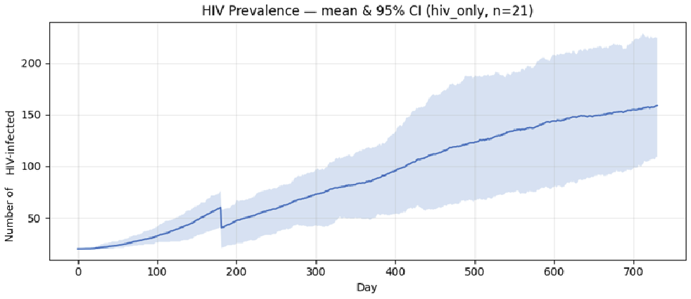
Figure 3: HIV Prevalence
number of HIV infected individuals each passing day

4.2 Influenza Focus
This section provides an insight into how Influenza behaves by itself when 20 individuals are seeded. Overall, influenza produced a rapid outbreak driven by mass community contacts and short incubation times.

4.2.1 Incidence
In contrast, influenza displayed an explosive epidemic wave. Cumulative incidence curves showed that by day 20, >95% of the population became infected with influenza (Figure 4). The rapid rise reflects influenza’s high transmissibility, and the inclusion of unstructured community mixing. (Ajelli & Merler, 2008).
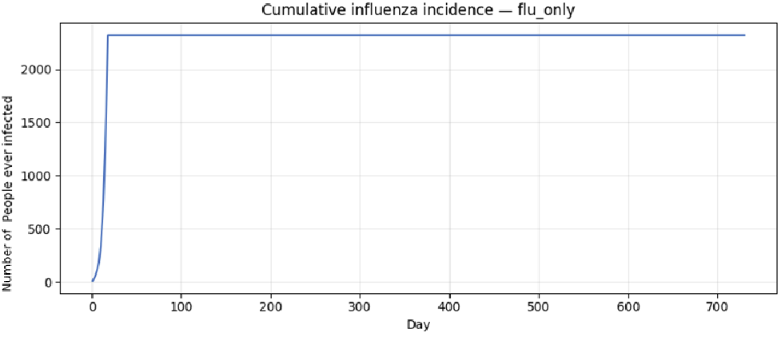
Figure 4: Influenza Cumulative Incidence
cumulative number of people infected with influenza

Daily new infections peaked sharply at around day 15, at >350 cases a day (Figure 5), then collapsed to zero once all susceptible individuals were exhausted. This behaviour mirrors real world seasonal influenza dynamics, where a rapid rise in infections is followed by fast resolution (Department of Health, 2023). 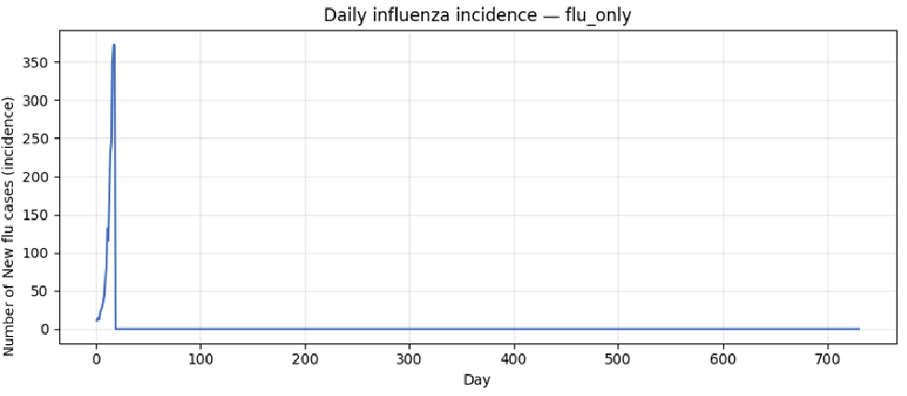
Figure 5: Daily Influenza Incidence
number of daily infections of influenza

4.2.2 Prevalence
Influenza Prevalence peaked at a maximum of ~1800 active infections (~75% of the population) before dropping to zero by day 30 (Figure 6). Following recovery, immunity lasted at 180 days in the model before disappearing, but due to influenza not being re-introduced in the population, it stays at zero.
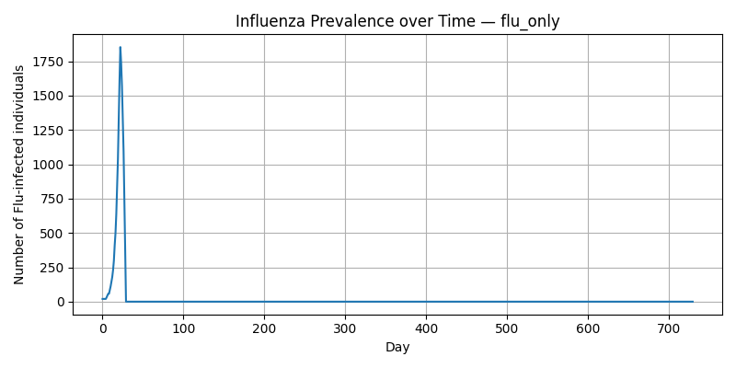
Figure 6: Influenza Prevalence
number of individuals with influenza over the simulation

4.3 Co-Infection Dynamics
When both diseases were simulated simultaneously, the interaction between HIV infection and influenza transmission produced different results as seen in the control tests.

4.3.1 HIV Transmission in the Presence of Influenza
Cumulative HIV incidence when both diseases were simulated followed a similar trajectory when compared to a HIV focus simulation, demonstrating gradual, near-linear growth over 730 days (Figure 7). Average cumulative infections reached up to 430-480 people per day by the end of the simulation. This represents approximately a 5% increase compared to the HIV only simulation. The shaded 95% confidence interval overlap quite substantially, confirming that the difference is modest, but still not to be overlooked.
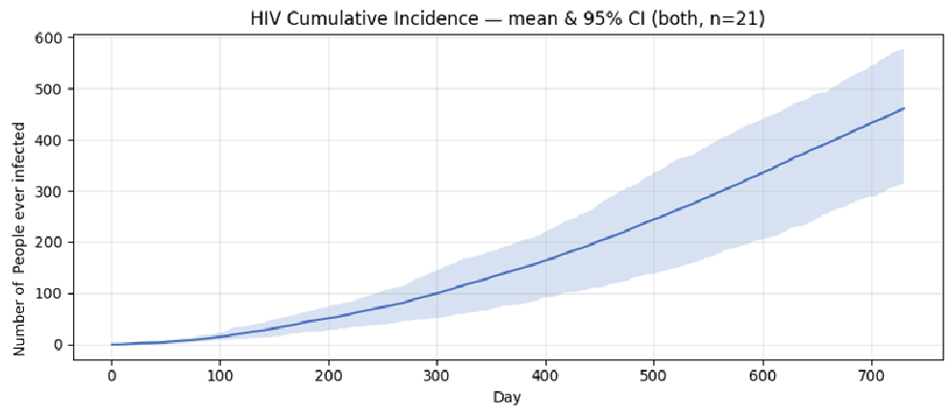
Figure 7: Co-Dynamics HIV Cumulative Incidence
cumulative incidence of HIV with influenza in the population

Daily incidence remained stable at roughly 1 new case per day, although on average still higher than the HIV focus (Figure 8). Meanwhile, HIV prevalence slowly increased to about 170-180 active HIV infections (Figure 9). Compared with HIV focus model, which had about 150 active infections. This marks a relative increase of about 10-15% in total prevalence. Once again, a sharp decrease of 20 individuals follows the 180 day recovery period.

This small but consistent rise reflects a slightly elevated transmission probability among immunocompromised hosts during influenza exposure and subsequent recovery.

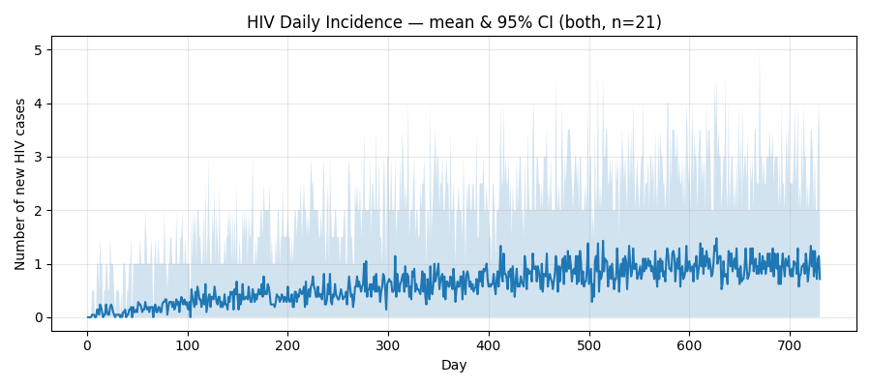
Figure 8: Co-Dynamics HIV daily incidence
number of daily HIV cases

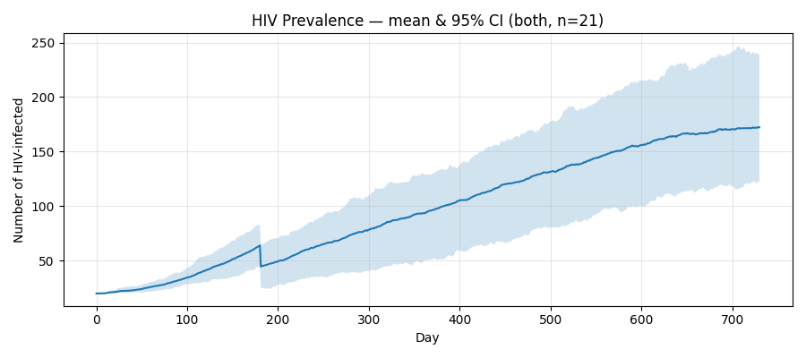
Figure 9: Co-Dynamics HIV Prevalence
number of people infected with HIV during the time period with influenza present

4.3.2 Influenza Transmission in the Presence of HIV
Influenza remained much the same from when compared to the influenza focus model and model with both diseases co-existing with each other. Comparing with the flu only model, it reveals that there is only a slightly steeper initial slope and marginally higher early-day attack rate among individuals living with HIV (Figure 10).

Daily Influenza incidence peaked at ~400 new cases per day (Figure 11), and prevalence peaked near 1800 concurrent infections (Figure 12). Despite the higher susceptibility of HIV-positive individuals, overall epidemic duration and magnitude remained largely unchanged as HIV was not prevalent enough to make a large difference.

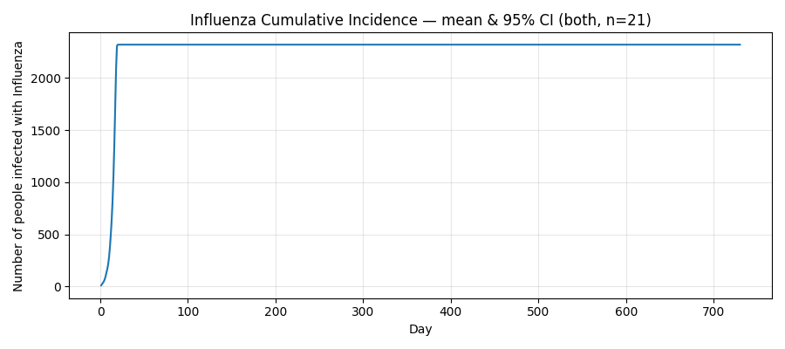
Figure 10: Co-Dynamics Influenza Cumulative Incidence
number of daily infections of influenza with HIV present

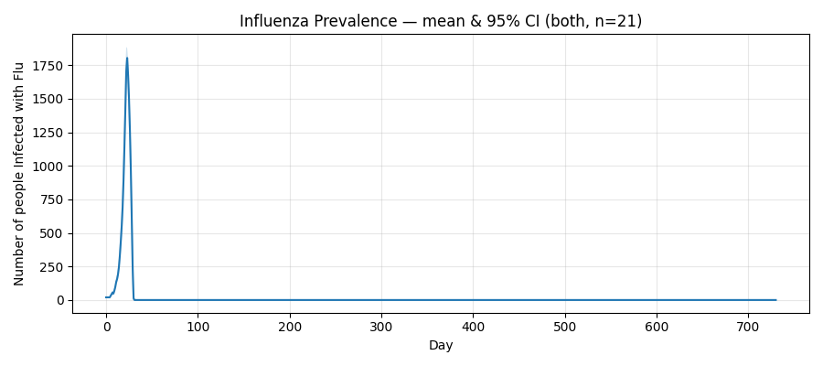
Figure 11: Co-Dynamics Influenza Prevalence
number of individuals with influenza over the simulation with HIV present

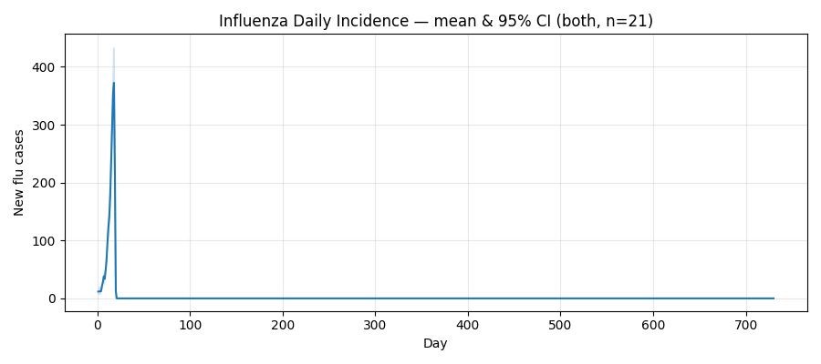
Figure 12: Co-Dynamics Influenza Daily Incidence
number of individuals with influenza over the simulation with HIV present

4.4 Interaction and Temporal Decoupling
The co-infection results highlight an asymmetric relationship between the two pathogens. Influenza’s short-duration, high transmissibility dynamics dominate early simulation time, while HIV’s slow but gradual transmission continues independently over years. The influenza epidemic concludes within the first month, long before HIV prevalence has substantially increased. As a result, the diseases do not really interact with each other in a significant way.

These findings reproduce patterns described in empirical and modelling literature: immunocompromised individuals face higher influenza, yet influenza outbreaks exert limited influence on HIV transmission at population scale because of their short outbreaks.

 |  | HIV-only | Influenza-only | HIV + Influenza (co-infection) | Relative Change (vs HIV-only)
HIV cumulative incidence (people ever infected) |  | ~450 (19 %) | – | ~470 (20 %) | +4%
HIV prevalence (active infections at day 730) |  | 150  (≈ 6 – 7 %) | – | 170–180  (≈ 7 –8 %) | +10 – 15 %
HIV daily incidence (steady-state mean) |  | ≈ 1 case day | – | ≈ 1 case day | ≈ 0 % change
Influenza cumulative incidence (people ever infected) |  | – | ~2,300  (> 95 %) | ~2,300 (> 95 %) | ≈ 0 % change
Influenza prevalence (peak) |  | – | ~1,800  (≈ 75 %) | ~1,800 (≈ 75 %) | ≈ 0 % change
Influenza daily incidence (peak) |  | – | ~350 – 400 cases day | ~400 cases day | +5 – 10 % (early-phase)
Epidemic duration |  | Chronic (persistent) | Acute < 30 days | Diseases decoupled | –
Table 1: Comparison of epidemic outcomes across simulation scenarios
each focus is compared with other focus instances

5. Discussion
This study modelled the co-dynamics of HIV/AIDS and influenza transmission in a small regional Australian population (Bourke, NSW) to investigate how HIV-related immunosuppression influences influenza spread and outcomes. The simulation integrated a network-based model of sexual partnerships for HIV transmission with unstructured community mixing for influenza transmission. This enabled comparison across three scenarios: HIV only, Influenza only, and co-infection.

5.1 Implications for Epidemiology and Public Health
The findings highlight the asymmetric relationship between chronic and acute infections within the same host population. HIV’s immunocompromising effects amplified individual vulnerability to influenza, leading to earlier infection among HIV-positive individuals (Kunisaki & Janoff, 2009; Cohen et al., 2013; Beck et al., 2012). However, influenza’s short duration relative to HIV, produced small feedback on long-term HIV transmission.

For Bourke and other similar sized regional communities, this suggests two complementary strategies to keep HIV in check.

- Sustain HIV suppression through testing and ART adherence
By maintaining undetectable viral loads, transmission probability falls to a significantly lower amount.

- Enhance Influenza vaccination
Annual flu vaccination would reduce flu severity and reduce the number of immunocompromised people.

Together, these two intervention strategies form a synergistic prevention framework: long-term viral suppression limits HIV persistence, while vaccination limits the number of immunocompromised individuals.

5.2 Model Strengths and Contributions
This thesis contributes a multi-layered network that integrates a sextual contact structure with population level respiratory spread. The hybrid approach realistically reproduces how heterogeneous contact patterns and health disparities can influenza epidemic behaviour.

Highlights of the model include:
- Demographically accurate population generation
Population was created exactly what ABS census data has, ensuring realism in age, gender and indigenous proportions.
- Bidirectional pathogen interaction, allowing analysis of both HIV and Influenza at the same time or independently

5.3 Limitations
A few assumptions were made that limit the precision and accuracy of the current model. Although the model is still relatively accurate, it doesn’t consider some factors that would make the population dynamic.

5.3.1 The use of a mean-field model
This project utilises a simplified computational model to simulate the co-dynamics of HIV and influenza transmission rather than a high-fidelity biological multiagent system. While this approach captures population-level trends and behavioural heterogeneity through stochastic processes, it takes away the complexity of biological systems that happen in reality, underlying infection and immune responses.

From a modelling perspective, the model sits closer to a mean-field model. Each node represents a person with simplified states, and transmission probabilities are treated as fixed stochastic events. Both diseases in reality exhibit nonlinear biological feedbacks that cannot be captured with the simplistic model implemented in this project.

The results from this project should therefore be understood as approximate trends rather than precise biological predictions. The model captures how structural properties shape disease spread, but does not reproduce the full physiological course of infection or intervention response.

5.3.2 No explicit healthcare intervention dynamics
In the current simulation, a node that is HIV-positive will recover in 180 days. In reality, this does not happen, some individuals take shorter or longer to recover, some individuals also do not ever recover. The difference this would make if implemented would alter results, but as the assumption 180 is an average, if this metric were to be implemented, there would not be much of a difference in results.

For influenza, no seasonal vaccination or antiviral treatment was modelled, if this were to be modelled, the results would be altered significantly, as vaccination would reduce infection probability, and would thus lower the incidence rate of influenza, also reduce the number of immunocompromised individuals. (Department of Health, 2023)

All this means that HIV is too static, and flu spreads too freely in the current model. As a result, the outputs of HIV and influenza prevalence are likely overestimated in the community. The model therefore describes a worst-case, under-served health system, instead of a more realistic model.

5.3.3 Static Demographic
The population currently is fixed at 2,340 people. This implies that no one is born, no one passes away, and no one moves in or out of Bourke. In reality, towns are not closed systems, migration happens for various reasons, and all such cases would import and export infection risk. Mortality (hiv-related, influenza related) is also not modelled.

For HIV, without death or removal, prevalence can only increase or stabilise. In reality, larger periods of time will see turnover, which can either dampen or sustain epidemics, depending on who leaves and who arrives.

For influenza, reintroduction risk is tied to mobility. The model doesn’t implement any reseeding after the first wave, which significantly underestimates the amount of influenza waves we see during the simulation.

As a result, long term projections are going to be less accurate, as in reality population changes will happen, which affect infection rates.

5.3.4 Homogenous behavioural response
In the simulation, sick individuals continue to engage in both community mixing and partnership level contract as if nothing has changed. In reality, symptomatic influenza cases stay at home and reduce contacts, especially in small towns where illnesses are more visible. Similarly, HIV risk behaviour can change after diagnosis (condom use, see less partners), especially when sexual health outreach is culturally appropriate and locally trusted (Ward et al., 2018).

This implies that the model estimates that first wave of influenza is too explosive as it assumes no one self-isolates. For HIV, the long run prevalence would be inflated as the model assumes no one changes their behaviour after diagnosis.

5.3.5 HIV Progression
In the model, HIV-positive nodes are treated as uniformly infectious over time, and their level of immune compromise is binary (infected or not infected). Clinically, HIV infection has phases: acute high viral load (extremely infectious), chronic suppressed state (often low transmission if on ART), and later AIDS-related immunosuppression, which elevates influenza severity and mortality risk.

Currently what this means is that the model does not distinguish newly infected and stably suppressed. We also cannot distinguish between a “well managed HIV” from “advanced HIV with major immune dysfunction”. What this implies is that the model may overstate influenza susceptibility uniformly across all HIV-positive individuals.

5.4 Future Work and Improvements
Building on these limitations we outline improvements that can be made. The goal for these improvements is not just to make the simulation more realistic, but to move it toward being a decision support for public health in not only Bourke, but also in other small regional towns.

5.4.1 Model Fidelity
While this study intentionally prioritised computational simplicity to enable large-scale transmission, given enough time, future work would explore how a higher fidelity model would enhance biological and behavioural realism without sacrificing efficiency.

Future versions could progressively include multi-agent or hybrid modelling approaches that allow individuals to act autonomously based on each individual’s attributes.

Developing a higher fidelity model would bridge the gap between this projects’ current approximate results and more precise and actionable context-sensitive results. This would strengthen the model’s relevance for regional health decision making.

5.4.2 Introduce Healthcare Interventions
In section 5.3.1, dynamic interventions was discussed, in this section it will be discussed what the next iterations should include.
- Decline in HIV infectiousness after ART initiation
- Annual influenza vaccination waves, reducing influenza incidence
With these additions, a more accurate model can be developed

5.4.3 Add Demographic Mobility
To improve the model, births, deaths, age progression and migration should be included. Improvements to consider:
- Increment node ages over years
- Remove nodes according to age-specific mortality and severe influenza outcomes in HIV-positive individuals
- Stochastically add new nodes to mirror migration in and out of the population
- Occasionally import influenza from one of the nodes mentioned above to reflect the seasonal aspect of the disease.

These additions would answer further questions such as “Does HIV settle into a stable endemic level?”.

5.4.4 Behavioural Adaptation
To further improve the model, implementation of behaviour changes in response to symptoms or diagnosis would help improve the model’s accuracy. Improvements to consider:
- When infected with influenza, reduce the amount of community contacts for that specific node.
- Once HIV is diagnosed, reduce relationship formation or transmission probability for that specific node.

These additions would also aid in a more accurate prediction. These changes can also be subbed in to answer the question “how effective are public health campaigns and education” with safe sex and “stay home if you’re sick”

6. Conclusion
This study investigated the co-dynamics of HIV and influenza transmission in the regional Australian town of Bourke, by developing a epidemiological model that integrated a sexual-contact network for HIV with community-level mixing for influenza. The model demonstrated the contrasting temporal and structural dynamics of both diseases.

HIV spread slowly, influenza was explosive, but when simulated together, co-infection produced a mostly asymmetric relationship. With influenza rampant, in the long run about a 10-15% increase of HIV was observed. On the other hand, HIV did not have too much of an impact on influenza spread as HIV was too slow to have an effect on the explosive nature of influenza.

The results reinforce the importance of sustained antiretroviral therapy (ART) coverage, to maintain viral suppression and annual influenza vaccination to reduce the number of immunocompromised individuals. Together these strategies form an integrated approach to infection control in small, resource limited populations such as regional towns.

While the model makes assumptions, they are still averaged assumptions based on other studies. Even still, these assumptions still do not provide the most accurate model possible. Additional implementation of healthcare interventions, demographic mobility, and behavioural responses will further enhance the accuracy of the model. Ultimately, this work contributes to understanding how overlapping diseases interact in small communities and supports data-driven planning to reduce disease burden and improve healthcare in regional Australia.

Reference List
Ajelli, M., & Merler, S. (2008). The impact of the unstructured contacts component in influenza pandemic modeling. PLoS ONE, 3(1), e1519.
https://doi.org/10.1371/journal.pone.0001519

Australian Bureau of Statistics. (n.d.). 2021 Census QuickStats: Bourke (LGA).
https://abs.gov.au/census/find-census-data/quickstats/2021/LGA11150

Australian Government Department of Health and Aged Care. (2023, December 21). Australian Influenza Surveillance Reports — 2023 national influenza season summary.
https://www.health.gov.au/topics/immunisation/vaccines/influenza-flu vaccine/australian-influenza-surveillance-reports-2023

Barabási, A.-L., & Albert, R. (1999). Emergence of scaling in random networks. Science, 286(5439), 509–512. https://doi.org/10.1126/science.286.5439.509

Beck, C. R., McKenzie, B. C., Hashim, A. B., Harris, R. C., & Nguyen-Van-Tam, J. S. (2012). Influenza vaccination for immunocompromised patients: Systematic review and meta-analysis by etiology. The Journal of Infectious Diseases, 206(8), 1250–1259. https://doi.org/10.1093/infdis/jis487

Biggerstaff, M., Cauchemez, S., Reed, C., Gambhir, M., & Finelli, L. (2014). Estimates of the reproduction number for seasonal, pandemic, and zoonotic influenza: A systematic review of the literature. BMC Infectious Diseases, 14, 480. https://doi.org/10.1186/1471-2334-14-480

Cohen, C., Moyes, J., Tempia, S., Groom, M., Walaza, S., Pretorius, M., … Madhi, S. A. (2013). Severe influenza–associated respiratory infection in a high HIV prevalence setting, South Africa, 2009–2011. Emerging Infectious Diseases, 19(11), 1766–1774. https://doi.org/10.3201/eid1911.130546

Granich, R. M., Gilks, C. F., Dye, C., De Cock, K. M., & Williams, B. G. (2009). Universal voluntary HIV testing with immediate antiretroviral therapy as a strategy for elimination of HIV transmission: A mathematical model. The Lancet, 373(9657), 48–57. https://doi.org/10.1016/S0140-6736(08)61697-9

Kirby Institute. (2023). Blood borne viral and sexually transmissible infections in Aboriginal and Torres Strait Islander peoples: Annual surveillance report 2023. UNSW Sydney. https://kirby.unsw.edu.au/report/annual-surveillance-report-2023-indigenous

Kunisaki, K. M., & Janoff, E. N. (2009). Influenza in immunosuppressed populations. The Lancet Infectious Diseases, 9(8), 493–504. https://doi.org/10.1016/S1473-3099(09)70175-6

Menzies, R., McIntyre, P., & Beard, F. (2013). Vaccine preventable diseases and vaccination coverage in Aboriginal and Torres Strait Islander people, Australia 2006–2010. Communicable Diseases Intelligence Quarterly Report, 37(Suppl), S1–S95.

Patel, P., Borkowf, C. B., Brooks, J. T., Lasry, A., Lansky, A., & Mermin, J. (2014). Estimating per-act HIV transmission risk: A systematic review. AIDS, 28(10), 1509–1519. https://doi.org/10.1097/QAD.0000000000000298

South Australian Health and Medical Research Institute. (2016). HIV and Aboriginal & Torres Strait Islander communities in 2016 [Booklet].
https://www.atsihiv.org.au/wp-content/uploads/2016/11/SAHMRI-booklet_HIV-ATSI_Communities_2016_FINAL.pdf

Ward, J. S., Hawke, K., & Guy, R. J. (2018). Priorities for preventing a concentrated HIV epidemic among Aboriginal and Torres Strait Islander Australians. Medical Journal of Australia, 209(1), 56. https://doi.org/10.5694/mja17.01071

Appendix:
The main repository for the codebase can be found here:
https://github.com/talwor/INFO4001-Model.git

