# TVGenius

## System Requirements :

.NET Framework 4.0 for the execution

VS2012 for open source code solution file

## Steps for Application Testing

### Setp 1: start the TVGenius

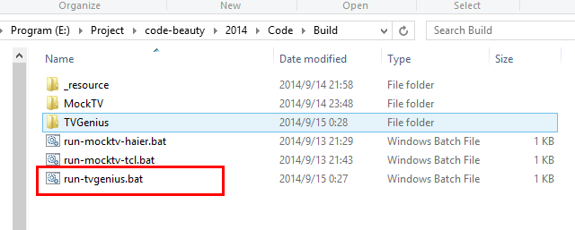

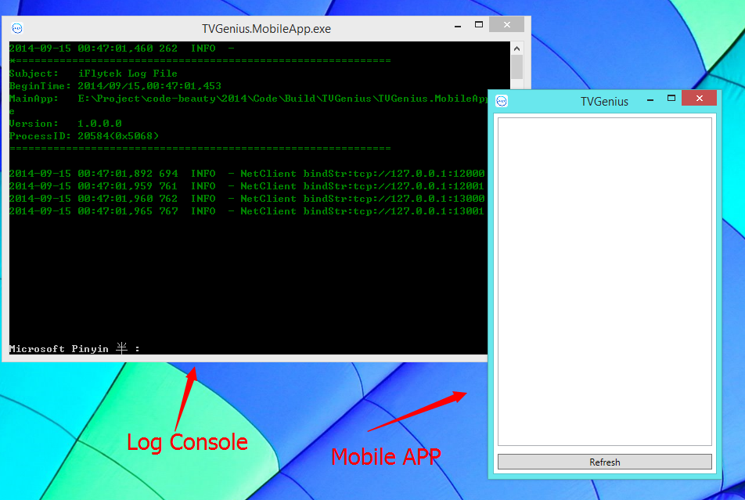

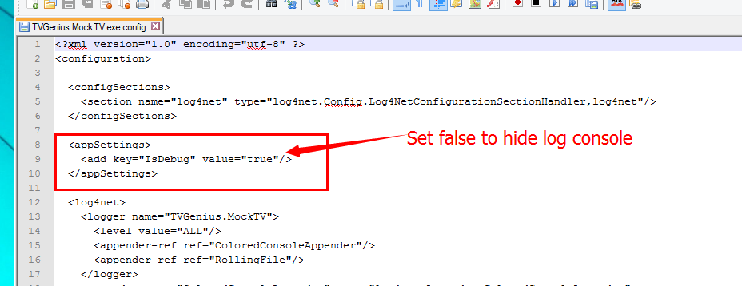

### Setp2: Start mock TV and add mock to TV List

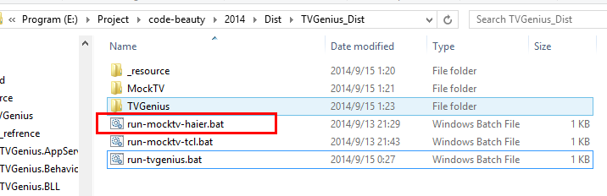

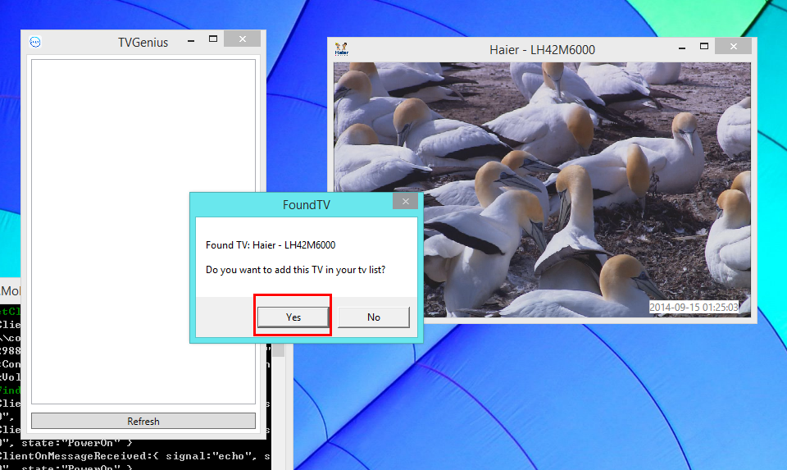

### Step 3: Enter the control panel

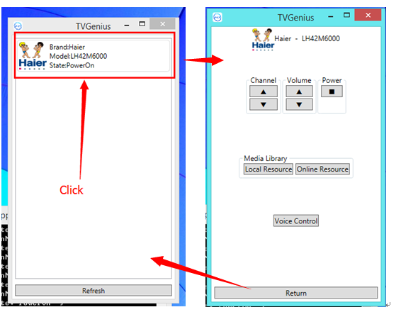

### Step 4: Add another mock TV

