Task 2
You are requested to implement the “tree” tool, in a long mode, meaning printing the file tree with it’s permitions, user and group, and size, like showed in the picture below.
Note that the default behaviour is to print from current folder moving down the tree
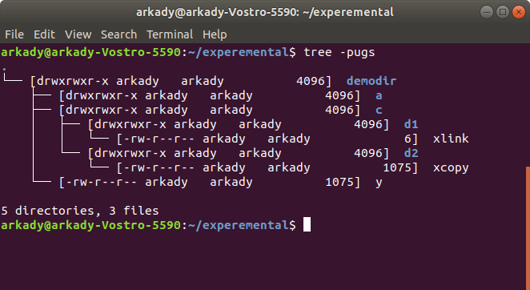
To help you with directory tree walking, two simple examples are provided (ftw1.c and ftw2.c)
i’ts suggested to understand them before starting your implementation.

To write the special tree chars (-,|, etc.) just copy them from the original tree terminal window.
Name your tool “stree” s – for student :). Submit the code, and working make file

Technical Notes:
- Submission day – up to 1/12/21 11:59pm
- Put your results in ZIP (not rar/7z/tar etc.) and name it by your ID. (-15 points if not)
- You can sibmit in pairs, name id ID_ID (-15 points if not)
- Failing to submit working Make may lower your point dramaticaly, down to Zero !
- If you are late, you can submit up to 6/12/21 11:59pm. 10 points loose for each day.
- Be aware of linux/windows files transfer. Linux is CaseSensitive, while Windows is not
- Don’t wait for the last minute, as “My VM is died”, “My cat swallowed the mouse” and other subterfuges will not be accepted

