Full Report 2023-06-19

Samuel Thelaus

2023-06-19

# Initial data checks

One participant had fewer than 630 total trials (total of 455 trials remained in file) and was missing columns for the final 3 MCQ questions (4-6). However, this participant was still included in analysis.

# Descriptive statistics

This section goes through the tests specified in the pre-registration report and specifies observed effect sizes in the sample so far.

There was a total of 199 participants after excluding participants. The mean age of participants was 21.6 (range 18-30) years old. The gender distribution was Female = 78, Male = 120, Other = 1. The distribution of majors for participants was STEM = 67, Business = 128, Humanities = 2, Other = 2.

Participant understanding of basic aspects of the task. “MCQ”: The table reports the percentage of correct replies to the 6 MCQ questions. “Pre-/Post-task quiz”: MCQ about the probability of a winning bet in a yellow/blue background session. The question is asked twice: just before the beginning of the task (“Pre”), and immediately after the task is completed (“Post”). “Optimal”: Participants who play optimally, i.e., they pass in all trials of all yellow background sessions. “Cravers”: Participants who bet at least twice across yellow background sessions during the experimental task (this is the definition used in Test 4; see also Table S3).

Participant type

MCQ

Post-game quiz

Total

Optimal

100%

* 100%
* Cravers
* 100%
* 99%
* 100%
* Total
* 100%
* 99%
* 100%

Participant report on whether they have a strategy of play just before they start performing the task.

No strategy

Not quite sure

Quite confident

Think it is right

n

1

29

120

49

Fraction of cravers in the experiment. “At least twice in yellow”: percentage of participants who bet at least twice across yellow background sessions during the experimental task (this is the definition of “craver” used in Test 4). “Bet in yellow”: percentage of participants who bet once or more in the yellow background sessions during the experimental task (reported here for reference).

Craving definition

Test

Control

Total

Bet in yellow

53/99 = 54%

36/100 = 36%

89/199 = 45%

At least twice in yellow

44/99 = 44%

33/100 = 33%

77/199 = 39%

Betting rate of all participants, in blue and yellow background sessions.

Blue

Yellow

n

199.000

199.000

mean

0.966

0.076

median

1.000

0.000

sd

0.091

0.142

min

0.500

0.000

max

1.000

0.742

skew

-3.537

2.369

# Test 1

Paired t-test to compare participant betting rate in the high-reward vs. low-reward sessions in the yellow background sessions, one-sided; H0: Betting rate is higher or equal in the low-reward sessions. We expect to be able to reject H0 at a 5% significance level (Prediction 1).

Participant-level test (N = 199).

Data was skewed at 1.611 (ideal values within [-1, 1]) and a Shapiro-Wilks test showed non-normality. Data were Box-Cox transformed with lambda = -18. This reduced skew to 0.816 (acceptable value), but SW test still showed non-normality.

Paired t-test using Box-Cox transformed data showed higher betting rate in high reward sessions (t(198) = -7.201, p < .001). Non-parametric paired Wilcoxon test using non-transformed data showed qualitatively same results (V = 242.5 p < .001).

# Test 2

Logistic mixed effects model predicting betting, with independent variables: potential reward value in the session, uncertainty level in the session, a dummy for treatment (reference: treatment C), a dummy for session colour (reference: blue), the interaction of treatment and session colour, and several control variables (which include the previous decision, to control for choice inertia/stickiness).

Logistic mixed model predicting betting (0: skip, 1: bet) for all participants in all trials. Variables are reward value (0: low, 1: high), uncertainty (0: low, 1: high), treatment (0: control, 1: test), session color (0: blue, 1: yellow), previous choice (0: skip, 1: bet), and the interaction between session color and treatment. Controls not shown were age, gender, major, and sequence number.

Variable

m_1

(Intercept)

2.91 (0.269)***

reward_valueHigh

1.556 (0.042)***

uncertaintyHigh

0.145 (0.036)***

treatmentTest

-0.822 (0.227)***

colorYellow

-8.493 (0.113)***

previous_choice

1.913 (0.039)***

sequence_number

-0.047 (0.018)*

treatmentTest:colorYellow

1.476 (0.13)***

R^2

0.836

N

119096

Note:

*p < .05,* ***p < .01,*** p < .001

# Test 3

Logistic mixed effects model predicting betting, with independent variables: potential reward value in the session, uncertainty level in the session, a dummy for treatment (reference: treatment C), a dummy for session colour (reference: blue), the previous decision, and reward exposure, which is the discounted sum of prior rewards as defined in our computational model (more below). The main variable of interest is the reward exposure variable. We expect it to be significantly positive (Prediction 2).

Logistic mixed model predicting betting (0: skip, 1: bet) for all participants in all trials. Variables are reward value (0: low, 1: high), uncertainty (0: low, 1: high), treatment (0: control, 1: test), session color (0: blue, 1: yellow), previous choice (0: skip, 1: bet), reward exposure, and the interaction between session color and treatment. Controls not shown were age, gender, major, and sequence number.

Variable

m_1

(Intercept)

2.905 (0.268)***

reward_valueHigh

1.557 (0.042)***

uncertaintyHigh

0.147 (0.037)***

treatmentTest

-0.817 (0.227)***

colorYellow

-8.517 (0.117)***

previous_choice

1.915 (0.039)***

reward_exposure

-0.02 (0.024)

sequence_number

-0.047 (0.018)*

treatmentTest:colorYellow

1.508 (0.135)***

Nakagawa R^2

0.836

N

119096

Note:

*p < .05,* ***p < .01,*** p < .001

Next we show the VIF for the model with previous choice and reward exposure. VIF at 1 suggests there is no multicollinearity and VIF >10 suggests problematic collinearity.

VIF for variables in test 3.

Variables

VIF

reward_value

1.003054

uncertainty

1.007319

treatment

1.028250

color

2.068245

age

1.029062

gender

1.015811

major

1.019029

sequence_number

1.001179

previous_choice

2.100844

reward_exposure

1.123431

## Stepwise model-building

This section shows the process of building the models from the theoretical version (in preregistration) to the model shown in the report. Models are built with incrementally more variables and each model is compared using R^2.

Stepwise comparison of models being built from theoretical base (1) to best fitting model (4). Noteworthy is that model (3) is the model from test 2.

Variable

* + - 1. (Intercept)
      * 4.616 (0.309)***
      * 4.624 (0.313)***
      * 2.911 (0.268)***
      * 2.905 (0.269)***
      * reward_valueHigh
      * 1.82 (0.041)***
      * 1.819 (0.041)***
      * 1.556 (0.042)***
      * 1.557 (0.042)***
      * uncertaintyHigh
      * 0.156 (0.034)***
      * 0.156 (0.034)***
      * 0.145 (0.036)***
      * 0.147 (0.037)***
      * treatmentTest
      * -0.885 (0.263)**
      * -0.882 (0.265)**
      * -0.822 (0.227)***
      * -0.817 (0.227)***
      * colorYellow
      * -9.991 (0.113)***
      * -9.991 (0.114)***
      * -8.492 (0.113)***
      * -8.517 (0.117)***
      * treatmentTest:colorYellow
      * 1.881 (0.13)***
      * 1.877 (0.131)***
      * 1.476 (0.129)***
      * 1.508 (0.135)***
      * sequence_number
        + -0.051 (0.017)**
        + -0.047 (0.018)*
        + -0.047 (0.018)*
        + previous_choice

1.913 (0.039)***

1.916 (0.039)***

reward_exposure

-0.02 (0.024)

R^2

0.84

0.84

0.836

0.836

N

119096

119096

119096

119096

Note:

*p < .05, **p < .01,** p < .001

# Test 4

Linear regression using as dependent variable participant betting rate in yellow (proxy for craving). We will also run a logistic regression using as dependent variable participant type (0: non craver; 1: craver). A craver is defined as a participant who chooses to bet at least twice across the yellow background sessions during the task.†† The independent variables will include a dummy code for treatment (reference: treatment C) and several control variables which include participant accuracy at the post-yellow-sessions lotteries (to control for the aforementioned miswanting aspect of behaviour). Our main variable of interest is the treatment variable: we expect a significantly positive coefficient on that variable (Prediction 3).

Linear model showed following F-statistic: F(7, 191) = 2.75, p = 0.01, R^2 = 0.058.

Linear model predicting betting rates in yellow for all participants. Main variable is the treatment effect (0: control, 1: test). Controls not shown were age, gender, major, and sequence number.

Variable

m_1

(Intercept)

0.057 (0.024)*

treatmentTest

0.041 (0.02)*

R^2

0.058

N

199

Note:

*p < .05,* ***p < .01,*** p < .001

Logistic model predicting whether a participant is a craver (bet at least twice in yellow). Main variable is the treatment effect (0: control, 1: test). Controls not shown were age, gender, major, and sequence number.

Variable

m_1

(Intercept)

-0.446 (0.36)

treatmentTest

0.543 (0.308)

Nakagawa R^2

0.067

N

199

Note:

*p < .05,* ***p < .01,*** p < .001

# Test 5

Logistic mixed effects model predicting betting in a yellow background session; the independent variables include potential reward value in the session, uncertainty level in the session, a dummy for treatment (reference: treatment C), and the previous decision (to control for choice inertia/stickiness). The main variables of interest are: - the reward variable; we expect a positive coefficient on that variable (Prediction 1). - the treatment variable; we expect a positive coefficient on this variable (Prediction 3). - the uncertainty variable; a positive coefficient would be consistent with Prediction 4.

Logistic mixed effects model predicting betting in yellow background sessions for cravers (bet at least twice in yellow). Independent variables were reward value (0: low, 1: high), uncertainty (0: low, 1: high), treatment (0: control, 1: test), and previous choice (0: skip, 1: bet). Controls not shown were age, gender, major, and sequence number.

Variable

m_1

(Intercept)

-3.797 (0.301)***

reward_valueHigh

1.383 (0.07)***

uncertaintyHigh

0.681 (0.065)***

treatmentTest

0.264 (0.271)

sequence_number

-0.321 (0.032)***

previous_choice

1.316 (0.066)***

Nakagawa R^2

0.44

N

9224

Note:

*p < .05,* ***p < .01,*** p < .001

## Test 5 with reward exposure and previous choice

Test 5 with previous choice and reward history.

Variable

m_1

(Intercept)

-3.854 (0.306)***

reward_valueHigh

1.387 (0.07)***

uncertaintyHigh

0.683 (0.065)***

treatmentTest

0.374 (0.282)

sequence_number

-0.319 (0.032)***

previous_choice

1.312 (0.066)***

reward_exposure

-0.073 (0.051)

Nakagawa R^2

0.441

N

9224

Note:

*p < .05,* ***p < .01,*** p < .001

Next we show the VIF for the model with previous choice and reward exposure. VIF at 1 suggests there is no multicollinearity and VIF >10 suggests problematic collinearity.

VIF for variables in test 5 with reward exposure included.

Variables

VIF

reward_value

1.027309

uncertainty

1.001925

treatment

2.678930

age

1.039347

gender

1.073227

major

1.024448

sequence_number

1.007021

previous_choice

1.049438

reward_exposure

2.625503

## Stepwise model-building

This section shows the process of building the models from the theoretical version (in preregistration) to the model shown in the report. Models are built with incrementally more variables and each model is compared using R^2.

Stepwise comparison of models being built from theoretical base (1) to best fitting model (4).

Variable

* + - 1. (Intercept)
      * -3.485 (0.336)***
      * -3.552 (0.342)***
      * -3.797 (0.301)***
      * -3.854 (0.306)***
      * reward_valueHigh
      * 1.552 (0.067)***
      * 1.583 (0.068)***
      * 1.383 (0.07)***
      * 1.387 (0.07)***
      * uncertaintyHigh
      * 0.744 (0.062)***
      * 0.759 (0.063)***
      * 0.681 (0.065)***
      * 0.683 (0.065)***
      * treatmentTest
      * 0.416 (0.305)
      * 0.426 (0.31)
      * 0.264 (0.271)
      * 0.374 (0.282)
      * sequence_number
        + -0.349 (0.031)***
        + -0.321 (0.032)***
        + -0.319 (0.032)***
        + previous_choice

1.316 (0.066)***

1.312 (0.066)***

reward_exposure

-0.073 (0.051)

R^2

0.427

0.447

0.44

0.441

N

9224

9224

9224

9224

Note:

*p < .05, **p < .01,** p < .001

# Test 6

Paired t-test to compare participant betting rate in the high-uncertainty vs. low uncertainty sessions in the yellow background sessions, one-sided; H0: Betting rate is higher or equal in the low-uncertainty sessions. We expect to be able to reject H0 at a significance level of 5% (Prediction 4).

Paired t-test to compare participant betting rate in the high-uncertainty vs. low-uncertainty sessions in the yellow background sessions, one-sided; H0: Betting rate is higher or equal in the low-uncertainty sessions. We expect to be able to reject H0 at a 5% significance level.

Participant-level test (N = 199).

Data was skewed at 1.402 (ideal values within [-1, 1]) and a Shapiro-Wilks test showed non-normality. Data were Box-Cox transformed with lambda = -10. This reduced skew to 0.738 (acceptable value), but SW test still showed non-normality.

Paired t-test using Box-Cox transformed data showed higher betting rate in high uncertainty sessions (t(198) = -3.542, p < .001). Non-parametric paired Wilcoxon test using non-transformed data showed qualitatively same results (V = 828.5 p < .001).

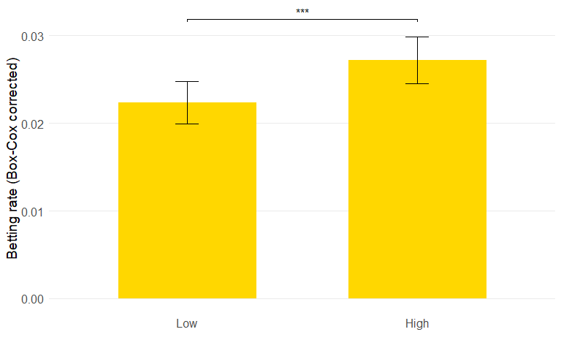

Average betting rate in yellow backround sessions for low and high uncertainty sessions for all participants (t(198) = -3.542, p < .001).

# Test 7

T-test checking if betting rate in yellow session in the test treatment is different from 0. Participant-level test (N = 99). Additionally, shows comparison of betting rate in yellow between control and test treatment through two-sample t-test.

The t-test investigating whether betting rate in yellow in test was different from 0 was significant at, t(98) = 5.948, p < .001.

The t-test comparing betting in yellow between the control and test treatment was also significant, showing that betting rate was on average higher in test compared to control treatment (t(191.632) = -2.38, p = 0.018). This test was run on Box-Cox transformed data with lambda = -13.5.

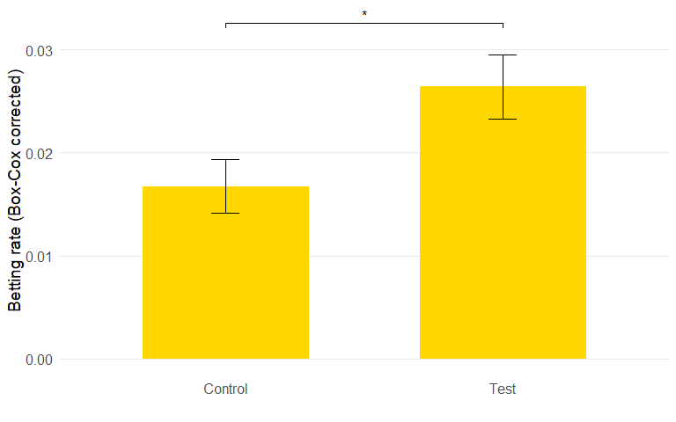

Average betting rate in yellow sessions for control and test treatment (t(191.632) = -2.38, p = 0.018).

# Figures

S2 from OSF but with color as well - only for pooled

S4 but theta 1.0