**Assignment 5**

**19UCS081 Shruti Goyal**

**Creating database**

create database coffee_store;

use coffee_store;

create table products(

productID int primary key auto_increment,

Name varchar(30),

Price decimal(3,2),

CoffeeOrigin varchar(30)

);

create table customers(

customerID int primary key auto_increment,

First_Name varchar(30),

Last_Name varchar(30),

Gender enum('M','F'),

ContactNumber decimal(11,0)

);

create table orders(

orderID int primary key auto_increment,

productID int,

customerID int,

Date_Time datetime,

constraint FK_ProductOrder

foreign key (productID) references products(productID),

constraint FK_CustomerOrder

foreign key (customerID) references customers(customerID)

);

insert into products (Name,Price,CoffeeOrigin)

values

('Espresso', 2.50, 'Brazil'),

('Machhiato', 3.00, 'Brazil'),

('Cappuccino', 3.50, 'CostaRica'),

('Latte', 3.50, 'Indonesia'),

('Americano', 3.00, 'Brazil'),

('Flat White', 3.50, 'Brazil'),

('Filter', 3.00, 'India');

INSERT INTO customers (First_Name, Last_Name, Gender, ContactNumber) VALUES ('Chris','Martin','M','01123147789'),('Emma','Law','F','01123439899'),('Mark','Watkins','M','01174592013'),('Daniel','Williams','M',NULL),('Sarah','Taylor','F','01176348290'),('Katie','Armstrong','F','01145787353'),('Michael','Bluth','M','01980289282'),('Kat','Nash','F','01176987789'),('Buster','Bluth','M','01173456782'),('Charlie',NULL,'F','01139287883'),('Lindsay','Bluth','F','01176923804'),('Harry','Johnson','M',NULL),('John','Smith','M','01174987221'),('John','Taylor','M',NULL),('Emma','Smith','F','01176984116'),('Gob','Bluth','M','01176985498'),('George','Bluth','M','01176984303'),('Lucille','Bluth','F','01198773214'),('George','Evans','M','01174502933'),('Emily','Simmonds','F','01899284352'),('John','Smith','M','01144473330'),('Jennifer',NULL,'F',NULL),('Toby','West','M','01176009822'),('Paul','Edmonds','M','01966947113');

INSERT INTO orders (productID,customerID,Date_Time) VALUES (1,1,'2017-01-01 08-02-11'),(1,2,'2017-01-01 08-05-16'),(5,12,'2017-01-01 08-44-34'),(3,4,'2017-01-01 09-20-02'),(1,9,'2017-01-01 11-51-56'),(6,22,'2017-01-01 13-07-10'),(1,1,'2017-01-02 08-03-41'),(3,10,'2017-01-02 09-15-22'),(2,2,'2017-01-02 10-10-10'),(3,13,'2017-01-02 12-07-23'),(1,1,'2017-01-03 08-13-50'),(7,16,'2017-01-03 08-47-09'),(6,21,'2017-01-03 09-12-11'),(5,22,'2017-01-03 11-05-33'),(4,3,'2017-01-03 11-08-55'),(3,11,'2017-01-03 12-02-14'),(2,23,'2017-01-03 13-41-22'),(1,1,'2017-01-04 08-08-56'),(3,10,'2017-01-04 11-23-43'),(4,12,'2017-01-05 08-30-09'),(7,1,'2017-01-06 09-02-47'),(3,18,'2017-01-06 13-23-34'),(2,16,'2017-01-07 09-12-39'),(2,14,'2017-01-07 11-24-15'),(4,5,'2017-01-08 08-54-11'),(1,1,'2017-01-09 08-03-11'),(6,20,'2017-01-10 10-34-12'),(3,3,'2017-01-10 11-02-11'),(4,24,'2017-01-11 08-39-11'),(4,8,'2017-01-12 13-20-13'),(1,1,'2017-01-14 08-27-10'),(4,15,'2017-01-15 08-30-56'),(1,7,'2017-01-16 10-02-11'),(2,10,'2017-01-17 09-50-05'),(1,1,'2017-01-18 08-22-55'),(3,9,'2017-01-19 09-00-19'),(7,11,'2017-01-19 11-33-00'),(6,12,'2017-01-20 08-02-21'),(3,14,'2017-01-21 09-45-50'),(5,2,'2017-01-22 10-10-34'),(6,24,'2017-01-23 08-32-19'),(6,22,'2017-01-23 08-45-12'),(6,17,'2017-01-23 12-45-30'),(2,11,'2017-01-24 08-01-27'),(1,1,'2017-01-25 08-05-13'),(6,11,'2017-01-26 10-49-10'),(7,3,'2017-01-27 09-23-57'),(7,1,'2017-01-27 10-08-16'),(3,18,'2017-01-27 10-13-09'),(4,19,'2017-01-27 11-02-40'),(3,10,'2017-01-28 08-03-21'),(1,2,'2017-01-28 08-33-28'),(1,12,'2017-01-28 11-55-33'),(1,13,'2017-01-29 09-10-17'),(6,6,'2017-01-30 10-07-13'),(1,1,'2017-02-01 08-10-14'),(2,14,'2017-02-02 10-02-11'),(7,10,'2017-02-02 09-43-17'),(7,20,'2017-02-03 08-33-49'),(4,21,'2017-02-04 09-31-01'),(5,22,'2017-02-05 09-07-10'),(3,23,'2017-02-06 08-15-10'),(2,24,'2017-02-07 08-27-26'),(1,1,'2017-02-07 08-45-10'),(6,11,'2017-02-08 10-37-10'),(3,13,'2017-02-09 08-58-18'),(3,14,'2017-02-10 09-12-40'),(5,4,'2017-02-10 11-05-34'),(1,2,'2017-02-11 08-00-38'),(3,8,'2017-02-12 08-08-08'),(7,20,'2017-02-12 09-22-10'),(1,1,'2017-02-13 08-37-45'),(5,2,'2017-02-13 12-34-56'),(4,3,'2017-02-14 08-22-43'),(5,4,'2017-02-14 09-12-56'),(3,5,'2017-02-15 08-09-10'),(6,7,'2017-02-15 09-05-12'),(1,8,'2017-02-15 09-27-50'),(2,9,'2017-02-16 08-51-12'),(3,10,'2017-02-16 13-07-46'),(4,11,'2017-02-17 08-03-55'),(4,12,'2017-02-17 09-12-11'),(5,10,'2017-02-17 11-41-17'),(6,18,'2017-02-17 13-05-56'),(7,19,'2017-02-18 08-33-27'),(1,17,'2017-02-19 08-12-31');

**Query -1**

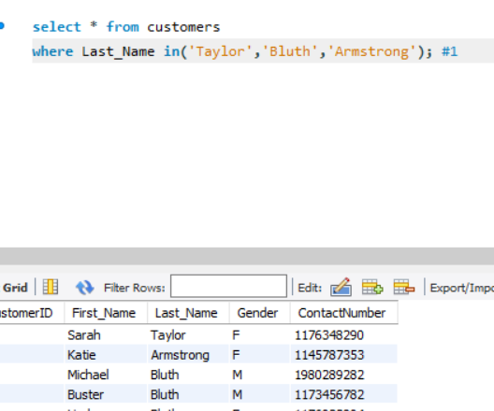**Find the list of customers whose last name is Taylor or Bluth or Armstrong. (Use IN)**

select * from customers

where Last_Name in('Taylor','Bluth','Armstrong');

**2. Find the list of customers whose first name is not Katie or John or George. (Use NOT IN)**

select * from customers

where First_Name not in('Katie','John','George');

**3. Find out the order details (productID, customerID, Date_Time) which are placed between ‘2017-01-01’ to ‘2017-01-07’.**

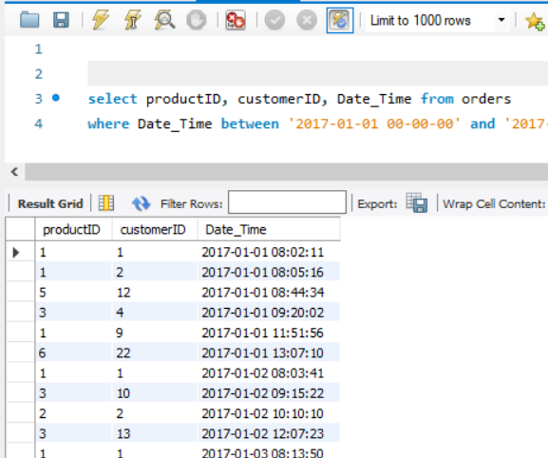select productID, customerID, Date_Time from orders

where Date_Time between '2017-01-01 00-00-00' and '2017-01-07 23-59-59' ;

**4. List the order details of customers with customersID between 5 and 10.**

select * from customers

where customerID between 5 and 10;

**5. Find out the list of customers whose last name should start with any alphabet between A and L.**

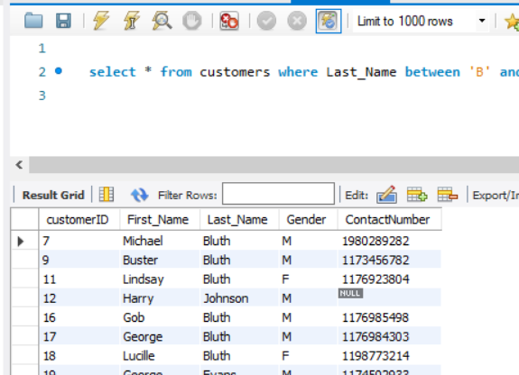

select * from customers where Last_Name between 'B' and 'L';

**6. Find out the list of customers whose last name should start with ‘W’.**

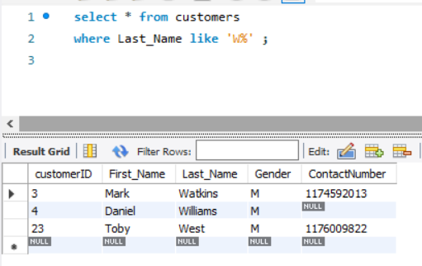select * from customers

where Last_Name like 'W%' ;

**7. Find out the list of customers whose last name should end with ‘o’.**

**select * from customers**

where Last_Name like '%o';

**8. Find out the list of customers who have alphabet ‘o’ in their first name.**

select * from customers

where First_Name like '%o%';

**9. Find out the product details whose price is starting with 3.**

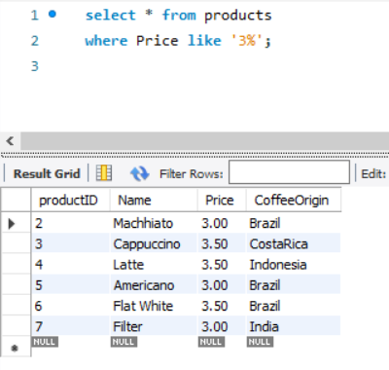

select * from products

where Price like '3%';

**10. List the products with ascending order of their price.**

select * from products

order by Price asc;

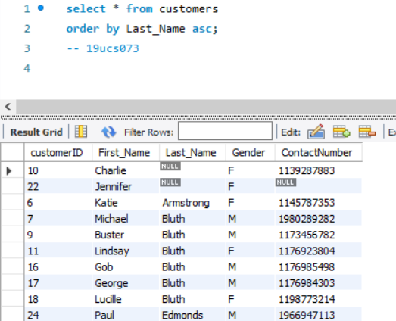 **11. List the customers with ascending order of their last name (starting with A to Z).**

select * from customers

order by Last_Name asc;

**12. Find out the orders placed by customer with customerID ‘1’ and list his orders from most recent order to oldest order.**

select * from orders

where customerID=1 order by Date_Time desc;

**13. Find out the distinct list of countries whose coffee product is there in the coffee_store.**

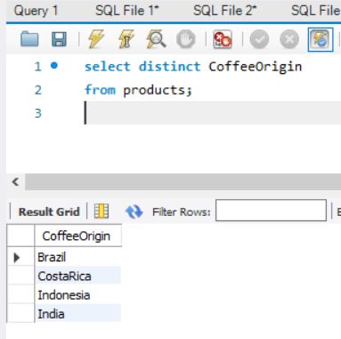

select distinct CoffeeOrigin

from products;

**14. Find out how many distinct customers (customer id) have placed their order from 2017- 02-01 to 2017-02-28**

select distinct customerID from orders

where Date_Time between '2017-02-01 00-00-00' and '2017-02-28 23-59-59';

**15. Find out the 5 customers with customer id starting from 6.**

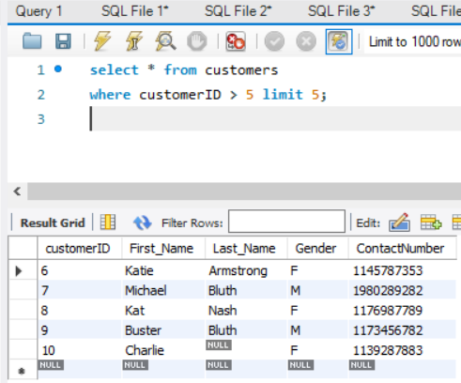

select * from customers

where customerID > 5 limit 5;

**16. List out top 10 customers ordered by their last name.**

select * from customers

order by Last_Name limit 10 ;

**17. From the products table, select the Name, Price, and Coffee Origin but rename the Name as Product Name and CoffeeOrigin as Country in the result set.**

select Name as ProductName, Price, CoffeeOrigin as Country

from products;

**18. Find out the name of all the products along with their order date and time information whose order is placed by all the customers.**

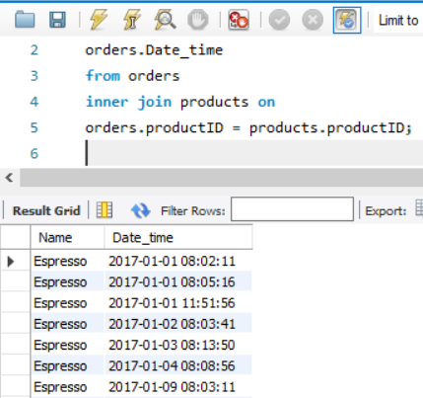select products.Name,

orders.Date_time

from orders

inner join products on

orders.productID = products.productID;

**19. Find out the newest to oldest orders placed for the product ‘Americano’. Display the product 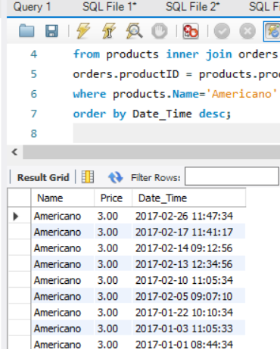name, price, order data and time for these orders.**

select products.Name,

products.Price,

orders.Date_Time

from products inner join orders on

orders.productID = products.productID

where products.Name='Americano'

order by Date_Time desc;

**20. List out the first name and contact numbers of the customers who have placed order for product ‘Espresso’.**

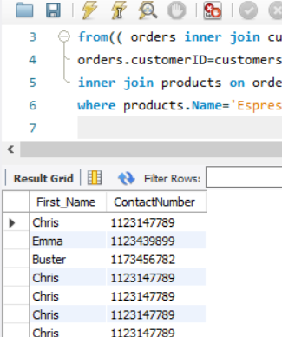select customers.First_Name,

customers.ContactNumber

from(( orders inner join customers on

orders.customerID=customers.customerID)

inner join products on orders.productID = products.productID)

where products.Name='Espresso';

**21. Find out the order ID, first name, last name, contact number, and order time of top 10 most recent to oldest orders.**

select orders.orderID,

customers.First_Name,

customers.Last_Name,

customers.ContactNumber,

orders.Date_Time

from orders inner join customers on

orders.customerID = customers.customerID

order by Date_Time desc limit 10;

**22. Find out the order ID, first name, last name, contact number, and order time of top 10 oldest to newest orders. (Use orders table as left table)**

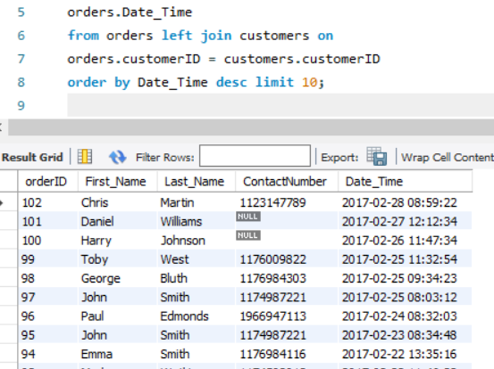**update orders set customerID = null where orderID=1;**

select orders.orderID,

customers.First_Name,

customers.Last_Name,

customers.ContactNumber,

orders.Date_Time

from orders left join customers on

orders.customerID = customers.customerID

order by Date_Time desc limit 10;

**23. Find out the order ID, first name, last name, contact number, and order time of top 10 oldest to newest orders. (Use customers table as left table)**

select orders.orderID,

customers.First_Name,

customers.Last_Name,

customers.ContactNumber,

orders.Date_Time

from customers left join orders on

orders.customerID = customers.customerID

order by Date_Time desc limit 10;

**24. Find out the order ID, first name, last name, contact number, and order time of top 10 oldest to newest orders. (Use orders table as left table)**

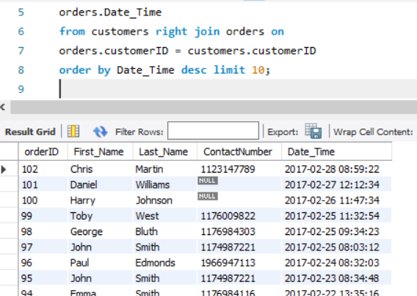

select orders.orderID,

customers.First_Name,

customers.Last_Name,

customers.ContactNumber,

orders.Date_Time

from customers right join orders on

orders.customerID = customers.customerID

order by Date_Time desc limit 10;

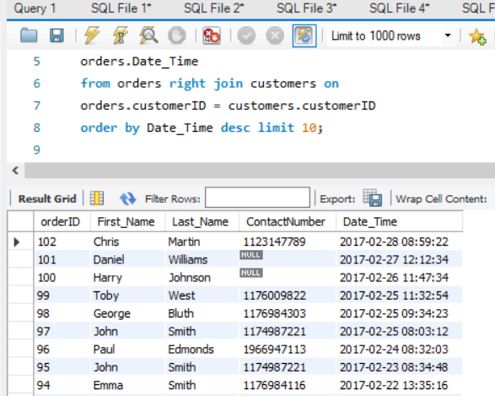**25. Find out the order ID, first name, last name, contact number, and order time of top 10 oldest to newest orders. (Use customers table as left table) (Observe the results for both these queries to know the working of right join) Again update the orders table using below query update orders set customerID=1 where orderID=1;**

select orders.orderID,

customers.First_Name,

customers.Last_Name,

customers.ContactNumber,

orders.Date_Time

from orders right join customers on

orders.customerID = customers.customerID

order by Date_Time desc limit 10;

**26. Find out the details of the orders with name of the products, product price, first and last names of customers who have purchased them with the order date and time information.**

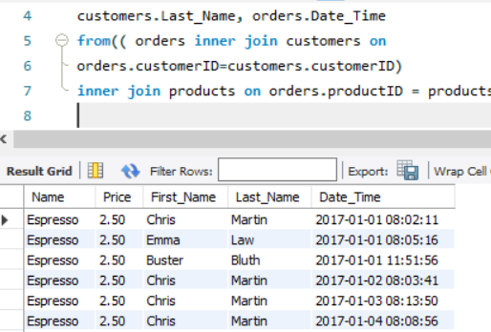update orders set customerID = 1 where orderID=1;

select products.Name,products.Price,customers.First_Name,

customers.Last_Name, orders.Date_Time

from(( orders inner join customers on

orders.customerID=customers.customerID)

inner join products on orders.productID = products.productID);

**27. Find out the newest to oldest orders placed by the customer whose last name is ‘Martin’. List the name of the product, price, first name, last name, and order date and time.**

select products.Name,products.Price,customers.First_Name,

customers.Last_Name, orders.Date_Time

from(( orders inner join customers on

orders.customerID=customers.customerID)

inner join products on orders.productID = products.productID)

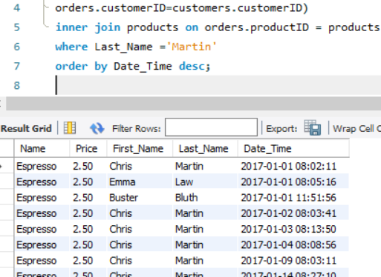where Last_Name ='Martin'

order by Date_Time desc;