Variables
- Mu: Population size
- F: Scaling factor

LexSMS-MODES

Config 1
- 100 gens for GIF generation
- 100 gens for experimentation
- 30 experiments
- Mu: 10
- F: 2.0
- Auto adaption: off
- Early stop: off
Pareto front progression
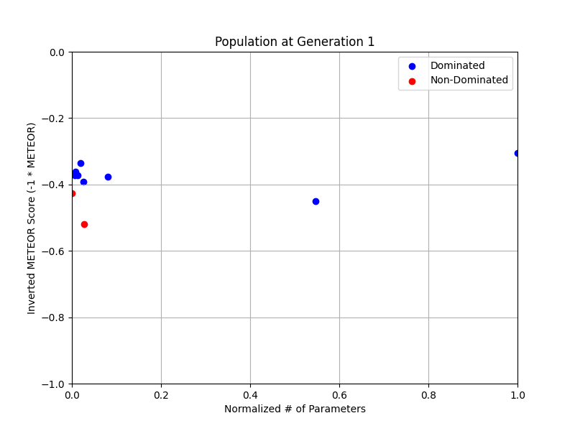
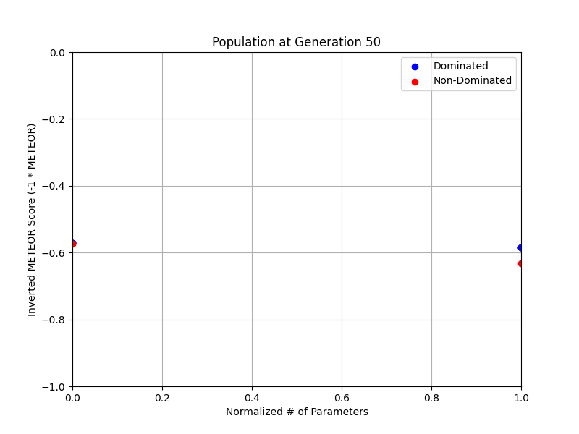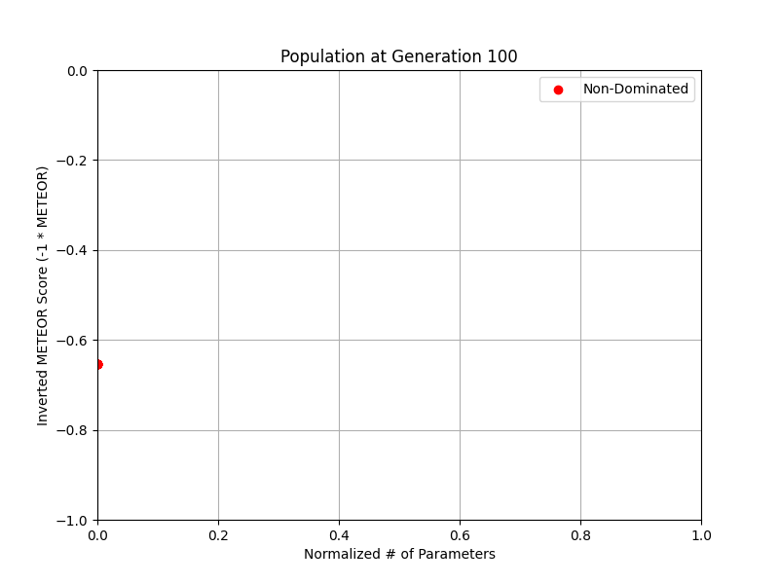
Hypervolume progression
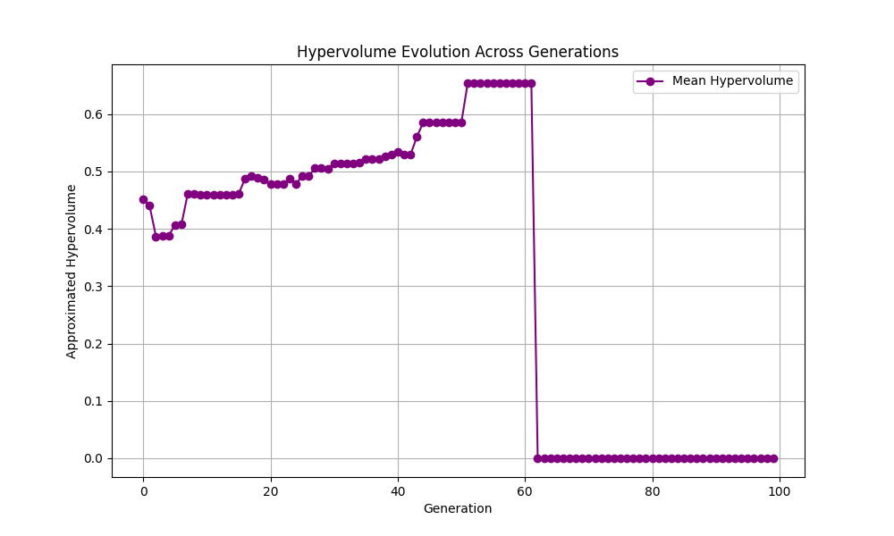
Evolution of F
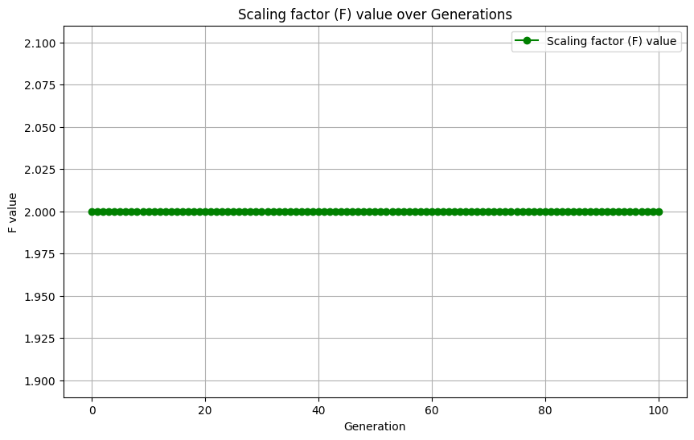
Distribution of parameter count (objective 1) over the first 30 gens
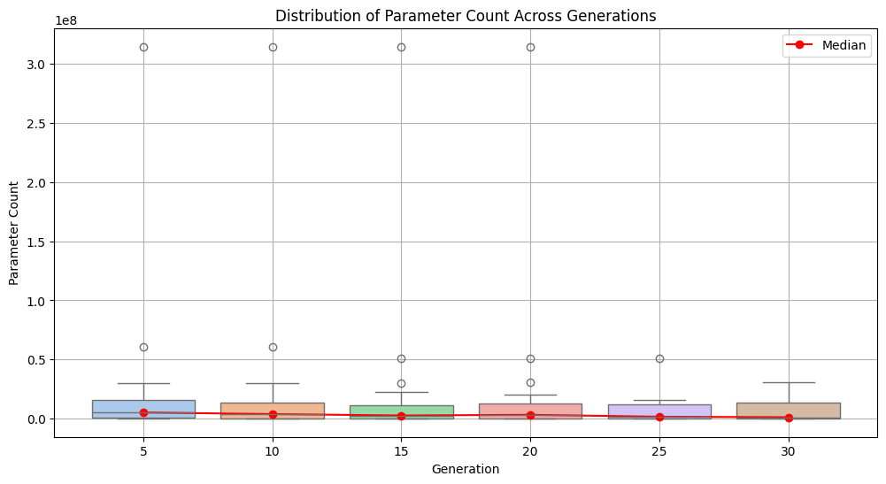
Distribution of METEOR score (objective 2) over the first 30 gens
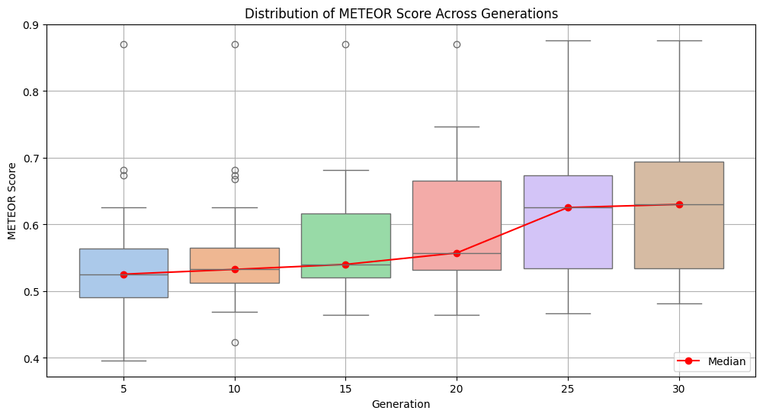
Convergence of param count
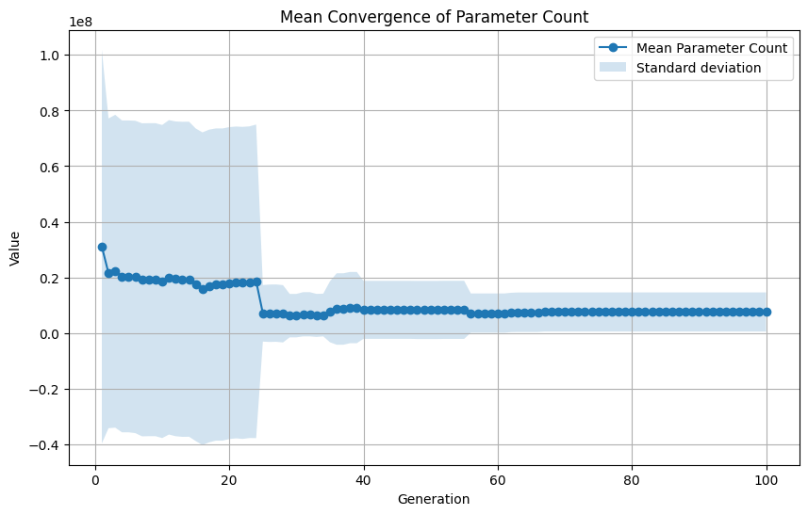
Convergence of METEOR score
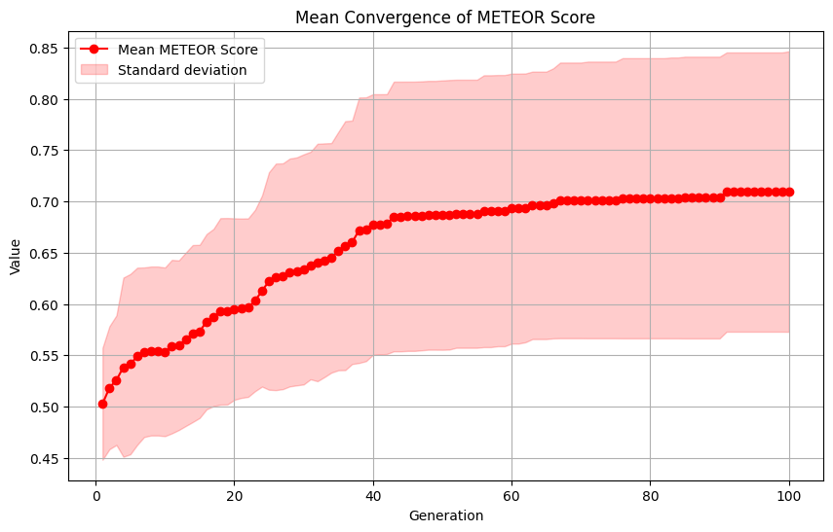

Config 2
- 100 gens for GIF generation
- 100 gens for experimentation
- 30 experiments
- Mu: 100
- F: 0.5
- Auto adaption: on
- Early stop: off
Pareto front progression
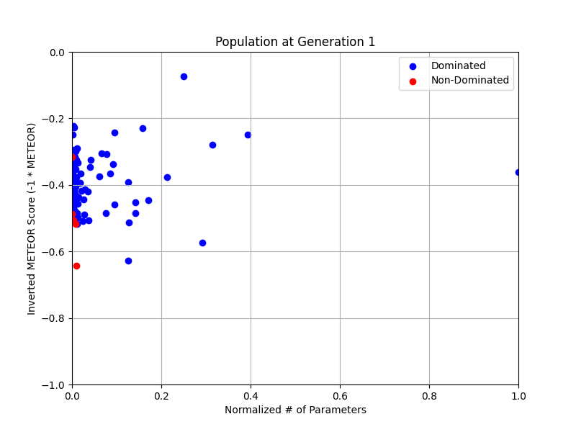
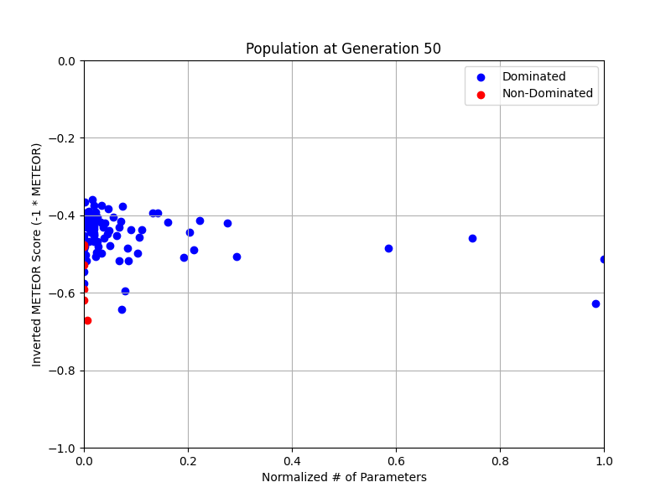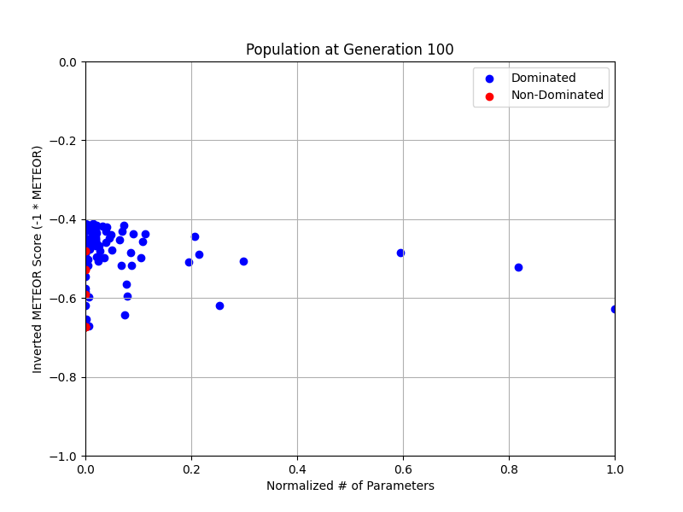
Hypervolume progression
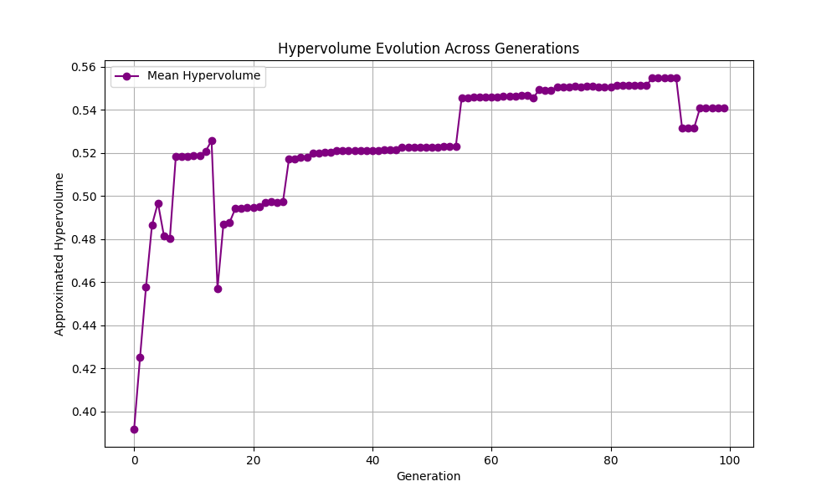
Evolution of F
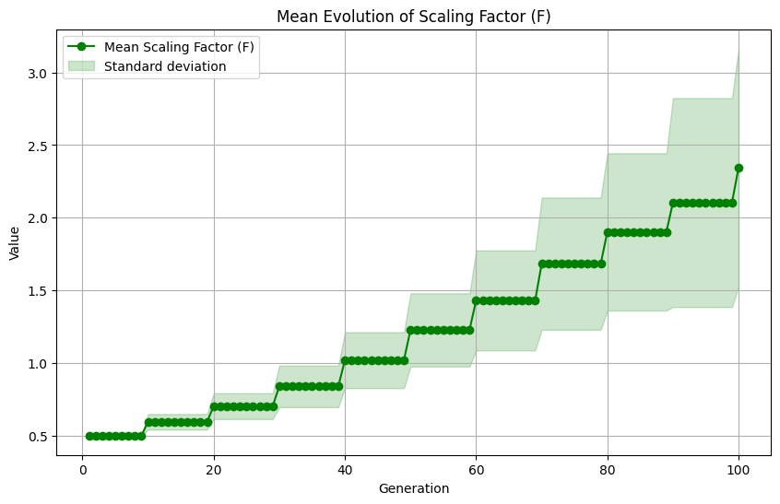
Distribution of parameter count (objective 1) over the first 30 gens
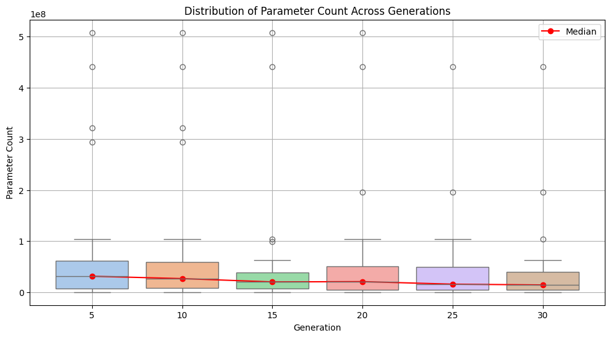
Distribution of METEOR score (objective 2) over the first 30 gens
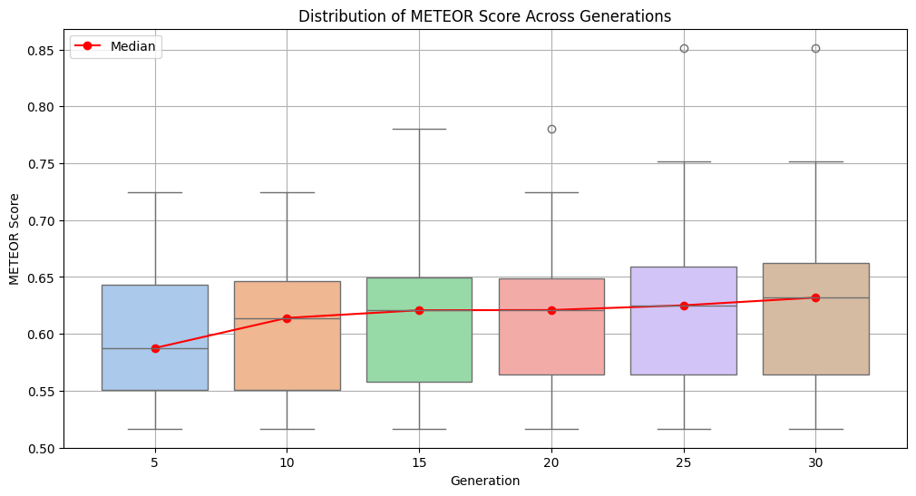
Convergence of param count
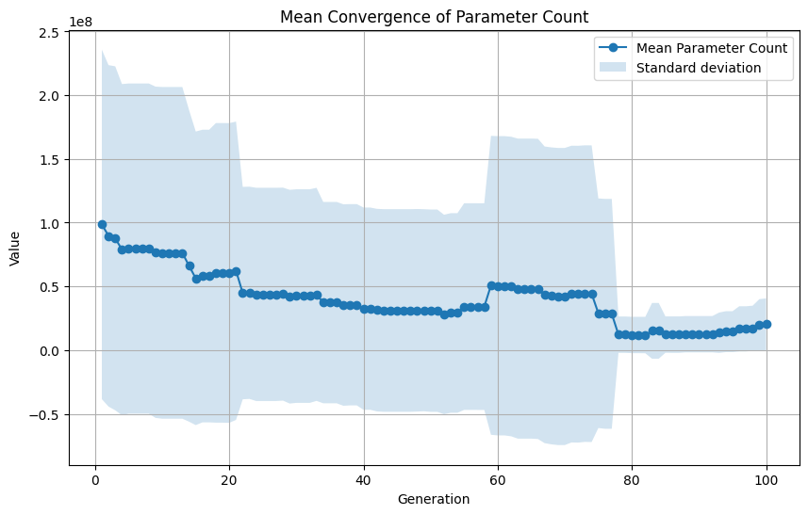
Convergence of METEOR score
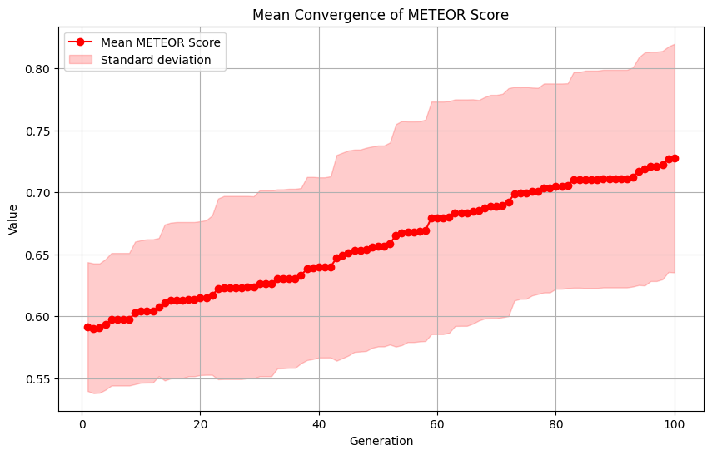

Config 3
- 500 gens for GIF generation
- 250 gens for experimentation
- 20 experiments
- Mu: 200
- F: 0.5
- Auto adaption: on
- Early stop: on (only for experimentation)
Pareto front progression
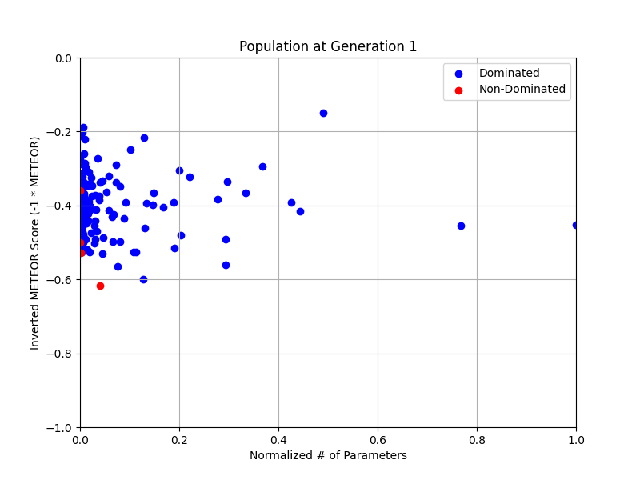
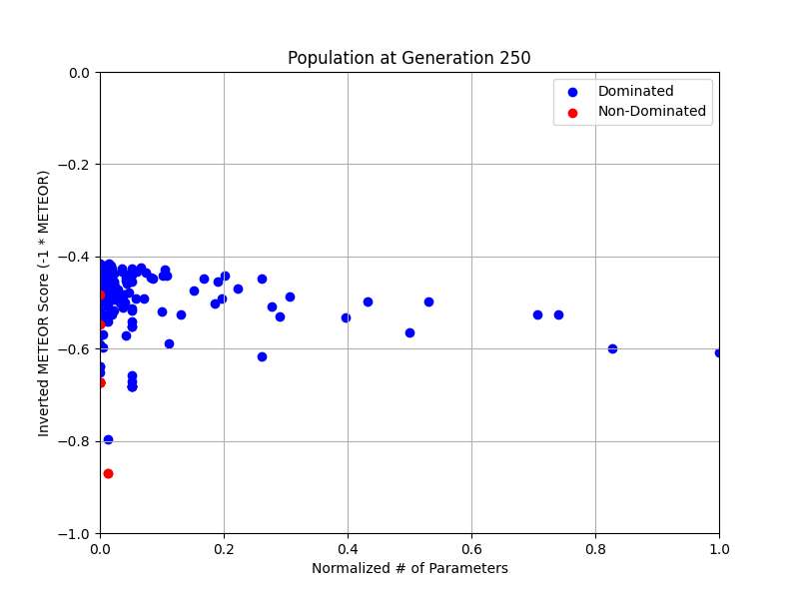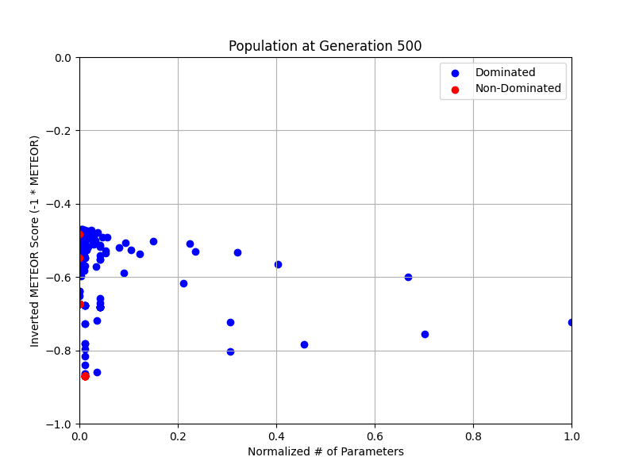
Hypervolume progression
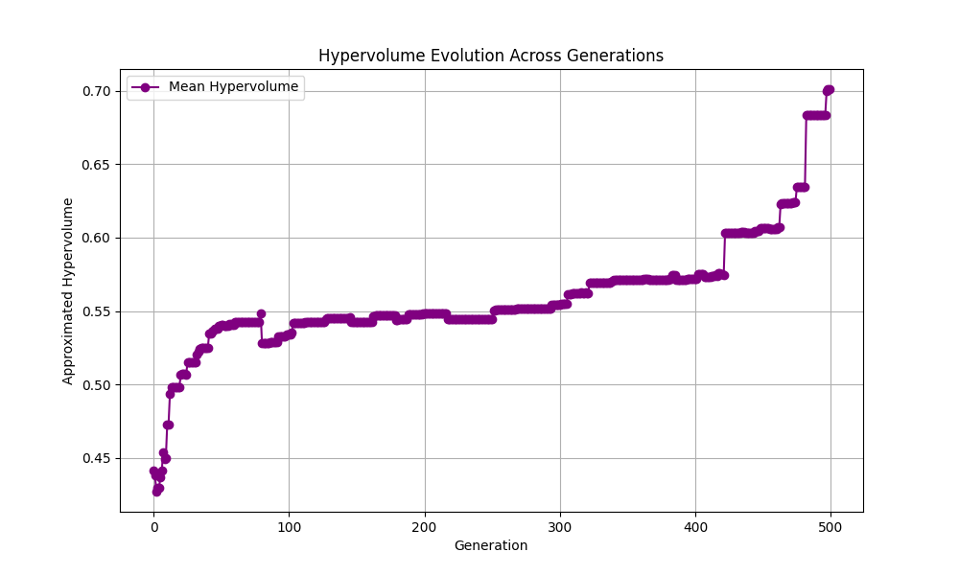
Evolution of F
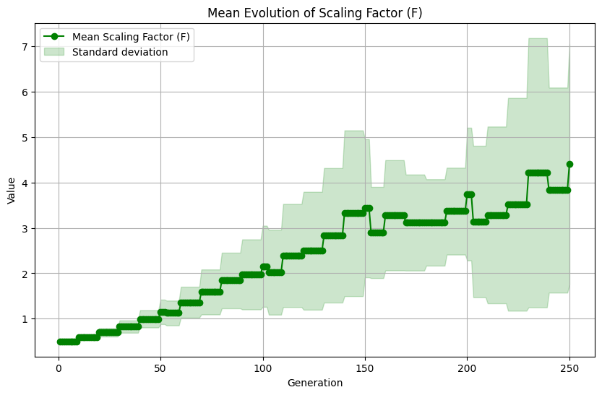
Distribution of parameter count (objective 1) over the first 30 gens
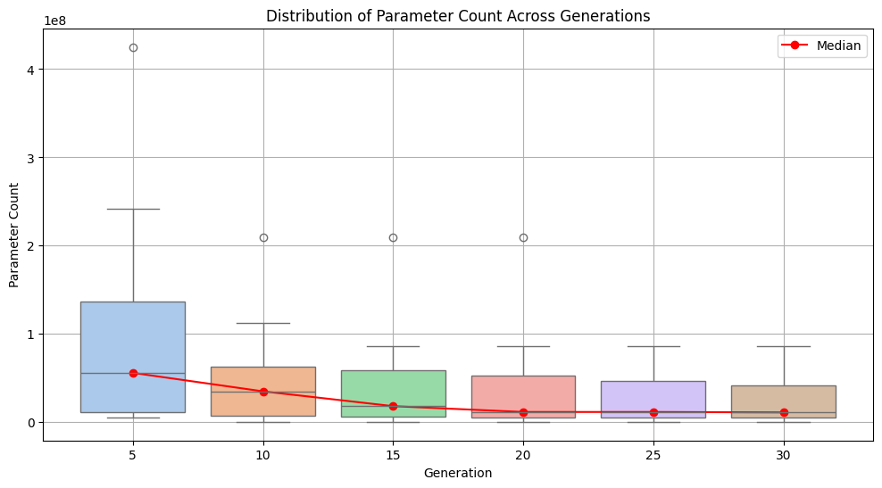
Distribution of METEOR score (objective 2) over the first 30 gens
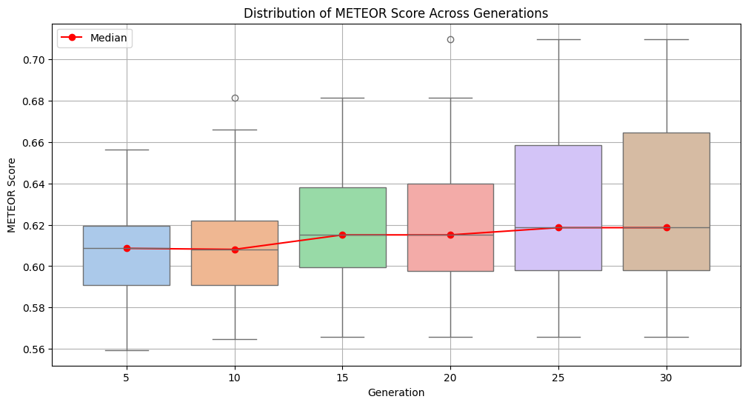
Convergence of param count
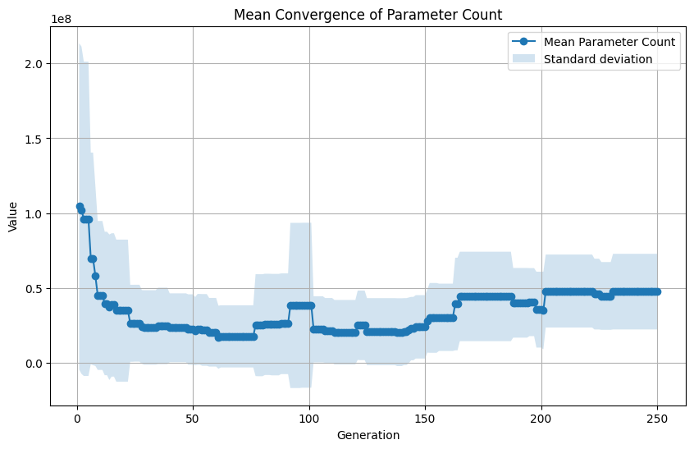
Convergence of METEOR score
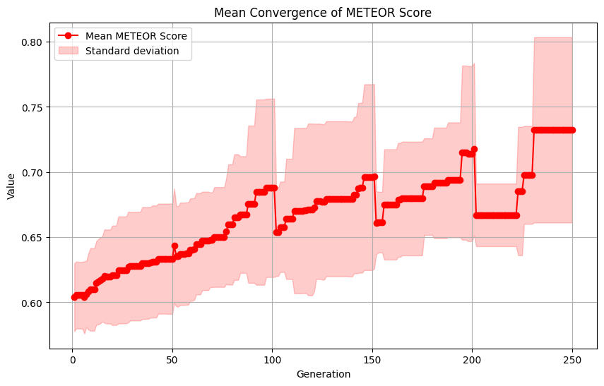

Config 4
- 500 gens for GIF generation
- 250 gens for experimentation
- 10 experiments
- Mu: 400
- F: 2.0
- Auto adaption: on
- Early stop: on (only for experimentation)
Pareto front progression
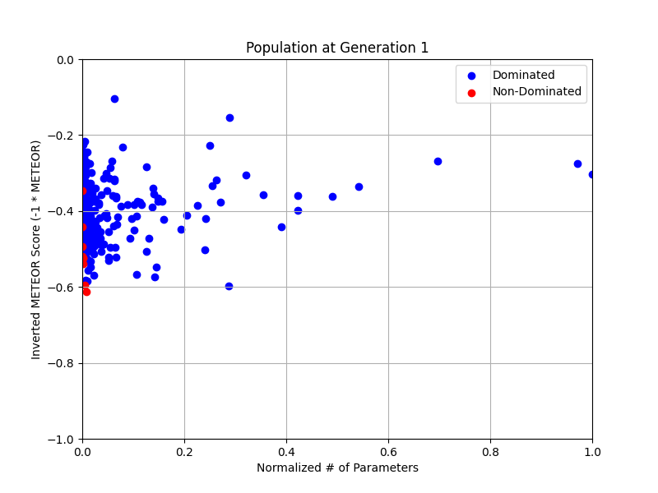
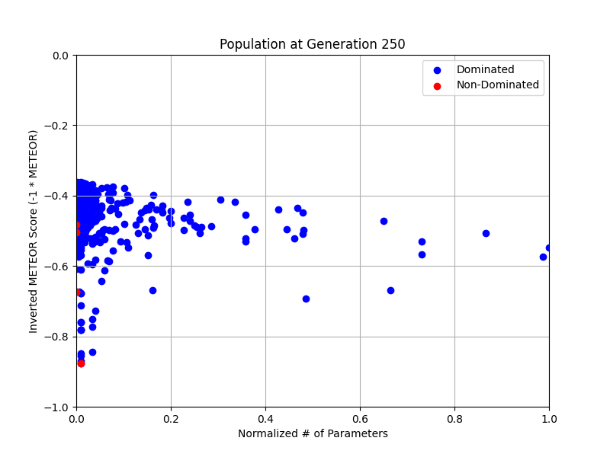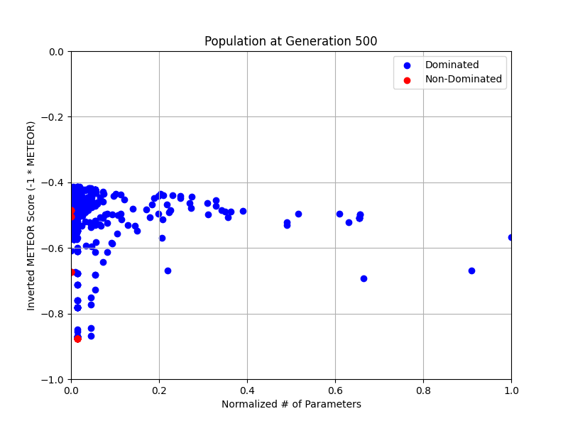
Hypervolume progression
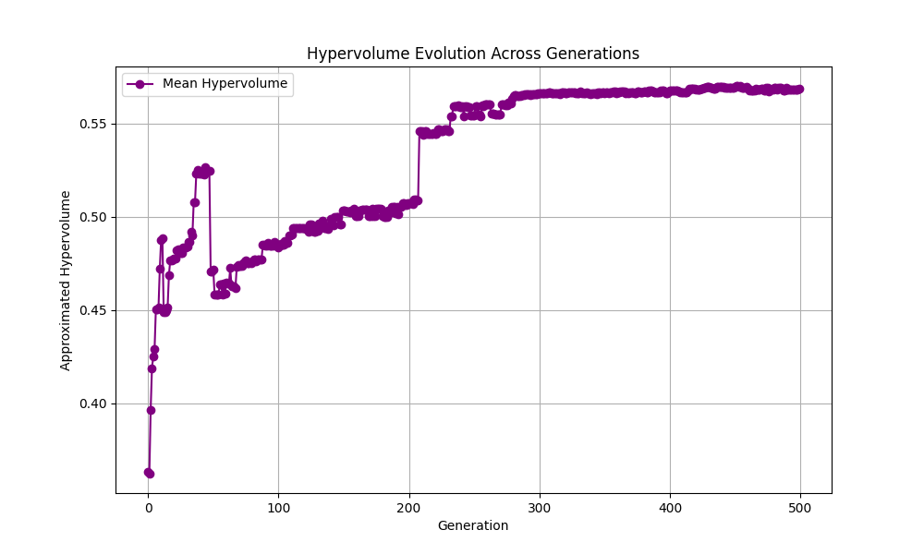
Evolution of F
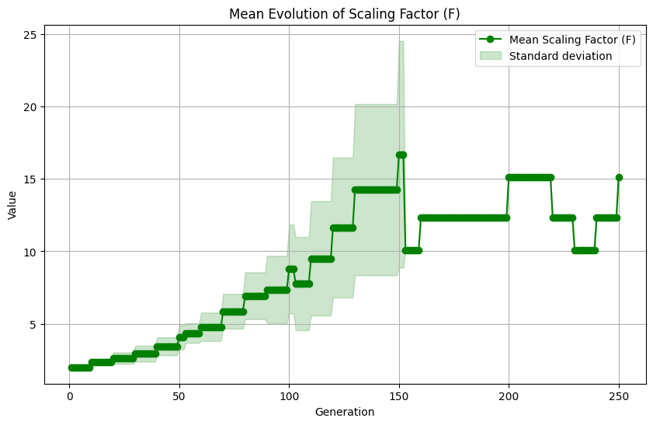
Distribution of parameter count (objective 1) over the first 30 gens
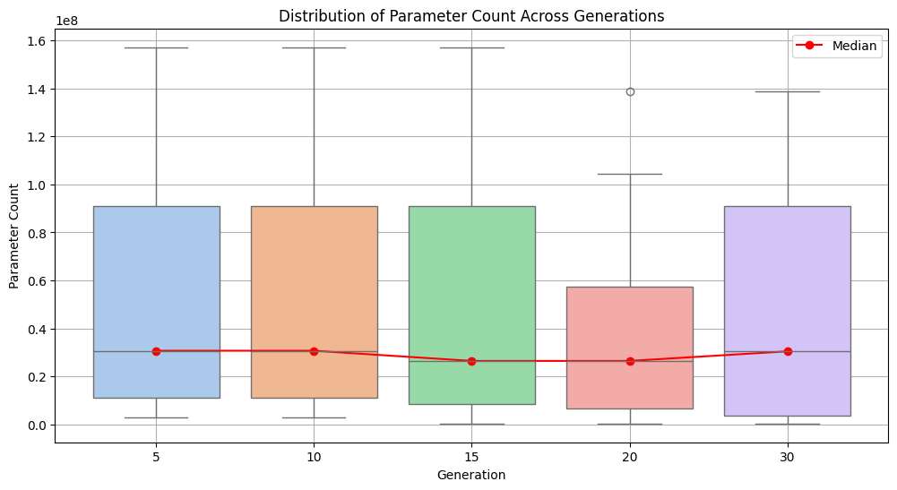
Distribution of METEOR score (objective 2) over the first 30 gens
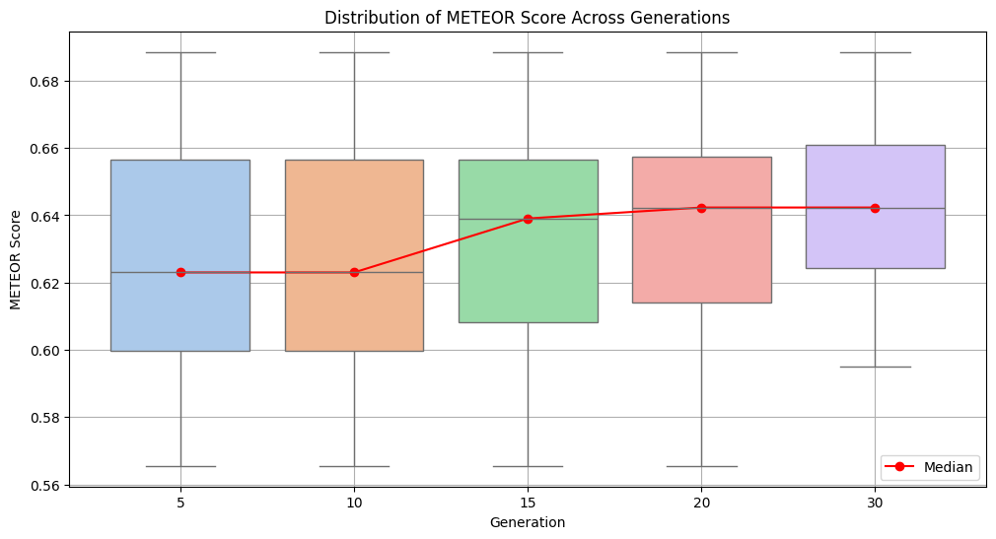
Convergence of param count
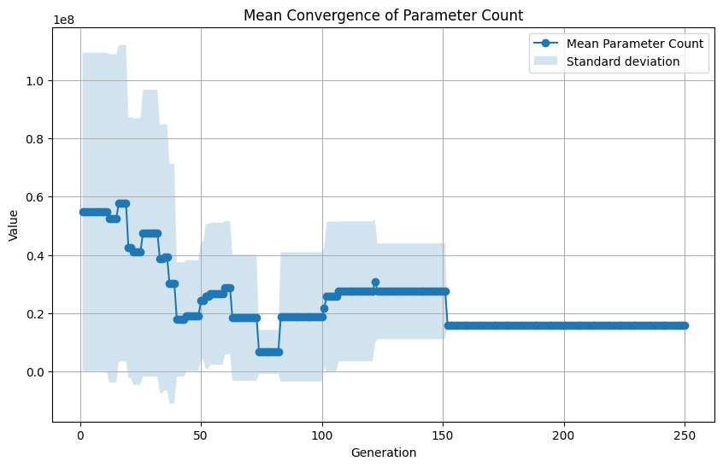
Convergence of METEOR score
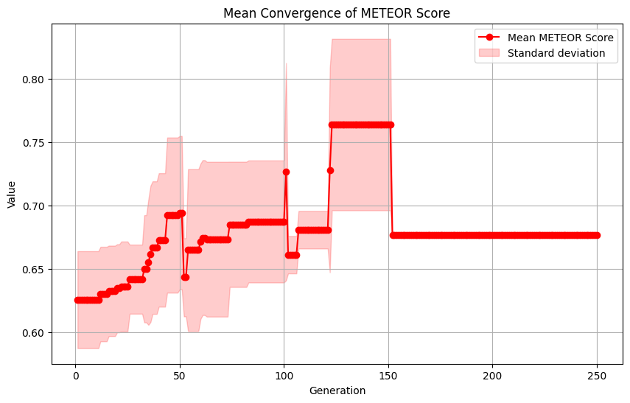

SMS-EMOA

Config 1
- Mu: 10
- Gens: 100 for GIF, 100 for experiments
- Experiments: 30
Pareto front:
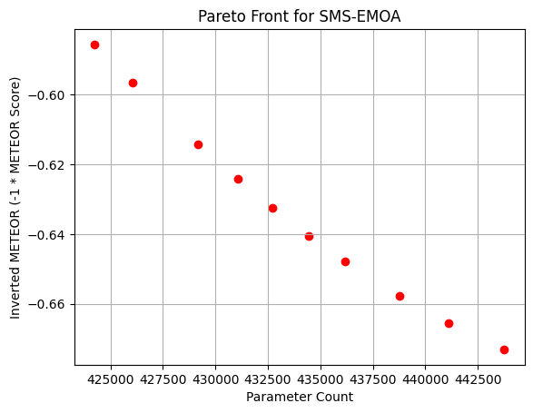
Pareto front evolution:
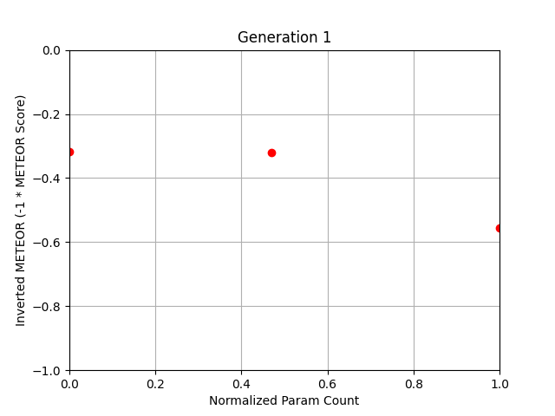
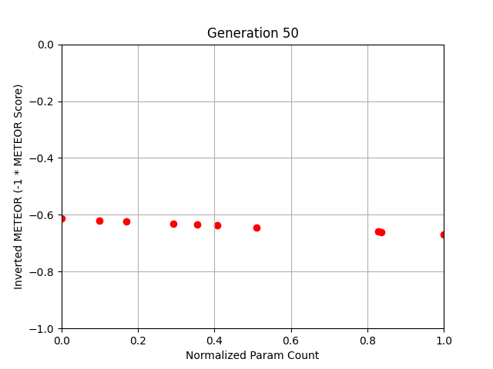
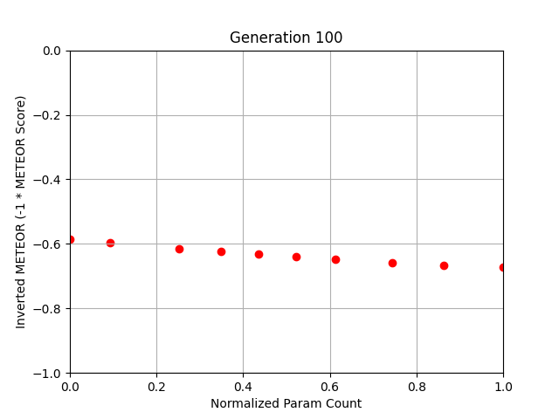
Hypervolume for GIF run
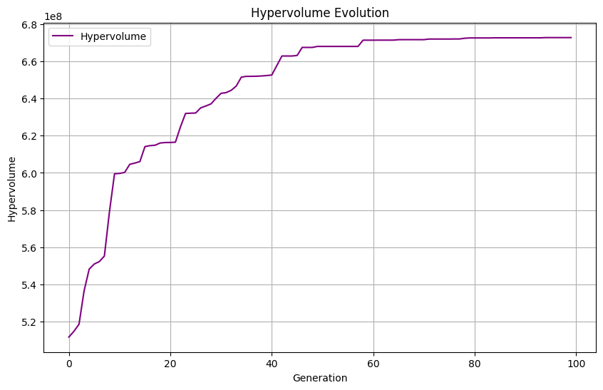
Param count (objective 1) distribution of the first 30 gens for GIF run
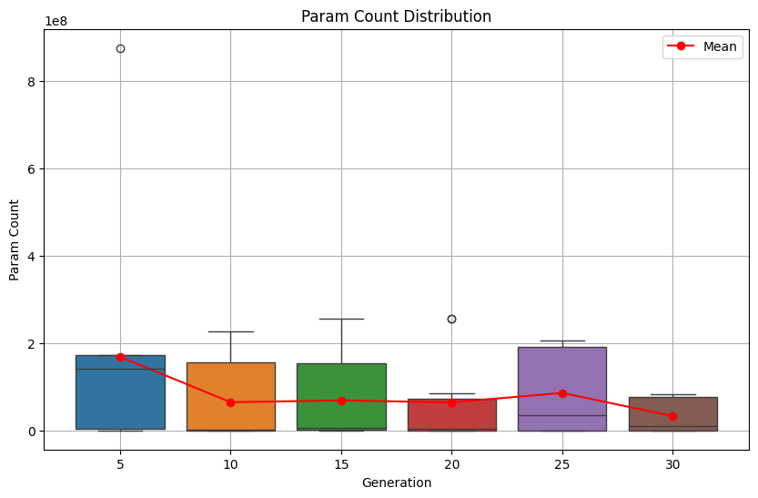
METEOR score (objective 2) distribution of the first 30 runs for GIF run
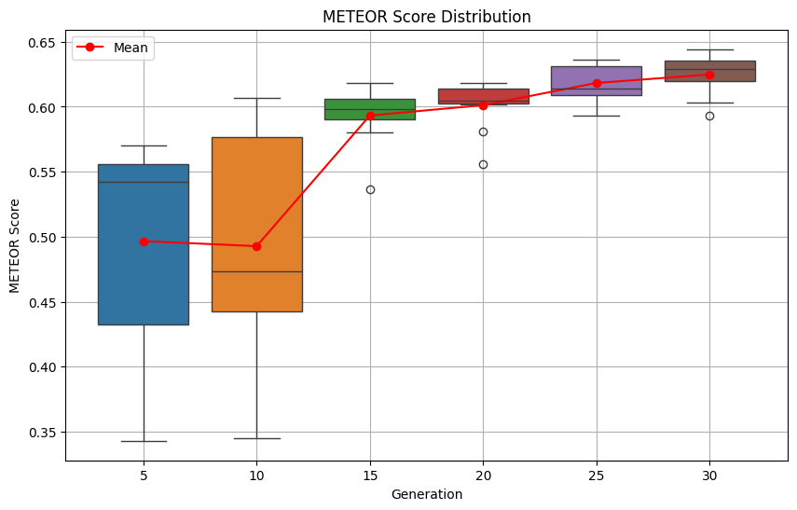
Param count convergence for the GIF run
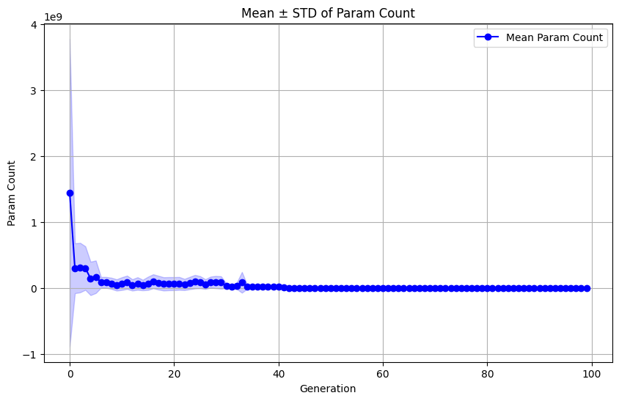
METEOR score convergence for the GIF run
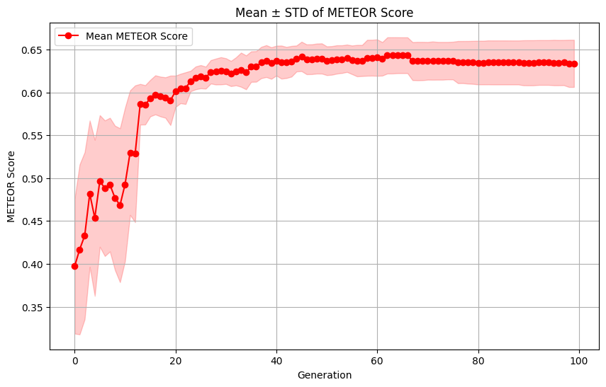Hypervolume progression for experiments
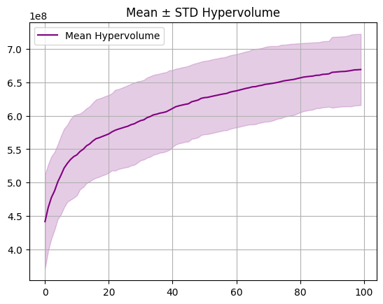
Param count distribution for the first 30 runs for experimentation
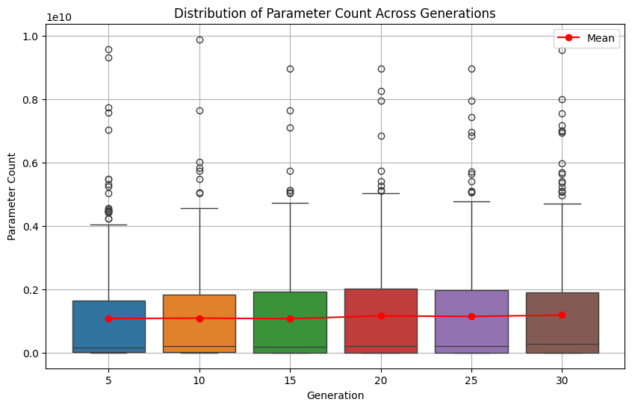
METEOR score distribution for the first 30 runs for experimentation
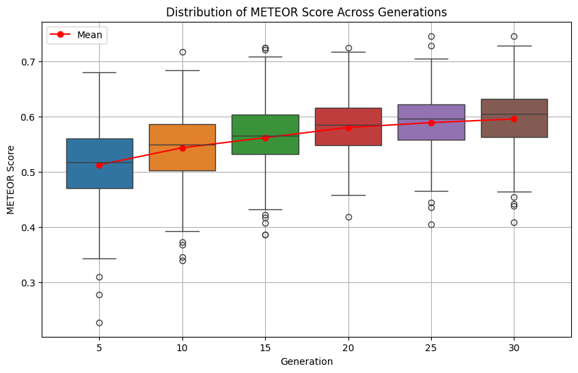
Param count convergence for experimentation
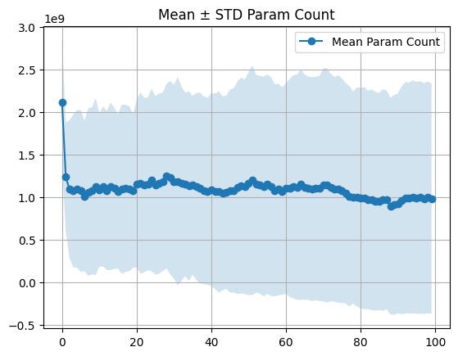
METEOR score convergence for experimentation
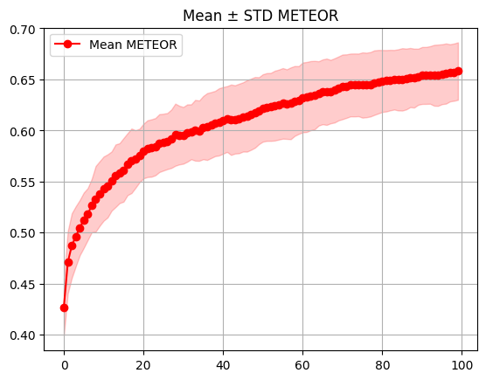
Config 2
- Mu: 100
- Gens: 100 for GIF, 100 for experiments
- Experiments: 30
Pareto front:
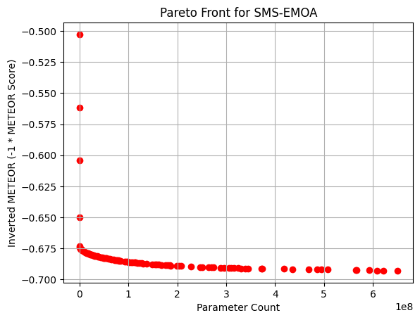
Pareto front evolution:
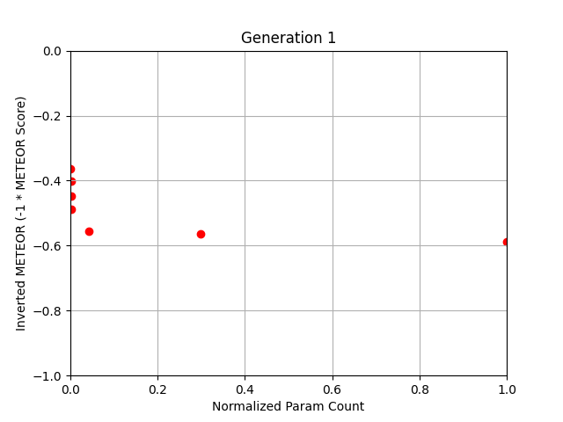
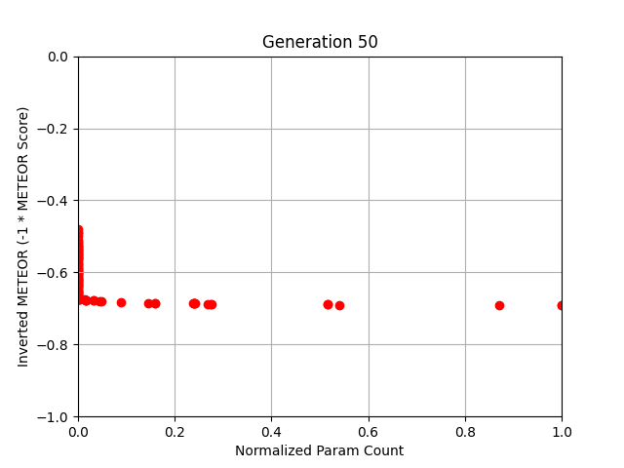
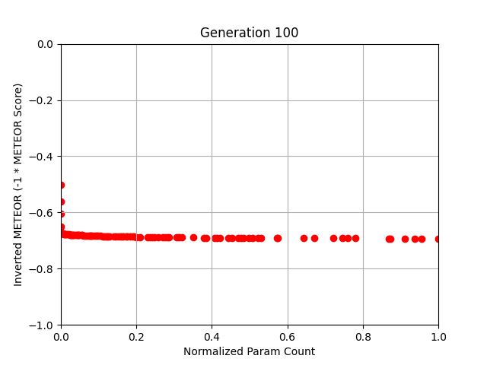
Hypervolume for GIF run
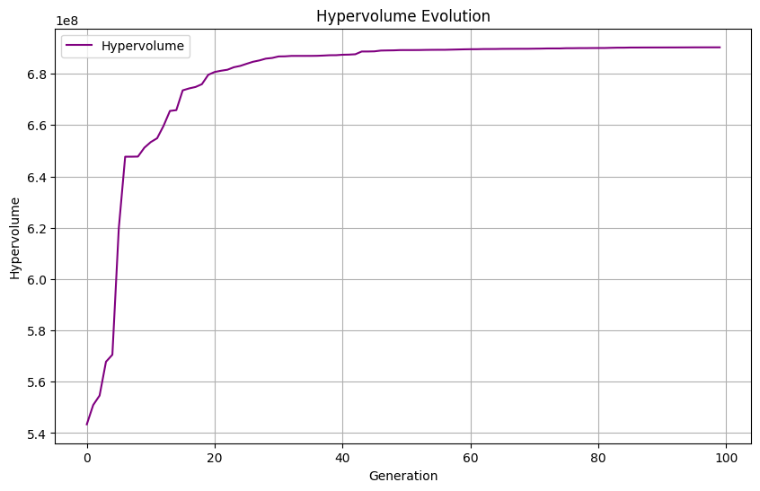
Param count (objective 1) distribution of the first 30 gens for GIF run
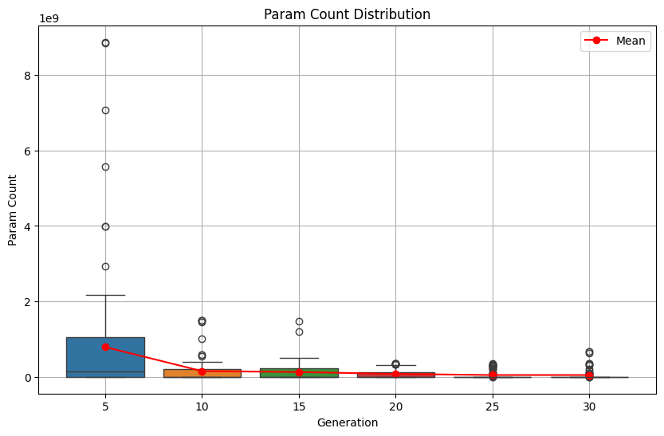
METEOR score (objective 2) distribution of the first 30 runs for GIF run
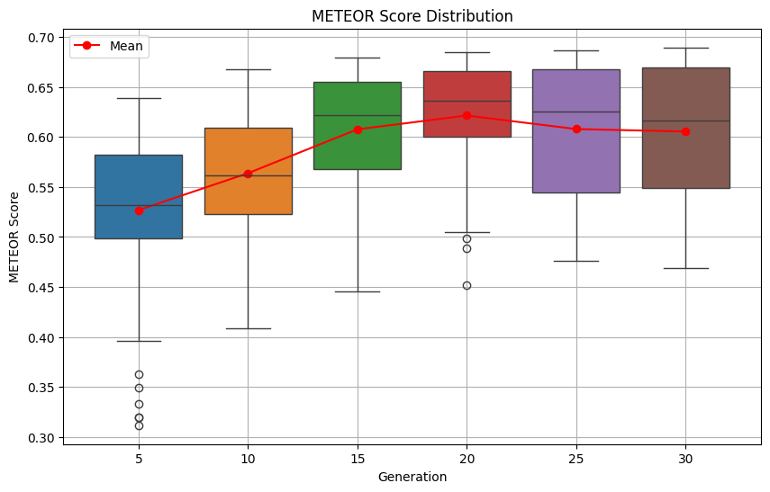
Param count convergence for the GIF run
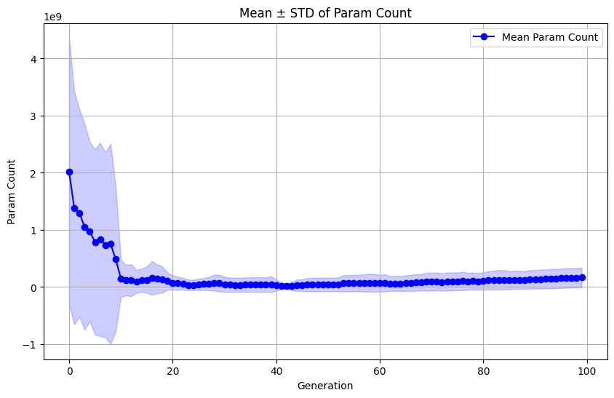
METEOR score convergence for the GIF run
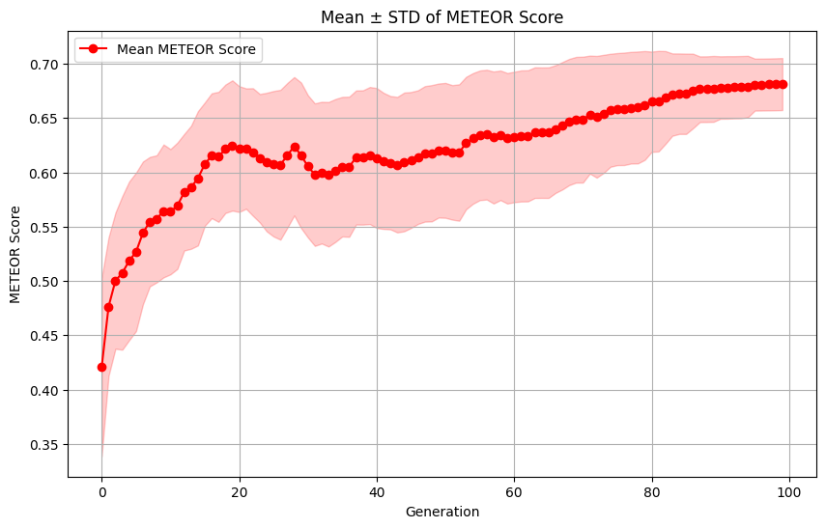Hypervolume progression for experiments
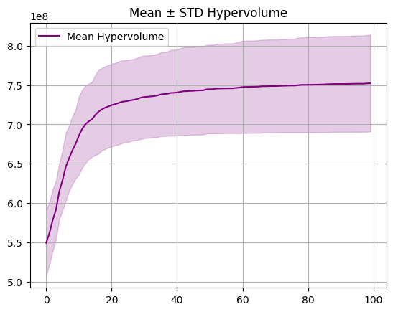
Param count distribution for the first 30 runs for experimentation
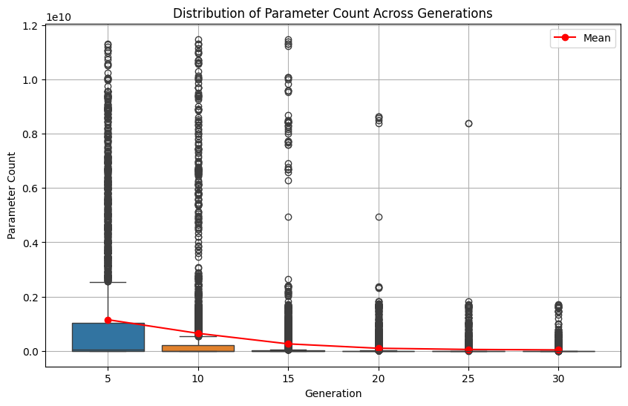
METEOR score distribution for the first 30 runs for experimentation
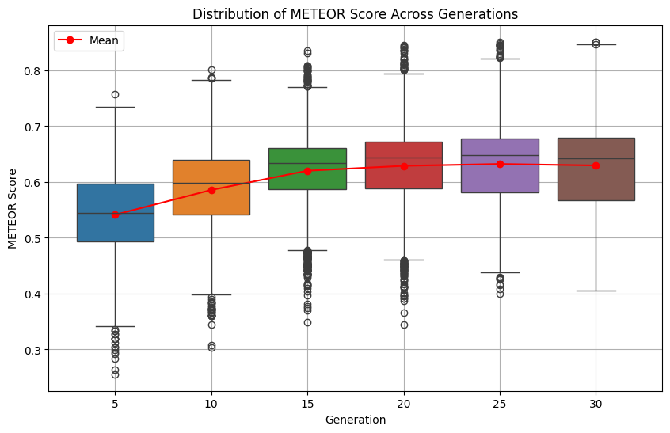
Param count convergence for experimentation
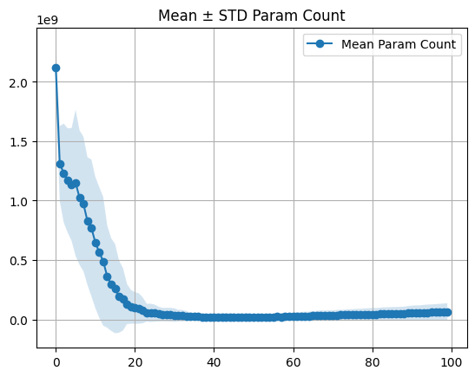
METEOR score convergence for experimentation
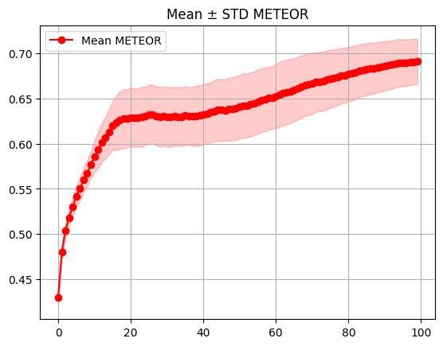
Config 3
- Mu: 200
- Gens: 500 for GIF, 250 for experiments
- Experiments: 20
Pareto front:
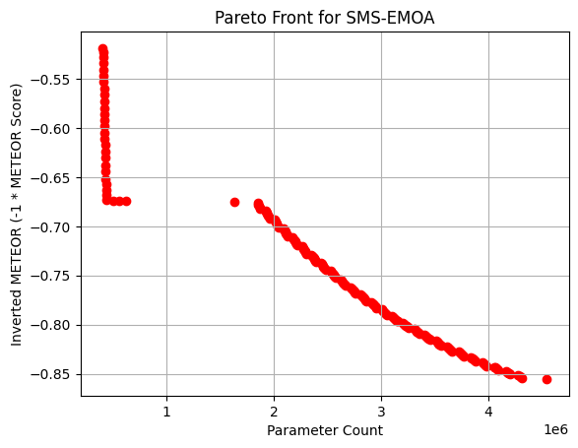
Pareto front evolution:
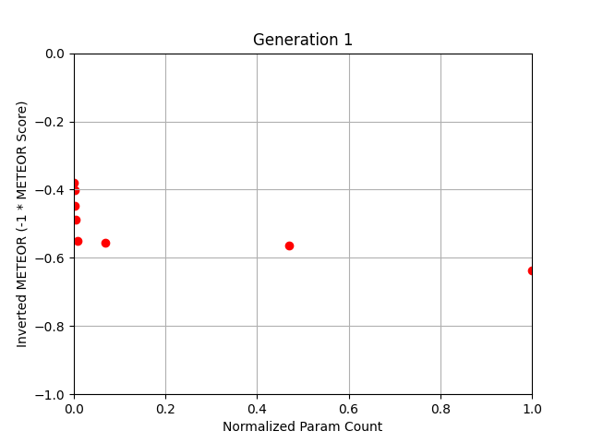
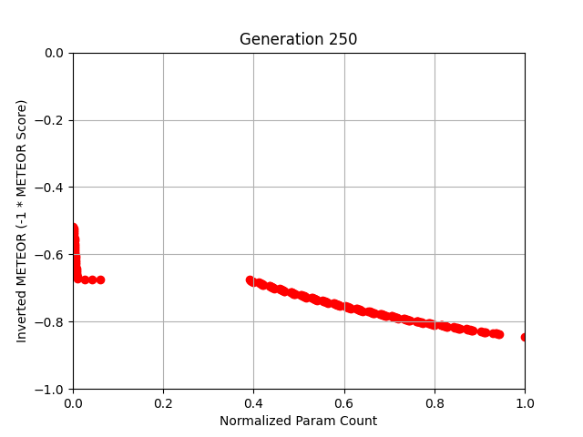
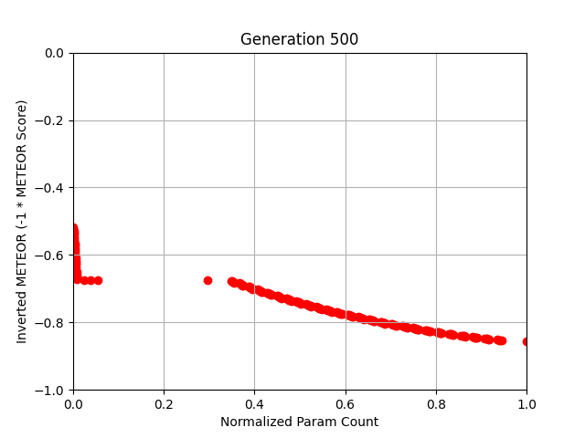
Hypervolume for GIF run
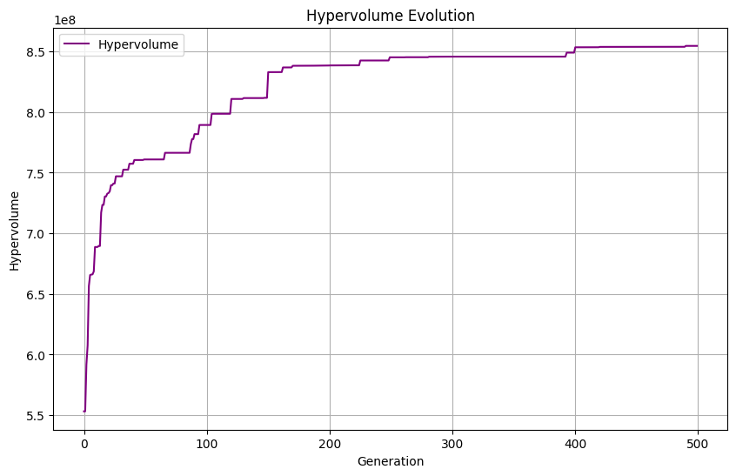
Param count (objective 1) distribution of the first 30 gens for GIF run
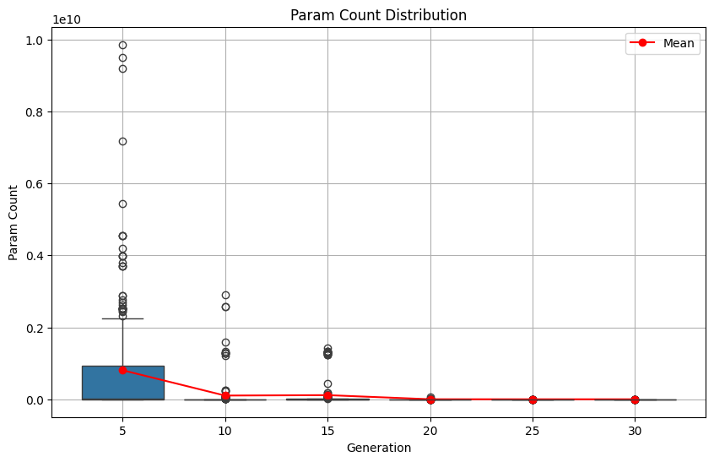
METEOR score (objective 2) distribution of the first 30 runs for GIF run
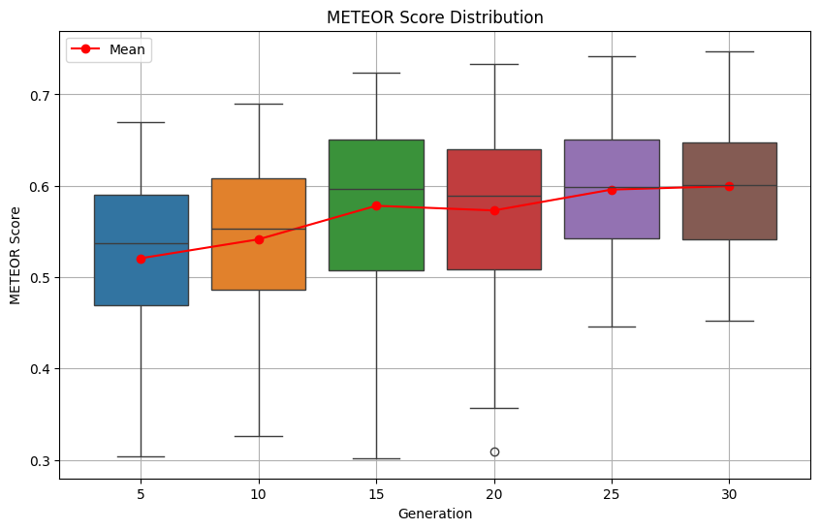
Param count convergence for the GIF run
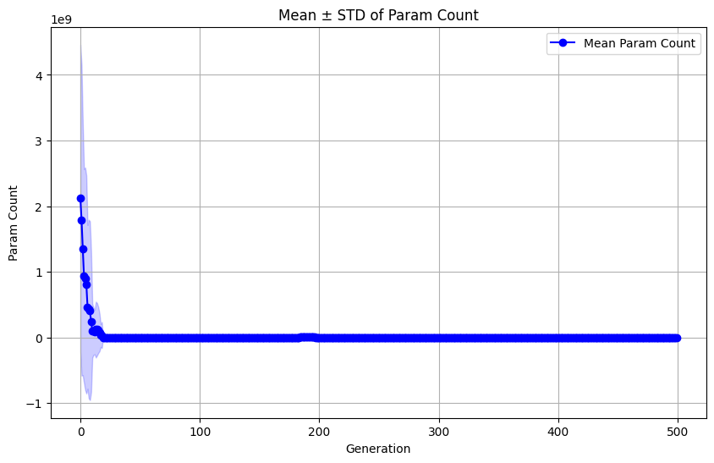
METEOR score convergence for the GIF run
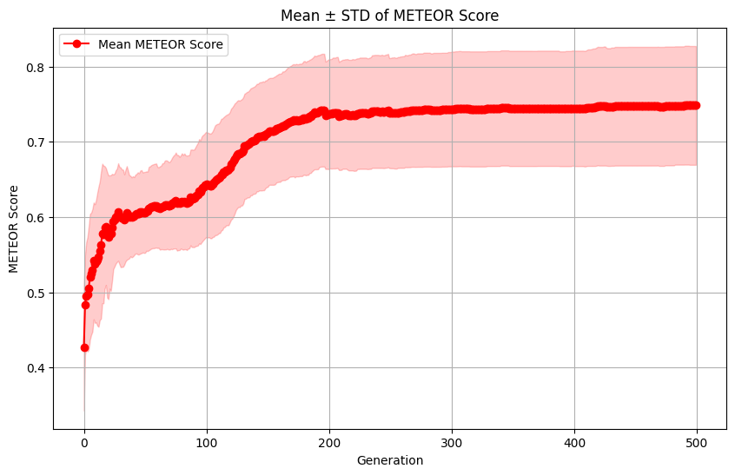Hypervolume progression for experiments
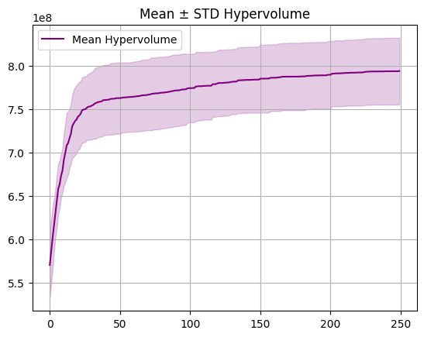
Param count distribution for the first 30 runs for experimentation
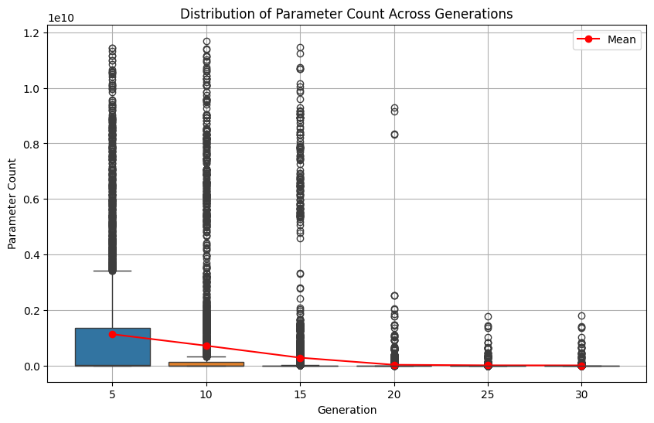
METEOR score distribution for the first 30 runs for experimentation
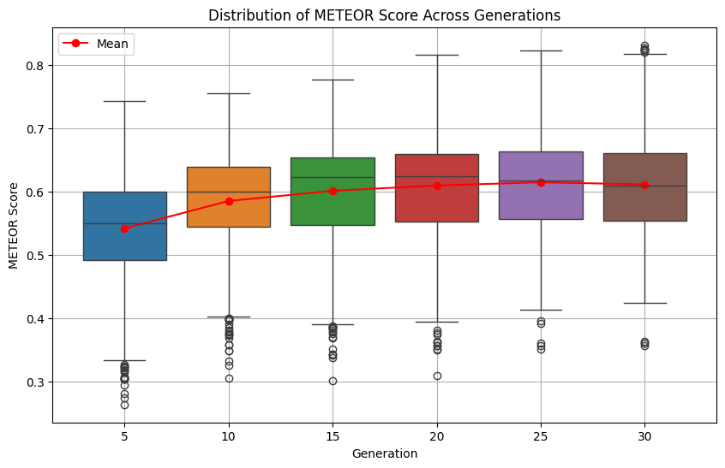
Param count convergence for experimentation
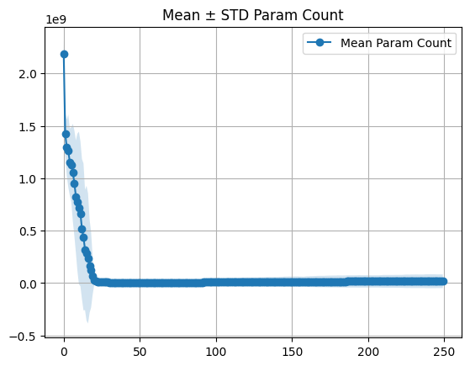
METEOR score convergence for experimentation
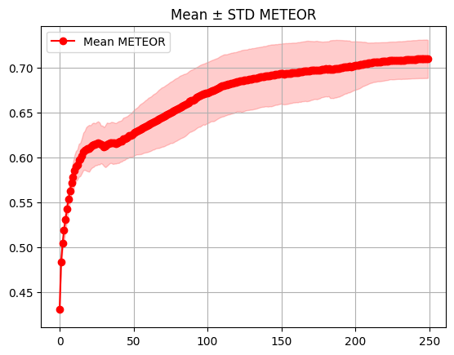
Config 4
- Mu: 400
- Gens: 500 for GIF, 250 for experiments
- Experiments: 10
Pareto front:
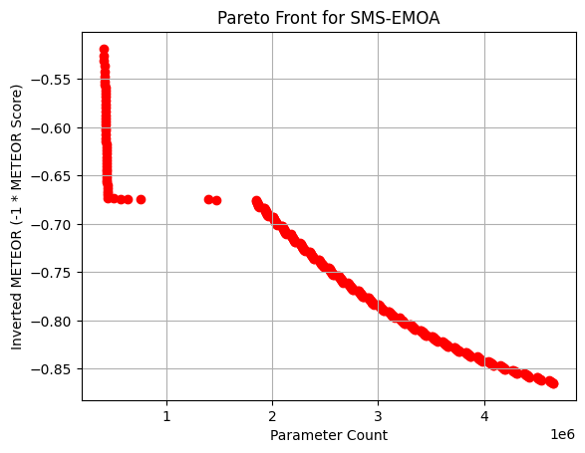
Pareto front evolution:
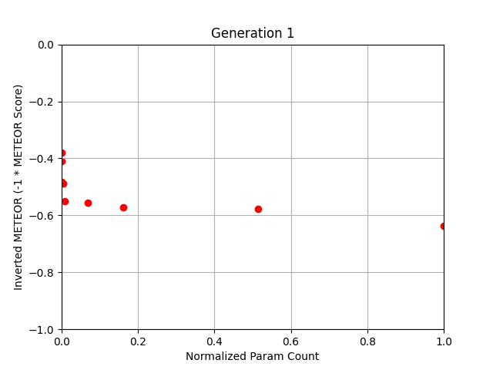
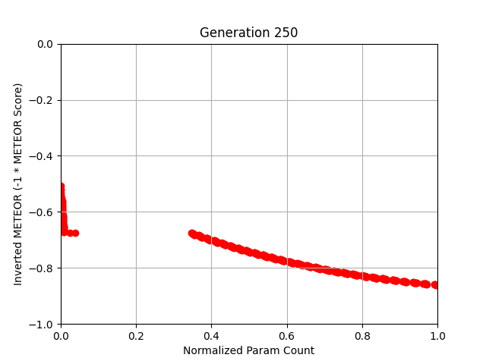
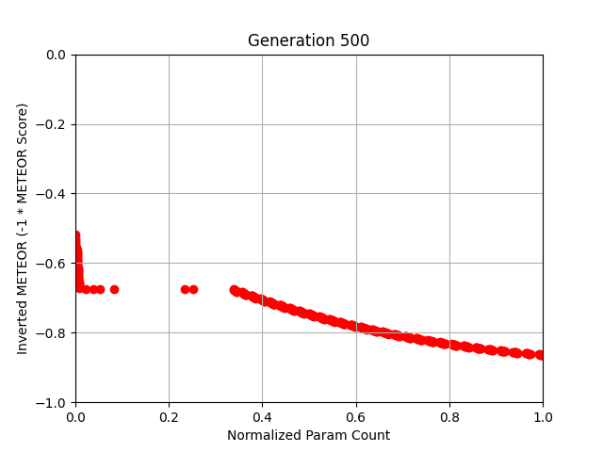
Hypervolume for GIF run
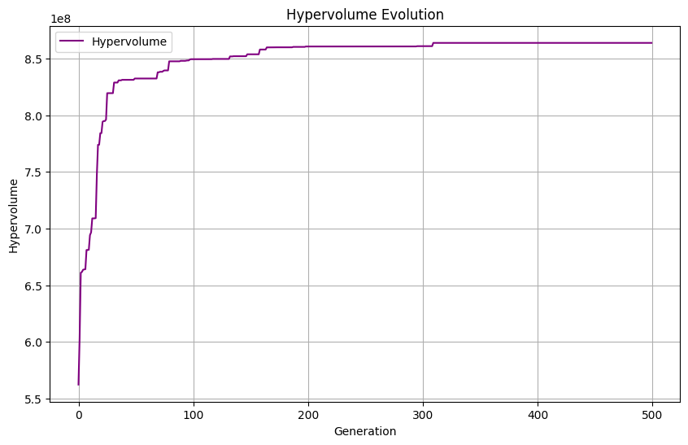
Param count (objective 1) distribution of the first 30 gens for GIF run
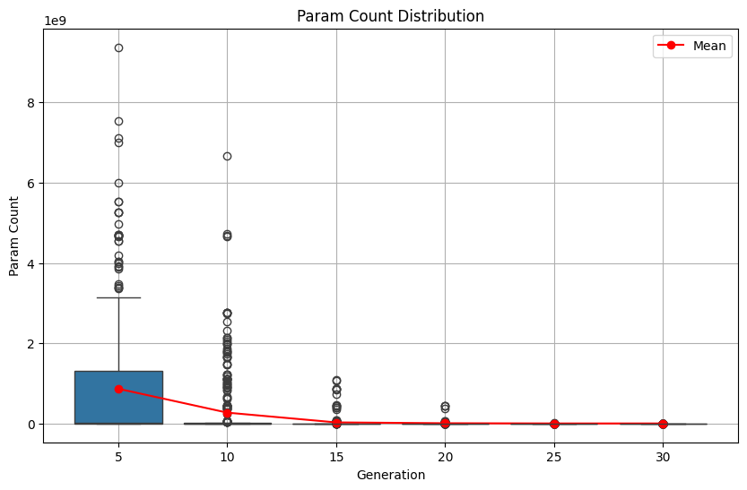
METEOR score (objective 2) distribution of the first 30 runs for GIF run
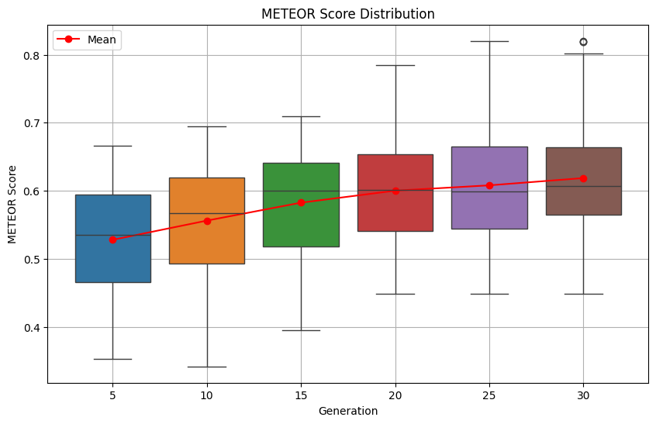
Param count convergence for the GIF run
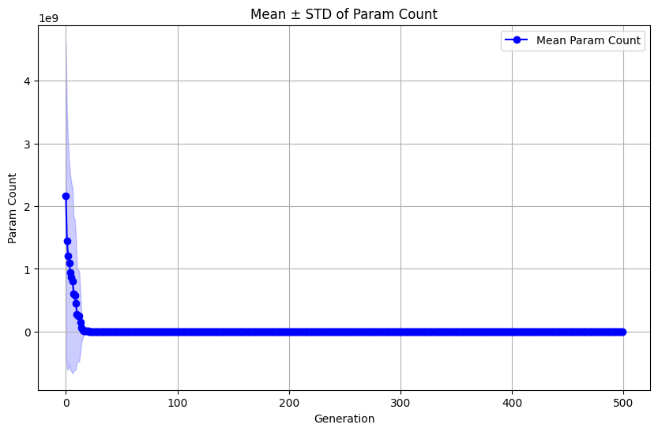
METEOR score convergence for the GIF run
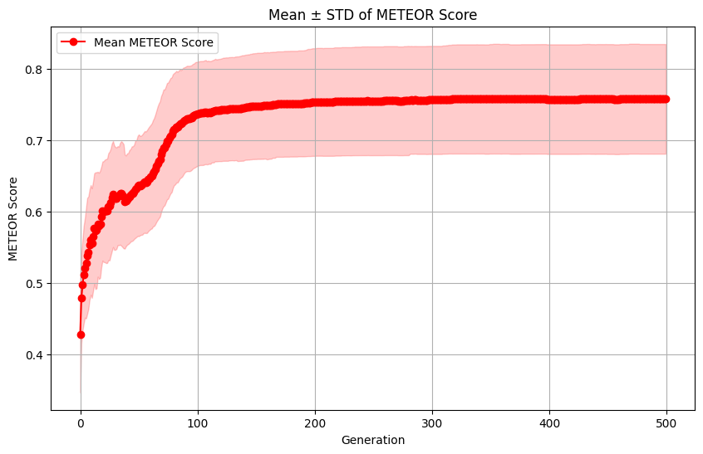Hypervolume progression for experiments
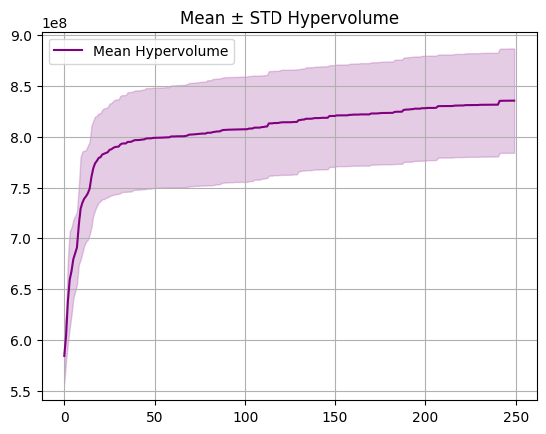
Param count distribution for the first 30 runs for experimentation
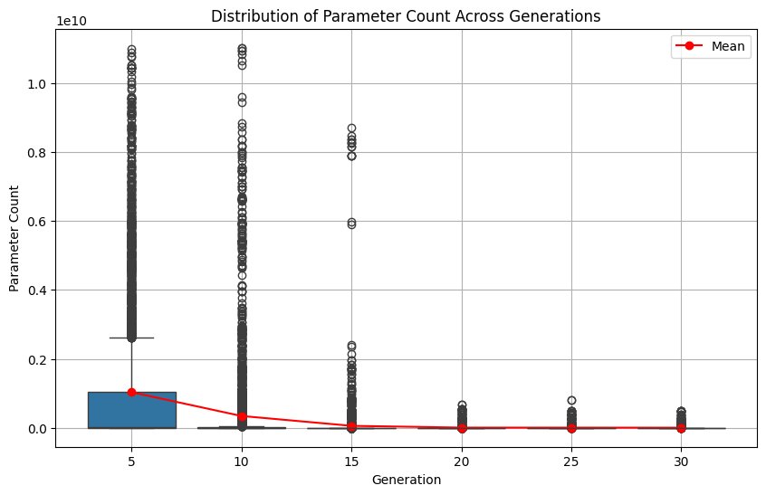
METEOR score distribution for the first 30 runs for experimentation
Param count convergence for experimentation
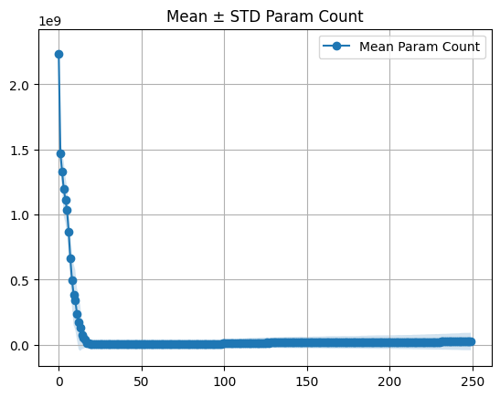
METEOR score convergence for experimentation
