Flexible Pavements Performance Prediction Using Machine Learning: Supervised Learning with Tree-Based Algorithms

Tiago Tamagusko & Adelino Ferreira

Research Centre for Territory, Transports and Environment (CITTA), Department of Civil Engineering, University of Coimbra, Portugal

adelino@dec.uc.pt

ABSTRACT: This paper presents the application of supervised machine learning tree-based algorithms to predict the performance of flexible pavements without maintenance or rehabilitation. Thus, the International Roughness Index (IRI) was used as a pavement performance indicator. Data were collected from the Long-Term Pavement Performance InfoPave database. Fifty-five experimental sections of the Asphalt Concrete on Granular Base and Asphalt Concrete on Bound Base were evaluated. Decision Tree, Random Forest, and XGBoost algorithms were evaluated. The training features were Structural Number, Annual Average Daily Truck Traffic, precipitation, and temperature, as well as the IRI was the target of the models. Finally, the best model was XGBoost, with an R-squared of 0.98 and root-mean-square-error of 0.08. Data and models are available at github.com/tamagusko/predict-iri-trees.

KEYWORDS: Pavement, Machine Learning, Decision Tree, Random Forest, XGBoost, IRI.

1. INTRODUCTION

To maintain a road network in good service condition, a Pavement Management System (PMS) is essential. Likewise, one of its main components are the pavement performance models (Ferreira et al., 2009; Jorge and Ferreira, 2012). This study presents a performance model of flexible pavements based on supervised Machine Learning (ML). Tree-based algorithms were used. The choice was based on the capacity and interpretability demonstrated by these algorithms. Also, the pavement quality indicator was the International Roughness Index (IRI), a widely used pavement smoothness and irregularity monitoring parameter.
The algorithms used were Decision Tree (Quinlan, 1986), Random Forest (Breiman, 2001), and XGBoost (Chen and Guestrin, 2016). The model created aims to predict the IRI of flexible pavements until its first intervention. The workflow adopted is to study the problem, obtain data, prepare the data, apply the model, evaluate the results, improve the model, and conclusively put the model into production (O'Neil and Schutt, 2013; Géron, 2017; Thakur, 2020). The data used are from the Federal Highway Administration (FHWA) program, called Long-Term Pavement Performance (LTPP) InfoPave (LTPP, 2020). Therefore, data from all monitoring sections of the Asphalt Concrete on Granular Base (GPS-1) and Asphalt Concrete on Bound Base (GPS-2) were analyzed. The collected data represents IRI, pavement structure, traffic, and climate conditions. Finally, to limit the complexity of the model, only pavements without maintenance or rehabilitation were selected.

2. BACKGROUND

A pavement performance model must predict the quality of a road network based on monitoring data. According to Meegoda et al. (2014), truck traffic volume, climatic data, and the pavement's structural condition are recommended variables for pavement performance prediction models. IRI is the main parameter used to define pavement smoothness (Fwa, 2006). The roughness of a road is defined by the variation in the surface that induces vibration in vehicles (Sayers et al., 1986). Likewise, by Gillespie (1992), the IRI "is a scale for roughness based on the response of a generic motor vehicle to the roughness of the road surface". Therefore, the IRI is an index representing the vertical response of a hypothetical quarter-car traveling at 80 km/h and is calculated based on the vehicle's responses to variations in the pavement surface, generating an average longitudinal profile of the road (Fwa, 2006).
Since the end of the 1980s, the LTPP program's objective has been to provide information that supports the development of models to explain the performance of road pavements (FHWA, 2019). The LTPP program has an online viewing platform called InfoPave (LTPP, 2020), where data from 2581 monitoring sections are available.
There are two types of machine learning problems, supervised and unsupervised learning problems. In supervised learning problems, there are multiple targets associated with the existing data in the dataset, so the model learns by example (Thakur, 2020). Tree-based regression models are supervised ML algorithms that use nested if-else conditions to partition datasets into subsets. It does this by building the tree-like structure for deciding the target value according to the features in the dataset. Each division adds complexity to the model. The final model is an if-else test sequence that describes the dataset. Decision trees are popular because they provide good results and are easy to implement and interpret (Gottard et al., 2020; Lundberg et al., 2020).

3. MATERIALS AND METHODS

The algorithms used were Decision Tree (Quinlan, 1986), Random Forest (Breiman, 2001), and XGBoost (Chen and Guestrin, 2016). The activities followed the steps covered by Thakur (Thakur, 2020), Géron (Géron, 2017), and O'Neil & Schutt (O'Neil and Schutt, 2013). Initially, it is necessary to understand the problem based on a real event, from which the data was collected and then pre-processed, transformed, and prepared for the model. At that time, the data was divided between training and test datasets. The training dataset is used to train the model. Then an independent test dataset is used to evaluate performance. Depending on the metrics adopted, the model may advance to production, or it may be necessary to improve the algorithm. The workflow is shown in Figure 1.

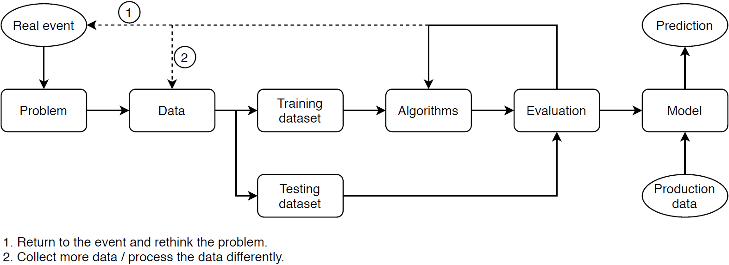

Figure 1: Machine learning workflow

3.1. Data
The data used to train the ML model were collected from InfoPave (LTPP, 2020). This study used sections classified as Asphalt Concrete on Granular Base (GPS-1) and Asphalt Concrete on Bound Base (GPS-2). The training features used data representing the pavement structure (Structural Number), performance (IRI), traffic (Annual Average Daily Truck Traffic), and climate indicators (Total Annual Precipitation and Annual Temperature Average). Only sections without maintenance and rehabilitation were selected. This choice was due to the complexity that different pavement interventions could add to the model. After the filters, 55 sections distributed across the US, Canada, and Puerto Rico became available.
The data under study are distributed between 1989 and 2017. Data are not available for all sections in all monitoring years. Most of the data used are concentrated between 1992 and 1999. The training features were Structural Number (SN), Annual Average Daily Truck Traffic (AADTT), Total Annual Precipitation (TAP), and Annual Temperature Average (ATA), while the target (value to be predicted) is the IRI. Table 1 describes the features used to train the ML model.

Table 1: Features used to train the model

Feature | Mean | Min | 25% | 50% | 75% | Max
Year | 1996 | 1989 | 1992 | 1995 | 1999 | 2017
IRI (m/km) | 1.34 | 0.61 | 0.92 | 1.20 | 1.60 | 4.10
SN | 4.16 | 1.10 | 2.80 | 4.20 | 5.30 | 8.00
AADTT | 452 | 4 | 142 | 262 | 526 | 3126
Precipitation (mm) | 1010 | 92 | 715 | 1061 | 1334 | 2091
Temperature (°C) | 13.80 | 2.70 | 7.90 | 15.30 | 17.50 | 25.90

3.2. Data processing
The data were organized in a relational database (rows and columns). For each row, the information presented corresponds to a section and year. There is no correlation between different years for the same section. Consequently, each row corresponds to an individual input for the machine learning model, with features and a target.
Furthermore, rows with missing values were excluded. After all, a random split was performed with 75% of the data for training and 25% for testing.

3.3. Parameter Optimizing
The optimization of the tree's depth was made (Figure 2). The objective is to find the lowest value for which a higher R-squared and the lowest Root-Mean-Square-Error (RMSE) are obtained. This activity is essential to minimize the possibility of over-fitting and under-fitting.

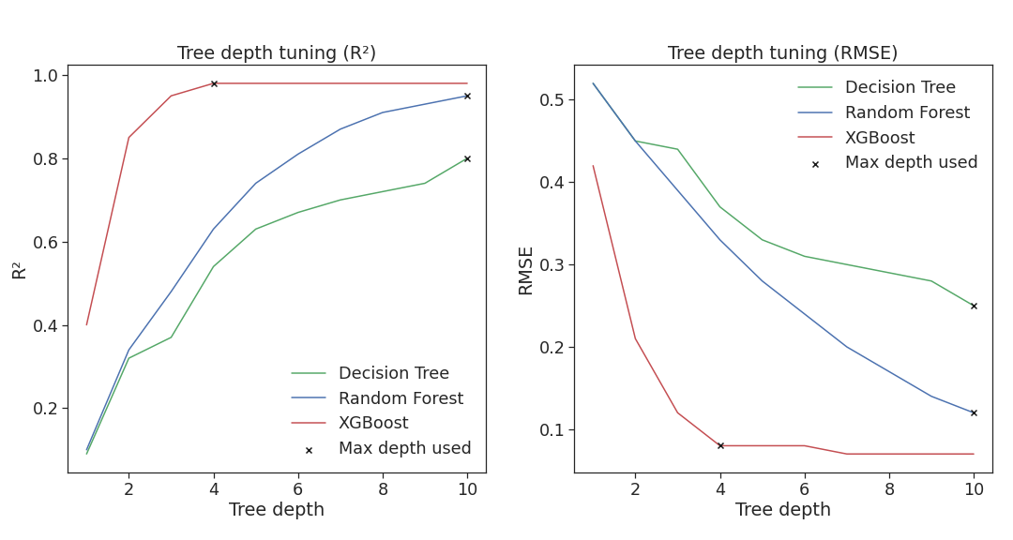

Figure 2: Tree depth tuning

The XGBoost algorithm converges with fewer interactions. Hence, the maximum depth of ten was adopted for the Decision Tree and Random Forest 10, for the XGBoost 4 was used. On the other hand, the default values were adopted for the other training parameters of the models.

4. RESULTS

The first element evaluated is the importance of the features to the predictions. The models had the same order of importance for the features. However, the weights differed (Table 2).

Table 2: Feature importance for models

Model | Decision Tree | Random Forest | XGBoost
AADTT | 33% | 35% | 32%
SN | 23% | 18% | 29%
Temperature | 17% | 18% | 16%
Precipitation | 14% | 16% | 12%
Year | 13% | 13% | 11%

For all models, the year had less influence. Nonetheless, this is a fundamental element as the data are organized by section and year. For the Random Forest Model, there was less importance for SN. In contrast, greater weight was given to climatic factors. Thus, the XGBoost Model, unlike the previous ones, took more into account the structural capacity. Likewise, traffic (AADTT) remained the primary feature. Finally, the percentages show that the choice of characteristics to train the models was adequate.
Predictive ability and errors were tested to choose the best model. The necessary computational power was also considered, but with less influence, since this is not a determining factor in a PMS. In the error analysis, the indicators used were the R-squared and the RMSE. For R-squared, the goal is to get as close as possible to value (1). For RMSE, the idea is to have the slightest possible error. Error: Reference source not found shows a comparison between Decision Tree, Random Forest, and XGBoost regression models.

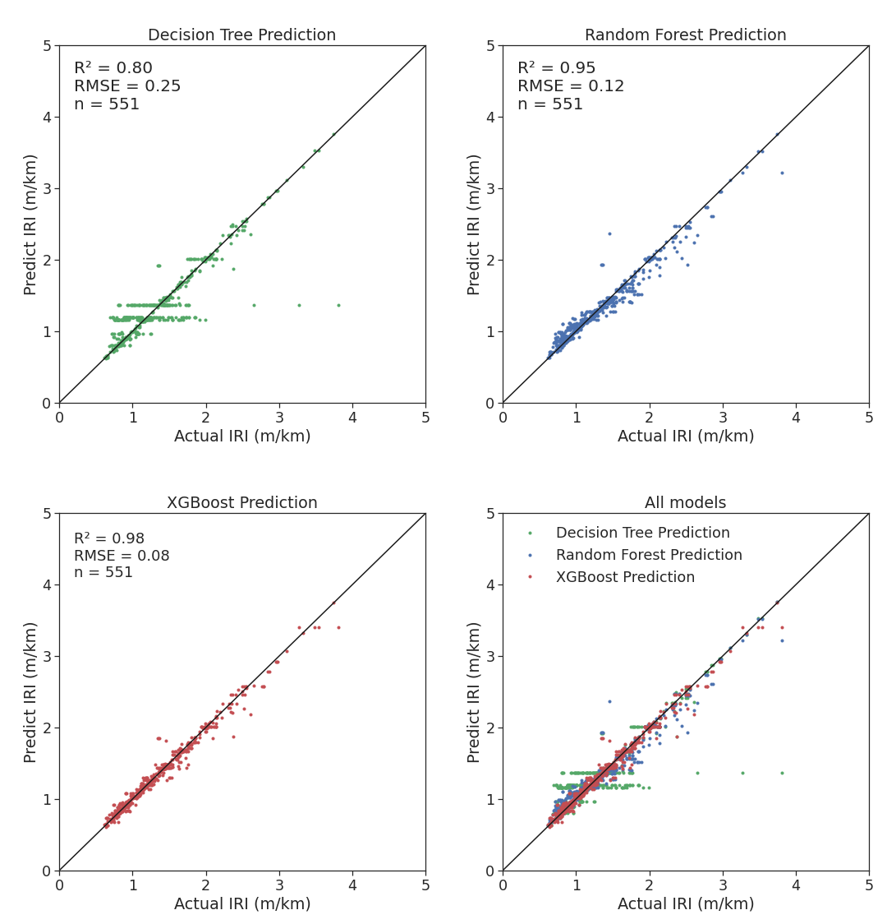

Figure 2: Models trained

Predictive values are indicated on the vertical axis and measured on the horizontal axis. Thus, an ideal model would have its points on the diagonal that connects the axes. In the first model, Decision Tree (green), it is seen that some measured values are outside the diagonal. The results were excellent in the model with Random Forest (blue), with an R-squared of 0.95 for the test sample. This model presents a good generalization, even for high values. The model with XGBoost (red) gave the best results, with an R-squared of 0.98 and RMSE of 0.08 for the test sample. Also, this model quickly converged to desirable values in parameter tuning.

5. CONCLUSIONS

The results of the ML models were good, especially for IRI values below 1.6. One possible explanation for this behavior is that these lower IRI values are for pavements in the early stages of their life cycle. Hence, pavement deterioration is usually almost linear, being predictable. However, this behavior should be better explored before reaching further conclusions.
As the model is at this moment, it can be used for PMS with SN, AADTT, climate information (precipitation and temperature), and without interventions. Besides, the model can be adapted to other structural or traffic parameters. Nevertheless, the models must be retrained, and the model's performance may be different.
As for the models, it requires little computational power for processing. The most time-consuming process was parameter optimizing, where the models are trained several times until they find the best values. Therefore, there are no problems applying this ML model for any agency with input parameters that wants to predict the IRI's evolution.
Finally, the best model developed is the XGBoost, obtaining an R-squared of 0.98 and RMSE of 0.08. This model used the IRI as a target, and the input features were SN, AADTT, precipitation, and temperature. In the near future, this model will be extended to pavements with interventions. It is also intended to create an auxiliary module capable of testing the IRI result according to planned interventions. Another objective will be to test the robustness of the model for data from sources other than LTPP. Data and models are available at github.com/tamagusko/predict-iri-trees.

REFERENCES

Breiman, L., 2001. Random forests. Maching Learning.
Chen, T. and Guestrin, C., 2016. XGBoost: A Scalable Tree Boosting System. Proceedings of the 22nd ACM SIGKDD International Conference on Knowledge Discovery and Data Mining, San Francisco, USA.
Ferreira, A., Picado-Santos, L. and Antunes, A., 2009. Pavement Performance Modelling: State of the Art. Computer Techniques for Civil and Structural Engineering.
FHWA, 2019. Long-Term Pavement Performance Information Management System. User Guide 2019.
Fwa, T., 2006. The handbook of highway engineering.
Géron, A., 2017. Hands-On Machine Learing With Scikit-Learn & Tensor Flow.
Gillespie, T., 1992. Everything You Always Wanted to Know about the IRI, But Were Afraid to Ask!
Gottard, A., Vannucci, G. and Marchetti, G., 2020. A note on the interpretation of tree-based regression models. Biometrical Journal.
Jorge, D. and Ferreira, A., 2012. Road network pavement maintenance optimisation using the HDM-4 pavement performance prediction models. International Journal of Pavement Engineering.
LTPP, 2020. Long-Term Pavement Performance program's data portal.
Lundberg, S., Erion, G., Chen, H., DeGrave, A., Prutkin, J., Nair, B., Katz, R., Himmelfarb, J., Bansal, N. and Lee, S.-I., 2020. From local explanations to global understanding with explainable AI for trees. Nature Machine Intelligence.
Meegoda, J. and Gao, S., 2014. Roughness progression model for asphalt pavements using long-term pavement performance data. Journal of Transportation Engineering.
O'Neil, C. and Schutt, R., 2013. Doing Data Science: Straight Talk from the Frontline.
Quinlan, J., 1986. Induction of decision trees. Machine Learning.
Sayers, M., Gillespie, T. and Queiroz, C., 1986. The International Road Roughness Experiment (IRRE): establishing correlation and a calibration standard for measurements.
Thakur, A., 2020. Approaching (Almost) Any Machine Learning Problem.

