TECHNICAL DESIGN DOCUMENT

Digital Storefront Platform
Shashibhushan's New School Book Press

HLD • LLD • System Design • Technical Requirements

Version | 1.0
Date | July 19, 2026
Based on | Business & System Requirements Document v1.0 (July 13, 2026)
Target stack | Next.js 16 (App Router) + TypeScript, custom-built
Prepared for | Tamajit
Status | Draft for Review

0. Scope Decisions & Assumptions
Two source documents were provided: a formal Business & System Requirements Document (BRD) scoped to a single Book Press storefront, and a spreadsheet (“Ultimate Master PRD”) describing a much larger multi-vertical platform for a different named client (“Balaji Communication”) covering legal products, lifestyle leads, a 25%-to-trust financial ledger, a free open-access repository, and community session booking, and suggesting WordPress/WooCommerce or Shopify as the engine. These two documents conflict on both scope and platform. The decisions below resolve that conflict and are the foundation for everything that follows.
Decision Point | Resolution
Scope | This plan covers the Book Press storefront only, as scoped in the BRD: catalogue browsing, physical + digital books, self-publishing portal, e-book creation services, and the admin back office. The multi-vertical items in the xlsx (legal products, lifestyle leads, trust ledger, community sessions, free repository, legacy timeline) are explicitly out of scope for this build.
Platform | Fully custom build on Next.js 16 + TypeScript — no WordPress/WooCommerce/Shopify. Two Next.js applications: a public storefront and an internal admin/CMS, sharing one database.
Non-technical CMS requirement | Satisfied by building a purpose-made admin app with a simple, guided UI (forms, not code) rather than by adopting an off-the-shelf CMS engine.
Hosting | Not yet decided by stakeholders. This plan assumes Vercel as the default and flags it as a revisitable assumption (Section 10).
Payments | Razorpay, matching the business's home market (India) and the xlsx's “domestic Indian aggregator” requirement.

Flag for your manager
The xlsx describes a materially different, larger platform for a different client name. If the multi-vertical scope is actually intended for this build, it needs its own requirements and architecture pass — the data model below is deliberately not designed to absorb legal products, lead-gen verticals, or the trust ledger without rework. Worth confirming explicitly before development starts.

1. Technology Stack
Versions reflect current stable releases as of July 2026.
Layer | Technology | Why
Framework | Next.js 16 (App Router) + TypeScript 5 | Required stack; Server Components + Server Actions remove the need for a separate API layer for most mutations.
Styling / UI | Tailwind CSS v4 + shadcn/ui (Radix primitives) | Fast, accessible-by-default components; easy to theme for the Publisher's brand.
Client state | Zustand (cart/UI) + TanStack Query (server-state cache) | Lightweight cart state; resilient data fetching/caching on client-heavy pages (catalogue filters, admin tables).
Forms & validation | React Hook Form + Zod | Shared Zod schemas between client validation and Server Actions — one source of truth per form.
ORM | Prisma 7 (Rust-free engine) | Type-safe queries and migrations against the Supabase Postgres database, shared by both apps via packages/database.
Database | Supabase (managed Postgres) | Managed, branchable Postgres with built-in connection pooling (Supavisor) — Prisma connects to it exactly as it would to any Postgres instance.
Authentication | Supabase Auth | Integrated with the Supabase Postgres instance (email/social sign-in, session/JWT management); pairs naturally with Postgres Row-Level Security as a database-level backstop to the app's role checks.
Backend | Supabase (Postgres + Auth + Realtime, Storage/Edge Functions available if needed) | Consolidates database, identity, and (optionally) serverless functions on one managed platform; Next.js Server Actions/Route Handlers remain the application's business-logic layer and call Supabase via its client libraries and Prisma.
File storage | Vercel Blob | Manuscripts, cover images, proofs, and EPUB/MOBI/PDF assets, served via short-lived signed URLs for secure digital delivery.
Payments | Razorpay (Orders API + Webhooks, RazorpayX for author payouts) | India-focused; UPI/cards/netbanking/wallets; PCI-DSS handled by Razorpay's hosted checkout so card data never touches our servers.
Transactional email | Resend + React Email | Component-based email templates in the same language/tooling as the app.
Background jobs | Inngest | Event-driven workflows (order confirmation, royalty calculation, delivery-link generation, malware-scan trigger, status-change notifications) that work well on serverless hosting.
Search | Postgres full-text search (tsvector + pg_trgm) for Phase 1 | No extra infra for launch; swappable for Meilisearch/Algolia later if catalogue size demands it (NFR-7).
Malware scanning | Cloudmersive Virus Scan API or a ClamAV microservice | Required before any uploaded manuscript is persisted (NFR-8).
Monitoring | Sentry (errors) + Vercel Analytics/Speed Insights | Error visibility and Core Web Vitals against the 3-second load target (NFR-1).
Testing | Vitest + React Testing Library, Playwright | Unit/component and end-to-end coverage for checkout, wizard, and payment flows.
CI/CD | GitHub Actions + Vercel Git integration | Preview deployment per PR, protected production deploys from main.
Monorepo tooling | Turborepo + pnpm workspaces | Two apps, shared packages, single source of truth for types and business logic.

2. High-Level Design (HLD)

2.1 Architecture Overview
The system is a Turborepo monorepo producing two independently deployed Next.js applications that share one Postgres database and a set of internal packages. This keeps customer-facing and internal tooling cleanly separated (different auth surfaces, different rate limits, different uptime/blast-radius concerns) while avoiding duplicated business logic.
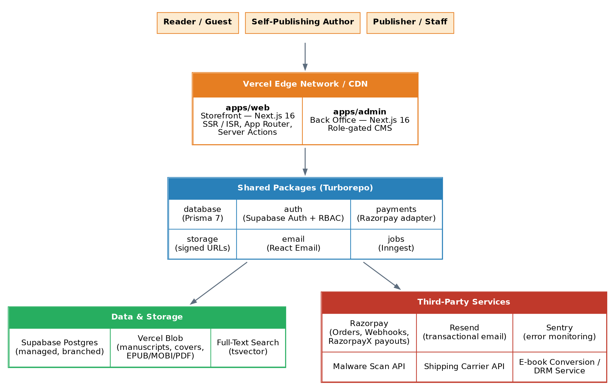
Figure 1 — System architecture: two Next.js apps, shared packages, Supabase, and third-party services.

2.2 Application Boundaries
App | Audience | Key responsibilities
apps/web (Storefront) | Readers, Guests, Self-Publishing Authors | Catalogue browsing & search, product/service detail pages, cart & checkout, payments, account area (order history, digital library), the self-publishing submission wizard, the author dashboard (project status, sales, royalty balance), reviews.
apps/admin (Back Office) | Publisher (Owner) & Staff only, on a separate subdomain (e.g. admin.‹domain›) with its own auth check + optional IP allowlist | Catalogue/pricing/inventory CMS, order dashboard, self-publishing & service-request queues, proof approval routing, royalty configuration & reporting, sales/traffic analytics, role-based admin access, review moderation, audit log viewer.

2.3 Shared Packages
- packages/database — Prisma schema and generated client, connected to Supabase Postgres; the single source of truth for both apps.
- packages/auth — Supabase Auth client configuration, session handling, and role/permission helpers shared by both apps.
- packages/ui — Shared design-system components (buttons, forms, tables) built on shadcn/ui.
- packages/payments — Razorpay client wrapper: order creation, signature verification, webhook handling.
- packages/storage — Vercel Blob upload helpers and signed-URL generation for digital delivery.
- packages/email — React Email templates + Resend send helpers.
- packages/jobs — Inngest function definitions (see Section 5.7).
- packages/config — Shared ESLint, TypeScript, and Tailwind configuration.

2.4 Deployment Topology
Each app is its own Vercel project pointing at the same Supabase project (Postgres + Auth). Supabase Branching, connected via GitHub, gives every pull request an isolated preview environment — database, Auth, and schema migrations — so preview deployments never touch production data. Production and Preview environments use separate Razorpay key pairs (test vs. live) and separate Blob storage prefixes.

3. Low-Level Design (LLD)

3.1 Monorepo Folder Structure
digital-storefront/
├─ apps/
│ ├─ web/ # customer storefront (Next.js)
│ │ ├─ app/
│ │ │ ├─ (storefront)/
│ │ │ │ ├─ books/[slug]/page.tsx
│ │ │ │ ├─ ebooks/[slug]/page.tsx
│ │ │ │ ├─ services/[slug]/page.tsx
│ │ │ │ └─ self-publishing/
│ │ │ ├─ (account)/
│ │ │ │ ├─ account/orders/page.tsx
│ │ │ │ ├─ account/library/page.tsx
│ │ │ │ └─ account/publishing/page.tsx # author dashboard
│ │ │ ├─ (checkout)/cart, checkout/
│ │ │ ├─ api/webhooks/razorpay/route.ts
│ │ │ └─ api/inngest/route.ts
│ │ └─ middleware.ts # auth guard for /account/**
│ └─ admin/ # internal back office (Next.js)
│ ├─ app/
│ │ ├─ catalogue/
│ │ ├─ orders/
│ │ ├─ submissions/ # self-publishing + service request queues
│ │ ├─ royalties/
│ │ ├─ reviews/
│ │ ├─ analytics/
│ │ └─ settings/roles/
│ └─ middleware.ts # role guard: STAFF | OWNER only
├─ packages/
│ ├─ database/ (prisma/schema.prisma, client.ts)
│ ├─ auth/
│ ├─ ui/
│ ├─ payments/
│ ├─ storage/
│ ├─ email/ (templates/*.tsx)
│ ├─ jobs/ (functions/*.ts)
│ └─ config/
├─ turbo.json
└─ pnpm-workspace.yaml

3.2 Data Model
Core entities, derived directly from the BRD's Data Model Overview (Section 7), with types filled in for implementation.
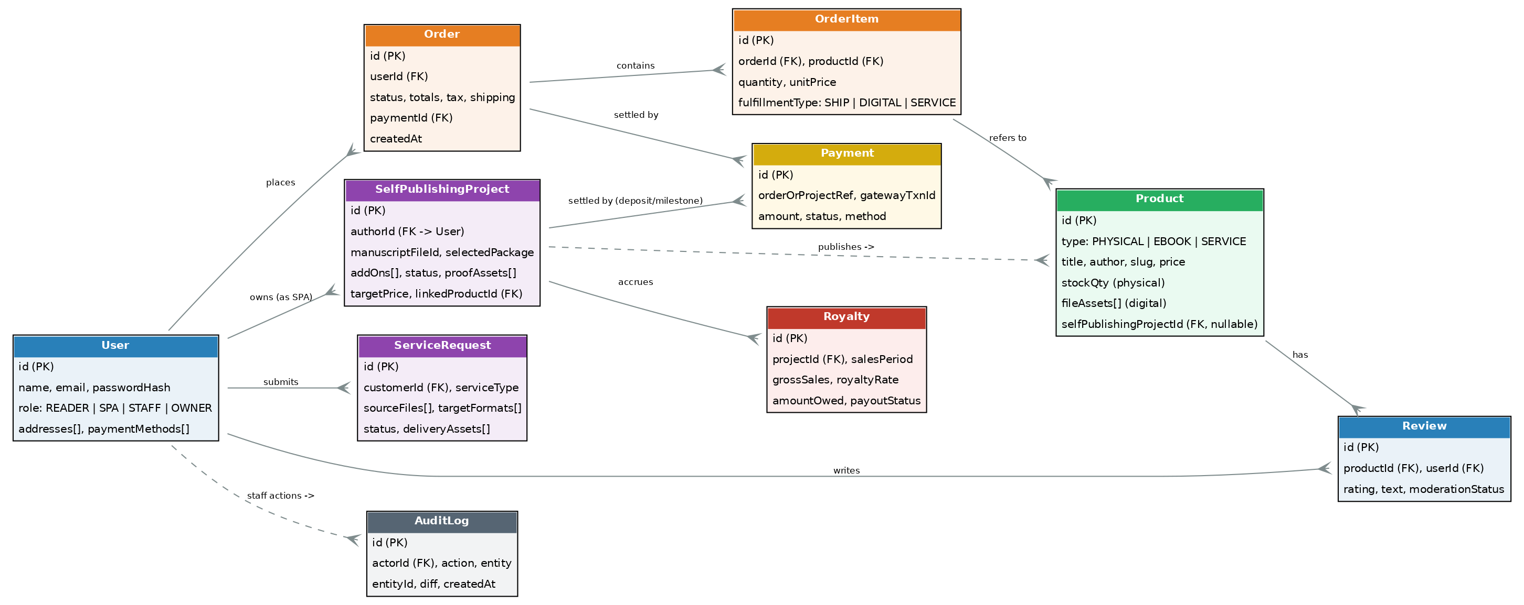
Figure 2 — Core entity relationships.

Prisma schema (core models, abridged)
enum Role { GUEST READER SELF_PUB_AUTHOR SUPPORT EDITOR OWNER }
enum ProductType { PHYSICAL_BOOK EBOOK SERVICE_PACKAGE }
enum OrderStatus { PENDING PAID PROCESSING SHIPPED DELIVERED
READY_FOR_DOWNLOAD CANCELLED REFUNDED }
enum ProjectStatus { SUBMITTED IN_REVIEW IN_PRODUCTION
PROOF_READY PUBLISHED REJECTED }

model User {
id String @id @default(cuid())
name String
email String @unique
role Role @default(READER)
addresses Address[]
orders Order[]
projects SelfPublishingProject[]
serviceReqs ServiceRequest[]
reviews Review[]
createdAt DateTime @default(now())
}

model Product {
id String @id @default(cuid())
type ProductType
title String
author String
slug String @unique
priceCents Int
stockQty Int? // physical only
fileAssets FileAsset[] // digital delivery assets
sourceProjectId String? // set if created via self-publishing
orderItems OrderItem[]
reviews Review[]
}

model Order {
id String @id @default(cuid())
userId String? // null for guest checkout
status OrderStatus @default(PENDING)
items OrderItem[]
subtotal Int
taxCents Int
shippingCents Int
payment Payment?
createdAt DateTime @default(now())
}

model SelfPublishingProject {
id String @id @default(cuid())
authorId String
bookTitle String
manuscript FileAsset
package String
addOns String[]
status ProjectStatus @default(SUBMITTED)
proofAssets FileAsset[]
targetPriceCents Int?
linkedProductId String? @unique
royalties Royalty[]
payments Payment[]
}
Full schema (Address, ServiceRequest, Royalty, Review, Payment, FileAsset, AuditLog, Notification) is maintained in packages/database/prisma/schema.prisma and mirrors the BRD's Section 7 entity list one-to-one, so every attribute in the BRD has a corresponding column.

3.3 Auth & Role-Based Access Control
Role | Portal | Access
Guest | Storefront | Browse catalogue, add to cart, guest checkout (FR-3.3). No account features.
Reader | Storefront | Everything Guest can do, plus order history, digital library, saved addresses/payment methods, reviews.
Self-Publishing Author (SPA) | Storefront | Everything Reader can do, plus the self-publishing wizard, project status tracking, proof approval, and the author dashboard (FR-5.3, FR-13).
Support | Admin | View orders and submission queues; respond to customers; cannot edit catalogue, pricing, or royalty rates.
Editor / Staff | Admin | Manage catalogue and inventory, action self-publishing/service submissions, upload proofs, moderate reviews (FR-11.6).
Owner (Publisher) | Admin | Full access: all Editor permissions plus pricing/royalty-rate configuration, role management, analytics, refunds.
Supabase Auth manages sessions and identity for both apps against the same auth.users table, with a synced public.User row carrying the app-specific role (a Google Workspace/email sign-in in admin can reuse the same identity as a storefront account if a staff member is also a customer). Route-level guards live in each app's middleware.ts; Server Actions additionally re-check role server-side so UI hiding is never the only protection; Postgres Row-Level Security policies provide a further database-level backstop against direct table access.

3.4 API Design
Most mutations use Next.js Server Actions (co-located with the page that needs them, fully typed end-to-end). Route Handlers are reserved for cases that need a stable HTTP contract: webhooks, file streaming, and the Inngest event endpoint.
Module | Interface | Examples
Catalogue | Server Actions + RSC data fetching | getProducts(filters), getProductBySlug(), searchProducts(query)
Cart & Checkout | Server Actions | addToCart(), updateQty(), calculateTax(), calculateShipping(), createOrder()
Payments | Route Handler | POST /api/checkout/create-razorpay-order, POST /api/webhooks/razorpay (signature-verified)
Self-Publishing Wizard | Server Actions (multi-step, persisted per step) | createProject(), uploadManuscript(), selectPackage(), submitForReview(), approveProof()
Service Requests | Server Actions | createServiceRequest(), uploadSourceFiles(), getRequestStatus()
Admin — Catalogue | Server Actions (role-guarded) | createProduct(), updateInventory(), archiveProduct()
Admin — Orders | Server Actions | updateOrderStatus(), issueRefund(), addTrackingNumber()
Admin — Submissions Queue | Server Actions | assignReviewer(), moveStatus(), postProjectNote(), publishProject() → auto-creates Product (FR-6.7)
Royalties | Server Actions + scheduled Inngest job | calculateRoyaltyForPeriod(), markPayoutSent(), getAuthorRoyaltyBalance()
Reviews | Server Actions (role-guarded moderation) | submitReview() [verified purchaser only], moderateReview()
Notifications | Inngest event-triggered | order.confirmed, project.status_changed, submission.received → email + in-app
File Delivery | Route Handler (signed, expiring) | GET /api/library/[assetId]/download — checks entitlement, issues short-lived Blob URL

3.5 Key Flow — Self-Publishing Wizard (FR-6.1–FR-6.8)
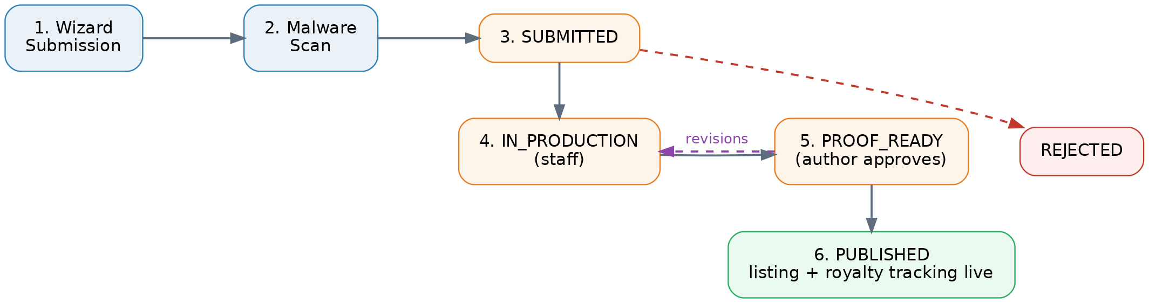
Figure 3 — Self-publishing project lifecycle, from wizard submission to a live storefront listing.
Each wizard step persists to a draft SelfPublishingProject row so authors can resume later. Manuscript upload triggers an Inngest malware-scan job before the file is retained (NFR-8); the project only advances to SUBMITTED once the scan clears. Publishing (Editor/Owner action) atomically creates the linked Product row so the title appears in the storefront catalogue (FR-6.7) and starts royalty tracking (FR-11.4).

3.6 Key Flow — Checkout & Payment
- Customer builds a mixed cart (physical books, e-books, services — FR-3.1); cart state lives in Zustand, persisted to a DB-backed cart for logged-in users.
- Checkout Server Action calculates tax and shipping based on the delivery address, and separates the order into shippable vs. digital vs. service line items (FR-3.2, FR-3.4).
- A Razorpay Order is created server-side; the client opens Razorpay's hosted Checkout — card/UPI/netbanking details never reach our servers (FR-4.1, FR-4.2).
- Razorpay redirects back with a payment reference; the webhook (signature-verified) is the source of truth for marking the order PAID, not the client redirect.
- On PAID: digital items are instantly entitled to the buyer's library with a signed download link (FR-8.2); physical items enter the fulfillment queue; a confirmation email with itemized receipt is sent via Resend (FR-3.5, FR-4.4).

3.7 File Upload & Malware Scanning Pipeline
- Client uploads manuscript/source file (DOC/DOCX/PDF) directly to a Vercel Blob staging path via a signed upload token (keeps large files off the Next.js server).
- An Inngest job picks up the upload event and calls the malware-scan API before the file is exposed anywhere else in the system (NFR-8).
- Clean files are moved to their permanent path and linked to the SelfPublishingProject / ServiceRequest record; infected files are quarantined and the uploader is notified to re-submit.

3.8 Notification System
All notification-worthy events (order confirmed, shipment update, digital delivery ready, project status changed, new submission received) are emitted as Inngest events from Server Actions. A single set of Inngest functions fans each event out to the right channels — transactional email via Resend, and an in-app Notification row read by both apps — which keeps FR-12.1–FR-12.3 implemented in one place instead of scattered across every mutation.

4. Functional Requirements Traceability
Every BRD functional module maps to a concrete part of the architecture above, so nothing in Section 4 of the BRD is unaccounted for.
BRD Module | Requirement IDs | Delivered by
Storefront & Catalogue Browsing | FR-1.1–1.5 | apps/web catalogue routes; Postgres full-text search + filter Server Actions.
Product & Service Detail Pages | FR-2.1–2.4 | Dynamic product pages (ISR); Review model for ratings.
Shopping Cart & Checkout | FR-3.1–3.5 | Zustand cart + checkout Server Actions; tax/shipping calculation; Resend confirmation email.
Payments | FR-4.1–4.4 | Razorpay hosted checkout, webhook-verified order status, packages/payments.
User Accounts & Profiles | FR-5.1–5.4 | Supabase Auth (email + social), Address model, role field on User.
Self-Publishing Portal | FR-6.1–6.8 | Multi-step wizard, SelfPublishingProject state machine, admin submissions queue, auto-listing on publish.
E-Book Creation Service Requests | FR-7.1–7.4 | ServiceRequest model, upload pipeline, status tracking, digital library delivery.
Order Management & Fulfillment | FR-8.1–8.4 | Order/OrderItem status machine, admin order dashboard, refund Server Action.
Digital Rights & Delivery Protection | FR-9.1–9.2 | Signed, expiring Blob URLs; download/device-count tracked on FileAsset access log.
Reviews & Ratings | FR-10.1–10.2 | Review model gated to verified purchasers; admin moderation queue.
Admin / Publisher Back Office | FR-11.1–11.6 | apps/admin: catalogue CMS, order dashboard, submissions queue, royalty reporting, analytics, RBAC (Section 3.3).
Notifications | FR-12.1–12.3 | Inngest event-driven notification pipeline (Section 3.8).
Author / Publisher Dashboard | FR-13.1–13.2 | apps/web /account/publishing route: project status, sales, royalty balance, downloadable reports.

5. Non-Functional Requirements — Technical Approach
ID | Requirement | Technical Approach
NFR-1 | Pages load within 3s on broadband | ISR/edge caching for catalogue pages, Vercel CDN, image optimization via next/image, Speed Insights monitoring against this budget.
NFR-2 | Responsive on desktop/tablet/mobile | Tailwind CSS mobile-first breakpoints; shadcn/ui components built on accessible, responsive Radix primitives.
NFR-3 | Encryption in transit & at rest | TLS everywhere via Vercel; Supabase (Postgres) encrypts data at rest by default; Blob storage encrypted at rest.
NFR-4 | PCI-DSS + data protection regulation | No card data ever touches our servers (Razorpay hosted checkout = PCI SAQ-A scope); India's DPDP Act 2023 principles applied to data collection/consent/retention.
NFR-5 | WCAG 2.1 AA | Radix/shadcn primitives are accessible by default; automated axe-core checks in CI; manual audit before launch.
NFR-6 | 99.5% uptime | Vercel's platform SLA + Supabase's platform SLA/HA; status page and Sentry alerting for fast incident response.
NFR-7 | Horizontal scalability | Fully serverless (Vercel Functions autoscale; Supabase's built-in connection pooler, Supavisor, manages Postgres connections under load for Prisma).
NFR-8 | Malware scan on uploads | Mandatory Inngest scan step before any uploaded file is persisted or linked to a record (Section 3.7).
NFR-9 | Audit log for admin actions | AuditLog model records actor, action, entity, and diff on every order/royalty/content mutation in apps/admin; viewable by Owner role.

6. Security & Compliance
- Payment data: Razorpay's hosted Checkout/fields handle all card and UPI input; the platform only ever sees a payment reference and status, keeping PCI-DSS scope minimal (SAQ-A).
- Secrets: All API keys (Razorpay, Resend, Blob, malware-scan) live in Vercel environment variables, scoped per environment, never committed to the repo.
- AuthZ defense in depth: Role checks happen in middleware (route-level) and again inside every Server Action (mutation-level) — hiding a button in the UI is never the only protection.
- Rate limiting: Auth endpoints, checkout creation, and the self-publishing upload endpoint are rate-limited (e.g. Upstash Ratelimit) to blunt credential-stuffing and abuse.
- Digital rights protection: Downloads are served via short-lived signed URLs; a per-purchase download/device counter enforces FR-9.2's re-download limits.
- Data protection: Minimal PII collection, explicit consent for marketing email, and data-subject deletion/export support in line with India's DPDP Act 2023 and GDPR-style good practice for any international buyers.
- Credential sovereignty: Every third-party account (Vercel, Supabase, Razorpay, Resend, domain registrar) should be created under the Publisher's own corporate email/organization from day one, not a developer's personal account — this avoids a costly account-migration exercise later.

7. Third-Party Integrations
Integration | BRD Purpose | Chosen Vendor / Approach
Payment Gateway | Secure payment processing, refunds, invoicing | Razorpay (Orders API, Webhooks, RazorpayX for author payouts)
Shipping Carrier API | Rate calculation, label generation, tracking | Not yet selected by stakeholders (BRD Section 10 notes fulfillment partner is TBD) — integration built behind a swappable adapter in packages/payments-adjacent shipping module.
E-book Conversion / DRM | Convert manuscripts to EPUB/MOBI, apply DRM | Phase 1: staff-assisted conversion via the admin portal (upload finished files manually); Phase 2: automated conversion API once a vendor is chosen.
Email Service Provider | Transactional emails | Resend + React Email templates
Cloud File Storage | Manuscripts, proofs, delivered assets | Vercel Blob
Analytics | Traffic, conversion, sales reporting | Vercel Analytics (traffic) + custom admin reporting queries (sales, per FR-11.5)

8. Deployment & Infrastructure

8.1 Environments
Environment | Purpose | Database | Payment keys
Local | Development | Local Postgres or personal Supabase branch | Razorpay test keys
Preview | One per pull request, auto-created by Vercel + Supabase Branching | Ephemeral Supabase preview branch (DB + Auth), seeded, destroyed on merge | Razorpay test keys
Production | Live site | Supabase production project (PITR enabled on Pro plan+) | Razorpay live keys

8.2 CI/CD
- GitHub Actions run typecheck, lint, unit tests (Vitest), and Playwright E2E on every PR.
- Vercel deploys a Preview build per PR for both apps, against an isolated Supabase preview branch.
- Merges to main trigger production deploys for apps/web and apps/admin independently.
- Prisma migrations run as a deploy step, gated behind a manual approval for production.

8.3 Backup & Disaster Recovery
Supabase provides point-in-time recovery (Pro plan and above); Vercel keeps immutable prior deployments for instant rollback. Blob storage is versioned so accidental overwrites of manuscripts/proofs are recoverable.

8.4 Hosting Decision — Open Item
Assumption to confirm
Hosting was left undecided by stakeholders; this plan defaults to Vercel because it is the natural fit for a Next.js app and simplifies handing full ownership to the client's own account. If AWS or another provider is preferred (e.g. for existing enterprise agreements), the architecture still holds — swap Vercel Functions for ECS/Amplify, and either self-host Supabase or move to RDS Postgres with a separate auth provider — but CI/CD and the preview-branch workflow in 8.1–8.2 would need to be rebuilt.

9. Development Roadmap
Phase | Scope | Approx. Duration
0 — Foundation | Monorepo setup, design system, auth, CI/CD, Supabase/Vercel projects, base data model | 1–2 weeks
1 — Core Commerce | Catalogue browsing/search, PDPs, cart, checkout, Razorpay integration, order confirmation email | 3–4 weeks
2 — Accounts & Fulfillment | Registration/login, order history, digital library + signed delivery, admin catalogue CMS, admin order dashboard | 2–3 weeks
3 — Self-Publishing | Submission wizard, manuscript upload + malware scan, admin submissions queue, proof approval, auto-listing on publish, author dashboard | 3–4 weeks
4 — Services & Royalties | Standalone e-book creation requests, royalty calculation engine, reviews & moderation | 2–3 weeks
5 — Hardening & Launch | Accessibility audit (WCAG 2.1 AA), load testing, security review, content migration, staff training on admin portal | 1–2 weeks

10. Open Risks & Questions
- E-book conversion/DRM vendor is unselected — Phase 1 relies on manual, staff-assisted conversion; this is a real operational cost until an API-based vendor is chosen.
- Shipping carrier/fulfillment partner is still “to be decided” per the BRD — blocks finalizing the shipping-rate integration.
- Hosting provider is unconfirmed (Section 8.4); Vercel is assumed for this plan.
- The xlsx's multi-vertical scope (legal products, lifestyle leads, trust ledger, community sessions) is intentionally excluded here — worth an explicit sign-off so it's a conscious decision, not a gap discovered later.
- Self-publishing royalty rate governance (who can change rates, approval workflow) is mentioned in the BRD user stories but not fully specified — recommend confirming before building the royalty engine in Phase 4.

