**PURBANCHAL UNIVERSITY**



**DEPARTMENT OF COMPUTER ENGINEERING**

**KHWOPA ENGINEERING COLLEGE  
LIBALI-8, BHAKTAPUR**

**A PROJECT PROPOSAL**

**ON**

**"Facial Recognition Attendance System"**

A project proposal submitted for the partial fulfillment of requirements for the degree of Bachelor of Engineering in Computer Engineering (Eighth Semester)

**SUBMITTED BY:**

Amar Nagaju (730305)

Anirudh Basukala (730307)

Manish Kharbuja (730319)

Manish Nhuchhe (730320)

Sunder Tamakhu (730345)

**SUBMITTED TO:**

DEPARTMENT OF COMPUTER ENGINEERING

KHWOPA ENGINEERING COLLEGE

12th December 2020

# ABSTRACT

This report briefly describes about the eight semester project proposal on "Facial Recognition Attendance System”. Normally, an attendance system is collected and managed manually through the use of deep learning the system can be trained to automatically keep the track of the attendance of the students. Automated Attendance System is when a system records the absence or presence of students by using the face detection of the students. In this system, the process starts by the input device detecting the frontal face of the person matching it with the faces in the database and based on which the student is matched to the available images and hence record the available data.

Keywords: Facial Recognition, Attendance.

Contents

ABSTRACT ii

List of Figures iv

CHAPTER 1 1

INTRODUCTION 1

1.1 Background 1

1.2 Motivation 1

1.3 Statement of Problem 2

1.4 Objectives 2

1.5 Scope 2

CHAPTER 2 3

LITERATURE REVIEW 3

CHAPTER 3 5

METHODOLOGY 5

3.1 Block Diagram 5

3.2 Use-Case Diagram 6

3.3 Work Schedule 7

3.4 Tools and Platform 7

3.5 Structure of Project Proposal 7

CHAPTER 4 8

EXPECTED RESULTS 8

Reference 9

# List of Figures

**Fig. no. Title Page No.**

3.1 Block Diagram 5

3.2 Usecase-diagram 6

3.3 Work Schedule 7

# CHAPTER 1

## INTRODUCTION

### 1.1 Background

In an educational environment, attendance is considered to be one of the important factors for the students. The attendance system makes sure of the presence of students in the college premises. Deep learning being of the fast evolving subject in the modern world, the system can now automatically detect and keep the track of the presence of the student as well as record and manage the data.

Generally, an attendance system is collected and managed manually. Through the use of deep learning the system can be trained to automatically keep the track of the attendance of the students.

Automated Attendance System is when a system records the absence or presence of students in the college by using the face detection of the student. In this system, the process starts by the input device detecting the frontal face of the person matching it with the faces in the database and based on which the person is matched to the available images and hence record the available data.

Face recognition is not really a new topic in the current world. It has been widely used in the face unlock system in the mobile phones. The auto focus system in cameras is very common these days as well. Extending the application of the face detection technique we focus in capturing the same for the attendance purpose in the concerned sector.

Principal Component Analysis (PCA): In simple words, principal component analysis is a method of extracting important variables (in form of components) from a large set of variables available in a data set.

A convolutional neural network (CNN): It is a type of artificial neural network used in image recognition and processing that is specifically designed to process pixel data. Convolutional neural networks are very good at picking up on patterns in the input image,

VGG-16: It is a deep convolution network for object recognition developed and trained by Oxford’s renowned ‘Visual Geometry Group’, which achieved very good performance on the ImageNet dataset.

Eigen Face: Eigen faces is the name given to a set of eigenvectors when they are used in the computer vision problem of human face recognition.

### 1.2 Motivation

With the rapid technological advancement, image processing and deep learning is to reach its peak. Utilizing the same opportunity to extend its use we wish to create the system that will make use of the knowledge on same to create the system that can detect, recognize, compare and record the data based on the frontal facial recognition. With the automated attendance system, the presence of student can be known.

### 1.3 Statement of Problem

1. Difficult and time consuming to take in attendance through traditional method.
2. Finger print is time consuming and boring.

### 1.4 Objectives

The main aim of the project is to create a system that will recognize the frontal face of student and make an automated attendance and generate reports.

### 1.5 Scope

* Attendance system for small organizations
* Security
* Surveillance System

# CHAPTER 2

## LITERATURE REVIEW

Dimension of facial features is too large and does not exist with deep learning face recognition which was a problem as stated by Hongling and Haoyou. Beside this project extract face features, reduce features dimensions and avoid irrelevant feature to participate in calculation. VGG-16, a convolution Network is obtained by training the training dataset, which is used for feature extraction, and PCA (Principal Component Analysis) is used for feature dimensionality reduction and lastly face recognition is performed by SVM (Support Vector Machine) classifier with linear kernel function. An SVM algorithm is used to predict sample, the basic idea of SVM is to map the input vector into a high dimensional space by non-linear transformation.

The authors Hongling Chen and Chen Haoyou initiate their paper by describing the need of biometric recognition and its advancement in security monitoring and human interaction. Here in this project, the extraction method is based on geometric features of face and treats face image as random vector which include Eigen face, independent component analysis and singular value decomposition. The VGG-16 used in this paper is a 16-layer deep convolutional network and use 3*3 convolution kernels. The authors have performed experiment on two datasets. The LFW (Label Face in the Wild) dataset is used to evaluate the algorithm in this experiment as well as CelebA (CelebFaces Attributes Datasets). LFW, a dataset composed of more than 13000 pictures concerning worldwide celebrities through the Internet, contains more 5000 people. Each face image has its unique ID and serial number to distinguish it. Celeb A is a large face attribute dataset with more than 200 thousand face images and each image has 40 attribute annotations. In the experiment, they have compared their method and VGG-16, and got highest accuracy in 400 dimensions. Beside they also compare state-of-the-art face recognition method on LFW dataset and got 97.47% result of accuracy [1].

As per Zhao pei, Hang Xu, Yanning Zhang, Min Guo and Yee-Hong Yang, VGG-16 network pre-trained with a VGG- Face dataset is used for face recognition. The input of the net is a ﬁxed RGB image of 224×224; this deep CNN architecture mainly consists of thirteen convolutional layers, ﬁve pooling layers, and three fully-connected layers; the last fully-connected layer has 54 channels. ReLU activation functions are used in the convolutional and fully-connected layers. It enlarges the training set using the method of data augmentation by generating multiple virtual images from each original image using bilateral ﬁlter and image translation. The result from [1] has accuracy of accuracy of 86.3%, which is higher than PCA. Its accuracy can be increased to 98.1%. Fine-tuning is applied to improve the efficiency of training and get a better result with fewer iterations [2].

Srikanth Tammina uses one of the pre-trained models- VGG-16 with Deep Convolutional Neural Network to classify images. Transfer of knowledge is a method of reusing pre-trained model knowledge for another task. VGG-16 architecture consists of 13 convolutional layers, 2 fully connected layers and 1 Softmax classifier. Input image (RGB image with depth 3) is passed into first and second convolutional layer and dimension is changed to 224*224*64. The third and fourth convolutional layers are followed by max pooling layer. The fifth, sixth and seventh layers use 256 feature maps. The eight to thirteen layers have 512 kernel filters. The fourteen and fifteen layers are fully connected hidden layers followed by a softmax output layer. The first model build using convolutional neural network gives testing accuracy of 72.40 %. Then with fine tuning, this model with image augmentation and achieved accuracy of 79.20 %. Eventually with use of one of the pre-trained models (VGG-16) trained on huge dataset of images and fine-tuned with image augmentation to achieve accuracy of 95.40 % [3].

According to Mei-Xiang Zhao, Zhi-Fang Jia and Dunwei, to improve the discriminative and generalization ability of lightweight network for face recognition, they propose an efficient variable group convolutional network called VarGFaceNet. This network solves conflict between small computational cost and unbalance of computational intensity inside a block. In order to enhance the discriminative ability of VarGNet for large scale face recognition task, they first add SE block and PReLU on blocks of VarGNet. Then we remove the down sample process at the start of network to preserve the more information.For setting of VarGNet, SE block is adding on normal block of VarGNet which is the down sampling block. Beside it does not use downsample in first convolution in order to keep enough information. For embedding setting of VarGNet, channel isexpanded from 320 to 1024. Then variable group convolution is employed and pointwise convolutions is used to reduce the parameters and computational cost, while remain essential information [4].

MengjiaYan Horizon Robotics, Qian Zhang Horizon Robotics, Guoli Wang Horizon Robotics, ZiningXu Horizon Robotics use 2-Dimensional Principal Component Analysis(2DCPA) to extract the spatial information and best features of 2D samples which can improve the performance of dimensional reduction. 2DPCA is to find a sub space (called Eigen faces or features). The 3 aspect of 2DCPA are abstracting the features of matrix samples in both row and column direction, being innovatively armed with generalized ability and weighting the main components by corresponding Eigen values. Beside it used Linear Discriminate Analysis (LDA) which is another powerful feature extraction algorithm and it maximize the ratio of between class distance to with class distance. R2DPCA utilizes the labels (if known) of training sample and can enhance the total scatter of whole project sample. And R2DPCA also generate weighted covariance matrix in newly proposed approach of face recognition. The objective of 2DPCA is to find left and/or right orthogonal bases vectors so that projected matrix samples have largest scatter after projection. 2DPCA is an unsupervised method and overlooks the potential or known label information of samples. 2DPCA avoid the over fitting and to enhance the generalization ability. In large amount of experiments, R2DPCA sufficiently utilizes the label (if known) of training samples, and can enhance the total scatter of whole projected samples. R2DPCA never suffers from the small samples size (3S) problem as supervised method such as LDA. R2DPCA 2 parts are weighting vector and objective function relaxation [5].

# CHAPTER 3

## METHODOLOGY

For developing the Facial Recognition Attendance System, various phases and methods will be proceeded with the help of various software, tools and languages. In our project, we will gather data in form of image and use it to train the system and later utilize it to recognize the person. For this project, we will be using VGG algorithm which is a face geometry based approach.

### 3.1 Block Diagram

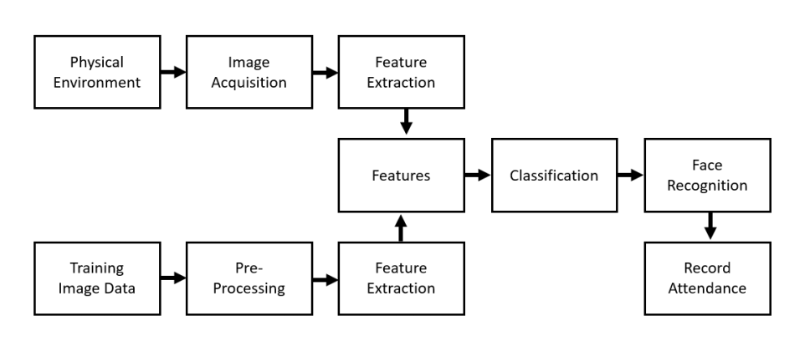

*Fig 3.1 : Block Diagram of Facial Recognition Attendance System*

An environment is everything in the world in which an agent is present. Here physical agents are agents situated in a physical real world. In our system individual person is agent in physical environment. So image acquisition of person is done in our system, in order to extract the features of a person i.e. from the face. Where we can define image acquisition as the creation of a digitally encoded representation of visual characteristics of an object, such as a physical scene or the interior structure of an object. Likewise, our system will also train the image capture with preprocessing of data for making dataset with features extraction. And AI is defined as the process of a machine imitating human intelligence factors such as; learning, self-correction and reasoning. So training data is often used in the validation and testing set of data. These two extracted feature that is from image acquisition and training dataset are classified according to their classification. Classification in machine learning is when a machine or computer uses an algorithm to draw conclusion from data that it already has, and then uses these conclusions to categories new data it receives. Hence the image recognition is done through the help of classification. Finally recognizing the person, our system automatically record the attendance of the person in the database.

### 3.2 Use-Case Diagram

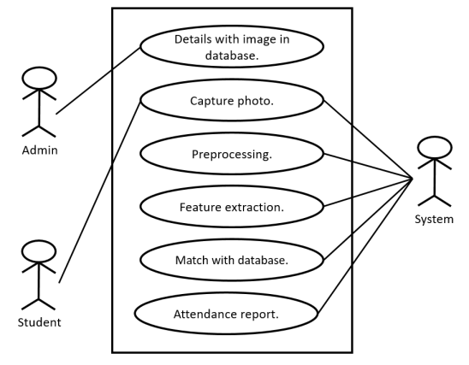

*Fig 3.3 Use-Case Diagram*

For our system, we used three actors in use-case diagram. Capturing the photo of Studen (i.e. first actor)is done. System actor is responsible for preprocessing of the captured photo and extracted features of photo as per the requriment. And matches the extracted features with the database and record the attendance report of those student by the system itself. Final actor i.e. Admin is overall manager which manages all the details of image of student in the database.

### 3.3 Work Schedule

|  |  |  |  |  |  |  |  |  |  |
| --- | --- | --- | --- | --- | --- | --- | --- | --- | --- |
| S.  N | Week Job  Description | 1st  Week | 2nd  Week | 3rd  Week | 4th  Week | 5th  Week | 6th  Week | 7th  Week | 8th  Week |
| 1. | Problem  Identification |  |  |  |  |  |  |  |  |
| 2. | Analysis |  |  |  |  |  |  |  |  |
| 3. | Design |  |  |  |  |  |  |  |  |
| 4. | Coding |  |  |  |  |  |  |  |  |
| 5. | Testing and  Debugging |  |  |  |  |  |  |  |  |
| 6. | Documentation |  |  |  |  |  |  |  |  |

*Fig 3.1 : Work Schedule*

### 3.4 Tools and Platform

1. Python
2. Matlab
3. MYSQL Database
4. Anaconda
5. Keras with TensorFlow backend

### 3.5 Structure of Project Proposal

This proposal includes following chapters:

* Chapter 1 includes the introduction of the project including background of the study, objectives, problem statement, motivation and scope of the project
* Chapter 2 presents the literature reviews of the project work.
* Chapter 3 presents the methodology for the development of the project.
* Chapter 4 shows the expected results from the project work.

# CHAPTER 4

## EXPECTED RESULTS

Our project (Facial Recognition Attendance system) will be able to recognize the student face as well as record attendance of student. Beside it, this project will save the paper work also by providing the softcopy of attendance record of the student. Likewise, this project can also be use for the security purpose. And this will minimize the time consuming instead of recording attendance manually, so this project will be efficient for the implementation.

# Reference

1. Hongling Chen and Chen Haoyou, “*Face Recognition Algorithm Based on VGG Network Model and SVM”,* IOP Conf. Series: Journal of Physics: Conf. Series 1229 (2019) 012015 IOP Publishing doi:10.1088/1742-6596/1229/1/012015, [Accessed: 28thFebruary, 2020]
2. Zhao Pei, Hang Xu, YanningZhang, Min Guo and Yee-Hong Yang, “*Face Recognition via Deep Learning Using Data Augmentation Based on Orthogonal Experiments*”, 25 September 2019. [Visited Date: 28thFebruary, 2020]
3. SrikanthTammina, "*Transfer learning using VGG-16 with Deep Convolutional Neural Network for Classifying Images*", Electrical Engineering, Indian Institute of Technology, Hyderabad, 2017 [Accessed: 28thFebruary, 2020]
4. Mei-Xiang Zhao, Zhi-Gang Jia, Dunwei Gong "*Sample-Relaxed Two-Dimensional Color Principal Component Analysis for Face Recognition and Image Reconstruction*", [Accessed: 28th February, 2020]
5. MengjiaYan Horizon Robotics, Qian Zhang Horizon Robotics, Guoli Wang Horizon Robotics, ZiningXu Horizon Robotics "*VarGFaceNet:An Efﬁcient Variable Group Convolutional Neural Networkfor Lightweight Face Recognition*", [Accessed: 3rd March, 2020]
6. Felipe L. Gewers, Gustavo R. Ferreira, Henrique F. de Arruda, Filipi N. Silva, Cesar H. Comin, Diego R. Amancio, and Luciano da F. Costa1 "*Principal Component Analysis: A Natural Approach to Data Exploration”, [*Accessed: 10th February, 2020]