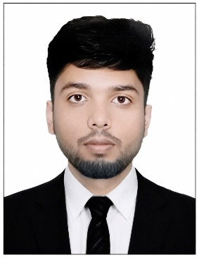
SHAON BASAK
Kuratoli, Dhaka • 01796751108
shaonbasaksb@gmail.com
https://github.com/Shaon-12
https://github.com/Shaon-12
https://linkedin.com/in/shaon-basak-576b7635a
CAREER OBJECTIVE
4th Year Computer Science and Engineering student seeking a Software Developer Intern to apply knowledge of software engineering, web development, and problem solving in a professional environment while contributing to software development projects and gaining practical industry experience.
EDUCATION
American International University Bangladesh (Kuratoli, Dhaka) Expected Graduation: Feb 2027
B.Sc. in Computer Science & Engineering | CGPA: 3.68 (Up to 11th Semester)
Dinajpur Govt. City College (Dinajpur) December 2021
Higher Secondary Certificate(HSC) in Science | GPA: 5.00
Dinajpur Zilla School (Dinajpur) February 2019
Secondary School Certificate(SSC) in Science | GPA: 4.67
ACHIEVEMENTS
- Dean's Honorable Mention — Fall 2025–2026, American International University-Bangladesh
- Cisco Networking Academy – Introduction to Computer Studies, 2023, American International University-Bangladesh
TECHNICAL SKILLS
Web Development: HTML, CSS, JavaScript, Node.js, React.js, Next.js
Databases: MySQL
Programming Languages: Java, C++, C#, Python
PROJECTS
Study Abroad & Credit Transfer Management System Web Technology Course Project
- Developed a full-stack web application to simplify study abroad and credit transfer management.
Home Expense Tracker Python Project
- Developed a Python CLI application to manage shared household expenses and automate cost distribution.
Bridge Gene Discovery in E. coli Pangenome Basic Graph Theory project
- Developed a graph-based framework to identify bridge genes using Maximum Spanning Tree and Betweenness Centrality.
Smart Traffic Management System ML Project
- Developed a deep learning-based traffic management system for real-time vehicle detection and adaptive signal control, comparing YOLOv8s, Faster R-CNN, and SSD300 for traffic optimization.
Political Bias Detection in News Text NLP Project
- Developed an NLP-based text classification system to detect political bias in news articles using machine learning.
Blood Bank Management System Database Project
- Developed a database system to manage donor records and blood inventory.
Online Voting Machine Java Project
- Developed a Java-based voting application for secure vote management.
VOLUNTEER EXPERIENCE
Arise Foundation Bangladesh, Ghasipara, Dinajpur February 2018
Volunteer Foundation Member
- Provided food, clothing, and financial assistance to underprivileged and vulnerable individuals in the community.
- Collaborated with team members to organize and distribute resources effectively.
- Engaged in outreach activities to identify and support those in need.
ACTIVITIES
Dinajpur Govt. City College (Dinajpur) Sept. 2019 – May 2021
- Member, College Cricket Team
- Event Management Volunteer
ADDITIONAL INFORMATION
Soft Skills: Teamwork & Collaboration, Leadership, Time Management & Task Prioritization, Problem Solving
Interests: Hiking, Travelling, Listening to Music, Watching Movies
REFERENCES
Ujjal Kumar
Principal Officer
Uttara Bank PLC
Sherpur Sub Branch, Bogura.
Mobile : 01712235013


Shaon Basak
Signature of Applicant

