Vector Voltmeter using Synchronous detection
- What is Synchronous Detection?
If the unknown voltage x(t) is complex in nature, i.e., when it contains fundamental and other harmonic components as well as some uncorrelated random noise etc, synchronous or coherent detection allows extraction of fundamental component in vector form from the complex wave.

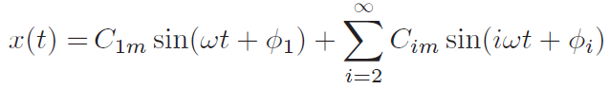
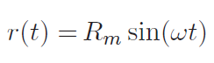

C_{1m} is the amplitude and φ₁ is the phase
C_{im} as amplitude and φ_{i} as phase for the i^{th} harmonic

Let I and Q be the r.m.s. amplitudes representing the in-phase and quadrature components of fundamental of x(t) wrt the reference voltage. Then I and Q may be estimated as:

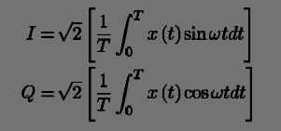
Where, 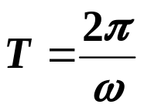

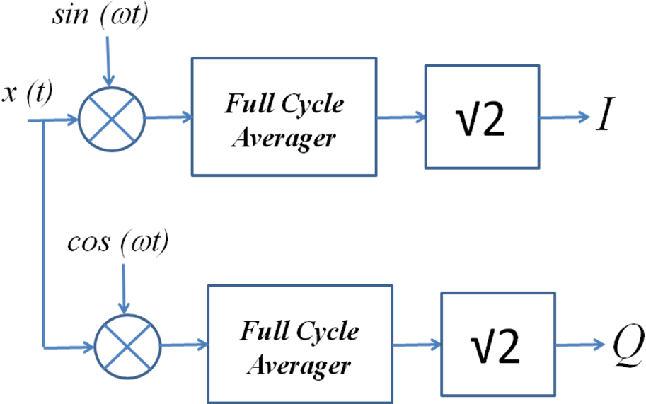

Implementation using FS
