|  |  |  |  |
| --- | --- | --- | --- |
| **TITLE:** | RFP | | |
| **sop #:** | IT-04 | **revision #:** | 1 |
| **EFFECTIVE DATE:** |  | | |
| **OWNER:** | Anna Figliomeni | | |

## REVIEWERS

|  |  |  |  |
| --- | --- | --- | --- |
| Name | tITLE | sIGNATURE | dATE |
| Amernauth Prasad | Warehouse Lead Hand |  |  |

## APPROVER

|  |  |  |  |
| --- | --- | --- | --- |
| Name | tITLE | sIGNATURE | dATE |
| Barry Fielding | Manager, Carrier Relations |  |  |

# 1.0 purpose

Guidelines to complete RFP.

# 2.0 SCOPE

Transportation RFP and/or rate requests for current customers or new opportunities.

# 3.0 equipment

N/A

# 4.0 definitions

|  |  |
| --- | --- |
| **Definition** | **Explanation** |
| **N/A** |  |

# 5.0 Responsibility

|  |  |
| --- | --- |
| **Responsibility** | **Activity** |
| **RFP/Rate request** | Participate sales opportunity for new and existing customers in order to secure new business and/or retain the current business |

# 6.0 policy

## 6.1 HIGHWAY RETAIL FUEL

1. Decide it’s a go or non-go (Sales/Procurement/OPS).
2. Complete RFP registration on website

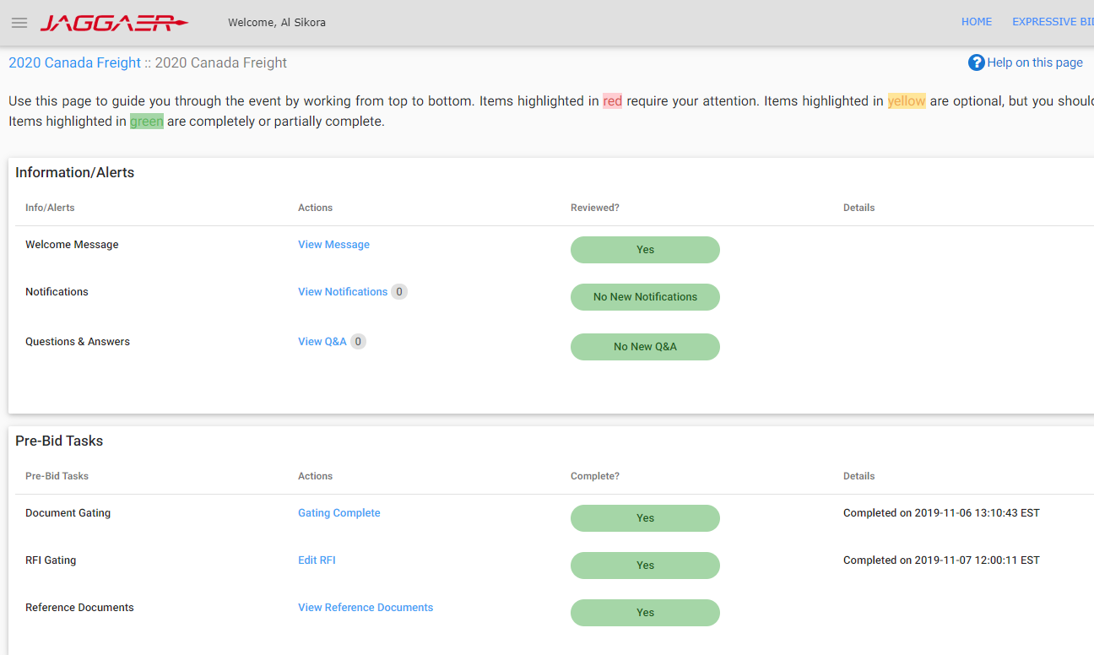

1. Accept terms, upload signed NDA, complete RFI or other gating documents, and fill in required information to get the access to bid lane details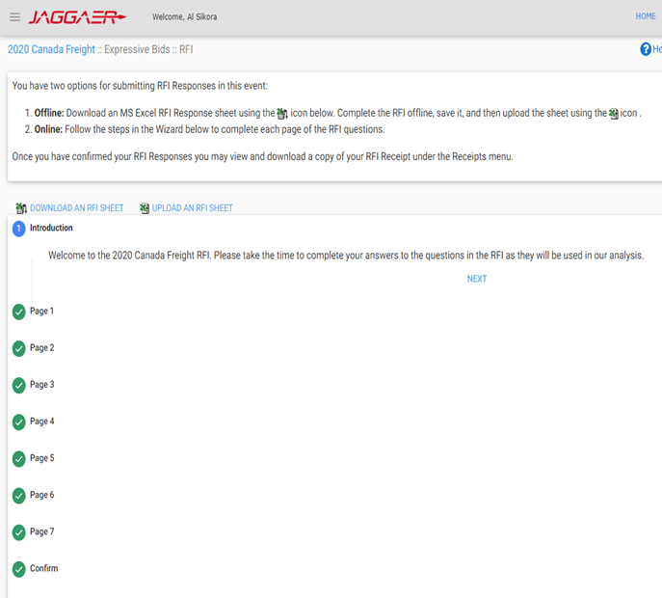
2. Download all RFP documents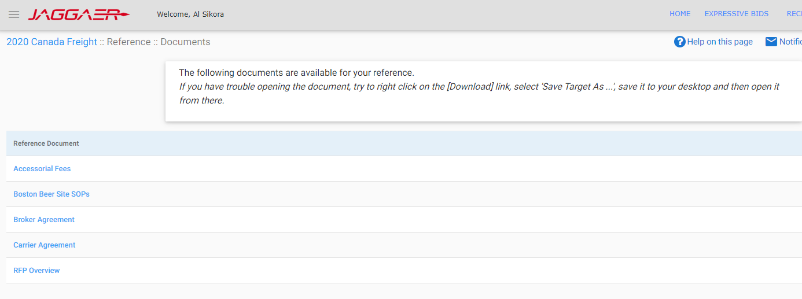
3. Quickly review and highlight points for special attention: contact length, insurance/claim, payment term, special requirements, accessorial schedule, fuel surcharge etc.
4. Prepare and send procurement template together with the other RFP documents to team

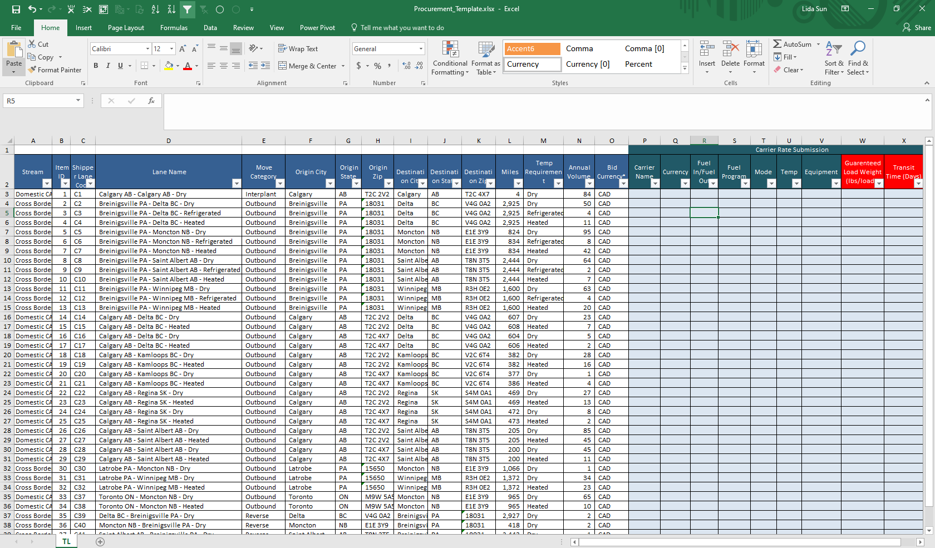

1. 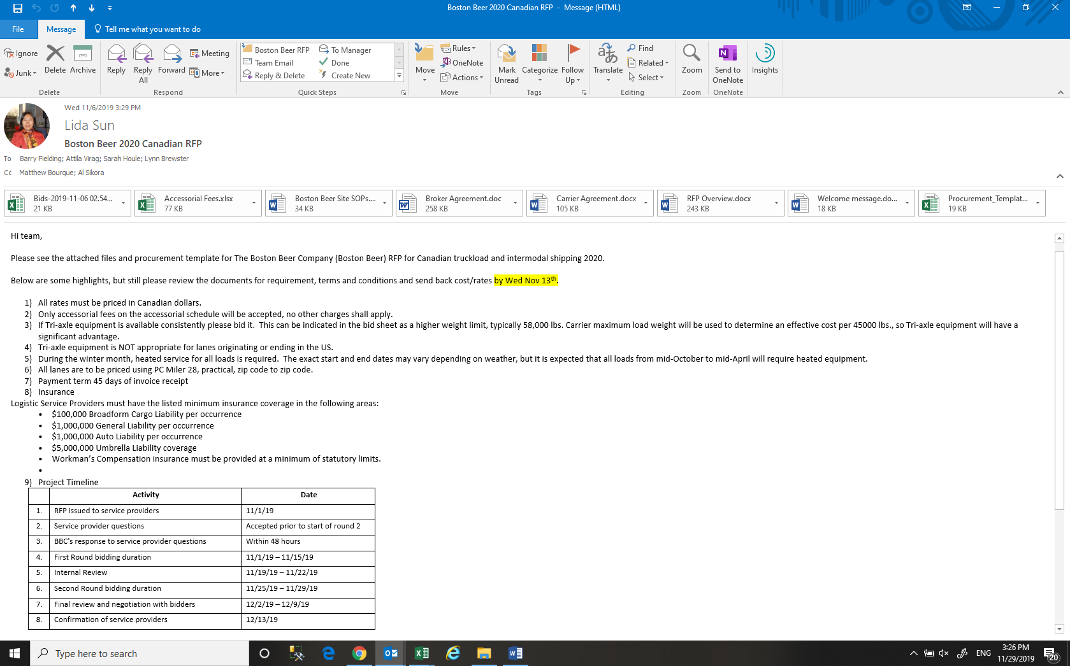Summarize the scope of the RFP (OTR/IMDL, CA/US/XB, FTL/LTL, Dry/Temp, Lanes, volume, multiple rounds timeline etc.)
2. Highlight points for team’s special attention

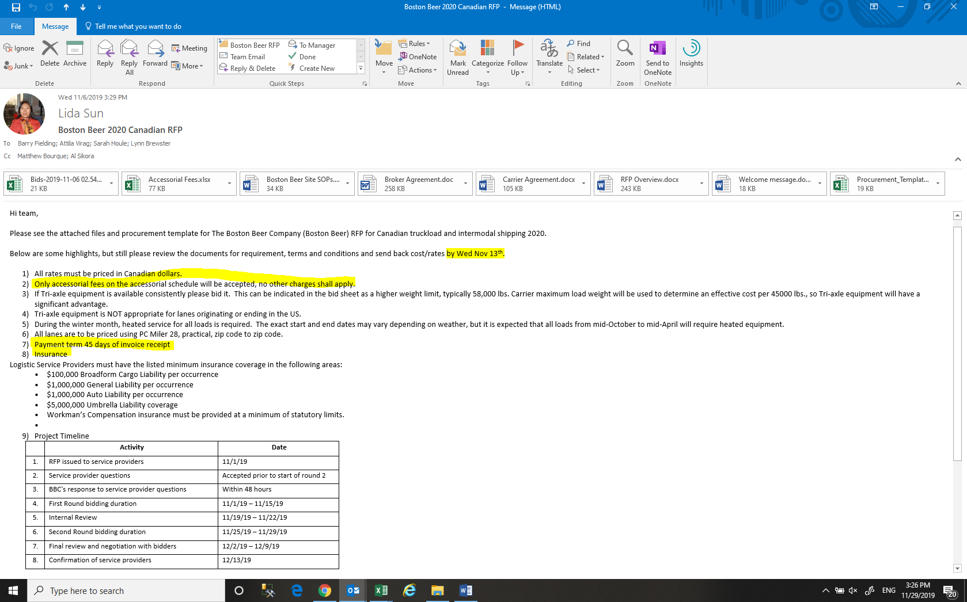

1. Get input from Ops for cost and other operational highlights
2. Schedule 1st review meeting within Procurement
3. Schedule 2nd review meeting with Procurement, Ops, and Sales
4. Pull historical data to match the lanes in RFP for reference

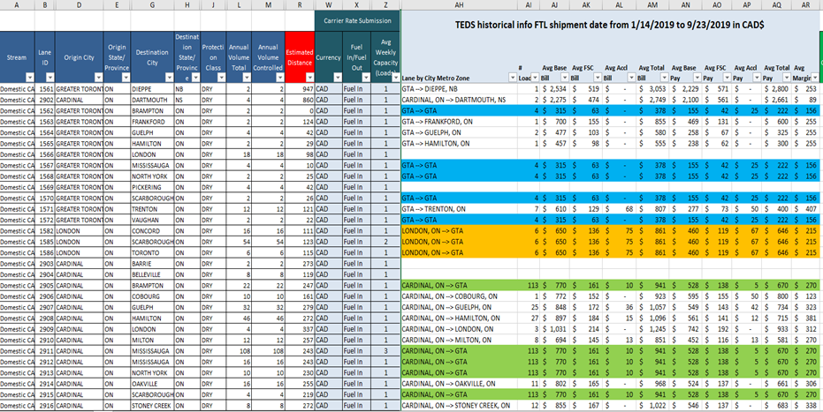

1. Understand RFP currency, fuel surcharge and accessorial charges, then buffer properly
2. Develop bill rates once cost is ready
3. Compare with historical to find changes
4. Summarize volume/revenue/margin for review

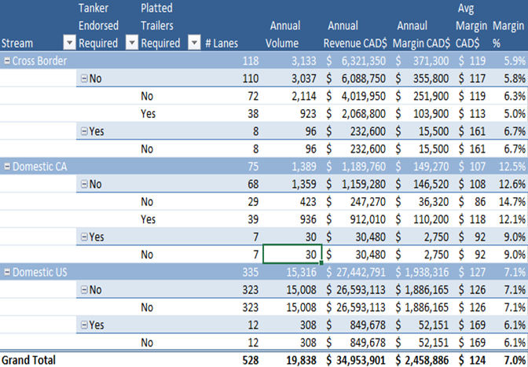

1. Complete review meetings and adjust accordingly based on the meeting outcome
2. Finalize bid submission package (bid sheets, capacity summary, etc.)

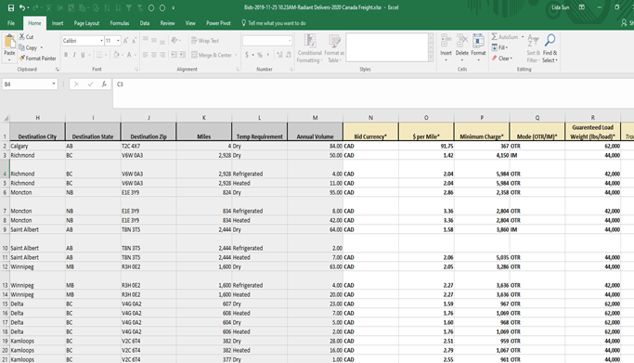

1. Submit bid package and keep receipt/proof of submission

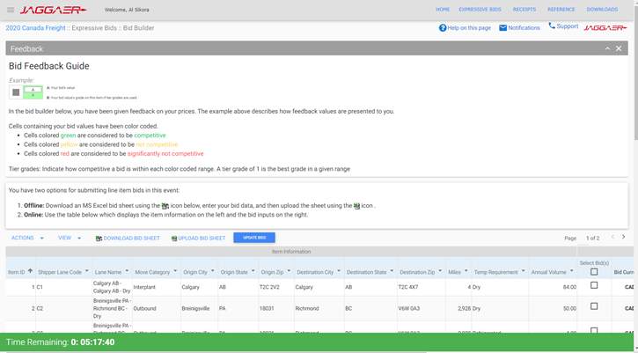

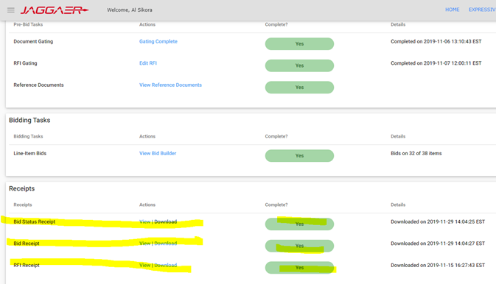

1. Send email notification to meeting parties for the completion of RFP submission with files/receipts and RFP summary
2. If there is Round 2, get the feedback from Round 1 and match it with our Round 1 lanes to see the variance and decide how much to reduce depending on the gap, volume, etc.

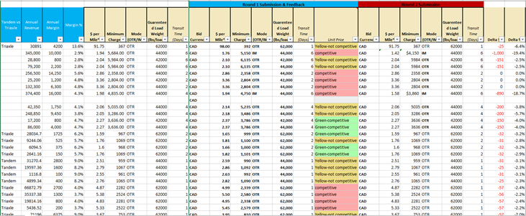

1. Once adjustment is done, repeat step 10 to 20
2. Once awards are issued, verify rates/volume/currency, etc. for the award lanes and identify any discrepancy
3. If all is OK, confirm back with customer
4. Also send signed documents to customers if any
5. Share award lanes, rates, accessorial files with Procurement (Mandeep, Michelle, Denise, Lynn, Sarah, Barry) and Operation teams

# 7.0 references

# 8.0 revision history

|  |  |  |
| --- | --- | --- |
| **Revision #** | **Revision Date** | **Description** |
|  |  |  |