TITLE:
sop #: |  | revision #:

EFFECTIVE DATE:
OWNER:

REVIEWERS
Name | tITLE | sIGNATURE | dATE

APPROVER
Name | tITLE | sIGNATURE | dATE

1.0 purpose
Guidelines to complete RFP.

2.0 SCOPE
Transportation RFP and/or rate requests for current customers or new opportunities.

3.0 equipment
N/A

4.0 definitions
Definition | Explanation
N/A

5.0 Responsibility
Responsibility | Activity
RFP/Rate request | Participate sales opportunity for new and existing customers in order to secure new business and/or retain the current business

6.0 policy

6.1 HIGHWAY RETAIL FUEL
- Decide it’s a go or non-go (Sales/Procurement/OPS).
- Complete RFP registration on website
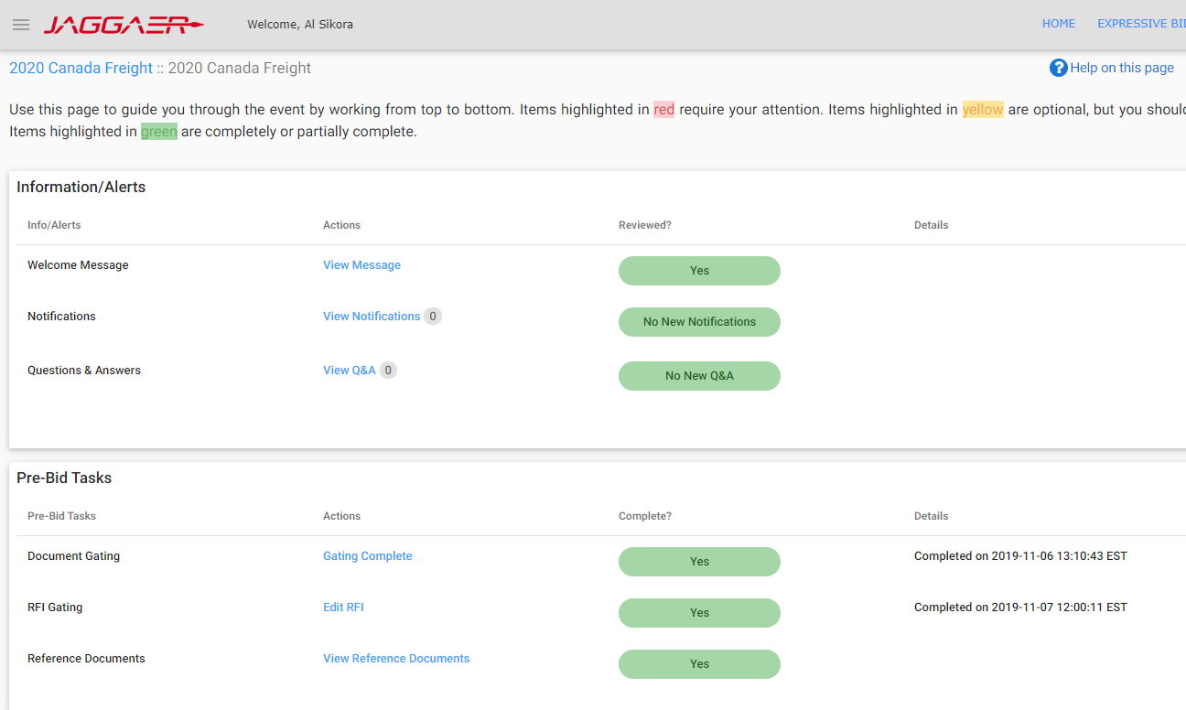
- Accept terms, upload signed NDA, complete RFI or other gating documents, and fill in required information to get the access to bid lane details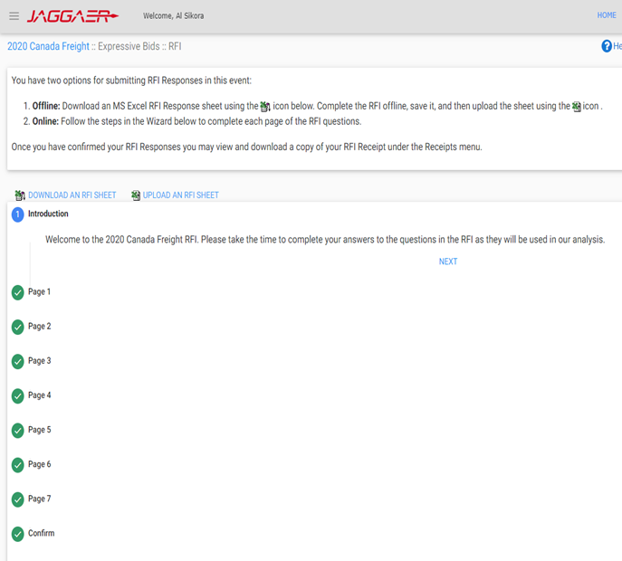

- Download all RFP documents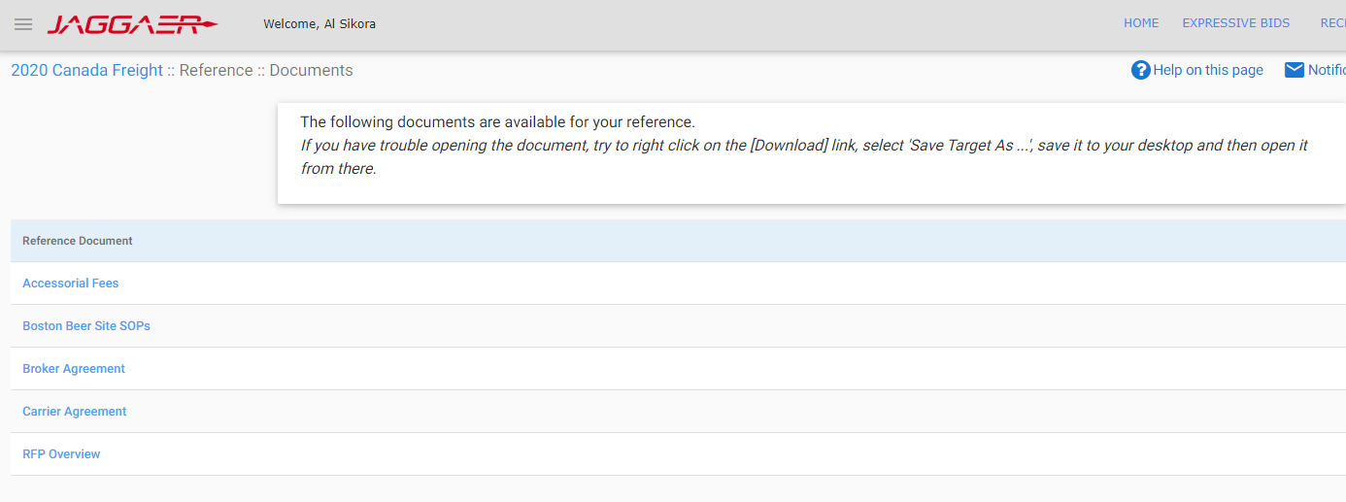

- Quickly review and highlight points for special attention: contact length, insurance/claim, payment term, special requirements, accessorial schedule, fuel surcharge etc.

- Prepare and send procurement template together with the other RFP documents to team
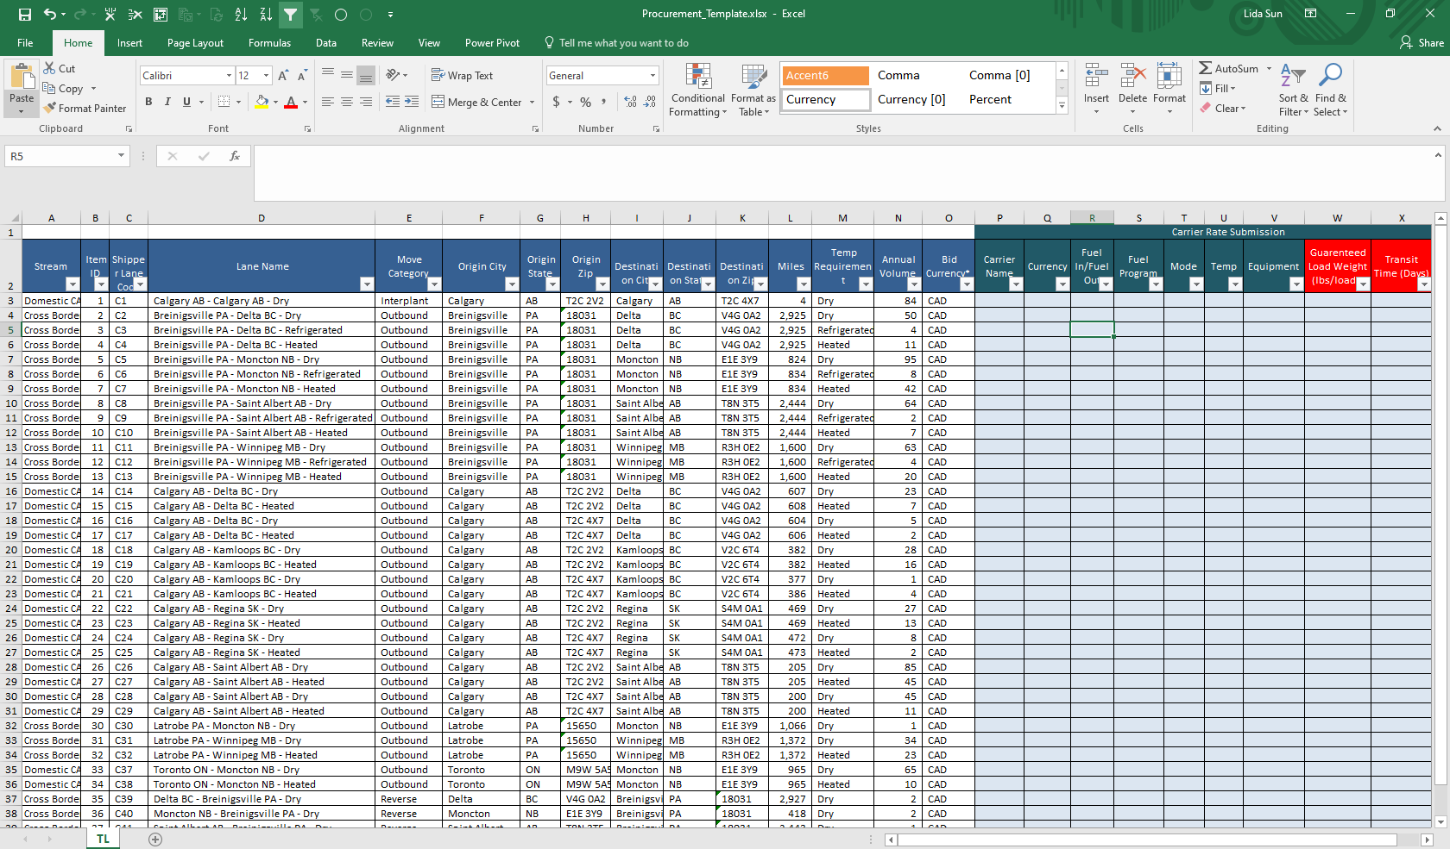

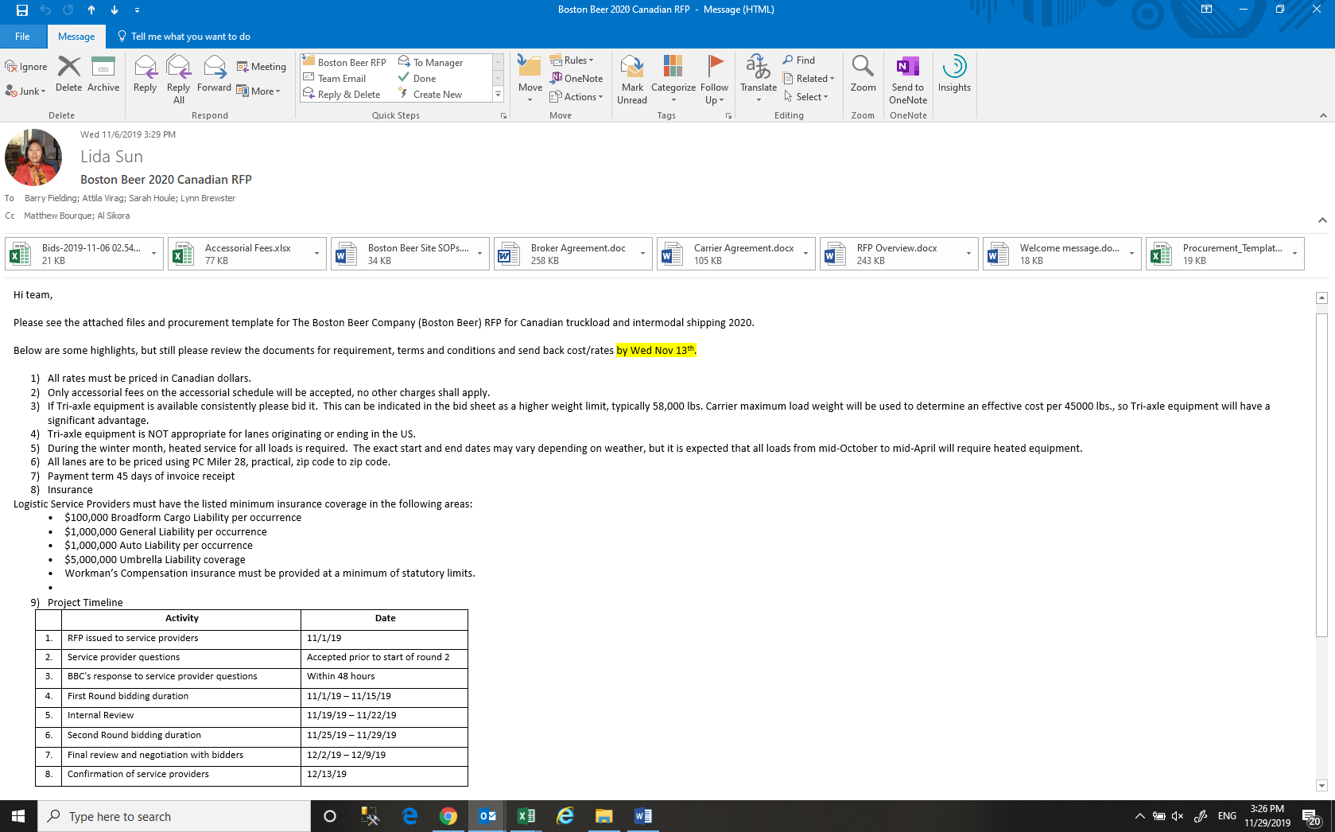
- Summarize the scope of the RFP (OTR/IMDL, CA/US/XB, FTL/LTL, Dry/Temp, Lanes, volume, multiple rounds timeline etc.)
- Highlight points for team’s special attention
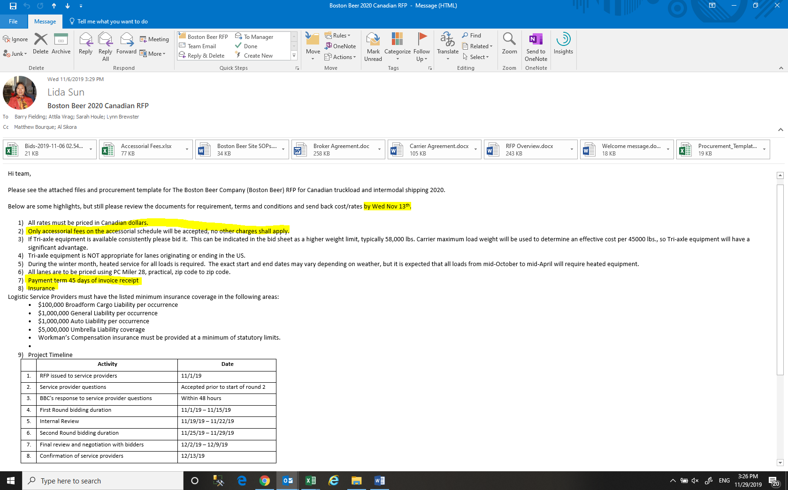

- Get input from Ops for cost and other operational highlights
- Schedule 1st review meeting within Procurement
- Schedule 2nd review meeting with Procurement, Ops, and Sales
- Pull historical data to match the lanes in RFP for reference
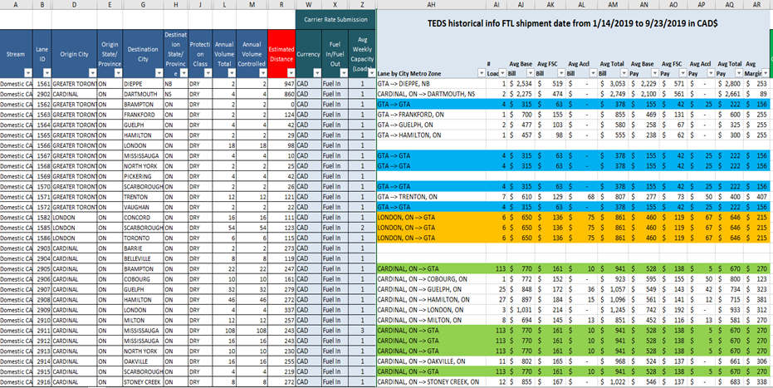
- Understand RFP currency, fuel surcharge and accessorial charges, then buffer properly

- Develop bill rates once cost is ready

- Compare with historical to find changes

- Summarize volume/revenue/margin for review
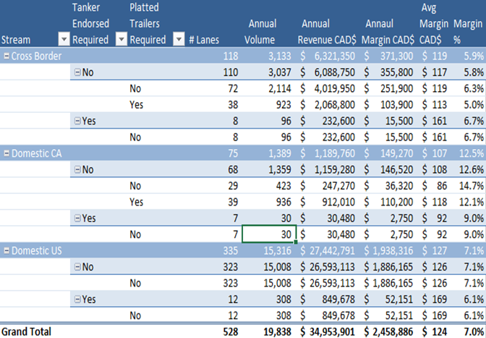

- Complete review meetings and adjust accordingly based on the meeting outcome

- Finalize bid submission package (bid sheets, capacity summary, etc.)
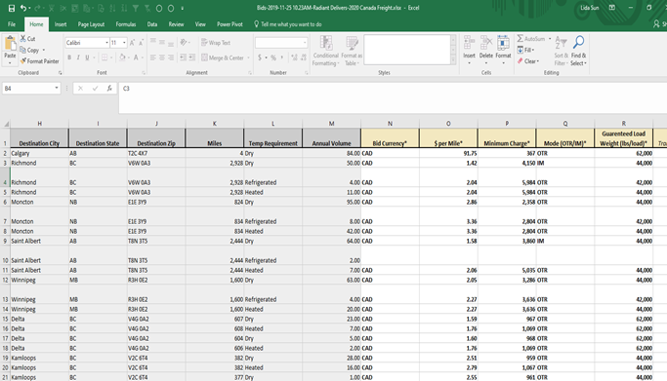

- Submit bid package and keep receipt/proof of submission

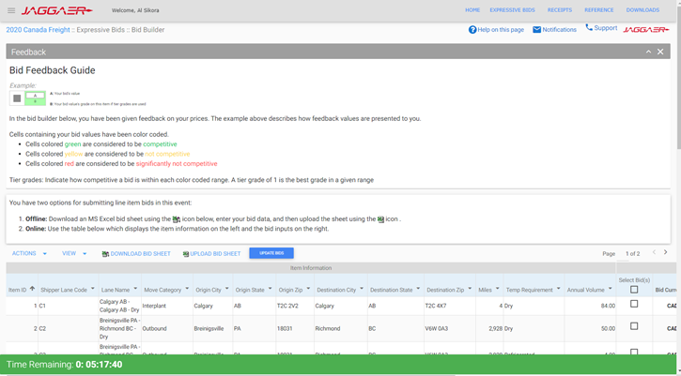
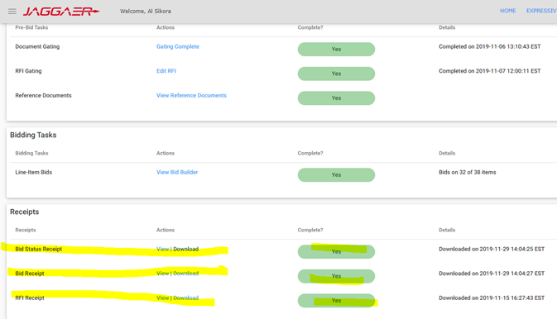

- Send email notification to meeting parties for the completion of RFP submission with files/receipts and RFP summary
- If there is Round 2, get the feedback from Round 1 and match it with our Round 1 lanes to see the variance and decide how much to reduce depending on the gap, volume, etc.
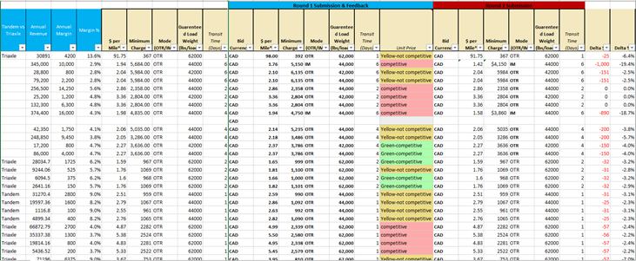
- Once adjustment is done, repeat step 10 to 20
- Once awards are issued, verify rates/volume/currency, etc. for the award lanes and identify any discrepancy
- If all is OK, confirm back with customer
- Also send signed documents to customers if any
- Share award lanes, rates, accessorial files with Procurement (Mandeep, Michelle, Denise, Lynn, Sarah, Barry) and Operation teams

7.0 references

8.0 revision history
Revision # | Revision Date | Description

