Please select the correct answer and briefly explain the reasoning for your selection.

1. Which of the following areas represent a watershed defined for point P?
2. A
3. B
4. Both
5. Neither

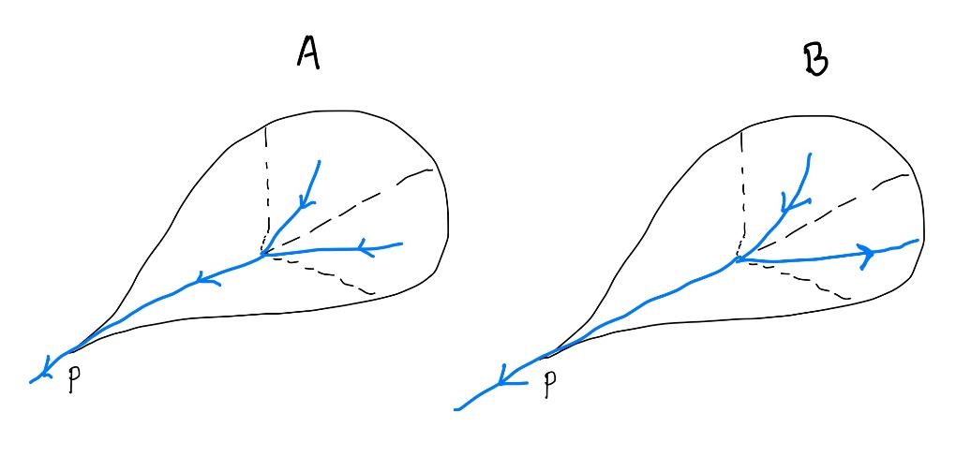

Answer: A. As for B, there are parts of the area that do not drain to point P and flowing to some other points.

1. Which technique can tackle the problem of fragmentation in land allocation?
2. Imposing shape constraints
3. Imposing spatial contiguity
4. Both
5. Neither

Answer: c) Both. On one hand, Shape constraint ensures that the farming land has a regular shape e.g. rectangular shape for the Midwestern US or circular area for a dry climate. On the other hand, spatial contiguity constraints ensure the minimum tile area needed for farming.